UNITED STATES
SECURITIES AND EXCHANGE COMMISSION
Washington, D.C. 20549

FORM 8-K

CURRENT REPORT
Pursuant to Section 13 or 15(d) of the Securities Exchange Act of 1934

Date of Report (Date of earliest event reported): July 23, 2026

HOMETRUST BANCSHARES, INC.
(Exact name of registrant as specified in its charter)

Maryland |  |  |  |  |  | 001-35593 |  |  |  |  |  | 45-5055422
(State or other jurisdiction of incorporation) |  |  |  |  |  | (Commission File Number) |  |  |  |  |  | (IRS Employer Identification No.)
10 Woodfin Street, Asheville, North Carolina |  |  |  |  |  |  |  |  |  |  |  | 28801
(Address of principal executive offices) |  |  |  |  |  |  |  |  |  |  |  | (Zip Code)
Registrant's telephone number, including area code: (828) 259-3939
Not Applicable
(Former name or former address, if changed since last report)

Check the appropriate box below if the Form 8-K filing is intended to simultaneously satisfy the filing obligation of the registrant under any of the following provisions:
☐ |  |  | Written communications pursuant to Rule 425 under the Securities Act (17 CFR 230.425)
☐ |  |  | Soliciting material pursuant to Rule 14a-12 under the Exchange Act (17 CFR 240.14a-12)
☐ |  |  | Pre-commencement communications pursuant to Rule 14d-2(b) under the Exchange Act (17 CFR 240.14d-2(b))
☐ |  |  | Pre-commencement communications pursuant to Rule 13e-4(c) under the Exchange Act (17 CFR 240.13e-4(c))
Securities Registered Pursuant to Section 12(b) of the Act:
Title of each class |  |  | Trading Symbol |  |  | Name of each exchange on which registered
Common Stock, par value $0.01 per share |  |  | HTB |  |  | The New York Stock Exchange LLC

Indicate by check mark whether the registrant is an emerging growth company as defined in Rule 405 of the Securities Act of 1933 (§230.405 of this chapter) or Rule 12b-2 of the Securities Exchange Act of 1934 (§240.12b-2 of this chapter).
Emerging growth company |  |  | ☐
If an emerging growth company, indicate by check mark if the registrant has elected not to use the extended transition period for complying with any new or revised financial accounting standards provided pursuant to Section 13(a) of the Exchange Act. |  |  | ☐

Item 2.02 Results of Operations and Financial Condition
On July 23, 2026, HomeTrust Bancshares, Inc., (the "Company") the holding company for HomeTrust Bank, issued a press release reporting financial results for the second quarter of the year ending December 31, 2026 and the declaration and approval of its quarterly cash dividend. A copy of the press release, including unaudited financial information released as a part thereof, is attached as Exhibit 99.1 to this Current Report on Form 8-K and incorporated herein by reference.
Item 7.01 Regulation FD Disclosure
The attached investor presentation contains financial data that members of management will use from time to time with investors, analysts and other interested parties to assist in their understanding of the Company. The investor presentation is also available on the Company’s website at ir.htb.com. The presentation is furnished as Exhibit 99.2 to this Current Report on Form 8-K and is incorporated herein by reference.
Item 9.01 Financial Statements and Exhibits
(d) Exhibits

99.1 |  |  | Press release dated July 23, 2026
99.2 |  |  | June 30, 2026 investor presentation

SIGNATURE
Pursuant to the requirements of the Securities Exchange Act of 1934, the registrant has duly caused this report to be signed on its behalf by the undersigned hereunto duly authorized.

 |  |  |  |  |  |  |  |  | HOMETRUST BANCSHARES, INC.
Date: July 23, 2026 |  |  |  |  |  | By: |  |  | /s/ Tony J. VunCannon
 |  |  |  |  |  |  |  |  | Tony J. VunCannon
 |  |  |  |  |  |  |  |  | Executive Vice President, Chief Financial Officer, Corporate Secretary and Treasurer

2

HomeTrust Bancshares, Inc. Announces Financial Results for the Second Quarter of the Year Ending December 31, 2026
and Declaration of a Quarterly Dividend
ASHEVILLE, N.C., July 23, 2026 – HomeTrust Bancshares, Inc. (NYSE: HTB) ("Company"), the holding company of HomeTrust Bank ("Bank"), today announced preliminary net income for the second quarter of the year ending December 31, 2026 and approval of its quarterly cash dividend.
For the quarter ended June 30, 2026 compared to the quarter ended March 31, 2026:
•net income was $15.6 million compared to $16.8 million;
•diluted earnings per share ("EPS") were $0.94 compared to $0.99;
•annualized return on assets ("ROA") was 1.46% compared to 1.55%;
•annualized return on equity ("ROE") was 10.44% compared to 11.35%;
•net interest margin was 4.41% compared to 4.31%;
•provision for credit losses was $920,000 compared to $370,000;
•gain on the sale of real estate was $1.1 million compared to $377,000;
•loss on the redemption of junior subordinated debt securities was $1.1 million compared to $0;
•quarterly cash dividends increased $0.02 per share, or 15.4%, to $0.15 per share totaling $2.4 million compared to $0.13 per share totaling $2.2 million; and
•153,606 shares of Company common stock were repurchased during the current quarter at an average price of $46.31 compared to 533,240 shares repurchased at an average price of $42.85 in the prior quarter.
For the six months ended June 30, 2026 compared to the six months ended June 30, 2025:
•net income was $32.4 million compared to $31.7 million;
•diluted EPS were $1.93 compared to $1.84;
•annualized ROA was 1.51% compared to 1.46%;
•annualized ROE was 10.89% compared to 11.26%;
•net interest margin was 4.36% compared to 4.25%;
•provision for credit losses was $1.3 million compared to $2.8 million;
•cash dividends were $0.28 per share totaling $4.6 million compared to $0.24 per share totaling $4.1 million; and
•686,846 shares of Company common stock were repurchased at an average price of $43.62 compared to 93,212 shares of Company common stock repurchased at an average price of $35.41 in the same period last year.
The Company also announced today that its Board of Directors declared a quarterly cash dividend of $0.15 per common share payable on August 27, 2026 to shareholders of record as of the close of business on August 13, 2026.
“We are pleased to report the continuation of our strong quarterly financial results driven by the expansion of our top-quartile net interest margin,” said Hunter Westbrook, President and Chief Executive Officer. “The quarter was highlighted by loan growth of 8.5% annualized, which increases to 14.6% after excluding portfolios we are intentionally reducing. This growth is consistent with our intention to accelerate loan growth, reflecting the strength of our franchise and dedication of our team.
“Shortly after quarter end we were excited to announce the launch of our new Healthcare Banking Division. This is another important strategic step in expanding our relationship-oriented approach to banking, while ensuring we continue to meet the needs of the communities we are proud to serve.
“We have has previously stated our goal is to be a consistently high-performing regional community bank and a regionally and nationally recognized ‘Best Place to Work.’ Reflecting our progress, for a third straight year the Company was included in Forbes’ America’s Best Banks for 2026 and for a second straight year was included in the 2026 KBW Bank Honor Roll, a distinction granted to only 6% of eligible banks based on best-in-class earnings growth over the past ten years. HTB was also recognized on American Banker’s ‘Best Banks to Work For’ list for the second consecutive year and as a best place to work for multiple years in all five states we serve. These recognitions demonstrate continued progress toward our goal and our commitment to building on that momentum. We remain focused on executing our strategy to continue delivering sustainable results and long-term value for all stakeholders.”

WEBSITE: WWW.HTB.COM

Contact:
C. Hunter Westbrook – President and Chief Executive Officer
Tony J. VunCannon – Executive Vice President, Chief Financial Officer, Corporate Secretary and Treasurer
828-259-3939

1
Comparison of Results of Operations for the Three Months Ended June 30, 2026 and March 31, 2026
Net Income. Net income totaled $15.6 million, or $0.94 per diluted share, for the three months ended June 30, 2026 compared to $16.8 million, or $0.99 per diluted share, for the three months ended March 31, 2026, a decrease of $1.2 million, or 6.8%. The results for the three months ended June 30, 2026 compared to the three months ended March 31, 2026 were negatively impacted by a $784,000 decrease in noninterest income and a $1.0 million increase in noninterest expense due to a $1.1 million loss resulting from the redemption of junior subordinated debt securities, partially offset by a $1.0 million increase in net interest income. Details of the changes in the various components of net income are further discussed below.
Net Interest Income. The following table presents the distribution of average assets, liabilities and equity, as well as interest income earned on average interest-earning assets and interest expense paid on average interest-bearing liabilities. All average balances are daily average balances. Nonaccruing loans have been included in the table as loans carrying a zero yield.
 |  |  | Three Months Ended
 |  |  | June 30, 2026 |  |  |  |  |  |  |  |  |  |  |  |  |  |  |  |  |  | March 31, 2026
(Dollars in thousands) |  |  | Average  Balance  Outstanding |  |  |  |  |  | Interest  Earned /  Paid |  |  |  |  |  | Yield /  Rate |  |  |  |  |  | Average  Balance  Outstanding |  |  |  |  |  | Interest  Earned /  Paid |  |  |  |  |  | Yield /  Rate
Assets
Interest-earning assets
Loans receivable(1) |  |  | $ | 3,770,898 |  |  |  |  | $ | 57,507 |  |  |  |  | 6.12 |  | % |  |  |  | $ | 3,793,994 |  |  |  |  | $ | 57,725 |  |  |  |  | 6.17 |  | %
Debt securities available for sale |  |  | 152,647 |  |  |  |  |  | 1,667 |  |  |  |  |  | 4.38 |  |  |  |  |  | 144,520 |  |  |  |  |  | 1,604 |  |  |  |  |  | 4.50
Other interest-earning assets(2) |  |  | 199,135 |  |  |  |  |  | 1,999 |  |  |  |  |  | 4.03 |  |  |  |  |  | 227,051 |  |  |  |  |  | 2,168 |  |  |  |  |  | 3.87
Total interest-earning assets |  |  | 4,122,680 |  |  |  |  |  | 61,173 |  |  |  |  |  | 5.95 |  |  |  |  |  | 4,165,565 |  |  |  |  |  | 61,497 |  |  |  |  |  | 5.99
Other assets |  |  | 175,077 |  |  |  |  |  |  |  |  |  |  |  |  |  |  |  |  |  | 218,936
Total assets |  |  | $ | 4,297,757 |  |  |  |  |  |  |  |  |  |  |  |  |  |  |  |  | $ | 4,384,501
Liabilities and equity
Interest-bearing liabilities
Interest-bearing checking accounts |  |  | $ | 556,610 |  |  |  |  | $ | 1,128 |  |  |  |  | 0.81 |  | % |  |  |  | $ | 561,216 |  |  |  |  | $ | 1,101 |  |  |  |  | 0.80 |  | %
Money market accounts |  |  | 1,376,199 |  |  |  |  |  | 8,678 |  |  |  |  |  | 2.53 |  |  |  |  |  | 1,369,569 |  |  |  |  |  | 8,616 |  |  |  |  |  | 2.55
Savings accounts |  |  | 170,067 |  |  |  |  |  | 28 |  |  |  |  |  | 0.07 |  |  |  |  |  | 170,227 |  |  |  |  |  | 28 |  |  |  |  |  | 0.07
Certificate accounts |  |  | 712,224 |  |  |  |  |  | 5,744 |  |  |  |  |  | 3.23 |  |  |  |  |  | 830,675 |  |  |  |  |  | 7,105 |  |  |  |  |  | 3.47
Total interest-bearing deposits |  |  | 2,815,100 |  |  |  |  |  | 15,578 |  |  |  |  |  | 2.22 |  |  |  |  |  | 2,931,687 |  |  |  |  |  | 16,850 |  |  |  |  |  | 2.33
Junior subordinated debt |  |  | 8,449 |  |  |  |  |  | 151 |  |  |  |  |  | 7.17 |  |  |  |  |  | 10,231 |  |  |  |  |  | 188 |  |  |  |  |  | 7.45
Borrowings |  |  | 15,978 |  |  |  |  |  | 150 |  |  |  |  |  | 3.77 |  |  |  |  |  | 16,667 |  |  |  |  |  | 154 |  |  |  |  |  | 3.75
Total interest-bearing liabilities |  |  | 2,839,527 |  |  |  |  |  | 15,879 |  |  |  |  |  | 2.24 |  |  |  |  |  | 2,958,585 |  |  |  |  |  | 17,192 |  |  |  |  |  | 2.36
Noninterest-bearing deposits |  |  | 806,566 |  |  |  |  |  |  |  |  |  |  |  |  |  |  |  |  |  | 759,493
Other liabilities |  |  | 50,949 |  |  |  |  |  |  |  |  |  |  |  |  |  |  |  |  |  | 67,106
Total liabilities |  |  | 3,697,042 |  |  |  |  |  |  |  |  |  |  |  |  |  |  |  |  |  | 3,785,184
Stockholders' equity |  |  | 600,715 |  |  |  |  |  |  |  |  |  |  |  |  |  |  |  |  |  | 599,317
Total liabilities and stockholders' equity |  |  | $ | 4,297,757 |  |  |  |  |  |  |  |  |  |  |  |  |  |  |  |  | $ | 4,384,501
Net earning assets |  |  | $ | 1,283,153 |  |  |  |  |  |  |  |  |  |  |  |  |  |  |  |  | $ | 1,206,980
Average interest-earning assets to average interest-bearing liabilities |  |  | 145.19 |  | % |  |  |  |  |  |  |  |  |  |  |  |  |  |  |  | 140.80 |  | %
Non-tax-equivalent
Net interest income |  |  |  |  |  |  |  |  | $ | 45,294 |  |  |  |  |  |  |  |  |  |  |  |  |  |  |  |  | $ | 44,305
Interest rate spread |  |  |  |  |  |  |  |  |  |  |  |  |  |  | 3.71 |  | % |  |  |  |  |  |  |  |  |  |  |  |  |  |  |  | 3.63 |  | %
Net interest margin(3) |  |  |  |  |  |  |  |  |  |  |  |  |  |  | 4.41 |  | % |  |  |  |  |  |  |  |  |  |  |  |  |  |  |  | 4.31 |  | %
Tax-equivalent(4)
Net interest income |  |  |  |  |  |  |  |  | $ | 45,752 |  |  |  |  |  |  |  |  |  |  |  |  |  |  |  |  | $ | 44,740
Interest rate spread |  |  |  |  |  |  |  |  |  |  |  |  |  |  | 3.76 |  | % |  |  |  |  |  |  |  |  |  |  |  |  |  |  |  | 3.67 |  | %
Net interest margin(3) |  |  |  |  |  |  |  |  |  |  |  |  |  |  | 4.45 |  | % |  |  |  |  |  |  |  |  |  |  |  |  |  |  |  | 4.36 |  | %
(1)Average loans receivable balances include loans held for sale and nonaccruing loans.
(2)Average other interest-earning assets consist of FRB stock, FHLB stock, SBIC investments and deposits in other banks.
(3)Net interest income divided by average interest-earning assets.
(4)Tax-equivalent results include adjustments to interest income of $458 and $435 for the three months ended June 30, 2026 and March 31, 2026, respectively, calculated based on a combined federal and state tax rate of 23%.
Total interest and dividend income for the three months ended June 30, 2026 decreased $324,000, or 0.5%, when compared to the three months ended March 31, 2026. A decline of $605,000 in accretion income was the primary driver of this change, partially offset by the impact of an additional day in the current quarter.
2
Total interest expense for the three months ended June 30, 2026 decreased $1.3 million, or 7.6%, when compared to the three months ended March 31, 2026. A decline of $1.3 million, or 7.5%, in deposit interest expense drove this change, the result of a decline in both the average balance of and rate paid on certificate accounts, specifically brokered deposits.
The following table shows the effects that changes in average balances (volume), including differences in the number of days in the periods compared, and average interest rates (rate) had on the interest earned on interest-earning assets and interest paid on interest-bearing liabilities:
 |  |  | Increase / (Decrease)  Due to |  |  |  |  |  |  |  |  |  |  |  | Total  Increase/  (Decrease)
(Dollars in thousands) |  |  | Volume |  |  |  |  |  | Rate
Interest-earning assets
Loans receivable |  |  | $ | 281 |  |  |  |  | $ | (499) |  |  |  |  | $ | (218)
Debt securities available for sale |  |  | 109 |  |  |  |  |  | (46) |  |  |  |  |  | 63
Other interest-earning assets |  |  | (245) |  |  |  |  |  | 76 |  |  |  |  |  | (169)
Total interest-earning assets |  |  | 145 |  |  |  |  |  | (469) |  |  |  |  |  | (324)
Interest-bearing liabilities
Interest-bearing checking accounts |  |  | 3 |  |  |  |  |  | 24 |  |  |  |  |  | 27
Money market accounts |  |  | 137 |  |  |  |  |  | (75) |  |  |  |  |  | 62
Savings accounts |  |  | — |  |  |  |  |  | — |  |  |  |  |  | —
Certificate accounts |  |  | (950) |  |  |  |  |  | (411) |  |  |  |  |  | (1,361)
Junior subordinated debt |  |  | (31) |  |  |  |  |  | (6) |  |  |  |  |  | (37)
Borrowings |  |  | (5) |  |  |  |  |  | 1 |  |  |  |  |  | (4)
Total interest-bearing liabilities |  |  | (846) |  |  |  |  |  | (467) |  |  |  |  |  | (1,313)
Increase in net interest income |  |  |  |  |  |  |  |  |  |  |  |  |  |  | $ | 989
Provision for Credit Losses. The provision for credit losses is the amount of expense that, based on our judgment, is required to maintain the allowance for credit losses ("ACL") at an appropriate level under the current expected credit losses model.
The following table presents a breakdown of the components of the provision for credit losses:
 |  |  | Three Months Ended
(Dollars in thousands) |  |  | June 30, 2026 |  |  |  |  |  | March 31, 2026 |  |  |  |  |  | $ Change |  |  |  |  |  | % Change
Provision for credit losses
Loans |  |  | $ | 1,020 |  |  |  |  | $ | 945 |  |  |  |  | $ | 75 |  |  |  |  | 8 |  | %
Off-balance sheet credit exposure |  |  | (100) |  |  |  |  |  | (575) |  |  |  |  |  | 475 |  |  |  |  |  | 83
Total provision for credit losses |  |  | $ | 920 |  |  |  |  | $ | 370 |  |  |  |  | $ | 550 |  |  |  |  | 149 |  | %
For the quarter ended June 30, 2026, the "loans" portion of the provision for credit losses was primarily the result of the following, offset by net charge-offs of $1.8 million during the quarter:
•$0.2 million provision driven by changes in the loan mix.
•$0.4 million benefit due to changes in the projected economic forecast, specifically the national unemployment rate, and changes in qualitative adjustments.
•$0.6 million decrease in specific reserves on individually evaluated loans.
For the quarter ended March 31, 2026, the "loans" portion of the provision for credit losses was primarily the result of the following, offset by net charge-offs of $1.8 million during the quarter:
•$0.5 million benefit driven by changes in the loan mix.
•$0.2 million provision due to changes in the projected economic forecast, specifically the national unemployment rate, and changes in qualitative adjustments.
•$0.6 million decrease in specific reserves on individually evaluated loans.
For the quarters ended June 30, 2026 and March 31, 2026, the amounts recorded for off-balance sheet credit exposure were the result of changes in the balance of loan commitments, loan mix, projected economic forecast and qualitative allocations as outlined above.
3
Noninterest Income. Noninterest income for the three months ended June 30, 2026 decreased $784,000, or 7.8%, when compared to the quarter ended March 31, 2026. Changes in the components of noninterest income are discussed below:
 |  |  | Three Months Ended
(Dollars in thousands) |  |  | June 30, 2026 |  |  |  |  |  | March 31, 2026 |  |  |  |  |  | $ Change |  |  |  |  |  | % Change
Noninterest income
Service charges and fees on deposit accounts |  |  | $ | 2,627 |  |  |  |  | $ | 2,414 |  |  |  |  | $ | 213 |  |  |  |  | 9 |  | %
Loan income and fees |  |  | 501 |  |  |  |  |  | 692 |  |  |  |  |  | (191) |  |  |  |  |  | (28)
Gain on sale of loans held for sale |  |  | 1,874 |  |  |  |  |  | 2,654 |  |  |  |  |  | (780) |  |  |  |  |  | (29)
Bank owned life insurance ("BOLI") income |  |  | 893 |  |  |  |  |  | 892 |  |  |  |  |  | 1 |  |  |  |  |  | —
Operating lease income |  |  | 1,407 |  |  |  |  |  | 1,892 |  |  |  |  |  | (485) |  |  |  |  |  | (26)
Gain on sale of premises and equipment |  |  | 1,101 |  |  |  |  |  | 377 |  |  |  |  |  | 724 |  |  |  |  |  | 192
Other |  |  | 844 |  |  |  |  |  | 1,110 |  |  |  |  |  | (266) |  |  |  |  |  | (24)
Total noninterest income |  |  | $ | 9,247 |  |  |  |  | $ | 10,031 |  |  |  |  | $ | (784) |  |  |  |  | (8) |  | %
•Loan income and fees: The decrease was primarily the result of $251,000 less in prepayment penalties, partially offset by a $68,000 increase in other servicing fees.
•Gain on sale of loans held for sale: The decrease was primarily driven by a drop in the sales volume of HELOC loans originated for sale, partially offset by an increase in the sales volume of residential mortgage loans. There were $17.2 million of HELOCs originated for sale which were sold during the current quarter with gains of $93,000 compared to $103.0 million sold with gains of $934,000 in the prior quarter. There were $39.9 million of residential mortgage loans sold for gains of $481,000 during the current quarter compared to $23.3 million sold with gains of $431,000 in the prior quarter. There were $15.3 million in sales of the guaranteed portion of SBA commercial loans with gains of $1.3 million for the current quarter compared to $16.4 million sold and gains of $1.2 million for the prior quarter. Lastly, our hedging of mandatory commitments on the residential mortgage loan pipeline resulted in a net gain of $4,000 for the current quarter compared to $68,000 for the prior quarter.
•Operating lease income: The decrease was the result of a $402,000 increase in losses upon contract termination in addition to a $83,000 decrease in contract earnings.
•Gain on sale of premises and equipment: In both periods presented, gains were recognized on the sale of excess real estate.
•Other: The decrease was primarily driven by a $108,000 reduction in investment services income quarter-over-quarter.
Noninterest Expense. Noninterest expense for the three months ended June 30, 2026 increased $1.0 million, or 3.0%, when compared to the three months ended March 31, 2026. Changes in the components of noninterest expense are discussed below:
 |  |  | Three Months Ended
(Dollars in thousands) |  |  | June 30, 2026 |  |  |  |  |  | March 31, 2026 |  |  |  |  |  | $ Change |  |  |  |  |  | % Change
Noninterest expense
Salaries and employee benefits |  |  | $ | 20,169 |  |  |  |  | $ | 19,877 |  |  |  |  | $ | 292 |  |  |  |  | 1 |  | %
Occupancy expense, net |  |  | 2,417 |  |  |  |  |  | 2,630 |  |  |  |  |  | (213) |  |  |  |  |  | (8)
Computer services |  |  | 3,027 |  |  |  |  |  | 2,877 |  |  |  |  |  | 150 |  |  |  |  |  | 5
Operating lease depreciation expense |  |  | 1,378 |  |  |  |  |  | 1,516 |  |  |  |  |  | (138) |  |  |  |  |  | (9)
Telecom, postage and supplies |  |  | 509 |  |  |  |  |  | 581 |  |  |  |  |  | (72) |  |  |  |  |  | (12)
Marketing and advertising |  |  | 584 |  |  |  |  |  | 417 |  |  |  |  |  | 167 |  |  |  |  |  | 40
Deposit insurance premiums |  |  | 481 |  |  |  |  |  | 484 |  |  |  |  |  | (3) |  |  |  |  |  | (1)
Core deposit intangible amortization |  |  | 302 |  |  |  |  |  | 374 |  |  |  |  |  | (72) |  |  |  |  |  | (19)
Loss on redemption of junior subordinated debt securities |  |  | 1,079 |  |  |  |  |  | — |  |  |  |  |  | 1,079 |  |  |  |  |  | 100
Other |  |  | 4,033 |  |  |  |  |  | 4,219 |  |  |  |  |  | (186) |  |  |  |  |  | (4)
Total noninterest expense |  |  | $ | 33,979 |  |  |  |  | $ | 32,975 |  |  |  |  | $ | 1,004 |  |  |  |  | 3 |  | %
•Marketing and advertising: The increase was associated with the launch of online deposit account opening.
•Loss on redemption of junior subordinated debt securities: We previously established a fair value mark (discount) on the junior subordinated debt securities assumed through our merger with Quantum Capital Corp. and had been accreting the discount into interest expense. Associated with our redemption of the debt instruments in the current quarter, we wrote-off the remaining discount as an expense.
Income Taxes. The amount of income tax expense is influenced by the amount of pre-tax income, tax-exempt income, changes in the statutory rate and the effect of changes in valuation allowances maintained against deferred tax benefits. The effective tax rates for the three months ended June 30, 2026 and March 31, 2026 were 20.4% and 20.1%, respectively.

Comparison of Results of Operations for the Six Months Ended June 30, 2026 and June 30, 2025
Net Income. Net income totaled $32.4 million, or $1.93 per diluted share, for the six months ended June 30, 2026 compared to $31.7 million, or $1.84 per diluted share, for the six months ended June 30, 2025, an increase of $653,000, or 2.1%. The results for the six months ended June 30, 2026 compared to the prior year were positively impacted by a $2.5 million increase in net interest income, a $1.6 million decrease in the provision for credit losses, and a $1.1 million increase in noninterest income, partially offset by a $4.7 million increase in noninterest expense. Details of the changes in the various components of net income are further discussed below.
4
Net Interest Income. The following table presents the distribution of average assets, liabilities and equity, as well as interest income earned on average interest-earning assets and interest expense paid on average interest-bearing liabilities. All average balances are daily average balances. Nonaccruing loans have been included in the table as loans carrying a zero yield.
 |  |  | Six Months Ended
 |  |  | June 30, 2026 |  |  |  |  |  |  |  |  |  |  |  |  |  |  |  |  |  | June 30, 2025
(Dollars in thousands) |  |  | Average  Balance  Outstanding |  |  |  |  |  | Interest  Earned /  Paid |  |  |  |  |  | Yield /  Rate |  |  |  |  |  | Average  Balance  Outstanding |  |  |  |  |  | Interest  Earned /  Paid |  |  |  |  |  | Yield /  Rate
Assets
Interest-earning assets
Loans receivable(1) |  |  | $ | 3,782,382 |  |  |  |  | $ | 115,232 |  |  |  |  | 6.14 |  | % |  |  |  | $ | 3,803,259 |  |  |  |  | $ | 119,053 |  |  |  |  | 6.31 |  | %
Debt securities available for sale |  |  | 148,606 |  |  |  |  |  | 3,271 |  |  |  |  |  | 4.44 |  |  |  |  |  | 151,127 |  |  |  |  |  | 3,445 |  |  |  |  |  | 4.60
Other interest-earning assets(2) |  |  | 213,016 |  |  |  |  |  | 4,167 |  |  |  |  |  | 3.94 |  |  |  |  |  | 177,551 |  |  |  |  |  | 4,778 |  |  |  |  |  | 5.43
Total interest-earning assets |  |  | 4,144,004 |  |  |  |  |  | 122,670 |  |  |  |  |  | 5.97 |  |  |  |  |  | 4,131,937 |  |  |  |  |  | 127,276 |  |  |  |  |  | 6.21
Other assets |  |  | 196,886 |  |  |  |  |  |  |  |  |  |  |  |  |  |  |  |  |  | 264,865
Total assets |  |  | $ | 4,340,890 |  |  |  |  |  |  |  |  |  |  |  |  |  |  |  |  | $ | 4,396,802
Liabilities and equity
Interest-bearing liabilities
Interest-bearing checking accounts |  |  | $ | 558,900 |  |  |  |  | $ | 2,229 |  |  |  |  | 0.80 |  | % |  |  |  | $ | 568,540 |  |  |  |  | $ | 2,575 |  |  |  |  | 0.91 |  | %
Money market accounts |  |  | 1,372,902 |  |  |  |  |  | 17,293 |  |  |  |  |  | 2.54 |  |  |  |  |  | 1,337,731 |  |  |  |  |  | 18,180 |  |  |  |  |  | 2.74
Savings accounts |  |  | 170,147 |  |  |  |  |  | 57 |  |  |  |  |  | 0.07 |  |  |  |  |  | 182,844 |  |  |  |  |  | 75 |  |  |  |  |  | 0.08
Certificate accounts |  |  | 771,122 |  |  |  |  |  | 12,849 |  |  |  |  |  | 3.36 |  |  |  |  |  | 909,787 |  |  |  |  |  | 18,389 |  |  |  |  |  | 4.08
Total interest-bearing deposits |  |  | 2,873,071 |  |  |  |  |  | 32,428 |  |  |  |  |  | 2.28 |  |  |  |  |  | 2,998,902 |  |  |  |  |  | 39,219 |  |  |  |  |  | 2.64
Junior subordinated debt |  |  | 9,335 |  |  |  |  |  | 339 |  |  |  |  |  | 7.32 |  |  |  |  |  | 10,142 |  |  |  |  |  | 411 |  |  |  |  |  | 8.17
Borrowings |  |  | 16,321 |  |  |  |  |  | 304 |  |  |  |  |  | 3.76 |  |  |  |  |  | 21,780 |  |  |  |  |  | 510 |  |  |  |  |  | 4.72
Total interest-bearing liabilities |  |  | 2,898,727 |  |  |  |  |  | 33,071 |  |  |  |  |  | 2.30 |  |  |  |  |  | 3,030,824 |  |  |  |  |  | 40,140 |  |  |  |  |  | 2.67
Noninterest-bearing deposits |  |  | 783,159 |  |  |  |  |  |  |  |  |  |  |  |  |  |  |  |  |  | 732,123
Other liabilities |  |  | 58,984 |  |  |  |  |  |  |  |  |  |  |  |  |  |  |  |  |  | 65,367
Total liabilities |  |  | 3,740,870 |  |  |  |  |  |  |  |  |  |  |  |  |  |  |  |  |  | 3,828,314
Stockholders' equity |  |  | 600,020 |  |  |  |  |  |  |  |  |  |  |  |  |  |  |  |  |  | 568,488
Total liabilities and stockholders' equity |  |  | $ | 4,340,890 |  |  |  |  |  |  |  |  |  |  |  |  |  |  |  |  | $ | 4,396,802
Net earning assets |  |  | $ | 1,245,277 |  |  |  |  |  |  |  |  |  |  |  |  |  |  |  |  | $ | 1,101,113
Average interest-earning assets to average interest-bearing liabilities |  |  | 142.96 |  | % |  |  |  |  |  |  |  |  |  |  |  |  |  |  |  | 136.33 |  | %
Non-tax-equivalent
Net interest income |  |  |  |  |  |  |  |  | $ | 89,599 |  |  |  |  |  |  |  |  |  |  |  |  |  |  |  |  | $ | 87,136
Interest rate spread |  |  |  |  |  |  |  |  |  |  |  |  |  |  | 3.67 |  | % |  |  |  |  |  |  |  |  |  |  |  |  |  |  |  | 3.54 |  | %
Net interest margin(3) |  |  |  |  |  |  |  |  |  |  |  |  |  |  | 4.36 |  | % |  |  |  |  |  |  |  |  |  |  |  |  |  |  |  | 4.25 |  | %
Tax-equivalent(4)
Net interest income |  |  |  |  |  |  |  |  | $ | 90,491 |  |  |  |  |  |  |  |  |  |  |  |  |  |  |  |  | $ | 87,985
Interest rate spread |  |  |  |  |  |  |  |  |  |  |  |  |  |  | 3.71 |  | % |  |  |  |  |  |  |  |  |  |  |  |  |  |  |  | 3.58 |  | %
Net interest margin(3) |  |  |  |  |  |  |  |  |  |  |  |  |  |  | 4.40 |  | % |  |  |  |  |  |  |  |  |  |  |  |  |  |  |  | 4.29 |  | %
(1)Average loans receivable balances include loans held for sale and nonaccruing loans.
(2)Average other interest-earning assets consist of FRB stock, FHLB stock, SBIC investments and deposits in other banks.
(3)Net interest income divided by average interest-earning assets.
(4)Tax-equivalent results include adjustments to interest income of $892 and $849 for the six months ended June 30, 2026 and 2025, respectively, calculated based on combined federal and state tax rates of 23% and 24% for the same periods, respectively.
Total interest and dividend income for the six months ended June 30, 2026 decreased $4.6 million, or 3.6%, when compared to the six months ended June 30, 2025. A decline of $3.8 million, or 3.2%, in interest income drove this change, primarily due to the impact of decreases in the federal funds rate upon loan yields. Accretion income on acquired loans of $1.1 million and $1.3 million was recognized during the same periods, respectively, and was included in loan interest income.
Total interest expense for the six months ended June 30, 2026 decreased $7.1 million, or 17.6%, when compared to the six months ended June 30, 2025. A decline of $6.8 million, or 17.3%, in deposit interest expense drove this change, the result of a decline in the average balance of certificate accounts, specifically brokered deposits, in addition to a decline in the average cost of funds across funding categories.
5
The following table shows the effects that changes in average balances (volume), including differences in the number of days in the periods compared, and average interest rates (rate) had on the interest earned on interest-earning assets and interest paid on interest-bearing liabilities:
 |  |  | Increase / (Decrease)  Due to |  |  |  |  |  |  |  |  |  |  |  | Total  Increase /  (Decrease)
(Dollars in thousands) |  |  | Volume |  |  |  |  |  | Rate
Interest-earning assets
Loans receivable |  |  | $ | (654) |  |  |  |  | $ | (3,167) |  |  |  |  | $ | (3,821)
Debt securities available for sale |  |  | (57) |  |  |  |  |  | (117) |  |  |  |  |  | (174)
Other interest-earning assets |  |  | 954 |  |  |  |  |  | (1,565) |  |  |  |  |  | (611)
Total interest-earning assets |  |  | 243 |  |  |  |  |  | (4,849) |  |  |  |  |  | (4,606)
Interest-bearing liabilities
Interest-bearing checking accounts |  |  | (44) |  |  |  |  |  | (302) |  |  |  |  |  | (346)
Money market accounts |  |  | 478 |  |  |  |  |  | (1,365) |  |  |  |  |  | (887)
Savings accounts |  |  | (5) |  |  |  |  |  | (13) |  |  |  |  |  | (18)
Certificate accounts |  |  | (2,803) |  |  |  |  |  | (2,737) |  |  |  |  |  | (5,540)
Junior subordinated debt |  |  | (33) |  |  |  |  |  | (39) |  |  |  |  |  | (72)
Borrowings |  |  | (128) |  |  |  |  |  | (78) |  |  |  |  |  | (206)
Total interest-bearing liabilities |  |  | (2,535) |  |  |  |  |  | (4,534) |  |  |  |  |  | (7,069)
Increase in net interest income |  |  |  |  |  |  |  |  |  |  |  |  |  |  | $ | 2,463
Provision for Credit Losses. The following table presents a breakdown of the components of the provision for credit losses:
 |  |  | Six Months Ended
(Dollars in thousands) |  |  | June 30, 2026 |  |  |  |  |  | June 30, 2025 |  |  |  |  |  | $ Change |  |  |  |  |  | % Change
Provision for credit losses
Loans |  |  | $ | 1,965 |  |  |  |  | $ | 2,185 |  |  |  |  | $ | (220) |  |  |  |  | (10) |  | %
Off-balance sheet credit exposure |  |  | (675) |  |  |  |  |  | 658 |  |  |  |  |  | (1,333) |  |  |  |  |  | (203)
Total provision for credit losses |  |  | $ | 1,290 |  |  |  |  | $ | 2,843 |  |  |  |  | $ | (1,553) |  |  |  |  | (55) |  | %
For the six months ended June 30, 2026, the "loans" portion of the provision for credit losses was the result of the following, offset by net charge-offs of $3.7 million during the period:
•$0.2 million benefit driven by changes in the loan mix.
•$0.3 million benefit due to changes in the projected economic forecast, specifically the national unemployment rate, and changes in qualitative adjustments.
•$1.2 million decrease in specific reserves on individually evaluated credits.
For the six months June 30, 2025, the "loans" portion of the provision for credit losses was the result of the following, offset by net charge-offs of $3.3 million during the period:
•$0.9 million benefit driven by changes in the loan mix.
•$1.6 million benefit due to changes in qualitative adjustments, partially offset by a slight worsening of the projected economic forecast, specifically the national unemployment rate. Of note, we released the $2.2 million qualitative allocation previously established for the potential impact of Hurricane Helene upon our loan portfolio which had been established in the quarter ended September 30, 2024.
•$1.4 million increase in specific reserves on individually evaluated loans.
For the six months ended June 30, 2026 and June 30, 2025, the amounts recorded for off-balance sheet credit exposure were the result of changes in the balance of loan commitments, loan mix, projected economic forecast and qualitative allocations as outlined above.

6
Noninterest Income. Noninterest income for the six months ended June 30, 2026 increased $1.1 million, or 6.0%, when compared to the same period last year. Changes in the components of noninterest income are discussed below:
 |  |  | Six Months Ended
(Dollars in thousands) |  |  | June 30, 2026 |  |  |  |  |  | June 30, 2025 |  |  |  |  |  | $ Change |  |  |  |  |  | % Change
Noninterest income
Service charges and fees on deposit accounts |  |  | $ | 5,041 |  |  |  |  | $ | 4,746 |  |  |  |  | $ | 295 |  |  |  |  | 6 |  | %
Loan income and fees |  |  | 1,193 |  |  |  |  |  | 1,269 |  |  |  |  |  | (76) |  |  |  |  |  | (6)
Gain on sale of loans held for sale |  |  | 4,528 |  |  |  |  |  | 4,017 |  |  |  |  |  | 511 |  |  |  |  |  | 13
BOLI income |  |  | 1,785 |  |  |  |  |  | 1,694 |  |  |  |  |  | 91 |  |  |  |  |  | 5
Operating lease income |  |  | 3,299 |  |  |  |  |  | 3,255 |  |  |  |  |  | 44 |  |  |  |  |  | 1
Gain on sale of branches |  |  | — |  |  |  |  |  | 1,448 |  |  |  |  |  | (1,448) |  |  |  |  |  | (100)
Gain on sale of premises and equipment |  |  | 1,478 |  |  |  |  |  | 28 |  |  |  |  |  | 1,450 |  |  |  |  |  | 5,179
Other |  |  | 1,954 |  |  |  |  |  | 1,727 |  |  |  |  |  | 227 |  |  |  |  |  | 13
Total noninterest income |  |  | $ | 19,278 |  |  |  |  | $ | 18,184 |  |  |  |  | $ | 1,094 |  |  |  |  | 6 |  | %
•Gain on sale of loans held for sale: The increase was primarily driven by an increase in the sales volume of the guaranteed portion of SBA commercial loans, partially offset by a reduction in the sales volume of HELOC loans. During the six months ended June 30, 2026, there were $31.7 million of sales of the guaranteed portion of SBA commercial loans with gains of $2.5 million compared to $11.9 million sold with gains of $936,000 for the corresponding period in the prior year. There were $63.2 million of residential mortgage loans sold during the current period for gains of $912,000 compared to $49.1 million sold with gains of $1.0 million for the corresponding period in the prior year. There were $120.2 million of HELOCs originated for sale which were sold during the current period with gains of $1.0 million compared to $198.2 million sold with gains of $2.0 million for the corresponding period in the prior year. Lastly, our hedging of mandatory commitments on the residential mortgage loan pipeline resulted in a net gain of $72,000 for the six months ended June 30, 2026 compared to $40,000 for the six months ended June 30, 2025.
•Gain on sale of branches: During the prior year we completed the sale of our two Knoxville, Tennessee branches, recognizing a gain of $1.4 million, with no similar activity occurring in the current year.
•Gain on sale of premises and equipment: In both periods presented, gains were recognized on the sale of excess parcels of real estate.
Noninterest Expense. Noninterest expense for the six months ended June 30, 2026 increased $4.7 million, or 7.6%, when compared to the same period last year. Changes in the components of noninterest expense are discussed below:
 |  |  | Six Months Ended
(Dollars in thousands) |  |  | June 30, 2026 |  |  |  |  |  | June 30, 2025 |  |  |  |  |  | $ Change |  |  |  |  |  | % Change
Noninterest expense
Salaries and employee benefits |  |  | $ | 40,046 |  |  |  |  | $ | 35,907 |  |  |  |  | $ | 4,139 |  |  |  |  | 12 |  | %
Occupancy expense, net |  |  | 5,047 |  |  |  |  |  | 4,886 |  |  |  |  |  | 161 |  |  |  |  |  | 3
Computer services |  |  | 5,904 |  |  |  |  |  | 5,293 |  |  |  |  |  | 611 |  |  |  |  |  | 12
Operating lease depreciation expense |  |  | 2,894 |  |  |  |  |  | 3,657 |  |  |  |  |  | (763) |  |  |  |  |  | (21)
Telecom, postage and supplies |  |  | 1,090 |  |  |  |  |  | 1,107 |  |  |  |  |  | (17) |  |  |  |  |  | (2)
Marketing and advertising |  |  | 1,001 |  |  |  |  |  | 894 |  |  |  |  |  | 107 |  |  |  |  |  | 12
Deposit insurance premiums |  |  | 965 |  |  |  |  |  | 984 |  |  |  |  |  | (19) |  |  |  |  |  | (2)
Core deposit intangible amortization |  |  | 676 |  |  |  |  |  | 926 |  |  |  |  |  | (250) |  |  |  |  |  | (27)
Loss on redemption of junior subordinated debt securities |  |  | 1,079 |  |  |  |  |  | — |  |  |  |  |  | 1,079 |  |  |  |  |  | 100
Other |  |  | 8,252 |  |  |  |  |  | 8,562 |  |  |  |  |  | (310) |  |  |  |  |  | (4)
Total noninterest expense |  |  | $ | 66,954 |  |  |  |  | $ | 62,216 |  |  |  |  | $ | 4,738 |  |  |  |  | 8 |  | %
•Salaries and employee benefits: The increase was primarily the result of increases in both pay and incentive compensation.
•Computer services: The increase year-over-year reflects the Company's further investment in both our internal- and external-facing technological capabilities.
•Operating lease depreciation expense: The decrease was due to a decline in the population of operating lease contracts (assets being depreciated) year-over-year.
•Core deposit intangible amortization: The intangible recorded associated with the Quantum merger is being amortized on an accelerated basis, so the rate of amortization slowed year-over-year.
•Loss on redemption of junior subordinated debt securities: See explanation in the "Comparison of Results of Operations for the Three Months Ended June 30, 2026 and March 31, 2026 – Noninterest Expense" section above.
Income Taxes. The amount of income tax expense is influenced by the amount of pre-tax income, tax-exempt income, changes in the statutory rate and the effect of changes in valuation allowances maintained against deferred tax benefits. The effective tax rates for the six months ended June 30, 2026 and 2025 were 20.3% and 21.1%, respectively.

7
Balance Sheet Review
Total assets decreased by $105.4 million to $4.4 billion and total liabilities decreased by $105.3 million to $3.8 billion at June 30, 2026 as compared to December 31, 2025. These changes can be traced to the use of existing liquidity and the proceeds from loan sales to offset a $103.2 million decline in deposits. The decrease in deposits was the result of a $134.6 million reduction in brokered deposits, partially offset by an increase of $31.5 million in all other deposit categories.
Stockholders' equity decreased $90,000, to $600.6 million at June 30, 2026 as compared to December 31, 2025. Activity within stockholders' equity included $32.4 million in net income and $4.0 million in share-based compensation and stock option exercises, partially offset by $4.6 million in cash dividends declared and $30.2 million in stock repurchases. In addition, accumulated other comprehensive income declined by $1.0 million due to an increase in the unrealized loss on available for sale securities due to higher market interest rates.
As of June 30, 2026, the Bank was considered "well capitalized" in accordance with its regulatory capital guidelines and exceeded all regulatory capital requirements.
Asset Quality
The ACL on loans was $39.8 million, or 1.10% of total loans, at June 30, 2026 compared to $41.5 million, or 1.16% of total loans, at December 31, 2025. The drivers of this change are discussed in the "Comparison of Results of Operations for the Six Months Ended June 30, 2026 and June 30, 2025 – Provision for Credit Losses" section above.
Net loan charge-offs totaled $3.7 million for the six months ended June 30, 2026 compared to $3.3 million for the same period last year. Net charge-offs were concentrated within our equipment finance portfolio, primarily related to over-the-road truck loans, where we recognized net charge-offs of $2.4 million and $2.1 million for the same periods, respectively. Annualized net charge-offs as a percentage of average loans were 0.19% for the six months ended June 30, 2026 as compared to 0.18% for the six months ended June 30, 2025.
The following table sets forth the composition of nonperforming assets, made up of nonaccrual loans and repossessed assets, across our asset categories.
(Dollars in thousands) |  |  | June 30, 2026 |  |  |  |  |  | March 31, 2026 |  |  |  |  |  | December 31, 2025
Nonaccruing loans
Commercial real estate
Construction and land development |  |  | $ | 472 |  |  |  |  | $ | 854 |  |  |  |  | $ | 381
Commercial real estate – owner occupied |  |  | 11,996 |  |  |  |  |  | 11,256 |  |  |  |  |  | 10,467
Commercial real estate – non-owner occupied |  |  | 4,273 |  |  |  |  |  | 6,704 |  |  |  |  |  | 6,566
Multifamily |  |  | 838 |  |  |  |  |  | — |  |  |  |  |  | —
Total commercial real estate |  |  | 17,579 |  |  |  |  |  | 18,814 |  |  |  |  |  | 17,414
Commercial
Commercial and industrial |  |  | 14,617 |  |  |  |  |  | 10,578 |  |  |  |  |  | 9,786
Equipment finance |  |  | 5,003 |  |  |  |  |  | 6,096 |  |  |  |  |  | 6,690
Total commercial |  |  | 19,620 |  |  |  |  |  | 16,674 |  |  |  |  |  | 16,476
Residential real estate
One-to-four family |  |  | 5,168 |  |  |  |  |  | 3,632 |  |  |  |  |  | 2,961
HELOCs |  |  | 7,797 |  |  |  |  |  | 7,140 |  |  |  |  |  | 6,523
Total residential real estate |  |  | 12,965 |  |  |  |  |  | 10,772 |  |  |  |  |  | 9,484
Consumer |  |  | 438 |  |  |  |  |  | 479 |  |  |  |  |  | 402
Total nonaccruing loans |  |  | $ | 50,602 |  |  |  |  | $ | 46,739 |  |  |  |  | $ | 43,776
Total repossessed assets |  |  | 4,049 |  |  |  |  |  | 316 |  |  |  |  |  | 657
Total nonperforming assets |  |  | $ | 54,651 |  |  |  |  | $ | 47,055 |  |  |  |  | $ | 44,433
Total nonperforming assets as a percentage of total assets |  |  | 1.23 |  | % |  |  |  | 1.07 |  | % |  |  |  | 0.98 |  | %
Total SBA loans included in nonaccrual loans |  |  | $ | 30,254 |  |  |  |  | $ | 22,720 |  |  |  |  | $ | 20,647
Portion of SBA loans fully guaranteed by the SBA |  |  | 23,563 |  |  |  |  |  | 16,348 |  |  |  |  |  | 14,885
Total nonaccruing loans, excluding the balance fully guaranteed by the SBA |  |  | 27,039 |  |  |  |  |  | 30,391 |  |  |  |  |  | 28,891
Total repossessed assets |  |  | 4,049 |  |  |  |  |  | 316 |  |  |  |  |  | 657
Total nonperforming assets, excluding the balance fully guaranteed by the SBA |  |  | $ | 31,088 |  |  |  |  | $ | 30,707 |  |  |  |  | $ | 29,548
Total nonperforming assets, excluding the balance fully guaranteed by the SBA, as a percentage of total assets |  |  | 0.70 |  | % |  |  |  | 0.70 |  | % |  |  |  | 0.65 |  | %
SBA loans made up 55.4%, 48.5% and 46.5% of total nonperforming assets at June 30, 2026, March 31, 2026 and December 31, 2025, respectively. The increase during the current six month period was primarily the result of a management decision to accelerate the repurchase of the sold portion of nonperforming SBA loans (fully guaranteed portion) to simplify the workout process.
Classified assets decreased by $1.4 million, or 2.0%, to $70.7 million, or 1.59% of total assets, as of June 30, 2026 when compared to the balance of $72.2 million, or 1.65% of total assets, as of March 31, 2026. Classified assets increased by $4.5 million, or 6.9%, to $70.7 million, or 1.59% of total assets, as of June 30, 2026 when compared to the balance of $66.2 million, or 1.46% of total assets, as of December 31,
8
2025. SBA loans made up the largest portion of classified assets at $32.3 million and $27.3 million, respectively, as of June 30, 2026 and December 31, 2025, of which $24.5 million and $19.8 million, respectively, was fully guaranteed. The remaining population of classified assets as of June 30, 2026 included $10.5 million of HELOCs, $10.0 million of 1-4 family residential real estate loans and $7.0 million of equipment finance loans (concentrated in the transportation sector).
About HomeTrust Bancshares, Inc.
HomeTrust Bancshares, Inc. (NYSE: HTB), headquartered in Asheville, North Carolina, is the holding company for HomeTrust Bank, a state-chartered community bank operating over 30 locations across North Carolina, South Carolina, East Tennessee, Southwest Virginia, and Georgia. With total assets of $4.4 billion as of June 30, 2026, the Company’s goal is to be a consistently high-performing regional community bank, guided by our strategy to be a best place to work. Reflecting this focus, the Company has been named one of Bank Director’s “Best U.S. Banks,” one of Forbes’ “America’s Best Banks,” one of S&P Global’s “Top 50 Community Banks,” and named to the 2026 and 2025 KBW Honor Rolls. In addition, the Company has been recognized as one of American Banker’s “Best Banks to Work For,” received a “Most Loved Workplace” certification by Best Practices Institute, named as one of Best Companies Group’s “America’s Best Workplaces,” as well as being named a “Best Place to Work” in all five states in which it operates.
Forward-Looking Statements
This press release includes "forward-looking statements" within the meaning of the Private Securities Litigation Reform Act of 1995. Forward-looking statements are not statements of historical fact, but instead are based on certain assumptions including statements with respect to the Company's beliefs, plans, objectives, goals, expectations, assumptions and statements about future economic performance and projections of financial items. These forward-looking statements are subject to known and unknown risks, uncertainties and other factors that could cause actual results to differ materially from the results anticipated or implied by forward-looking statements. The factors that could result in material differentiation include, but are not limited to expected revenues, cost savings, synergies and other benefits from merger and acquisition activities might not be realized to the extent anticipated, within the anticipated time frames, or at all, costs or difficulties relating to integration matters, including but not limited to customer and employee retention, might be greater than expected, and goodwill impairment charges might be incurred; increased competitive pressures among financial services companies; changes in the interest rate environment; changes in general economic conditions, both nationally and in our market areas; the impact of geopolitical instability and trade policies on our operations including the imposition of tariffs and retaliatory tariffs; natural disasters; legislative and regulatory changes; and the effects of inflation, a potential recession, and other factors described in the Company's latest Annual Report on Form 10-K and Quarterly Reports on Form 10-Q and other documents filed with or furnished to the Securities and Exchange Commission - which are available on the Company's website at www.htb.com and on the SEC's website at www.sec.gov. Any of the forward-looking statements that the Company makes in this press release or in the documents the Company files with or furnishes to the SEC are based upon management's beliefs and assumptions at the time they are made and may turn out to be wrong because of inaccurate assumptions, the factors described above or other factors that management cannot foresee. The Company does not undertake, and specifically disclaims any obligation, to revise any forward-looking statements to reflect the occurrence of anticipated or unanticipated events or circumstances after the date of such statements.

9
Consolidated Balance Sheets (Unaudited)
(Dollars in thousands) |  |  | June 30, 2026 |  |  |  |  |  | March 31, 2026 |  |  |  |  |  | December 31, 2025(1) |  |  |  |  |  | September 30, 2025 |  |  |  |  |  | June 30, 2025
Assets
Cash |  |  | $ | 17,141 |  |  |  |  | $ | 14,505 |  |  |  |  | $ | 14,411 |  |  |  |  | $ | 15,435 |  |  |  |  | $ | 16,662
Interest-bearing deposits |  |  | 255,403 |  |  |  |  |  | 286,188 |  |  |  |  |  | 310,281 |  |  |  |  |  | 300,395 |  |  |  |  |  | 280,547
Cash and cash equivalents |  |  | 272,544 |  |  |  |  |  | 300,693 |  |  |  |  |  | 324,692 |  |  |  |  |  | 315,830 |  |  |  |  |  | 297,209
Certificates of deposit in other banks |  |  | 11,629 |  |  |  |  |  | 13,619 |  |  |  |  |  | 18,841 |  |  |  |  |  | 20,833 |  |  |  |  |  | 23,319
Debt securities available for sale, at fair value |  |  | 145,880 |  |  |  |  |  | 149,729 |  |  |  |  |  | 142,540 |  |  |  |  |  | 145,682 |  |  |  |  |  | 143,942
FHLB and FRB stock |  |  | 13,620 |  |  |  |  |  | 13,614 |  |  |  |  |  | 13,636 |  |  |  |  |  | 14,325 |  |  |  |  |  | 15,263
SBIC investments |  |  | 20,398 |  |  |  |  |  | 19,461 |  |  |  |  |  | 18,818 |  |  |  |  |  | 18,346 |  |  |  |  |  | 17,720
Loans held for sale, at fair value |  |  | 2,999 |  |  |  |  |  | 6,562 |  |  |  |  |  | 7,005 |  |  |  |  |  | 7,907 |  |  |  |  |  | 1,106
Loans held for sale, at the lower of cost or fair value |  |  | 117,891 |  |  |  |  |  | 101,930 |  |  |  |  |  | 198,688 |  |  |  |  |  | 189,047 |  |  |  |  |  | 169,835
Total loans, net of deferred loan fees and costs |  |  | 3,622,244 |  |  |  |  |  | 3,546,580 |  |  |  |  |  | 3,578,154 |  |  |  |  |  | 3,643,619 |  |  |  |  |  | 3,671,951
Allowance for credit losses – loans |  |  | (39,789) |  |  |  |  |  | (40,607) |  |  |  |  |  | (41,479) |  |  |  |  |  | (43,086) |  |  |  |  |  | (44,139)
Loans, net |  |  | 3,582,455 |  |  |  |  |  | 3,505,973 |  |  |  |  |  | 3,536,675 |  |  |  |  |  | 3,600,533 |  |  |  |  |  | 3,627,812
Premises and equipment, net |  |  | 62,485 |  |  |  |  |  | 62,210 |  |  |  |  |  | 62,400 |  |  |  |  |  | 62,437 |  |  |  |  |  | 62,706
Accrued interest receivable |  |  | 14,530 |  |  |  |  |  | 14,636 |  |  |  |  |  | 15,973 |  |  |  |  |  | 17,077 |  |  |  |  |  | 16,554
Deferred income taxes, net |  |  | 9,395 |  |  |  |  |  | 8,514 |  |  |  |  |  | 9,922 |  |  |  |  |  | 9,789 |  |  |  |  |  | 9,968
BOLI |  |  | 95,456 |  |  |  |  |  | 94,555 |  |  |  |  |  | 93,930 |  |  |  |  |  | 93,474 |  |  |  |  |  | 92,576
Goodwill |  |  | 34,111 |  |  |  |  |  | 34,111 |  |  |  |  |  | 34,111 |  |  |  |  |  | 34,111 |  |  |  |  |  | 34,111
Core deposit intangibles, net |  |  | 4,172 |  |  |  |  |  | 4,474 |  |  |  |  |  | 4,848 |  |  |  |  |  | 5,259 |  |  |  |  |  | 5,670
Other assets |  |  | 52,713 |  |  |  |  |  | 56,260 |  |  |  |  |  | 63,556 |  |  |  |  |  | 57,487 |  |  |  |  |  | 60,262
Total assets |  |  | $ | 4,440,278 |  |  |  |  | $ | 4,386,341 |  |  |  |  | $ | 4,545,635 |  |  |  |  | $ | 4,592,137 |  |  |  |  | $ | 4,578,053
Liabilities and stockholders' equity
Liabilities
Deposits |  |  | $ | 3,606,847 |  |  |  |  | $ | 3,639,542 |  |  |  |  | $ | 3,709,997 |  |  |  |  | $ | 3,698,227 |  |  |  |  | $ | 3,666,178
Junior subordinated debt |  |  | — |  |  |  |  |  | 10,245 |  |  |  |  |  | 10,220 |  |  |  |  |  | 10,195 |  |  |  |  |  | 10,170
Borrowings |  |  | 175,000 |  |  |  |  |  | 90,000 |  |  |  |  |  | 165,000 |  |  |  |  |  | 230,000 |  |  |  |  |  | 265,000
Other liabilities |  |  | 57,831 |  |  |  |  |  | 54,147 |  |  |  |  |  | 59,728 |  |  |  |  |  | 57,882 |  |  |  |  |  | 57,431
Total liabilities |  |  | 3,839,678 |  |  |  |  |  | 3,793,934 |  |  |  |  |  | 3,944,945 |  |  |  |  |  | 3,996,304 |  |  |  |  |  | 3,998,779
Stockholders' equity
Preferred stock, $0.01 par value, 10,000,000 shares authorized, none issued or outstanding |  |  | — |  |  |  |  |  | — |  |  |  |  |  | — |  |  |  |  |  | — |  |  |  |  |  | —
Common stock, $0.01 par value, 60,000,000 shares authorized (2) |  |  | 168 |  |  |  |  |  | 168 |  |  |  |  |  | 173 |  |  |  |  |  | 175 |  |  |  |  |  | 175
Additional paid in capital |  |  | 139,759 |  |  |  |  |  | 144,465 |  |  |  |  |  | 166,856 |  |  |  |  |  | 176,289 |  |  |  |  |  | 174,900
Retained earnings |  |  | 464,285 |  |  |  |  |  | 451,127 |  |  |  |  |  | 436,524 |  |  |  |  |  | 422,615 |  |  |  |  |  | 408,178
Unearned Employee Stock Ownership Plan ("ESOP") shares |  |  | (3,174) |  |  |  |  |  | (3,306) |  |  |  |  |  | (3,438) |  |  |  |  |  | (3,571) |  |  |  |  |  | (3,703)
Accumulated other comprehensive income (loss) |  |  | (438) |  |  |  |  |  | (47) |  |  |  |  |  | 575 |  |  |  |  |  | 325 |  |  |  |  |  | (276)
Total stockholders' equity |  |  | 600,600 |  |  |  |  |  | 592,407 |  |  |  |  |  | 600,690 |  |  |  |  |  | 595,833 |  |  |  |  |  | 579,274
Total liabilities and stockholders' equity |  |  | $ | 4,440,278 |  |  |  |  | $ | 4,386,341 |  |  |  |  | $ | 4,545,635 |  |  |  |  | $ | 4,592,137 |  |  |  |  | $ | 4,578,053
(1)Derived from audited financial statements.
(2)Shares of common stock issued and outstanding were 16,727,821 at June 30, 2026; 16,803,185 at March 31, 2026; 17,286,289 at December 31, 2025; 17,520,425 at September 30, 2025; and 17,492,143 at June 30, 2025.

10
Consolidated Statements of Income (Unaudited)
 |  |  |  |  | Three Months Ended |  |  |  |  |  |  |  |  |  |  |  |  |  | Six Month Ended
(Dollars in thousands) |  |  |  |  | June 30, 2026 |  | March 31, 2026 |  |  |  |  |  |  |  |  |  |  |  | June 30, 2026 |  | June 30, 2025
Interest and dividend income
Loans |  |  |  |  |  |  | $ | 57,507 |  |  |  |  | $ | 57,725 |  |  |  |  |  |  | $ | 115,232 |  |  |  |  | $ | 119,053
Debt securities available for sale |  |  |  |  |  |  | 1,667 |  |  |  |  |  | 1,604 |  |  |  |  |  |  |  | 3,271 |  |  |  |  |  | 3,445
Other investments and interest-bearing deposits |  |  |  |  |  |  | 1,999 |  |  |  |  |  | 2,168 |  |  |  |  |  |  |  | 4,167 |  |  |  |  |  | 4,778
Total interest and dividend income |  |  |  |  |  |  | 61,173 |  |  |  |  |  | 61,497 |  |  |  |  |  |  |  | 122,670 |  |  |  |  |  | 127,276
Interest expense
Deposits |  |  |  |  |  |  | 15,578 |  |  |  |  |  | 16,850 |  |  |  |  |  |  |  | 32,428 |  |  |  |  |  | 39,219
Junior subordinated debt |  |  |  |  |  |  | 151 |  |  |  |  |  | 188 |  |  |  |  |  |  |  | 339 |  |  |  |  |  | 411
Borrowings |  |  |  |  |  |  | 150 |  |  |  |  |  | 154 |  |  |  |  |  |  |  | 304 |  |  |  |  |  | 510
Total interest expense |  |  |  |  |  |  | 15,879 |  |  |  |  |  | 17,192 |  |  |  |  |  |  |  | 33,071 |  |  |  |  |  | 40,140
Net interest income |  |  |  |  |  |  | 45,294 |  |  |  |  |  | 44,305 |  |  |  |  |  |  |  | 89,599 |  |  |  |  |  | 87,136
Provision for credit losses |  |  |  |  |  |  | 920 |  |  |  |  |  | 370 |  |  |  |  |  |  |  | 1,290 |  |  |  |  |  | 2,843
Net interest income after provision for credit losses |  |  |  |  |  |  | 44,374 |  |  |  |  |  | 43,935 |  |  |  |  |  |  |  | 88,309 |  |  |  |  |  | 84,293
Noninterest income
Service charges and fees on deposit accounts |  |  |  |  |  |  | 2,627 |  |  |  |  |  | 2,414 |  |  |  |  |  |  |  | 5,041 |  |  |  |  |  | 4,746
Loan income and fees |  |  |  |  |  |  | 501 |  |  |  |  |  | 692 |  |  |  |  |  |  |  | 1,193 |  |  |  |  |  | 1,269
Gain on sale of loans held for sale |  |  |  |  |  |  | 1,874 |  |  |  |  |  | 2,654 |  |  |  |  |  |  |  | 4,528 |  |  |  |  |  | 4,017
BOLI income |  |  |  |  |  |  | 893 |  |  |  |  |  | 892 |  |  |  |  |  |  |  | 1,785 |  |  |  |  |  | 1,694
Operating lease income |  |  |  |  |  |  | 1,407 |  |  |  |  |  | 1,892 |  |  |  |  |  |  |  | 3,299 |  |  |  |  |  | 3,255
Gain on sale of branches |  |  |  |  |  |  | — |  |  |  |  |  | — |  |  |  |  |  |  |  | — |  |  |  |  |  | 1,448
Gain on sale of premises and equipment |  |  |  |  |  |  | 1,101 |  |  |  |  |  | 377 |  |  |  |  |  |  |  | 1,478 |  |  |  |  |  | 28
Other |  |  |  |  |  |  | 844 |  |  |  |  |  | 1,110 |  |  |  |  |  |  |  | 1,954 |  |  |  |  |  | 1,727
Total noninterest income |  |  |  |  |  |  | 9,247 |  |  |  |  |  | 10,031 |  |  |  |  |  |  |  | 19,278 |  |  |  |  |  | 18,184
Noninterest expense
Salaries and employee benefits |  |  |  |  |  |  | 20,169 |  |  |  |  |  | 19,877 |  |  |  |  |  |  |  | 40,046 |  |  |  |  |  | 35,907
Occupancy expense, net |  |  |  |  |  |  | 2,417 |  |  |  |  |  | 2,630 |  |  |  |  |  |  |  | 5,047 |  |  |  |  |  | 4,886
Computer services |  |  |  |  |  |  | 3,027 |  |  |  |  |  | 2,877 |  |  |  |  |  |  |  | 5,904 |  |  |  |  |  | 5,293
Operating lease depreciation expense |  |  |  |  |  |  | 1,378 |  |  |  |  |  | 1,516 |  |  |  |  |  |  |  | 2,894 |  |  |  |  |  | 3,657
Telecom, postage and supplies |  |  |  |  |  |  | 509 |  |  |  |  |  | 581 |  |  |  |  |  |  |  | 1,090 |  |  |  |  |  | 1,107
Marketing and advertising |  |  |  |  |  |  | 584 |  |  |  |  |  | 417 |  |  |  |  |  |  |  | 1,001 |  |  |  |  |  | 894
Deposit insurance premiums |  |  |  |  |  |  | 481 |  |  |  |  |  | 484 |  |  |  |  |  |  |  | 965 |  |  |  |  |  | 984
Core deposit intangible amortization |  |  |  |  |  |  | 302 |  |  |  |  |  | 374 |  |  |  |  |  |  |  | 676 |  |  |  |  |  | 926
Loss on redemption of junior subordinated debt securities |  |  |  |  |  |  | 1,079 |  |  |  |  |  | — |  |  |  |  |  |  |  | 1,079 |  |  |  |  |  | —
Other |  |  |  |  |  |  | 4,033 |  |  |  |  |  | 4,219 |  |  |  |  |  |  |  | 8,252 |  |  |  |  |  | 8,562
Total noninterest expense |  |  |  |  |  |  | 33,979 |  |  |  |  |  | 32,975 |  |  |  |  |  |  |  | 66,954 |  |  |  |  |  | 62,216
Income before income taxes |  |  |  |  |  |  | 19,642 |  |  |  |  |  | 20,991 |  |  |  |  |  |  |  | 40,633 |  |  |  |  |  | 40,261
Income tax expense |  |  |  |  |  |  | 4,012 |  |  |  |  |  | 4,219 |  |  |  |  |  |  |  | 8,231 |  |  |  |  |  | 8,512
Net income |  |  |  |  |  |  | $ | 15,630 |  |  |  |  | $ | 16,772 |  |  |  |  |  |  | $ | 32,402 |  |  |  |  | $ | 31,749

11
Per Share Data
 |  |  | Three Months Ended |  |  |  |  |  |  |  |  |  |  |  |  |  | Six Months Ended
 |  |  | June 30, 2026 |  |  |  |  |  | March 31, 2026 |  |  |  |  |  |  |  | June 30, 2026 |  |  |  |  |  | June 30, 2025
Net income per common share(1)
Basic |  |  | $ | 0.95 |  |  |  |  | $ | 1.00 |  |  |  |  |  |  | $ | 1.95 |  |  |  |  | $ | 1.85
Diluted |  |  | $ | 0.94 |  |  |  |  | $ | 0.99 |  |  |  |  |  |  | $ | 1.93 |  |  |  |  | $ | 1.84
Average shares outstanding
Basic |  |  | 16,311,782 |  |  |  |  |  | 16,582,376 |  |  |  |  |  |  |  | 16,446,295 |  |  |  |  |  | 17,008,699
Diluted |  |  | 16,423,442 |  |  |  |  |  | 16,716,089 |  |  |  |  |  |  |  | 16,569,902 |  |  |  |  |  | 17,109,842
Book value per share at end of period |  |  | $ | 35.90 |  |  |  |  | $ | 35.26 |  |  |  |  |  |  | $ | 35.90 |  |  |  |  | $ | 33.12
Tangible book value per share at end of period(2) |  |  | $ | 33.67 |  |  |  |  | $ | 33.02 |  |  |  |  |  |  | $ | 33.67 |  |  |  |  | $ | 30.92
Cash dividends declared per common share |  |  | $ | 0.15 |  |  |  |  | $ | 0.13 |  |  |  |  |  |  | $ | 0.28 |  |  |  |  | $ | 0.24
Total shares outstanding at end of period |  |  | 16,727,821 |  |  |  |  |  | 16,803,185 |  |  |  |  |  |  |  | 16,727,821 |  |  |  |  |  | 17,492,143
(1)Basic and diluted net income per common share have been prepared in accordance with the two-class method.
(2)See Non-GAAP reconciliations below for adjustments.

Selected Financial Ratios and Other Data
 |  |  | Three Months Ended |  |  |  |  |  |  |  |  |  | Six Months Ended
 |  |  | June 30, 2026 |  |  |  |  |  | March 31, 2026 |  |  |  |  |  |  |  | June 30, 2026 |  |  |  |  |  | June 30, 2025
Performance ratios(1)
Return on assets (ratio of net income to average total assets) |  |  | 1.46 |  | % |  |  |  | 1.55 |  | % |  |  |  |  |  | 1.51 |  | % |  |  |  | 1.46 |  | %
Return on equity (ratio of net income to average equity) |  |  | 10.44 |  |  |  |  |  | 11.35 |  |  |  |  |  |  |  | 10.89 |  |  |  |  |  | 11.26
Yield on earning assets |  |  | 5.95 |  |  |  |  |  | 5.99 |  |  |  |  |  |  |  | 5.97 |  |  |  |  |  | 6.21
Rate paid on interest-bearing liabilities |  |  | 2.24 |  |  |  |  |  | 2.36 |  |  |  |  |  |  |  | 2.30 |  |  |  |  |  | 2.67
Average interest rate spread |  |  | 3.71 |  |  |  |  |  | 3.63 |  |  |  |  |  |  |  | 3.67 |  |  |  |  |  | 3.54
Net interest margin(2) |  |  | 4.41 |  |  |  |  |  | 4.31 |  |  |  |  |  |  |  | 4.36 |  |  |  |  |  | 4.25
Average interest-earning assets to average interest-bearing liabilities |  |  | 145.19 |  |  |  |  |  | 140.80 |  |  |  |  |  |  |  | 142.96 |  |  |  |  |  | 136.33
Noninterest expense to average total assets |  |  | 3.17 |  |  |  |  |  | 3.05 |  |  |  |  |  |  |  | 3.11 |  |  |  |  |  | 2.85
Efficiency ratio |  |  | 62.30 |  |  |  |  |  | 60.69 |  |  |  |  |  |  |  | 61.50 |  |  |  |  |  | 59.07
Efficiency ratio – adjusted(3) |  |  | 61.04 |  |  |  |  |  | 60.62 |  |  |  |  |  |  |  | 60.83 |  |  |  |  |  | 59.43
(1)Ratios are annualized where appropriate.
(2)Net interest income divided by average interest-earning assets.
(3)See Non-GAAP reconciliations below for adjustments.

 |  |  | At or For the Three Months Ended
 |  |  | June 30, 2026 |  |  |  |  |  | March 31, 2026 |  |  |  |  |  | December 31, 2025 |  |  |  |  |  | September 30, 2025 |  |  |  |  |  | June 30, 2025
Asset quality ratios
Nonperforming assets to total assets(1) |  |  | 1.23 |  | % |  |  |  | 1.07 |  | % |  |  |  | 0.98 |  | % |  |  |  | 0.72 |  | % |  |  |  | 0.67 |  | %
Nonperforming loans to total loans(1) |  |  | 1.40 |  |  |  |  |  | 1.32 |  |  |  |  |  | 1.22 |  |  |  |  |  | 0.89 |  |  |  |  |  | 0.81
Total classified assets to total assets |  |  | 1.59 |  |  |  |  |  | 1.65 |  |  |  |  |  | 1.46 |  |  |  |  |  | 1.23 |  |  |  |  |  | 1.07
Allowance for credit losses to nonperforming loans(1) |  |  | 78.63 |  |  |  |  |  | 86.88 |  |  |  |  |  | 94.75 |  |  |  |  |  | 132.26 |  |  |  |  |  | 147.98
Allowance for credit losses to total loans |  |  | 1.10 |  |  |  |  |  | 1.14 |  |  |  |  |  | 1.16 |  |  |  |  |  | 1.18 |  |  |  |  |  | 1.20
Net charge-offs to average loans (annualized) |  |  | 0.19 |  |  |  |  |  | 0.19 |  |  |  |  |  | 0.33 |  |  |  |  |  | 0.29 |  |  |  |  |  | 0.21
Capital ratios
Equity to total assets at end of period |  |  | 13.53 |  | % |  |  |  | 13.51 |  | % |  |  |  | 13.21 |  | % |  |  |  | 12.98 |  | % |  |  |  | 12.65 |  | %
Tangible equity to total tangible assets(2) |  |  | 12.79 |  |  |  |  |  | 12.76 |  |  |  |  |  | 12.49 |  |  |  |  |  | 12.25 |  |  |  |  |  | 11.91
Average equity to average assets |  |  | 13.98 |  |  |  |  |  | 13.67 |  |  |  |  |  | 13.56 |  |  |  |  |  | 13.31 |  |  |  |  |  | 13.20
(1)Nonperforming assets include nonaccruing loans and repossessed assets. There were no accruing loans more than 90 days past due at the dates indicated. For the periods presented, as shown in the "Asset Quality" section above, a portion of the nonaccrual loan balances was fully guaranteed by the SBA.
(2)See Non-GAAP reconciliations below for adjustments.

12
Loans
(Dollars in thousands) |  |  | June 30, 2026 |  |  |  |  |  | March 31, 2026 |  |  |  |  |  | December 31, 2025 |  |  |  |  |  | September 30, 2025 |  |  |  |  |  | June 30, 2025
Commercial real estate
Construction and land development |  |  | $ | 326,985 |  |  |  |  | $ | 317,497 |  |  |  |  | $ | 277,028 |  |  |  |  | $ | 268,953 |  |  |  |  | $ | 267,494
Commercial real estate – owner occupied |  |  | 536,475 |  |  |  |  |  | 527,375 |  |  |  |  |  | 562,049 |  |  |  |  |  | 540,807 |  |  |  |  |  | 561,623
Commercial real estate – non-owner occupied |  |  | 875,143 |  |  |  |  |  | 823,672 |  |  |  |  |  | 832,502 |  |  |  |  |  | 861,244 |  |  |  |  |  | 877,440
Multifamily |  |  | 128,492 |  |  |  |  |  | 109,564 |  |  |  |  |  | 110,912 |  |  |  |  |  | 115,403 |  |  |  |  |  | 113,416
Total commercial real estate |  |  | 1,867,095 |  |  |  |  |  | 1,778,108 |  |  |  |  |  | 1,782,491 |  |  |  |  |  | 1,786,407 |  |  |  |  |  | 1,819,973
Commercial loans
Commercial and industrial |  |  | 392,876 |  |  |  |  |  | 392,114 |  |  |  |  |  | 378,686 |  |  |  |  |  | 399,155 |  |  |  |  |  | 367,359
Equipment finance |  |  | 260,670 |  |  |  |  |  | 286,455 |  |  |  |  |  | 311,356 |  |  |  |  |  | 340,322 |  |  |  |  |  | 360,499
Municipal leases |  |  | 169,611 |  |  |  |  |  | 167,371 |  |  |  |  |  | 166,396 |  |  |  |  |  | 164,967 |  |  |  |  |  | 168,623
Total commercial |  |  | 823,157 |  |  |  |  |  | 845,940 |  |  |  |  |  | 856,438 |  |  |  |  |  | 904,444 |  |  |  |  |  | 896,481
Residential real estate
Construction and land development |  |  | 47,694 |  |  |  |  |  | 48,715 |  |  |  |  |  | 45,617 |  |  |  |  |  | 51,110 |  |  |  |  |  | 53,020
One-to-four family |  |  | 617,469 |  |  |  |  |  | 619,735 |  |  |  |  |  | 633,511 |  |  |  |  |  | 636,857 |  |  |  |  |  | 640,287
HELOCs |  |  | 236,357 |  |  |  |  |  | 218,283 |  |  |  |  |  | 217,310 |  |  |  |  |  | 216,122 |  |  |  |  |  | 205,918
Total residential real estate |  |  | 901,520 |  |  |  |  |  | 886,733 |  |  |  |  |  | 896,438 |  |  |  |  |  | 904,089 |  |  |  |  |  | 899,225
Consumer |  |  | 30,472 |  |  |  |  |  | 35,799 |  |  |  |  |  | 42,787 |  |  |  |  |  | 48,679 |  |  |  |  |  | 56,272
Total loans, net of deferred loan fees and costs |  |  | 3,622,244 |  |  |  |  |  | 3,546,580 |  |  |  |  |  | 3,578,154 |  |  |  |  |  | 3,643,619 |  |  |  |  |  | 3,671,951
Allowance for credit losses – loans |  |  | (39,789) |  |  |  |  |  | (40,607) |  |  |  |  |  | (41,479) |  |  |  |  |  | (43,086) |  |  |  |  |  | (44,139)
Loans, net |  |  | $ | 3,582,455 |  |  |  |  | $ | 3,505,973 |  |  |  |  | $ | 3,536,675 |  |  |  |  | $ | 3,600,533 |  |  |  |  | $ | 3,627,812
Deposits
(Dollars in thousands) |  |  | June 30, 2026 |  |  |  |  |  | March 31, 2026 |  |  |  |  |  | December 31, 2025 |  |  |  |  |  | September 30, 2025 |  |  |  |  |  | June 30, 2025
Core deposits
Noninterest-bearing accounts |  |  | $ | 739,787 |  |  |  |  | $ | 730,666 |  |  |  |  | $ | 707,748 |  |  |  |  | $ | 689,352 |  |  |  |  | $ | 698,843
NOW accounts |  |  | 541,807 |  |  |  |  |  | 575,525 |  |  |  |  |  | 546,387 |  |  |  |  |  | 537,954 |  |  |  |  |  | 561,524
Money market accounts |  |  | 1,421,600 |  |  |  |  |  | 1,393,120 |  |  |  |  |  | 1,374,635 |  |  |  |  |  | 1,343,008 |  |  |  |  |  | 1,323,762
Savings accounts |  |  | 165,902 |  |  |  |  |  | 171,754 |  |  |  |  |  | 171,455 |  |  |  |  |  | 172,883 |  |  |  |  |  | 179,980
Total core deposits |  |  | 2,869,096 |  |  |  |  |  | 2,871,065 |  |  |  |  |  | 2,800,225 |  |  |  |  |  | 2,743,197 |  |  |  |  |  | 2,764,109
Certificates of deposit |  |  | 737,751 |  |  |  |  |  | 768,477 |  |  |  |  |  | 909,772 |  |  |  |  |  | 955,030 |  |  |  |  |  | 902,069
Total |  |  | $ | 3,606,847 |  |  |  |  | $ | 3,639,542 |  |  |  |  | $ | 3,709,997 |  |  |  |  | $ | 3,698,227 |  |  |  |  | $ | 3,666,178

13
Non-GAAP Reconciliations
In addition to results presented in accordance with generally accepted accounting principles utilized in the United States ("GAAP"), this earnings release contains certain non-GAAP financial measures, which include: the efficiency ratio, tangible book value, tangible book value per share and the tangible equity to tangible assets ratio. The Company believes these non-GAAP financial measures and ratios as presented are useful for both investors and management to understand the effects of certain items and provide an alternative view of its performance over time and in comparison to its competitors. These non-GAAP measures have inherent limitations, are not required to be uniformly applied and are not audited. They should not be considered in isolation or as a substitute for total stockholders' equity or operating results determined in accordance with GAAP. These non-GAAP measures may not be comparable to similarly titled measures reported by other companies.
Set forth below is a reconciliation to GAAP of the Company's efficiency ratio:
 |  |  | Three Months Ended |  |  |  |  |  |  |  |  |  |  |  |  |  | Six Months Ended
(Dollars in thousands) |  |  | June 30, 2026 |  |  |  |  |  | March 31, 2026 |  |  |  |  |  |  |  | June 30, 2026 |  |  |  |  |  | June 30, 2025
Noninterest expense |  |  | $ | 33,979 |  |  |  |  | $ | 32,975 |  |  |  |  |  |  | $ | 66,954 |  |  |  |  | $ | 62,216
Less: loss on redemption of junior subordinated debt securities |  |  | 1,079 |  |  |  |  |  | — |  |  |  |  |  |  |  | 1,079 |  |  |  |  |  | —
Noninterest expense – adjusted |  |  | $ | 32,900 |  |  |  |  | $ | 32,975 |  |  |  |  |  |  | $ | 65,875 |  |  |  |  | $ | 62,216
Net interest income |  |  | $ | 45,294 |  |  |  |  | $ | 44,305 |  |  |  |  |  |  | $ | 89,599 |  |  |  |  | $ | 87,136
Plus: tax-equivalent adjustment |  |  | 458 |  |  |  |  |  | 435 |  |  |  |  |  |  |  | 892 |  |  |  |  |  | 849
Plus: noninterest income |  |  | 9,247 |  |  |  |  |  | 10,031 |  |  |  |  |  |  |  | 19,278 |  |  |  |  |  | 18,184
Less: gain on sale of branches |  |  | — |  |  |  |  |  | — |  |  |  |  |  |  |  | — |  |  |  |  |  | 1,448
Less: gain on sale of premises and equipment |  |  | 1,101 |  |  |  |  |  | 377 |  |  |  |  |  |  |  | 1,478 |  |  |  |  |  | 28
Net interest income plus noninterest income – adjusted |  |  | $ | 53,898 |  |  |  |  | $ | 54,394 |  |  |  |  |  |  | $ | 108,291 |  |  |  |  | $ | 104,693
Efficiency ratio |  |  | 62.30 |  | % |  |  |  | 60.69 |  | % |  |  |  |  |  | 61.50 |  | % |  |  |  | 59.07 |  | %
Efficiency ratio – adjusted |  |  | 61.04 |  | % |  |  |  | 60.62 |  | % |  |  |  |  |  | 60.83 |  | % |  |  |  | 59.43 |  | %
Set forth below is a reconciliation to GAAP of tangible book value and tangible book value per share:
 |  |  | As of
(Dollars in thousands, except per share data) |  |  | June 30, 2026 |  |  |  |  |  | March 31, 2026 |  |  |  |  |  | December 31, 2025 |  |  |  |  |  | September 30, 2025 |  |  |  |  |  | June 30, 2025
Total stockholders' equity |  |  | $ | 600,600 |  |  |  |  | $ | 592,407 |  |  |  |  | $ | 600,690 |  |  |  |  | $ | 595,833 |  |  |  |  | $ | 579,274
Less: goodwill, core deposit intangibles, net of taxes |  |  | 37,323 |  |  |  |  |  | 37,556 |  |  |  |  |  | 37,844 |  |  |  |  |  | 38,160 |  |  |  |  |  | 38,477
Tangible book value |  |  | $ | 563,277 |  |  |  |  | $ | 554,851 |  |  |  |  | $ | 562,846 |  |  |  |  | $ | 557,673 |  |  |  |  | $ | 540,797
Common shares outstanding |  |  | 16,727,821 |  |  |  |  |  | 16,803,185 |  |  |  |  |  | 17,286,289 |  |  |  |  |  | 17,520,425 |  |  |  |  |  | 17,492,143
Book value per share |  |  | $ | 35.90 |  |  |  |  | $ | 35.26 |  |  |  |  | $ | 34.75 |  |  |  |  | $ | 34.01 |  |  |  |  | $ | 33.12
Tangible book value per share |  |  | $ | 33.67 |  |  |  |  | $ | 33.02 |  |  |  |  | $ | 32.56 |  |  |  |  | $ | 31.83 |  |  |  |  | $ | 30.92
Set forth below is a reconciliation to GAAP of tangible equity to tangible assets:
 |  |  | As of
(Dollars in thousands) |  |  | June 30, 2026 |  |  |  |  |  | March 31, 2026 |  |  |  |  |  | December 31, 2025 |  |  |  |  |  | September 30, 2025 |  |  |  |  |  | June 30, 2025
Tangible equity(1) |  |  | $ | 563,277 |  |  |  |  | $ | 554,851 |  |  |  |  | $ | 562,846 |  |  |  |  | $ | 557,673 |  |  |  |  | $ | 540,797
Total assets |  |  | 4,440,278 |  |  |  |  |  | 4,386,341 |  |  |  |  |  | 4,545,635 |  |  |  |  |  | 4,592,137 |  |  |  |  |  | 4,578,053
Less: goodwill, core deposit intangibles, net of taxes |  |  | 37,323 |  |  |  |  |  | 37,556 |  |  |  |  |  | 37,844 |  |  |  |  |  | 38,160 |  |  |  |  |  | 38,477
Total tangible assets |  |  | $ | 4,402,955 |  |  |  |  | $ | 4,348,785 |  |  |  |  | $ | 4,507,791 |  |  |  |  | $ | 4,553,977 |  |  |  |  | $ | 4,539,576
Tangible equity to tangible assets |  |  | 12.79 |  | % |  |  |  | 12.76 |  | % |  |  |  | 12.49 |  | % |  |  |  | 12.25 |  | % |  |  |  | 11.91 |  | %
(1)Tangible equity (or tangible book value) is equal to total stockholders' equity less goodwill and core deposit intangibles, net of related deferred tax liabilities.

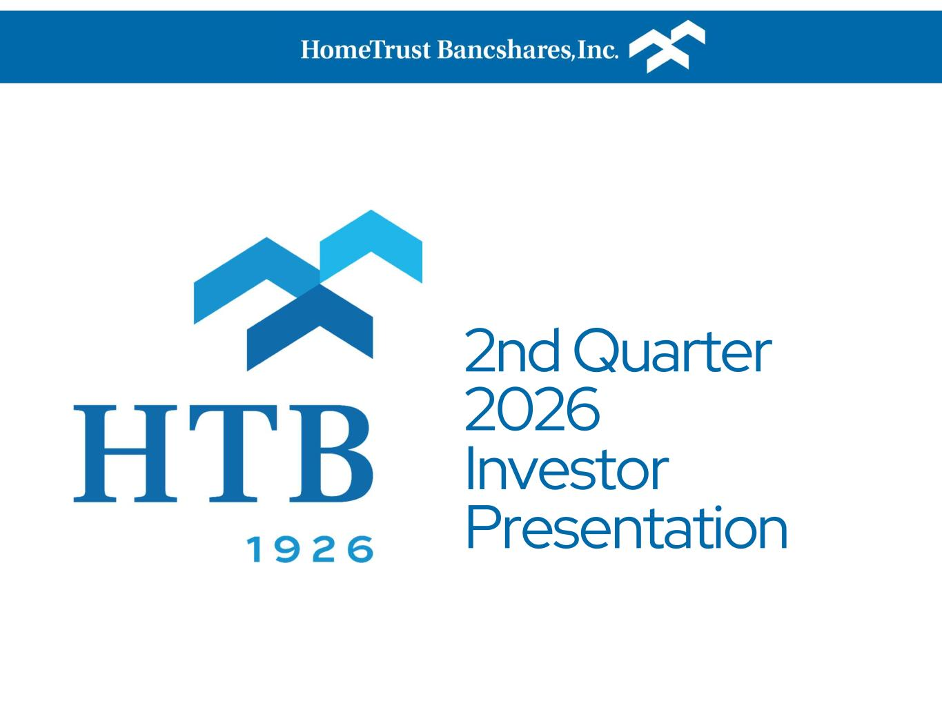
14
2nd Quarter 2026 Investor Presentation

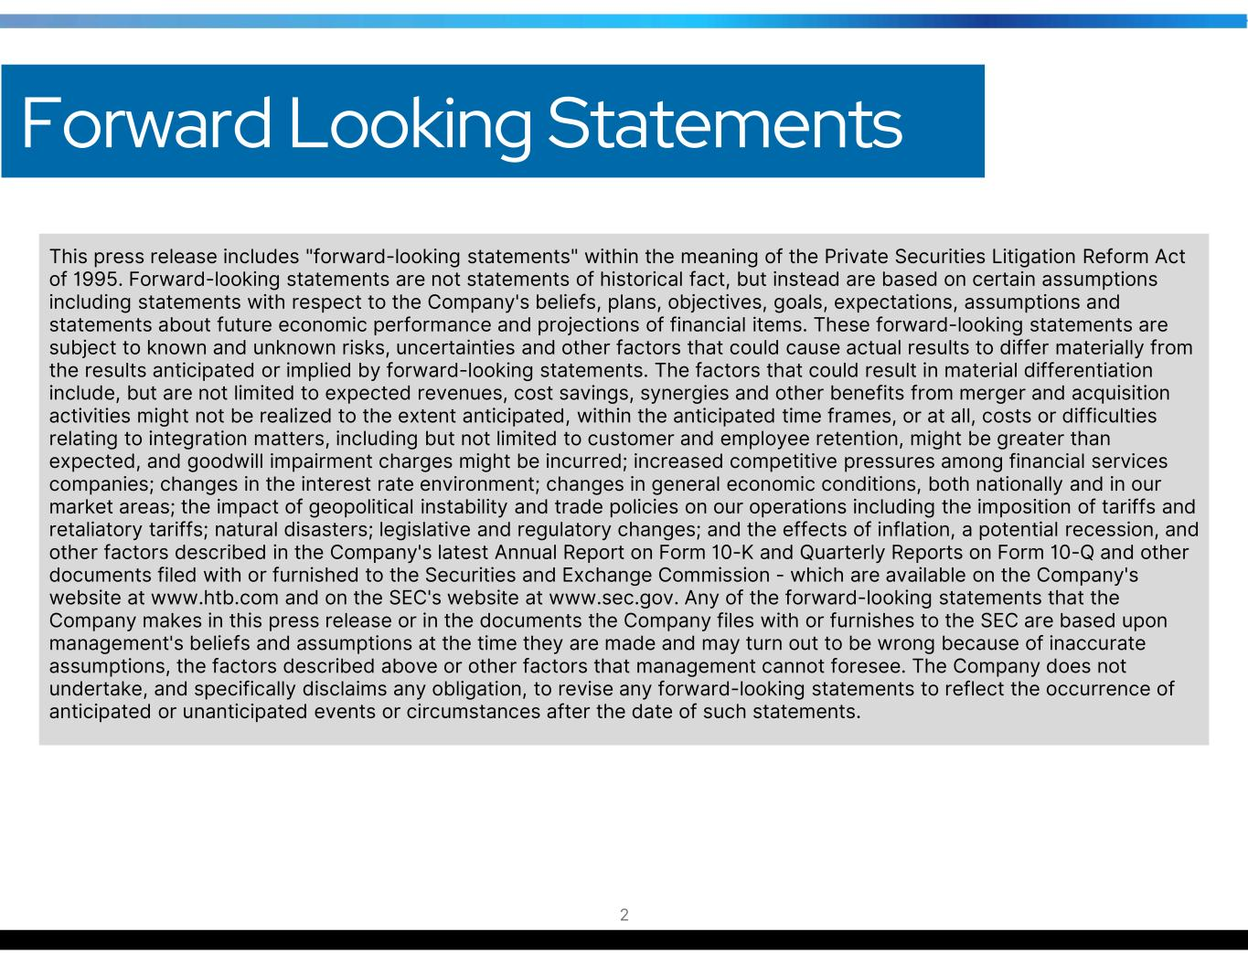
This press release includes "forward-looking statements" within the meaning of the Private Securities Litigation Reform Act of 1995. Forward-looking statements are not statements of historical fact, but instead are based on certain assumptions including statements with respect to the Company's beliefs, plans, objectives, goals, expectations, assumptions and statements about future economic performance and projections of financial items. These forward-looking statements are subject to known and unknown risks, uncertainties and other factors that could cause actual results to differ materially from the results anticipated or implied by forward-looking statements. The factors that could result in material differentiation include, but are not limited to expected revenues, cost savings, synergies and other benefits from merger and acquisition activities might not be realized to the extent anticipated, within the anticipated time frames, or at all, costs or difficulties relating to integration matters, including but not limited to customer and employee retention, might be greater than expected, and goodwill impairment charges might be incurred; increased competitive pressures among financial services companies; changes in the interest rate environment; changes in general economic conditions, both nationally and in our market areas; the impact of geopolitical instability and trade policies on our operations including the imposition of tariffs and retaliatory tariffs; natural disasters; legislative and regulatory changes; and the effects of inflation, a potential recession, and other factors described in the Company's latest Annual Report on Form 10-K and Quarterly Reports on Form 10-Q and other documents filed with or furnished to the Securities and Exchange Commission - which are available on the Company's website at www.htb.com and on the SEC's website at www.sec.gov. Any of the forward-looking statements that the Company makes in this press release or in the documents the Company files with or furnishes to the SEC are based upon management's beliefs and assumptions at the time they are made and may turn out to be wrong because of inaccurate assumptions, the factors described above or other factors that management cannot foresee. The Company does not undertake, and specifically disclaims any obligation, to revise any forward-looking statements to reflect the occurrence of anticipated or unanticipated events or circumstances after the date of such statements. Forward Looking Statements 2

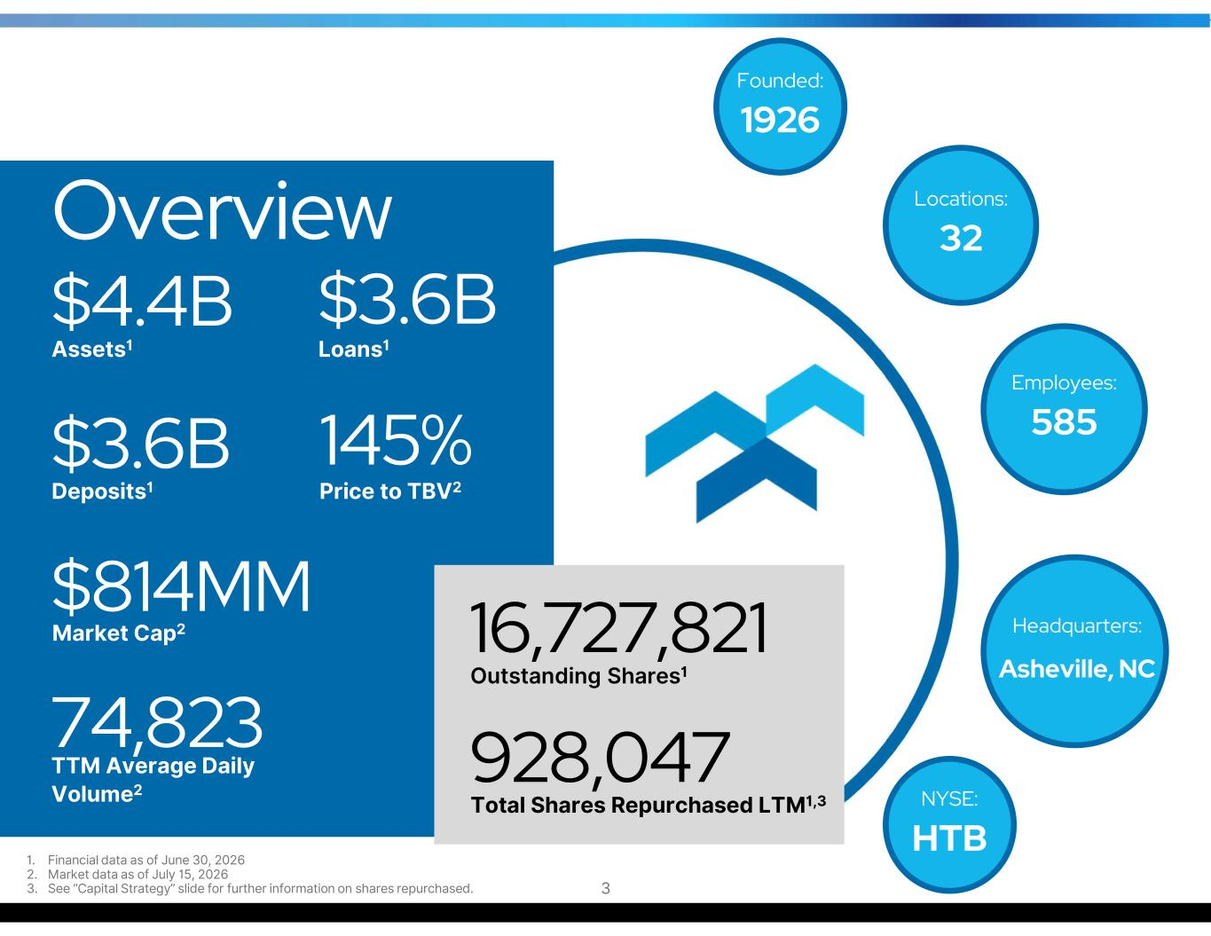
Founded: 1926 Locations: 32 Employees: 585 Headquarters: Asheville, NC NYSE: HTB Overview $4.4B Assets1 $3.6B Loans1 $3.6B Deposits1 145% Price to TBV2 928,047 Total Shares Repurchased LTM1,3 $814MM Market Cap2 74,823 TTM Average Daily Volume2 16,727,821 Outstanding Shares1 1. Financial data as of June 30, 2026 2. Market data as of July 15, 2026 3. See “Capital Strategy” slide for further information on shares repurchased. 3

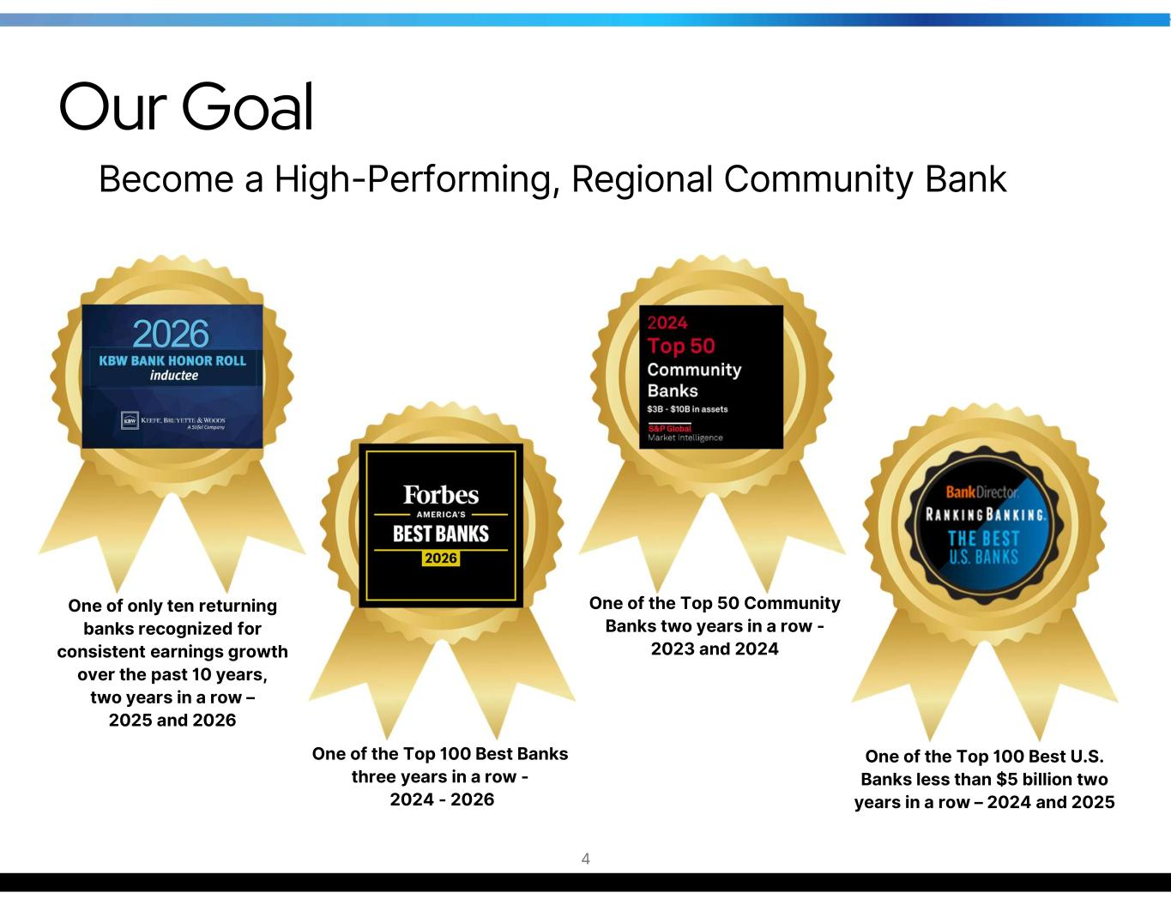
One of the Top 50 Community Banks two years in a row - 2023 and 2024 One of the Top 100 Best Banks three years in a row - 2024 - 2026 One of the Top 100 Best U.S. Banks less than $5 billion two years in a row – 2024 and 2025 4 Our Goal Become a High-Performing, Regional Community Bank One of only ten returning banks recognized for consistent earnings growth over the past 10 years, two years in a row – 2025 and 2026 2026


Become a regionally & nationally recognized Best Place to Work The Strategy to Reach Our Goal 5

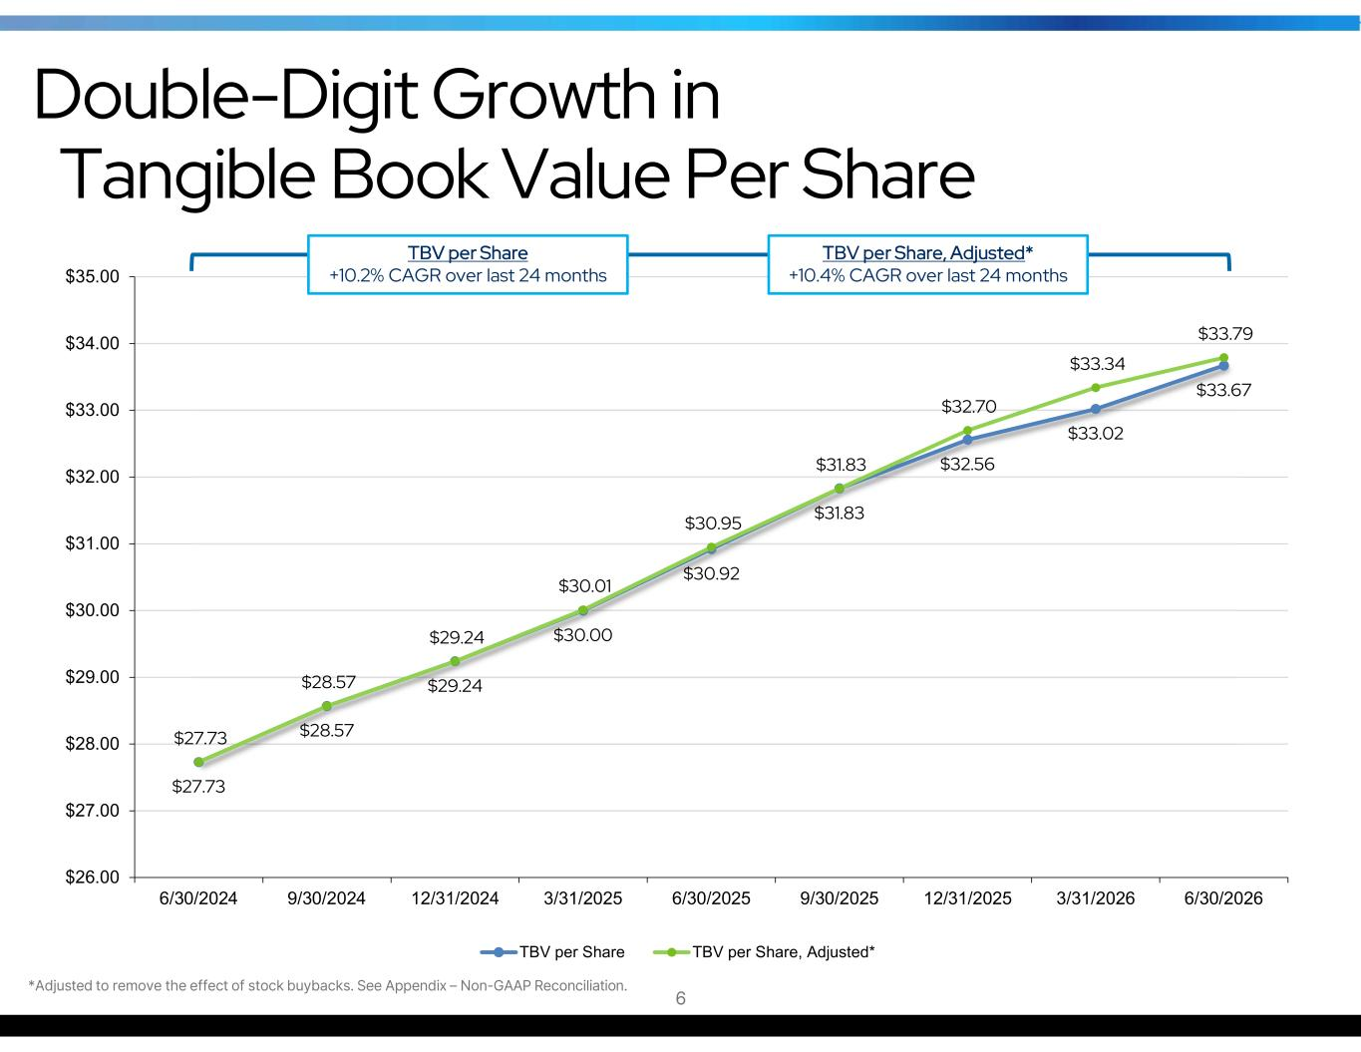
$27.73 $28.57 $29.24 $30.00 $30.92 $31.83 $32.56 $33.02 $33.67 $27.73 $28.57 $29.24 $30.01 $30.95 $31.83 $32.70 $33.34 $33.79 $26.00 $27.00 $28.00 $29.00 $30.00 $31.00 $32.00 $33.00 $34.00 $35.00 6/30/2024 9/30/2024 12/31/2024 3/31/2025 6/30/2025 9/30/2025 12/31/2025 3/31/2026 6/30/2026 TBV per Share TBV per Share, Adjusted* *Adjusted to remove the effect of stock buybacks. See Appendix – Non-GAAP Reconciliation. Double-Digit Growth in Tangible Book Value Per Share TBV per Share +10.2% CAGR over last 24 months 6 TBV per Share, Adjusted* +10.4% CAGR over last 24 months

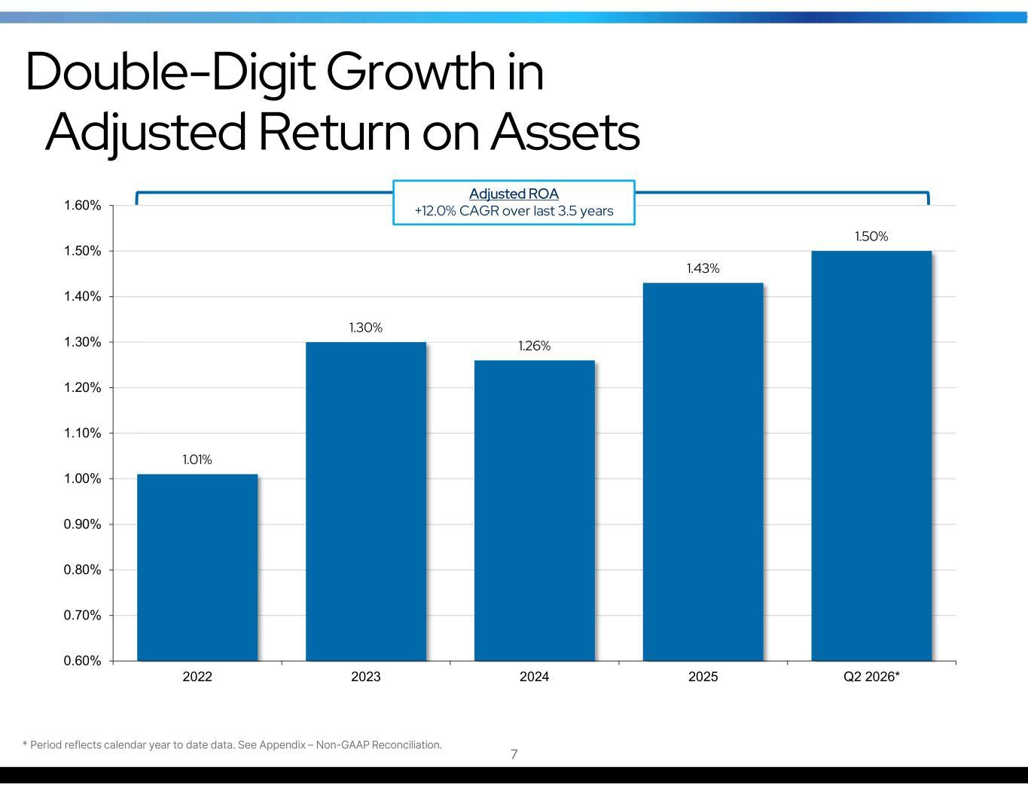
1.01% 1.30% 1.26% 1.43% 1.50% 0.60% 0.70% 0.80% 0.90% 1.00% 1.10% 1.20% 1.30% 1.40% 1.50% 1.60% 2022 2023 2024 2025 Q2 2026* Adjusted ROA +12.0% CAGR over last 3.5 years Double-Digit Growth in Adjusted Return on Assets * Period reflects calendar year to date data. See Appendix – Non-GAAP Reconciliation. 7

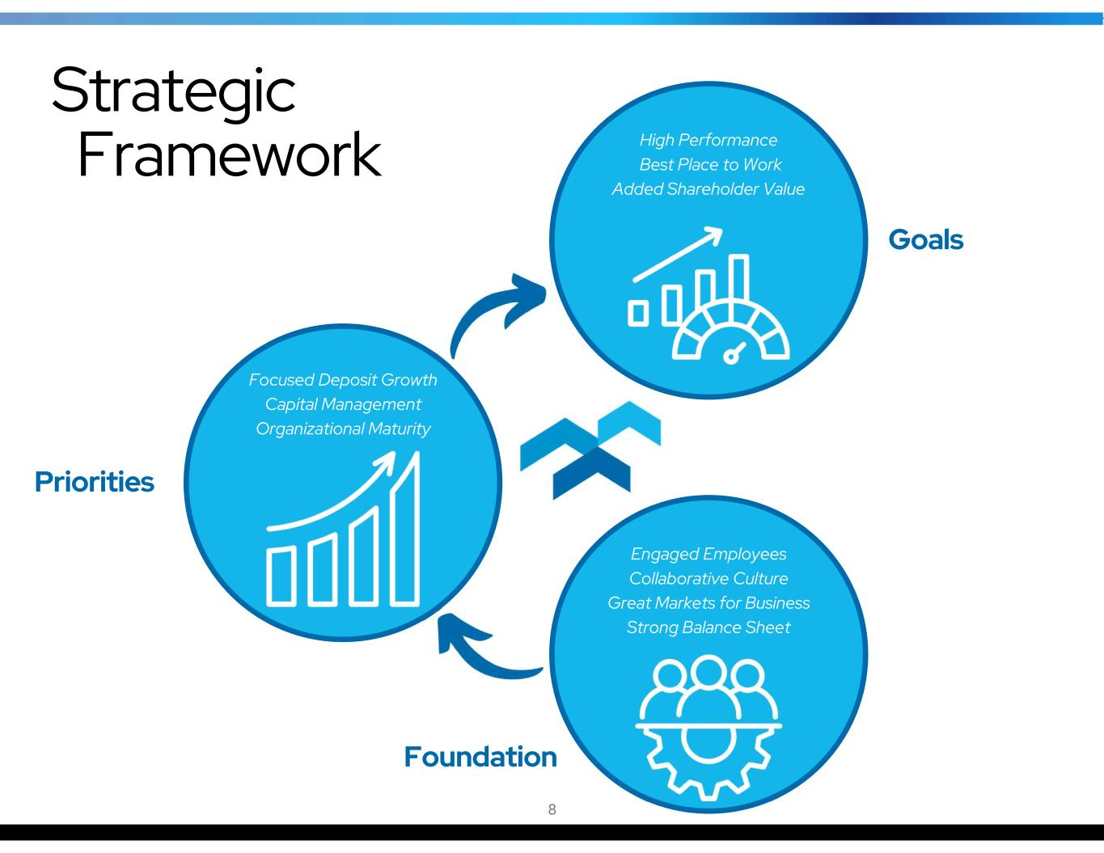
Focused Deposit Growth Capital Management Organizational Maturity Strategic Framework High Performance Best Place to Work Added Shareholder Value Engaged Employees Collaborative Culture Great Markets for Business Strong Balance Sheet Foundation Priorities Goals 8

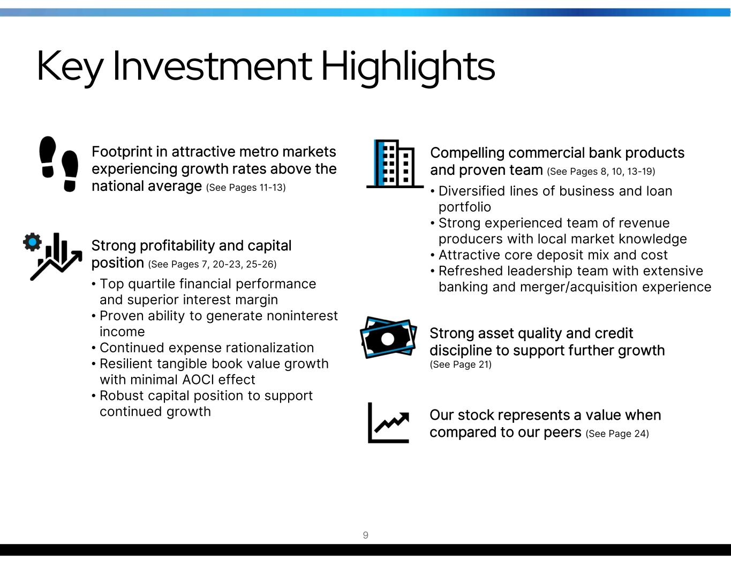
Key Investment Highlights Footprint in attractive metro markets experiencing growth rates above the national average (See Pages 11-13) Compelling commercial bank products and proven team (See Pages 8, 10, 13-19) • Diversified lines of business and loan portfolio • Strong experienced team of revenue producers with local market knowledge • Attractive core deposit mix and cost • Refreshed leadership team with extensive banking and merger/acquisition experience Our stock represents a value when compared to our peers (See Page 24) Strong profitability and capital position (See Pages 7, 20-23, 25-26) • Top quartile financial performance and superior interest margin • Proven ability to generate noninterest income • Continued expense rationalization • Resilient tangible book value growth with minimal AOCI effect • Robust capital position to support continued growth Strong asset quality and credit discipline to support further growth (See Page 21) 9


*The years identified above reflect the years these individuals joined the Company. 10 C. Hunter Westbrook President & CEO (2012) Charles F. Sivley Jr. Chief Technology Officer (2024) John Sprink Commercial Banking Group Exec. (2014) Kevin M. Nunley Chief Credit Officer (2020) Kristin Y. Powell Consumer & Business Banking Group Executive (2015) Lora Jex Chief Risk Officer (2023) Megan Pelletier Chief Operations & People Officer (2022) Tony J. VunCannon CFO, Corporate Secretary & Treasurer (1992) Experienced Leadership Team

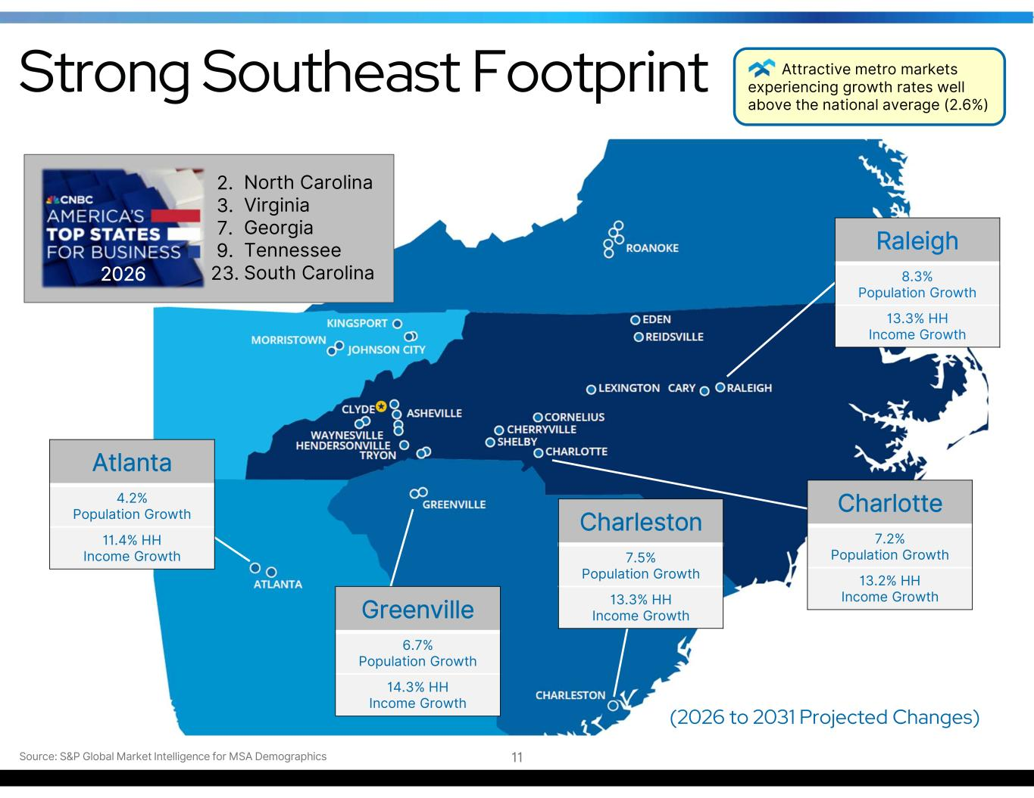
Strong Southeast Footprint Source: S&P Global Market Intelligence for MSA Demographics Raleigh 8.3% Population Growth 13.3% HH Income Growth Charlotte 7.2% Population Growth 13.2% HH Income Growth Atlanta 4.2% Population Growth 11.4% HH Income Growth Greenville 6.7% Population Growth 14.3% HH Income Growth (2026 to 2031 Projected Changes) Charleston 7.5% Population Growth 13.3% HH Income Growth 11 2. 3. 7. 9. 23. North Carolina Virginia Georgia Tennessee South Carolina2026 Attractive metro markets experiencing growth rates well above the national average (2.6%)

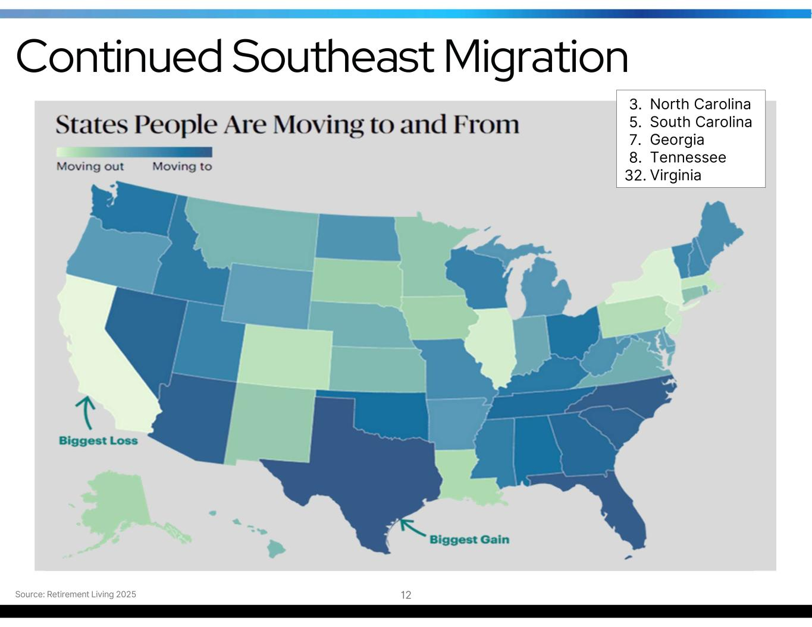
Source: Retirement Living 2025 12 3. 5. 7. 8. 32. North Carolina South Carolina Georgia Tennessee Virginia Continued Southeast Migration

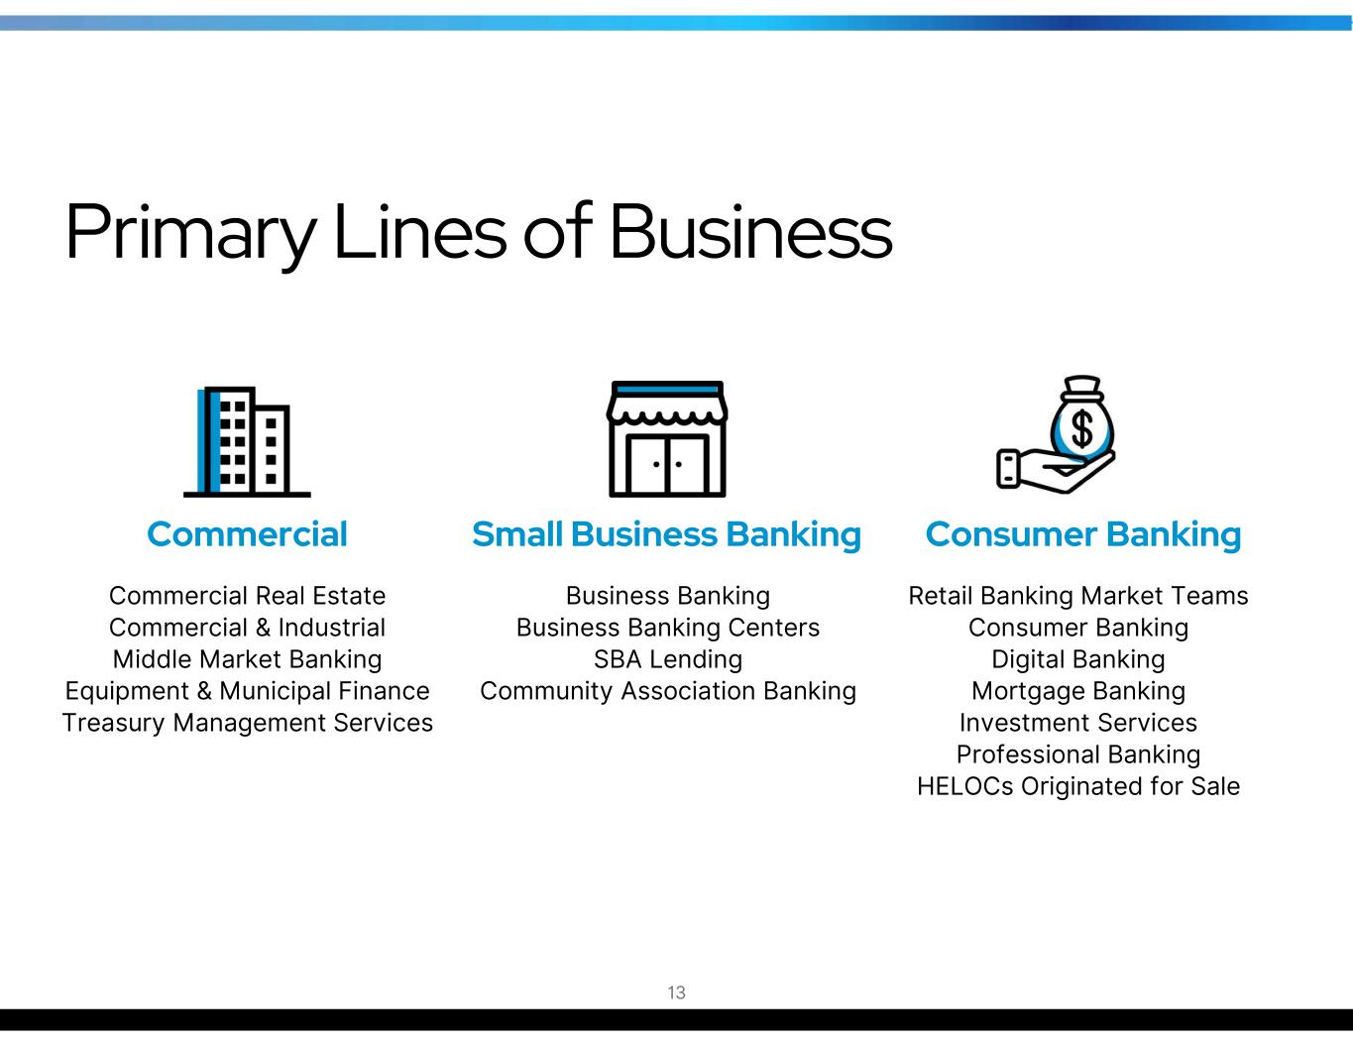
Business Banking Business Banking Centers SBA Lending Community Association Banking Small Business Banking Consumer Banking Commercial Commercial Real Estate Commercial & Industrial Middle Market Banking Equipment & Municipal Finance Treasury Management Services Retail Banking Market Teams Consumer Banking Digital Banking Mortgage Banking Investment Services Professional Banking HELOCs Originated for Sale Primary Lines of Business 13

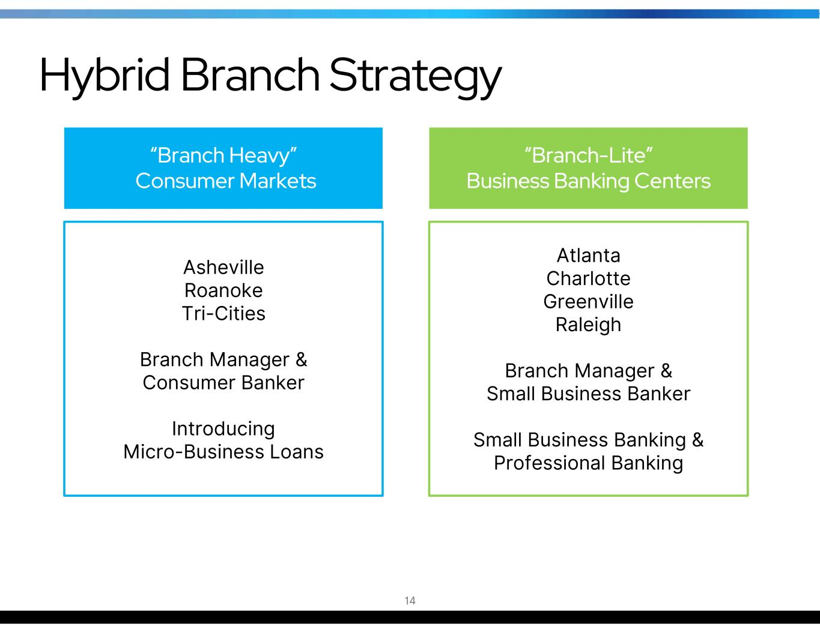
“Branch-Lite” Business Banking Centers “Branch Heavy” Consumer Markets Asheville Roanoke Tri-Cities Branch Manager & Consumer Banker Introducing Micro-Business Loans Atlanta Charlotte Greenville Raleigh Branch Manager & Small Business Banker Small Business Banking & Professional Banking 14 Hybrid Branch Strategy

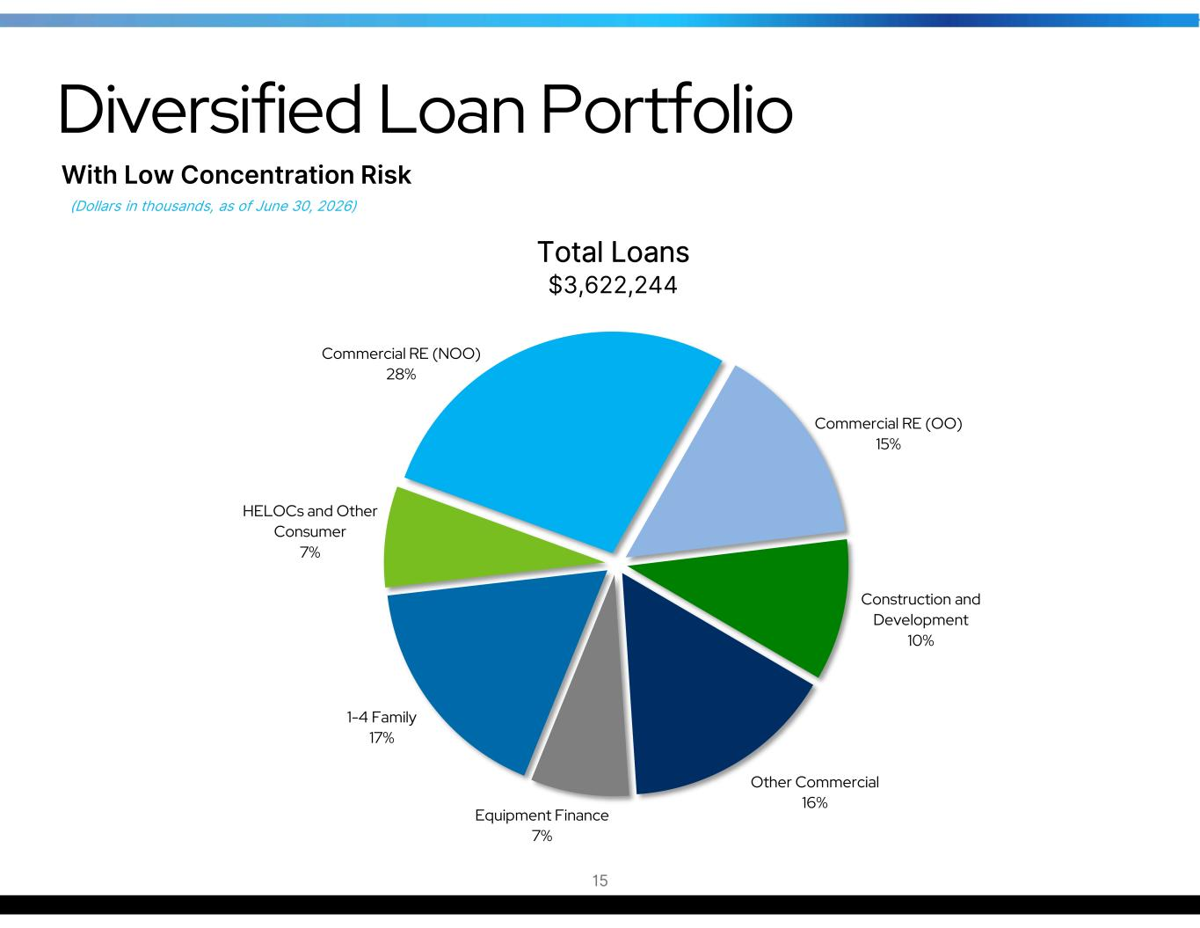
Commercial RE (NOO) 28% Commercial RE (OO) 15% Construction and Development 10% Other Commercial 16% Equipment Finance 7% 1-4 Family 17% HELOCs and Other Consumer 7% Diversified Loan Portfolio 15 Total Loans $3,622,244 (Dollars in thousands, as of June 30, 2026) With Low Concentration Risk

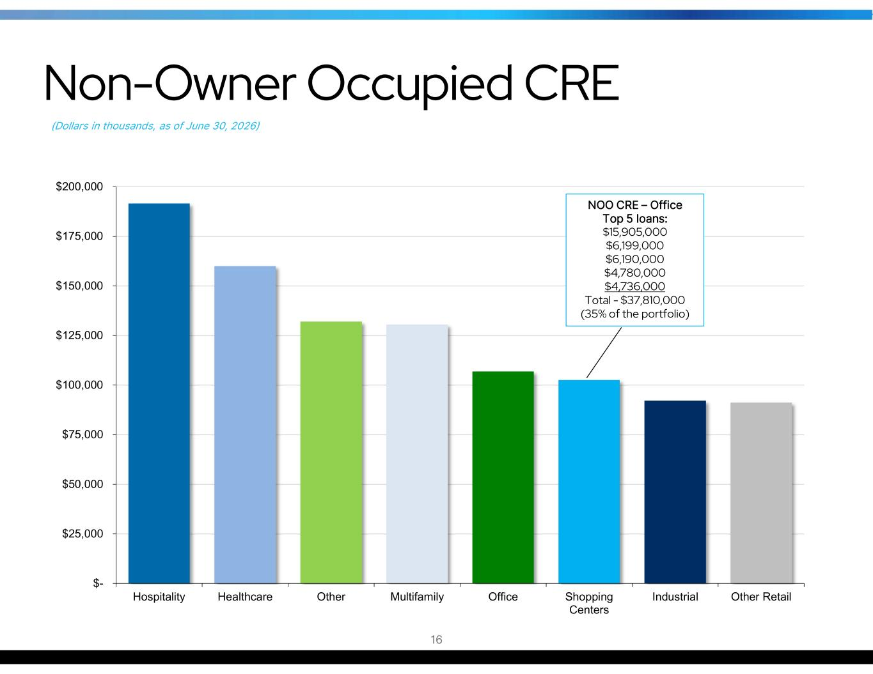
$- $25,000 $50,000 $75,000 $100,000 $125,000 $150,000 $175,000 $200,000 Hospitality Healthcare Other Multifamily Office Shopping Centers Industrial Other Retail Non-Owner Occupied CRE NOO CRE – Office Top 5 loans: $15,905,000 $6,199,000 $6,190,000 $4,780,000 $4,736,000 Total - $37,810,000 (35% of the portfolio) 16 (Dollars in thousands, as of June 30, 2026)

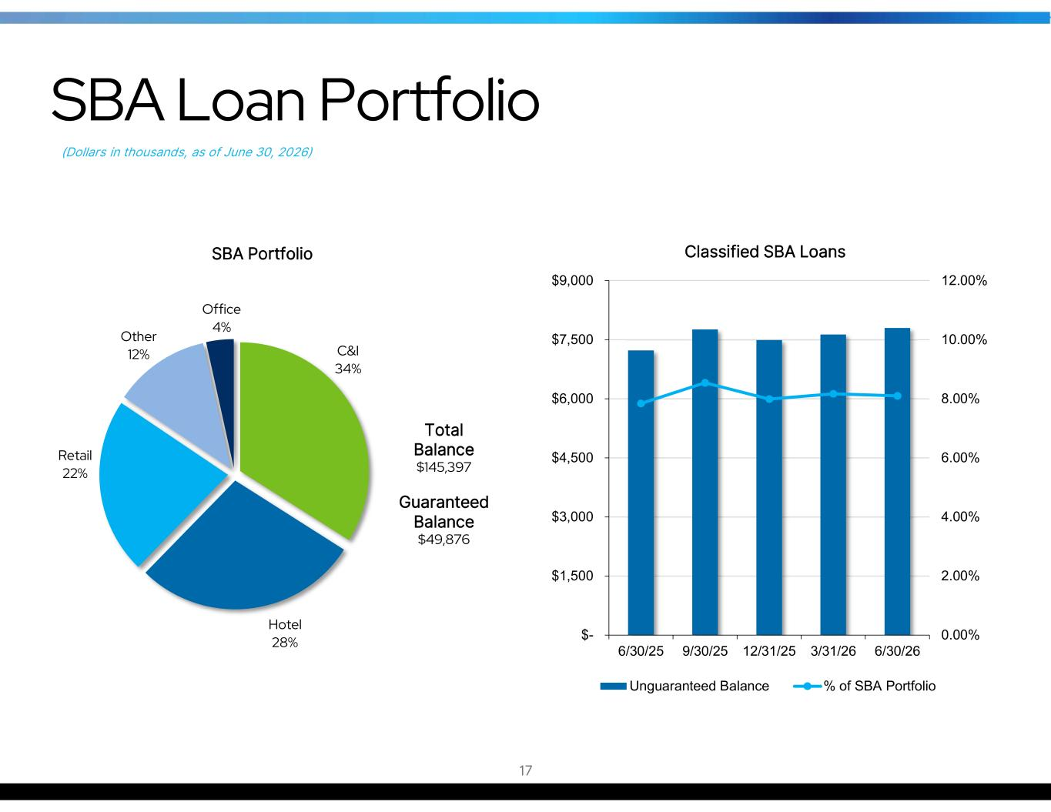
C&I 34% Hotel 28% Retail 22% Other 12% Office 4% SBA Portfolio Total Balance $145,397 Guaranteed Balance $49,876 0.00% 2.00% 4.00% 6.00% 8.00% 10.00% 12.00% $- $1,500 $3,000 $4,500 $6,000 $7,500 $9,000 6/30/25 9/30/25 12/31/25 3/31/26 6/30/26 Classified SBA Loans Unguaranteed Balance % of SBA Portfolio 17 SBA Loan Portfolio (Dollars in thousands, as of June 30, 2026)

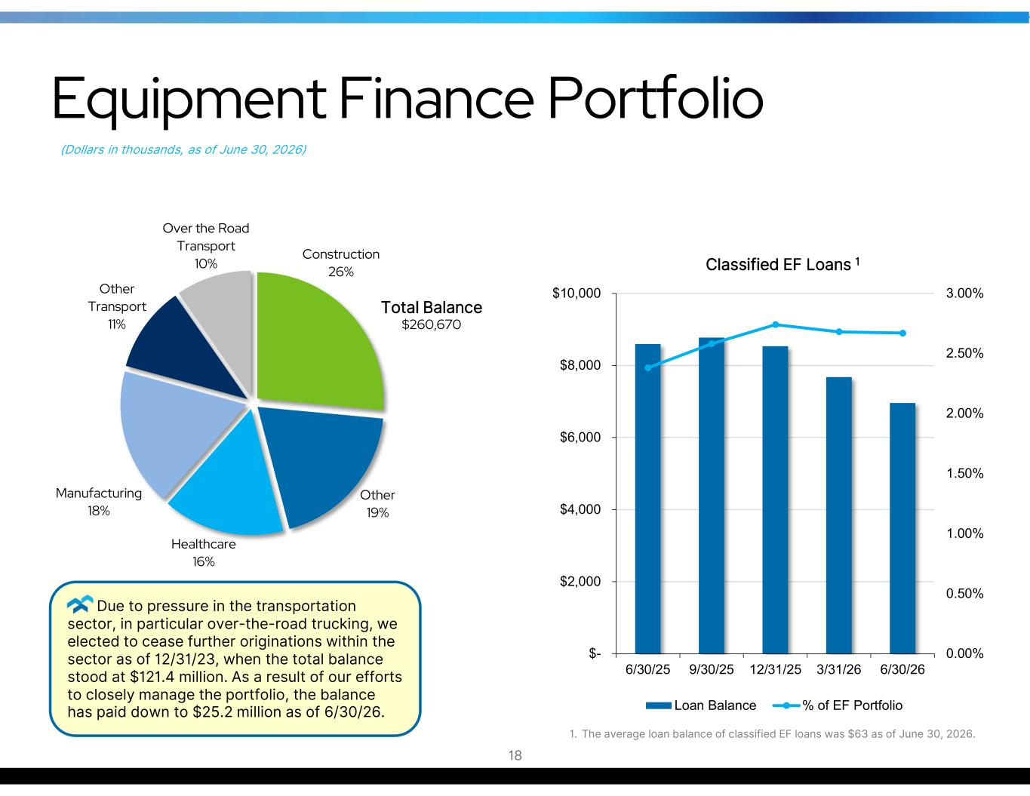
0.00% 0.50% 1.00% 1.50% 2.00% 2.50% 3.00% $- $2,000 $4,000 $6,000 $8,000 $10,000 6/30/25 9/30/25 12/31/25 3/31/26 6/30/26 Classified EF Loans 1 Loan Balance % of EF Portfolio 18 Equipment Finance Portfolio (Dollars in thousands, as of June 30, 2026) Construction 26% Other 19% Healthcare 16% Manufacturing 18% Other Transport 11% Over the Road Transport 10% Total Balance $260,670 1. The average loan balance of classified EF loans was $63 as of June 30, 2026. Due to pressure in the transportation sector, in particular over-the-road trucking, we elected to cease further originations within the sector as of 12/31/23, when the total balance stood at $121.4 million. As a result of our efforts to closely manage the portfolio, the balance has paid down to $25.2 million as of 6/30/26.

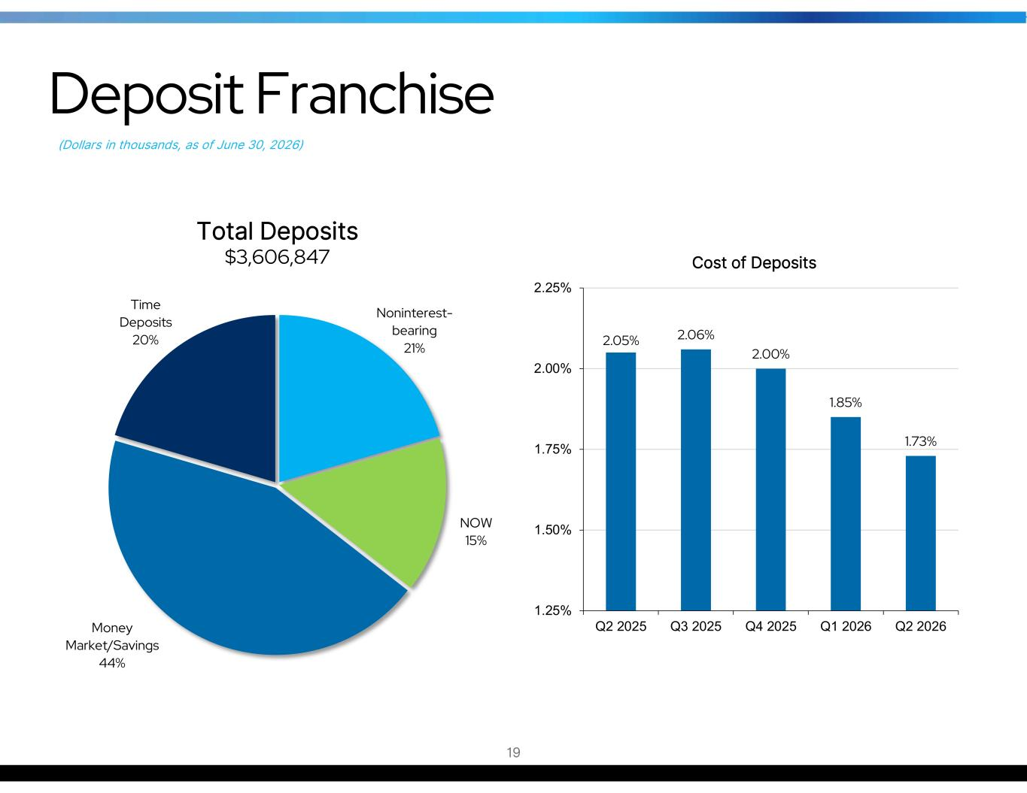
Noninterest- bearing 21% NOW 15% Money Market/Savings 44% Time Deposits 20% 2.05% 2.06% 2.00% 1.85% 1.73% 1.25% 1.50% 1.75% 2.00% 2.25% Q2 2025 Q3 2025 Q4 2025 Q1 2026 Q2 2026 Cost of Deposits Deposit Franchise 19 (Dollars in thousands, as of June 30, 2026) Total Deposits $3,606,847

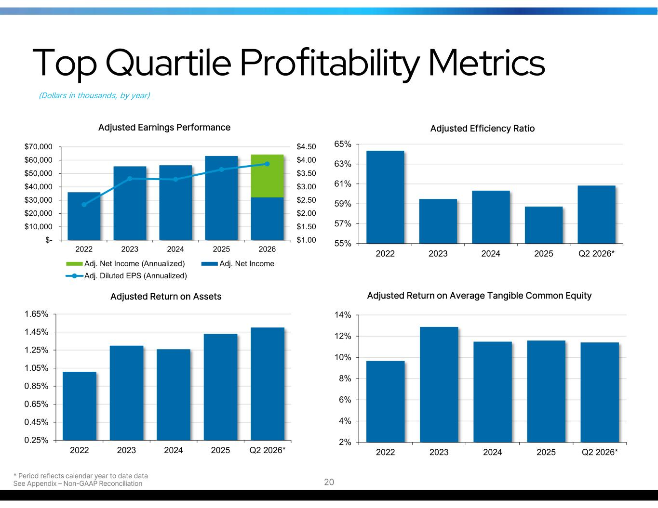
$1.00 $1.50 $2.00 $2.50 $3.00 $3.50 $4.00 $4.50 $- $10,000 $20,000 $30,000 $40,000 $50,000 $60,000 $70,000 2022 2023 2024 2025 2026 Adjusted Earnings Performance Adj. Net Income (Annualized) Adj. Net Income Adj. Diluted EPS (Annualized) Top Quartile Profitability Metrics (Dollars in thousands, by year) 0.25% 0.45% 0.65% 0.85% 1.05% 1.25% 1.45% 1.65% 2022 2023 2024 2025 Q2 2026* Adjusted Return on Assets 55% 57% 59% 61% 63% 65% 2022 2023 2024 2025 Q2 2026* Adjusted Efficiency Ratio 2% 4% 6% 8% 10% 12% 14% 2022 2023 2024 2025 Q2 2026* Adjusted Return on Average Tangible Common Equity * Period reflects calendar year to date data See Appendix – Non-GAAP Reconciliation 20

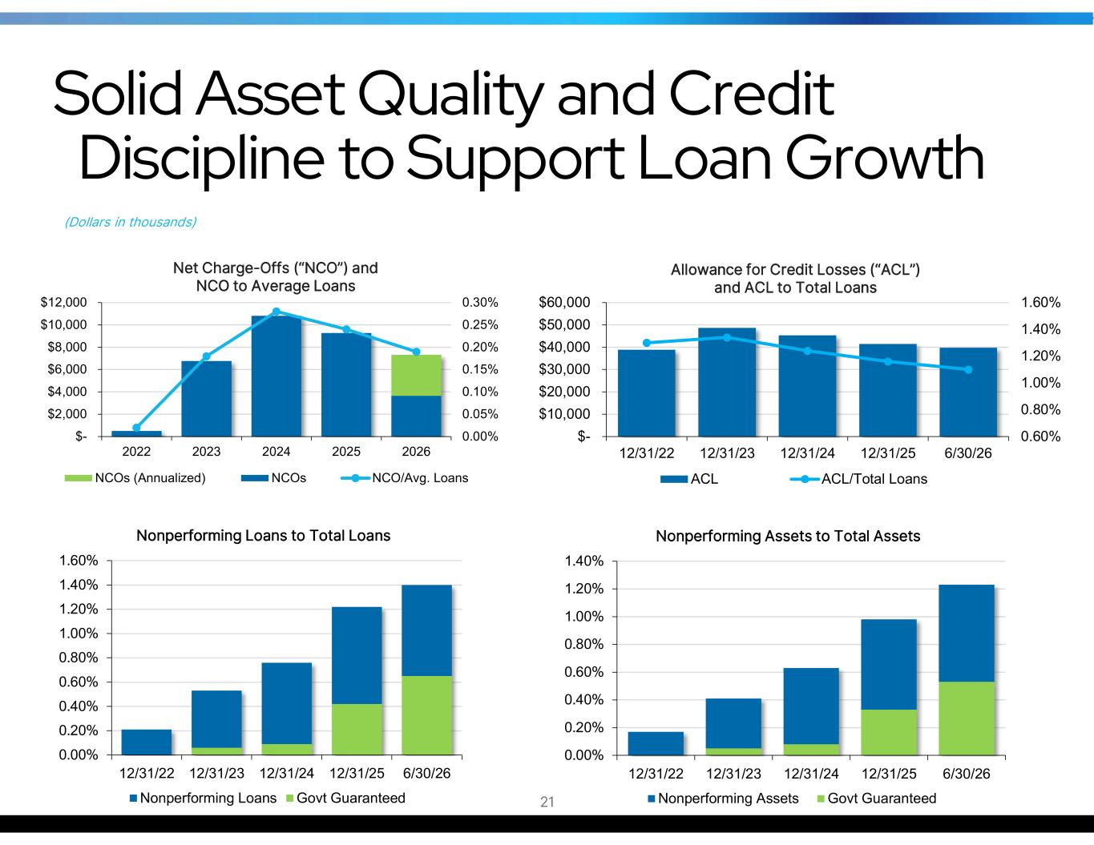
0.00% 0.05% 0.10% 0.15% 0.20% 0.25% 0.30% $- $2,000 $4,000 $6,000 $8,000 $10,000 $12,000 2022 2023 2024 2025 2026 Net Charge-Offs (“NCO”) and NCO to Average Loans NCOs (Annualized) NCOs NCO/Avg. Loans Solid Asset Quality and Credit Discipline to Support Loan Growth (Dollars in thousands) 0.00% 0.20% 0.40% 0.60% 0.80% 1.00% 1.20% 1.40% 1.60% 12/31/22 12/31/23 12/31/24 12/31/25 6/30/26 Nonperforming Loans to Total Loans Nonperforming Loans Govt Guaranteed 21 0.60% 0.80% 1.00% 1.20% 1.40% 1.60% $- $10,000 $20,000 $30,000 $40,000 $50,000 $60,000 12/31/22 12/31/23 12/31/24 12/31/25 6/30/26 Allowance for Credit Losses (“ACL”) and ACL to Total Loans ACL ACL/Total Loans 0.00% 0.20% 0.40% 0.60% 0.80% 1.00% 1.20% 1.40% 12/31/22 12/31/23 12/31/24 12/31/25 6/30/26 Nonperforming Assets to Total Assets Nonperforming Assets Govt Guaranteed

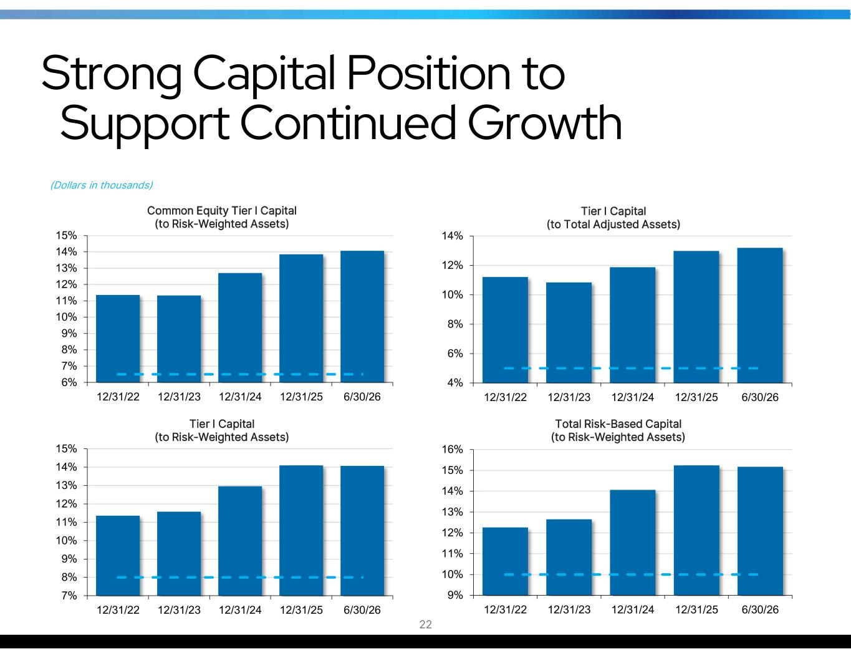
Strong Capital Position to Support Continued Growth (Dollars in thousands) 7% 8% 9% 10% 11% 12% 13% 14% 15% 12/31/22 12/31/23 12/31/24 12/31/25 6/30/26 Tier I Capital (to Risk-Weighted Assets) 9% 10% 11% 12% 13% 14% 15% 16% 12/31/22 12/31/23 12/31/24 12/31/25 6/30/26 Total Risk-Based Capital (to Risk-Weighted Assets) 6% 7% 8% 9% 10% 11% 12% 13% 14% 15% 12/31/22 12/31/23 12/31/24 12/31/25 6/30/26 Common Equity Tier I Capital (to Risk-Weighted Assets) 4% 6% 8% 10% 12% 14% 12/31/22 12/31/23 12/31/24 12/31/25 6/30/26 Tier I Capital (to Total Adjusted Assets) 22

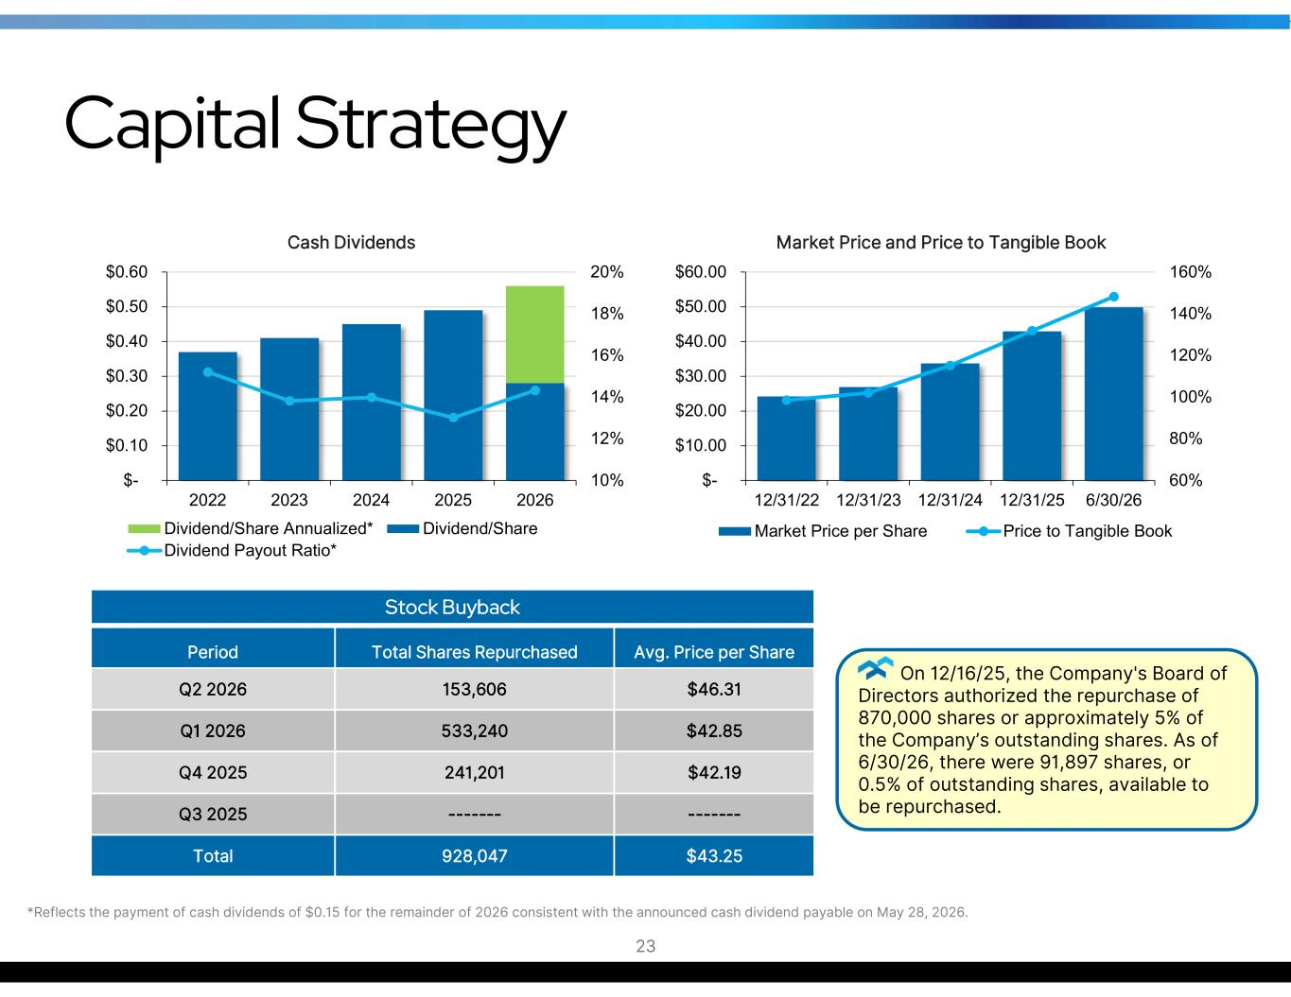
Capital Strategy 10% 12% 14% 16% 18% 20% $- $0.10 $0.20 $0.30 $0.40 $0.50 $0.60 2022 2023 2024 2025 2026 Cash Dividends Dividend/Share Annualized* Dividend/Share Dividend Payout Ratio* 60% 80% 100% 120% 140% 160% $- $10.00 $20.00 $30.00 $40.00 $50.00 $60.00 12/31/22 12/31/23 12/31/24 12/31/25 6/30/26 Market Price and Price to Tangible Book Market Price per Share Price to Tangible Book 23 Stock Buyback Avg. Price per ShareTotal Shares RepurchasedPeriod $46.31153,606Q2 2026 $42.85533,240Q1 2026 $42.19241,201Q4 2025 --------------Q3 2025 $43.25928,047Total On 12/16/25, the Company's Board of Directors authorized the repurchase of 870,000 shares or approximately 5% of the Company’s outstanding shares. As of 6/30/26, there were 91,897 shares, or 0.5% of outstanding shares, available to be repurchased. *Reflects the payment of cash dividends of $0.15 for the remainder of 2026 consistent with the announced cash dividend payable on May 28, 2026.

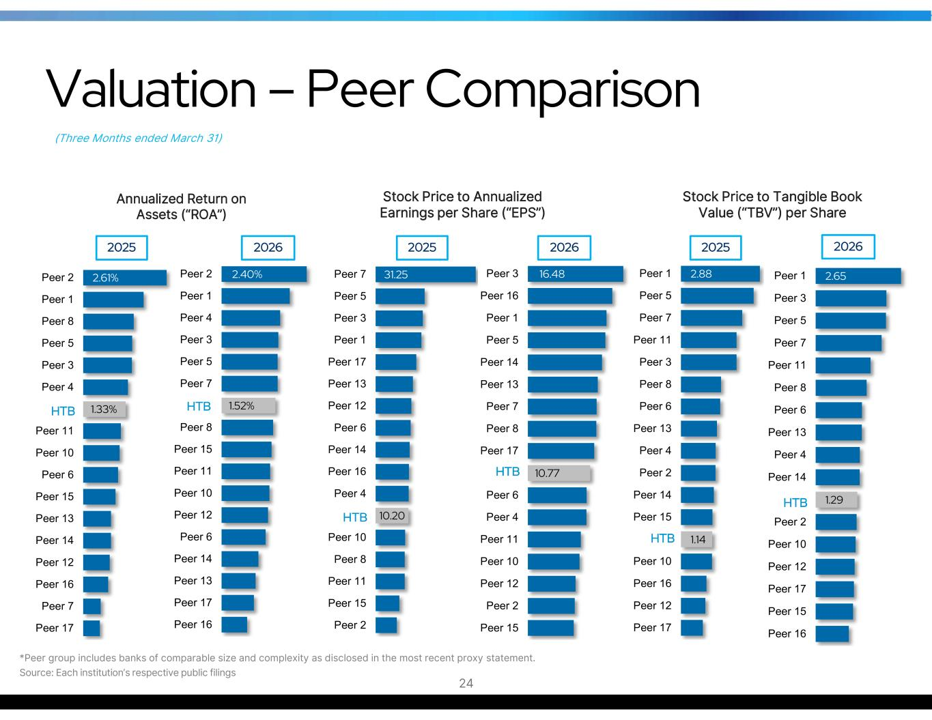
1.14 2.88 Peer 17 Peer 12 Peer 16 Peer 10 Peer 15 Peer 14 Peer 2 Peer 4 Peer 13 Peer 6 Peer 8 Peer 3 Peer 11 Peer 7 Peer 5 Peer 1 1.29 2.65 Peer 16 Peer 15 Peer 17 Peer 12 Peer 10 Peer 2 Peer 14 Peer 4 Peer 13 Peer 6 Peer 8 Peer 11 Peer 7 Peer 5 Peer 3 Peer 1 1.33% 2.61% Peer 17 Peer 7 Peer 16 Peer 12 Peer 14 Peer 13 Peer 15 Peer 6 Peer 10 Peer 11 Peer 4 Peer 3 Peer 5 Peer 8 Peer 1 Peer 2 1.52% 2.40% Peer 16 Peer 17 Peer 13 Peer 14 Peer 6 Peer 12 Peer 10 Peer 11 Peer 15 Peer 8 Peer 7 Peer 5 Peer 3 Peer 4 Peer 1 Peer 2 (Three Months ended March 31) Valuation – Peer Comparison *Peer group includes banks of comparable size and complexity as disclosed in the most recent proxy statement. Source: Each institution’s respective public filings 24 2025 2026 2026 10.20 31.25 Peer 2 Peer 15 Peer 11 Peer 8 Peer 10 Peer 4 Peer 16 Peer 14 Peer 6 Peer 12 Peer 13 Peer 17 Peer 1 Peer 3 Peer 5 Peer 7 2025 2025 2026 Annualized Return on Assets (“ROA”) Stock Price to Annualized Earnings per Share (“EPS”) Stock Price to Tangible Book Value (“TBV”) per Share HTB HTB HTB HTB HTB HTB 10.77 16.48 Peer 15 Peer 2 Peer 12 Peer 10 Peer 11 Peer 4 Peer 6 Peer 17 Peer 8 Peer 7 Peer 13 Peer 14 Peer 5 Peer 1 Peer 16 Peer 3

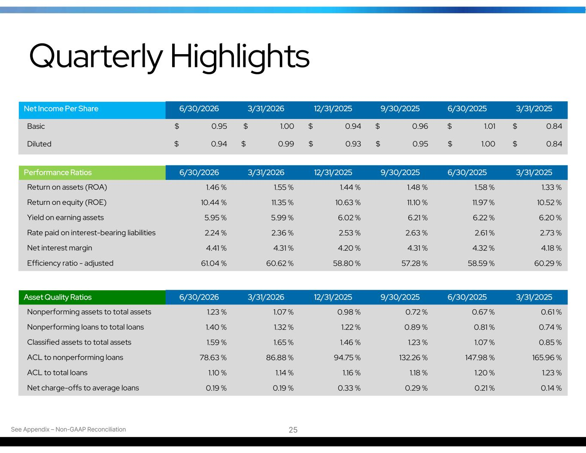
Quarterly Highlights 3/31/20256/30/20259/30/202512/31/20253/31/20266/30/2026Net Income Per Share $ 0.84$ 1.01$ 0.96$ 0.94$ 1.00$ 0.95Basic $ 0.84$ 1.00$ 0.95$ 0.93$ 0.99$ 0.94Diluted See Appendix – Non-GAAP Reconciliation 3/31/20256/30/20259/30/202512/31/20253/31/20266/30/2026Performance Ratios 1.33 %1.58 %1.48 %1.44 %1.55 %1.46 %Return on assets (ROA) 10.52 %11.97 %11.10 %10.63 %11.35 %10.44 %Return on equity (ROE) 6.20 %6.22 %6.21 %6.02 %5.99 %5.95 %Yield on earning assets 2.73 %2.61 %2.63 %2.53 %2.36 %2.24 %Rate paid on interest-bearing liabilities 4.18 %4.32 %4.31 %4.20 %4.31 %4.41 %Net interest margin 60.29 %58.59 %57.28 %58.80 %60.62 %61.04 %Efficiency ratio - adjusted 3/31/20256/30/20259/30/202512/31/20253/31/20266/30/2026Asset Quality Ratios 0.61 %0.67 %0.72 %0.98 %1.07 %1.23 %Nonperforming assets to total assets 0.74 %0.81 %0.89 %1.22 %1.32 %1.40 %Nonperforming loans to total loans 0.85 %1.07 %1.23 %1.46 %1.65 %1.59 %Classified assets to total assets 165.96 %147.98 %132.26 %94.75 %86.88 %78.63 %ACL to nonperforming loans 1.23 %1.20 %1.18 %1.16 %1.14 %1.10 %ACL to total loans 0.14 %0.21 %0.29 %0.33 %0.19 %0.19 %Net charge-offs to average loans 25

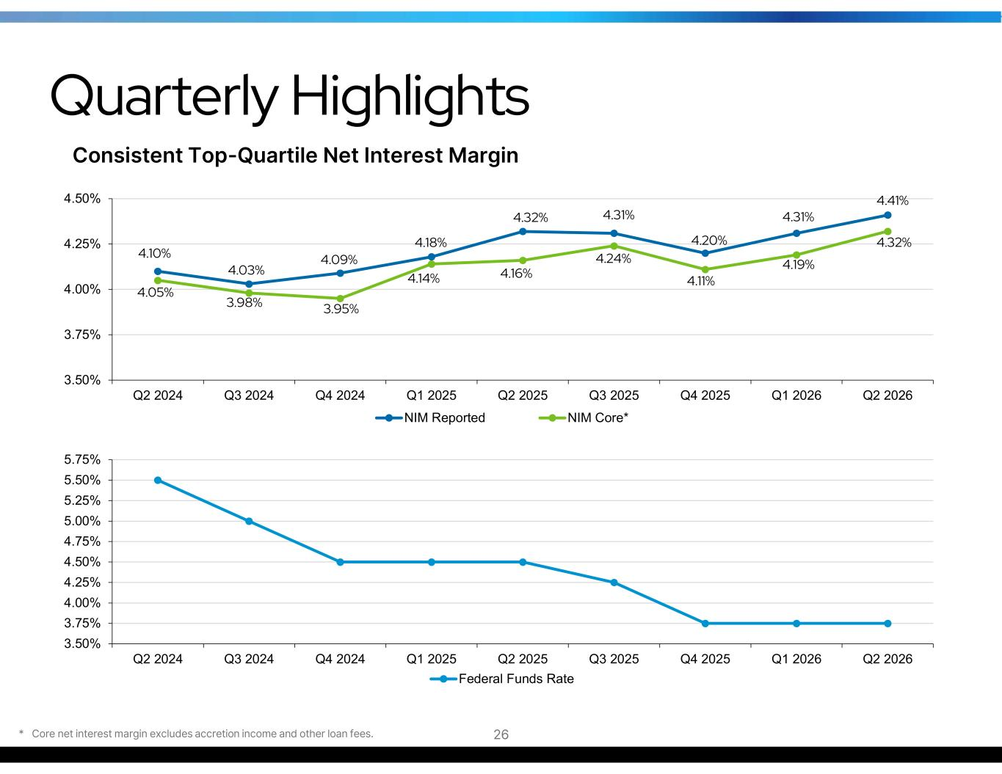
Quarterly Highlights Consistent Top-Quartile Net Interest Margin 4.10% 4.03% 4.09% 4.18% 4.32% 4.31% 4.20% 4.31% 4.41% 4.05% 3.98% 3.95% 4.14% 4.16% 4.24% 4.11% 4.19% 4.32% 3.50% 3.75% 4.00% 4.25% 4.50% Q2 2024 Q3 2024 Q4 2024 Q1 2025 Q2 2025 Q3 2025 Q4 2025 Q1 2026 Q2 2026 NIM Reported NIM Core* 3.50% 3.75% 4.00% 4.25% 4.50% 4.75% 5.00% 5.25% 5.50% 5.75% Q2 2024 Q3 2024 Q4 2024 Q1 2025 Q2 2025 Q3 2025 Q4 2025 Q1 2026 Q2 2026 Federal Funds Rate * Core net interest margin excludes accretion income and other loan fees. 26

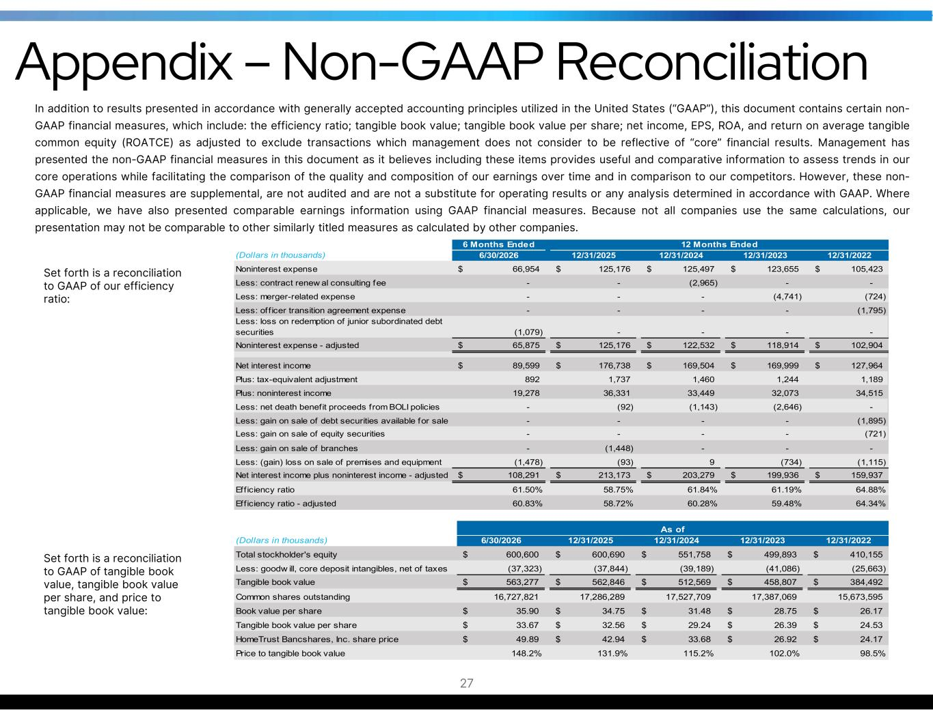
Appendix – Non-GAAP Reconciliation In addition to results presented in accordance with generally accepted accounting principles utilized in the United States (“GAAP”), this document contains certain non- GAAP financial measures, which include: the efficiency ratio; tangible book value; tangible book value per share; net income, EPS, ROA, and return on average tangible common equity (ROATCE) as adjusted to exclude transactions which management does not consider to be reflective of “core” financial results. Management has presented the non-GAAP financial measures in this document as it believes including these items provides useful and comparative information to assess trends in our core operations while facilitating the comparison of the quality and composition of our earnings over time and in comparison to our competitors. However, these non- GAAP financial measures are supplemental, are not audited and are not a substitute for operating results or any analysis determined in accordance with GAAP. Where applicable, we have also presented comparable earnings information using GAAP financial measures. Because not all companies use the same calculations, our presentation may not be comparable to other similarly titled measures as calculated by other companies. 6 Months Ended (Dollars in thousands) 6/30/2026 12/31/2025 12/31/2024 12/31/2023 12/31/2022 Noninterest expense 66,954$ 125,176$ 125,497$ 123,655$ 105,423$ Less: contract renew al consulting fee - - (2,965) - - Less: merger-related expense - - - (4,741) (724) Less: of f icer transition agreement expense - - - - (1,795) Less: loss on redemption of junior subordinated debt securities (1,079) - - - - Noninterest expense - adjusted 65,875$ 125,176$ 122,532$ 118,914$ 102,904$ Net interest income 89,599$ 176,738$ 169,504$ 169,999$ 127,964$ Plus: tax-equivalent adjustment 892 1,737 1,460 1,244 1,189 Plus: noninterest income 19,278 36,331 33,449 32,073 34,515 Less: net death benefit proceeds from BOLI policies - (92) (1,143) (2,646) - Less: gain on sale of debt securities available for sale - - - - (1,895) Less: gain on sale of equity securities - - - - (721) Less: gain on sale of branches - (1,448) - - - Less: (gain) loss on sale of premises and equipment (1,478) (93) 9 (734) (1,115) Net interest income plus noninterest income - adjusted 108,291$ 213,173$ 203,279$ 199,936$ 159,937$ Eff iciency ratio 61.50% 58.75% 61.84% 61.19% 64.88% Efficiency ratio - adjusted 60.83% 58.72% 60.28% 59.48% 64.34% 12 Months Ended (Dollars in thousands) 6/30/2026 12/31/2025 12/31/2024 12/31/2023 12/31/2022 Total stockholder's equity 600,600$ 600,690$ 551,758$ 499,893$ 410,155$ Less: goodw ill, core deposit intangibles, net of taxes (37,323) (37,844) (39,189) (41,086) (25,663) Tangible book value 563,277$ 562,846$ 512,569$ 458,807$ 384,492$ Common shares outstanding 16,727,821 17,286,289 17,527,709 17,387,069 15,673,595 Book value per share 35.90$ 34.75$ 31.48$ 28.75$ 26.17$ Tangible book value per share 33.67$ 32.56$ 29.24$ 26.39$ 24.53$ HomeTrust Bancshares, Inc. share price 49.89$ 42.94$ 33.68$ 26.92$ 24.17$ Price to tangible book value 148.2% 131.9% 115.2% 102.0% 98.5% As of Set forth is a reconciliation to GAAP of our efficiency ratio: Set forth is a reconciliation to GAAP of tangible book value, tangible book value per share, and price to tangible book value: 27

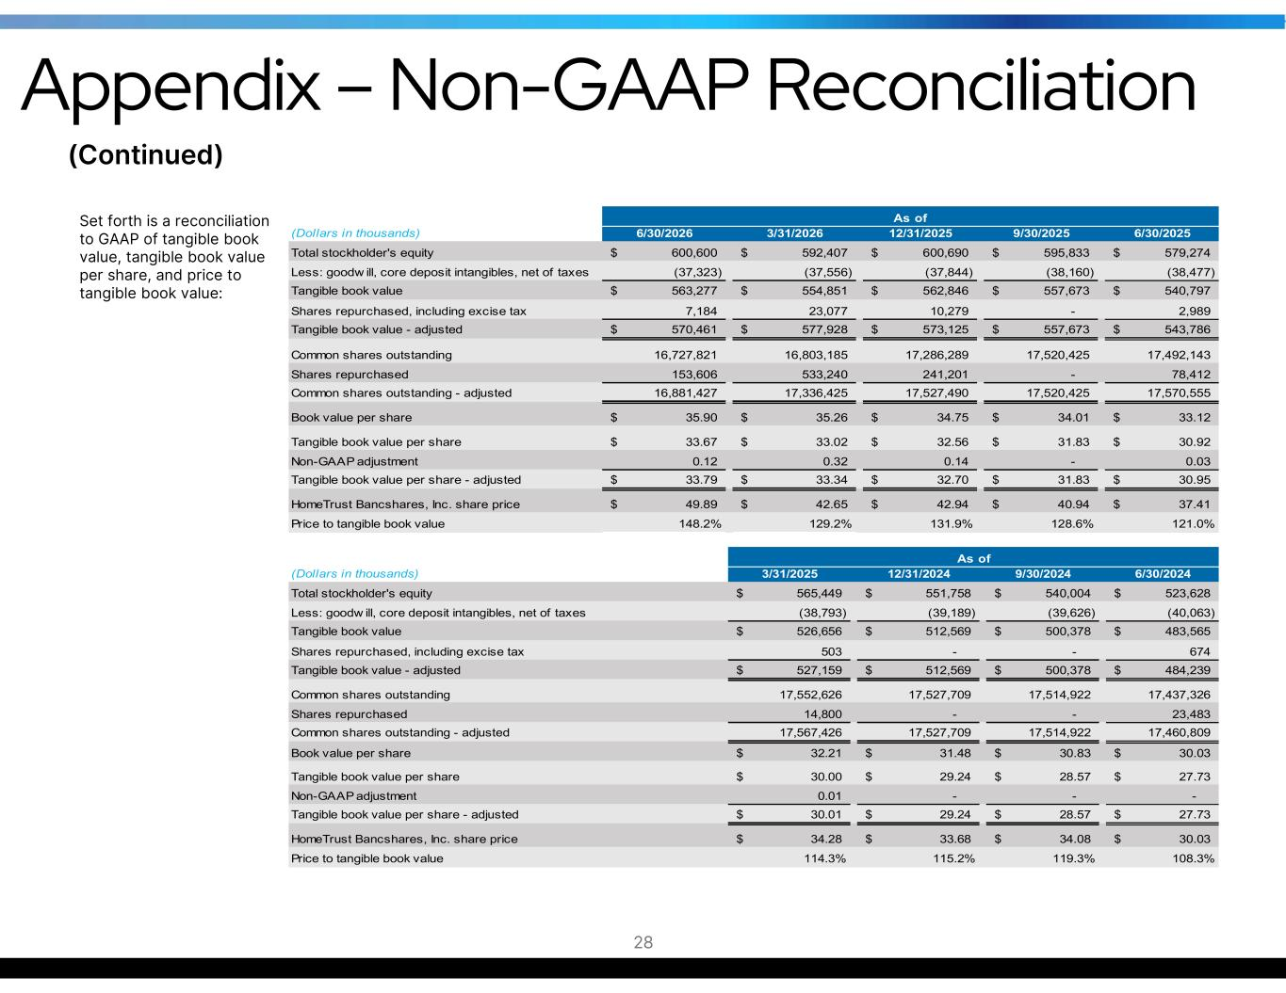
Set forth is a reconciliation to GAAP of tangible book value, tangible book value per share, and price to tangible book value: (Dollars in thousands) 6/30/2026 3/31/2026 12/31/2025 9/30/2025 6/30/2025 Total stockholder's equity 600,600$ 592,407$ 600,690$ 595,833$ 579,274$ Less: goodw ill, core deposit intangibles, net of taxes (37,323) (37,556) (37,844) (38,160) (38,477) Tangible book value 563,277$ 554,851$ 562,846$ 557,673$ 540,797$ Shares repurchased, including excise tax 7,184 23,077 10,279 - 2,989 Tangible book value - adjusted 570,461$ 577,928$ 573,125$ 557,673$ 543,786$ Common shares outstanding 16,727,821 16,803,185 17,286,289 17,520,425 17,492,143 Shares repurchased 153,606 533,240 241,201 - 78,412 Common shares outstanding - adjusted 16,881,427 17,336,425 17,527,490 17,520,425 17,570,555 Book value per share 35.90$ 35.26$ 34.75$ 34.01$ 33.12$ Tangible book value per share 33.67$ 33.02$ 32.56$ 31.83$ 30.92$ Non-GAAP adjustment 0.12 0.32 0.14 - 0.03 Tangible book value per share - adjusted 33.79$ 33.34$ 32.70$ 31.83$ 30.95$ HomeTrust Bancshares, Inc. share price 49.89$ 42.65$ 42.94$ 40.94$ 37.41$ Price to tangible book value 148.2% 129.2% 131.9% 128.6% 121.0% As of (Dollars in thousands) 3/31/2025 12/31/2024 9/30/2024 6/30/2024 Total stockholder's equity 565,449$ 551,758$ 540,004$ 523,628$ Less: goodw ill, core deposit intangibles, net of taxes (38,793) (39,189) (39,626) (40,063) Tangible book value 526,656$ 512,569$ 500,378$ 483,565$ Shares repurchased, including excise tax 503 - - 674 Tangible book value - adjusted 527,159$ 512,569$ 500,378$ 484,239$ Common shares outstanding 17,552,626 17,527,709 17,514,922 17,437,326 Shares repurchased 14,800 - - 23,483 Common shares outstanding - adjusted 17,567,426 17,527,709 17,514,922 17,460,809 Book value per share 32.21$ 31.48$ 30.83$ 30.03$ Tangible book value per share 30.00$ 29.24$ 28.57$ 27.73$ Non-GAAP adjustment 0.01 - - - Tangible book value per share - adjusted 30.01$ 29.24$ 28.57$ 27.73$ HomeTrust Bancshares, Inc. share price 34.28$ 33.68$ 34.08$ 30.03$ Price to tangible book value 114.3% 115.2% 119.3% 108.3% As of (Continued) 28 Appendix – Non-GAAP Reconciliation

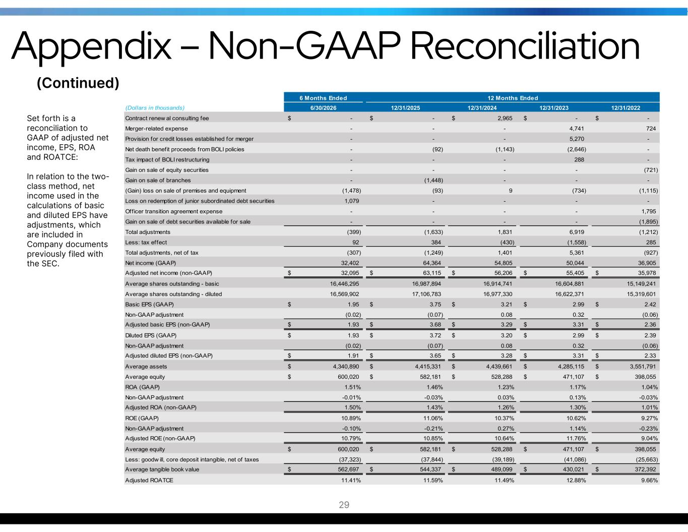
6 Months Ended (Dollars in thousands) 6/30/2026 12/31/2025 12/31/2024 12/31/2023 12/31/2022 Contract renew al consulting fee -$ -$ 2,965$ -$ -$ Merger-related expense - - - 4,741 724 Provision for credit losses established for merger - - - 5,270 - Net death benefit proceeds from BOLI policies - (92) (1,143) (2,646) - Tax impact of BOLI restructuring - - - 288 - Gain on sale of equity securities - - - - (721) Gain on sale of branches - (1,448) - - - (Gain) loss on sale of premises and equipment (1,478) (93) 9 (734) (1,115) Loss on redemption of junior subordinated debt securities 1,079 - - - - Officer transition agreement expense - - - - 1,795 Gain on sale of debt securities available for sale - - - - (1,895) Total adjustments (399) (1,633) 1,831 6,919 (1,212) Less: tax effect 92 384 (430) (1,558) 285 Total adjustments, net of tax (307) (1,249) 1,401 5,361 (927) Net income (GAAP) 32,402 64,364 54,805 50,044 36,905 Adjusted net income (non-GAAP) 32,095$ 63,115$ 56,206$ 55,405$ 35,978$ Average shares outstanding - basic 16,446,295 16,987,894 16,914,741 16,604,881 15,149,241 Average shares outstanding - diluted 16,569,902 17,106,783 16,977,330 16,622,371 15,319,601 Basic EPS (GAAP) 1.95$ 3.75$ 3.21$ 2.99$ 2.42$ Non-GAAP adjustment (0.02) (0.07) 0.08 0.32 (0.06) Adjusted basic EPS (non-GAAP) 1.93$ 3.68$ 3.29$ 3.31$ 2.36$ Diluted EPS (GAAP) 1.93$ 3.72$ 3.20$ 2.99$ 2.39$ Non-GAAP adjustment (0.02) (0.07) 0.08 0.32 (0.06) Adjusted diluted EPS (non-GAAP) 1.91$ 3.65$ 3.28$ 3.31$ 2.33$ Average assets 4,340,890$ 4,415,331$ 4,439,661$ 4,285,115$ 3,551,791$ Average equity 600,020$ 582,181$ 528,288$ 471,107$ 398,055$ ROA (GAAP) 1.51% 1.46% 1.23% 1.17% 1.04% Non-GAAP adjustment -0.01% -0.03% 0.03% 0.13% -0.03% Adjusted ROA (non-GAAP) 1.50% 1.43% 1.26% 1.30% 1.01% ROE (GAAP) 10.89% 11.06% 10.37% 10.62% 9.27% Non-GAAP adjustment -0.10% -0.21% 0.27% 1.14% -0.23% Adjusted ROE (non-GAAP) 10.79% 10.85% 10.64% 11.76% 9.04% Average equity 600,020$ 582,181$ 528,288$ 471,107$ 398,055$ Less: goodw ill, core deposit intangible, net of taxes (37,323) (37,844) (39,189) (41,086) (25,663) Average tangible book value 562,697$ 544,337$ 489,099$ 430,021$ 372,392$ Adjusted ROATCE 11.41% 11.59% 11.49% 12.88% 9.66% 12 Months Ended Set forth is a reconciliation to GAAP of adjusted net income, EPS, ROA and ROATCE: In relation to the two- class method, net income used in the calculations of basic and diluted EPS have adjustments, which are included in Company documents previously filed with the SEC. (Continued) 29 Appendix – Non-GAAP Reconciliation

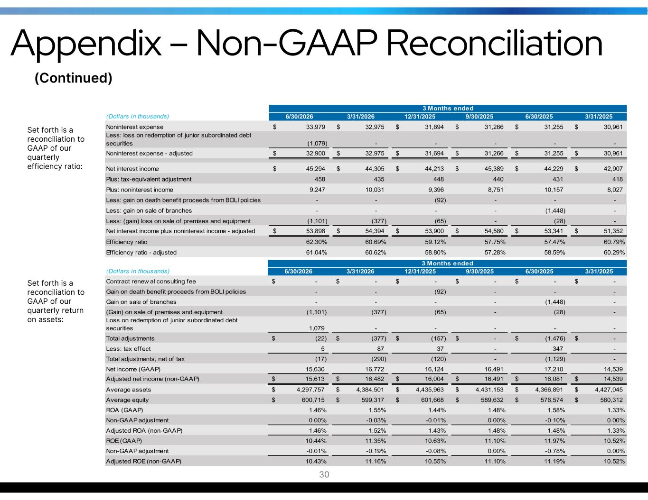
(Dollars in thousands) 6/30/2026 3/31/2026 12/31/2025 9/30/2025 6/30/2025 3/31/2025 Noninterest expense 33,979$ 32,975$ 31,694$ 31,266$ 31,255$ 30,961$ Less: loss on redemption of junior subordinated debt securities (1,079) - - - - - Noninterest expense - adjusted 32,900$ 32,975$ 31,694$ 31,266$ 31,255$ 30,961$ Net interest income 45,294$ 44,305$ 44,213$ 45,389$ 44,229$ 42,907$ Plus: tax-equivalent adjustment 458 435 448 440 431 418 Plus: noninterest income 9,247 10,031 9,396 8,751 10,157 8,027 Less: gain on death benefit proceeds from BOLI policies - - (92) - - - Less: gain on sale of branches - - - - (1,448) - Less: (gain) loss on sale of premises and equipment (1,101) (377) (65) - (28) - Net interest income plus noninterest income - adjusted 53,898$ 54,394$ 53,900$ 54,580$ 53,341$ 51,352$ Eff iciency ratio 62.30% 60.69% 59.12% 57.75% 57.47% 60.79% Efficiency ratio - adjusted 61.04% 60.62% 58.80% 57.28% 58.59% 60.29% 3 Months ended Set forth is a reconciliation to GAAP of our quarterly return on assets: (Dollars in thousands) 6/30/2026 3/31/2026 12/31/2025 9/30/2025 6/30/2025 3/31/2025 Contract renew al consulting fee -$ -$ -$ -$ -$ -$ Gain on death benefit proceeds from BOLI policies - - (92) - - - Gain on sale of branches - - - - (1,448) - (Gain) on sale of premises and equipment (1,101) (377) (65) - (28) - Loss on redemption of junior subordinated debt securities 1,079 - - - - - Total adjustments (22)$ (377)$ (157)$ -$ (1,476)$ -$ Less: tax effect 5 87 37 - 347 - Total adjustments, net of tax (17) (290) (120) - (1,129) - Net income (GAAP) 15,630 16,772 16,124 16,491 17,210 14,539 Adjusted net income (non-GAAP) 15,613$ 16,482$ 16,004$ 16,491$ 16,081$ 14,539$ Average assets 4,297,757$ 4,384,501$ 4,435,963$ 4,431,153$ 4,366,891$ 4,427,045$ Average equity 600,715$ 599,317$ 601,668$ 589,632$ 576,574$ 560,312$ ROA (GAAP) 1.46% 1.55% 1.44% 1.48% 1.58% 1.33% Non-GAAP adjustment 0.00% -0.03% -0.01% 0.00% -0.10% 0.00% Adjusted ROA (non-GAAP) 1.46% 1.52% 1.43% 1.48% 1.48% 1.33% ROE (GAAP) 10.44% 11.35% 10.63% 11.10% 11.97% 10.52% Non-GAAP adjustment -0.01% -0.19% -0.08% 0.00% -0.78% 0.00% Adjusted ROE (non-GAAP) 10.43% 11.16% 10.55% 11.10% 11.19% 10.52% 3 Months ended Set forth is a reconciliation to GAAP of our quarterly efficiency ratio: (Continued) 30 Appendix – Non-GAAP Reconciliation


33 Culture Fundamentals 31 1. DO THE RIGHT THING, ALWAYS 2. LOOK AHEAD AND ANTICIPATE 3. BE POSITIVE 4. THINK TEAM 5. LISTEN GENEROUSLY 6. SPEAK STRAIGHT 7. EMBRACE DIVERSE PERSPECTIVES 8. FIND A WAY 9. PRACTICE BLAMELESS PROBLEM-SOLVING 10. BE OBJECTIVE 11. PAY ATTENTION TO THE DETAILS 12. INVEST IN RELATIONSHIPS 13. DEBATE, THEN ALIGN 14. GO THE EXTRA MILE 15. TAKE INTELLIGENT RISKS 16. PRACTICE KINDNESS 17. THINK AND ACT LIKE AN OWNER 18. GET CLEAR ON EXPECTATIONS 19. HONOR COMMITMENTS 20. SHOW MEANINGFUL APPRECIATION 21. ASSUME POSITIVE INTENT 22. “BRING IT” EVERY DAY 23. BE RELENTLESS ABOUT IMPROVEMENT 24. BE A FANATIC ABOUT RESPONSE TIME 25. WORK ON YOURSELF 26. COLLABORATE 27. MAKE QUALITY PERSONAL 28. BE READY FOR WHAT’S NEXT 29. DELIVER AN EFFORTLESS EXPERIENCE 30. CREATE A GREAT IMPRESSION 31. OWN YOUR WORK-LIFE BALANCE 32. FOCUSED EXECUTION 33. KEEP THINGS FUN “How we engage our customers, how we treat each other, and how we manage the Bank.”


Hunter Westbrook President and Chief Executive Officer hunter.westbrook@htb.com Tony VunCannon EVP / Chief Financial Officer Corporate Secretary / Treasurer tony.vuncannon@htb.com 10 Woodfin Street Asheville, NC 28801 (828) 259-3939 www.htb.com 32

