UNITED STATES
SECURITIES AND EXCHANGE COMMISSION
Washington, D.C. 20549

FORM 8-K

CURRENT REPORT
Pursuant to Section 13 or 15(d) of the Securities Exchange Act of 1934

Date of Report (Date of earliest event reported): August 16, 2026

HOMETRUST BANCSHARES, INC.
(Exact name of registrant as specified in its charter)

Maryland |  |  |  |  |  | 001-35593 |  |  |  |  |  | 45-5055422
(State or other jurisdiction of incorporation) |  |  |  |  |  | (Commission File Number) |  |  |  |  |  | (IRS Employer Identification No.)
10 Woodfin Street  Asheville, North Carolina |  |  |  |  |  |  |  |  |  |  |  | 28801
(Address of principal executive offices) |  |  |  |  |  |  |  |  |  |  |  | (Zip Code)
Registrant's telephone number, including area code: (828) 259-3939
Not Applicable
(Former name or former address, if changed since last report)

Check the appropriate box below if the Form 8-K filing is intended to simultaneously satisfy the filing obligation of the registrant under any of the following provisions:
☒ |  |  | Written communications pursuant to Rule 425 under the Securities Act (17 CFR 230.425)
☐ |  |  | Soliciting material pursuant to Rule 14a-12 under the Exchange Act (17 CFR 240.14a-12)
☐ |  |  | Pre-commencement communications pursuant to Rule 14d-2(b) under the Exchange Act (17 CFR 240.14d-2(b))
☐ |  |  | Pre-commencement communications pursuant to Rule 13e-4(c) under the Exchange Act (17 CFR 240.13e-4(c))
Securities Registered Pursuant to Section 12(b) of the Act:
Title of each class |  |  | Trading Symbol |  |  | Name of each exchange on which registered
Common Stock, par value $0.01 per share |  |  | HTB |  |  | The New York Stock Exchange LLC

Indicate by check mark whether the registrant is an emerging growth company as defined in Rule 405 of the Securities Act of 1933 (§230.405 of this chapter) or Rule 12b-2 of the Securities Exchange Act of 1934 (§240.12b-2 of this chapter).
Emerging growth company |  |  | ☐
If an emerging growth company, indicate by check mark if the registrant has elected not to use the extended transition period for complying with any new or revised financial accounting standards provided pursuant to Section 13(a) of the Exchange Act. |  |  | ☐

Item 1.01 Entry Into A Material Definitive Agreement
On August 16, 2026, HomeTrust Bancshares, Inc., a Maryland corporation (“HomeTrust”), Blue Ridge Bankshares, Inc., a Virginia corporation (“Blue Ridge”), and Kinloch Merger Sub, Inc., a Virginia corporation and wholly owned subsidiary of HomeTrust (“Merger Sub”), entered into an Agreement and Plan of Merger (the “Merger Agreement”). Pursuant to the terms and conditions set forth in the Merger Agreement, Merger Sub will merge with and into Blue Ridge (the “Merger”), with Blue Ridge continuing as the surviving corporation, and immediately following the Merger, Blue Ridge will merge with and into HomeTrust (the “Second Step Merger”), with HomeTrust continuing as the surviving corporation.
Immediately following the Second Step Merger, Blue Ridge Bank, National Association, the wholly owned bank subsidiary of Blue Ridge, will merge with and into HomeTrust Bank, the wholly owned bank subsidiary of HomeTrust, with HomeTrust Bank as the surviving bank.
Subject to the terms and conditions of the Merger Agreement, which has been unanimously approved by the boards of directors of both Blue Ridge and HomeTrust, at the effective time of the Merger (the “Effective Time”), each share of Blue Ridge common stock issued and outstanding immediately prior to the Effective Time, subject to limited exceptions, will be converted into the right to receive 0.086 of a share of HomeTrust common stock (the “Exchange Ratio”), plus cash in lieu of any fractional shares (collectively, the “Merger Consideration”).
Concurrent with the execution of the Merger Agreement, Blue Ridge has entered into a warrant conversion agreement with a holder of outstanding warrants to purchase Blue Ridge common stock. The warrant conversion agreement provides for the automatic cashless exercise of such warrants immediately prior to the Effective Time. The shares of Blue Ridge common stock issued pursuant to such exercise will be converted into the right to receive the Merger Consideration at the Effective Time. Holders of the remaining outstanding Blue Ridge warrants will be given the same cashless exercise opportunity, which must be elected by executing and delivering a warrant conversion agreement to Blue Ridge on or before September 19, 2026. No later than August 31, 2026, Blue Ridge will provide written notice to holders of Blue Ridge warrants other than the holder that entered into a warrant conversion agreement with Blue Ridge on August 16, 2026, offering such other holders an opportunity to enter into the same form of warrant conversion agreement. At the Effective Time, any outstanding Blue Ridge warrants for which the holders have not executed warrant conversion agreements will automatically be assumed by HomeTrust in accordance with the terms of such Blue Ridge warrants. The form of the warrant conversion agreement is included as Exhibit C to the copy of the Merger Agreement attached hereto as Exhibit 2.1.
Each option to purchase shares of Blue Ridge common stock, whether vested or unvested, that is outstanding and in-the-money immediately prior to the Effective Time will be cancelled at the Effective Time in exchange for a cash payment equal to the product of (i) the number of shares of Blue Ridge common stock underlying the option and (ii) the excess, if any, of (1) the average closing price of HomeTrust common stock for the five consecutive trading days prior to the Merger closing date multiplied by the Exchange Ratio over (2) the exercise price of the option, less any required tax withholding. Each Blue Ridge stock option that is outstanding and out-of-the-money immediately prior to the Effective Time will be cancelled at the Effective Time for no consideration or payment.
At the Effective Time, each time-vesting only share of Blue Ridge restricted common stock that is outstanding and unvested immediately prior to the Effective Time will fully vest and entitle its holder to receive the Merger Consideration, subject to any required tax withholding. Each performance-vesting Blue Ridge restricted stock award that is outstanding and unvested immediately prior to the Effective Time will automatically convert at the Effective Time into a HomeTrust restricted stock award that is time-based only for future vesting based on the holder’s continuous service through the unexpired performance period(s). The number of shares underlying the converted award will be determined by multiplying (i) the number of shares of Blue Ridge common stock subject to the award immediately prior to the Effective Time that would be earned assuming full performance for the unexpired performance periods by (ii) the Exchange Ratio.
The Merger Agreement contains customary representations and warranties from both HomeTrust and Blue Ridge, and each party has agreed to customary covenants, including, among others, covenants relating to (1) the conduct of HomeTrust's and Blue Ridge's respective business during the interim period between the execution of the Merger Agreement and the Effective Time, (2) Blue Ridge’s obligation to call a meeting of its shareholders to approve the Merger Agreement and, subject to certain exceptions, that its board of directors recommends that Blue Ridge shareholders vote to approve the Merger Agreement, (3) HomeTrust’s obligation to call a meeting of its stockholders to approve the issuance of HomeTrust common stock in the Merger and, subject to certain exceptions, that its board of directors recommends that HomeTrust stockholders vote to approve such issuance, and (4) Blue Ridge’s non-solicitation obligations regarding alternative acquisition proposals.
The completion of the Merger is subject to customary conditions, including approval of the Merger Agreement by the shareholders of Blue Ridge and approval of the issuance of shares of HomeTrust common stock in the Merger by the stockholders of HomeTrust, and the receipt of required regulatory approvals. The Merger is currently expected to be completed in the first quarter of 2027.
The Merger Agreement contains certain termination rights for both Blue Ridge and HomeTrust, including if there has been a breach by the other party that is not cured such that the applicable closing conditions are not satisfied or the Merger is not consummated by August 16, 2027. A termination fee of $18.0 million will be payable by HomeTrust or Blue Ridge upon termination of the Merger Agreement under certain circumstances.
Pursuant to the Merger Agreement, HomeTrust will appoint two mutually agreed upon members of Blue Ridge's board of directors to become directors of HomeTrust at the Effective Time, one of whom to serve for a term ending at the 2028 annual meeting of HomeTrust’s stockholders and the other to serve for a term ending at the 2029 annual meeting of HomeTrust’s stockholders. These individuals will also serve as directors of HomeTrust Bank.
The foregoing description of the Merger Agreement and the transactions contemplated thereby is not complete and is subject to and qualified in its entirety by reference to the Merger Agreement, a copy of which is attached hereto as Exhibit 2.1 and the terms of which are incorporated herein by reference.
The representations, warranties and covenants contained in the Merger Agreement generally will not survive consummation of the Merger and were made only for purposes of such agreement and as of specific dates, were solely for the benefit of the parties to the Merger Agreement, are subject to limitations agreed upon by the parties as stated in the Merger Agreement, including being qualified by confidential disclosure schedules made for the purposes of allocating contractual risk between the parties to the Merger Agreement instead of establishing these matters as facts, and are, in most cases, subject to standards of materiality applicable to the contracting parties that differ from those applicable to investors under
2

applicable securities law standards of materiality. Accordingly, the representations and warranties may not describe the actual state of affairs at the date they were made or at any other time, and investors should not rely on them as statements of fact. Moreover, information concerning the subject matter of the representations, warranties and covenants may change after the date of the Merger Agreement, which subsequent information may or may not be fully reflected in public disclosures by Blue Ridge or HomeTrust. Accordingly, the Merger Agreement is included with this filing only to provide investors with information regarding the terms of the Merger Agreement, and not to provide investors with any other factual information regarding HomeTrust or Blue Ridge, their respective affiliates or their respective businesses. The Merger Agreement should not be read alone, but should instead be read in conjunction with the other information regarding HomeTrust, Blue Ridge, their respective affiliates or their respective businesses, the Merger Agreement and the Merger that will be contained in, or incorporated by reference into, the Registration Statement on Form S-4 that will include a joint proxy statement of HomeTrust and Blue Ridge and a prospectus of HomeTrust, as well as in the Form 10-Ks, Form 10-Qs, Form 8-Ks and other documents that HomeTrust and Blue Ridge may file with or furnish to the Securities and Exchange Commission (“SEC”).
Each director and certain significant non-director shareholders of Blue Ridge have executed a voting agreement with HomeTrust pursuant to which the individual or entity has agreed to vote his, her or its shares of Blue Ridge common stock in favor of the Merger Agreement. Each director of Blue Ridge also has executed a resignation, non-solicitation and confidentiality agreement with HomeTrust. Each director of HomeTrust has executed a voting agreement with Blue Ridge pursuant to which the individual has agreed to vote his or shares of HomeTrust common stock in favor of the issuance of HomeTrust common stock in the Merger.
Item 7.01 Regulation FD Disclosure
On August 17, 2026, HomeTrust and Blue Ridge issued a joint press release announcing the execution of the Merger Agreement. A copy of the press release is attached to this Current Report on Form 8-K as Exhibit 99.1 and is incorporated into this Item 7.01 by reference. In addition, HomeTrust has prepared investor presentation material regarding the transactions contemplated by the Merger Agreement, which it expects to use in connection with presentations to analysts and investors. The presentation material is attached to this Current Report on Form 8-K as Exhibit 99.2 and is incorporated into this Item 7.01 by reference.
The press release and presentation material are furnished pursuant to Item 7.01 and shall not be deemed “filed” for the purposes of Section 18 of the Securities Exchange Act of 1934, as amended (the “Exchange Act”). They may only be incorporated by reference in another filing under the Exchange Act or the Securities Act of 1933, as amended (the “Securities Act”), if such subsequent filing specifically references the information furnished pursuant to Item 7.01 of this Current Report on Form 8-K.
Item 9.01 Financial Statements and Exhibits
(a) Not applicable.
(b) Not applicable.
(c) Not applicable.
(d) The following exhibits are included with this Report:
Exhibit No. |  |  |  |  |  | Description
2.1 |  |  |  |  |  | Agreement and Plan of Merger dated August 16, 2026*
99.1 |  |  |  |  |  | Press release dated August 17, 2026
99.2 |  |  |  |  |  | Investor presentation material dated August 17, 2026
104.0 |  |  |  |  |  | Cover Page Interactive Data File (embedded within the Inline XBRL document)
*Exhibits and Schedules have been omitted pursuant to Item 601(b)(2) of Regulation S-K. HomeTrust agrees to furnish a supplemental copy of any such omitted Exhibit or Schedule to the SEC upon request.
Forward-Looking Statements
This Current Report, including the Exhibits hereto, contain “forward-looking statements” within the meaning of the Private Securities Litigation Reform Act of 1995. Forward-looking statements can be identified by the use of words such as "may," "should," "will," "could," "estimates," "predicts," "potential," "continue," "anticipates," "believes," "plans," "expects," "future," "intends," "projects," the negative of these terms and other comparable terminology. These forward-looking statements include, but are not limited to, statements regarding the outlook and expectations of HomeTrust and Blue Ridge with respect to the Merger, the anticipated strategic and financial benefits of the Merger, including the expected impact of the Merger on HomeTrust’s or Blue Ridge’s future financial performance pending the completion of the Merger and on HomeTrust's financial performance following the Merger, and the timing of the closing of the Merger.
Forward-looking statements are neither historical facts, nor assurance of future performance. Instead, such statements are based on current beliefs, expectations and assumptions regarding the future of HomeTrust's and Blue Ridge’s respective businesses, future plans and strategies, projections, anticipated events and trends, the economy and other future conditions. Because forward-looking statements relate to the future, they are subject to inherent uncertainties, risks and changes in circumstances that are difficult to predict and many of which are outside of HomeTrust’s or Blue Ridge's control, and actual results and financial condition may differ materially from those indicated in the forward-looking statements. Therefore, you should not unduly rely on any of these forward-looking statements. Any forward-looking statement is based only on information currently available and speaks only as of the date when made. HomeTrust and Blue Ridge undertake no obligation, other than as required by law, to update or revise any forward-looking statements, whether as a result of new information, future events or otherwise.
Forward-looking statements contained in this Current Report are subject to, among others, the following risks, uncertainties and assumptions:
•The possibility that the anticipated benefits of the Merger, including anticipated cost savings and strategic gains, are not realized when expected or at all, including as a result of the impact of, or challenges arising from, the integration of Blue Ridge into HomeTrust or as a
3

result of the strength of the economy, competitive factors in the areas where Blue Ridge and HomeTrust do business, or as a result of other unexpected factors or events;
•The timing and completion of the Merger is dependent on the satisfaction of customary closing conditions, and various other factors that cannot be predicted with precision at this point;
•The occurrence of any event, change or other circumstances that could give rise to the right of HomeTrust, Blue Ridge or both to terminate the Merger Agreement;
•Completion of the Merger is subject to bank regulatory approvals and such approvals may not be obtained in a timely manner or at all or may be subject to conditions which may cause additional significant expense or delay the consummation of the Merger;
•Potential adverse reactions or changes to business or employee relationships, including those resulting from the announcement or completion of the Merger;
•The diversion of attention and time by the respective management teams of HomeTrust and Blue Ridge from ongoing business operations and opportunities on Merger-related matters;
•The outcome of any legal proceedings related to the Merger which may be instituted against HomeTrust or Blue Ridge;
•Unanticipated challenges or delays in the integration of Blue Ridge’s business into HomeTrust’s business and/or the conversion of Blue Ridge’s operating systems and customer data onto HomeTrust’s may significantly increase the expense associated with the Merger; and
•Other factors that may affect future results of Blue Ridge and HomeTrust.
These forward-looking statements are also subject to the principal risks and uncertainties applicable to Blue Ridge’s and HomeTrust’s respective businesses and activities generally that are disclosed in HomeTrust’s and Blue Ridge's respective Annual Reports on Form 10-K for the year ended December 31, 2025 and in other documents HomeTrust and Blue Ridge file with the SEC. HomeTrust’s and Blue Ridge's SEC filings are accessible on the SEC website at www.sec.gov.
No Offer or Solicitation
This Current Report and related communications are not intended to and shall not constitute an offer to sell or the solicitation of an offer to buy any securities, nor shall there be any sale of securities in any jurisdiction in which such offer, solicitation or sale would be unlawful prior to registration or qualification under the securities laws of any such jurisdiction. No offer of securities shall be made except by means of a prospectus that meets the requirements of Section 10 of the Securities Act.
Additional Information and Where to Find It
In connection with the proposed merger transaction, HomeTrust expects to file with the SEC a Registration Statement on Form S-4 (the "Registration Statement") that will include a preliminary joint proxy statement of HomeTrust and Blue Ridge and a preliminary prospectus of HomeTrust (the "Joint Proxy Statement/Prospectus"), as well as other relevant documents concerning the proposed transaction. After the Registration Statement is declared effective, HomeTrust and Blue Ridge will mail a definitive Joint Proxy Statement/Prospectus to their stockholders and shareholders, respectively. This communication is not a substitute for the Joint Proxy Statement/Prospectus or Registration Statement or for any other document that HomeTrust or Blue Ridge may file with the SEC and send to their respective stockholders or shareholders in connection with the proposed merger transaction. Stockholders of HomeTrust and shareholders of Blue Ridge are urged to read carefully the Registration Statement and the Joint Proxy Statement/Prospectus regarding the proposed merger transaction when they become available and any other relevant documents filed with the SEC, as well as any amendments or supplements to those documents, because they will contain important information.
Free copies of the Joint Proxy Statement/Prospectus included in the Registration Statement, as well as other filings containing information about HomeTrust, Blue Ridge, and the proposed transaction, may be obtained at the SEC's website (www.sec.gov). You will also be able to obtain these documents, free of charge, in the "Investor Relations" section of HomeTrust's website, www.htb.com, under "SEC Filings" in the "Financials & Filings" heading, and in the "Investor Relations" section of Blue Ridge’s website, www.mybrb.bank, under “SEC Filings” in the "Financials" heading or by requesting them in writing or by telephone from HomeTrust at: HomeTrust Bancshares, Inc., 10 Woodfin Street, Asheville, North Carolina 28801, Attn: Tony J. VunCannon; Telephone (828) 350-3049 or by requesting them in writing or by telephone from Blue Ridge at: Blue Ridge Bankshares, Inc., 1801 Bayberry Court, Suite 101, Richmond, Virginia 23226, Attn: Judy C. Gavant; Telephone (804) 518-2606.
Participants in Solicitation
HomeTrust and Blue Ridge and certain of their respective directors and executive officers may be deemed to be participants in the solicitation of proxies from the stockholders of HomeTrust and from the shareholders of Blue Ridge in respect of the proposed merger transaction. Information regarding HomeTrust’s directors and executive officers is contained in HomeTrust’s definitive proxy statement on Schedule 14A filed with the SEC on April 7, 2026. Information regarding Blue Ridge’s directors and executive officers is contained in Blue Ridge’s definitive proxy statement on Schedule 14A filed with the SEC on April 30, 2026. Additional information regarding the interests of those participants and other persons who may be deemed participants in the transaction may be obtained by reading the Joint Proxy Statement/Prospectus regarding the proposed merger transaction when it becomes available. Free copies of this document may be obtained as described above.
4

SIGNATURE
Pursuant to the requirements of the Securities Exchange Act of 1934, the registrant has duly caused this report to be signed on its behalf by the undersigned hereunto duly authorized.
 |  |  |  |  |  |  |  |  | HOMETRUST BANCSHARES, INC.
Date: August 17, 2026 |  |  |  |  |  | By: |  |  | /s/ Tony J. VunCannon
 |  |  |  |  |  |  |  |  | Tony J. VunCannon
 |  |  |  |  |  |  |  |  | Executive Vice President, Chief Financial Officer, Corporate Secretary and Treasurer

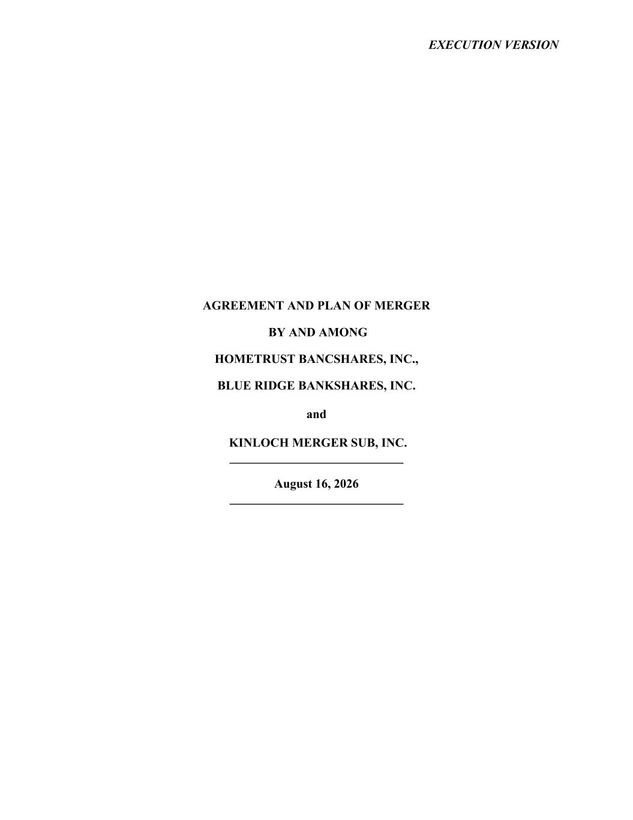
5
EXECUTION VERSION AGREEMENT AND PLAN OF MERGER BY AND AMONG HOMETRUST BANCSHARES, INC., BLUE RIDGE BANKSHARES, INC. and KINLOCH MERGER SUB, INC. ____________________________ August 16, 2026 ____________________________

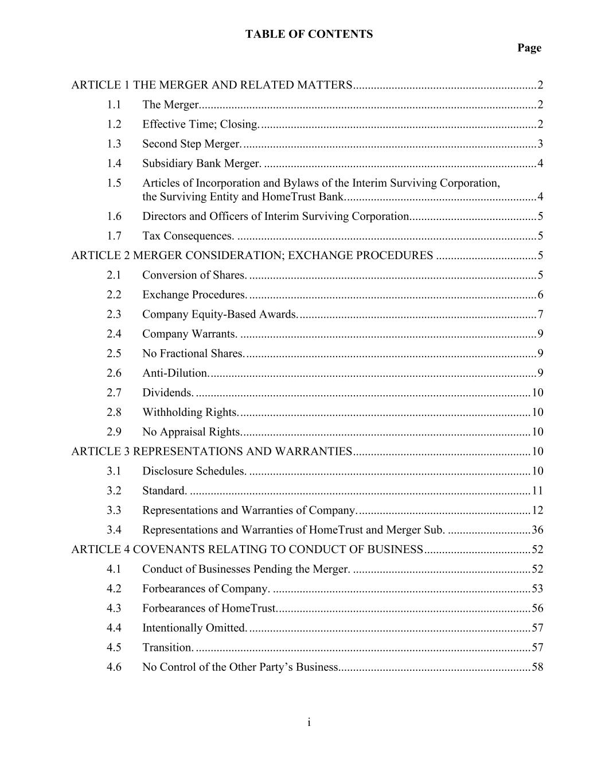
TABLE OF CONTENTS Page i ARTICLE 1 THE MERGER AND RELATED MATTERS .............................................................. 2 1.1 The Merger.................................................................................................................. 2 1.2 Effective Time; Closing. ............................................................................................. 2 1.3 Second Step Merger. ................................................................................................... 3 1.4 Subsidiary Bank Merger. ............................................................................................ 4 1.5 Articles of Incorporation and Bylaws of the Interim Surviving Corporation, the Surviving Entity and HomeTrust Bank. ................................................................ 4 1.6 Directors and Officers of Interim Surviving Corporation. .......................................... 5 1.7 Tax Consequences. ..................................................................................................... 5 ARTICLE 2 MERGER CONSIDERATION; EXCHANGE PROCEDURES .................................. 5 2.1 Conversion of Shares. ................................................................................................. 5 2.2 Exchange Procedures. ................................................................................................. 6 2.3 Company Equity-Based Awards. ................................................................................ 7 2.4 Company Warrants. .................................................................................................... 9 2.5 No Fractional Shares. .................................................................................................. 9 2.6 Anti-Dilution. .............................................................................................................. 9 2.7 Dividends. ................................................................................................................. 10 2.8 Withholding Rights. .................................................................................................. 10 2.9 No Appraisal Rights. ................................................................................................. 10 ARTICLE 3 REPRESENTATIONS AND WARRANTIES ............................................................ 10 3.1 Disclosure Schedules. ............................................................................................... 10 3.2 Standard. ................................................................................................................... 11 3.3 Representations and Warranties of Company. .......................................................... 12 3.4 Representations and Warranties of HomeTrust and Merger Sub. ............................ 36 ARTICLE 4 COVENANTS RELATING TO CONDUCT OF BUSINESS .................................... 52 4.1 Conduct of Businesses Pending the Merger. ............................................................ 52 4.2 Forbearances of Company. ....................................................................................... 53 4.3 Forbearances of HomeTrust. ..................................................................................... 56 4.4 Intentionally Omitted. ............................................................................................... 57 4.5 Transition. ................................................................................................................. 57 4.6 No Control of the Other Party’s Business................................................................. 58

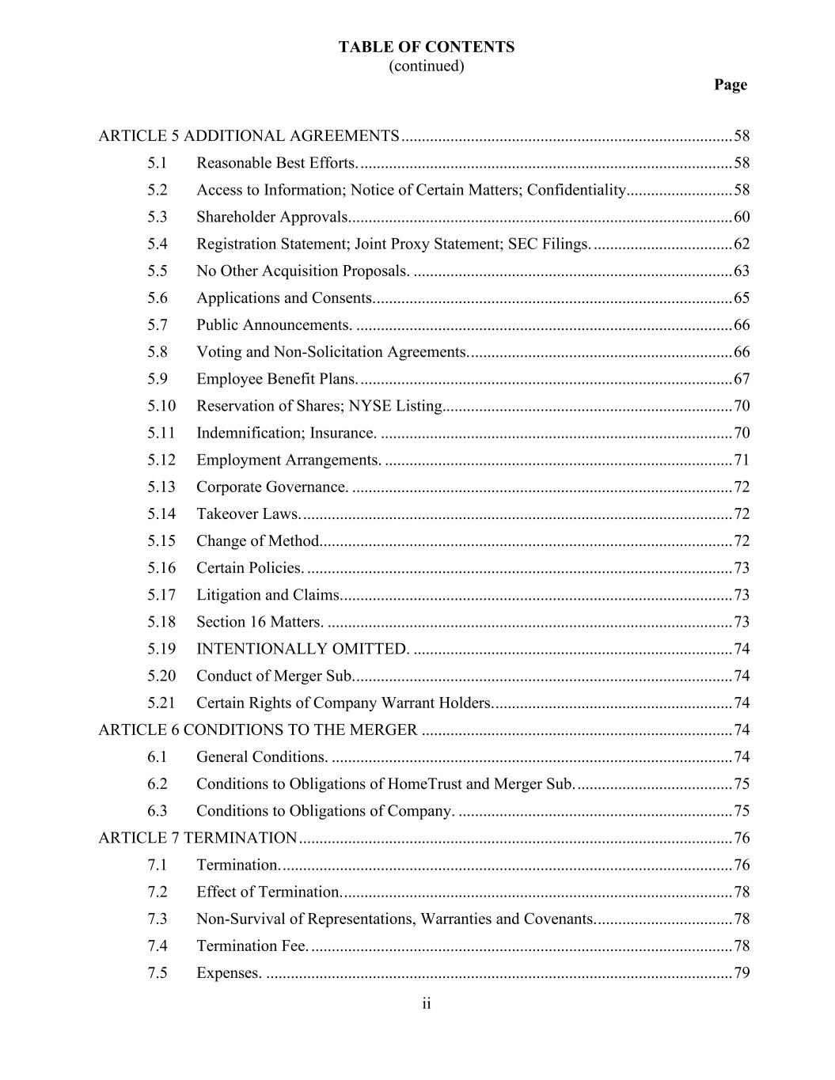
TABLE OF CONTENTS (continued) Page ii ARTICLE 5 ADDITIONAL AGREEMENTS ................................................................................. 58 5.1 Reasonable Best Efforts. ........................................................................................... 58 5.2 Access to Information; Notice of Certain Matters; Confidentiality.......................... 58 5.3 Shareholder Approvals.............................................................................................. 60 5.4 Registration Statement; Joint Proxy Statement; SEC Filings. .................................. 62 5.5 No Other Acquisition Proposals. .............................................................................. 63 5.6 Applications and Consents. ....................................................................................... 65 5.7 Public Announcements. ............................................................................................ 66 5.8 Voting and Non-Solicitation Agreements. ................................................................ 66 5.9 Employee Benefit Plans. ........................................................................................... 67 5.10 Reservation of Shares; NYSE Listing....................................................................... 70 5.11 Indemnification; Insurance. ...................................................................................... 70 5.12 Employment Arrangements. ..................................................................................... 71 5.13 Corporate Governance. ............................................................................................. 72 5.14 Takeover Laws. ......................................................................................................... 72 5.15 Change of Method..................................................................................................... 72 5.16 Certain Policies. ........................................................................................................ 73 5.17 Litigation and Claims. ............................................................................................... 73 5.18 Section 16 Matters. ................................................................................................... 73 5.19 INTENTIONALLY OMITTED. .............................................................................. 74 5.20 Conduct of Merger Sub. ............................................................................................ 74 5.21 Certain Rights of Company Warrant Holders. .......................................................... 74 ARTICLE 6 CONDITIONS TO THE MERGER ............................................................................ 74 6.1 General Conditions. .................................................................................................. 74 6.2 Conditions to Obligations of HomeTrust and Merger Sub. ...................................... 75 6.3 Conditions to Obligations of Company. ................................................................... 75 ARTICLE 7 TERMINATION .......................................................................................................... 76 7.1 Termination. .............................................................................................................. 76 7.2 Effect of Termination. ............................................................................................... 78 7.3 Non-Survival of Representations, Warranties and Covenants. ................................. 78 7.4 Termination Fee. ....................................................................................................... 78 7.5 Expenses. .................................................................................................................. 79

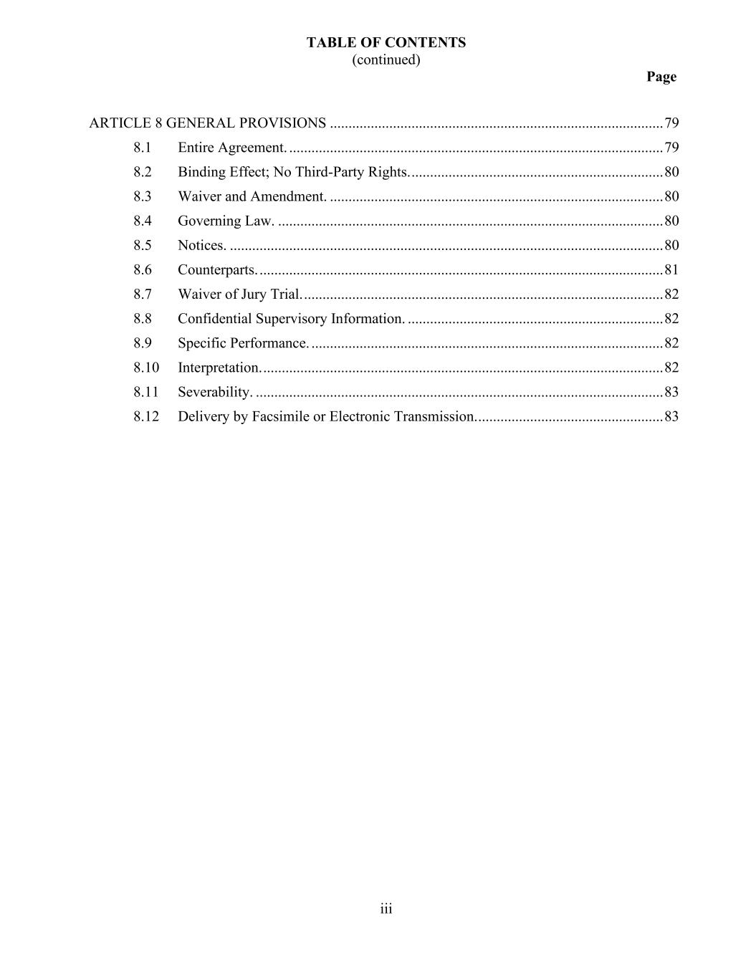
TABLE OF CONTENTS (continued) Page iii ARTICLE 8 GENERAL PROVISIONS .......................................................................................... 79 8.1 Entire Agreement. ..................................................................................................... 79 8.2 Binding Effect; No Third-Party Rights. .................................................................... 80 8.3 Waiver and Amendment. .......................................................................................... 80 8.4 Governing Law. ........................................................................................................ 80 8.5 Notices. ..................................................................................................................... 80 8.6 Counterparts. ............................................................................................................. 81 8.7 Waiver of Jury Trial. ................................................................................................. 82 8.8 Confidential Supervisory Information. ..................................................................... 82 8.9 Specific Performance. ............................................................................................... 82 8.10 Interpretation. ............................................................................................................ 82 8.11 Severability. .............................................................................................................. 83 8.12 Delivery by Facsimile or Electronic Transmission. .................................................. 83

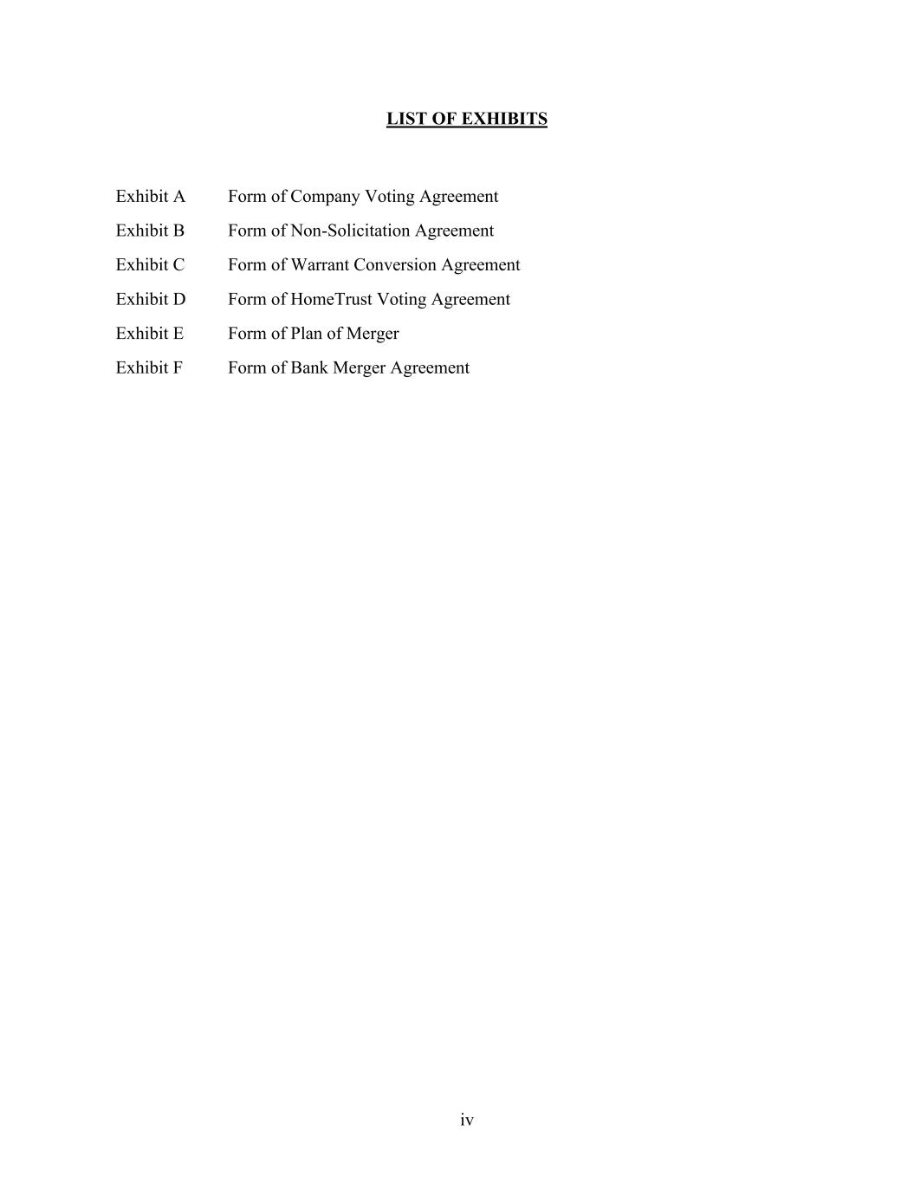
iv LIST OF EXHIBITS Exhibit A Form of Company Voting Agreement Exhibit B Form of Non-Solicitation Agreement Exhibit C Form of Warrant Conversion Agreement Exhibit D Form of HomeTrust Voting Agreement Exhibit E Form of Plan of Merger Exhibit F Form of Bank Merger Agreement

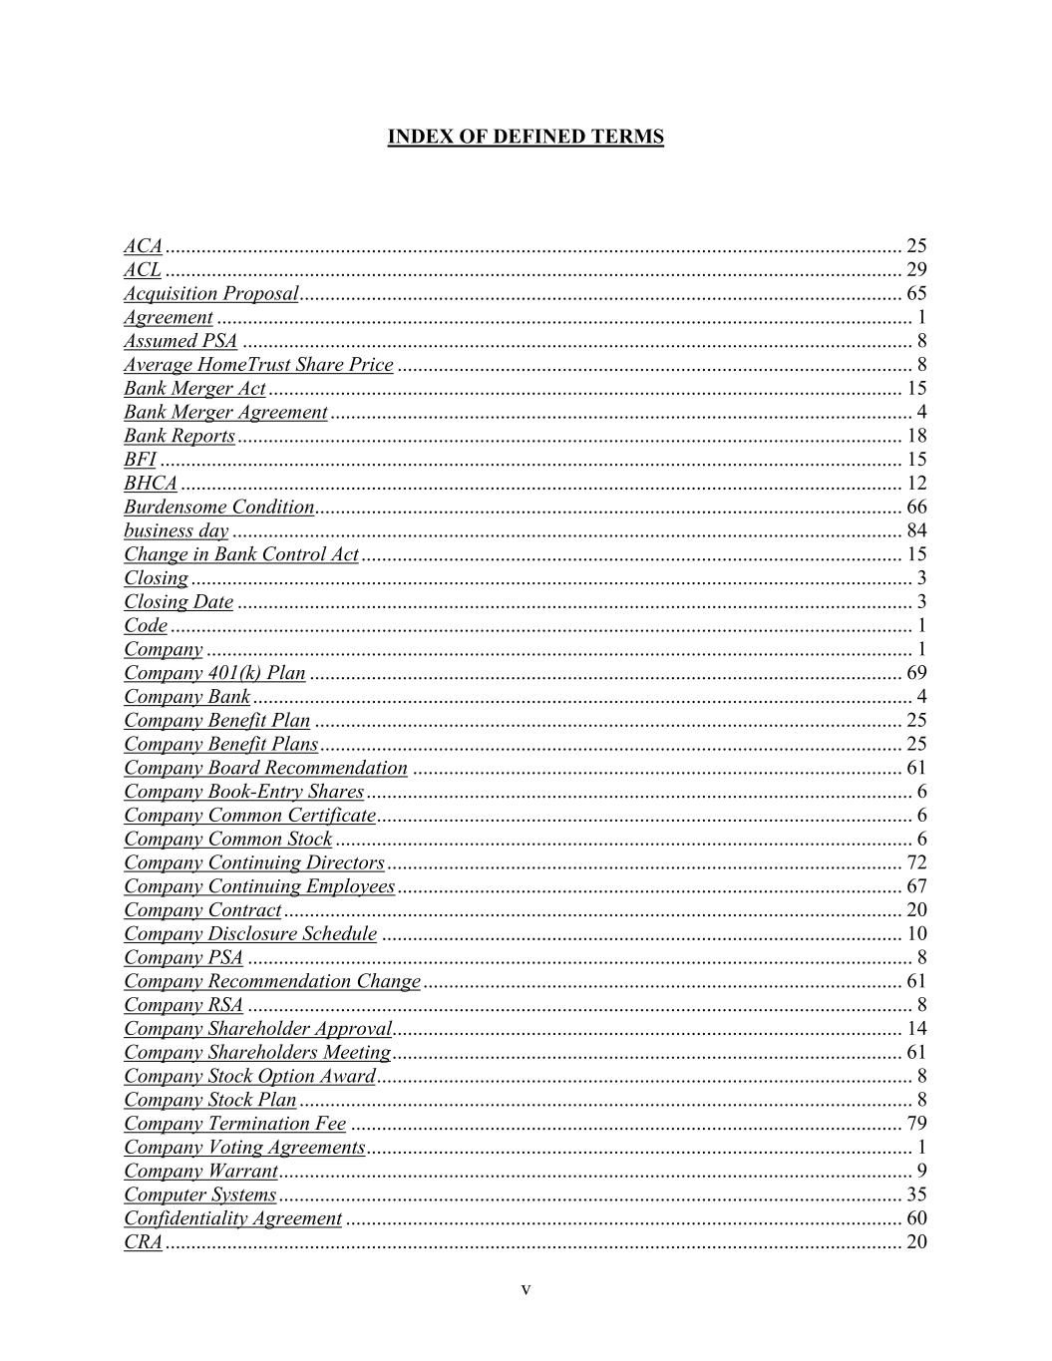
v INDEX OF DEFINED TERMS ACA ............................................................................................................................................... 25 ACL ............................................................................................................................................... 29 Acquisition Proposal ..................................................................................................................... 65 Agreement ....................................................................................................................................... 1 Assumed PSA .................................................................................................................................. 8 Average HomeTrust Share Price .................................................................................................... 8 Bank Merger Act ........................................................................................................................... 15 Bank Merger Agreement ................................................................................................................. 4 Bank Reports ................................................................................................................................. 18 BFI ................................................................................................................................................ 15 BHCA ............................................................................................................................................ 12 Burdensome Condition.................................................................................................................. 66 business day .................................................................................................................................. 84 Change in Bank Control Act ......................................................................................................... 15 Closing ............................................................................................................................................ 3 Closing Date ................................................................................................................................... 3 Code ................................................................................................................................................ 1 Company ......................................................................................................................................... 1 Company 401(k) Plan ................................................................................................................... 69 Company Bank ................................................................................................................................ 4 Company Benefit Plan .................................................................................................................. 25 Company Benefit Plans ................................................................................................................. 25 Company Board Recommendation ............................................................................................... 61 Company Book-Entry Shares .......................................................................................................... 6 Company Common Certificate ........................................................................................................ 6 Company Common Stock ................................................................................................................ 6 Company Continuing Directors .................................................................................................... 72 Company Continuing Employees .................................................................................................. 67 Company Contract ........................................................................................................................ 20 Company Disclosure Schedule ..................................................................................................... 10 Company PSA ................................................................................................................................. 8 Company Recommendation Change ............................................................................................. 61 Company RSA ................................................................................................................................. 8 Company Shareholder Approval................................................................................................... 14 Company Shareholders Meeting ................................................................................................... 61 Company Stock Option Award ........................................................................................................ 8 Company Stock Plan ....................................................................................................................... 8 Company Termination Fee ........................................................................................................... 79 Company Voting Agreements .......................................................................................................... 1 Company Warrant ........................................................................................................................... 9 Computer Systems ......................................................................................................................... 35 Confidentiality Agreement ............................................................................................................ 60 CRA ............................................................................................................................................... 20

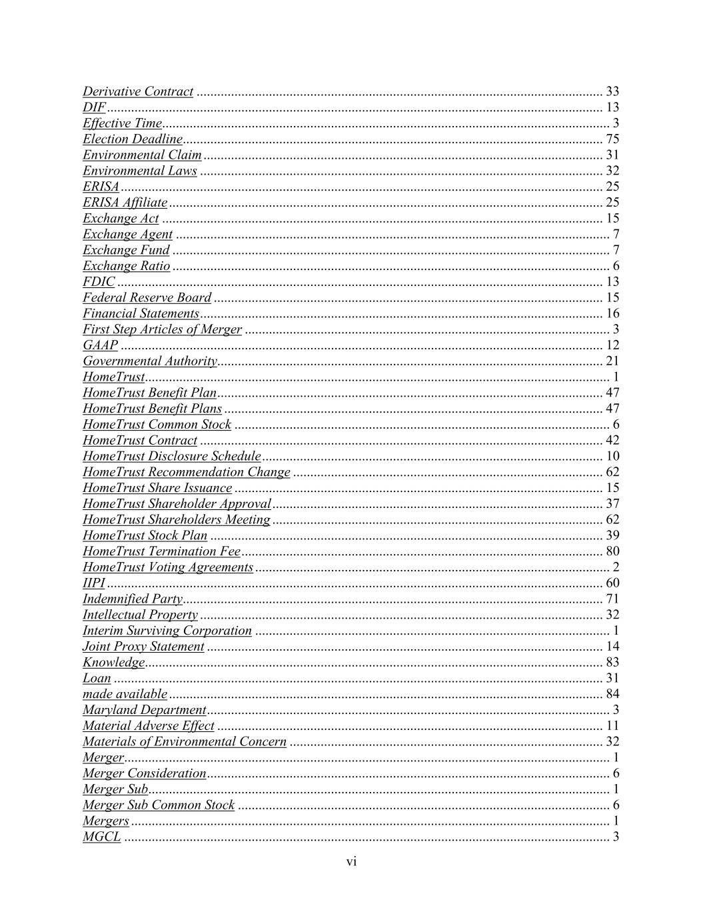
vi Derivative Contract ...................................................................................................................... 33 DIF ................................................................................................................................................ 13 Effective Time.................................................................................................................................. 3 Election Deadline.......................................................................................................................... 75 Environmental Claim .................................................................................................................... 31 Environmental Laws ..................................................................................................................... 32 ERISA ............................................................................................................................................ 25 ERISA Affiliate .............................................................................................................................. 25 Exchange Act ................................................................................................................................ 15 Exchange Agent .............................................................................................................................. 7 Exchange Fund ............................................................................................................................... 7 Exchange Ratio ............................................................................................................................... 6 FDIC ............................................................................................................................................. 13 Federal Reserve Board ................................................................................................................. 15 Financial Statements ..................................................................................................................... 16 First Step Articles of Merger .......................................................................................................... 3 GAAP ............................................................................................................................................ 12 Governmental Authority................................................................................................................ 21 HomeTrust....................................................................................................................................... 1 HomeTrust Benefit Plan ................................................................................................................ 47 HomeTrust Benefit Plans .............................................................................................................. 47 HomeTrust Common Stock ............................................................................................................. 6 HomeTrust Contract ..................................................................................................................... 42 HomeTrust Disclosure Schedule ................................................................................................... 10 HomeTrust Recommendation Change .......................................................................................... 62 HomeTrust Share Issuance ........................................................................................................... 15 HomeTrust Shareholder Approval ................................................................................................ 37 HomeTrust Shareholders Meeting ................................................................................................ 62 HomeTrust Stock Plan .................................................................................................................. 39 HomeTrust Termination Fee ......................................................................................................... 80 HomeTrust Voting Agreements ....................................................................................................... 2 IIPI ................................................................................................................................................ 60 Indemnified Party.......................................................................................................................... 71 Intellectual Property ..................................................................................................................... 32 Interim Surviving Corporation ....................................................................................................... 1 Joint Proxy Statement ................................................................................................................... 14 Knowledge..................................................................................................................................... 83 Loan .............................................................................................................................................. 31 made available .............................................................................................................................. 84 Maryland Department ..................................................................................................................... 3 Material Adverse Effect ................................................................................................................ 11 Materials of Environmental Concern ........................................................................................... 32 Merger............................................................................................................................................. 1 Merger Consideration ..................................................................................................................... 6 Merger Sub...................................................................................................................................... 1 Merger Sub Common Stock ............................................................................................................ 6 Mergers ........................................................................................................................................... 1 MGCL ............................................................................................................................................. 3

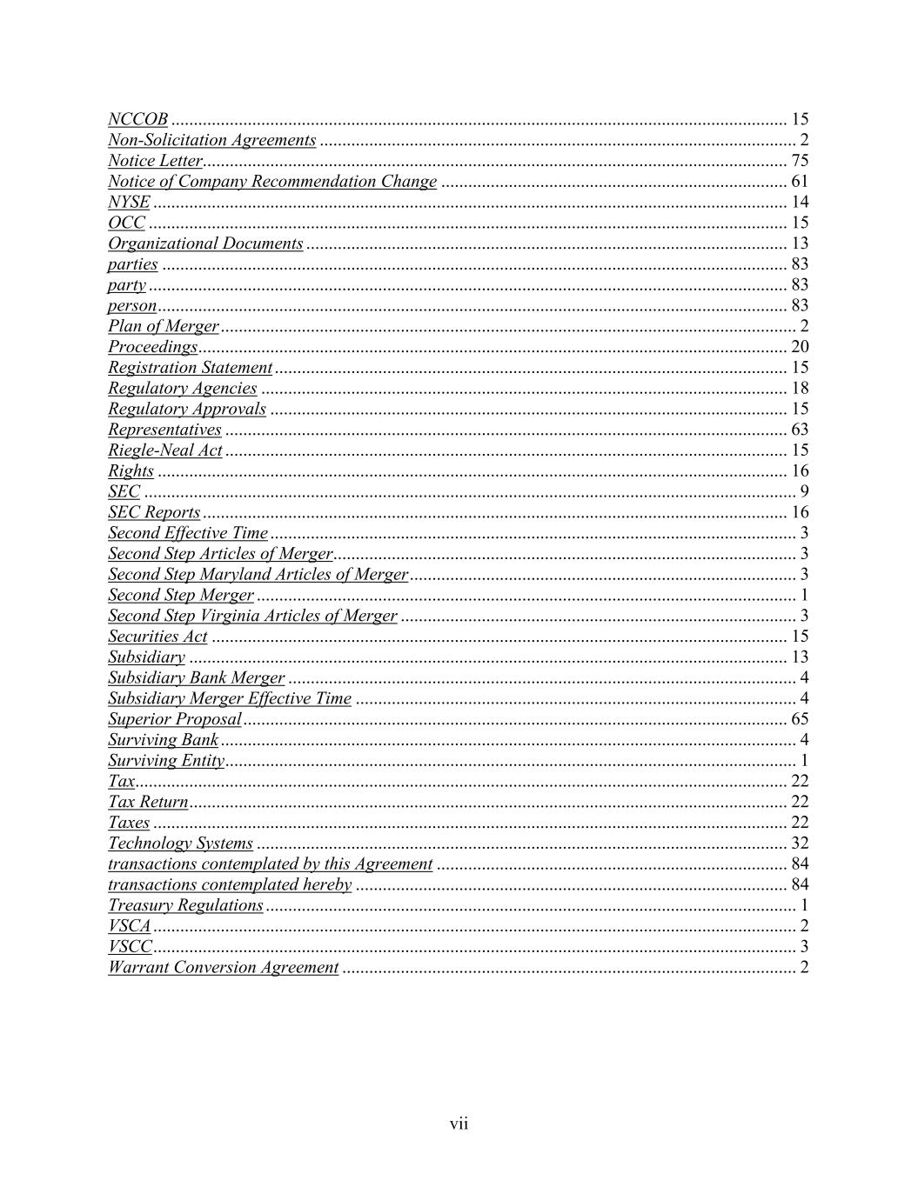
vii NCCOB ......................................................................................................................................... 15 Non-Solicitation Agreements .......................................................................................................... 2 Notice Letter.................................................................................................................................. 75 Notice of Company Recommendation Change ............................................................................. 61 NYSE ............................................................................................................................................. 14 OCC .............................................................................................................................................. 15 Organizational Documents ........................................................................................................... 13 parties ........................................................................................................................................... 83 party .............................................................................................................................................. 83 person ............................................................................................................................................ 83 Plan of Merger ................................................................................................................................ 2 Proceedings................................................................................................................................... 20 Registration Statement .................................................................................................................. 15 Regulatory Agencies ..................................................................................................................... 18 Regulatory Approvals ................................................................................................................... 15 Representatives ............................................................................................................................. 63 Riegle-Neal Act ............................................................................................................................. 15 Rights ............................................................................................................................................ 16 SEC ................................................................................................................................................. 9 SEC Reports .................................................................................................................................. 16 Second Effective Time ..................................................................................................................... 3 Second Step Articles of Merger....................................................................................................... 3 Second Step Maryland Articles of Merger ...................................................................................... 3 Second Step Merger ........................................................................................................................ 1 Second Step Virginia Articles of Merger ........................................................................................ 3 Securities Act ................................................................................................................................ 15 Subsidiary ..................................................................................................................................... 13 Subsidiary Bank Merger ................................................................................................................. 4 Subsidiary Merger Effective Time .................................................................................................. 4 Superior Proposal ......................................................................................................................... 65 Surviving Bank ................................................................................................................................ 4 Surviving Entity ............................................................................................................................... 1 Tax................................................................................................................................................. 22 Tax Return ..................................................................................................................................... 22 Taxes ............................................................................................................................................. 22 Technology Systems ...................................................................................................................... 32 transactions contemplated by this Agreement .............................................................................. 84 transactions contemplated hereby ................................................................................................ 84 Treasury Regulations ...................................................................................................................... 1 VSCA ............................................................................................................................................... 2 VSCC ............................................................................................................................................... 3 Warrant Conversion Agreement ..................................................................................................... 2

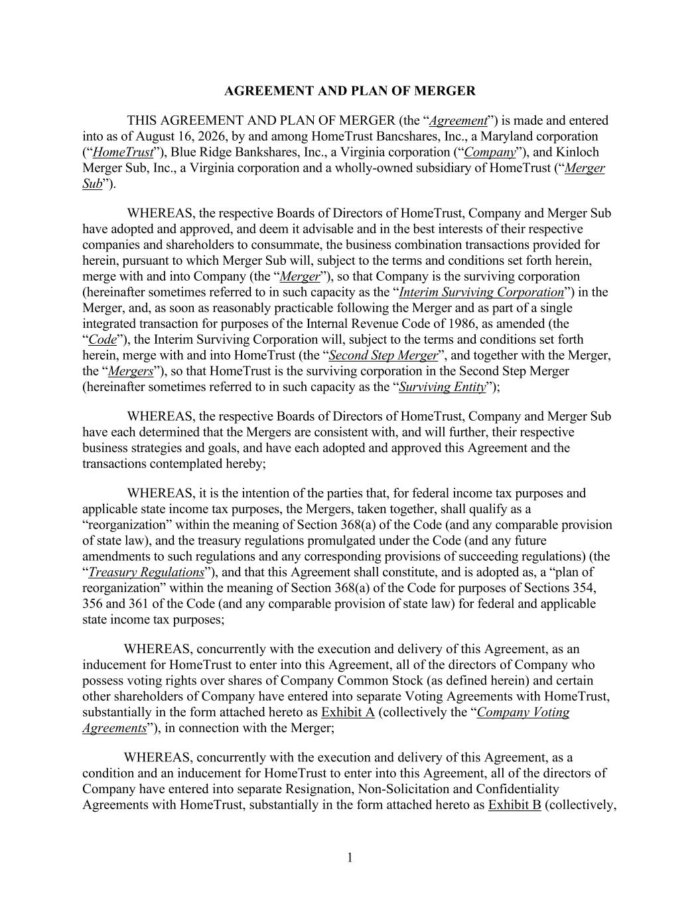
1 AGREEMENT AND PLAN OF MERGER THIS AGREEMENT AND PLAN OF MERGER (the “Agreement”) is made and entered into as of August 16, 2026, by and among HomeTrust Bancshares, Inc., a Maryland corporation (“HomeTrust”), Blue Ridge Bankshares, Inc., a Virginia corporation (“Company”), and Kinloch Merger Sub, Inc., a Virginia corporation and a wholly-owned subsidiary of HomeTrust (“Merger Sub”). WHEREAS, the respective Boards of Directors of HomeTrust, Company and Merger Sub have adopted and approved, and deem it advisable and in the best interests of their respective companies and shareholders to consummate, the business combination transactions provided for herein, pursuant to which Merger Sub will, subject to the terms and conditions set forth herein, merge with and into Company (the “Merger”), so that Company is the surviving corporation (hereinafter sometimes referred to in such capacity as the “Interim Surviving Corporation”) in the Merger, and, as soon as reasonably practicable following the Merger and as part of a single integrated transaction for purposes of the Internal Revenue Code of 1986, as amended (the “Code”), the Interim Surviving Corporation will, subject to the terms and conditions set forth herein, merge with and into HomeTrust (the “Second Step Merger”, and together with the Merger, the “Mergers”), so that HomeTrust is the surviving corporation in the Second Step Merger (hereinafter sometimes referred to in such capacity as the “Surviving Entity”); WHEREAS, the respective Boards of Directors of HomeTrust, Company and Merger Sub have each determined that the Mergers are consistent with, and will further, their respective business strategies and goals, and have each adopted and approved this Agreement and the transactions contemplated hereby; WHEREAS, it is the intention of the parties that, for federal income tax purposes and applicable state income tax purposes, the Mergers, taken together, shall qualify as a “reorganization” within the meaning of Section 368(a) of the Code (and any comparable provision of state law), and the treasury regulations promulgated under the Code (and any future amendments to such regulations and any corresponding provisions of succeeding regulations) (the “Treasury Regulations”), and that this Agreement shall constitute, and is adopted as, a “plan of reorganization” within the meaning of Section 368(a) of the Code for purposes of Sections 354, 356 and 361 of the Code (and any comparable provision of state law) for federal and applicable state income tax purposes; WHEREAS, concurrently with the execution and delivery of this Agreement, as an inducement for HomeTrust to enter into this Agreement, all of the directors of Company who possess voting rights over shares of Company Common Stock (as defined herein) and certain other shareholders of Company have entered into separate Voting Agreements with HomeTrust, substantially in the form attached hereto as Exhibit A (collectively the “Company Voting Agreements”), in connection with the Merger; WHEREAS, concurrently with the execution and delivery of this Agreement, as a condition and an inducement for HomeTrust to enter into this Agreement, all of the directors of Company have entered into separate Resignation, Non-Solicitation and Confidentiality Agreements with HomeTrust, substantially in the form attached hereto as Exhibit B (collectively,

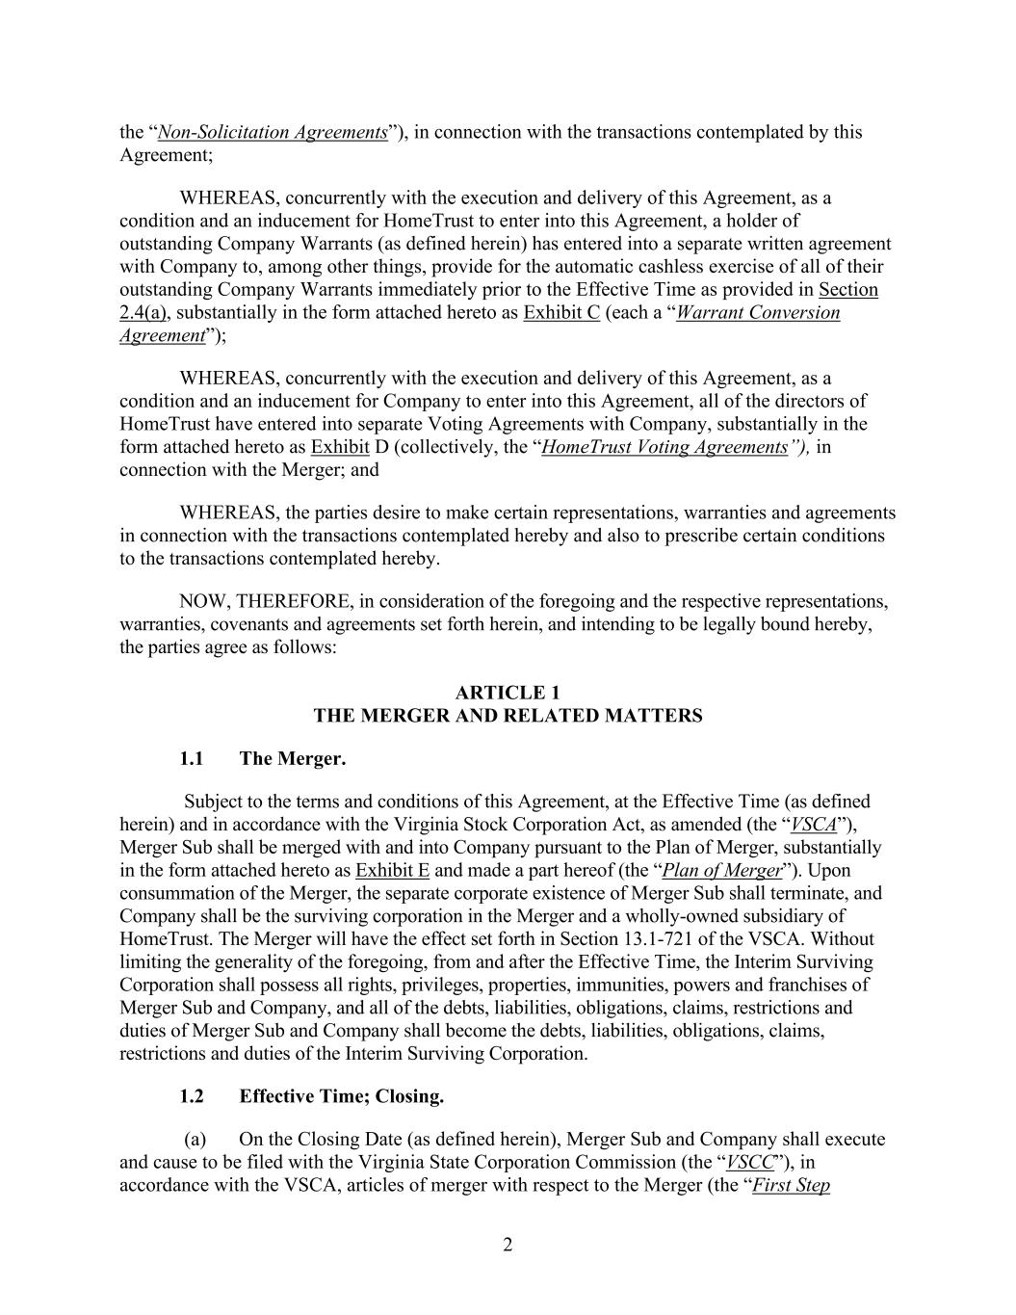
2 the “Non-Solicitation Agreements”), in connection with the transactions contemplated by this Agreement; WHEREAS, concurrently with the execution and delivery of this Agreement, as a condition and an inducement for HomeTrust to enter into this Agreement, a holder of outstanding Company Warrants (as defined herein) has entered into a separate written agreement with Company to, among other things, provide for the automatic cashless exercise of all of their outstanding Company Warrants immediately prior to the Effective Time as provided in Section 2.4(a), substantially in the form attached hereto as Exhibit C (each a “Warrant Conversion Agreement”); WHEREAS, concurrently with the execution and delivery of this Agreement, as a condition and an inducement for Company to enter into this Agreement, all of the directors of HomeTrust have entered into separate Voting Agreements with Company, substantially in the form attached hereto as Exhibit D (collectively, the “HomeTrust Voting Agreements”), in connection with the Merger; and WHEREAS, the parties desire to make certain representations, warranties and agreements in connection with the transactions contemplated hereby and also to prescribe certain conditions to the transactions contemplated hereby. NOW, THEREFORE, in consideration of the foregoing and the respective representations, warranties, covenants and agreements set forth herein, and intending to be legally bound hereby, the parties agree as follows: ARTICLE 1 THE MERGER AND RELATED MATTERS 1.1 The Merger. Subject to the terms and conditions of this Agreement, at the Effective Time (as defined herein) and in accordance with the Virginia Stock Corporation Act, as amended (the “VSCA”), Merger Sub shall be merged with and into Company pursuant to the Plan of Merger, substantially in the form attached hereto as Exhibit E and made a part hereof (the “Plan of Merger”). Upon consummation of the Merger, the separate corporate existence of Merger Sub shall terminate, and Company shall be the surviving corporation in the Merger and a wholly-owned subsidiary of HomeTrust. The Merger will have the effect set forth in Section 13.1-721 of the VSCA. Without limiting the generality of the foregoing, from and after the Effective Time, the Interim Surviving Corporation shall possess all rights, privileges, properties, immunities, powers and franchises of Merger Sub and Company, and all of the debts, liabilities, obligations, claims, restrictions and duties of Merger Sub and Company shall become the debts, liabilities, obligations, claims, restrictions and duties of the Interim Surviving Corporation. 1.2 Effective Time; Closing. (a) On the Closing Date (as defined herein), Merger Sub and Company shall execute and cause to be filed with the Virginia State Corporation Commission (the “VSCC”), in accordance with the VSCA, articles of merger with respect to the Merger (the “First Step

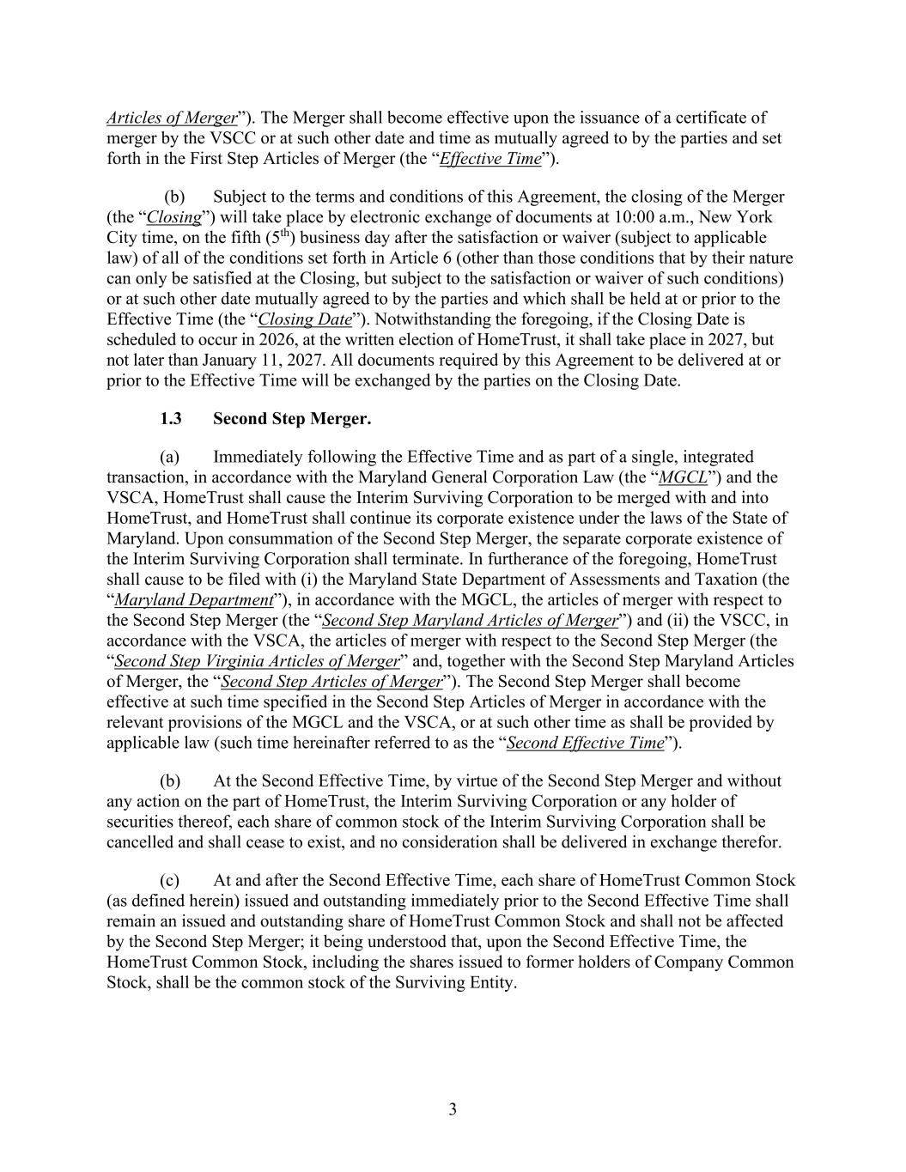
3 Articles of Merger”). The Merger shall become effective upon the issuance of a certificate of merger by the VSCC or at such other date and time as mutually agreed to by the parties and set forth in the First Step Articles of Merger (the “Effective Time”). (b) Subject to the terms and conditions of this Agreement, the closing of the Merger (the “Closing”) will take place by electronic exchange of documents at 10:00 a.m., New York City time, on the fifth (5th) business day after the satisfaction or waiver (subject to applicable law) of all of the conditions set forth in Article 6 (other than those conditions that by their nature can only be satisfied at the Closing, but subject to the satisfaction or waiver of such conditions) or at such other date mutually agreed to by the parties and which shall be held at or prior to the Effective Time (the “Closing Date”). Notwithstanding the foregoing, if the Closing Date is scheduled to occur in 2026, at the written election of HomeTrust, it shall take place in 2027, but not later than January 11, 2027. All documents required by this Agreement to be delivered at or prior to the Effective Time will be exchanged by the parties on the Closing Date. 1.3 Second Step Merger. (a) Immediately following the Effective Time and as part of a single, integrated transaction, in accordance with the Maryland General Corporation Law (the “MGCL”) and the VSCA, HomeTrust shall cause the Interim Surviving Corporation to be merged with and into HomeTrust, and HomeTrust shall continue its corporate existence under the laws of the State of Maryland. Upon consummation of the Second Step Merger, the separate corporate existence of the Interim Surviving Corporation shall terminate. In furtherance of the foregoing, HomeTrust shall cause to be filed with (i) the Maryland State Department of Assessments and Taxation (the “Maryland Department”), in accordance with the MGCL, the articles of merger with respect to the Second Step Merger (the “Second Step Maryland Articles of Merger”) and (ii) the VSCC, in accordance with the VSCA, the articles of merger with respect to the Second Step Merger (the “Second Step Virginia Articles of Merger” and, together with the Second Step Maryland Articles of Merger, the “Second Step Articles of Merger”). The Second Step Merger shall become effective at such time specified in the Second Step Articles of Merger in accordance with the relevant provisions of the MGCL and the VSCA, or at such other time as shall be provided by applicable law (such time hereinafter referred to as the “Second Effective Time”). (b) At the Second Effective Time, by virtue of the Second Step Merger and without any action on the part of HomeTrust, the Interim Surviving Corporation or any holder of securities thereof, each share of common stock of the Interim Surviving Corporation shall be cancelled and shall cease to exist, and no consideration shall be delivered in exchange therefor. (c) At and after the Second Effective Time, each share of HomeTrust Common Stock (as defined herein) issued and outstanding immediately prior to the Second Effective Time shall remain an issued and outstanding share of HomeTrust Common Stock and shall not be affected by the Second Step Merger; it being understood that, upon the Second Effective Time, the HomeTrust Common Stock, including the shares issued to former holders of Company Common Stock, shall be the common stock of the Surviving Entity.

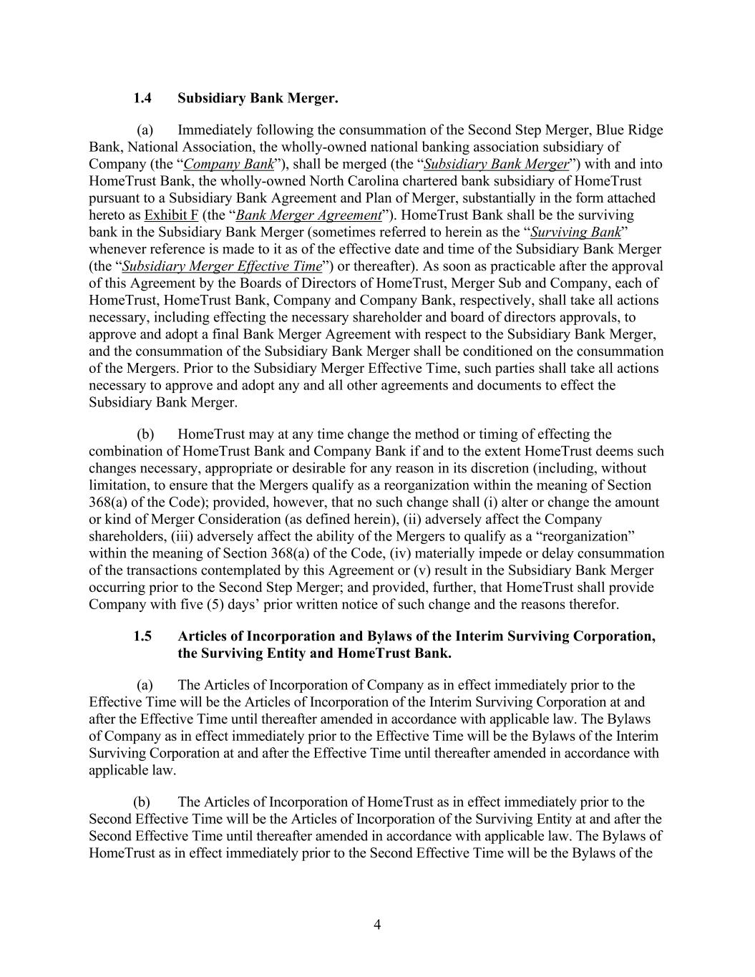
4 1.4 Subsidiary Bank Merger. (a) Immediately following the consummation of the Second Step Merger, Blue Ridge Bank, National Association, the wholly-owned national banking association subsidiary of Company (the “Company Bank”), shall be merged (the “Subsidiary Bank Merger”) with and into HomeTrust Bank, the wholly-owned North Carolina chartered bank subsidiary of HomeTrust pursuant to a Subsidiary Bank Agreement and Plan of Merger, substantially in the form attached hereto as Exhibit F (the “Bank Merger Agreement”). HomeTrust Bank shall be the surviving bank in the Subsidiary Bank Merger (sometimes referred to herein as the “Surviving Bank” whenever reference is made to it as of the effective date and time of the Subsidiary Bank Merger (the “Subsidiary Merger Effective Time”) or thereafter). As soon as practicable after the approval of this Agreement by the Boards of Directors of HomeTrust, Merger Sub and Company, each of HomeTrust, HomeTrust Bank, Company and Company Bank, respectively, shall take all actions necessary, including effecting the necessary shareholder and board of directors approvals, to approve and adopt a final Bank Merger Agreement with respect to the Subsidiary Bank Merger, and the consummation of the Subsidiary Bank Merger shall be conditioned on the consummation of the Mergers. Prior to the Subsidiary Merger Effective Time, such parties shall take all actions necessary to approve and adopt any and all other agreements and documents to effect the Subsidiary Bank Merger. (b) HomeTrust may at any time change the method or timing of effecting the combination of HomeTrust Bank and Company Bank if and to the extent HomeTrust deems such changes necessary, appropriate or desirable for any reason in its discretion (including, without limitation, to ensure that the Mergers qualify as a reorganization within the meaning of Section 368(a) of the Code); provided, however, that no such change shall (i) alter or change the amount or kind of Merger Consideration (as defined herein), (ii) adversely affect the Company shareholders, (iii) adversely affect the ability of the Mergers to qualify as a “reorganization” within the meaning of Section 368(a) of the Code, (iv) materially impede or delay consummation of the transactions contemplated by this Agreement or (v) result in the Subsidiary Bank Merger occurring prior to the Second Step Merger; and provided, further, that HomeTrust shall provide Company with five (5) days’ prior written notice of such change and the reasons therefor. 1.5 Articles of Incorporation and Bylaws of the Interim Surviving Corporation, the Surviving Entity and HomeTrust Bank. (a) The Articles of Incorporation of Company as in effect immediately prior to the Effective Time will be the Articles of Incorporation of the Interim Surviving Corporation at and after the Effective Time until thereafter amended in accordance with applicable law. The Bylaws of Company as in effect immediately prior to the Effective Time will be the Bylaws of the Interim Surviving Corporation at and after the Effective Time until thereafter amended in accordance with applicable law. (b) The Articles of Incorporation of HomeTrust as in effect immediately prior to the Second Effective Time will be the Articles of Incorporation of the Surviving Entity at and after the Second Effective Time until thereafter amended in accordance with applicable law. The Bylaws of HomeTrust as in effect immediately prior to the Second Effective Time will be the Bylaws of the

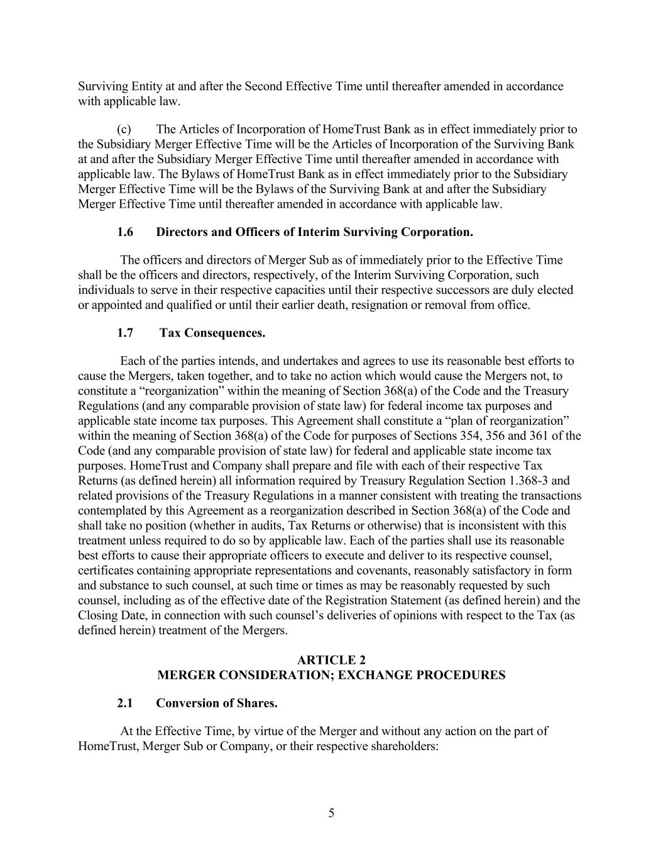
5 Surviving Entity at and after the Second Effective Time until thereafter amended in accordance with applicable law. (c) The Articles of Incorporation of HomeTrust Bank as in effect immediately prior to the Subsidiary Merger Effective Time will be the Articles of Incorporation of the Surviving Bank at and after the Subsidiary Merger Effective Time until thereafter amended in accordance with applicable law. The Bylaws of HomeTrust Bank as in effect immediately prior to the Subsidiary Merger Effective Time will be the Bylaws of the Surviving Bank at and after the Subsidiary Merger Effective Time until thereafter amended in accordance with applicable law. 1.6 Directors and Officers of Interim Surviving Corporation. The officers and directors of Merger Sub as of immediately prior to the Effective Time shall be the officers and directors, respectively, of the Interim Surviving Corporation, such individuals to serve in their respective capacities until their respective successors are duly elected or appointed and qualified or until their earlier death, resignation or removal from office. 1.7 Tax Consequences. Each of the parties intends, and undertakes and agrees to use its reasonable best efforts to cause the Mergers, taken together, and to take no action which would cause the Mergers not, to constitute a “reorganization” within the meaning of Section 368(a) of the Code and the Treasury Regulations (and any comparable provision of state law) for federal income tax purposes and applicable state income tax purposes. This Agreement shall constitute a “plan of reorganization” within the meaning of Section 368(a) of the Code for purposes of Sections 354, 356 and 361 of the Code (and any comparable provision of state law) for federal and applicable state income tax purposes. HomeTrust and Company shall prepare and file with each of their respective Tax Returns (as defined herein) all information required by Treasury Regulation Section 1.368-3 and related provisions of the Treasury Regulations in a manner consistent with treating the transactions contemplated by this Agreement as a reorganization described in Section 368(a) of the Code and shall take no position (whether in audits, Tax Returns or otherwise) that is inconsistent with this treatment unless required to do so by applicable law. Each of the parties shall use its reasonable best efforts to cause their appropriate officers to execute and deliver to its respective counsel, certificates containing appropriate representations and covenants, reasonably satisfactory in form and substance to such counsel, at such time or times as may be reasonably requested by such counsel, including as of the effective date of the Registration Statement (as defined herein) and the Closing Date, in connection with such counsel’s deliveries of opinions with respect to the Tax (as defined herein) treatment of the Mergers. ARTICLE 2 MERGER CONSIDERATION; EXCHANGE PROCEDURES 2.1 Conversion of Shares. At the Effective Time, by virtue of the Merger and without any action on the part of HomeTrust, Merger Sub or Company, or their respective shareholders:

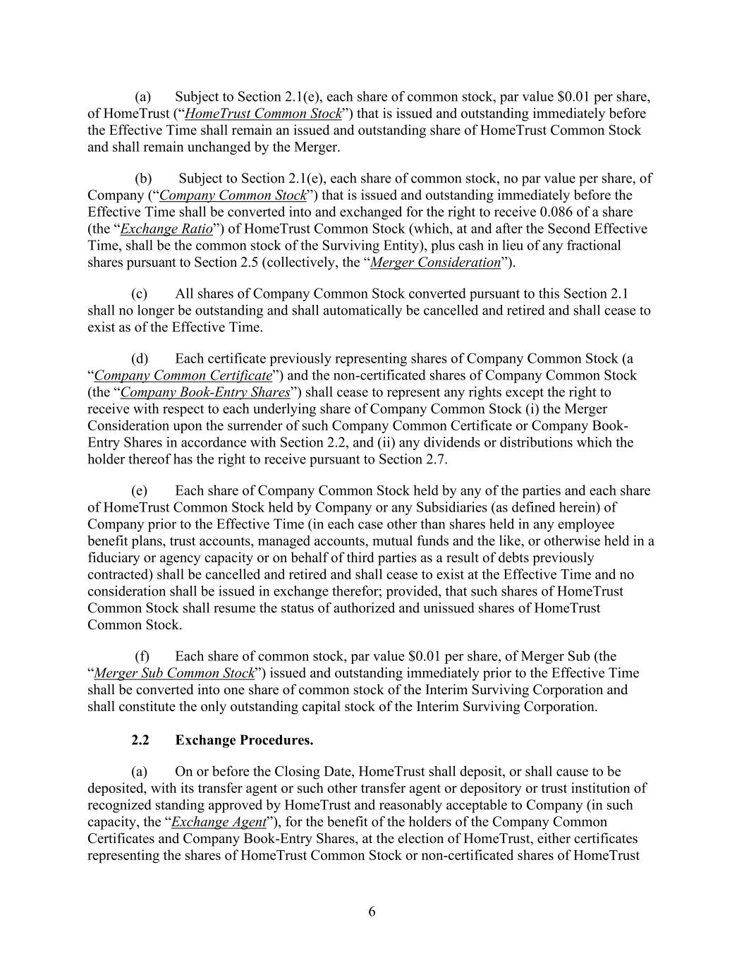
6 (a) Subject to Section 2.1(e), each share of common stock, par value $0.01 per share, of HomeTrust (“HomeTrust Common Stock”) that is issued and outstanding immediately before the Effective Time shall remain an issued and outstanding share of HomeTrust Common Stock and shall remain unchanged by the Merger. (b) Subject to Section 2.1(e), each share of common stock, no par value per share, of Company (“Company Common Stock”) that is issued and outstanding immediately before the Effective Time shall be converted into and exchanged for the right to receive 0.086 of a share (the “Exchange Ratio”) of HomeTrust Common Stock (which, at and after the Second Effective Time, shall be the common stock of the Surviving Entity), plus cash in lieu of any fractional shares pursuant to Section 2.5 (collectively, the “Merger Consideration”). (c) All shares of Company Common Stock converted pursuant to this Section 2.1 shall no longer be outstanding and shall automatically be cancelled and retired and shall cease to exist as of the Effective Time. (d) Each certificate previously representing shares of Company Common Stock (a “Company Common Certificate”) and the non-certificated shares of Company Common Stock (the “Company Book-Entry Shares”) shall cease to represent any rights except the right to receive with respect to each underlying share of Company Common Stock (i) the Merger Consideration upon the surrender of such Company Common Certificate or Company Book- Entry Shares in accordance with Section 2.2, and (ii) any dividends or distributions which the holder thereof has the right to receive pursuant to Section 2.7. (e) Each share of Company Common Stock held by any of the parties and each share of HomeTrust Common Stock held by Company or any Subsidiaries (as defined herein) of Company prior to the Effective Time (in each case other than shares held in any employee benefit plans, trust accounts, managed accounts, mutual funds and the like, or otherwise held in a fiduciary or agency capacity or on behalf of third parties as a result of debts previously contracted) shall be cancelled and retired and shall cease to exist at the Effective Time and no consideration shall be issued in exchange therefor; provided, that such shares of HomeTrust Common Stock shall resume the status of authorized and unissued shares of HomeTrust Common Stock. (f) Each share of common stock, par value $0.01 per share, of Merger Sub (the “Merger Sub Common Stock”) issued and outstanding immediately prior to the Effective Time shall be converted into one share of common stock of the Interim Surviving Corporation and shall constitute the only outstanding capital stock of the Interim Surviving Corporation. 2.2 Exchange Procedures. (a) On or before the Closing Date, HomeTrust shall deposit, or shall cause to be deposited, with its transfer agent or such other transfer agent or depository or trust institution of recognized standing approved by HomeTrust and reasonably acceptable to Company (in such capacity, the “Exchange Agent”), for the benefit of the holders of the Company Common Certificates and Company Book-Entry Shares, at the election of HomeTrust, either certificates representing the shares of HomeTrust Common Stock or non-certificated shares of HomeTrust

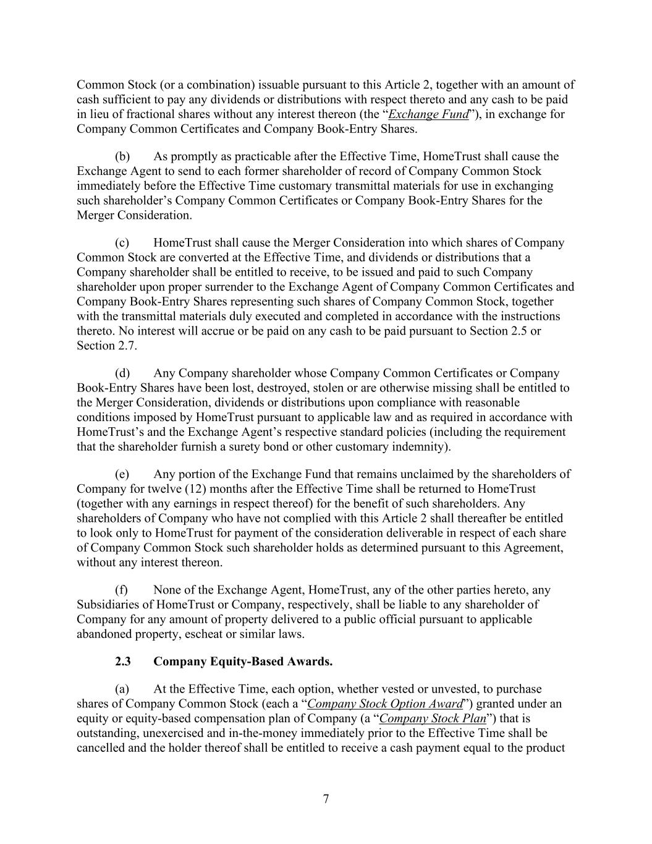
7 Common Stock (or a combination) issuable pursuant to this Article 2, together with an amount of cash sufficient to pay any dividends or distributions with respect thereto and any cash to be paid in lieu of fractional shares without any interest thereon (the “Exchange Fund”), in exchange for Company Common Certificates and Company Book-Entry Shares. (b) As promptly as practicable after the Effective Time, HomeTrust shall cause the Exchange Agent to send to each former shareholder of record of Company Common Stock immediately before the Effective Time customary transmittal materials for use in exchanging such shareholder’s Company Common Certificates or Company Book-Entry Shares for the Merger Consideration. (c) HomeTrust shall cause the Merger Consideration into which shares of Company Common Stock are converted at the Effective Time, and dividends or distributions that a Company shareholder shall be entitled to receive, to be issued and paid to such Company shareholder upon proper surrender to the Exchange Agent of Company Common Certificates and Company Book-Entry Shares representing such shares of Company Common Stock, together with the transmittal materials duly executed and completed in accordance with the instructions thereto. No interest will accrue or be paid on any cash to be paid pursuant to Section 2.5 or Section 2.7. (d) Any Company shareholder whose Company Common Certificates or Company Book-Entry Shares have been lost, destroyed, stolen or are otherwise missing shall be entitled to the Merger Consideration, dividends or distributions upon compliance with reasonable conditions imposed by HomeTrust pursuant to applicable law and as required in accordance with HomeTrust’s and the Exchange Agent’s respective standard policies (including the requirement that the shareholder furnish a surety bond or other customary indemnity). (e) Any portion of the Exchange Fund that remains unclaimed by the shareholders of Company for twelve (12) months after the Effective Time shall be returned to HomeTrust (together with any earnings in respect thereof) for the benefit of such shareholders. Any shareholders of Company who have not complied with this Article 2 shall thereafter be entitled to look only to HomeTrust for payment of the consideration deliverable in respect of each share of Company Common Stock such shareholder holds as determined pursuant to this Agreement, without any interest thereon. (f) None of the Exchange Agent, HomeTrust, any of the other parties hereto, any Subsidiaries of HomeTrust or Company, respectively, shall be liable to any shareholder of Company for any amount of property delivered to a public official pursuant to applicable abandoned property, escheat or similar laws. 2.3 Company Equity-Based Awards. (a) At the Effective Time, each option, whether vested or unvested, to purchase shares of Company Common Stock (each a “Company Stock Option Award”) granted under an equity or equity-based compensation plan of Company (a “Company Stock Plan”) that is outstanding, unexercised and in-the-money immediately prior to the Effective Time shall be cancelled and the holder thereof shall be entitled to receive a cash payment equal to the product

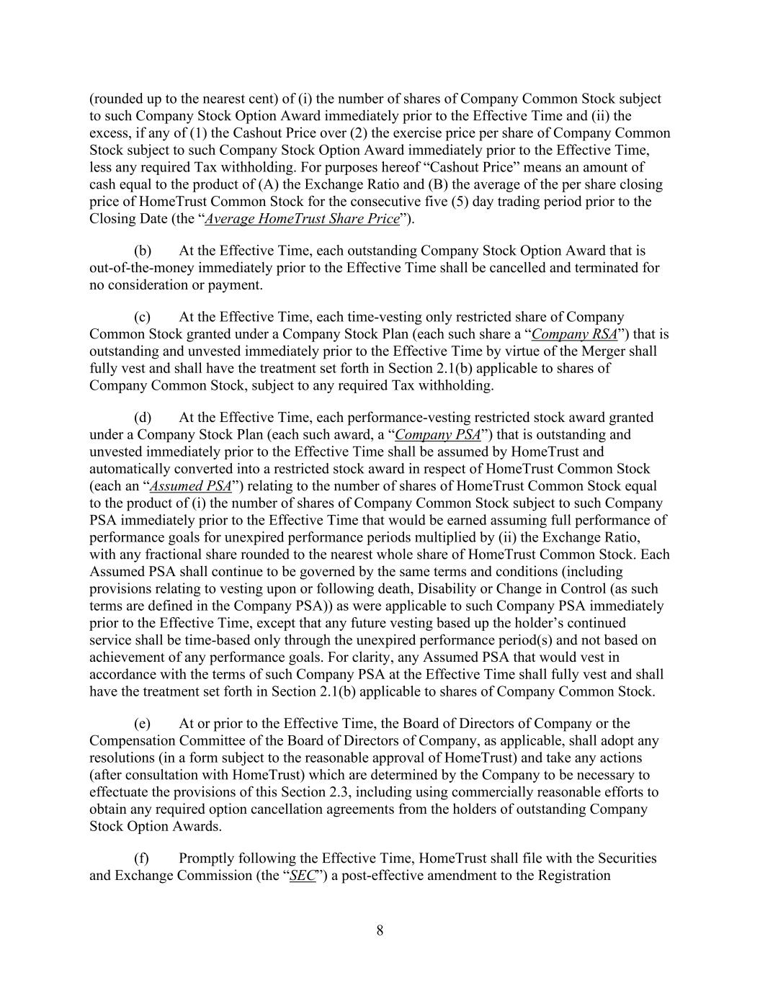
8 (rounded up to the nearest cent) of (i) the number of shares of Company Common Stock subject to such Company Stock Option Award immediately prior to the Effective Time and (ii) the excess, if any of (1) the Cashout Price over (2) the exercise price per share of Company Common Stock subject to such Company Stock Option Award immediately prior to the Effective Time, less any required Tax withholding. For purposes hereof “Cashout Price” means an amount of cash equal to the product of (A) the Exchange Ratio and (B) the average of the per share closing price of HomeTrust Common Stock for the consecutive five (5) day trading period prior to the Closing Date (the “Average HomeTrust Share Price”). (b) At the Effective Time, each outstanding Company Stock Option Award that is out-of-the-money immediately prior to the Effective Time shall be cancelled and terminated for no consideration or payment. (c) At the Effective Time, each time-vesting only restricted share of Company Common Stock granted under a Company Stock Plan (each such share a “Company RSA”) that is outstanding and unvested immediately prior to the Effective Time by virtue of the Merger shall fully vest and shall have the treatment set forth in Section 2.1(b) applicable to shares of Company Common Stock, subject to any required Tax withholding. (d) At the Effective Time, each performance-vesting restricted stock award granted under a Company Stock Plan (each such award, a “Company PSA”) that is outstanding and unvested immediately prior to the Effective Time shall be assumed by HomeTrust and automatically converted into a restricted stock award in respect of HomeTrust Common Stock (each an “Assumed PSA”) relating to the number of shares of HomeTrust Common Stock equal to the product of (i) the number of shares of Company Common Stock subject to such Company PSA immediately prior to the Effective Time that would be earned assuming full performance of performance goals for unexpired performance periods multiplied by (ii) the Exchange Ratio, with any fractional share rounded to the nearest whole share of HomeTrust Common Stock. Each Assumed PSA shall continue to be governed by the same terms and conditions (including provisions relating to vesting upon or following death, Disability or Change in Control (as such terms are defined in the Company PSA)) as were applicable to such Company PSA immediately prior to the Effective Time, except that any future vesting based up the holder’s continued service shall be time-based only through the unexpired performance period(s) and not based on achievement of any performance goals. For clarity, any Assumed PSA that would vest in accordance with the terms of such Company PSA at the Effective Time shall fully vest and shall have the treatment set forth in Section 2.1(b) applicable to shares of Company Common Stock. (e) At or prior to the Effective Time, the Board of Directors of Company or the Compensation Committee of the Board of Directors of Company, as applicable, shall adopt any resolutions (in a form subject to the reasonable approval of HomeTrust) and take any actions (after consultation with HomeTrust) which are determined by the Company to be necessary to effectuate the provisions of this Section 2.3, including using commercially reasonable efforts to obtain any required option cancellation agreements from the holders of outstanding Company Stock Option Awards. (f) Promptly following the Effective Time, HomeTrust shall file with the Securities and Exchange Commission (the “SEC”) a post-effective amendment to the Registration

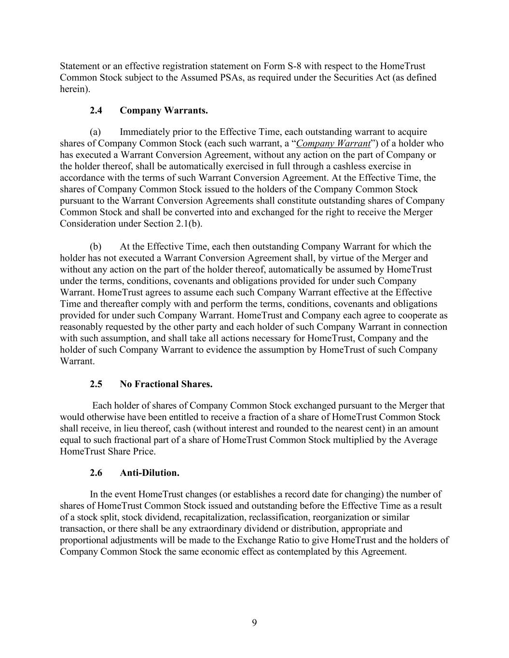
9 Statement or an effective registration statement on Form S-8 with respect to the HomeTrust Common Stock subject to the Assumed PSAs, as required under the Securities Act (as defined herein). 2.4 Company Warrants. (a) Immediately prior to the Effective Time, each outstanding warrant to acquire shares of Company Common Stock (each such warrant, a “Company Warrant”) of a holder who has executed a Warrant Conversion Agreement, without any action on the part of Company or the holder thereof, shall be automatically exercised in full through a cashless exercise in accordance with the terms of such Warrant Conversion Agreement. At the Effective Time, the shares of Company Common Stock issued to the holders of the Company Common Stock pursuant to the Warrant Conversion Agreements shall constitute outstanding shares of Company Common Stock and shall be converted into and exchanged for the right to receive the Merger Consideration under Section 2.1(b). (b) At the Effective Time, each then outstanding Company Warrant for which the holder has not executed a Warrant Conversion Agreement shall, by virtue of the Merger and without any action on the part of the holder thereof, automatically be assumed by HomeTrust under the terms, conditions, covenants and obligations provided for under such Company Warrant. HomeTrust agrees to assume each such Company Warrant effective at the Effective Time and thereafter comply with and perform the terms, conditions, covenants and obligations provided for under such Company Warrant. HomeTrust and Company each agree to cooperate as reasonably requested by the other party and each holder of such Company Warrant in connection with such assumption, and shall take all actions necessary for HomeTrust, Company and the holder of such Company Warrant to evidence the assumption by HomeTrust of such Company Warrant. 2.5 No Fractional Shares. Each holder of shares of Company Common Stock exchanged pursuant to the Merger that would otherwise have been entitled to receive a fraction of a share of HomeTrust Common Stock shall receive, in lieu thereof, cash (without interest and rounded to the nearest cent) in an amount equal to such fractional part of a share of HomeTrust Common Stock multiplied by the Average HomeTrust Share Price. 2.6 Anti-Dilution. In the event HomeTrust changes (or establishes a record date for changing) the number of shares of HomeTrust Common Stock issued and outstanding before the Effective Time as a result of a stock split, stock dividend, recapitalization, reclassification, reorganization or similar transaction, or there shall be any extraordinary dividend or distribution, appropriate and proportional adjustments will be made to the Exchange Ratio to give HomeTrust and the holders of Company Common Stock the same economic effect as contemplated by this Agreement.

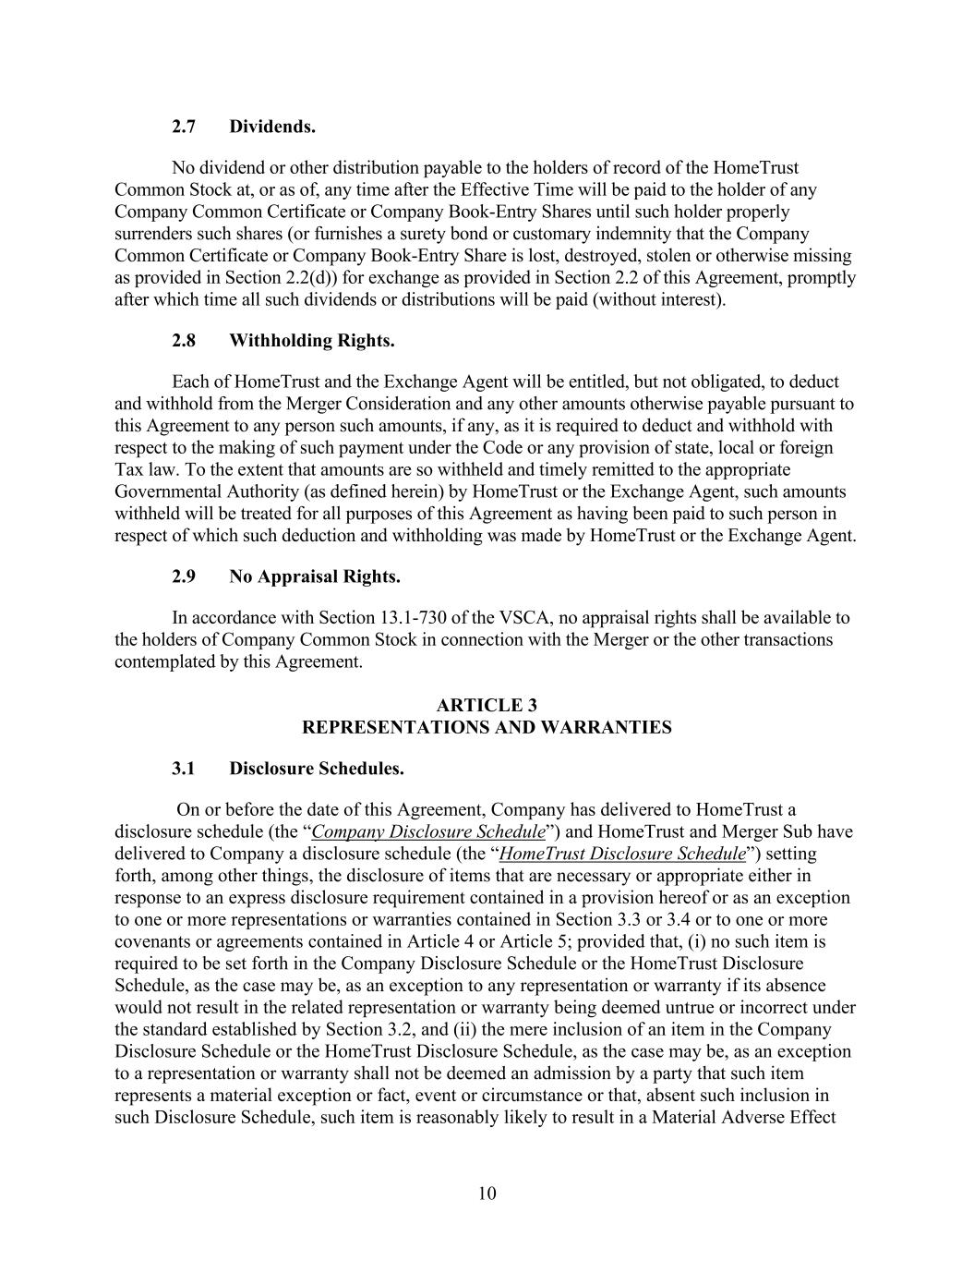
10 2.7 Dividends. No dividend or other distribution payable to the holders of record of the HomeTrust Common Stock at, or as of, any time after the Effective Time will be paid to the holder of any Company Common Certificate or Company Book-Entry Shares until such holder properly surrenders such shares (or furnishes a surety bond or customary indemnity that the Company Common Certificate or Company Book-Entry Share is lost, destroyed, stolen or otherwise missing as provided in Section 2.2(d)) for exchange as provided in Section 2.2 of this Agreement, promptly after which time all such dividends or distributions will be paid (without interest). 2.8 Withholding Rights. Each of HomeTrust and the Exchange Agent will be entitled, but not obligated, to deduct and withhold from the Merger Consideration and any other amounts otherwise payable pursuant to this Agreement to any person such amounts, if any, as it is required to deduct and withhold with respect to the making of such payment under the Code or any provision of state, local or foreign Tax law. To the extent that amounts are so withheld and timely remitted to the appropriate Governmental Authority (as defined herein) by HomeTrust or the Exchange Agent, such amounts withheld will be treated for all purposes of this Agreement as having been paid to such person in respect of which such deduction and withholding was made by HomeTrust or the Exchange Agent. 2.9 No Appraisal Rights. In accordance with Section 13.1-730 of the VSCA, no appraisal rights shall be available to the holders of Company Common Stock in connection with the Merger or the other transactions contemplated by this Agreement. ARTICLE 3 REPRESENTATIONS AND WARRANTIES 3.1 Disclosure Schedules. On or before the date of this Agreement, Company has delivered to HomeTrust a disclosure schedule (the “Company Disclosure Schedule”) and HomeTrust and Merger Sub have delivered to Company a disclosure schedule (the “HomeTrust Disclosure Schedule”) setting forth, among other things, the disclosure of items that are necessary or appropriate either in response to an express disclosure requirement contained in a provision hereof or as an exception to one or more representations or warranties contained in Section 3.3 or 3.4 or to one or more covenants or agreements contained in Article 4 or Article 5; provided that, (i) no such item is required to be set forth in the Company Disclosure Schedule or the HomeTrust Disclosure Schedule, as the case may be, as an exception to any representation or warranty if its absence would not result in the related representation or warranty being deemed untrue or incorrect under the standard established by Section 3.2, and (ii) the mere inclusion of an item in the Company Disclosure Schedule or the HomeTrust Disclosure Schedule, as the case may be, as an exception to a representation or warranty shall not be deemed an admission by a party that such item represents a material exception or fact, event or circumstance or that, absent such inclusion in such Disclosure Schedule, such item is reasonably likely to result in a Material Adverse Effect

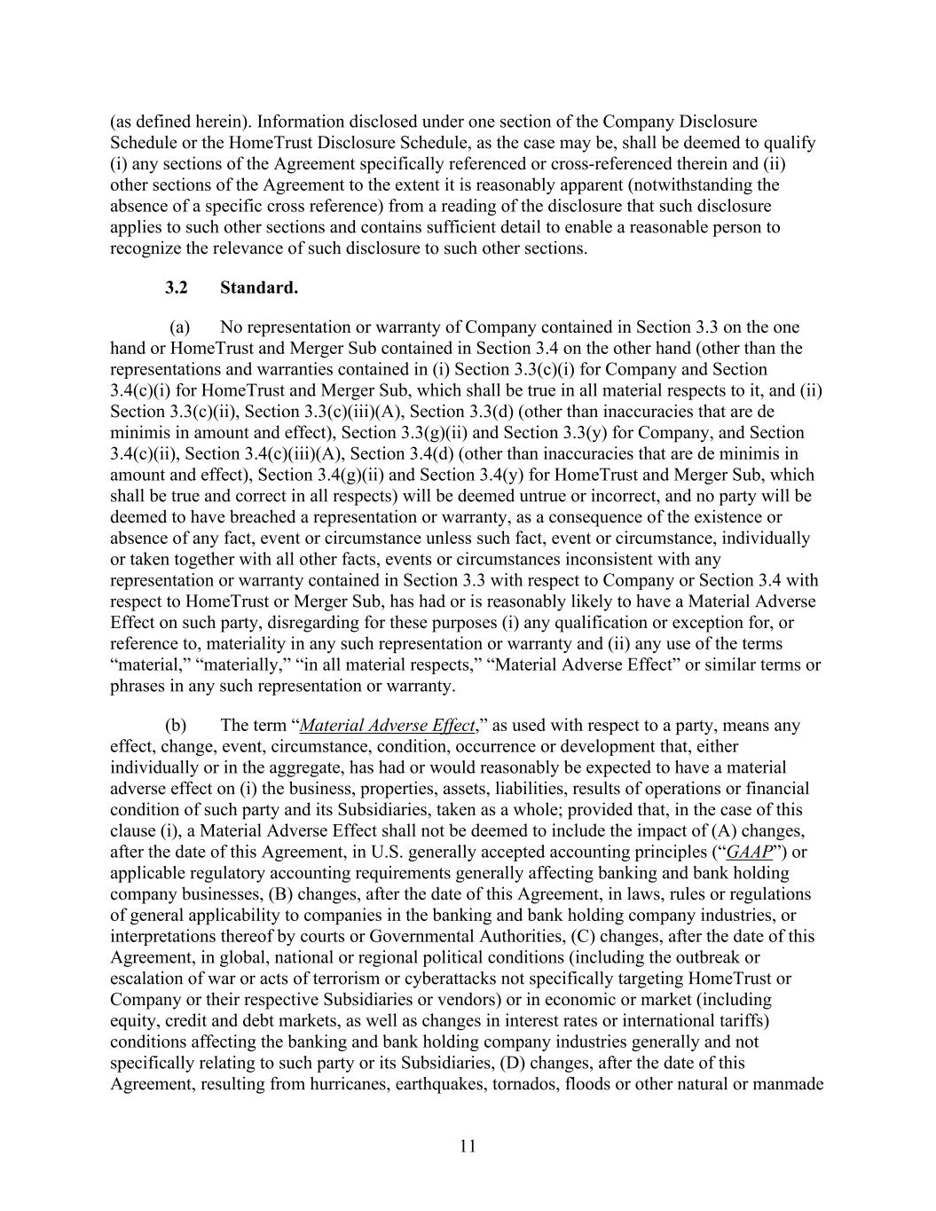
11 (as defined herein). Information disclosed under one section of the Company Disclosure Schedule or the HomeTrust Disclosure Schedule, as the case may be, shall be deemed to qualify (i) any sections of the Agreement specifically referenced or cross-referenced therein and (ii) other sections of the Agreement to the extent it is reasonably apparent (notwithstanding the absence of a specific cross reference) from a reading of the disclosure that such disclosure applies to such other sections and contains sufficient detail to enable a reasonable person to recognize the relevance of such disclosure to such other sections. 3.2 Standard. (a) No representation or warranty of Company contained in Section 3.3 on the one hand or HomeTrust and Merger Sub contained in Section 3.4 on the other hand (other than the representations and warranties contained in (i) Section 3.3(c)(i) for Company and Section 3.4(c)(i) for HomeTrust and Merger Sub, which shall be true in all material respects to it, and (ii) Section 3.3(c)(ii), Section 3.3(c)(iii)(A), Section 3.3(d) (other than inaccuracies that are de minimis in amount and effect), Section 3.3(g)(ii) and Section 3.3(y) for Company, and Section 3.4(c)(ii), Section 3.4(c)(iii)(A), Section 3.4(d) (other than inaccuracies that are de minimis in amount and effect), Section 3.4(g)(ii) and Section 3.4(y) for HomeTrust and Merger Sub, which shall be true and correct in all respects) will be deemed untrue or incorrect, and no party will be deemed to have breached a representation or warranty, as a consequence of the existence or absence of any fact, event or circumstance unless such fact, event or circumstance, individually or taken together with all other facts, events or circumstances inconsistent with any representation or warranty contained in Section 3.3 with respect to Company or Section 3.4 with respect to HomeTrust or Merger Sub, has had or is reasonably likely to have a Material Adverse Effect on such party, disregarding for these purposes (i) any qualification or exception for, or reference to, materiality in any such representation or warranty and (ii) any use of the terms “material,” “materially,” “in all material respects,” “Material Adverse Effect” or similar terms or phrases in any such representation or warranty. (b) The term “Material Adverse Effect,” as used with respect to a party, means any effect, change, event, circumstance, condition, occurrence or development that, either individually or in the aggregate, has had or would reasonably be expected to have a material adverse effect on (i) the business, properties, assets, liabilities, results of operations or financial condition of such party and its Subsidiaries, taken as a whole; provided that, in the case of this clause (i), a Material Adverse Effect shall not be deemed to include the impact of (A) changes, after the date of this Agreement, in U.S. generally accepted accounting principles (“GAAP”) or applicable regulatory accounting requirements generally affecting banking and bank holding company businesses, (B) changes, after the date of this Agreement, in laws, rules or regulations of general applicability to companies in the banking and bank holding company industries, or interpretations thereof by courts or Governmental Authorities, (C) changes, after the date of this Agreement, in global, national or regional political conditions (including the outbreak or escalation of war or acts of terrorism or cyberattacks not specifically targeting HomeTrust or Company or their respective Subsidiaries or vendors) or in economic or market (including equity, credit and debt markets, as well as changes in interest rates or international tariffs) conditions affecting the banking and bank holding company industries generally and not specifically relating to such party or its Subsidiaries, (D) changes, after the date of this Agreement, resulting from hurricanes, earthquakes, tornados, floods or other natural or manmade

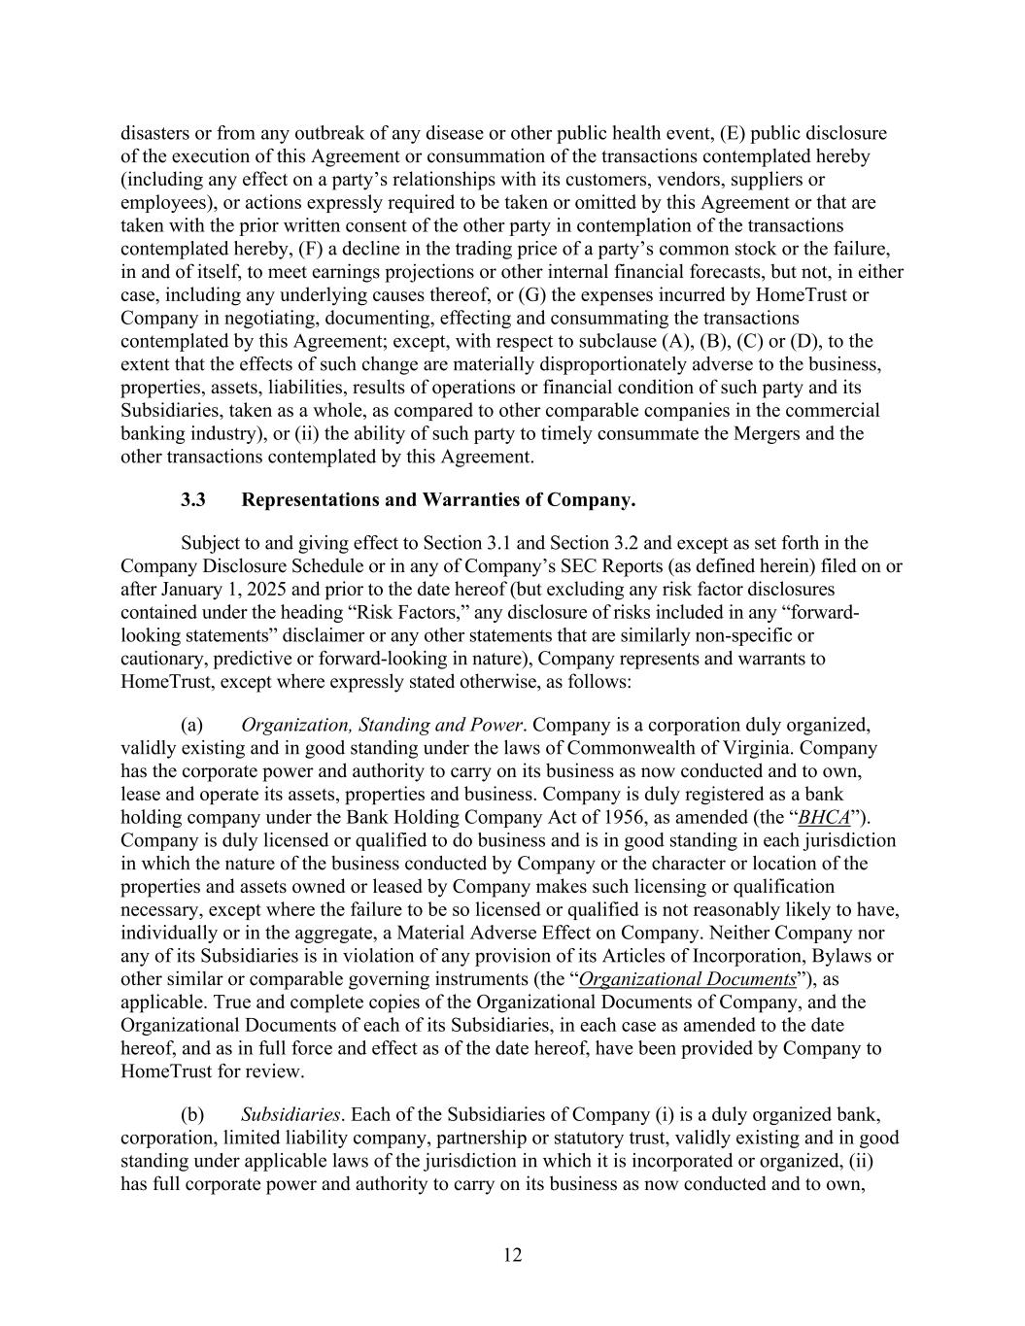
12 disasters or from any outbreak of any disease or other public health event, (E) public disclosure of the execution of this Agreement or consummation of the transactions contemplated hereby (including any effect on a party’s relationships with its customers, vendors, suppliers or employees), or actions expressly required to be taken or omitted by this Agreement or that are taken with the prior written consent of the other party in contemplation of the transactions contemplated hereby, (F) a decline in the trading price of a party’s common stock or the failure, in and of itself, to meet earnings projections or other internal financial forecasts, but not, in either case, including any underlying causes thereof, or (G) the expenses incurred by HomeTrust or Company in negotiating, documenting, effecting and consummating the transactions contemplated by this Agreement; except, with respect to subclause (A), (B), (C) or (D), to the extent that the effects of such change are materially disproportionately adverse to the business, properties, assets, liabilities, results of operations or financial condition of such party and its Subsidiaries, taken as a whole, as compared to other comparable companies in the commercial banking industry), or (ii) the ability of such party to timely consummate the Mergers and the other transactions contemplated by this Agreement. 3.3 Representations and Warranties of Company. Subject to and giving effect to Section 3.1 and Section 3.2 and except as set forth in the Company Disclosure Schedule or in any of Company’s SEC Reports (as defined herein) filed on or after January 1, 2025 and prior to the date hereof (but excluding any risk factor disclosures contained under the heading “Risk Factors,” any disclosure of risks included in any “forward- looking statements” disclaimer or any other statements that are similarly non-specific or cautionary, predictive or forward-looking in nature), Company represents and warrants to HomeTrust, except where expressly stated otherwise, as follows: (a) Organization, Standing and Power. Company is a corporation duly organized, validly existing and in good standing under the laws of Commonwealth of Virginia. Company has the corporate power and authority to carry on its business as now conducted and to own, lease and operate its assets, properties and business. Company is duly registered as a bank holding company under the Bank Holding Company Act of 1956, as amended (the “BHCA”). Company is duly licensed or qualified to do business and is in good standing in each jurisdiction in which the nature of the business conducted by Company or the character or location of the properties and assets owned or leased by Company makes such licensing or qualification necessary, except where the failure to be so licensed or qualified is not reasonably likely to have, individually or in the aggregate, a Material Adverse Effect on Company. Neither Company nor any of its Subsidiaries is in violation of any provision of its Articles of Incorporation, Bylaws or other similar or comparable governing instruments (the “Organizational Documents”), as applicable. True and complete copies of the Organizational Documents of Company, and the Organizational Documents of each of its Subsidiaries, in each case as amended to the date hereof, and as in full force and effect as of the date hereof, have been provided by Company to HomeTrust for review. (b) Subsidiaries. Each of the Subsidiaries of Company (i) is a duly organized bank, corporation, limited liability company, partnership or statutory trust, validly existing and in good standing under applicable laws of the jurisdiction in which it is incorporated or organized, (ii) has full corporate power and authority to carry on its business as now conducted and to own,

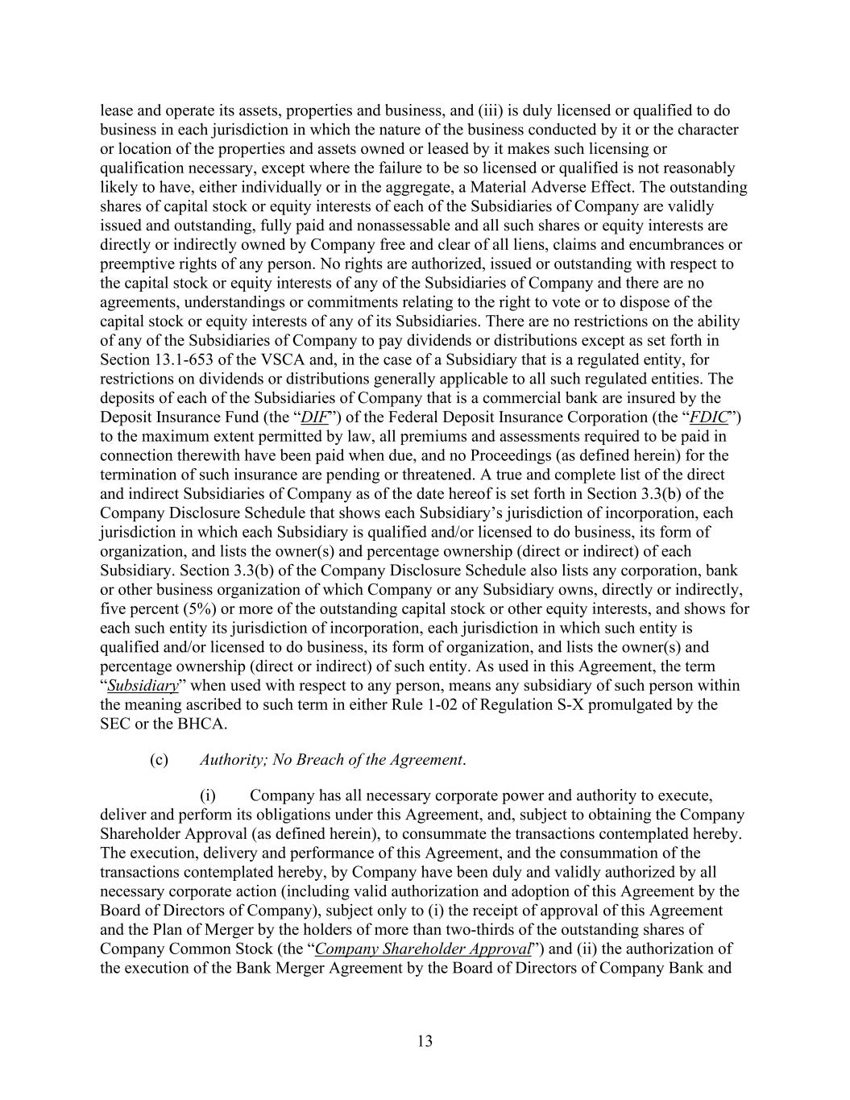
13 lease and operate its assets, properties and business, and (iii) is duly licensed or qualified to do business in each jurisdiction in which the nature of the business conducted by it or the character or location of the properties and assets owned or leased by it makes such licensing or qualification necessary, except where the failure to be so licensed or qualified is not reasonably likely to have, either individually or in the aggregate, a Material Adverse Effect. The outstanding shares of capital stock or equity interests of each of the Subsidiaries of Company are validly issued and outstanding, fully paid and nonassessable and all such shares or equity interests are directly or indirectly owned by Company free and clear of all liens, claims and encumbrances or preemptive rights of any person. No rights are authorized, issued or outstanding with respect to the capital stock or equity interests of any of the Subsidiaries of Company and there are no agreements, understandings or commitments relating to the right to vote or to dispose of the capital stock or equity interests of any of its Subsidiaries. There are no restrictions on the ability of any of the Subsidiaries of Company to pay dividends or distributions except as set forth in Section 13.1-653 of the VSCA and, in the case of a Subsidiary that is a regulated entity, for restrictions on dividends or distributions generally applicable to all such regulated entities. The deposits of each of the Subsidiaries of Company that is a commercial bank are insured by the Deposit Insurance Fund (the “DIF”) of the Federal Deposit Insurance Corporation (the “FDIC”) to the maximum extent permitted by law, all premiums and assessments required to be paid in connection therewith have been paid when due, and no Proceedings (as defined herein) for the termination of such insurance are pending or threatened. A true and complete list of the direct and indirect Subsidiaries of Company as of the date hereof is set forth in Section 3.3(b) of the Company Disclosure Schedule that shows each Subsidiary’s jurisdiction of incorporation, each jurisdiction in which each Subsidiary is qualified and/or licensed to do business, its form of organization, and lists the owner(s) and percentage ownership (direct or indirect) of each Subsidiary. Section 3.3(b) of the Company Disclosure Schedule also lists any corporation, bank or other business organization of which Company or any Subsidiary owns, directly or indirectly, five percent (5%) or more of the outstanding capital stock or other equity interests, and shows for each such entity its jurisdiction of incorporation, each jurisdiction in which such entity is qualified and/or licensed to do business, its form of organization, and lists the owner(s) and percentage ownership (direct or indirect) of such entity. As used in this Agreement, the term “Subsidiary” when used with respect to any person, means any subsidiary of such person within the meaning ascribed to such term in either Rule 1-02 of Regulation S-X promulgated by the SEC or the BHCA. (c) Authority; No Breach of the Agreement. (i) Company has all necessary corporate power and authority to execute, deliver and perform its obligations under this Agreement, and, subject to obtaining the Company Shareholder Approval (as defined herein), to consummate the transactions contemplated hereby. The execution, delivery and performance of this Agreement, and the consummation of the transactions contemplated hereby, by Company have been duly and validly authorized by all necessary corporate action (including valid authorization and adoption of this Agreement by the Board of Directors of Company), subject only to (i) the receipt of approval of this Agreement and the Plan of Merger by the holders of more than two-thirds of the outstanding shares of Company Common Stock (the “Company Shareholder Approval”) and (ii) the authorization of the execution of the Bank Merger Agreement by the Board of Directors of Company Bank and

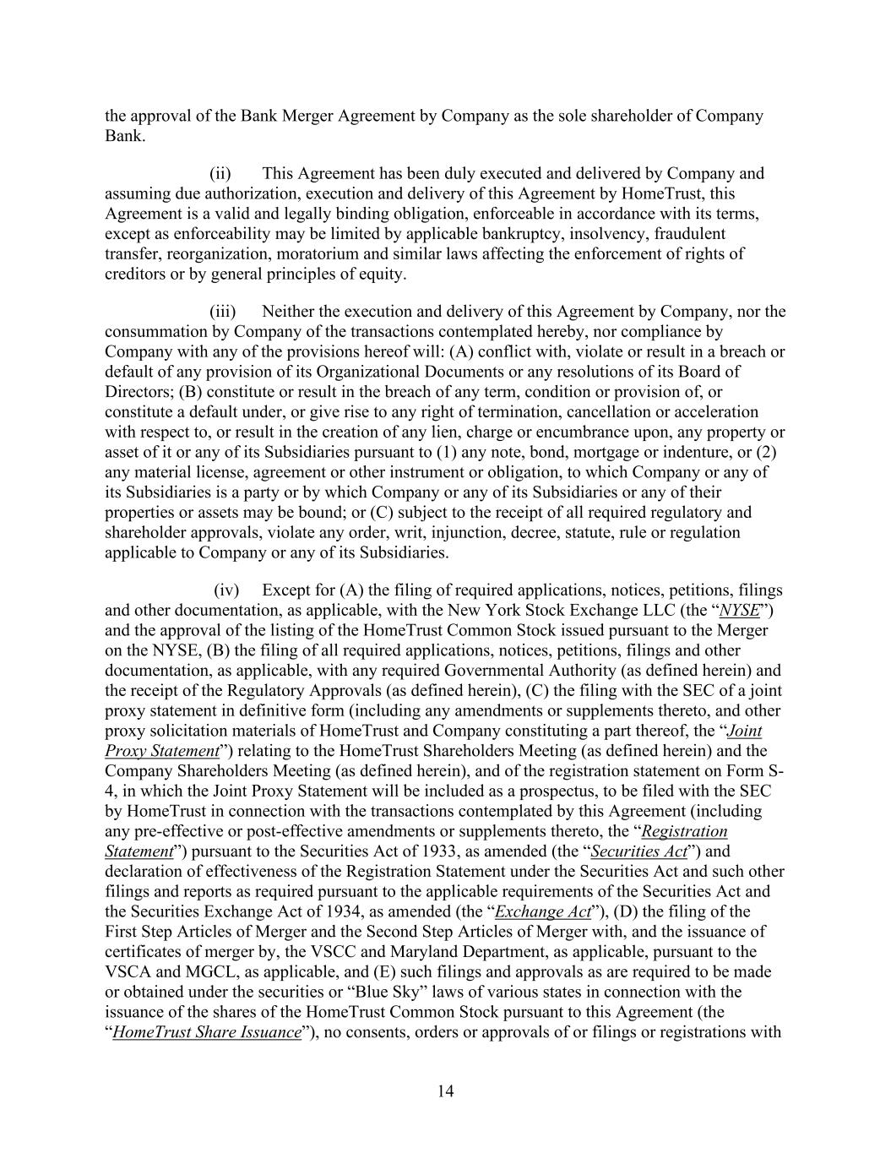
14 the approval of the Bank Merger Agreement by Company as the sole shareholder of Company Bank. (ii) This Agreement has been duly executed and delivered by Company and assuming due authorization, execution and delivery of this Agreement by HomeTrust, this Agreement is a valid and legally binding obligation, enforceable in accordance with its terms, except as enforceability may be limited by applicable bankruptcy, insolvency, fraudulent transfer, reorganization, moratorium and similar laws affecting the enforcement of rights of creditors or by general principles of equity. (iii) Neither the execution and delivery of this Agreement by Company, nor the consummation by Company of the transactions contemplated hereby, nor compliance by Company with any of the provisions hereof will: (A) conflict with, violate or result in a breach or default of any provision of its Organizational Documents or any resolutions of its Board of Directors; (B) constitute or result in the breach of any term, condition or provision of, or constitute a default under, or give rise to any right of termination, cancellation or acceleration with respect to, or result in the creation of any lien, charge or encumbrance upon, any property or asset of it or any of its Subsidiaries pursuant to (1) any note, bond, mortgage or indenture, or (2) any material license, agreement or other instrument or obligation, to which Company or any of its Subsidiaries is a party or by which Company or any of its Subsidiaries or any of their properties or assets may be bound; or (C) subject to the receipt of all required regulatory and shareholder approvals, violate any order, writ, injunction, decree, statute, rule or regulation applicable to Company or any of its Subsidiaries. (iv) Except for (A) the filing of required applications, notices, petitions, filings and other documentation, as applicable, with the New York Stock Exchange LLC (the “NYSE”) and the approval of the listing of the HomeTrust Common Stock issued pursuant to the Merger on the NYSE, (B) the filing of all required applications, notices, petitions, filings and other documentation, as applicable, with any required Governmental Authority (as defined herein) and the receipt of the Regulatory Approvals (as defined herein), (C) the filing with the SEC of a joint proxy statement in definitive form (including any amendments or supplements thereto, and other proxy solicitation materials of HomeTrust and Company constituting a part thereof, the “Joint Proxy Statement”) relating to the HomeTrust Shareholders Meeting (as defined herein) and the Company Shareholders Meeting (as defined herein), and of the registration statement on Form S- 4, in which the Joint Proxy Statement will be included as a prospectus, to be filed with the SEC by HomeTrust in connection with the transactions contemplated by this Agreement (including any pre-effective or post-effective amendments or supplements thereto, the “Registration Statement”) pursuant to the Securities Act of 1933, as amended (the “Securities Act”) and declaration of effectiveness of the Registration Statement under the Securities Act and such other filings and reports as required pursuant to the applicable requirements of the Securities Act and the Securities Exchange Act of 1934, as amended (the “Exchange Act”), (D) the filing of the First Step Articles of Merger and the Second Step Articles of Merger with, and the issuance of certificates of merger by, the VSCC and Maryland Department, as applicable, pursuant to the VSCA and MGCL, as applicable, and (E) such filings and approvals as are required to be made or obtained under the securities or “Blue Sky” laws of various states in connection with the issuance of the shares of the HomeTrust Common Stock pursuant to this Agreement (the “HomeTrust Share Issuance”), no consents, orders or approvals of or filings or registrations with

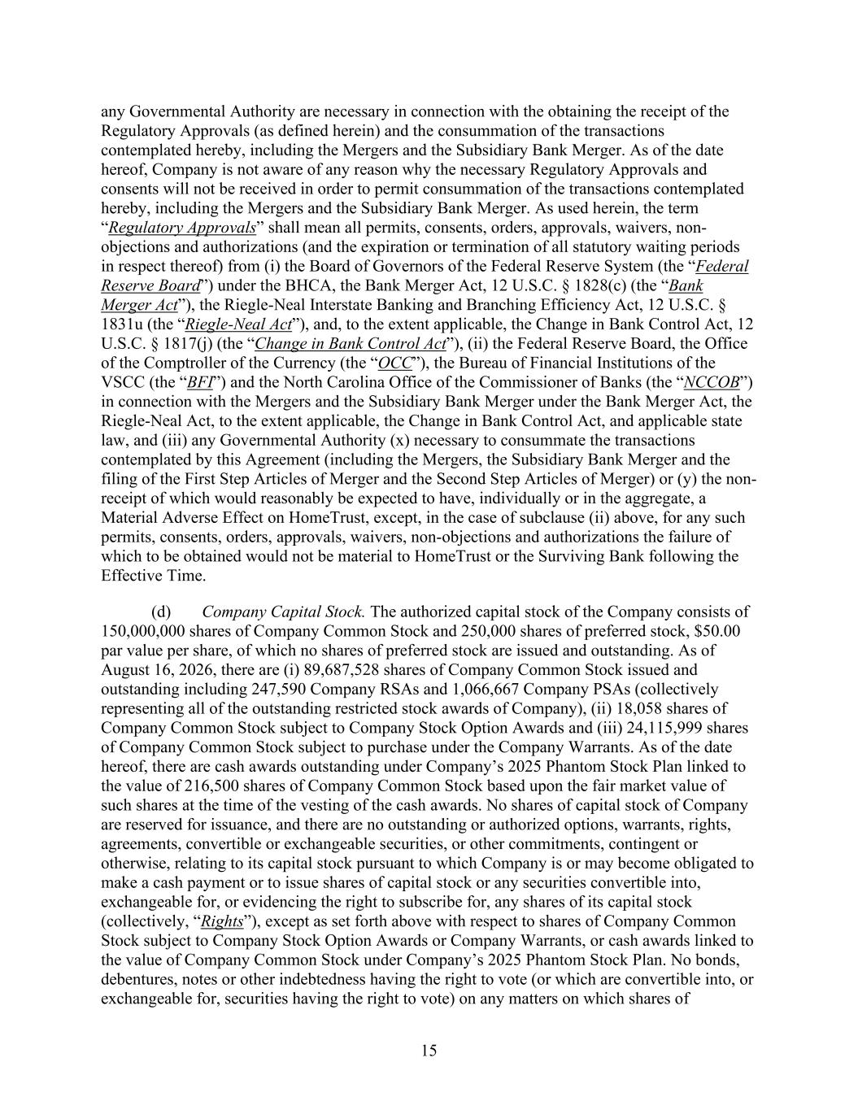
15 any Governmental Authority are necessary in connection with the obtaining the receipt of the Regulatory Approvals (as defined herein) and the consummation of the transactions contemplated hereby, including the Mergers and the Subsidiary Bank Merger. As of the date hereof, Company is not aware of any reason why the necessary Regulatory Approvals and consents will not be received in order to permit consummation of the transactions contemplated hereby, including the Mergers and the Subsidiary Bank Merger. As used herein, the term “Regulatory Approvals” shall mean all permits, consents, orders, approvals, waivers, non- objections and authorizations (and the expiration or termination of all statutory waiting periods in respect thereof) from (i) the Board of Governors of the Federal Reserve System (the “Federal Reserve Board”) under the BHCA, the Bank Merger Act, 12 U.S.C. § 1828(c) (the “Bank Merger Act”), the Riegle-Neal Interstate Banking and Branching Efficiency Act, 12 U.S.C. § 1831u (the “Riegle-Neal Act”), and, to the extent applicable, the Change in Bank Control Act, 12 U.S.C. § 1817(j) (the “Change in Bank Control Act”), (ii) the Federal Reserve Board, the Office of the Comptroller of the Currency (the “OCC”), the Bureau of Financial Institutions of the VSCC (the “BFI”) and the North Carolina Office of the Commissioner of Banks (the “NCCOB”) in connection with the Mergers and the Subsidiary Bank Merger under the Bank Merger Act, the Riegle-Neal Act, to the extent applicable, the Change in Bank Control Act, and applicable state law, and (iii) any Governmental Authority (x) necessary to consummate the transactions contemplated by this Agreement (including the Mergers, the Subsidiary Bank Merger and the filing of the First Step Articles of Merger and the Second Step Articles of Merger) or (y) the non- receipt of which would reasonably be expected to have, individually or in the aggregate, a Material Adverse Effect on HomeTrust, except, in the case of subclause (ii) above, for any such permits, consents, orders, approvals, waivers, non-objections and authorizations the failure of which to be obtained would not be material to HomeTrust or the Surviving Bank following the Effective Time. (d) Company Capital Stock. The authorized capital stock of the Company consists of 150,000,000 shares of Company Common Stock and 250,000 shares of preferred stock, $50.00 par value per share, of which no shares of preferred stock are issued and outstanding. As of August 16, 2026, there are (i) 89,687,528 shares of Company Common Stock issued and outstanding including 247,590 Company RSAs and 1,066,667 Company PSAs (collectively representing all of the outstanding restricted stock awards of Company), (ii) 18,058 shares of Company Common Stock subject to Company Stock Option Awards and (iii) 24,115,999 shares of Company Common Stock subject to purchase under the Company Warrants. As of the date hereof, there are cash awards outstanding under Company’s 2025 Phantom Stock Plan linked to the value of 216,500 shares of Company Common Stock based upon the fair market value of such shares at the time of the vesting of the cash awards. No shares of capital stock of Company are reserved for issuance, and there are no outstanding or authorized options, warrants, rights, agreements, convertible or exchangeable securities, or other commitments, contingent or otherwise, relating to its capital stock pursuant to which Company is or may become obligated to make a cash payment or to issue shares of capital stock or any securities convertible into, exchangeable for, or evidencing the right to subscribe for, any shares of its capital stock (collectively, “Rights”), except as set forth above with respect to shares of Company Common Stock subject to Company Stock Option Awards or Company Warrants, or cash awards linked to the value of Company Common Stock under Company’s 2025 Phantom Stock Plan. No bonds, debentures, notes or other indebtedness having the right to vote (or which are convertible into, or exchangeable for, securities having the right to vote) on any matters on which shares of

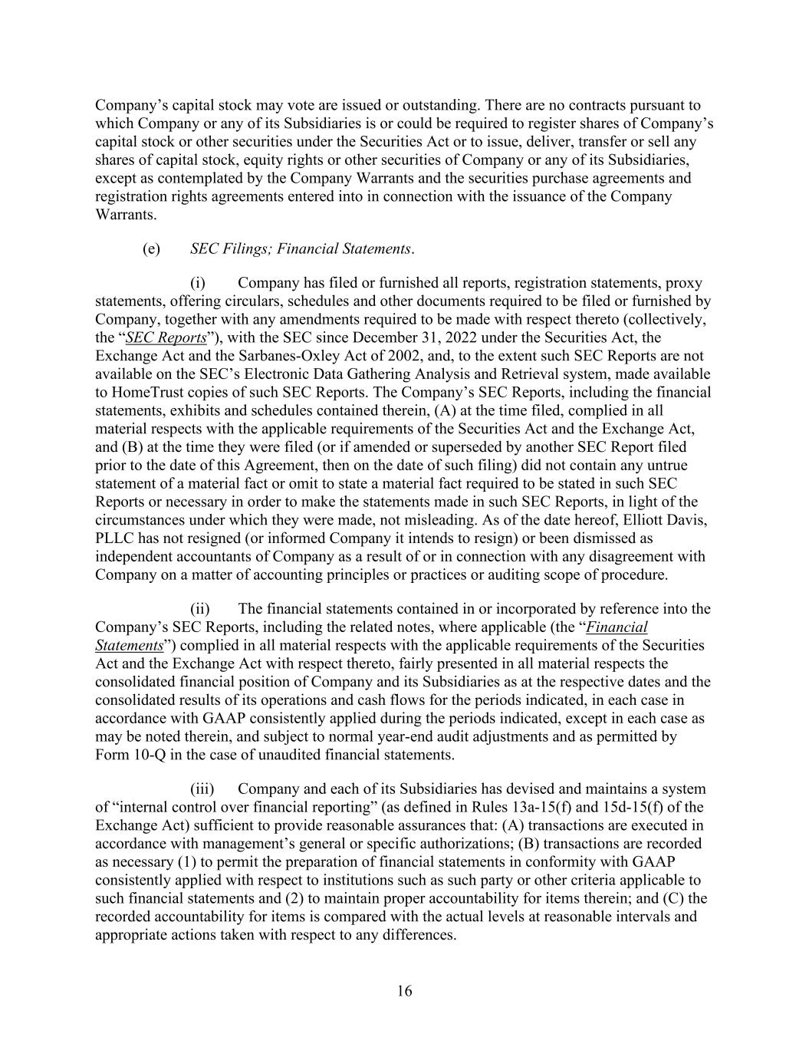
16 Company’s capital stock may vote are issued or outstanding. There are no contracts pursuant to which Company or any of its Subsidiaries is or could be required to register shares of Company’s capital stock or other securities under the Securities Act or to issue, deliver, transfer or sell any shares of capital stock, equity rights or other securities of Company or any of its Subsidiaries, except as contemplated by the Company Warrants and the securities purchase agreements and registration rights agreements entered into in connection with the issuance of the Company Warrants. (e) SEC Filings; Financial Statements. (i) Company has filed or furnished all reports, registration statements, proxy statements, offering circulars, schedules and other documents required to be filed or furnished by Company, together with any amendments required to be made with respect thereto (collectively, the “SEC Reports”), with the SEC since December 31, 2022 under the Securities Act, the Exchange Act and the Sarbanes-Oxley Act of 2002, and, to the extent such SEC Reports are not available on the SEC’s Electronic Data Gathering Analysis and Retrieval system, made available to HomeTrust copies of such SEC Reports. The Company’s SEC Reports, including the financial statements, exhibits and schedules contained therein, (A) at the time filed, complied in all material respects with the applicable requirements of the Securities Act and the Exchange Act, and (B) at the time they were filed (or if amended or superseded by another SEC Report filed prior to the date of this Agreement, then on the date of such filing) did not contain any untrue statement of a material fact or omit to state a material fact required to be stated in such SEC Reports or necessary in order to make the statements made in such SEC Reports, in light of the circumstances under which they were made, not misleading. As of the date hereof, Elliott Davis, PLLC has not resigned (or informed Company it intends to resign) or been dismissed as independent accountants of Company as a result of or in connection with any disagreement with Company on a matter of accounting principles or practices or auditing scope of procedure. (ii) The financial statements contained in or incorporated by reference into the Company’s SEC Reports, including the related notes, where applicable (the “Financial Statements”) complied in all material respects with the applicable requirements of the Securities Act and the Exchange Act with respect thereto, fairly presented in all material respects the consolidated financial position of Company and its Subsidiaries as at the respective dates and the consolidated results of its operations and cash flows for the periods indicated, in each case in accordance with GAAP consistently applied during the periods indicated, except in each case as may be noted therein, and subject to normal year-end audit adjustments and as permitted by Form 10-Q in the case of unaudited financial statements. (iii) Company and each of its Subsidiaries has devised and maintains a system of “internal control over financial reporting” (as defined in Rules 13a-15(f) and 15d-15(f) of the Exchange Act) sufficient to provide reasonable assurances that: (A) transactions are executed in accordance with management’s general or specific authorizations; (B) transactions are recorded as necessary (1) to permit the preparation of financial statements in conformity with GAAP consistently applied with respect to institutions such as such party or other criteria applicable to such financial statements and (2) to maintain proper accountability for items therein; and (C) the recorded accountability for items is compared with the actual levels at reasonable intervals and appropriate actions taken with respect to any differences.

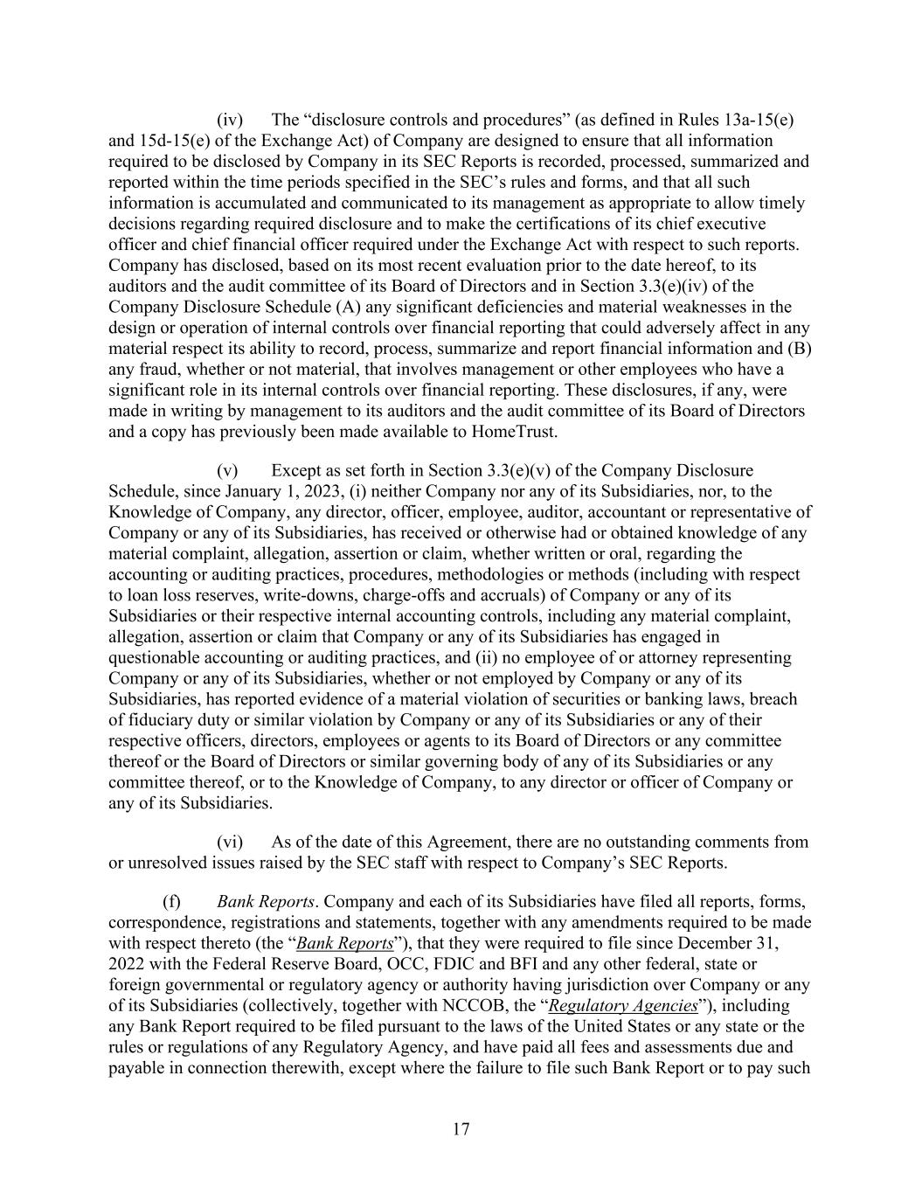
17 (iv) The “disclosure controls and procedures” (as defined in Rules 13a-15(e) and 15d-15(e) of the Exchange Act) of Company are designed to ensure that all information required to be disclosed by Company in its SEC Reports is recorded, processed, summarized and reported within the time periods specified in the SEC’s rules and forms, and that all such information is accumulated and communicated to its management as appropriate to allow timely decisions regarding required disclosure and to make the certifications of its chief executive officer and chief financial officer required under the Exchange Act with respect to such reports. Company has disclosed, based on its most recent evaluation prior to the date hereof, to its auditors and the audit committee of its Board of Directors and in Section 3.3(e)(iv) of the Company Disclosure Schedule (A) any significant deficiencies and material weaknesses in the design or operation of internal controls over financial reporting that could adversely affect in any material respect its ability to record, process, summarize and report financial information and (B) any fraud, whether or not material, that involves management or other employees who have a significant role in its internal controls over financial reporting. These disclosures, if any, were made in writing by management to its auditors and the audit committee of its Board of Directors and a copy has previously been made available to HomeTrust. (v) Except as set forth in Section 3.3(e)(v) of the Company Disclosure Schedule, since January 1, 2023, (i) neither Company nor any of its Subsidiaries, nor, to the Knowledge of Company, any director, officer, employee, auditor, accountant or representative of Company or any of its Subsidiaries, has received or otherwise had or obtained knowledge of any material complaint, allegation, assertion or claim, whether written or oral, regarding the accounting or auditing practices, procedures, methodologies or methods (including with respect to loan loss reserves, write-downs, charge-offs and accruals) of Company or any of its Subsidiaries or their respective internal accounting controls, including any material complaint, allegation, assertion or claim that Company or any of its Subsidiaries has engaged in questionable accounting or auditing practices, and (ii) no employee of or attorney representing Company or any of its Subsidiaries, whether or not employed by Company or any of its Subsidiaries, has reported evidence of a material violation of securities or banking laws, breach of fiduciary duty or similar violation by Company or any of its Subsidiaries or any of their respective officers, directors, employees or agents to its Board of Directors or any committee thereof or the Board of Directors or similar governing body of any of its Subsidiaries or any committee thereof, or to the Knowledge of Company, to any director or officer of Company or any of its Subsidiaries. (vi) As of the date of this Agreement, there are no outstanding comments from or unresolved issues raised by the SEC staff with respect to Company’s SEC Reports. (f) Bank Reports. Company and each of its Subsidiaries have filed all reports, forms, correspondence, registrations and statements, together with any amendments required to be made with respect thereto (the “Bank Reports”), that they were required to file since December 31, 2022 with the Federal Reserve Board, OCC, FDIC and BFI and any other federal, state or foreign governmental or regulatory agency or authority having jurisdiction over Company or any of its Subsidiaries (collectively, together with NCCOB, the “Regulatory Agencies”), including any Bank Report required to be filed pursuant to the laws of the United States or any state or the rules or regulations of any Regulatory Agency, and have paid all fees and assessments due and payable in connection therewith, except where the failure to file such Bank Report or to pay such

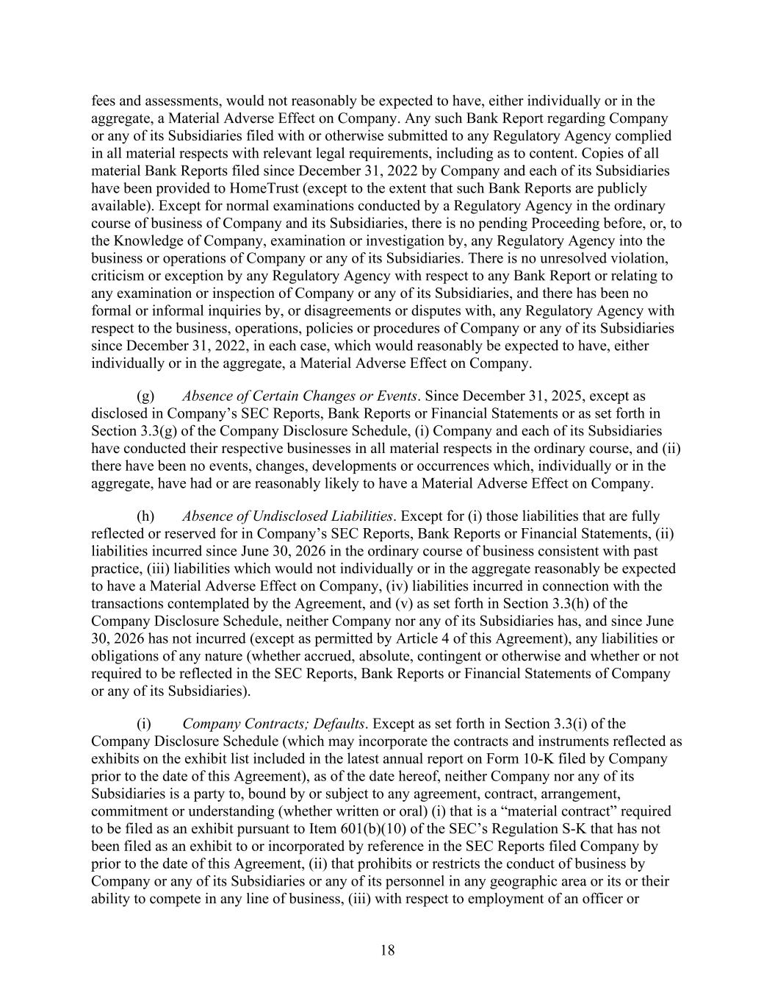
18 fees and assessments, would not reasonably be expected to have, either individually or in the aggregate, a Material Adverse Effect on Company. Any such Bank Report regarding Company or any of its Subsidiaries filed with or otherwise submitted to any Regulatory Agency complied in all material respects with relevant legal requirements, including as to content. Copies of all material Bank Reports filed since December 31, 2022 by Company and each of its Subsidiaries have been provided to HomeTrust (except to the extent that such Bank Reports are publicly available). Except for normal examinations conducted by a Regulatory Agency in the ordinary course of business of Company and its Subsidiaries, there is no pending Proceeding before, or, to the Knowledge of Company, examination or investigation by, any Regulatory Agency into the business or operations of Company or any of its Subsidiaries. There is no unresolved violation, criticism or exception by any Regulatory Agency with respect to any Bank Report or relating to any examination or inspection of Company or any of its Subsidiaries, and there has been no formal or informal inquiries by, or disagreements or disputes with, any Regulatory Agency with respect to the business, operations, policies or procedures of Company or any of its Subsidiaries since December 31, 2022, in each case, which would reasonably be expected to have, either individually or in the aggregate, a Material Adverse Effect on Company. (g) Absence of Certain Changes or Events. Since December 31, 2025, except as disclosed in Company’s SEC Reports, Bank Reports or Financial Statements or as set forth in Section 3.3(g) of the Company Disclosure Schedule, (i) Company and each of its Subsidiaries have conducted their respective businesses in all material respects in the ordinary course, and (ii) there have been no events, changes, developments or occurrences which, individually or in the aggregate, have had or are reasonably likely to have a Material Adverse Effect on Company. (h) Absence of Undisclosed Liabilities. Except for (i) those liabilities that are fully reflected or reserved for in Company’s SEC Reports, Bank Reports or Financial Statements, (ii) liabilities incurred since June 30, 2026 in the ordinary course of business consistent with past practice, (iii) liabilities which would not individually or in the aggregate reasonably be expected to have a Material Adverse Effect on Company, (iv) liabilities incurred in connection with the transactions contemplated by the Agreement, and (v) as set forth in Section 3.3(h) of the Company Disclosure Schedule, neither Company nor any of its Subsidiaries has, and since June 30, 2026 has not incurred (except as permitted by Article 4 of this Agreement), any liabilities or obligations of any nature (whether accrued, absolute, contingent or otherwise and whether or not required to be reflected in the SEC Reports, Bank Reports or Financial Statements of Company or any of its Subsidiaries). (i) Company Contracts; Defaults. Except as set forth in Section 3.3(i) of the Company Disclosure Schedule (which may incorporate the contracts and instruments reflected as exhibits on the exhibit list included in the latest annual report on Form 10-K filed by Company prior to the date of this Agreement), as of the date hereof, neither Company nor any of its Subsidiaries is a party to, bound by or subject to any agreement, contract, arrangement, commitment or understanding (whether written or oral) (i) that is a “material contract” required to be filed as an exhibit pursuant to Item 601(b)(10) of the SEC’s Regulation S-K that has not been filed as an exhibit to or incorporated by reference in the SEC Reports filed Company by prior to the date of this Agreement, (ii) that prohibits or restricts the conduct of business by Company or any of its Subsidiaries or any of its personnel in any geographic area or its or their ability to compete in any line of business, (iii) with respect to employment of an officer or

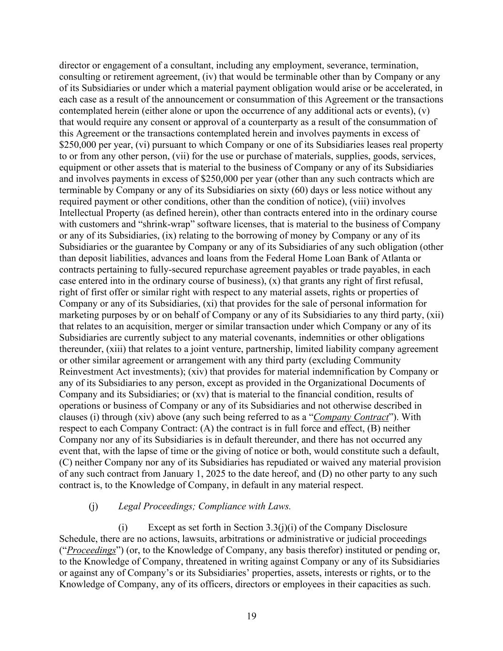
19 director or engagement of a consultant, including any employment, severance, termination, consulting or retirement agreement, (iv) that would be terminable other than by Company or any of its Subsidiaries or under which a material payment obligation would arise or be accelerated, in each case as a result of the announcement or consummation of this Agreement or the transactions contemplated herein (either alone or upon the occurrence of any additional acts or events), (v) that would require any consent or approval of a counterparty as a result of the consummation of this Agreement or the transactions contemplated herein and involves payments in excess of $250,000 per year, (vi) pursuant to which Company or one of its Subsidiaries leases real property to or from any other person, (vii) for the use or purchase of materials, supplies, goods, services, equipment or other assets that is material to the business of Company or any of its Subsidiaries and involves payments in excess of $250,000 per year (other than any such contracts which are terminable by Company or any of its Subsidiaries on sixty (60) days or less notice without any required payment or other conditions, other than the condition of notice), (viii) involves Intellectual Property (as defined herein), other than contracts entered into in the ordinary course with customers and “shrink-wrap” software licenses, that is material to the business of Company or any of its Subsidiaries, (ix) relating to the borrowing of money by Company or any of its Subsidiaries or the guarantee by Company or any of its Subsidiaries of any such obligation (other than deposit liabilities, advances and loans from the Federal Home Loan Bank of Atlanta or contracts pertaining to fully-secured repurchase agreement payables or trade payables, in each case entered into in the ordinary course of business), (x) that grants any right of first refusal, right of first offer or similar right with respect to any material assets, rights or properties of Company or any of its Subsidiaries, (xi) that provides for the sale of personal information for marketing purposes by or on behalf of Company or any of its Subsidiaries to any third party, (xii) that relates to an acquisition, merger or similar transaction under which Company or any of its Subsidiaries are currently subject to any material covenants, indemnities or other obligations thereunder, (xiii) that relates to a joint venture, partnership, limited liability company agreement or other similar agreement or arrangement with any third party (excluding Community Reinvestment Act investments); (xiv) that provides for material indemnification by Company or any of its Subsidiaries to any person, except as provided in the Organizational Documents of Company and its Subsidiaries; or (xv) that is material to the financial condition, results of operations or business of Company or any of its Subsidiaries and not otherwise described in clauses (i) through (xiv) above (any such being referred to as a “Company Contract”). With respect to each Company Contract: (A) the contract is in full force and effect, (B) neither Company nor any of its Subsidiaries is in default thereunder, and there has not occurred any event that, with the lapse of time or the giving of notice or both, would constitute such a default, (C) neither Company nor any of its Subsidiaries has repudiated or waived any material provision of any such contract from January 1, 2025 to the date hereof, and (D) no other party to any such contract is, to the Knowledge of Company, in default in any material respect. (j) Legal Proceedings; Compliance with Laws. (i) Except as set forth in Section 3.3(j)(i) of the Company Disclosure Schedule, there are no actions, lawsuits, arbitrations or administrative or judicial proceedings (“Proceedings”) (or, to the Knowledge of Company, any basis therefor) instituted or pending or, to the Knowledge of Company, threatened in writing against Company or any of its Subsidiaries or against any of Company’s or its Subsidiaries’ properties, assets, interests or rights, or to the Knowledge of Company, any of its officers, directors or employees in their capacities as such.

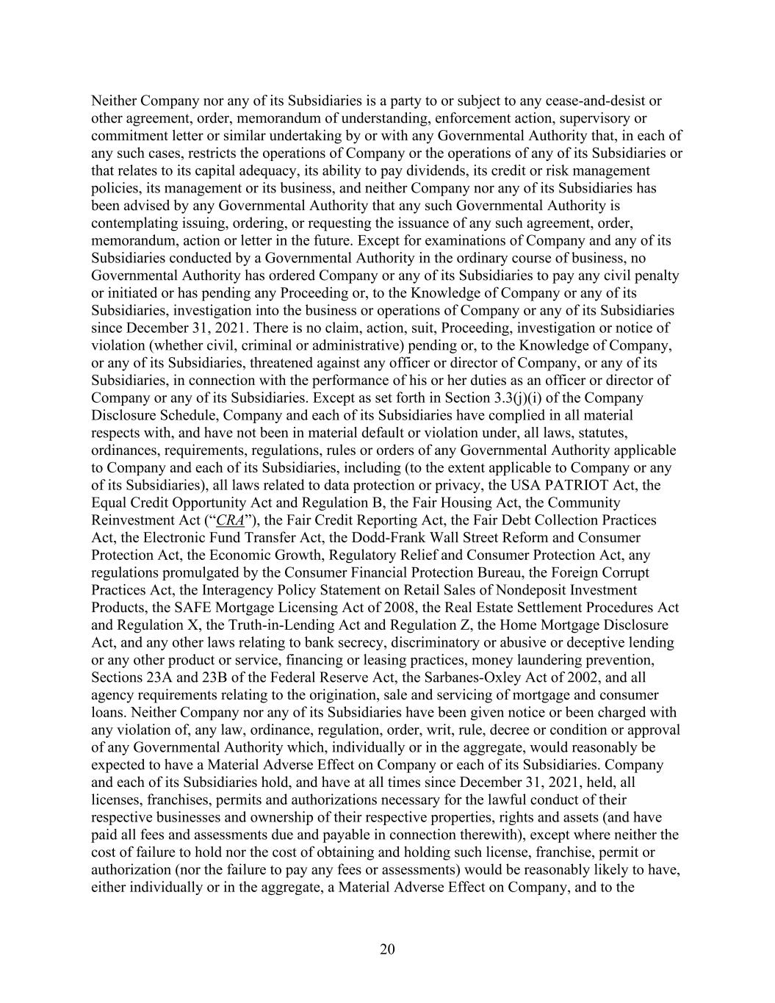
20 Neither Company nor any of its Subsidiaries is a party to or subject to any cease-and-desist or other agreement, order, memorandum of understanding, enforcement action, supervisory or commitment letter or similar undertaking by or with any Governmental Authority that, in each of any such cases, restricts the operations of Company or the operations of any of its Subsidiaries or that relates to its capital adequacy, its ability to pay dividends, its credit or risk management policies, its management or its business, and neither Company nor any of its Subsidiaries has been advised by any Governmental Authority that any such Governmental Authority is contemplating issuing, ordering, or requesting the issuance of any such agreement, order, memorandum, action or letter in the future. Except for examinations of Company and any of its Subsidiaries conducted by a Governmental Authority in the ordinary course of business, no Governmental Authority has ordered Company or any of its Subsidiaries to pay any civil penalty or initiated or has pending any Proceeding or, to the Knowledge of Company or any of its Subsidiaries, investigation into the business or operations of Company or any of its Subsidiaries since December 31, 2021. There is no claim, action, suit, Proceeding, investigation or notice of violation (whether civil, criminal or administrative) pending or, to the Knowledge of Company, or any of its Subsidiaries, threatened against any officer or director of Company, or any of its Subsidiaries, in connection with the performance of his or her duties as an officer or director of Company or any of its Subsidiaries. Except as set forth in Section 3.3(j)(i) of the Company Disclosure Schedule, Company and each of its Subsidiaries have complied in all material respects with, and have not been in material default or violation under, all laws, statutes, ordinances, requirements, regulations, rules or orders of any Governmental Authority applicable to Company and each of its Subsidiaries, including (to the extent applicable to Company or any of its Subsidiaries), all laws related to data protection or privacy, the USA PATRIOT Act, the Equal Credit Opportunity Act and Regulation B, the Fair Housing Act, the Community Reinvestment Act (“CRA”), the Fair Credit Reporting Act, the Fair Debt Collection Practices Act, the Electronic Fund Transfer Act, the Dodd-Frank Wall Street Reform and Consumer Protection Act, the Economic Growth, Regulatory Relief and Consumer Protection Act, any regulations promulgated by the Consumer Financial Protection Bureau, the Foreign Corrupt Practices Act, the Interagency Policy Statement on Retail Sales of Nondeposit Investment Products, the SAFE Mortgage Licensing Act of 2008, the Real Estate Settlement Procedures Act and Regulation X, the Truth-in-Lending Act and Regulation Z, the Home Mortgage Disclosure Act, and any other laws relating to bank secrecy, discriminatory or abusive or deceptive lending or any other product or service, financing or leasing practices, money laundering prevention, Sections 23A and 23B of the Federal Reserve Act, the Sarbanes-Oxley Act of 2002, and all agency requirements relating to the origination, sale and servicing of mortgage and consumer loans. Neither Company nor any of its Subsidiaries have been given notice or been charged with any violation of, any law, ordinance, regulation, order, writ, rule, decree or condition or approval of any Governmental Authority which, individually or in the aggregate, would reasonably be expected to have a Material Adverse Effect on Company or each of its Subsidiaries. Company and each of its Subsidiaries hold, and have at all times since December 31, 2021, held, all licenses, franchises, permits and authorizations necessary for the lawful conduct of their respective businesses and ownership of their respective properties, rights and assets (and have paid all fees and assessments due and payable in connection therewith), except where neither the cost of failure to hold nor the cost of obtaining and holding such license, franchise, permit or authorization (nor the failure to pay any fees or assessments) would be reasonably likely to have, either individually or in the aggregate, a Material Adverse Effect on Company, and to the

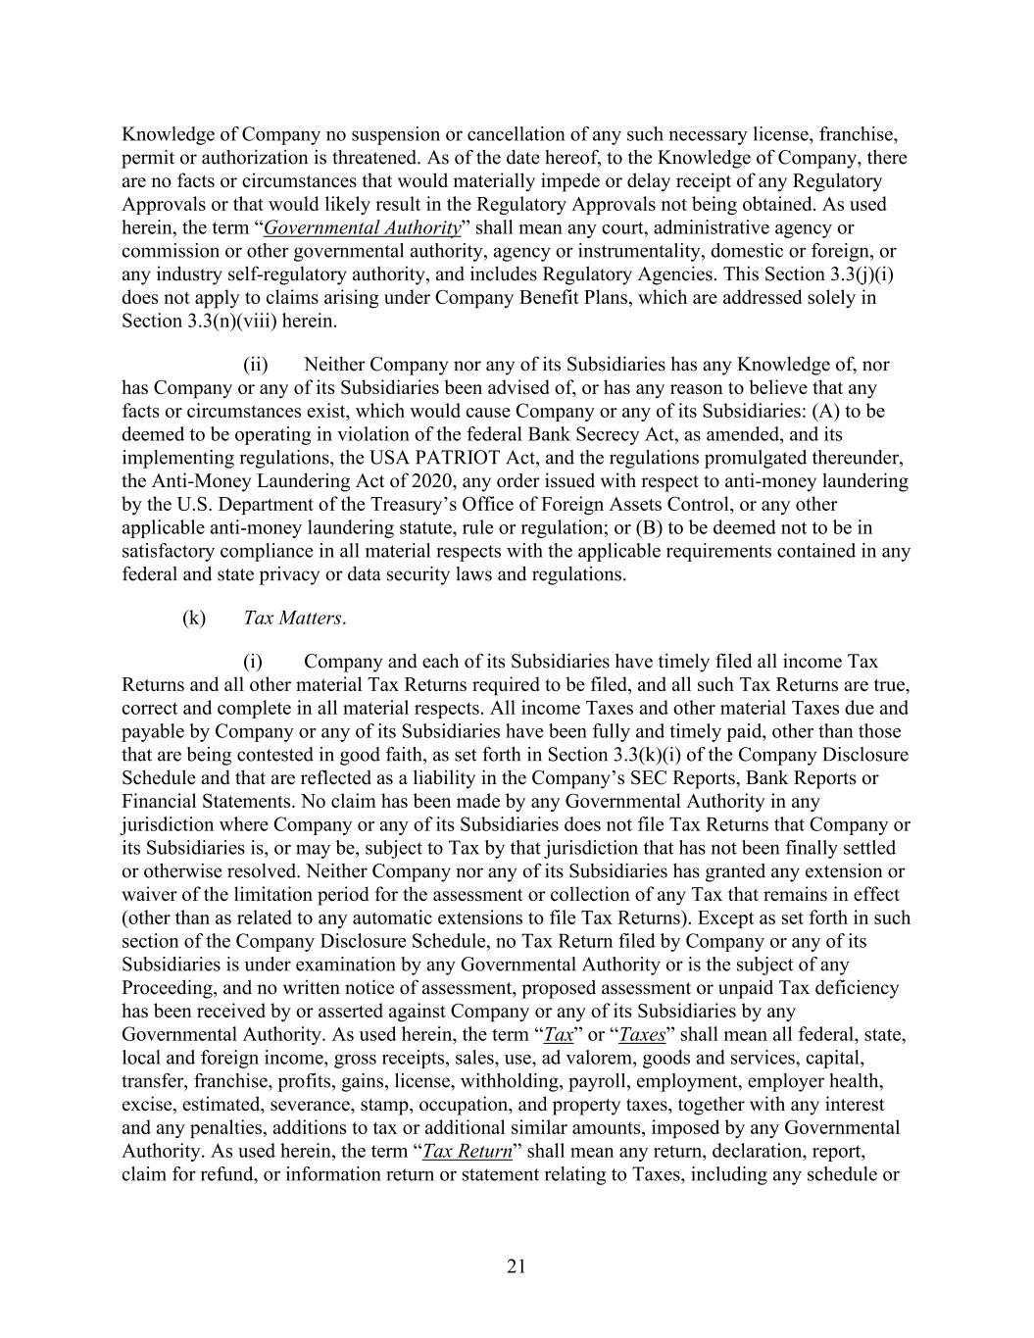
21 Knowledge of Company no suspension or cancellation of any such necessary license, franchise, permit or authorization is threatened. As of the date hereof, to the Knowledge of Company, there are no facts or circumstances that would materially impede or delay receipt of any Regulatory Approvals or that would likely result in the Regulatory Approvals not being obtained. As used herein, the term “Governmental Authority” shall mean any court, administrative agency or commission or other governmental authority, agency or instrumentality, domestic or foreign, or any industry self-regulatory authority, and includes Regulatory Agencies. This Section 3.3(j)(i) does not apply to claims arising under Company Benefit Plans, which are addressed solely in Section 3.3(n)(viii) herein. (ii) Neither Company nor any of its Subsidiaries has any Knowledge of, nor has Company or any of its Subsidiaries been advised of, or has any reason to believe that any facts or circumstances exist, which would cause Company or any of its Subsidiaries: (A) to be deemed to be operating in violation of the federal Bank Secrecy Act, as amended, and its implementing regulations, the USA PATRIOT Act, and the regulations promulgated thereunder, the Anti-Money Laundering Act of 2020, any order issued with respect to anti-money laundering by the U.S. Department of the Treasury’s Office of Foreign Assets Control, or any other applicable anti-money laundering statute, rule or regulation; or (B) to be deemed not to be in satisfactory compliance in all material respects with the applicable requirements contained in any federal and state privacy or data security laws and regulations. (k) Tax Matters. (i) Company and each of its Subsidiaries have timely filed all income Tax Returns and all other material Tax Returns required to be filed, and all such Tax Returns are true, correct and complete in all material respects. All income Taxes and other material Taxes due and payable by Company or any of its Subsidiaries have been fully and timely paid, other than those that are being contested in good faith, as set forth in Section 3.3(k)(i) of the Company Disclosure Schedule and that are reflected as a liability in the Company’s SEC Reports, Bank Reports or Financial Statements. No claim has been made by any Governmental Authority in any jurisdiction where Company or any of its Subsidiaries does not file Tax Returns that Company or its Subsidiaries is, or may be, subject to Tax by that jurisdiction that has not been finally settled or otherwise resolved. Neither Company nor any of its Subsidiaries has granted any extension or waiver of the limitation period for the assessment or collection of any Tax that remains in effect (other than as related to any automatic extensions to file Tax Returns). Except as set forth in such section of the Company Disclosure Schedule, no Tax Return filed by Company or any of its Subsidiaries is under examination by any Governmental Authority or is the subject of any Proceeding, and no written notice of assessment, proposed assessment or unpaid Tax deficiency has been received by or asserted against Company or any of its Subsidiaries by any Governmental Authority. As used herein, the term “Tax” or “Taxes” shall mean all federal, state, local and foreign income, gross receipts, sales, use, ad valorem, goods and services, capital, transfer, franchise, profits, gains, license, withholding, payroll, employment, employer health, excise, estimated, severance, stamp, occupation, and property taxes, together with any interest and any penalties, additions to tax or additional similar amounts, imposed by any Governmental Authority. As used herein, the term “Tax Return” shall mean any return, declaration, report, claim for refund, or information return or statement relating to Taxes, including any schedule or

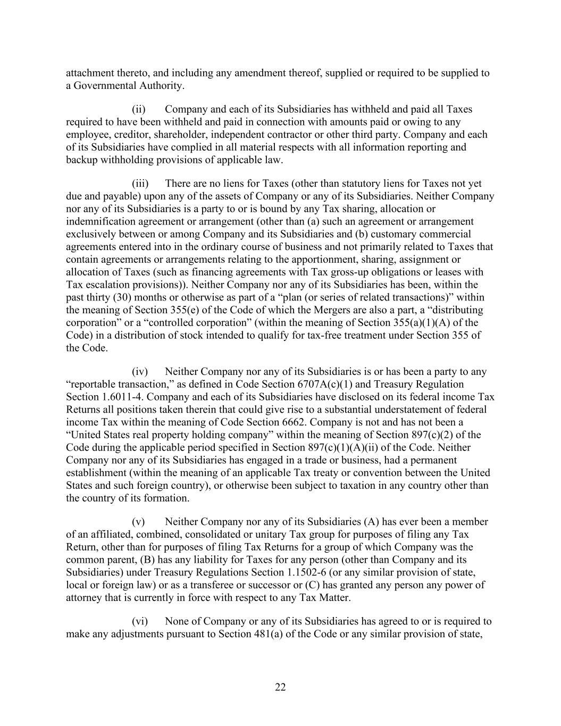
22 attachment thereto, and including any amendment thereof, supplied or required to be supplied to a Governmental Authority. (ii) Company and each of its Subsidiaries has withheld and paid all Taxes required to have been withheld and paid in connection with amounts paid or owing to any employee, creditor, shareholder, independent contractor or other third party. Company and each of its Subsidiaries have complied in all material respects with all information reporting and backup withholding provisions of applicable law. (iii) There are no liens for Taxes (other than statutory liens for Taxes not yet due and payable) upon any of the assets of Company or any of its Subsidiaries. Neither Company nor any of its Subsidiaries is a party to or is bound by any Tax sharing, allocation or indemnification agreement or arrangement (other than (a) such an agreement or arrangement exclusively between or among Company and its Subsidiaries and (b) customary commercial agreements entered into in the ordinary course of business and not primarily related to Taxes that contain agreements or arrangements relating to the apportionment, sharing, assignment or allocation of Taxes (such as financing agreements with Tax gross-up obligations or leases with Tax escalation provisions)). Neither Company nor any of its Subsidiaries has been, within the past thirty (30) months or otherwise as part of a “plan (or series of related transactions)” within the meaning of Section 355(e) of the Code of which the Mergers are also a part, a “distributing corporation” or a “controlled corporation” (within the meaning of Section 355(a)(1)(A) of the Code) in a distribution of stock intended to qualify for tax-free treatment under Section 355 of the Code. (iv) Neither Company nor any of its Subsidiaries is or has been a party to any “reportable transaction,” as defined in Code Section 6707A(c)(1) and Treasury Regulation Section 1.6011-4. Company and each of its Subsidiaries have disclosed on its federal income Tax Returns all positions taken therein that could give rise to a substantial understatement of federal income Tax within the meaning of Code Section 6662. Company is not and has not been a “United States real property holding company” within the meaning of Section 897(c)(2) of the Code during the applicable period specified in Section 897(c)(1)(A)(ii) of the Code. Neither Company nor any of its Subsidiaries has engaged in a trade or business, had a permanent establishment (within the meaning of an applicable Tax treaty or convention between the United States and such foreign country), or otherwise been subject to taxation in any country other than the country of its formation. (v) Neither Company nor any of its Subsidiaries (A) has ever been a member of an affiliated, combined, consolidated or unitary Tax group for purposes of filing any Tax Return, other than for purposes of filing Tax Returns for a group of which Company was the common parent, (B) has any liability for Taxes for any person (other than Company and its Subsidiaries) under Treasury Regulations Section 1.1502-6 (or any similar provision of state, local or foreign law) or as a transferee or successor or (C) has granted any person any power of attorney that is currently in force with respect to any Tax Matter. (vi) None of Company or any of its Subsidiaries has agreed to or is required to make any adjustments pursuant to Section 481(a) of the Code or any similar provision of state,

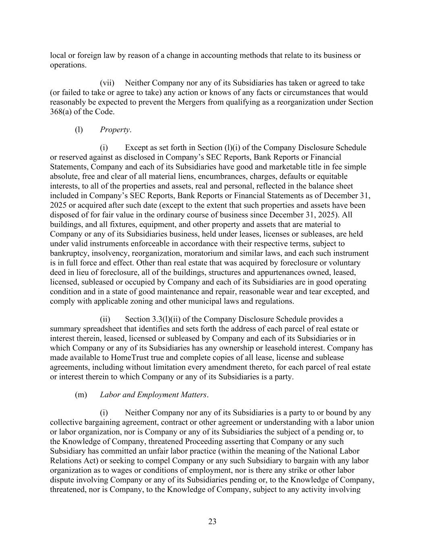
23 local or foreign law by reason of a change in accounting methods that relate to its business or operations. (vii) Neither Company nor any of its Subsidiaries has taken or agreed to take (or failed to take or agree to take) any action or knows of any facts or circumstances that would reasonably be expected to prevent the Mergers from qualifying as a reorganization under Section 368(a) of the Code. (l) Property. (i) Except as set forth in Section (l)(i) of the Company Disclosure Schedule or reserved against as disclosed in Company’s SEC Reports, Bank Reports or Financial Statements, Company and each of its Subsidiaries have good and marketable title in fee simple absolute, free and clear of all material liens, encumbrances, charges, defaults or equitable interests, to all of the properties and assets, real and personal, reflected in the balance sheet included in Company’s SEC Reports, Bank Reports or Financial Statements as of December 31, 2025 or acquired after such date (except to the extent that such properties and assets have been disposed of for fair value in the ordinary course of business since December 31, 2025). All buildings, and all fixtures, equipment, and other property and assets that are material to Company or any of its Subsidiaries business, held under leases, licenses or subleases, are held under valid instruments enforceable in accordance with their respective terms, subject to bankruptcy, insolvency, reorganization, moratorium and similar laws, and each such instrument is in full force and effect. Other than real estate that was acquired by foreclosure or voluntary deed in lieu of foreclosure, all of the buildings, structures and appurtenances owned, leased, licensed, subleased or occupied by Company and each of its Subsidiaries are in good operating condition and in a state of good maintenance and repair, reasonable wear and tear excepted, and comply with applicable zoning and other municipal laws and regulations. (ii) Section 3.3(l)(ii) of the Company Disclosure Schedule provides a summary spreadsheet that identifies and sets forth the address of each parcel of real estate or interest therein, leased, licensed or subleased by Company and each of its Subsidiaries or in which Company or any of its Subsidiaries has any ownership or leasehold interest. Company has made available to HomeTrust true and complete copies of all lease, license and sublease agreements, including without limitation every amendment thereto, for each parcel of real estate or interest therein to which Company or any of its Subsidiaries is a party. (m) Labor and Employment Matters. (i) Neither Company nor any of its Subsidiaries is a party to or bound by any collective bargaining agreement, contract or other agreement or understanding with a labor union or labor organization, nor is Company or any of its Subsidiaries the subject of a pending or, to the Knowledge of Company, threatened Proceeding asserting that Company or any such Subsidiary has committed an unfair labor practice (within the meaning of the National Labor Relations Act) or seeking to compel Company or any such Subsidiary to bargain with any labor organization as to wages or conditions of employment, nor is there any strike or other labor dispute involving Company or any of its Subsidiaries pending or, to the Knowledge of Company, threatened, nor is Company, to the Knowledge of Company, subject to any activity involving

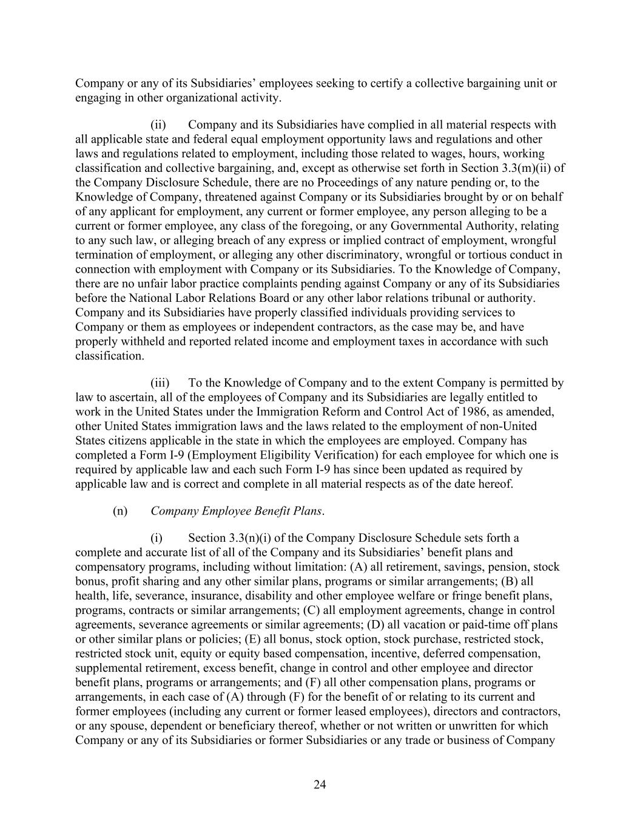
24 Company or any of its Subsidiaries’ employees seeking to certify a collective bargaining unit or engaging in other organizational activity. (ii) Company and its Subsidiaries have complied in all material respects with all applicable state and federal equal employment opportunity laws and regulations and other laws and regulations related to employment, including those related to wages, hours, working classification and collective bargaining, and, except as otherwise set forth in Section 3.3(m)(ii) of the Company Disclosure Schedule, there are no Proceedings of any nature pending or, to the Knowledge of Company, threatened against Company or its Subsidiaries brought by or on behalf of any applicant for employment, any current or former employee, any person alleging to be a current or former employee, any class of the foregoing, or any Governmental Authority, relating to any such law, or alleging breach of any express or implied contract of employment, wrongful termination of employment, or alleging any other discriminatory, wrongful or tortious conduct in connection with employment with Company or its Subsidiaries. To the Knowledge of Company, there are no unfair labor practice complaints pending against Company or any of its Subsidiaries before the National Labor Relations Board or any other labor relations tribunal or authority. Company and its Subsidiaries have properly classified individuals providing services to Company or them as employees or independent contractors, as the case may be, and have properly withheld and reported related income and employment taxes in accordance with such classification. (iii) To the Knowledge of Company and to the extent Company is permitted by law to ascertain, all of the employees of Company and its Subsidiaries are legally entitled to work in the United States under the Immigration Reform and Control Act of 1986, as amended, other United States immigration laws and the laws related to the employment of non-United States citizens applicable in the state in which the employees are employed. Company has completed a Form I-9 (Employment Eligibility Verification) for each employee for which one is required by applicable law and each such Form I-9 has since been updated as required by applicable law and is correct and complete in all material respects as of the date hereof. (n) Company Employee Benefit Plans. (i) Section 3.3(n)(i) of the Company Disclosure Schedule sets forth a complete and accurate list of all of the Company and its Subsidiaries’ benefit plans and compensatory programs, including without limitation: (A) all retirement, savings, pension, stock bonus, profit sharing and any other similar plans, programs or similar arrangements; (B) all health, life, severance, insurance, disability and other employee welfare or fringe benefit plans, programs, contracts or similar arrangements; (C) all employment agreements, change in control agreements, severance agreements or similar agreements; (D) all vacation or paid-time off plans or other similar plans or policies; (E) all bonus, stock option, stock purchase, restricted stock, restricted stock unit, equity or equity based compensation, incentive, deferred compensation, supplemental retirement, excess benefit, change in control and other employee and director benefit plans, programs or arrangements; and (F) all other compensation plans, programs or arrangements, in each case of (A) through (F) for the benefit of or relating to its current and former employees (including any current or former leased employees), directors and contractors, or any spouse, dependent or beneficiary thereof, whether or not written or unwritten for which Company or any of its Subsidiaries or former Subsidiaries or any trade or business of Company

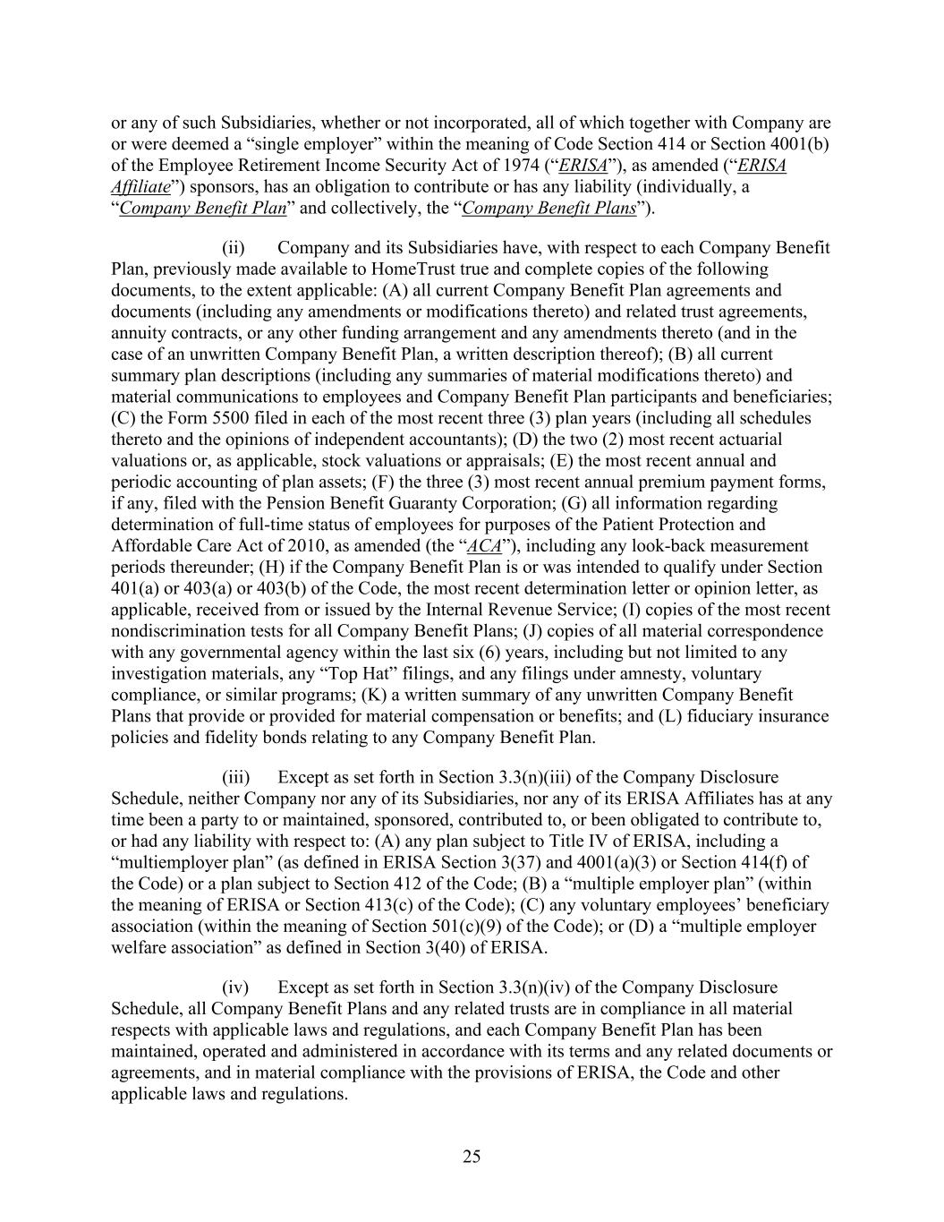
25 or any of such Subsidiaries, whether or not incorporated, all of which together with Company are or were deemed a “single employer” within the meaning of Code Section 414 or Section 4001(b) of the Employee Retirement Income Security Act of 1974 (“ERISA”), as amended (“ERISA Affiliate”) sponsors, has an obligation to contribute or has any liability (individually, a “Company Benefit Plan” and collectively, the “Company Benefit Plans”). (ii) Company and its Subsidiaries have, with respect to each Company Benefit Plan, previously made available to HomeTrust true and complete copies of the following documents, to the extent applicable: (A) all current Company Benefit Plan agreements and documents (including any amendments or modifications thereto) and related trust agreements, annuity contracts, or any other funding arrangement and any amendments thereto (and in the case of an unwritten Company Benefit Plan, a written description thereof); (B) all current summary plan descriptions (including any summaries of material modifications thereto) and material communications to employees and Company Benefit Plan participants and beneficiaries; (C) the Form 5500 filed in each of the most recent three (3) plan years (including all schedules thereto and the opinions of independent accountants); (D) the two (2) most recent actuarial valuations or, as applicable, stock valuations or appraisals; (E) the most recent annual and periodic accounting of plan assets; (F) the three (3) most recent annual premium payment forms, if any, filed with the Pension Benefit Guaranty Corporation; (G) all information regarding determination of full-time status of employees for purposes of the Patient Protection and Affordable Care Act of 2010, as amended (the “ACA”), including any look-back measurement periods thereunder; (H) if the Company Benefit Plan is or was intended to qualify under Section 401(a) or 403(a) or 403(b) of the Code, the most recent determination letter or opinion letter, as applicable, received from or issued by the Internal Revenue Service; (I) copies of the most recent nondiscrimination tests for all Company Benefit Plans; (J) copies of all material correspondence with any governmental agency within the last six (6) years, including but not limited to any investigation materials, any “Top Hat” filings, and any filings under amnesty, voluntary compliance, or similar programs; (K) a written summary of any unwritten Company Benefit Plans that provide or provided for material compensation or benefits; and (L) fiduciary insurance policies and fidelity bonds relating to any Company Benefit Plan. (iii) Except as set forth in Section 3.3(n)(iii) of the Company Disclosure Schedule, neither Company nor any of its Subsidiaries, nor any of its ERISA Affiliates has at any time been a party to or maintained, sponsored, contributed to, or been obligated to contribute to, or had any liability with respect to: (A) any plan subject to Title IV of ERISA, including a “multiemployer plan” (as defined in ERISA Section 3(37) and 4001(a)(3) or Section 414(f) of the Code) or a plan subject to Section 412 of the Code; (B) a “multiple employer plan” (within the meaning of ERISA or Section 413(c) of the Code); (C) any voluntary employees’ beneficiary association (within the meaning of Section 501(c)(9) of the Code); or (D) a “multiple employer welfare association” as defined in Section 3(40) of ERISA. (iv) Except as set forth in Section 3.3(n)(iv) of the Company Disclosure Schedule, all Company Benefit Plans and any related trusts are in compliance in all material respects with applicable laws and regulations, and each Company Benefit Plan has been maintained, operated and administered in accordance with its terms and any related documents or agreements, and in material compliance with the provisions of ERISA, the Code and other applicable laws and regulations.

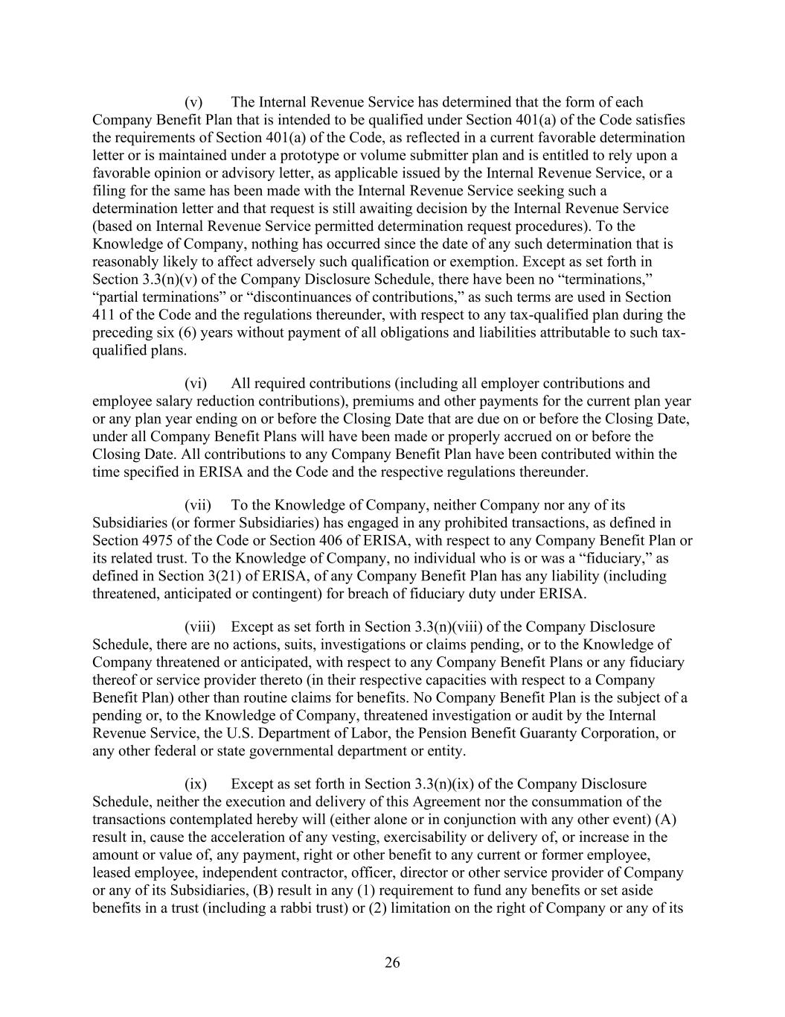
26 (v) The Internal Revenue Service has determined that the form of each Company Benefit Plan that is intended to be qualified under Section 401(a) of the Code satisfies the requirements of Section 401(a) of the Code, as reflected in a current favorable determination letter or is maintained under a prototype or volume submitter plan and is entitled to rely upon a favorable opinion or advisory letter, as applicable issued by the Internal Revenue Service, or a filing for the same has been made with the Internal Revenue Service seeking such a determination letter and that request is still awaiting decision by the Internal Revenue Service (based on Internal Revenue Service permitted determination request procedures). To the Knowledge of Company, nothing has occurred since the date of any such determination that is reasonably likely to affect adversely such qualification or exemption. Except as set forth in Section 3.3(n)(v) of the Company Disclosure Schedule, there have been no “terminations,” “partial terminations” or “discontinuances of contributions,” as such terms are used in Section 411 of the Code and the regulations thereunder, with respect to any tax-qualified plan during the preceding six (6) years without payment of all obligations and liabilities attributable to such tax- qualified plans. (vi) All required contributions (including all employer contributions and employee salary reduction contributions), premiums and other payments for the current plan year or any plan year ending on or before the Closing Date that are due on or before the Closing Date, under all Company Benefit Plans will have been made or properly accrued on or before the Closing Date. All contributions to any Company Benefit Plan have been contributed within the time specified in ERISA and the Code and the respective regulations thereunder. (vii) To the Knowledge of Company, neither Company nor any of its Subsidiaries (or former Subsidiaries) has engaged in any prohibited transactions, as defined in Section 4975 of the Code or Section 406 of ERISA, with respect to any Company Benefit Plan or its related trust. To the Knowledge of Company, no individual who is or was a “fiduciary,” as defined in Section 3(21) of ERISA, of any Company Benefit Plan has any liability (including threatened, anticipated or contingent) for breach of fiduciary duty under ERISA. (viii) Except as set forth in Section 3.3(n)(viii) of the Company Disclosure Schedule, there are no actions, suits, investigations or claims pending, or to the Knowledge of Company threatened or anticipated, with respect to any Company Benefit Plans or any fiduciary thereof or service provider thereto (in their respective capacities with respect to a Company Benefit Plan) other than routine claims for benefits. No Company Benefit Plan is the subject of a pending or, to the Knowledge of Company, threatened investigation or audit by the Internal Revenue Service, the U.S. Department of Labor, the Pension Benefit Guaranty Corporation, or any other federal or state governmental department or entity. (ix) Except as set forth in Section 3.3(n)(ix) of the Company Disclosure Schedule, neither the execution and delivery of this Agreement nor the consummation of the transactions contemplated hereby will (either alone or in conjunction with any other event) (A) result in, cause the acceleration of any vesting, exercisability or delivery of, or increase in the amount or value of, any payment, right or other benefit to any current or former employee, leased employee, independent contractor, officer, director or other service provider of Company or any of its Subsidiaries, (B) result in any (1) requirement to fund any benefits or set aside benefits in a trust (including a rabbi trust) or (2) limitation on the right of Company or any of its

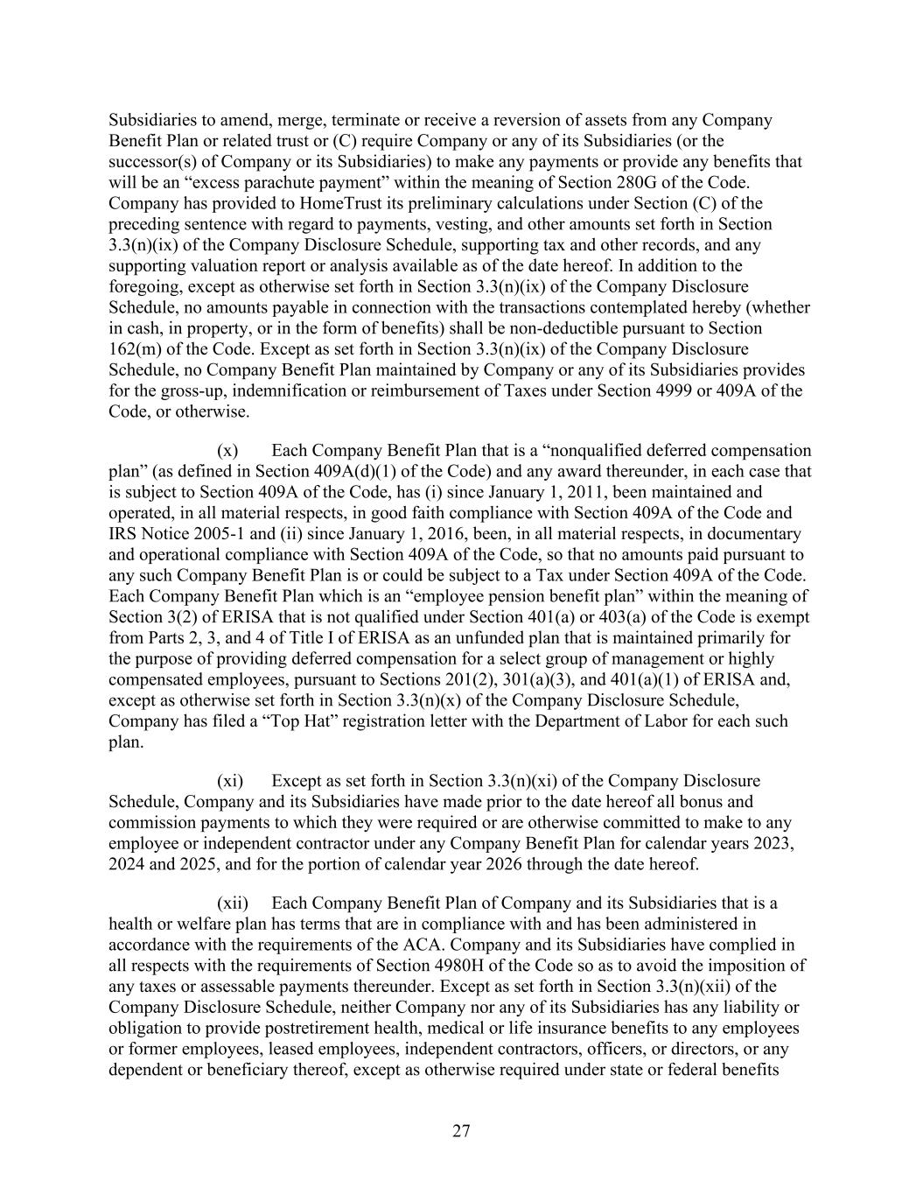
27 Subsidiaries to amend, merge, terminate or receive a reversion of assets from any Company Benefit Plan or related trust or (C) require Company or any of its Subsidiaries (or the successor(s) of Company or its Subsidiaries) to make any payments or provide any benefits that will be an “excess parachute payment” within the meaning of Section 280G of the Code. Company has provided to HomeTrust its preliminary calculations under Section (C) of the preceding sentence with regard to payments, vesting, and other amounts set forth in Section 3.3(n)(ix) of the Company Disclosure Schedule, supporting tax and other records, and any supporting valuation report or analysis available as of the date hereof. In addition to the foregoing, except as otherwise set forth in Section 3.3(n)(ix) of the Company Disclosure Schedule, no amounts payable in connection with the transactions contemplated hereby (whether in cash, in property, or in the form of benefits) shall be non-deductible pursuant to Section 162(m) of the Code. Except as set forth in Section 3.3(n)(ix) of the Company Disclosure Schedule, no Company Benefit Plan maintained by Company or any of its Subsidiaries provides for the gross-up, indemnification or reimbursement of Taxes under Section 4999 or 409A of the Code, or otherwise. (x) Each Company Benefit Plan that is a “nonqualified deferred compensation plan” (as defined in Section 409A(d)(1) of the Code) and any award thereunder, in each case that is subject to Section 409A of the Code, has (i) since January 1, 2011, been maintained and operated, in all material respects, in good faith compliance with Section 409A of the Code and IRS Notice 2005-1 and (ii) since January 1, 2016, been, in all material respects, in documentary and operational compliance with Section 409A of the Code, so that no amounts paid pursuant to any such Company Benefit Plan is or could be subject to a Tax under Section 409A of the Code. Each Company Benefit Plan which is an “employee pension benefit plan” within the meaning of Section 3(2) of ERISA that is not qualified under Section 401(a) or 403(a) of the Code is exempt from Parts 2, 3, and 4 of Title I of ERISA as an unfunded plan that is maintained primarily for the purpose of providing deferred compensation for a select group of management or highly compensated employees, pursuant to Sections 201(2), 301(a)(3), and 401(a)(1) of ERISA and, except as otherwise set forth in Section 3.3(n)(x) of the Company Disclosure Schedule, Company has filed a “Top Hat” registration letter with the Department of Labor for each such plan. (xi) Except as set forth in Section 3.3(n)(xi) of the Company Disclosure Schedule, Company and its Subsidiaries have made prior to the date hereof all bonus and commission payments to which they were required or are otherwise committed to make to any employee or independent contractor under any Company Benefit Plan for calendar years 2023, 2024 and 2025, and for the portion of calendar year 2026 through the date hereof. (xii) Each Company Benefit Plan of Company and its Subsidiaries that is a health or welfare plan has terms that are in compliance with and has been administered in accordance with the requirements of the ACA. Company and its Subsidiaries have complied in all respects with the requirements of Section 4980H of the Code so as to avoid the imposition of any taxes or assessable payments thereunder. Except as set forth in Section 3.3(n)(xii) of the Company Disclosure Schedule, neither Company nor any of its Subsidiaries has any liability or obligation to provide postretirement health, medical or life insurance benefits to any employees or former employees, leased employees, independent contractors, officers, or directors, or any dependent or beneficiary thereof, except as otherwise required under state or federal benefits

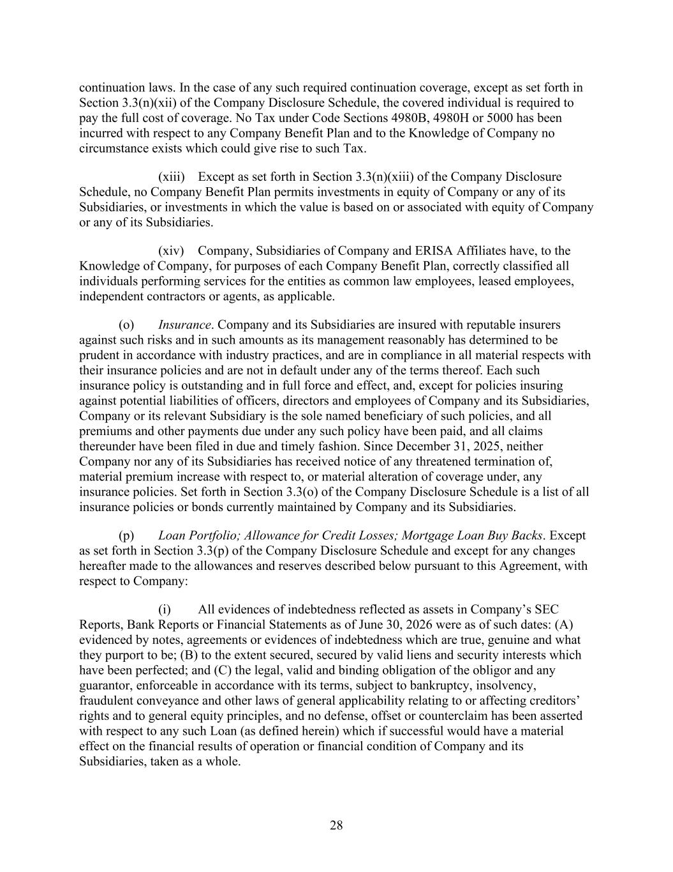
28 continuation laws. In the case of any such required continuation coverage, except as set forth in Section 3.3(n)(xii) of the Company Disclosure Schedule, the covered individual is required to pay the full cost of coverage. No Tax under Code Sections 4980B, 4980H or 5000 has been incurred with respect to any Company Benefit Plan and to the Knowledge of Company no circumstance exists which could give rise to such Tax. (xiii) Except as set forth in Section 3.3(n)(xiii) of the Company Disclosure Schedule, no Company Benefit Plan permits investments in equity of Company or any of its Subsidiaries, or investments in which the value is based on or associated with equity of Company or any of its Subsidiaries. (xiv) Company, Subsidiaries of Company and ERISA Affiliates have, to the Knowledge of Company, for purposes of each Company Benefit Plan, correctly classified all individuals performing services for the entities as common law employees, leased employees, independent contractors or agents, as applicable. (o) Insurance. Company and its Subsidiaries are insured with reputable insurers against such risks and in such amounts as its management reasonably has determined to be prudent in accordance with industry practices, and are in compliance in all material respects with their insurance policies and are not in default under any of the terms thereof. Each such insurance policy is outstanding and in full force and effect, and, except for policies insuring against potential liabilities of officers, directors and employees of Company and its Subsidiaries, Company or its relevant Subsidiary is the sole named beneficiary of such policies, and all premiums and other payments due under any such policy have been paid, and all claims thereunder have been filed in due and timely fashion. Since December 31, 2025, neither Company nor any of its Subsidiaries has received notice of any threatened termination of, material premium increase with respect to, or material alteration of coverage under, any insurance policies. Set forth in Section 3.3(o) of the Company Disclosure Schedule is a list of all insurance policies or bonds currently maintained by Company and its Subsidiaries. (p) Loan Portfolio; Allowance for Credit Losses; Mortgage Loan Buy Backs. Except as set forth in Section 3.3(p) of the Company Disclosure Schedule and except for any changes hereafter made to the allowances and reserves described below pursuant to this Agreement, with respect to Company: (i) All evidences of indebtedness reflected as assets in Company’s SEC Reports, Bank Reports or Financial Statements as of June 30, 2026 were as of such dates: (A) evidenced by notes, agreements or evidences of indebtedness which are true, genuine and what they purport to be; (B) to the extent secured, secured by valid liens and security interests which have been perfected; and (C) the legal, valid and binding obligation of the obligor and any guarantor, enforceable in accordance with its terms, subject to bankruptcy, insolvency, fraudulent conveyance and other laws of general applicability relating to or affecting creditors’ rights and to general equity principles, and no defense, offset or counterclaim has been asserted with respect to any such Loan (as defined herein) which if successful would have a material effect on the financial results of operation or financial condition of Company and its Subsidiaries, taken as a whole.

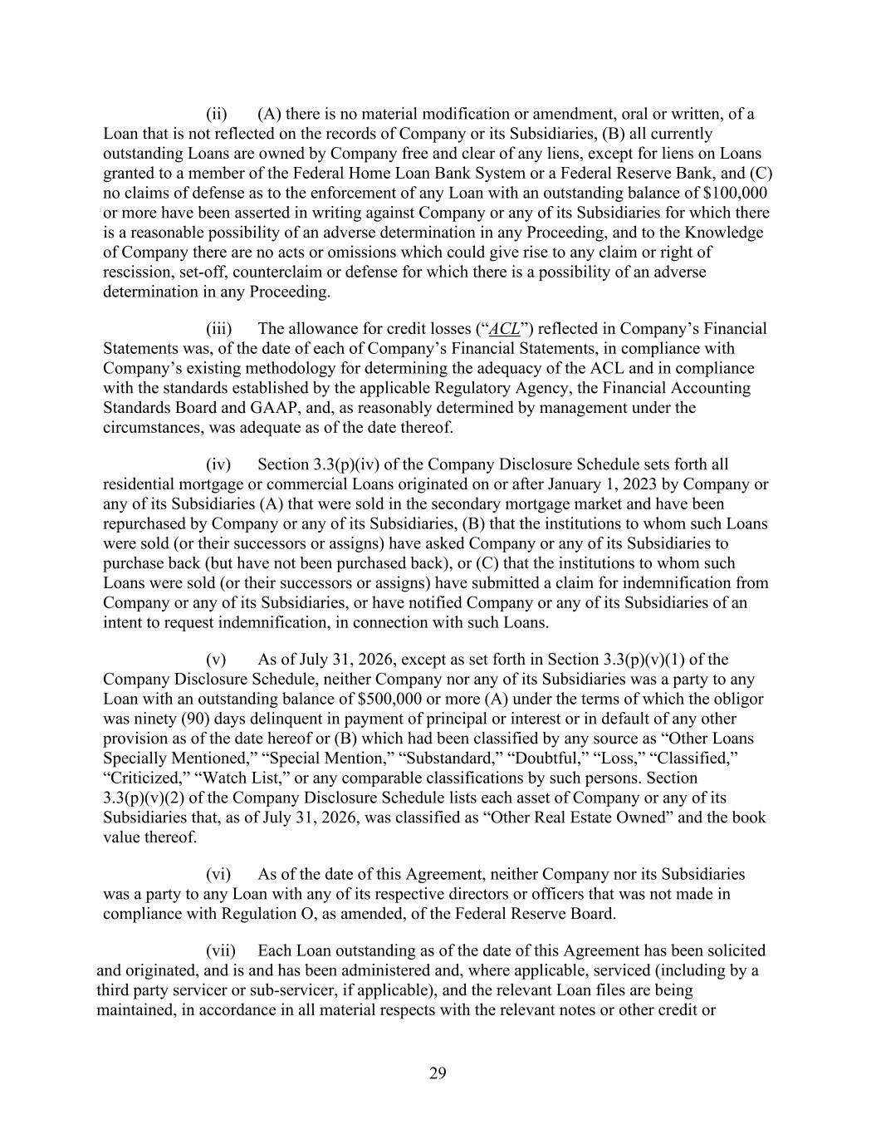
29 (ii) (A) there is no material modification or amendment, oral or written, of a Loan that is not reflected on the records of Company or its Subsidiaries, (B) all currently outstanding Loans are owned by Company free and clear of any liens, except for liens on Loans granted to a member of the Federal Home Loan Bank System or a Federal Reserve Bank, and (C) no claims of defense as to the enforcement of any Loan with an outstanding balance of $100,000 or more have been asserted in writing against Company or any of its Subsidiaries for which there is a reasonable possibility of an adverse determination in any Proceeding, and to the Knowledge of Company there are no acts or omissions which could give rise to any claim or right of rescission, set-off, counterclaim or defense for which there is a possibility of an adverse determination in any Proceeding. (iii) The allowance for credit losses (“ACL”) reflected in Company’s Financial Statements was, of the date of each of Company’s Financial Statements, in compliance with Company’s existing methodology for determining the adequacy of the ACL and in compliance with the standards established by the applicable Regulatory Agency, the Financial Accounting Standards Board and GAAP, and, as reasonably determined by management under the circumstances, was adequate as of the date thereof. (iv) Section 3.3(p)(iv) of the Company Disclosure Schedule sets forth all residential mortgage or commercial Loans originated on or after January 1, 2023 by Company or any of its Subsidiaries (A) that were sold in the secondary mortgage market and have been repurchased by Company or any of its Subsidiaries, (B) that the institutions to whom such Loans were sold (or their successors or assigns) have asked Company or any of its Subsidiaries to purchase back (but have not been purchased back), or (C) that the institutions to whom such Loans were sold (or their successors or assigns) have submitted a claim for indemnification from Company or any of its Subsidiaries, or have notified Company or any of its Subsidiaries of an intent to request indemnification, in connection with such Loans. (v) As of July 31, 2026, except as set forth in Section 3.3(p)(v)(1) of the Company Disclosure Schedule, neither Company nor any of its Subsidiaries was a party to any Loan with an outstanding balance of $500,000 or more (A) under the terms of which the obligor was ninety (90) days delinquent in payment of principal or interest or in default of any other provision as of the date hereof or (B) which had been classified by any source as “Other Loans Specially Mentioned,” “Special Mention,” “Substandard,” “Doubtful,” “Loss,” “Classified,” “Criticized,” “Watch List,” or any comparable classifications by such persons. Section 3.3(p)(v)(2) of the Company Disclosure Schedule lists each asset of Company or any of its Subsidiaries that, as of July 31, 2026, was classified as “Other Real Estate Owned” and the book value thereof. (vi) As of the date of this Agreement, neither Company nor its Subsidiaries was a party to any Loan with any of its respective directors or officers that was not made in compliance with Regulation O, as amended, of the Federal Reserve Board. (vii) Each Loan outstanding as of the date of this Agreement has been solicited and originated, and is and has been administered and, where applicable, serviced (including by a third party servicer or sub-servicer, if applicable), and the relevant Loan files are being maintained, in accordance in all material respects with the relevant notes or other credit or

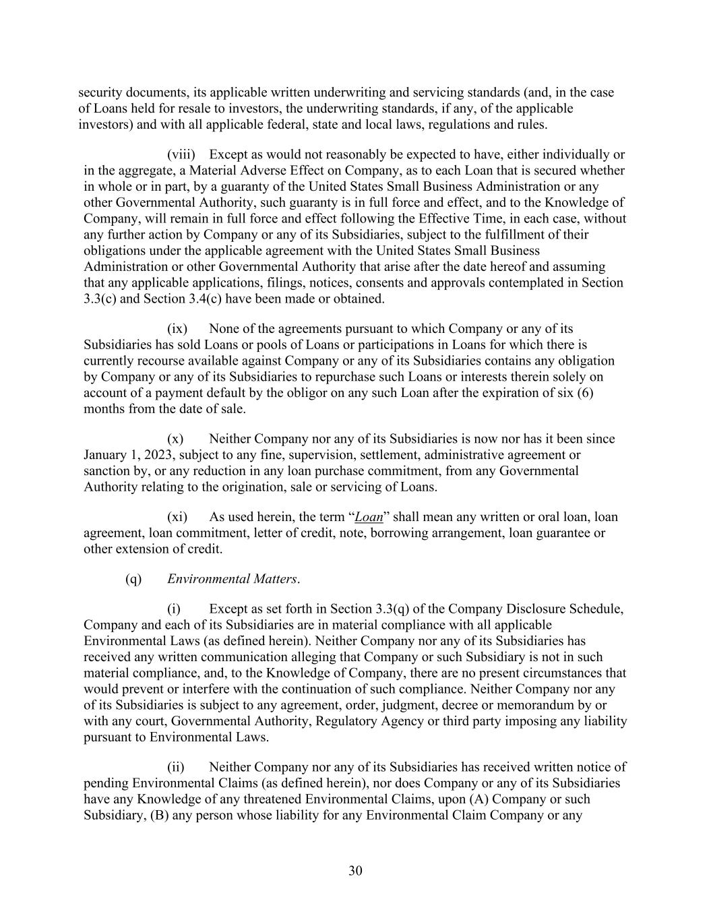
30 security documents, its applicable written underwriting and servicing standards (and, in the case of Loans held for resale to investors, the underwriting standards, if any, of the applicable investors) and with all applicable federal, state and local laws, regulations and rules. (viii) Except as would not reasonably be expected to have, either individually or in the aggregate, a Material Adverse Effect on Company, as to each Loan that is secured whether in whole or in part, by a guaranty of the United States Small Business Administration or any other Governmental Authority, such guaranty is in full force and effect, and to the Knowledge of Company, will remain in full force and effect following the Effective Time, in each case, without any further action by Company or any of its Subsidiaries, subject to the fulfillment of their obligations under the applicable agreement with the United States Small Business Administration or other Governmental Authority that arise after the date hereof and assuming that any applicable applications, filings, notices, consents and approvals contemplated in Section 3.3(c) and Section 3.4(c) have been made or obtained. (ix) None of the agreements pursuant to which Company or any of its Subsidiaries has sold Loans or pools of Loans or participations in Loans for which there is currently recourse available against Company or any of its Subsidiaries contains any obligation by Company or any of its Subsidiaries to repurchase such Loans or interests therein solely on account of a payment default by the obligor on any such Loan after the expiration of six (6) months from the date of sale. (x) Neither Company nor any of its Subsidiaries is now nor has it been since January 1, 2023, subject to any fine, supervision, settlement, administrative agreement or sanction by, or any reduction in any loan purchase commitment, from any Governmental Authority relating to the origination, sale or servicing of Loans. (xi) As used herein, the term “Loan” shall mean any written or oral loan, loan agreement, loan commitment, letter of credit, note, borrowing arrangement, loan guarantee or other extension of credit. (q) Environmental Matters. (i) Except as set forth in Section 3.3(q) of the Company Disclosure Schedule, Company and each of its Subsidiaries are in material compliance with all applicable Environmental Laws (as defined herein). Neither Company nor any of its Subsidiaries has received any written communication alleging that Company or such Subsidiary is not in such material compliance, and, to the Knowledge of Company, there are no present circumstances that would prevent or interfere with the continuation of such compliance. Neither Company nor any of its Subsidiaries is subject to any agreement, order, judgment, decree or memorandum by or with any court, Governmental Authority, Regulatory Agency or third party imposing any liability pursuant to Environmental Laws. (ii) Neither Company nor any of its Subsidiaries has received written notice of pending Environmental Claims (as defined herein), nor does Company or any of its Subsidiaries have any Knowledge of any threatened Environmental Claims, upon (A) Company or such Subsidiary, (B) any person whose liability for any Environmental Claim Company or any

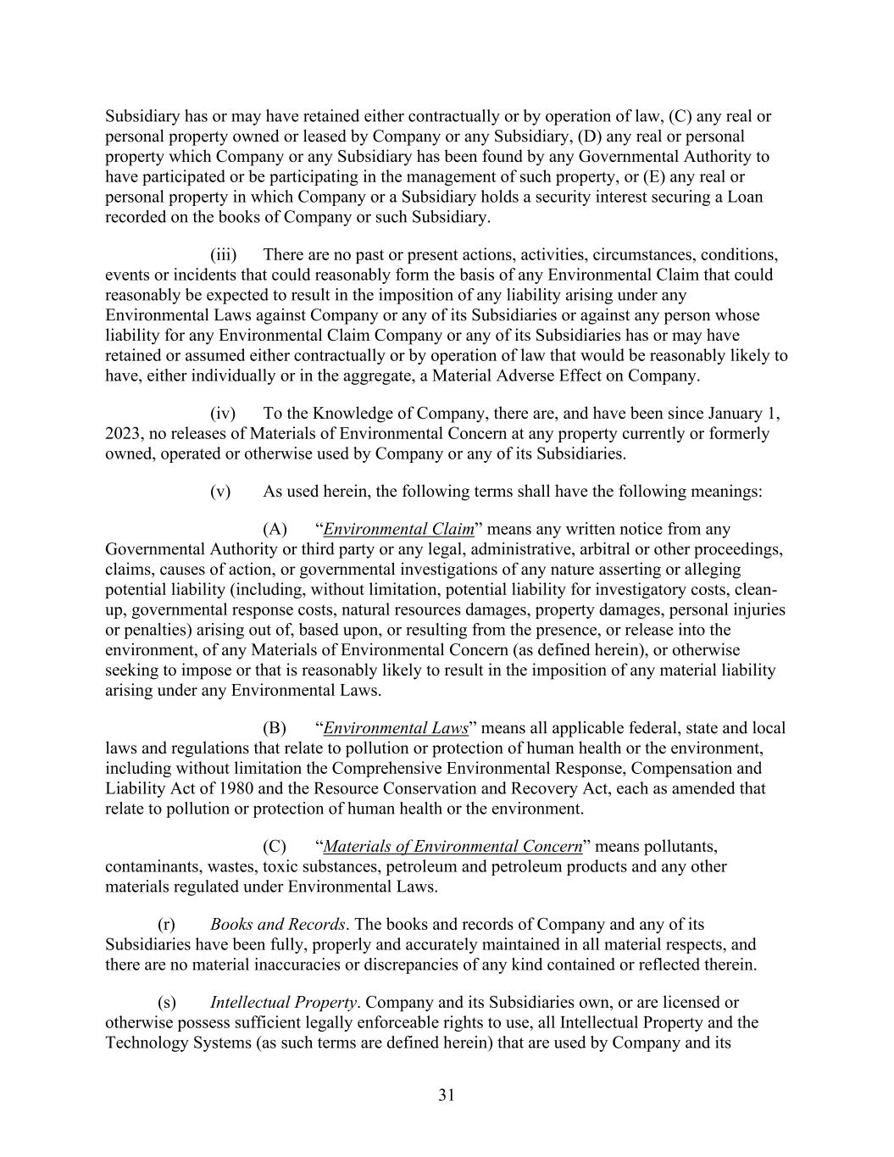
31 Subsidiary has or may have retained either contractually or by operation of law, (C) any real or personal property owned or leased by Company or any Subsidiary, (D) any real or personal property which Company or any Subsidiary has been found by any Governmental Authority to have participated or be participating in the management of such property, or (E) any real or personal property in which Company or a Subsidiary holds a security interest securing a Loan recorded on the books of Company or such Subsidiary. (iii) There are no past or present actions, activities, circumstances, conditions, events or incidents that could reasonably form the basis of any Environmental Claim that could reasonably be expected to result in the imposition of any liability arising under any Environmental Laws against Company or any of its Subsidiaries or against any person whose liability for any Environmental Claim Company or any of its Subsidiaries has or may have retained or assumed either contractually or by operation of law that would be reasonably likely to have, either individually or in the aggregate, a Material Adverse Effect on Company. (iv) To the Knowledge of Company, there are, and have been since January 1, 2023, no releases of Materials of Environmental Concern at any property currently or formerly owned, operated or otherwise used by Company or any of its Subsidiaries. (v) As used herein, the following terms shall have the following meanings: (A) “Environmental Claim” means any written notice from any Governmental Authority or third party or any legal, administrative, arbitral or other proceedings, claims, causes of action, or governmental investigations of any nature asserting or alleging potential liability (including, without limitation, potential liability for investigatory costs, clean- up, governmental response costs, natural resources damages, property damages, personal injuries or penalties) arising out of, based upon, or resulting from the presence, or release into the environment, of any Materials of Environmental Concern (as defined herein), or otherwise seeking to impose or that is reasonably likely to result in the imposition of any material liability arising under any Environmental Laws. (B) “Environmental Laws” means all applicable federal, state and local laws and regulations that relate to pollution or protection of human health or the environment, including without limitation the Comprehensive Environmental Response, Compensation and Liability Act of 1980 and the Resource Conservation and Recovery Act, each as amended that relate to pollution or protection of human health or the environment. (C) “Materials of Environmental Concern” means pollutants, contaminants, wastes, toxic substances, petroleum and petroleum products and any other materials regulated under Environmental Laws. (r) Books and Records. The books and records of Company and any of its Subsidiaries have been fully, properly and accurately maintained in all material respects, and there are no material inaccuracies or discrepancies of any kind contained or reflected therein. (s) Intellectual Property. Company and its Subsidiaries own, or are licensed or otherwise possess sufficient legally enforceable rights to use, all Intellectual Property and the Technology Systems (as such terms are defined herein) that are used by Company and its

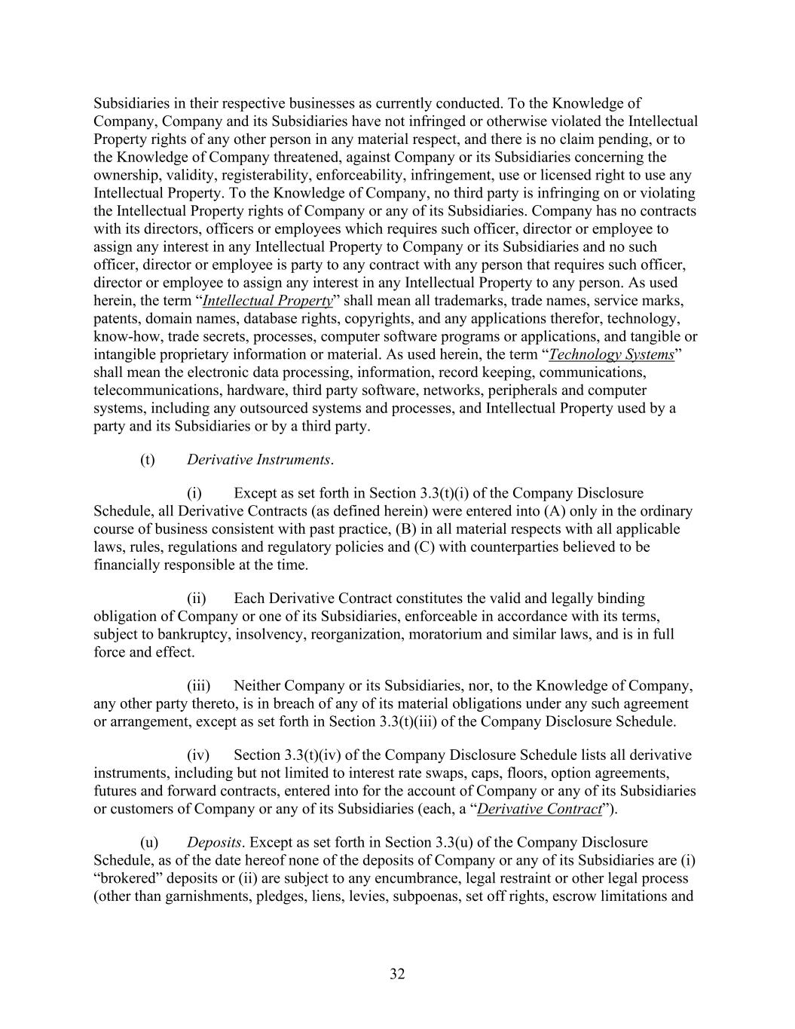
32 Subsidiaries in their respective businesses as currently conducted. To the Knowledge of Company, Company and its Subsidiaries have not infringed or otherwise violated the Intellectual Property rights of any other person in any material respect, and there is no claim pending, or to the Knowledge of Company threatened, against Company or its Subsidiaries concerning the ownership, validity, registerability, enforceability, infringement, use or licensed right to use any Intellectual Property. To the Knowledge of Company, no third party is infringing on or violating the Intellectual Property rights of Company or any of its Subsidiaries. Company has no contracts with its directors, officers or employees which requires such officer, director or employee to assign any interest in any Intellectual Property to Company or its Subsidiaries and no such officer, director or employee is party to any contract with any person that requires such officer, director or employee to assign any interest in any Intellectual Property to any person. As used herein, the term “Intellectual Property” shall mean all trademarks, trade names, service marks, patents, domain names, database rights, copyrights, and any applications therefor, technology, know-how, trade secrets, processes, computer software programs or applications, and tangible or intangible proprietary information or material. As used herein, the term “Technology Systems” shall mean the electronic data processing, information, record keeping, communications, telecommunications, hardware, third party software, networks, peripherals and computer systems, including any outsourced systems and processes, and Intellectual Property used by a party and its Subsidiaries or by a third party. (t) Derivative Instruments. (i) Except as set forth in Section 3.3(t)(i) of the Company Disclosure Schedule, all Derivative Contracts (as defined herein) were entered into (A) only in the ordinary course of business consistent with past practice, (B) in all material respects with all applicable laws, rules, regulations and regulatory policies and (C) with counterparties believed to be financially responsible at the time. (ii) Each Derivative Contract constitutes the valid and legally binding obligation of Company or one of its Subsidiaries, enforceable in accordance with its terms, subject to bankruptcy, insolvency, reorganization, moratorium and similar laws, and is in full force and effect. (iii) Neither Company or its Subsidiaries, nor, to the Knowledge of Company, any other party thereto, is in breach of any of its material obligations under any such agreement or arrangement, except as set forth in Section 3.3(t)(iii) of the Company Disclosure Schedule. (iv) Section 3.3(t)(iv) of the Company Disclosure Schedule lists all derivative instruments, including but not limited to interest rate swaps, caps, floors, option agreements, futures and forward contracts, entered into for the account of Company or any of its Subsidiaries or customers of Company or any of its Subsidiaries (each, a “Derivative Contract”). (u) Deposits. Except as set forth in Section 3.3(u) of the Company Disclosure Schedule, as of the date hereof none of the deposits of Company or any of its Subsidiaries are (i) “brokered” deposits or (ii) are subject to any encumbrance, legal restraint or other legal process (other than garnishments, pledges, liens, levies, subpoenas, set off rights, escrow limitations and

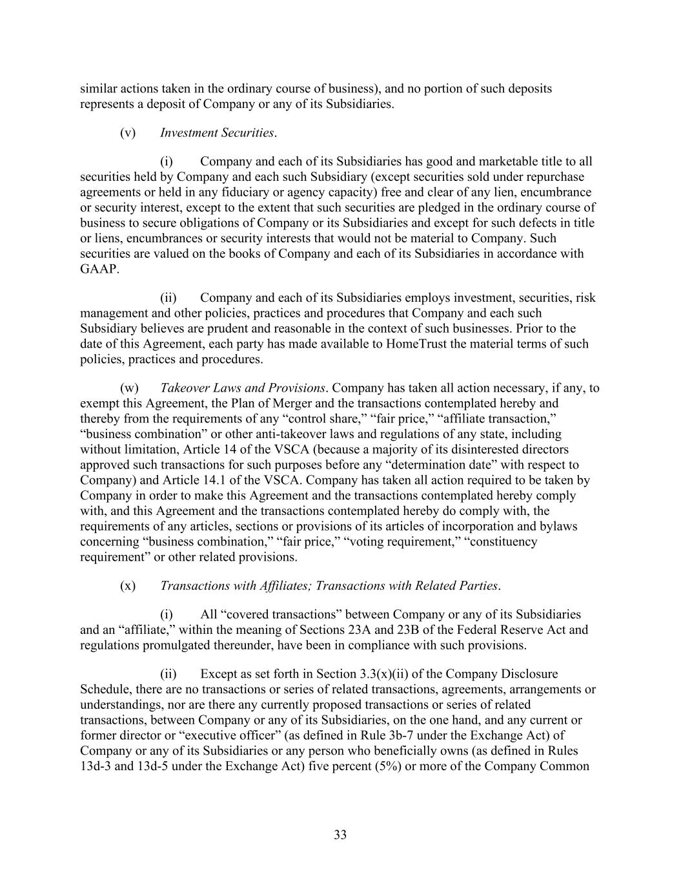
33 similar actions taken in the ordinary course of business), and no portion of such deposits represents a deposit of Company or any of its Subsidiaries. (v) Investment Securities. (i) Company and each of its Subsidiaries has good and marketable title to all securities held by Company and each such Subsidiary (except securities sold under repurchase agreements or held in any fiduciary or agency capacity) free and clear of any lien, encumbrance or security interest, except to the extent that such securities are pledged in the ordinary course of business to secure obligations of Company or its Subsidiaries and except for such defects in title or liens, encumbrances or security interests that would not be material to Company. Such securities are valued on the books of Company and each of its Subsidiaries in accordance with GAAP. (ii) Company and each of its Subsidiaries employs investment, securities, risk management and other policies, practices and procedures that Company and each such Subsidiary believes are prudent and reasonable in the context of such businesses. Prior to the date of this Agreement, each party has made available to HomeTrust the material terms of such policies, practices and procedures. (w) Takeover Laws and Provisions. Company has taken all action necessary, if any, to exempt this Agreement, the Plan of Merger and the transactions contemplated hereby and thereby from the requirements of any “control share,” “fair price,” “affiliate transaction,” “business combination” or other anti-takeover laws and regulations of any state, including without limitation, Article 14 of the VSCA (because a majority of its disinterested directors approved such transactions for such purposes before any “determination date” with respect to Company) and Article 14.1 of the VSCA. Company has taken all action required to be taken by Company in order to make this Agreement and the transactions contemplated hereby comply with, and this Agreement and the transactions contemplated hereby do comply with, the requirements of any articles, sections or provisions of its articles of incorporation and bylaws concerning “business combination,” “fair price,” “voting requirement,” “constituency requirement” or other related provisions. (x) Transactions with Affiliates; Transactions with Related Parties. (i) All “covered transactions” between Company or any of its Subsidiaries and an “affiliate,” within the meaning of Sections 23A and 23B of the Federal Reserve Act and regulations promulgated thereunder, have been in compliance with such provisions. (ii) Except as set forth in Section 3.3(x)(ii) of the Company Disclosure Schedule, there are no transactions or series of related transactions, agreements, arrangements or understandings, nor are there any currently proposed transactions or series of related transactions, between Company or any of its Subsidiaries, on the one hand, and any current or former director or “executive officer” (as defined in Rule 3b-7 under the Exchange Act) of Company or any of its Subsidiaries or any person who beneficially owns (as defined in Rules 13d-3 and 13d-5 under the Exchange Act) five percent (5%) or more of the Company Common

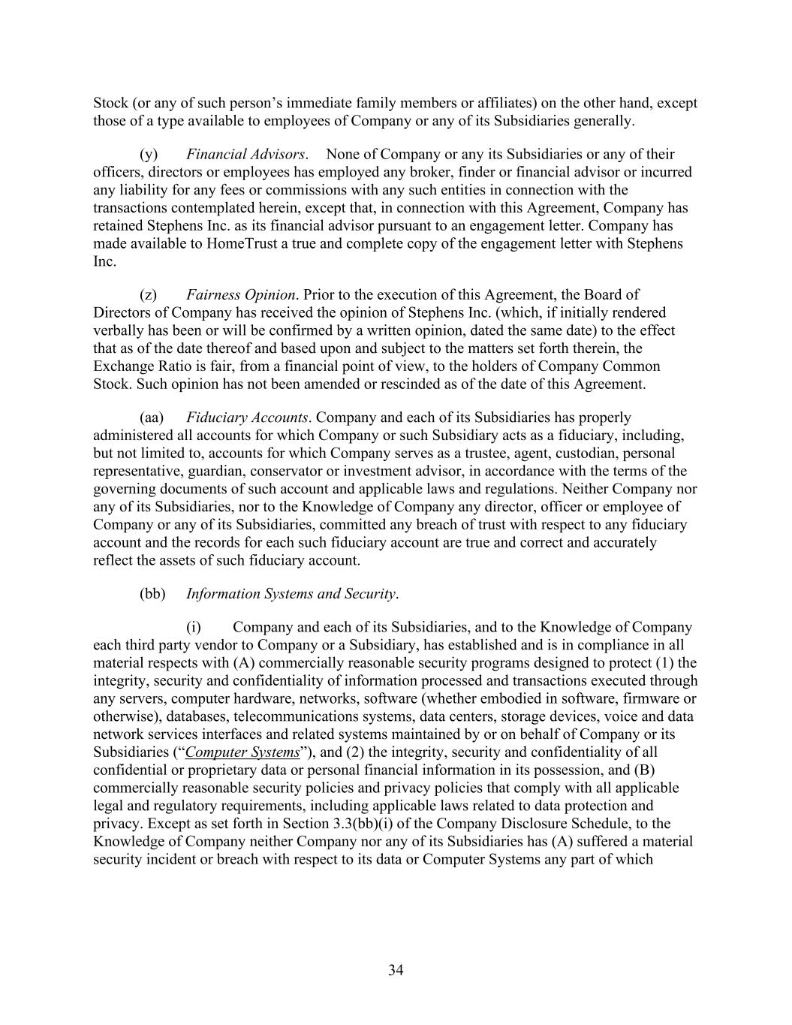
34 Stock (or any of such person’s immediate family members or affiliates) on the other hand, except those of a type available to employees of Company or any of its Subsidiaries generally. (y) Financial Advisors. None of Company or any its Subsidiaries or any of their officers, directors or employees has employed any broker, finder or financial advisor or incurred any liability for any fees or commissions with any such entities in connection with the transactions contemplated herein, except that, in connection with this Agreement, Company has retained Stephens Inc. as its financial advisor pursuant to an engagement letter. Company has made available to HomeTrust a true and complete copy of the engagement letter with Stephens Inc. (z) Fairness Opinion. Prior to the execution of this Agreement, the Board of Directors of Company has received the opinion of Stephens Inc. (which, if initially rendered verbally has been or will be confirmed by a written opinion, dated the same date) to the effect that as of the date thereof and based upon and subject to the matters set forth therein, the Exchange Ratio is fair, from a financial point of view, to the holders of Company Common Stock. Such opinion has not been amended or rescinded as of the date of this Agreement. (aa) Fiduciary Accounts. Company and each of its Subsidiaries has properly administered all accounts for which Company or such Subsidiary acts as a fiduciary, including, but not limited to, accounts for which Company serves as a trustee, agent, custodian, personal representative, guardian, conservator or investment advisor, in accordance with the terms of the governing documents of such account and applicable laws and regulations. Neither Company nor any of its Subsidiaries, nor to the Knowledge of Company any director, officer or employee of Company or any of its Subsidiaries, committed any breach of trust with respect to any fiduciary account and the records for each such fiduciary account are true and correct and accurately reflect the assets of such fiduciary account. (bb) Information Systems and Security. (i) Company and each of its Subsidiaries, and to the Knowledge of Company each third party vendor to Company or a Subsidiary, has established and is in compliance in all material respects with (A) commercially reasonable security programs designed to protect (1) the integrity, security and confidentiality of information processed and transactions executed through any servers, computer hardware, networks, software (whether embodied in software, firmware or otherwise), databases, telecommunications systems, data centers, storage devices, voice and data network services interfaces and related systems maintained by or on behalf of Company or its Subsidiaries (“Computer Systems”), and (2) the integrity, security and confidentiality of all confidential or proprietary data or personal financial information in its possession, and (B) commercially reasonable security policies and privacy policies that comply with all applicable legal and regulatory requirements, including applicable laws related to data protection and privacy. Except as set forth in Section 3.3(bb)(i) of the Company Disclosure Schedule, to the Knowledge of Company neither Company nor any of its Subsidiaries has (A) suffered a material security incident or breach with respect to its data or Computer Systems any part of which

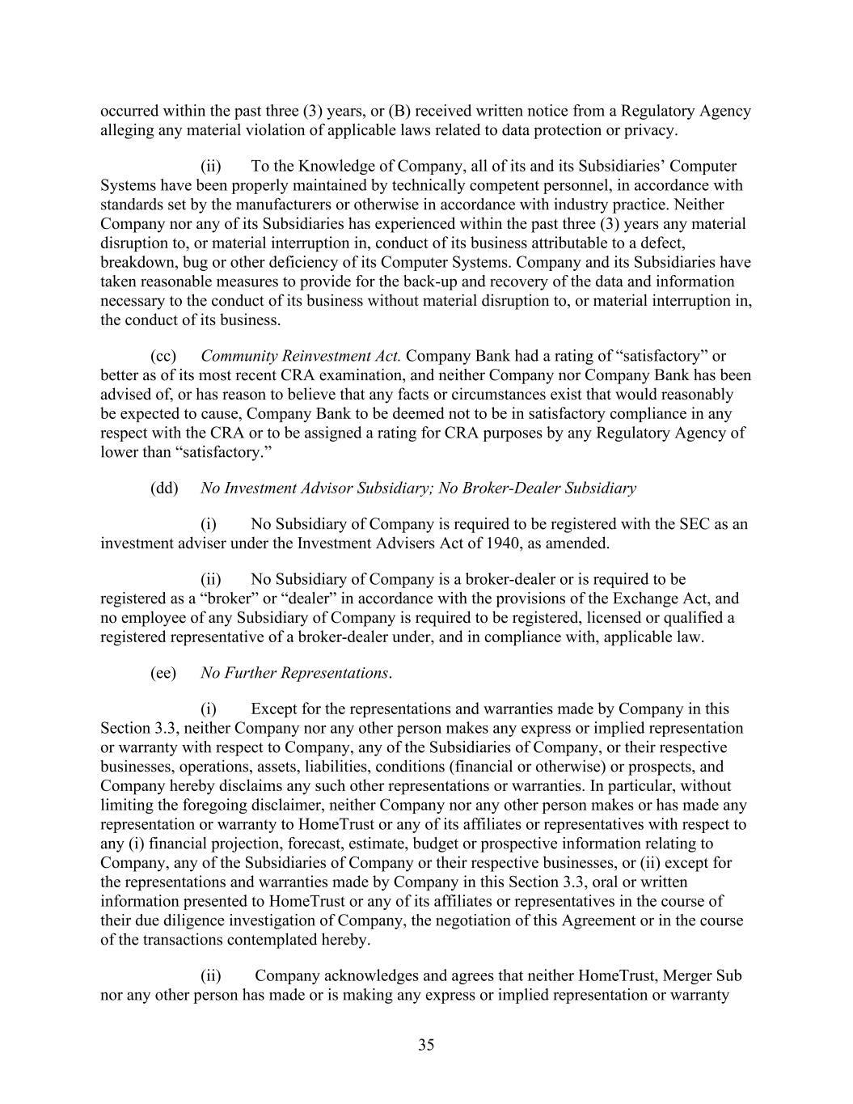
35 occurred within the past three (3) years, or (B) received written notice from a Regulatory Agency alleging any material violation of applicable laws related to data protection or privacy. (ii) To the Knowledge of Company, all of its and its Subsidiaries’ Computer Systems have been properly maintained by technically competent personnel, in accordance with standards set by the manufacturers or otherwise in accordance with industry practice. Neither Company nor any of its Subsidiaries has experienced within the past three (3) years any material disruption to, or material interruption in, conduct of its business attributable to a defect, breakdown, bug or other deficiency of its Computer Systems. Company and its Subsidiaries have taken reasonable measures to provide for the back-up and recovery of the data and information necessary to the conduct of its business without material disruption to, or material interruption in, the conduct of its business. (cc) Community Reinvestment Act. Company Bank had a rating of “satisfactory” or better as of its most recent CRA examination, and neither Company nor Company Bank has been advised of, or has reason to believe that any facts or circumstances exist that would reasonably be expected to cause, Company Bank to be deemed not to be in satisfactory compliance in any respect with the CRA or to be assigned a rating for CRA purposes by any Regulatory Agency of lower than “satisfactory.” (dd) No Investment Advisor Subsidiary; No Broker-Dealer Subsidiary (i) No Subsidiary of Company is required to be registered with the SEC as an investment adviser under the Investment Advisers Act of 1940, as amended. (ii) No Subsidiary of Company is a broker-dealer or is required to be registered as a “broker” or “dealer” in accordance with the provisions of the Exchange Act, and no employee of any Subsidiary of Company is required to be registered, licensed or qualified a registered representative of a broker-dealer under, and in compliance with, applicable law. (ee) No Further Representations. (i) Except for the representations and warranties made by Company in this Section 3.3, neither Company nor any other person makes any express or implied representation or warranty with respect to Company, any of the Subsidiaries of Company, or their respective businesses, operations, assets, liabilities, conditions (financial or otherwise) or prospects, and Company hereby disclaims any such other representations or warranties. In particular, without limiting the foregoing disclaimer, neither Company nor any other person makes or has made any representation or warranty to HomeTrust or any of its affiliates or representatives with respect to any (i) financial projection, forecast, estimate, budget or prospective information relating to Company, any of the Subsidiaries of Company or their respective businesses, or (ii) except for the representations and warranties made by Company in this Section 3.3, oral or written information presented to HomeTrust or any of its affiliates or representatives in the course of their due diligence investigation of Company, the negotiation of this Agreement or in the course of the transactions contemplated hereby. (ii) Company acknowledges and agrees that neither HomeTrust, Merger Sub nor any other person has made or is making any express or implied representation or warranty

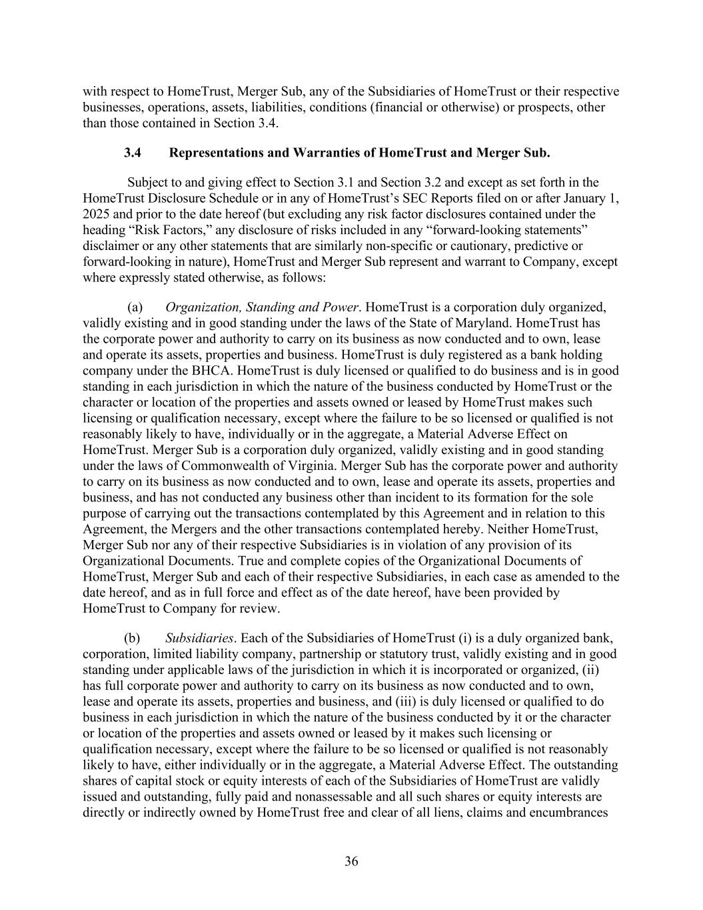
36 with respect to HomeTrust, Merger Sub, any of the Subsidiaries of HomeTrust or their respective businesses, operations, assets, liabilities, conditions (financial or otherwise) or prospects, other than those contained in Section 3.4. 3.4 Representations and Warranties of HomeTrust and Merger Sub. Subject to and giving effect to Section 3.1 and Section 3.2 and except as set forth in the HomeTrust Disclosure Schedule or in any of HomeTrust’s SEC Reports filed on or after January 1, 2025 and prior to the date hereof (but excluding any risk factor disclosures contained under the heading “Risk Factors,” any disclosure of risks included in any “forward-looking statements” disclaimer or any other statements that are similarly non-specific or cautionary, predictive or forward-looking in nature), HomeTrust and Merger Sub represent and warrant to Company, except where expressly stated otherwise, as follows: (a) Organization, Standing and Power. HomeTrust is a corporation duly organized, validly existing and in good standing under the laws of the State of Maryland. HomeTrust has the corporate power and authority to carry on its business as now conducted and to own, lease and operate its assets, properties and business. HomeTrust is duly registered as a bank holding company under the BHCA. HomeTrust is duly licensed or qualified to do business and is in good standing in each jurisdiction in which the nature of the business conducted by HomeTrust or the character or location of the properties and assets owned or leased by HomeTrust makes such licensing or qualification necessary, except where the failure to be so licensed or qualified is not reasonably likely to have, individually or in the aggregate, a Material Adverse Effect on HomeTrust. Merger Sub is a corporation duly organized, validly existing and in good standing under the laws of Commonwealth of Virginia. Merger Sub has the corporate power and authority to carry on its business as now conducted and to own, lease and operate its assets, properties and business, and has not conducted any business other than incident to its formation for the sole purpose of carrying out the transactions contemplated by this Agreement and in relation to this Agreement, the Mergers and the other transactions contemplated hereby. Neither HomeTrust, Merger Sub nor any of their respective Subsidiaries is in violation of any provision of its Organizational Documents. True and complete copies of the Organizational Documents of HomeTrust, Merger Sub and each of their respective Subsidiaries, in each case as amended to the date hereof, and as in full force and effect as of the date hereof, have been provided by HomeTrust to Company for review. (b) Subsidiaries. Each of the Subsidiaries of HomeTrust (i) is a duly organized bank, corporation, limited liability company, partnership or statutory trust, validly existing and in good standing under applicable laws of the jurisdiction in which it is incorporated or organized, (ii) has full corporate power and authority to carry on its business as now conducted and to own, lease and operate its assets, properties and business, and (iii) is duly licensed or qualified to do business in each jurisdiction in which the nature of the business conducted by it or the character or location of the properties and assets owned or leased by it makes such licensing or qualification necessary, except where the failure to be so licensed or qualified is not reasonably likely to have, either individually or in the aggregate, a Material Adverse Effect. The outstanding shares of capital stock or equity interests of each of the Subsidiaries of HomeTrust are validly issued and outstanding, fully paid and nonassessable and all such shares or equity interests are directly or indirectly owned by HomeTrust free and clear of all liens, claims and encumbrances

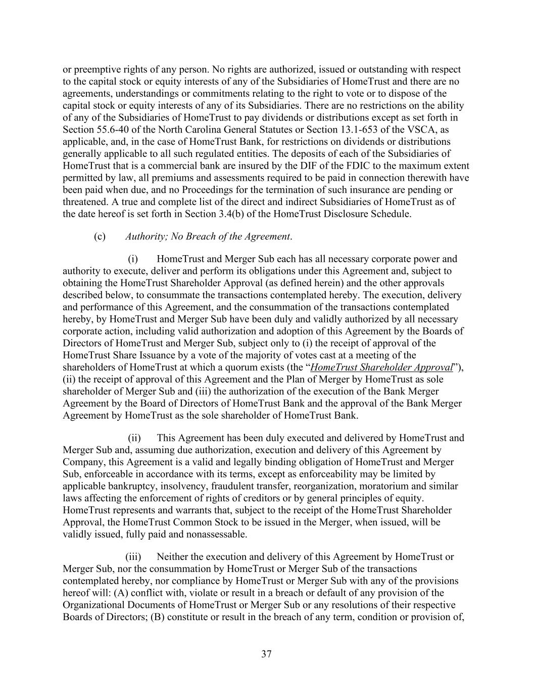
37 or preemptive rights of any person. No rights are authorized, issued or outstanding with respect to the capital stock or equity interests of any of the Subsidiaries of HomeTrust and there are no agreements, understandings or commitments relating to the right to vote or to dispose of the capital stock or equity interests of any of its Subsidiaries. There are no restrictions on the ability of any of the Subsidiaries of HomeTrust to pay dividends or distributions except as set forth in Section 55.6-40 of the North Carolina General Statutes or Section 13.1-653 of the VSCA, as applicable, and, in the case of HomeTrust Bank, for restrictions on dividends or distributions generally applicable to all such regulated entities. The deposits of each of the Subsidiaries of HomeTrust that is a commercial bank are insured by the DIF of the FDIC to the maximum extent permitted by law, all premiums and assessments required to be paid in connection therewith have been paid when due, and no Proceedings for the termination of such insurance are pending or threatened. A true and complete list of the direct and indirect Subsidiaries of HomeTrust as of the date hereof is set forth in Section 3.4(b) of the HomeTrust Disclosure Schedule. (c) Authority; No Breach of the Agreement. (i) HomeTrust and Merger Sub each has all necessary corporate power and authority to execute, deliver and perform its obligations under this Agreement and, subject to obtaining the HomeTrust Shareholder Approval (as defined herein) and the other approvals described below, to consummate the transactions contemplated hereby. The execution, delivery and performance of this Agreement, and the consummation of the transactions contemplated hereby, by HomeTrust and Merger Sub have been duly and validly authorized by all necessary corporate action, including valid authorization and adoption of this Agreement by the Boards of Directors of HomeTrust and Merger Sub, subject only to (i) the receipt of approval of the HomeTrust Share Issuance by a vote of the majority of votes cast at a meeting of the shareholders of HomeTrust at which a quorum exists (the “HomeTrust Shareholder Approval”), (ii) the receipt of approval of this Agreement and the Plan of Merger by HomeTrust as sole shareholder of Merger Sub and (iii) the authorization of the execution of the Bank Merger Agreement by the Board of Directors of HomeTrust Bank and the approval of the Bank Merger Agreement by HomeTrust as the sole shareholder of HomeTrust Bank. (ii) This Agreement has been duly executed and delivered by HomeTrust and Merger Sub and, assuming due authorization, execution and delivery of this Agreement by Company, this Agreement is a valid and legally binding obligation of HomeTrust and Merger Sub, enforceable in accordance with its terms, except as enforceability may be limited by applicable bankruptcy, insolvency, fraudulent transfer, reorganization, moratorium and similar laws affecting the enforcement of rights of creditors or by general principles of equity. HomeTrust represents and warrants that, subject to the receipt of the HomeTrust Shareholder Approval, the HomeTrust Common Stock to be issued in the Merger, when issued, will be validly issued, fully paid and nonassessable. (iii) Neither the execution and delivery of this Agreement by HomeTrust or Merger Sub, nor the consummation by HomeTrust or Merger Sub of the transactions contemplated hereby, nor compliance by HomeTrust or Merger Sub with any of the provisions hereof will: (A) conflict with, violate or result in a breach or default of any provision of the Organizational Documents of HomeTrust or Merger Sub or any resolutions of their respective Boards of Directors; (B) constitute or result in the breach of any term, condition or provision of,

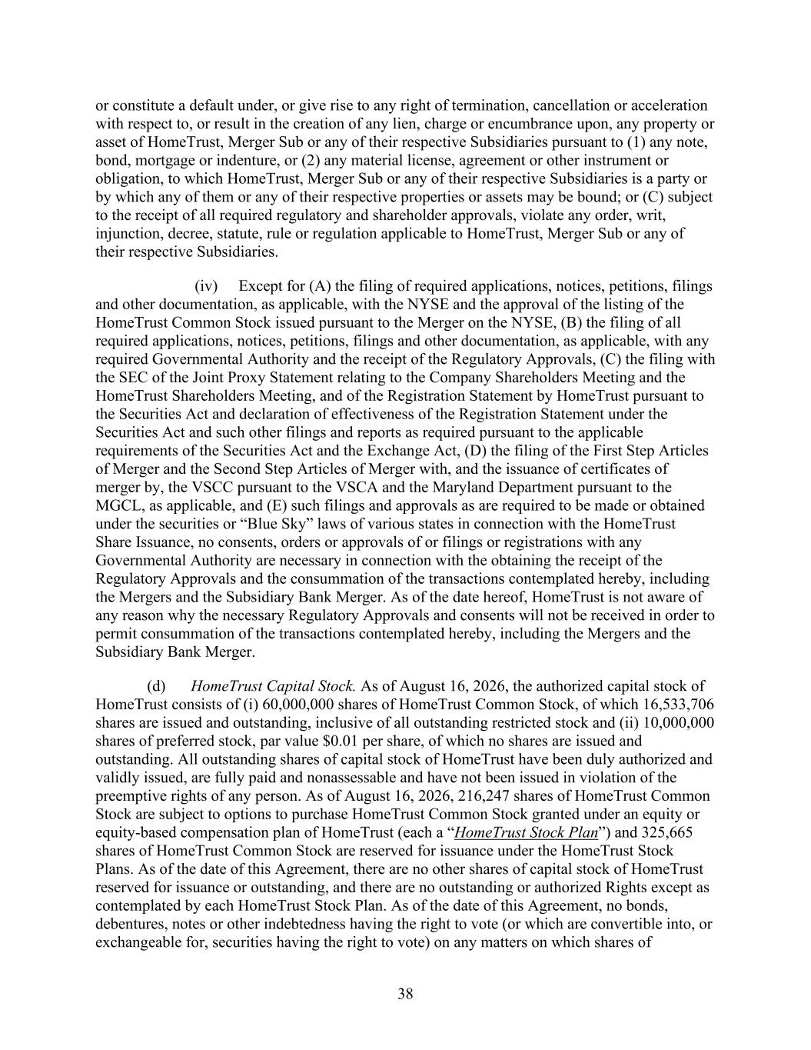
38 or constitute a default under, or give rise to any right of termination, cancellation or acceleration with respect to, or result in the creation of any lien, charge or encumbrance upon, any property or asset of HomeTrust, Merger Sub or any of their respective Subsidiaries pursuant to (1) any note, bond, mortgage or indenture, or (2) any material license, agreement or other instrument or obligation, to which HomeTrust, Merger Sub or any of their respective Subsidiaries is a party or by which any of them or any of their respective properties or assets may be bound; or (C) subject to the receipt of all required regulatory and shareholder approvals, violate any order, writ, injunction, decree, statute, rule or regulation applicable to HomeTrust, Merger Sub or any of their respective Subsidiaries. (iv) Except for (A) the filing of required applications, notices, petitions, filings and other documentation, as applicable, with the NYSE and the approval of the listing of the HomeTrust Common Stock issued pursuant to the Merger on the NYSE, (B) the filing of all required applications, notices, petitions, filings and other documentation, as applicable, with any required Governmental Authority and the receipt of the Regulatory Approvals, (C) the filing with the SEC of the Joint Proxy Statement relating to the Company Shareholders Meeting and the HomeTrust Shareholders Meeting, and of the Registration Statement by HomeTrust pursuant to the Securities Act and declaration of effectiveness of the Registration Statement under the Securities Act and such other filings and reports as required pursuant to the applicable requirements of the Securities Act and the Exchange Act, (D) the filing of the First Step Articles of Merger and the Second Step Articles of Merger with, and the issuance of certificates of merger by, the VSCC pursuant to the VSCA and the Maryland Department pursuant to the MGCL, as applicable, and (E) such filings and approvals as are required to be made or obtained under the securities or “Blue Sky” laws of various states in connection with the HomeTrust Share Issuance, no consents, orders or approvals of or filings or registrations with any Governmental Authority are necessary in connection with the obtaining the receipt of the Regulatory Approvals and the consummation of the transactions contemplated hereby, including the Mergers and the Subsidiary Bank Merger. As of the date hereof, HomeTrust is not aware of any reason why the necessary Regulatory Approvals and consents will not be received in order to permit consummation of the transactions contemplated hereby, including the Mergers and the Subsidiary Bank Merger. (d) HomeTrust Capital Stock. As of August 16, 2026, the authorized capital stock of HomeTrust consists of (i) 60,000,000 shares of HomeTrust Common Stock, of which 16,533,706 shares are issued and outstanding, inclusive of all outstanding restricted stock and (ii) 10,000,000 shares of preferred stock, par value $0.01 per share, of which no shares are issued and outstanding. All outstanding shares of capital stock of HomeTrust have been duly authorized and validly issued, are fully paid and nonassessable and have not been issued in violation of the preemptive rights of any person. As of August 16, 2026, 216,247 shares of HomeTrust Common Stock are subject to options to purchase HomeTrust Common Stock granted under an equity or equity-based compensation plan of HomeTrust (each a “HomeTrust Stock Plan”) and 325,665 shares of HomeTrust Common Stock are reserved for issuance under the HomeTrust Stock Plans. As of the date of this Agreement, there are no other shares of capital stock of HomeTrust reserved for issuance or outstanding, and there are no outstanding or authorized Rights except as contemplated by each HomeTrust Stock Plan. As of the date of this Agreement, no bonds, debentures, notes or other indebtedness having the right to vote (or which are convertible into, or exchangeable for, securities having the right to vote) on any matters on which shares of

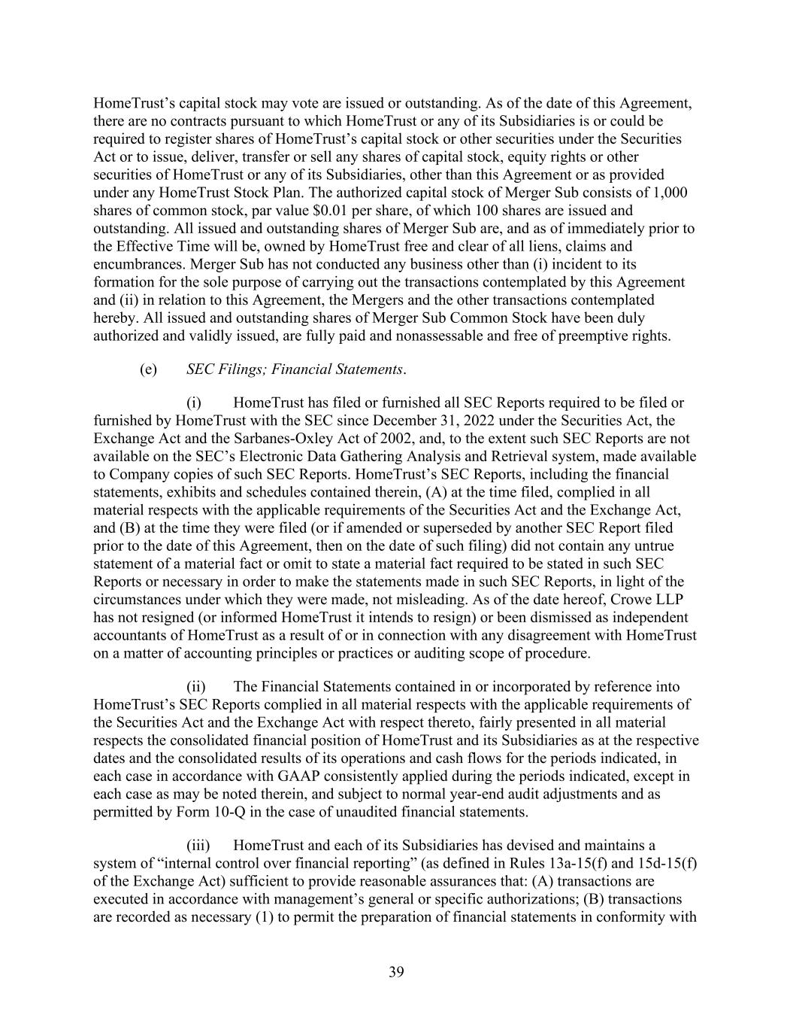
39 HomeTrust’s capital stock may vote are issued or outstanding. As of the date of this Agreement, there are no contracts pursuant to which HomeTrust or any of its Subsidiaries is or could be required to register shares of HomeTrust’s capital stock or other securities under the Securities Act or to issue, deliver, transfer or sell any shares of capital stock, equity rights or other securities of HomeTrust or any of its Subsidiaries, other than this Agreement or as provided under any HomeTrust Stock Plan. The authorized capital stock of Merger Sub consists of 1,000 shares of common stock, par value $0.01 per share, of which 100 shares are issued and outstanding. All issued and outstanding shares of Merger Sub are, and as of immediately prior to the Effective Time will be, owned by HomeTrust free and clear of all liens, claims and encumbrances. Merger Sub has not conducted any business other than (i) incident to its formation for the sole purpose of carrying out the transactions contemplated by this Agreement and (ii) in relation to this Agreement, the Mergers and the other transactions contemplated hereby. All issued and outstanding shares of Merger Sub Common Stock have been duly authorized and validly issued, are fully paid and nonassessable and free of preemptive rights. (e) SEC Filings; Financial Statements. (i) HomeTrust has filed or furnished all SEC Reports required to be filed or furnished by HomeTrust with the SEC since December 31, 2022 under the Securities Act, the Exchange Act and the Sarbanes-Oxley Act of 2002, and, to the extent such SEC Reports are not available on the SEC’s Electronic Data Gathering Analysis and Retrieval system, made available to Company copies of such SEC Reports. HomeTrust’s SEC Reports, including the financial statements, exhibits and schedules contained therein, (A) at the time filed, complied in all material respects with the applicable requirements of the Securities Act and the Exchange Act, and (B) at the time they were filed (or if amended or superseded by another SEC Report filed prior to the date of this Agreement, then on the date of such filing) did not contain any untrue statement of a material fact or omit to state a material fact required to be stated in such SEC Reports or necessary in order to make the statements made in such SEC Reports, in light of the circumstances under which they were made, not misleading. As of the date hereof, Crowe LLP has not resigned (or informed HomeTrust it intends to resign) or been dismissed as independent accountants of HomeTrust as a result of or in connection with any disagreement with HomeTrust on a matter of accounting principles or practices or auditing scope of procedure. (ii) The Financial Statements contained in or incorporated by reference into HomeTrust’s SEC Reports complied in all material respects with the applicable requirements of the Securities Act and the Exchange Act with respect thereto, fairly presented in all material respects the consolidated financial position of HomeTrust and its Subsidiaries as at the respective dates and the consolidated results of its operations and cash flows for the periods indicated, in each case in accordance with GAAP consistently applied during the periods indicated, except in each case as may be noted therein, and subject to normal year-end audit adjustments and as permitted by Form 10-Q in the case of unaudited financial statements. (iii) HomeTrust and each of its Subsidiaries has devised and maintains a system of “internal control over financial reporting” (as defined in Rules 13a-15(f) and 15d-15(f) of the Exchange Act) sufficient to provide reasonable assurances that: (A) transactions are executed in accordance with management’s general or specific authorizations; (B) transactions are recorded as necessary (1) to permit the preparation of financial statements in conformity with

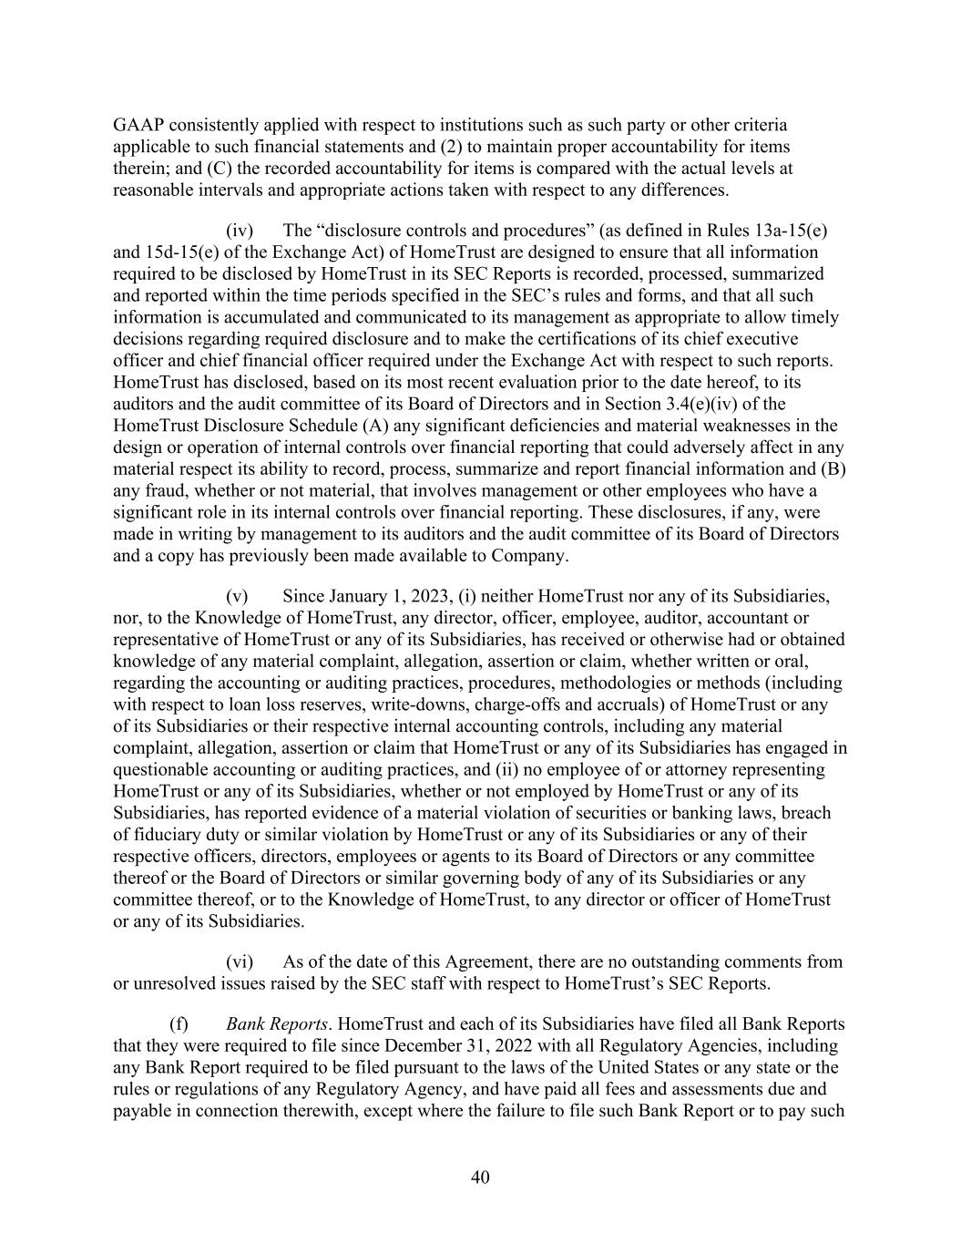
40 GAAP consistently applied with respect to institutions such as such party or other criteria applicable to such financial statements and (2) to maintain proper accountability for items therein; and (C) the recorded accountability for items is compared with the actual levels at reasonable intervals and appropriate actions taken with respect to any differences. (iv) The “disclosure controls and procedures” (as defined in Rules 13a-15(e) and 15d-15(e) of the Exchange Act) of HomeTrust are designed to ensure that all information required to be disclosed by HomeTrust in its SEC Reports is recorded, processed, summarized and reported within the time periods specified in the SEC’s rules and forms, and that all such information is accumulated and communicated to its management as appropriate to allow timely decisions regarding required disclosure and to make the certifications of its chief executive officer and chief financial officer required under the Exchange Act with respect to such reports. HomeTrust has disclosed, based on its most recent evaluation prior to the date hereof, to its auditors and the audit committee of its Board of Directors and in Section 3.4(e)(iv) of the HomeTrust Disclosure Schedule (A) any significant deficiencies and material weaknesses in the design or operation of internal controls over financial reporting that could adversely affect in any material respect its ability to record, process, summarize and report financial information and (B) any fraud, whether or not material, that involves management or other employees who have a significant role in its internal controls over financial reporting. These disclosures, if any, were made in writing by management to its auditors and the audit committee of its Board of Directors and a copy has previously been made available to Company. (v) Since January 1, 2023, (i) neither HomeTrust nor any of its Subsidiaries, nor, to the Knowledge of HomeTrust, any director, officer, employee, auditor, accountant or representative of HomeTrust or any of its Subsidiaries, has received or otherwise had or obtained knowledge of any material complaint, allegation, assertion or claim, whether written or oral, regarding the accounting or auditing practices, procedures, methodologies or methods (including with respect to loan loss reserves, write-downs, charge-offs and accruals) of HomeTrust or any of its Subsidiaries or their respective internal accounting controls, including any material complaint, allegation, assertion or claim that HomeTrust or any of its Subsidiaries has engaged in questionable accounting or auditing practices, and (ii) no employee of or attorney representing HomeTrust or any of its Subsidiaries, whether or not employed by HomeTrust or any of its Subsidiaries, has reported evidence of a material violation of securities or banking laws, breach of fiduciary duty or similar violation by HomeTrust or any of its Subsidiaries or any of their respective officers, directors, employees or agents to its Board of Directors or any committee thereof or the Board of Directors or similar governing body of any of its Subsidiaries or any committee thereof, or to the Knowledge of HomeTrust, to any director or officer of HomeTrust or any of its Subsidiaries. (vi) As of the date of this Agreement, there are no outstanding comments from or unresolved issues raised by the SEC staff with respect to HomeTrust’s SEC Reports. (f) Bank Reports. HomeTrust and each of its Subsidiaries have filed all Bank Reports that they were required to file since December 31, 2022 with all Regulatory Agencies, including any Bank Report required to be filed pursuant to the laws of the United States or any state or the rules or regulations of any Regulatory Agency, and have paid all fees and assessments due and payable in connection therewith, except where the failure to file such Bank Report or to pay such

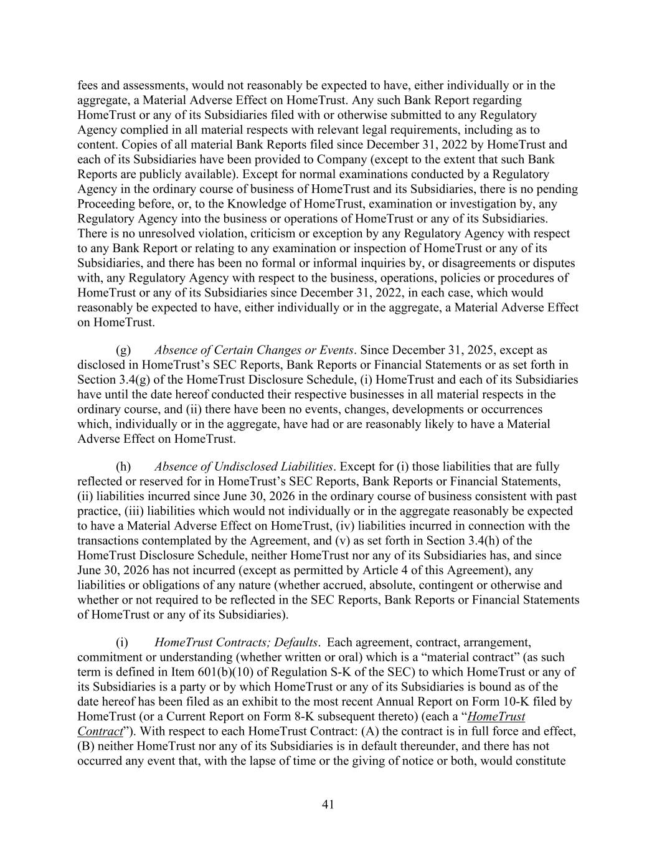
41 fees and assessments, would not reasonably be expected to have, either individually or in the aggregate, a Material Adverse Effect on HomeTrust. Any such Bank Report regarding HomeTrust or any of its Subsidiaries filed with or otherwise submitted to any Regulatory Agency complied in all material respects with relevant legal requirements, including as to content. Copies of all material Bank Reports filed since December 31, 2022 by HomeTrust and each of its Subsidiaries have been provided to Company (except to the extent that such Bank Reports are publicly available). Except for normal examinations conducted by a Regulatory Agency in the ordinary course of business of HomeTrust and its Subsidiaries, there is no pending Proceeding before, or, to the Knowledge of HomeTrust, examination or investigation by, any Regulatory Agency into the business or operations of HomeTrust or any of its Subsidiaries. There is no unresolved violation, criticism or exception by any Regulatory Agency with respect to any Bank Report or relating to any examination or inspection of HomeTrust or any of its Subsidiaries, and there has been no formal or informal inquiries by, or disagreements or disputes with, any Regulatory Agency with respect to the business, operations, policies or procedures of HomeTrust or any of its Subsidiaries since December 31, 2022, in each case, which would reasonably be expected to have, either individually or in the aggregate, a Material Adverse Effect on HomeTrust. (g) Absence of Certain Changes or Events. Since December 31, 2025, except as disclosed in HomeTrust’s SEC Reports, Bank Reports or Financial Statements or as set forth in Section 3.4(g) of the HomeTrust Disclosure Schedule, (i) HomeTrust and each of its Subsidiaries have until the date hereof conducted their respective businesses in all material respects in the ordinary course, and (ii) there have been no events, changes, developments or occurrences which, individually or in the aggregate, have had or are reasonably likely to have a Material Adverse Effect on HomeTrust. (h) Absence of Undisclosed Liabilities. Except for (i) those liabilities that are fully reflected or reserved for in HomeTrust’s SEC Reports, Bank Reports or Financial Statements, (ii) liabilities incurred since June 30, 2026 in the ordinary course of business consistent with past practice, (iii) liabilities which would not individually or in the aggregate reasonably be expected to have a Material Adverse Effect on HomeTrust, (iv) liabilities incurred in connection with the transactions contemplated by the Agreement, and (v) as set forth in Section 3.4(h) of the HomeTrust Disclosure Schedule, neither HomeTrust nor any of its Subsidiaries has, and since June 30, 2026 has not incurred (except as permitted by Article 4 of this Agreement), any liabilities or obligations of any nature (whether accrued, absolute, contingent or otherwise and whether or not required to be reflected in the SEC Reports, Bank Reports or Financial Statements of HomeTrust or any of its Subsidiaries). (i) HomeTrust Contracts; Defaults. Each agreement, contract, arrangement, commitment or understanding (whether written or oral) which is a “material contract” (as such term is defined in Item 601(b)(10) of Regulation S-K of the SEC) to which HomeTrust or any of its Subsidiaries is a party or by which HomeTrust or any of its Subsidiaries is bound as of the date hereof has been filed as an exhibit to the most recent Annual Report on Form 10-K filed by HomeTrust (or a Current Report on Form 8-K subsequent thereto) (each a “HomeTrust Contract”). With respect to each HomeTrust Contract: (A) the contract is in full force and effect, (B) neither HomeTrust nor any of its Subsidiaries is in default thereunder, and there has not occurred any event that, with the lapse of time or the giving of notice or both, would constitute

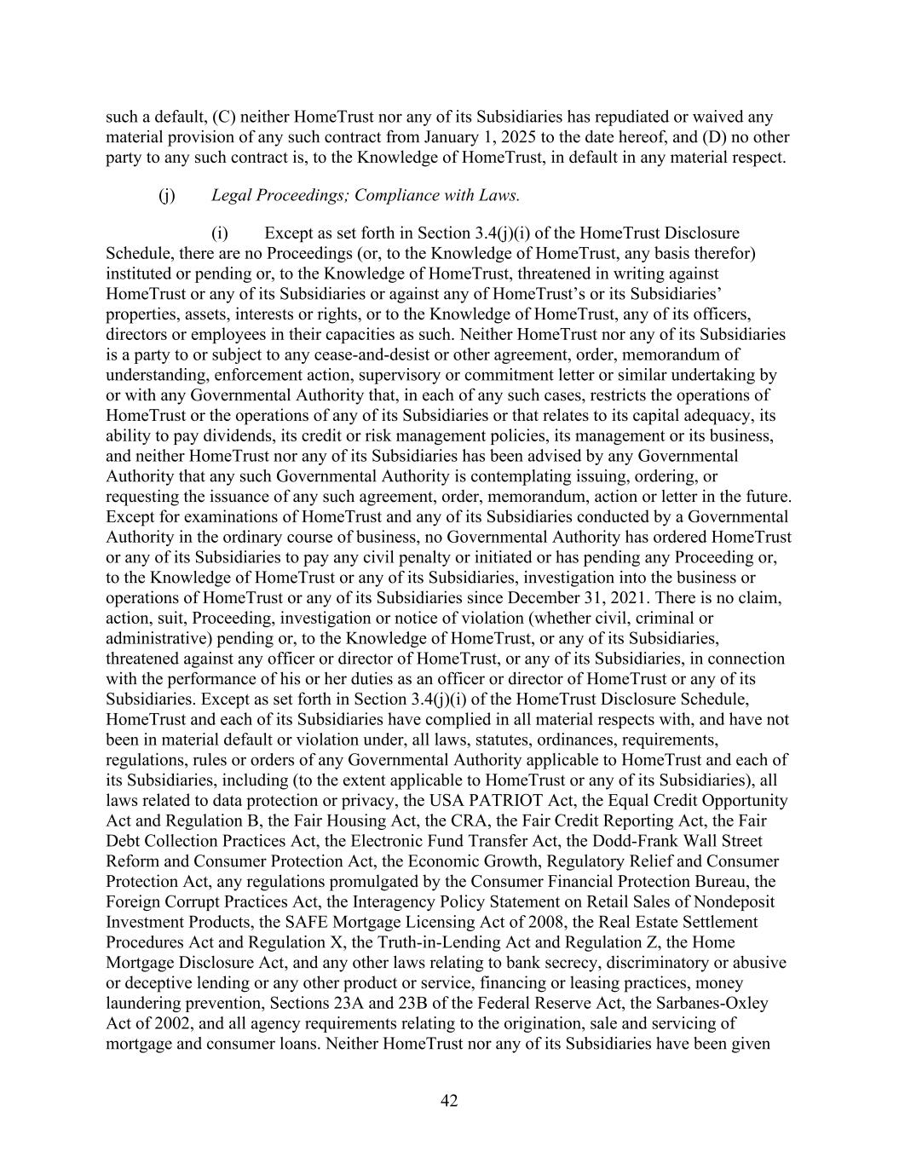
42 such a default, (C) neither HomeTrust nor any of its Subsidiaries has repudiated or waived any material provision of any such contract from January 1, 2025 to the date hereof, and (D) no other party to any such contract is, to the Knowledge of HomeTrust, in default in any material respect. (j) Legal Proceedings; Compliance with Laws. (i) Except as set forth in Section 3.4(j)(i) of the HomeTrust Disclosure Schedule, there are no Proceedings (or, to the Knowledge of HomeTrust, any basis therefor) instituted or pending or, to the Knowledge of HomeTrust, threatened in writing against HomeTrust or any of its Subsidiaries or against any of HomeTrust’s or its Subsidiaries’ properties, assets, interests or rights, or to the Knowledge of HomeTrust, any of its officers, directors or employees in their capacities as such. Neither HomeTrust nor any of its Subsidiaries is a party to or subject to any cease-and-desist or other agreement, order, memorandum of understanding, enforcement action, supervisory or commitment letter or similar undertaking by or with any Governmental Authority that, in each of any such cases, restricts the operations of HomeTrust or the operations of any of its Subsidiaries or that relates to its capital adequacy, its ability to pay dividends, its credit or risk management policies, its management or its business, and neither HomeTrust nor any of its Subsidiaries has been advised by any Governmental Authority that any such Governmental Authority is contemplating issuing, ordering, or requesting the issuance of any such agreement, order, memorandum, action or letter in the future. Except for examinations of HomeTrust and any of its Subsidiaries conducted by a Governmental Authority in the ordinary course of business, no Governmental Authority has ordered HomeTrust or any of its Subsidiaries to pay any civil penalty or initiated or has pending any Proceeding or, to the Knowledge of HomeTrust or any of its Subsidiaries, investigation into the business or operations of HomeTrust or any of its Subsidiaries since December 31, 2021. There is no claim, action, suit, Proceeding, investigation or notice of violation (whether civil, criminal or administrative) pending or, to the Knowledge of HomeTrust, or any of its Subsidiaries, threatened against any officer or director of HomeTrust, or any of its Subsidiaries, in connection with the performance of his or her duties as an officer or director of HomeTrust or any of its Subsidiaries. Except as set forth in Section 3.4(j)(i) of the HomeTrust Disclosure Schedule, HomeTrust and each of its Subsidiaries have complied in all material respects with, and have not been in material default or violation under, all laws, statutes, ordinances, requirements, regulations, rules or orders of any Governmental Authority applicable to HomeTrust and each of its Subsidiaries, including (to the extent applicable to HomeTrust or any of its Subsidiaries), all laws related to data protection or privacy, the USA PATRIOT Act, the Equal Credit Opportunity Act and Regulation B, the Fair Housing Act, the CRA, the Fair Credit Reporting Act, the Fair Debt Collection Practices Act, the Electronic Fund Transfer Act, the Dodd-Frank Wall Street Reform and Consumer Protection Act, the Economic Growth, Regulatory Relief and Consumer Protection Act, any regulations promulgated by the Consumer Financial Protection Bureau, the Foreign Corrupt Practices Act, the Interagency Policy Statement on Retail Sales of Nondeposit Investment Products, the SAFE Mortgage Licensing Act of 2008, the Real Estate Settlement Procedures Act and Regulation X, the Truth-in-Lending Act and Regulation Z, the Home Mortgage Disclosure Act, and any other laws relating to bank secrecy, discriminatory or abusive or deceptive lending or any other product or service, financing or leasing practices, money laundering prevention, Sections 23A and 23B of the Federal Reserve Act, the Sarbanes-Oxley Act of 2002, and all agency requirements relating to the origination, sale and servicing of mortgage and consumer loans. Neither HomeTrust nor any of its Subsidiaries have been given

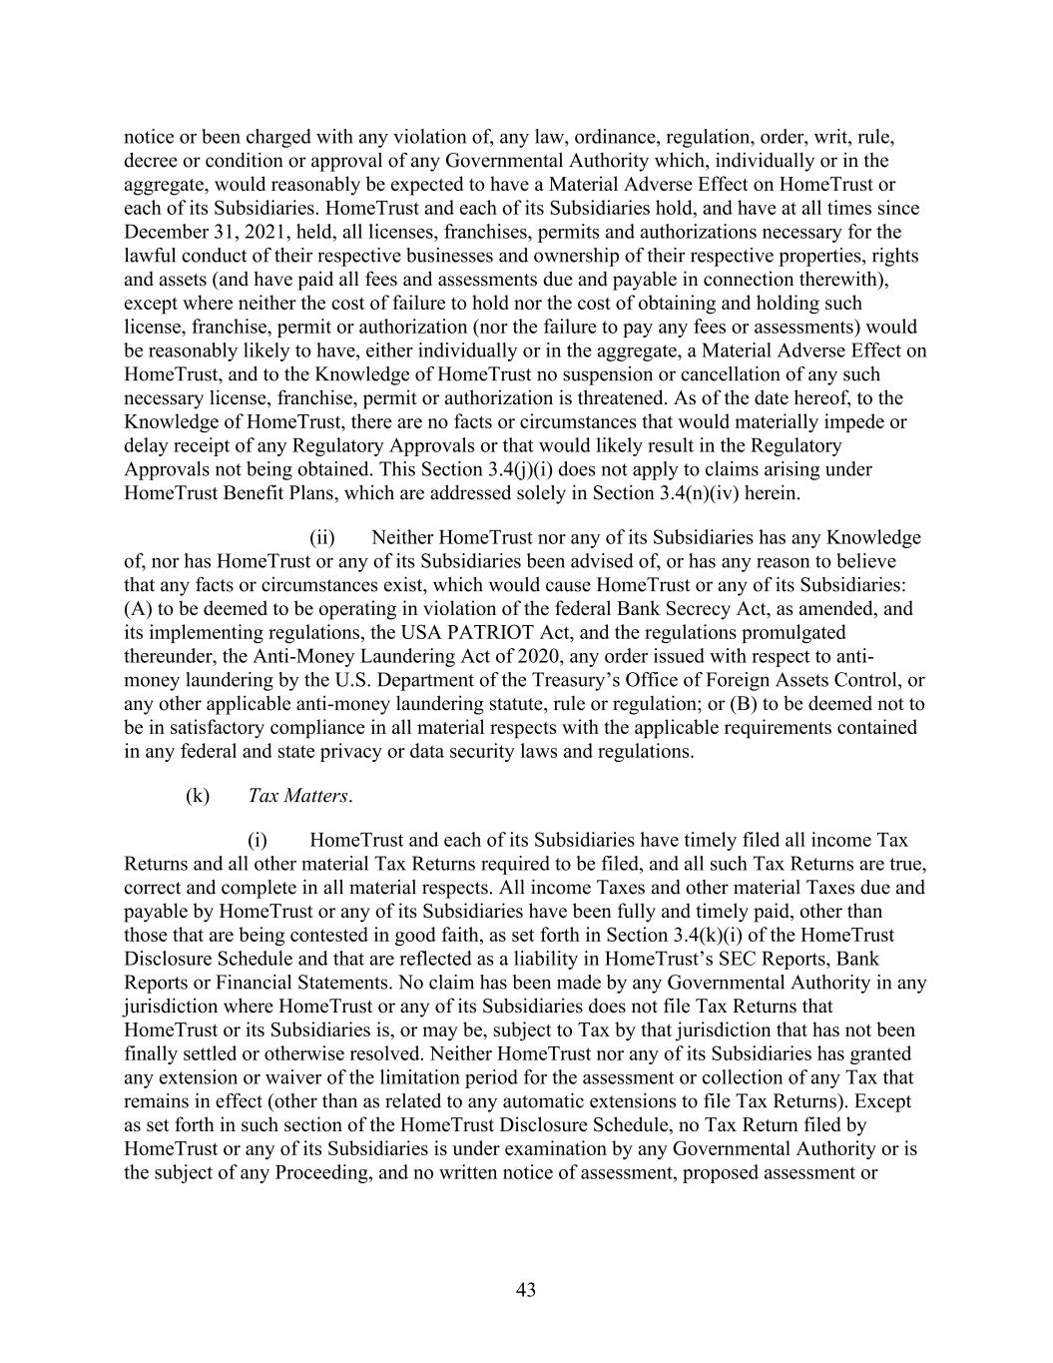
43 notice or been charged with any violation of, any law, ordinance, regulation, order, writ, rule, decree or condition or approval of any Governmental Authority which, individually or in the aggregate, would reasonably be expected to have a Material Adverse Effect on HomeTrust or each of its Subsidiaries. HomeTrust and each of its Subsidiaries hold, and have at all times since December 31, 2021, held, all licenses, franchises, permits and authorizations necessary for the lawful conduct of their respective businesses and ownership of their respective properties, rights and assets (and have paid all fees and assessments due and payable in connection therewith), except where neither the cost of failure to hold nor the cost of obtaining and holding such license, franchise, permit or authorization (nor the failure to pay any fees or assessments) would be reasonably likely to have, either individually or in the aggregate, a Material Adverse Effect on HomeTrust, and to the Knowledge of HomeTrust no suspension or cancellation of any such necessary license, franchise, permit or authorization is threatened. As of the date hereof, to the Knowledge of HomeTrust, there are no facts or circumstances that would materially impede or delay receipt of any Regulatory Approvals or that would likely result in the Regulatory Approvals not being obtained. This Section 3.4(j)(i) does not apply to claims arising under HomeTrust Benefit Plans, which are addressed solely in Section 3.4(n)(iv) herein. (ii) Neither HomeTrust nor any of its Subsidiaries has any Knowledge of, nor has HomeTrust or any of its Subsidiaries been advised of, or has any reason to believe that any facts or circumstances exist, which would cause HomeTrust or any of its Subsidiaries: (A) to be deemed to be operating in violation of the federal Bank Secrecy Act, as amended, and its implementing regulations, the USA PATRIOT Act, and the regulations promulgated thereunder, the Anti-Money Laundering Act of 2020, any order issued with respect to anti- money laundering by the U.S. Department of the Treasury’s Office of Foreign Assets Control, or any other applicable anti-money laundering statute, rule or regulation; or (B) to be deemed not to be in satisfactory compliance in all material respects with the applicable requirements contained in any federal and state privacy or data security laws and regulations. (k) Tax Matters. (i) HomeTrust and each of its Subsidiaries have timely filed all income Tax Returns and all other material Tax Returns required to be filed, and all such Tax Returns are true, correct and complete in all material respects. All income Taxes and other material Taxes due and payable by HomeTrust or any of its Subsidiaries have been fully and timely paid, other than those that are being contested in good faith, as set forth in Section 3.4(k)(i) of the HomeTrust Disclosure Schedule and that are reflected as a liability in HomeTrust’s SEC Reports, Bank Reports or Financial Statements. No claim has been made by any Governmental Authority in any jurisdiction where HomeTrust or any of its Subsidiaries does not file Tax Returns that HomeTrust or its Subsidiaries is, or may be, subject to Tax by that jurisdiction that has not been finally settled or otherwise resolved. Neither HomeTrust nor any of its Subsidiaries has granted any extension or waiver of the limitation period for the assessment or collection of any Tax that remains in effect (other than as related to any automatic extensions to file Tax Returns). Except as set forth in such section of the HomeTrust Disclosure Schedule, no Tax Return filed by HomeTrust or any of its Subsidiaries is under examination by any Governmental Authority or is the subject of any Proceeding, and no written notice of assessment, proposed assessment or

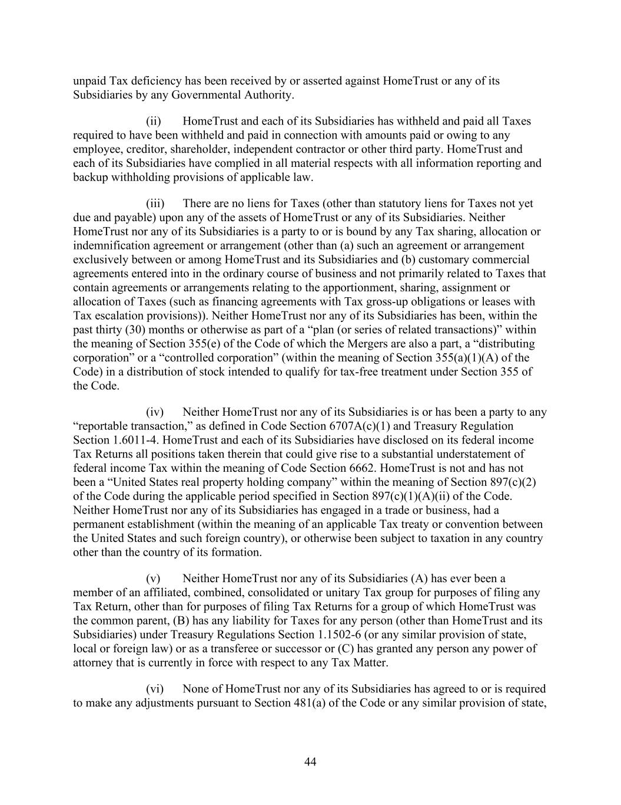
44 unpaid Tax deficiency has been received by or asserted against HomeTrust or any of its Subsidiaries by any Governmental Authority. (ii) HomeTrust and each of its Subsidiaries has withheld and paid all Taxes required to have been withheld and paid in connection with amounts paid or owing to any employee, creditor, shareholder, independent contractor or other third party. HomeTrust and each of its Subsidiaries have complied in all material respects with all information reporting and backup withholding provisions of applicable law. (iii) There are no liens for Taxes (other than statutory liens for Taxes not yet due and payable) upon any of the assets of HomeTrust or any of its Subsidiaries. Neither HomeTrust nor any of its Subsidiaries is a party to or is bound by any Tax sharing, allocation or indemnification agreement or arrangement (other than (a) such an agreement or arrangement exclusively between or among HomeTrust and its Subsidiaries and (b) customary commercial agreements entered into in the ordinary course of business and not primarily related to Taxes that contain agreements or arrangements relating to the apportionment, sharing, assignment or allocation of Taxes (such as financing agreements with Tax gross-up obligations or leases with Tax escalation provisions)). Neither HomeTrust nor any of its Subsidiaries has been, within the past thirty (30) months or otherwise as part of a “plan (or series of related transactions)” within the meaning of Section 355(e) of the Code of which the Mergers are also a part, a “distributing corporation” or a “controlled corporation” (within the meaning of Section 355(a)(1)(A) of the Code) in a distribution of stock intended to qualify for tax-free treatment under Section 355 of the Code. (iv) Neither HomeTrust nor any of its Subsidiaries is or has been a party to any “reportable transaction,” as defined in Code Section 6707A(c)(1) and Treasury Regulation Section 1.6011-4. HomeTrust and each of its Subsidiaries have disclosed on its federal income Tax Returns all positions taken therein that could give rise to a substantial understatement of federal income Tax within the meaning of Code Section 6662. HomeTrust is not and has not been a “United States real property holding company” within the meaning of Section 897(c)(2) of the Code during the applicable period specified in Section 897(c)(1)(A)(ii) of the Code. Neither HomeTrust nor any of its Subsidiaries has engaged in a trade or business, had a permanent establishment (within the meaning of an applicable Tax treaty or convention between the United States and such foreign country), or otherwise been subject to taxation in any country other than the country of its formation. (v) Neither HomeTrust nor any of its Subsidiaries (A) has ever been a member of an affiliated, combined, consolidated or unitary Tax group for purposes of filing any Tax Return, other than for purposes of filing Tax Returns for a group of which HomeTrust was the common parent, (B) has any liability for Taxes for any person (other than HomeTrust and its Subsidiaries) under Treasury Regulations Section 1.1502-6 (or any similar provision of state, local or foreign law) or as a transferee or successor or (C) has granted any person any power of attorney that is currently in force with respect to any Tax Matter. (vi) None of HomeTrust nor any of its Subsidiaries has agreed to or is required to make any adjustments pursuant to Section 481(a) of the Code or any similar provision of state,

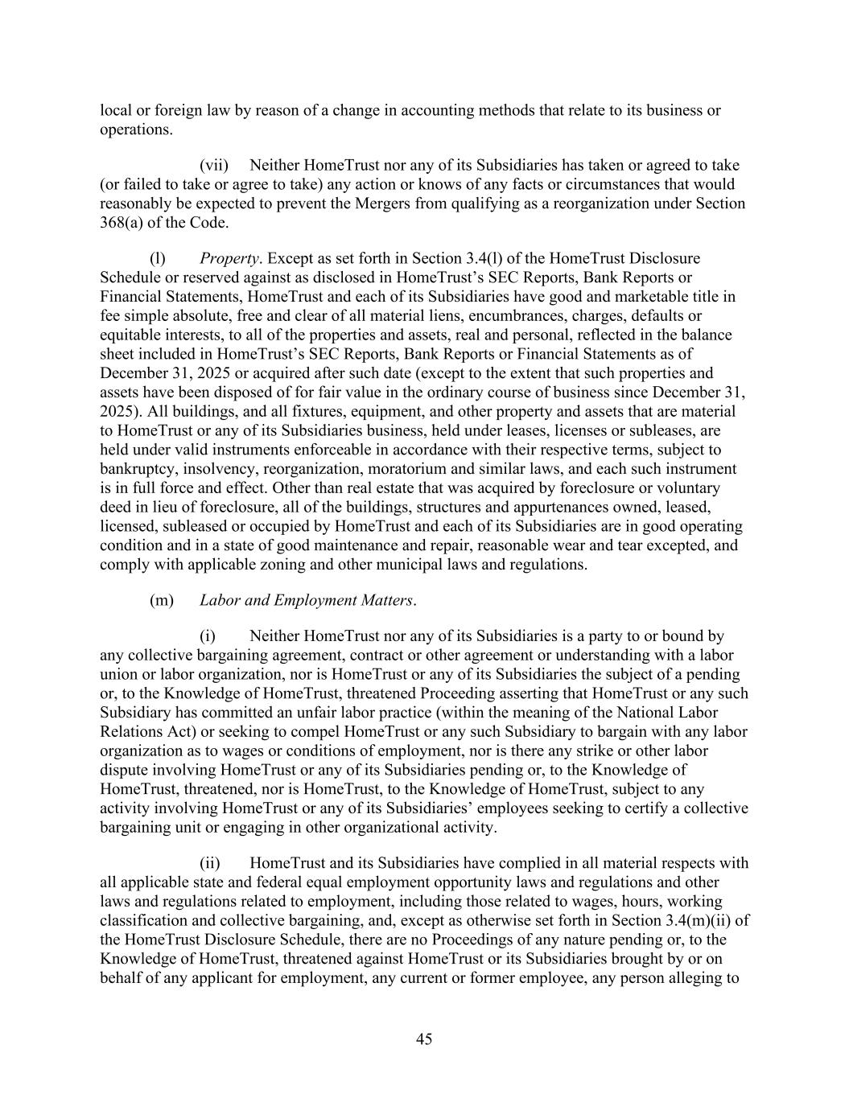
45 local or foreign law by reason of a change in accounting methods that relate to its business or operations. (vii) Neither HomeTrust nor any of its Subsidiaries has taken or agreed to take (or failed to take or agree to take) any action or knows of any facts or circumstances that would reasonably be expected to prevent the Mergers from qualifying as a reorganization under Section 368(a) of the Code. (l) Property. Except as set forth in Section 3.4(l) of the HomeTrust Disclosure Schedule or reserved against as disclosed in HomeTrust’s SEC Reports, Bank Reports or Financial Statements, HomeTrust and each of its Subsidiaries have good and marketable title in fee simple absolute, free and clear of all material liens, encumbrances, charges, defaults or equitable interests, to all of the properties and assets, real and personal, reflected in the balance sheet included in HomeTrust’s SEC Reports, Bank Reports or Financial Statements as of December 31, 2025 or acquired after such date (except to the extent that such properties and assets have been disposed of for fair value in the ordinary course of business since December 31, 2025). All buildings, and all fixtures, equipment, and other property and assets that are material to HomeTrust or any of its Subsidiaries business, held under leases, licenses or subleases, are held under valid instruments enforceable in accordance with their respective terms, subject to bankruptcy, insolvency, reorganization, moratorium and similar laws, and each such instrument is in full force and effect. Other than real estate that was acquired by foreclosure or voluntary deed in lieu of foreclosure, all of the buildings, structures and appurtenances owned, leased, licensed, subleased or occupied by HomeTrust and each of its Subsidiaries are in good operating condition and in a state of good maintenance and repair, reasonable wear and tear excepted, and comply with applicable zoning and other municipal laws and regulations. (m) Labor and Employment Matters. (i) Neither HomeTrust nor any of its Subsidiaries is a party to or bound by any collective bargaining agreement, contract or other agreement or understanding with a labor union or labor organization, nor is HomeTrust or any of its Subsidiaries the subject of a pending or, to the Knowledge of HomeTrust, threatened Proceeding asserting that HomeTrust or any such Subsidiary has committed an unfair labor practice (within the meaning of the National Labor Relations Act) or seeking to compel HomeTrust or any such Subsidiary to bargain with any labor organization as to wages or conditions of employment, nor is there any strike or other labor dispute involving HomeTrust or any of its Subsidiaries pending or, to the Knowledge of HomeTrust, threatened, nor is HomeTrust, to the Knowledge of HomeTrust, subject to any activity involving HomeTrust or any of its Subsidiaries’ employees seeking to certify a collective bargaining unit or engaging in other organizational activity. (ii) HomeTrust and its Subsidiaries have complied in all material respects with all applicable state and federal equal employment opportunity laws and regulations and other laws and regulations related to employment, including those related to wages, hours, working classification and collective bargaining, and, except as otherwise set forth in Section 3.4(m)(ii) of the HomeTrust Disclosure Schedule, there are no Proceedings of any nature pending or, to the Knowledge of HomeTrust, threatened against HomeTrust or its Subsidiaries brought by or on behalf of any applicant for employment, any current or former employee, any person alleging to

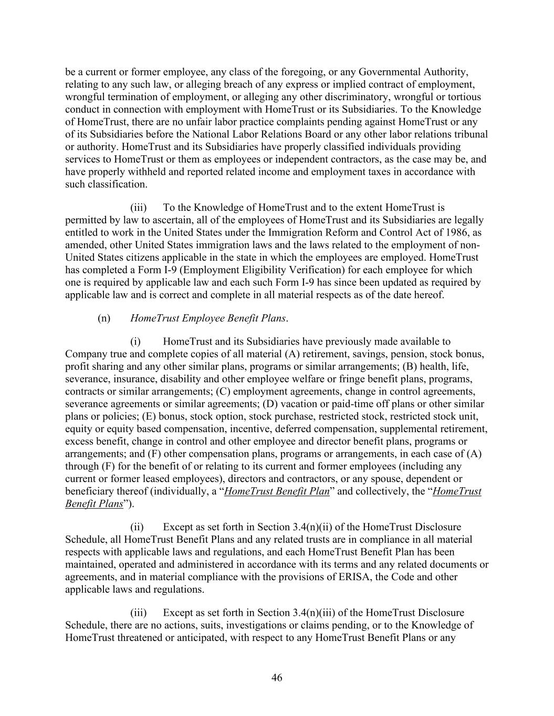
46 be a current or former employee, any class of the foregoing, or any Governmental Authority, relating to any such law, or alleging breach of any express or implied contract of employment, wrongful termination of employment, or alleging any other discriminatory, wrongful or tortious conduct in connection with employment with HomeTrust or its Subsidiaries. To the Knowledge of HomeTrust, there are no unfair labor practice complaints pending against HomeTrust or any of its Subsidiaries before the National Labor Relations Board or any other labor relations tribunal or authority. HomeTrust and its Subsidiaries have properly classified individuals providing services to HomeTrust or them as employees or independent contractors, as the case may be, and have properly withheld and reported related income and employment taxes in accordance with such classification. (iii) To the Knowledge of HomeTrust and to the extent HomeTrust is permitted by law to ascertain, all of the employees of HomeTrust and its Subsidiaries are legally entitled to work in the United States under the Immigration Reform and Control Act of 1986, as amended, other United States immigration laws and the laws related to the employment of non- United States citizens applicable in the state in which the employees are employed. HomeTrust has completed a Form I-9 (Employment Eligibility Verification) for each employee for which one is required by applicable law and each such Form I-9 has since been updated as required by applicable law and is correct and complete in all material respects as of the date hereof. (n) HomeTrust Employee Benefit Plans. (i) HomeTrust and its Subsidiaries have previously made available to Company true and complete copies of all material (A) retirement, savings, pension, stock bonus, profit sharing and any other similar plans, programs or similar arrangements; (B) health, life, severance, insurance, disability and other employee welfare or fringe benefit plans, programs, contracts or similar arrangements; (C) employment agreements, change in control agreements, severance agreements or similar agreements; (D) vacation or paid-time off plans or other similar plans or policies; (E) bonus, stock option, stock purchase, restricted stock, restricted stock unit, equity or equity based compensation, incentive, deferred compensation, supplemental retirement, excess benefit, change in control and other employee and director benefit plans, programs or arrangements; and (F) other compensation plans, programs or arrangements, in each case of (A) through (F) for the benefit of or relating to its current and former employees (including any current or former leased employees), directors and contractors, or any spouse, dependent or beneficiary thereof (individually, a “HomeTrust Benefit Plan” and collectively, the “HomeTrust Benefit Plans”). (ii) Except as set forth in Section 3.4(n)(ii) of the HomeTrust Disclosure Schedule, all HomeTrust Benefit Plans and any related trusts are in compliance in all material respects with applicable laws and regulations, and each HomeTrust Benefit Plan has been maintained, operated and administered in accordance with its terms and any related documents or agreements, and in material compliance with the provisions of ERISA, the Code and other applicable laws and regulations. (iii) Except as set forth in Section 3.4(n)(iii) of the HomeTrust Disclosure Schedule, there are no actions, suits, investigations or claims pending, or to the Knowledge of HomeTrust threatened or anticipated, with respect to any HomeTrust Benefit Plans or any

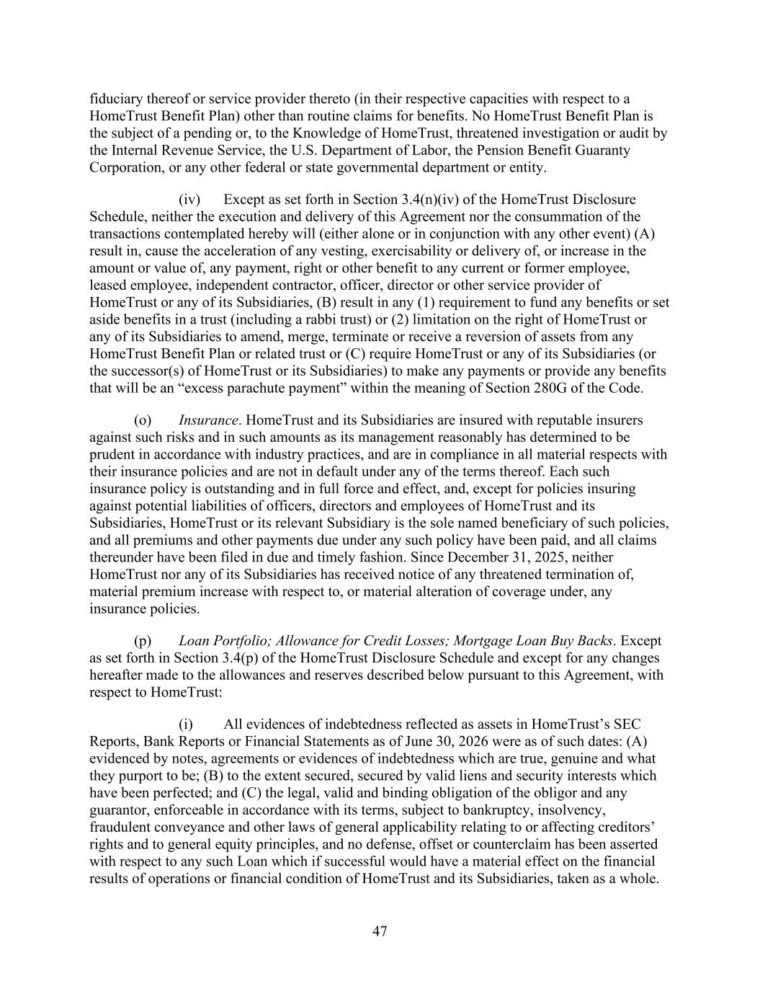
47 fiduciary thereof or service provider thereto (in their respective capacities with respect to a HomeTrust Benefit Plan) other than routine claims for benefits. No HomeTrust Benefit Plan is the subject of a pending or, to the Knowledge of HomeTrust, threatened investigation or audit by the Internal Revenue Service, the U.S. Department of Labor, the Pension Benefit Guaranty Corporation, or any other federal or state governmental department or entity. (iv) Except as set forth in Section 3.4(n)(iv) of the HomeTrust Disclosure Schedule, neither the execution and delivery of this Agreement nor the consummation of the transactions contemplated hereby will (either alone or in conjunction with any other event) (A) result in, cause the acceleration of any vesting, exercisability or delivery of, or increase in the amount or value of, any payment, right or other benefit to any current or former employee, leased employee, independent contractor, officer, director or other service provider of HomeTrust or any of its Subsidiaries, (B) result in any (1) requirement to fund any benefits or set aside benefits in a trust (including a rabbi trust) or (2) limitation on the right of HomeTrust or any of its Subsidiaries to amend, merge, terminate or receive a reversion of assets from any HomeTrust Benefit Plan or related trust or (C) require HomeTrust or any of its Subsidiaries (or the successor(s) of HomeTrust or its Subsidiaries) to make any payments or provide any benefits that will be an “excess parachute payment” within the meaning of Section 280G of the Code. (o) Insurance. HomeTrust and its Subsidiaries are insured with reputable insurers against such risks and in such amounts as its management reasonably has determined to be prudent in accordance with industry practices, and are in compliance in all material respects with their insurance policies and are not in default under any of the terms thereof. Each such insurance policy is outstanding and in full force and effect, and, except for policies insuring against potential liabilities of officers, directors and employees of HomeTrust and its Subsidiaries, HomeTrust or its relevant Subsidiary is the sole named beneficiary of such policies, and all premiums and other payments due under any such policy have been paid, and all claims thereunder have been filed in due and timely fashion. Since December 31, 2025, neither HomeTrust nor any of its Subsidiaries has received notice of any threatened termination of, material premium increase with respect to, or material alteration of coverage under, any insurance policies. (p) Loan Portfolio; Allowance for Credit Losses; Mortgage Loan Buy Backs. Except as set forth in Section 3.4(p) of the HomeTrust Disclosure Schedule and except for any changes hereafter made to the allowances and reserves described below pursuant to this Agreement, with respect to HomeTrust: (i) All evidences of indebtedness reflected as assets in HomeTrust’s SEC Reports, Bank Reports or Financial Statements as of June 30, 2026 were as of such dates: (A) evidenced by notes, agreements or evidences of indebtedness which are true, genuine and what they purport to be; (B) to the extent secured, secured by valid liens and security interests which have been perfected; and (C) the legal, valid and binding obligation of the obligor and any guarantor, enforceable in accordance with its terms, subject to bankruptcy, insolvency, fraudulent conveyance and other laws of general applicability relating to or affecting creditors’ rights and to general equity principles, and no defense, offset or counterclaim has been asserted with respect to any such Loan which if successful would have a material effect on the financial results of operations or financial condition of HomeTrust and its Subsidiaries, taken as a whole.

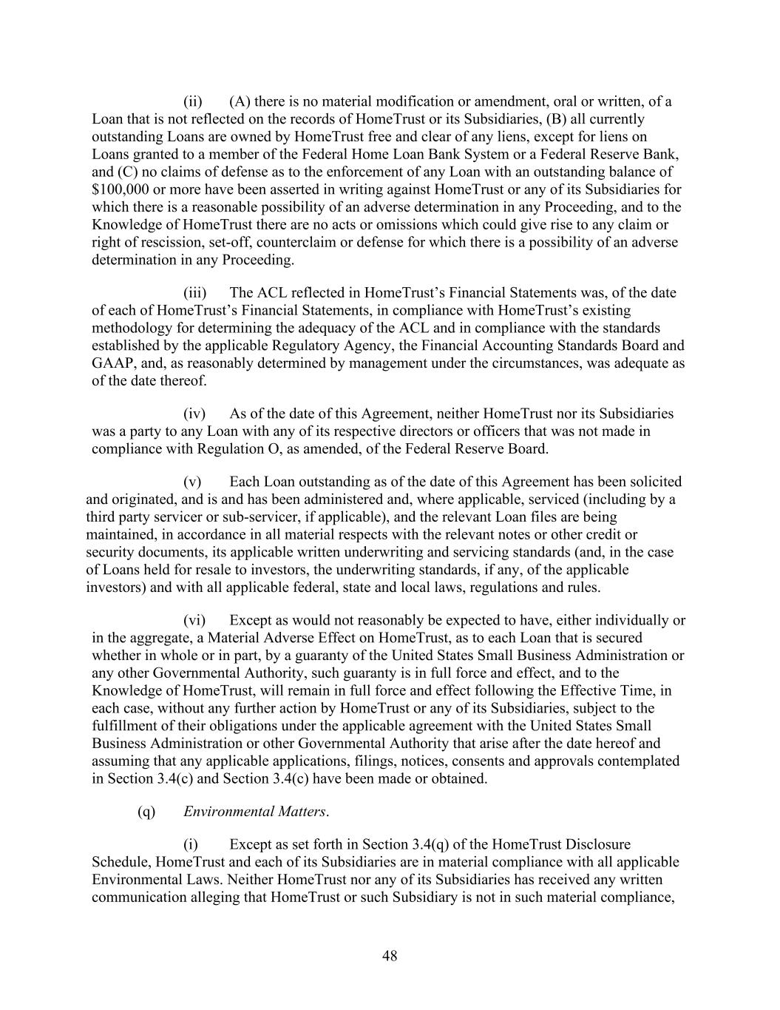
48 (ii) (A) there is no material modification or amendment, oral or written, of a Loan that is not reflected on the records of HomeTrust or its Subsidiaries, (B) all currently outstanding Loans are owned by HomeTrust free and clear of any liens, except for liens on Loans granted to a member of the Federal Home Loan Bank System or a Federal Reserve Bank, and (C) no claims of defense as to the enforcement of any Loan with an outstanding balance of $100,000 or more have been asserted in writing against HomeTrust or any of its Subsidiaries for which there is a reasonable possibility of an adverse determination in any Proceeding, and to the Knowledge of HomeTrust there are no acts or omissions which could give rise to any claim or right of rescission, set-off, counterclaim or defense for which there is a possibility of an adverse determination in any Proceeding. (iii) The ACL reflected in HomeTrust’s Financial Statements was, of the date of each of HomeTrust’s Financial Statements, in compliance with HomeTrust’s existing methodology for determining the adequacy of the ACL and in compliance with the standards established by the applicable Regulatory Agency, the Financial Accounting Standards Board and GAAP, and, as reasonably determined by management under the circumstances, was adequate as of the date thereof. (iv) As of the date of this Agreement, neither HomeTrust nor its Subsidiaries was a party to any Loan with any of its respective directors or officers that was not made in compliance with Regulation O, as amended, of the Federal Reserve Board. (v) Each Loan outstanding as of the date of this Agreement has been solicited and originated, and is and has been administered and, where applicable, serviced (including by a third party servicer or sub-servicer, if applicable), and the relevant Loan files are being maintained, in accordance in all material respects with the relevant notes or other credit or security documents, its applicable written underwriting and servicing standards (and, in the case of Loans held for resale to investors, the underwriting standards, if any, of the applicable investors) and with all applicable federal, state and local laws, regulations and rules. (vi) Except as would not reasonably be expected to have, either individually or in the aggregate, a Material Adverse Effect on HomeTrust, as to each Loan that is secured whether in whole or in part, by a guaranty of the United States Small Business Administration or any other Governmental Authority, such guaranty is in full force and effect, and to the Knowledge of HomeTrust, will remain in full force and effect following the Effective Time, in each case, without any further action by HomeTrust or any of its Subsidiaries, subject to the fulfillment of their obligations under the applicable agreement with the United States Small Business Administration or other Governmental Authority that arise after the date hereof and assuming that any applicable applications, filings, notices, consents and approvals contemplated in Section 3.4(c) and Section 3.4(c) have been made or obtained. (q) Environmental Matters. (i) Except as set forth in Section 3.4(q) of the HomeTrust Disclosure Schedule, HomeTrust and each of its Subsidiaries are in material compliance with all applicable Environmental Laws. Neither HomeTrust nor any of its Subsidiaries has received any written communication alleging that HomeTrust or such Subsidiary is not in such material compliance,

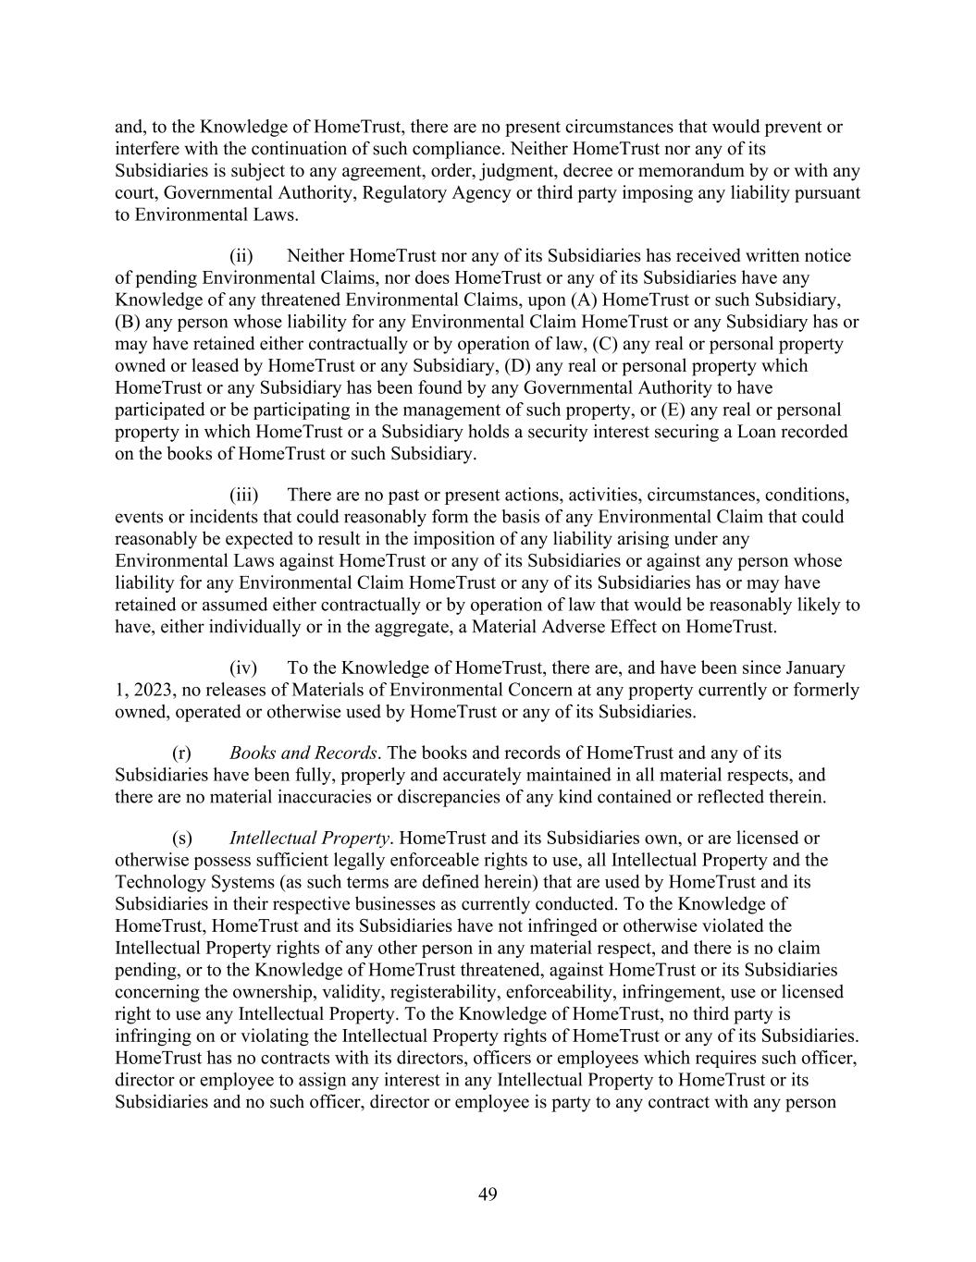
49 and, to the Knowledge of HomeTrust, there are no present circumstances that would prevent or interfere with the continuation of such compliance. Neither HomeTrust nor any of its Subsidiaries is subject to any agreement, order, judgment, decree or memorandum by or with any court, Governmental Authority, Regulatory Agency or third party imposing any liability pursuant to Environmental Laws. (ii) Neither HomeTrust nor any of its Subsidiaries has received written notice of pending Environmental Claims, nor does HomeTrust or any of its Subsidiaries have any Knowledge of any threatened Environmental Claims, upon (A) HomeTrust or such Subsidiary, (B) any person whose liability for any Environmental Claim HomeTrust or any Subsidiary has or may have retained either contractually or by operation of law, (C) any real or personal property owned or leased by HomeTrust or any Subsidiary, (D) any real or personal property which HomeTrust or any Subsidiary has been found by any Governmental Authority to have participated or be participating in the management of such property, or (E) any real or personal property in which HomeTrust or a Subsidiary holds a security interest securing a Loan recorded on the books of HomeTrust or such Subsidiary. (iii) There are no past or present actions, activities, circumstances, conditions, events or incidents that could reasonably form the basis of any Environmental Claim that could reasonably be expected to result in the imposition of any liability arising under any Environmental Laws against HomeTrust or any of its Subsidiaries or against any person whose liability for any Environmental Claim HomeTrust or any of its Subsidiaries has or may have retained or assumed either contractually or by operation of law that would be reasonably likely to have, either individually or in the aggregate, a Material Adverse Effect on HomeTrust. (iv) To the Knowledge of HomeTrust, there are, and have been since January 1, 2023, no releases of Materials of Environmental Concern at any property currently or formerly owned, operated or otherwise used by HomeTrust or any of its Subsidiaries. (r) Books and Records. The books and records of HomeTrust and any of its Subsidiaries have been fully, properly and accurately maintained in all material respects, and there are no material inaccuracies or discrepancies of any kind contained or reflected therein. (s) Intellectual Property. HomeTrust and its Subsidiaries own, or are licensed or otherwise possess sufficient legally enforceable rights to use, all Intellectual Property and the Technology Systems (as such terms are defined herein) that are used by HomeTrust and its Subsidiaries in their respective businesses as currently conducted. To the Knowledge of HomeTrust, HomeTrust and its Subsidiaries have not infringed or otherwise violated the Intellectual Property rights of any other person in any material respect, and there is no claim pending, or to the Knowledge of HomeTrust threatened, against HomeTrust or its Subsidiaries concerning the ownership, validity, registerability, enforceability, infringement, use or licensed right to use any Intellectual Property. To the Knowledge of HomeTrust, no third party is infringing on or violating the Intellectual Property rights of HomeTrust or any of its Subsidiaries. HomeTrust has no contracts with its directors, officers or employees which requires such officer, director or employee to assign any interest in any Intellectual Property to HomeTrust or its Subsidiaries and no such officer, director or employee is party to any contract with any person

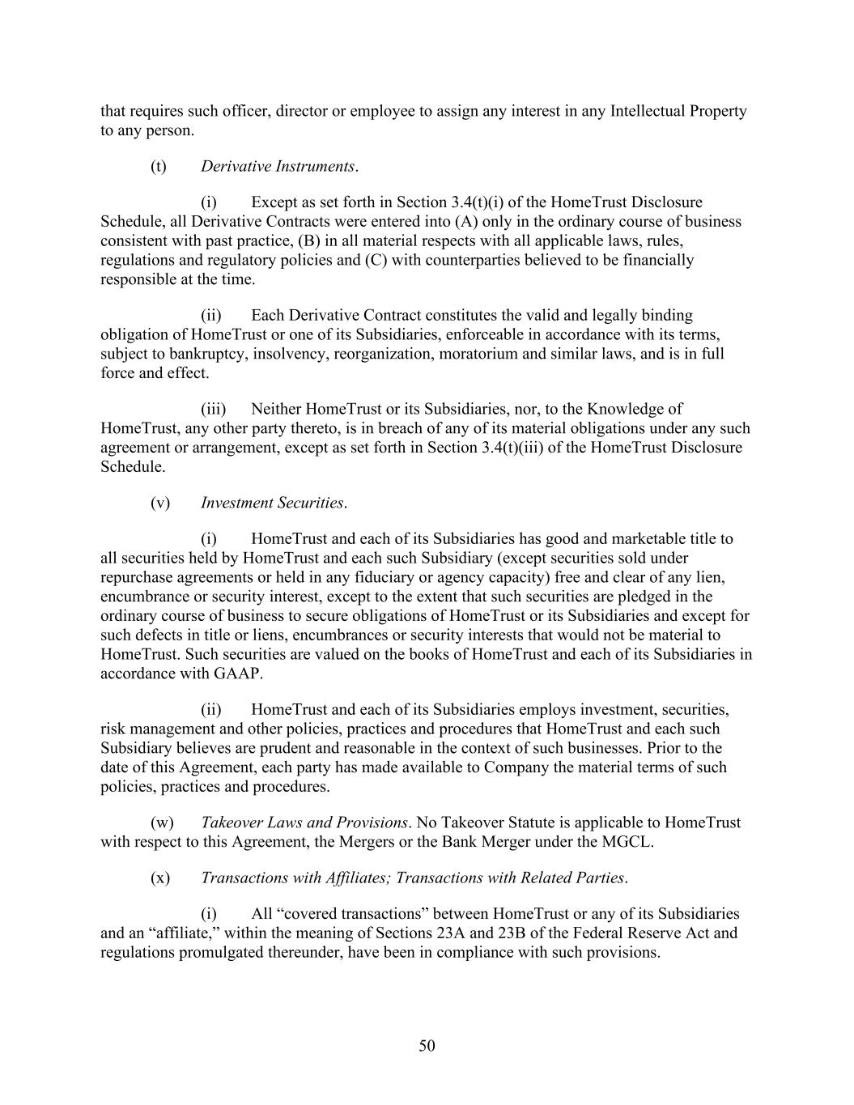
50 that requires such officer, director or employee to assign any interest in any Intellectual Property to any person. (t) Derivative Instruments. (i) Except as set forth in Section 3.4(t)(i) of the HomeTrust Disclosure Schedule, all Derivative Contracts were entered into (A) only in the ordinary course of business consistent with past practice, (B) in all material respects with all applicable laws, rules, regulations and regulatory policies and (C) with counterparties believed to be financially responsible at the time. (ii) Each Derivative Contract constitutes the valid and legally binding obligation of HomeTrust or one of its Subsidiaries, enforceable in accordance with its terms, subject to bankruptcy, insolvency, reorganization, moratorium and similar laws, and is in full force and effect. (iii) Neither HomeTrust or its Subsidiaries, nor, to the Knowledge of HomeTrust, any other party thereto, is in breach of any of its material obligations under any such agreement or arrangement, except as set forth in Section 3.4(t)(iii) of the HomeTrust Disclosure Schedule. (v) Investment Securities. (i) HomeTrust and each of its Subsidiaries has good and marketable title to all securities held by HomeTrust and each such Subsidiary (except securities sold under repurchase agreements or held in any fiduciary or agency capacity) free and clear of any lien, encumbrance or security interest, except to the extent that such securities are pledged in the ordinary course of business to secure obligations of HomeTrust or its Subsidiaries and except for such defects in title or liens, encumbrances or security interests that would not be material to HomeTrust. Such securities are valued on the books of HomeTrust and each of its Subsidiaries in accordance with GAAP. (ii) HomeTrust and each of its Subsidiaries employs investment, securities, risk management and other policies, practices and procedures that HomeTrust and each such Subsidiary believes are prudent and reasonable in the context of such businesses. Prior to the date of this Agreement, each party has made available to Company the material terms of such policies, practices and procedures. (w) Takeover Laws and Provisions. No Takeover Statute is applicable to HomeTrust with respect to this Agreement, the Mergers or the Bank Merger under the MGCL. (x) Transactions with Affiliates; Transactions with Related Parties. (i) All “covered transactions” between HomeTrust or any of its Subsidiaries and an “affiliate,” within the meaning of Sections 23A and 23B of the Federal Reserve Act and regulations promulgated thereunder, have been in compliance with such provisions.

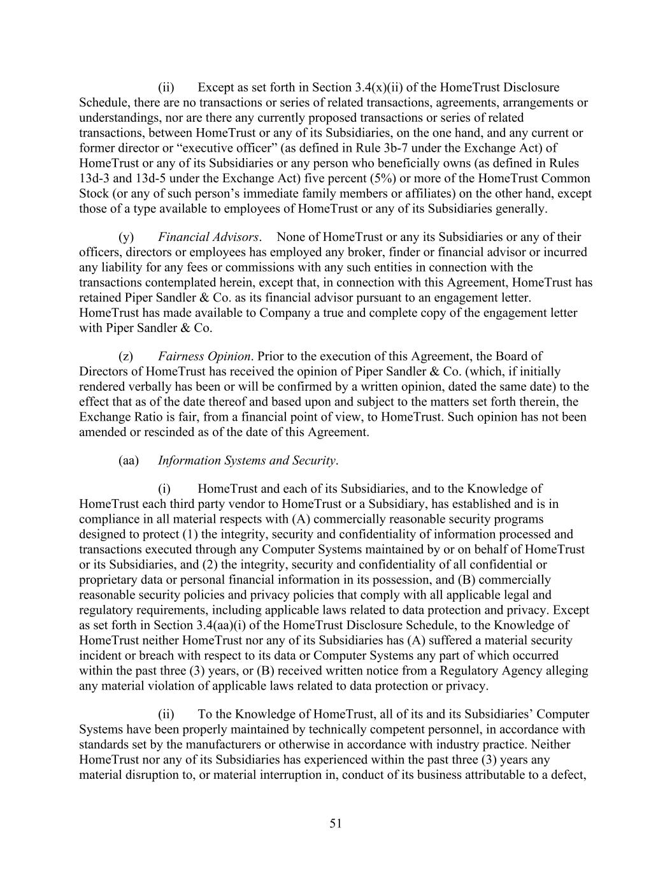
51 (ii) Except as set forth in Section 3.4(x)(ii) of the HomeTrust Disclosure Schedule, there are no transactions or series of related transactions, agreements, arrangements or understandings, nor are there any currently proposed transactions or series of related transactions, between HomeTrust or any of its Subsidiaries, on the one hand, and any current or former director or “executive officer” (as defined in Rule 3b-7 under the Exchange Act) of HomeTrust or any of its Subsidiaries or any person who beneficially owns (as defined in Rules 13d-3 and 13d-5 under the Exchange Act) five percent (5%) or more of the HomeTrust Common Stock (or any of such person’s immediate family members or affiliates) on the other hand, except those of a type available to employees of HomeTrust or any of its Subsidiaries generally. (y) Financial Advisors. None of HomeTrust or any its Subsidiaries or any of their officers, directors or employees has employed any broker, finder or financial advisor or incurred any liability for any fees or commissions with any such entities in connection with the transactions contemplated herein, except that, in connection with this Agreement, HomeTrust has retained Piper Sandler & Co. as its financial advisor pursuant to an engagement letter. HomeTrust has made available to Company a true and complete copy of the engagement letter with Piper Sandler & Co. (z) Fairness Opinion. Prior to the execution of this Agreement, the Board of Directors of HomeTrust has received the opinion of Piper Sandler & Co. (which, if initially rendered verbally has been or will be confirmed by a written opinion, dated the same date) to the effect that as of the date thereof and based upon and subject to the matters set forth therein, the Exchange Ratio is fair, from a financial point of view, to HomeTrust. Such opinion has not been amended or rescinded as of the date of this Agreement. (aa) Information Systems and Security. (i) HomeTrust and each of its Subsidiaries, and to the Knowledge of HomeTrust each third party vendor to HomeTrust or a Subsidiary, has established and is in compliance in all material respects with (A) commercially reasonable security programs designed to protect (1) the integrity, security and confidentiality of information processed and transactions executed through any Computer Systems maintained by or on behalf of HomeTrust or its Subsidiaries, and (2) the integrity, security and confidentiality of all confidential or proprietary data or personal financial information in its possession, and (B) commercially reasonable security policies and privacy policies that comply with all applicable legal and regulatory requirements, including applicable laws related to data protection and privacy. Except as set forth in Section 3.4(aa)(i) of the HomeTrust Disclosure Schedule, to the Knowledge of HomeTrust neither HomeTrust nor any of its Subsidiaries has (A) suffered a material security incident or breach with respect to its data or Computer Systems any part of which occurred within the past three (3) years, or (B) received written notice from a Regulatory Agency alleging any material violation of applicable laws related to data protection or privacy. (ii) To the Knowledge of HomeTrust, all of its and its Subsidiaries’ Computer Systems have been properly maintained by technically competent personnel, in accordance with standards set by the manufacturers or otherwise in accordance with industry practice. Neither HomeTrust nor any of its Subsidiaries has experienced within the past three (3) years any material disruption to, or material interruption in, conduct of its business attributable to a defect,

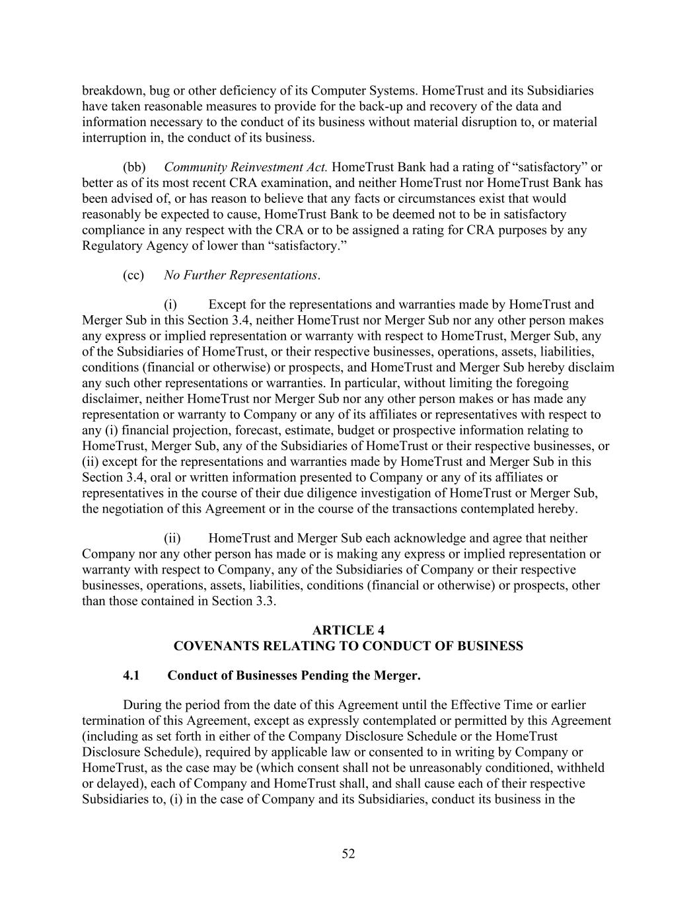
52 breakdown, bug or other deficiency of its Computer Systems. HomeTrust and its Subsidiaries have taken reasonable measures to provide for the back-up and recovery of the data and information necessary to the conduct of its business without material disruption to, or material interruption in, the conduct of its business. (bb) Community Reinvestment Act. HomeTrust Bank had a rating of “satisfactory” or better as of its most recent CRA examination, and neither HomeTrust nor HomeTrust Bank has been advised of, or has reason to believe that any facts or circumstances exist that would reasonably be expected to cause, HomeTrust Bank to be deemed not to be in satisfactory compliance in any respect with the CRA or to be assigned a rating for CRA purposes by any Regulatory Agency of lower than “satisfactory.” (cc) No Further Representations. (i) Except for the representations and warranties made by HomeTrust and Merger Sub in this Section 3.4, neither HomeTrust nor Merger Sub nor any other person makes any express or implied representation or warranty with respect to HomeTrust, Merger Sub, any of the Subsidiaries of HomeTrust, or their respective businesses, operations, assets, liabilities, conditions (financial or otherwise) or prospects, and HomeTrust and Merger Sub hereby disclaim any such other representations or warranties. In particular, without limiting the foregoing disclaimer, neither HomeTrust nor Merger Sub nor any other person makes or has made any representation or warranty to Company or any of its affiliates or representatives with respect to any (i) financial projection, forecast, estimate, budget or prospective information relating to HomeTrust, Merger Sub, any of the Subsidiaries of HomeTrust or their respective businesses, or (ii) except for the representations and warranties made by HomeTrust and Merger Sub in this Section 3.4, oral or written information presented to Company or any of its affiliates or representatives in the course of their due diligence investigation of HomeTrust or Merger Sub, the negotiation of this Agreement or in the course of the transactions contemplated hereby. (ii) HomeTrust and Merger Sub each acknowledge and agree that neither Company nor any other person has made or is making any express or implied representation or warranty with respect to Company, any of the Subsidiaries of Company or their respective businesses, operations, assets, liabilities, conditions (financial or otherwise) or prospects, other than those contained in Section 3.3. ARTICLE 4 COVENANTS RELATING TO CONDUCT OF BUSINESS 4.1 Conduct of Businesses Pending the Merger. During the period from the date of this Agreement until the Effective Time or earlier termination of this Agreement, except as expressly contemplated or permitted by this Agreement (including as set forth in either of the Company Disclosure Schedule or the HomeTrust Disclosure Schedule), required by applicable law or consented to in writing by Company or HomeTrust, as the case may be (which consent shall not be unreasonably conditioned, withheld or delayed), each of Company and HomeTrust shall, and shall cause each of their respective Subsidiaries to, (i) in the case of Company and its Subsidiaries, conduct its business in the

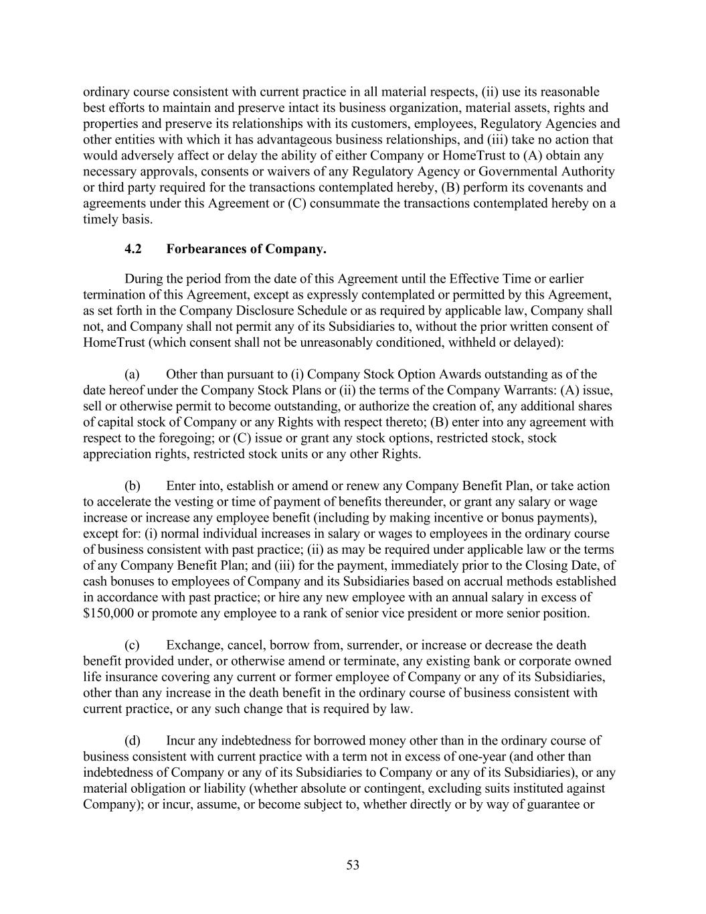
53 ordinary course consistent with current practice in all material respects, (ii) use its reasonable best efforts to maintain and preserve intact its business organization, material assets, rights and properties and preserve its relationships with its customers, employees, Regulatory Agencies and other entities with which it has advantageous business relationships, and (iii) take no action that would adversely affect or delay the ability of either Company or HomeTrust to (A) obtain any necessary approvals, consents or waivers of any Regulatory Agency or Governmental Authority or third party required for the transactions contemplated hereby, (B) perform its covenants and agreements under this Agreement or (C) consummate the transactions contemplated hereby on a timely basis. 4.2 Forbearances of Company. During the period from the date of this Agreement until the Effective Time or earlier termination of this Agreement, except as expressly contemplated or permitted by this Agreement, as set forth in the Company Disclosure Schedule or as required by applicable law, Company shall not, and Company shall not permit any of its Subsidiaries to, without the prior written consent of HomeTrust (which consent shall not be unreasonably conditioned, withheld or delayed): (a) Other than pursuant to (i) Company Stock Option Awards outstanding as of the date hereof under the Company Stock Plans or (ii) the terms of the Company Warrants: (A) issue, sell or otherwise permit to become outstanding, or authorize the creation of, any additional shares of capital stock of Company or any Rights with respect thereto; (B) enter into any agreement with respect to the foregoing; or (C) issue or grant any stock options, restricted stock, stock appreciation rights, restricted stock units or any other Rights. (b) Enter into, establish or amend or renew any Company Benefit Plan, or take action to accelerate the vesting or time of payment of benefits thereunder, or grant any salary or wage increase or increase any employee benefit (including by making incentive or bonus payments), except for: (i) normal individual increases in salary or wages to employees in the ordinary course of business consistent with past practice; (ii) as may be required under applicable law or the terms of any Company Benefit Plan; and (iii) for the payment, immediately prior to the Closing Date, of cash bonuses to employees of Company and its Subsidiaries based on accrual methods established in accordance with past practice; or hire any new employee with an annual salary in excess of $150,000 or promote any employee to a rank of senior vice president or more senior position. (c) Exchange, cancel, borrow from, surrender, or increase or decrease the death benefit provided under, or otherwise amend or terminate, any existing bank or corporate owned life insurance covering any current or former employee of Company or any of its Subsidiaries, other than any increase in the death benefit in the ordinary course of business consistent with current practice, or any such change that is required by law. (d) Incur any indebtedness for borrowed money other than in the ordinary course of business consistent with current practice with a term not in excess of one-year (and other than indebtedness of Company or any of its Subsidiaries to Company or any of its Subsidiaries), or any material obligation or liability (whether absolute or contingent, excluding suits instituted against Company); or incur, assume, or become subject to, whether directly or by way of guarantee or

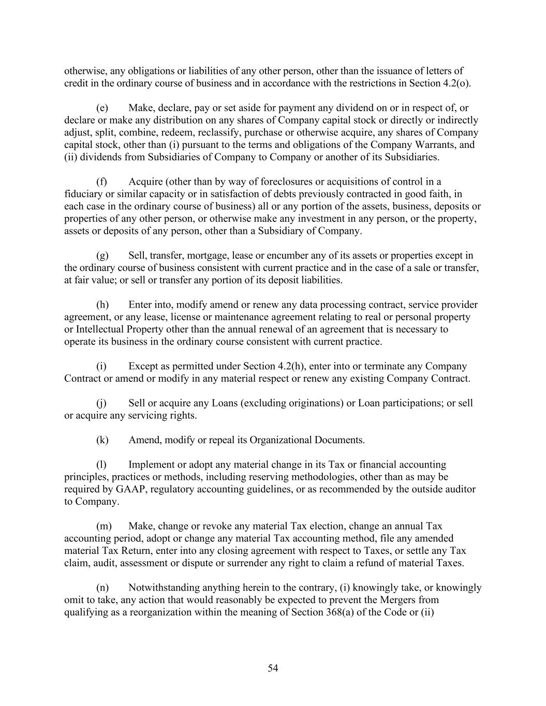
54 otherwise, any obligations or liabilities of any other person, other than the issuance of letters of credit in the ordinary course of business and in accordance with the restrictions in Section 4.2(o). (e) Make, declare, pay or set aside for payment any dividend on or in respect of, or declare or make any distribution on any shares of Company capital stock or directly or indirectly adjust, split, combine, redeem, reclassify, purchase or otherwise acquire, any shares of Company capital stock, other than (i) pursuant to the terms and obligations of the Company Warrants, and (ii) dividends from Subsidiaries of Company to Company or another of its Subsidiaries. (f) Acquire (other than by way of foreclosures or acquisitions of control in a fiduciary or similar capacity or in satisfaction of debts previously contracted in good faith, in each case in the ordinary course of business) all or any portion of the assets, business, deposits or properties of any other person, or otherwise make any investment in any person, or the property, assets or deposits of any person, other than a Subsidiary of Company. (g) Sell, transfer, mortgage, lease or encumber any of its assets or properties except in the ordinary course of business consistent with current practice and in the case of a sale or transfer, at fair value; or sell or transfer any portion of its deposit liabilities. (h) Enter into, modify amend or renew any data processing contract, service provider agreement, or any lease, license or maintenance agreement relating to real or personal property or Intellectual Property other than the annual renewal of an agreement that is necessary to operate its business in the ordinary course consistent with current practice. (i) Except as permitted under Section 4.2(h), enter into or terminate any Company Contract or amend or modify in any material respect or renew any existing Company Contract. (j) Sell or acquire any Loans (excluding originations) or Loan participations; or sell or acquire any servicing rights. (k) Amend, modify or repeal its Organizational Documents. (l) Implement or adopt any material change in its Tax or financial accounting principles, practices or methods, including reserving methodologies, other than as may be required by GAAP, regulatory accounting guidelines, or as recommended by the outside auditor to Company. (m) Make, change or revoke any material Tax election, change an annual Tax accounting period, adopt or change any material Tax accounting method, file any amended material Tax Return, enter into any closing agreement with respect to Taxes, or settle any Tax claim, audit, assessment or dispute or surrender any right to claim a refund of material Taxes. (n) Notwithstanding anything herein to the contrary, (i) knowingly take, or knowingly omit to take, any action that would reasonably be expected to prevent the Mergers from qualifying as a reorganization within the meaning of Section 368(a) of the Code or (ii)

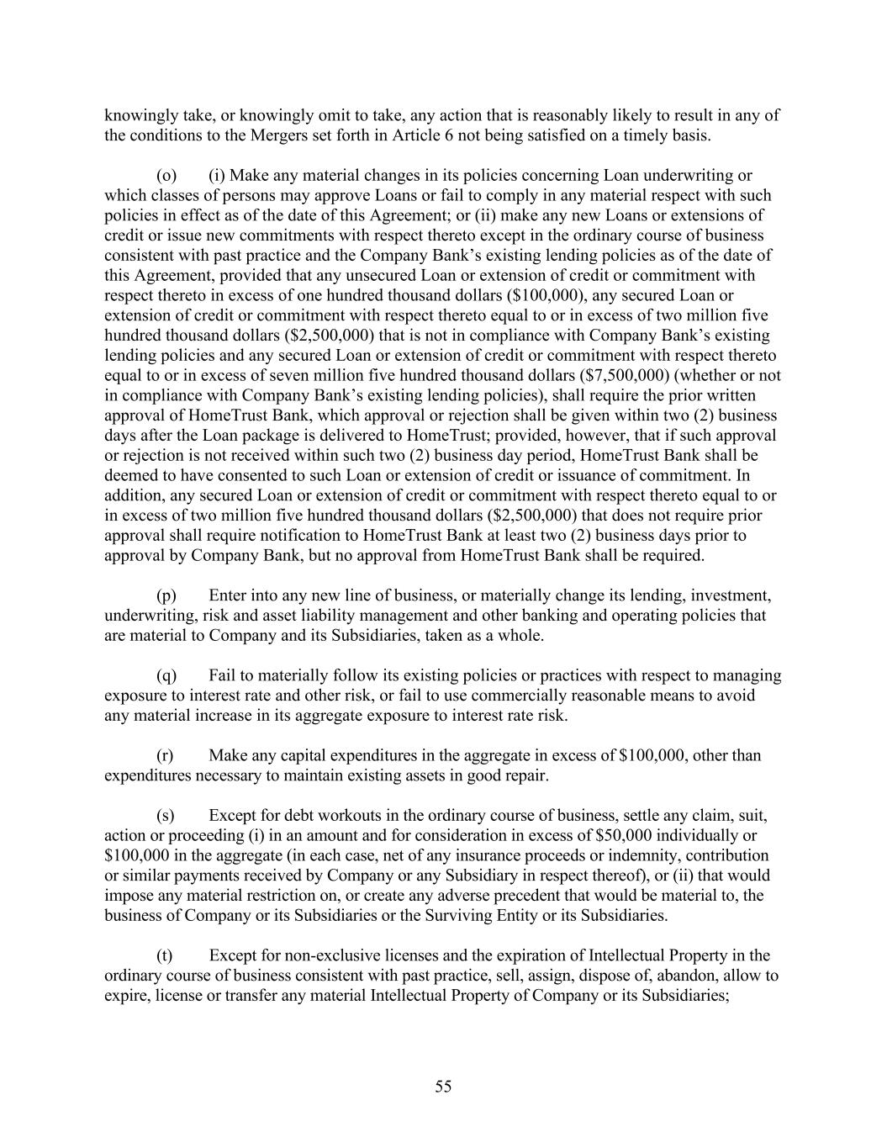
55 knowingly take, or knowingly omit to take, any action that is reasonably likely to result in any of the conditions to the Mergers set forth in Article 6 not being satisfied on a timely basis. (o) (i) Make any material changes in its policies concerning Loan underwriting or which classes of persons may approve Loans or fail to comply in any material respect with such policies in effect as of the date of this Agreement; or (ii) make any new Loans or extensions of credit or issue new commitments with respect thereto except in the ordinary course of business consistent with past practice and the Company Bank’s existing lending policies as of the date of this Agreement, provided that any unsecured Loan or extension of credit or commitment with respect thereto in excess of one hundred thousand dollars ($100,000), any secured Loan or extension of credit or commitment with respect thereto equal to or in excess of two million five hundred thousand dollars ($2,500,000) that is not in compliance with Company Bank’s existing lending policies and any secured Loan or extension of credit or commitment with respect thereto equal to or in excess of seven million five hundred thousand dollars ($7,500,000) (whether or not in compliance with Company Bank’s existing lending policies), shall require the prior written approval of HomeTrust Bank, which approval or rejection shall be given within two (2) business days after the Loan package is delivered to HomeTrust; provided, however, that if such approval or rejection is not received within such two (2) business day period, HomeTrust Bank shall be deemed to have consented to such Loan or extension of credit or issuance of commitment. In addition, any secured Loan or extension of credit or commitment with respect thereto equal to or in excess of two million five hundred thousand dollars ($2,500,000) that does not require prior approval shall require notification to HomeTrust Bank at least two (2) business days prior to approval by Company Bank, but no approval from HomeTrust Bank shall be required. (p) Enter into any new line of business, or materially change its lending, investment, underwriting, risk and asset liability management and other banking and operating policies that are material to Company and its Subsidiaries, taken as a whole. (q) Fail to materially follow its existing policies or practices with respect to managing exposure to interest rate and other risk, or fail to use commercially reasonable means to avoid any material increase in its aggregate exposure to interest rate risk. (r) Make any capital expenditures in the aggregate in excess of $100,000, other than expenditures necessary to maintain existing assets in good repair. (s) Except for debt workouts in the ordinary course of business, settle any claim, suit, action or proceeding (i) in an amount and for consideration in excess of $50,000 individually or $100,000 in the aggregate (in each case, net of any insurance proceeds or indemnity, contribution or similar payments received by Company or any Subsidiary in respect thereof), or (ii) that would impose any material restriction on, or create any adverse precedent that would be material to, the business of Company or its Subsidiaries or the Surviving Entity or its Subsidiaries. (t) Except for non-exclusive licenses and the expiration of Intellectual Property in the ordinary course of business consistent with past practice, sell, assign, dispose of, abandon, allow to expire, license or transfer any material Intellectual Property of Company or its Subsidiaries;

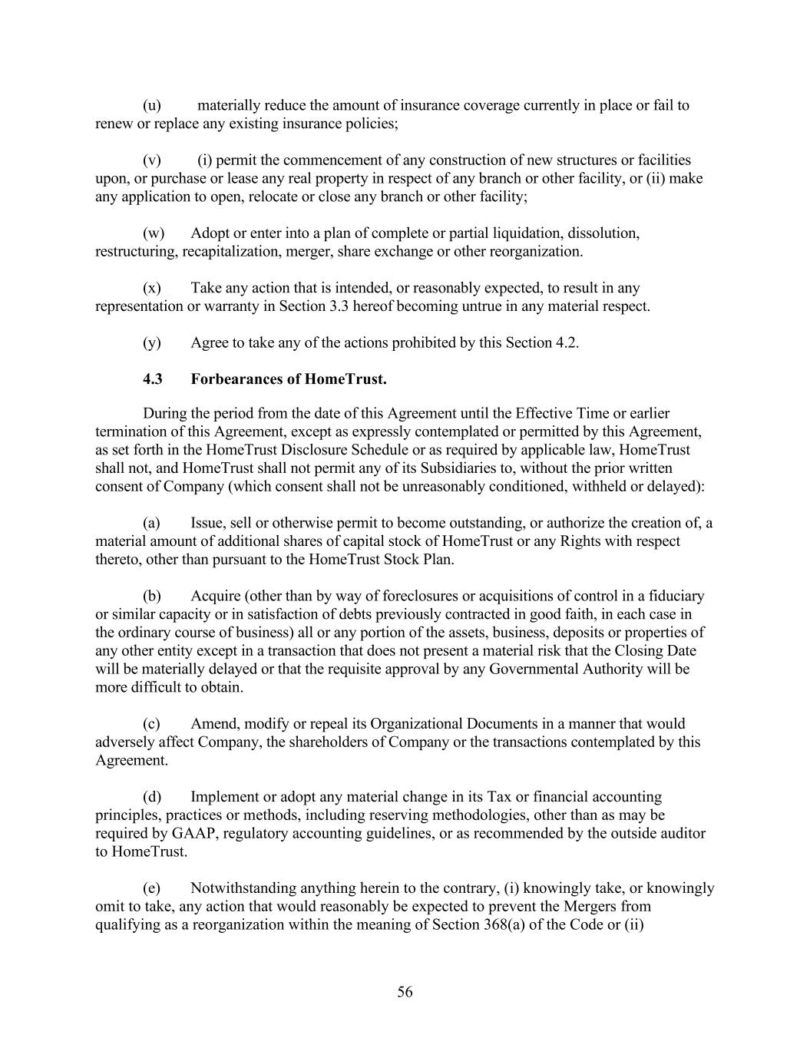
56 (u) materially reduce the amount of insurance coverage currently in place or fail to renew or replace any existing insurance policies; (v) (i) permit the commencement of any construction of new structures or facilities upon, or purchase or lease any real property in respect of any branch or other facility, or (ii) make any application to open, relocate or close any branch or other facility; (w) Adopt or enter into a plan of complete or partial liquidation, dissolution, restructuring, recapitalization, merger, share exchange or other reorganization. (x) Take any action that is intended, or reasonably expected, to result in any representation or warranty in Section 3.3 hereof becoming untrue in any material respect. (y) Agree to take any of the actions prohibited by this Section 4.2. 4.3 Forbearances of HomeTrust. During the period from the date of this Agreement until the Effective Time or earlier termination of this Agreement, except as expressly contemplated or permitted by this Agreement, as set forth in the HomeTrust Disclosure Schedule or as required by applicable law, HomeTrust shall not, and HomeTrust shall not permit any of its Subsidiaries to, without the prior written consent of Company (which consent shall not be unreasonably conditioned, withheld or delayed): (a) Issue, sell or otherwise permit to become outstanding, or authorize the creation of, a material amount of additional shares of capital stock of HomeTrust or any Rights with respect thereto, other than pursuant to the HomeTrust Stock Plan. (b) Acquire (other than by way of foreclosures or acquisitions of control in a fiduciary or similar capacity or in satisfaction of debts previously contracted in good faith, in each case in the ordinary course of business) all or any portion of the assets, business, deposits or properties of any other entity except in a transaction that does not present a material risk that the Closing Date will be materially delayed or that the requisite approval by any Governmental Authority will be more difficult to obtain. (c) Amend, modify or repeal its Organizational Documents in a manner that would adversely affect Company, the shareholders of Company or the transactions contemplated by this Agreement. (d) Implement or adopt any material change in its Tax or financial accounting principles, practices or methods, including reserving methodologies, other than as may be required by GAAP, regulatory accounting guidelines, or as recommended by the outside auditor to HomeTrust. (e) Notwithstanding anything herein to the contrary, (i) knowingly take, or knowingly omit to take, any action that would reasonably be expected to prevent the Mergers from qualifying as a reorganization within the meaning of Section 368(a) of the Code or (ii)

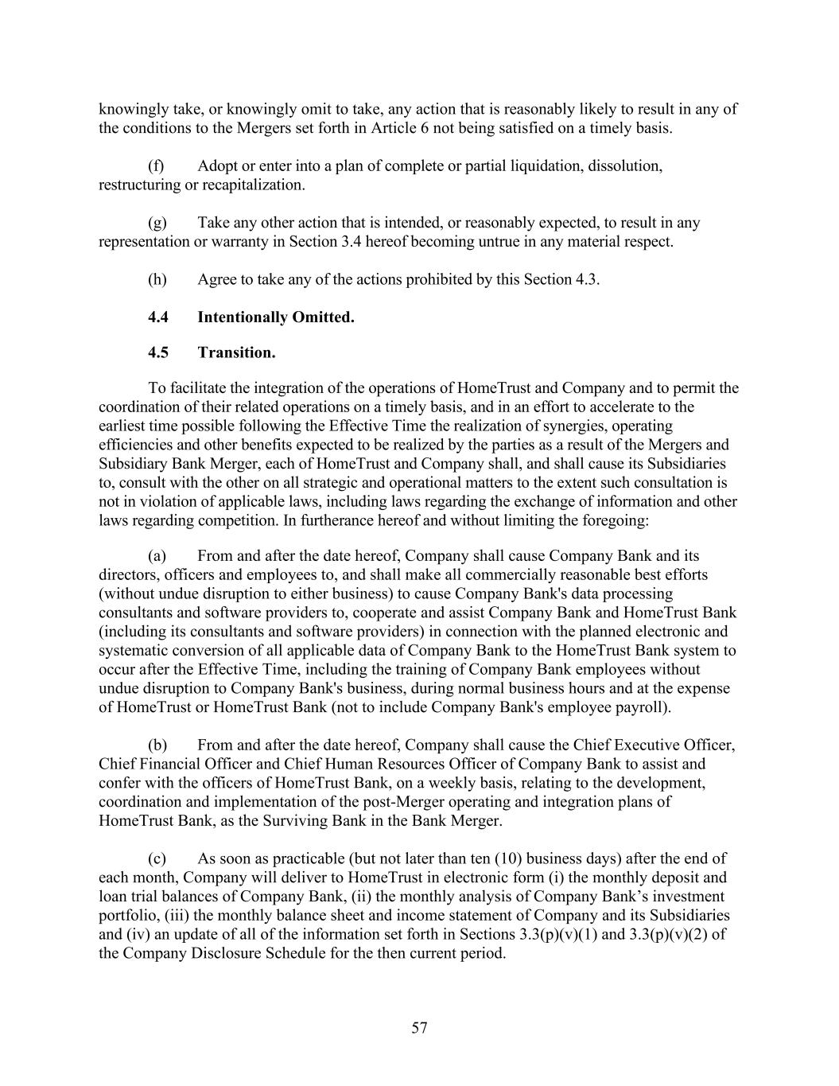
57 knowingly take, or knowingly omit to take, any action that is reasonably likely to result in any of the conditions to the Mergers set forth in Article 6 not being satisfied on a timely basis. (f) Adopt or enter into a plan of complete or partial liquidation, dissolution, restructuring or recapitalization. (g) Take any other action that is intended, or reasonably expected, to result in any representation or warranty in Section 3.4 hereof becoming untrue in any material respect. (h) Agree to take any of the actions prohibited by this Section 4.3. 4.4 Intentionally Omitted. 4.5 Transition. To facilitate the integration of the operations of HomeTrust and Company and to permit the coordination of their related operations on a timely basis, and in an effort to accelerate to the earliest time possible following the Effective Time the realization of synergies, operating efficiencies and other benefits expected to be realized by the parties as a result of the Mergers and Subsidiary Bank Merger, each of HomeTrust and Company shall, and shall cause its Subsidiaries to, consult with the other on all strategic and operational matters to the extent such consultation is not in violation of applicable laws, including laws regarding the exchange of information and other laws regarding competition. In furtherance hereof and without limiting the foregoing: (a) From and after the date hereof, Company shall cause Company Bank and its directors, officers and employees to, and shall make all commercially reasonable best efforts (without undue disruption to either business) to cause Company Bank's data processing consultants and software providers to, cooperate and assist Company Bank and HomeTrust Bank (including its consultants and software providers) in connection with the planned electronic and systematic conversion of all applicable data of Company Bank to the HomeTrust Bank system to occur after the Effective Time, including the training of Company Bank employees without undue disruption to Company Bank's business, during normal business hours and at the expense of HomeTrust or HomeTrust Bank (not to include Company Bank's employee payroll). (b) From and after the date hereof, Company shall cause the Chief Executive Officer, Chief Financial Officer and Chief Human Resources Officer of Company Bank to assist and confer with the officers of HomeTrust Bank, on a weekly basis, relating to the development, coordination and implementation of the post-Merger operating and integration plans of HomeTrust Bank, as the Surviving Bank in the Bank Merger. (c) As soon as practicable (but not later than ten (10) business days) after the end of each month, Company will deliver to HomeTrust in electronic form (i) the monthly deposit and loan trial balances of Company Bank, (ii) the monthly analysis of Company Bank’s investment portfolio, (iii) the monthly balance sheet and income statement of Company and its Subsidiaries and (iv) an update of all of the information set forth in Sections 3.3(p)(v)(1) and 3.3(p)(v)(2) of the Company Disclosure Schedule for the then current period.

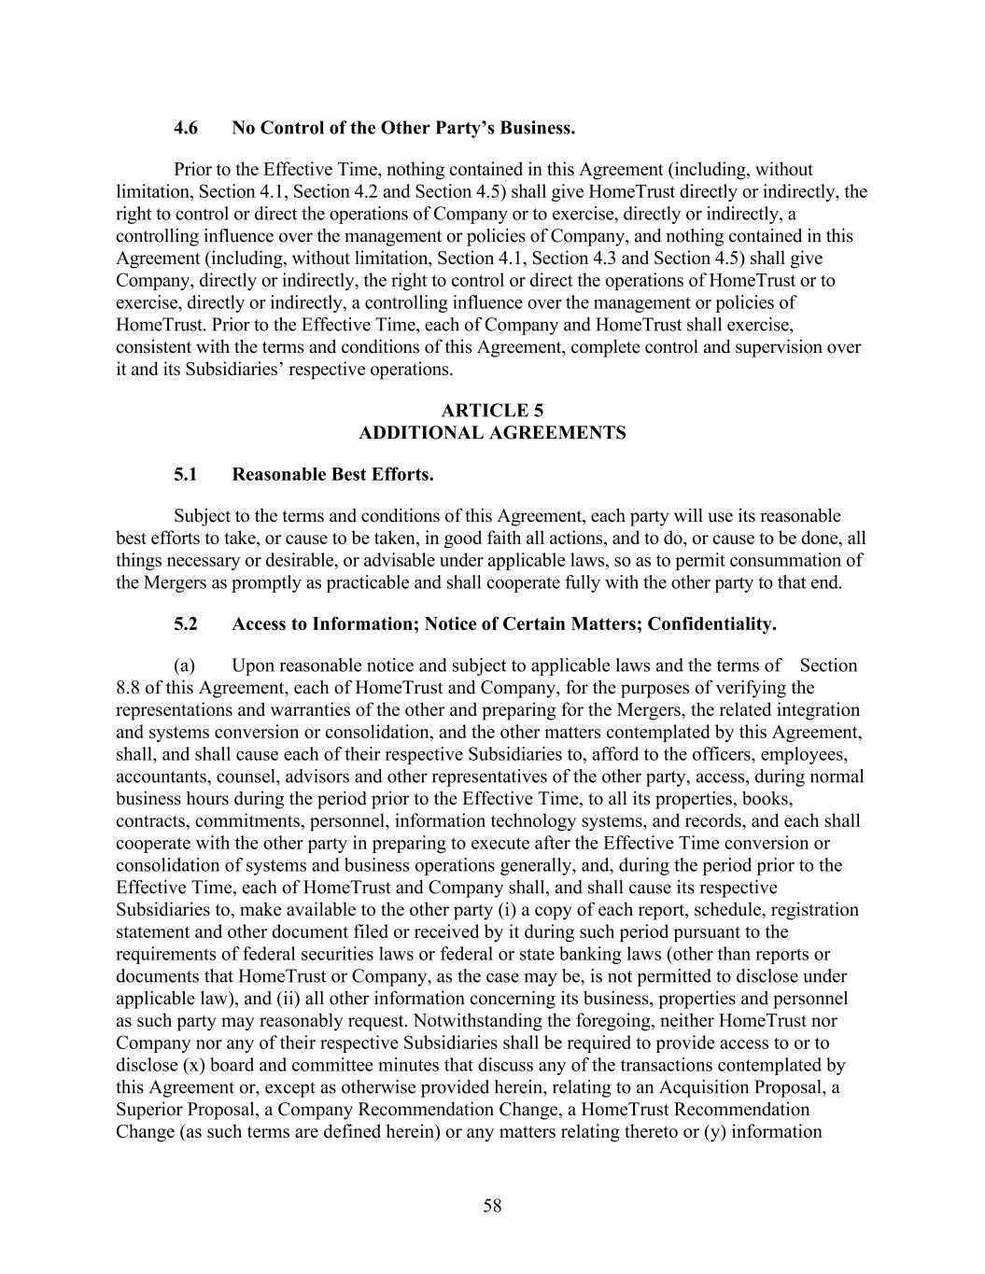
58 4.6 No Control of the Other Party’s Business. Prior to the Effective Time, nothing contained in this Agreement (including, without limitation, Section 4.1, Section 4.2 and Section 4.5) shall give HomeTrust directly or indirectly, the right to control or direct the operations of Company or to exercise, directly or indirectly, a controlling influence over the management or policies of Company, and nothing contained in this Agreement (including, without limitation, Section 4.1, Section 4.3 and Section 4.5) shall give Company, directly or indirectly, the right to control or direct the operations of HomeTrust or to exercise, directly or indirectly, a controlling influence over the management or policies of HomeTrust. Prior to the Effective Time, each of Company and HomeTrust shall exercise, consistent with the terms and conditions of this Agreement, complete control and supervision over it and its Subsidiaries’ respective operations. ARTICLE 5 ADDITIONAL AGREEMENTS 5.1 Reasonable Best Efforts. Subject to the terms and conditions of this Agreement, each party will use its reasonable best efforts to take, or cause to be taken, in good faith all actions, and to do, or cause to be done, all things necessary or desirable, or advisable under applicable laws, so as to permit consummation of the Mergers as promptly as practicable and shall cooperate fully with the other party to that end. 5.2 Access to Information; Notice of Certain Matters; Confidentiality. (a) Upon reasonable notice and subject to applicable laws and the terms of Section 8.8 of this Agreement, each of HomeTrust and Company, for the purposes of verifying the representations and warranties of the other and preparing for the Mergers, the related integration and systems conversion or consolidation, and the other matters contemplated by this Agreement, shall, and shall cause each of their respective Subsidiaries to, afford to the officers, employees, accountants, counsel, advisors and other representatives of the other party, access, during normal business hours during the period prior to the Effective Time, to all its properties, books, contracts, commitments, personnel, information technology systems, and records, and each shall cooperate with the other party in preparing to execute after the Effective Time conversion or consolidation of systems and business operations generally, and, during the period prior to the Effective Time, each of HomeTrust and Company shall, and shall cause its respective Subsidiaries to, make available to the other party (i) a copy of each report, schedule, registration statement and other document filed or received by it during such period pursuant to the requirements of federal securities laws or federal or state banking laws (other than reports or documents that HomeTrust or Company, as the case may be, is not permitted to disclose under applicable law), and (ii) all other information concerning its business, properties and personnel as such party may reasonably request. Notwithstanding the foregoing, neither HomeTrust nor Company nor any of their respective Subsidiaries shall be required to provide access to or to disclose (x) board and committee minutes that discuss any of the transactions contemplated by this Agreement or, except as otherwise provided herein, relating to an Acquisition Proposal, a Superior Proposal, a Company Recommendation Change, a HomeTrust Recommendation Change (as such terms are defined herein) or any matters relating thereto or (y) information

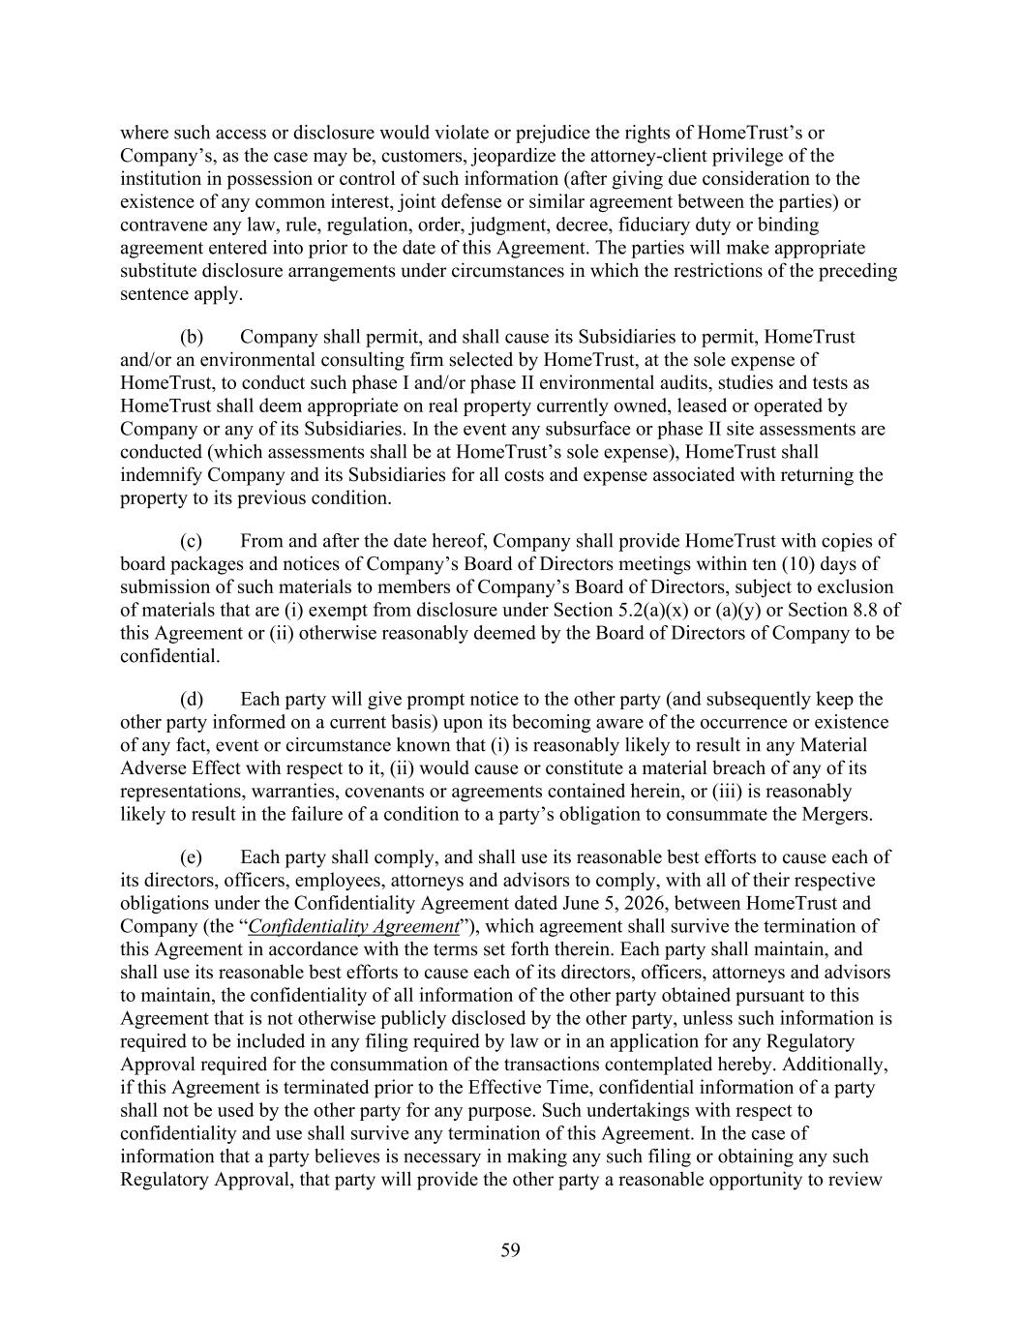
59 where such access or disclosure would violate or prejudice the rights of HomeTrust’s or Company’s, as the case may be, customers, jeopardize the attorney-client privilege of the institution in possession or control of such information (after giving due consideration to the existence of any common interest, joint defense or similar agreement between the parties) or contravene any law, rule, regulation, order, judgment, decree, fiduciary duty or binding agreement entered into prior to the date of this Agreement. The parties will make appropriate substitute disclosure arrangements under circumstances in which the restrictions of the preceding sentence apply. (b) Company shall permit, and shall cause its Subsidiaries to permit, HomeTrust and/or an environmental consulting firm selected by HomeTrust, at the sole expense of HomeTrust, to conduct such phase I and/or phase II environmental audits, studies and tests as HomeTrust shall deem appropriate on real property currently owned, leased or operated by Company or any of its Subsidiaries. In the event any subsurface or phase II site assessments are conducted (which assessments shall be at HomeTrust’s sole expense), HomeTrust shall indemnify Company and its Subsidiaries for all costs and expense associated with returning the property to its previous condition. (c) From and after the date hereof, Company shall provide HomeTrust with copies of board packages and notices of Company’s Board of Directors meetings within ten (10) days of submission of such materials to members of Company’s Board of Directors, subject to exclusion of materials that are (i) exempt from disclosure under Section 5.2(a)(x) or (a)(y) or Section 8.8 of this Agreement or (ii) otherwise reasonably deemed by the Board of Directors of Company to be confidential. (d) Each party will give prompt notice to the other party (and subsequently keep the other party informed on a current basis) upon its becoming aware of the occurrence or existence of any fact, event or circumstance known that (i) is reasonably likely to result in any Material Adverse Effect with respect to it, (ii) would cause or constitute a material breach of any of its representations, warranties, covenants or agreements contained herein, or (iii) is reasonably likely to result in the failure of a condition to a party’s obligation to consummate the Mergers. (e) Each party shall comply, and shall use its reasonable best efforts to cause each of its directors, officers, employees, attorneys and advisors to comply, with all of their respective obligations under the Confidentiality Agreement dated June 5, 2026, between HomeTrust and Company (the “Confidentiality Agreement”), which agreement shall survive the termination of this Agreement in accordance with the terms set forth therein. Each party shall maintain, and shall use its reasonable best efforts to cause each of its directors, officers, attorneys and advisors to maintain, the confidentiality of all information of the other party obtained pursuant to this Agreement that is not otherwise publicly disclosed by the other party, unless such information is required to be included in any filing required by law or in an application for any Regulatory Approval required for the consummation of the transactions contemplated hereby. Additionally, if this Agreement is terminated prior to the Effective Time, confidential information of a party shall not be used by the other party for any purpose. Such undertakings with respect to confidentiality and use shall survive any termination of this Agreement. In the case of information that a party believes is necessary in making any such filing or obtaining any such Regulatory Approval, that party will provide the other party a reasonable opportunity to review

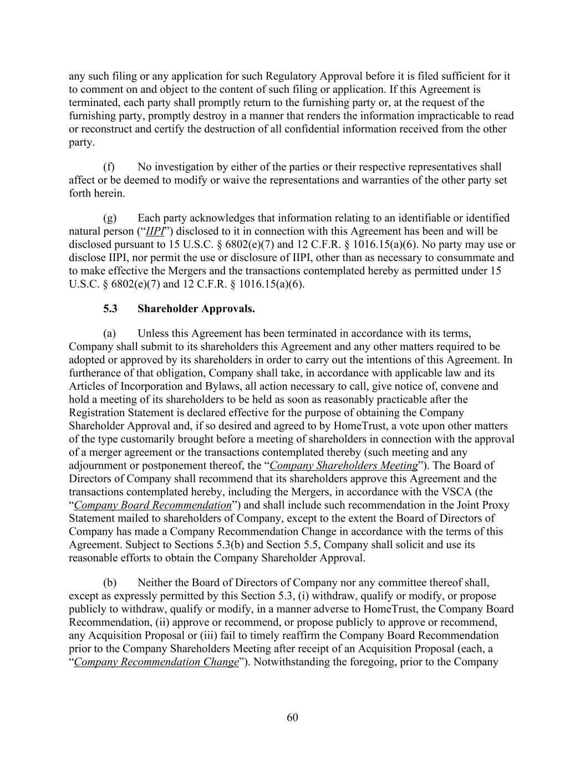
60 any such filing or any application for such Regulatory Approval before it is filed sufficient for it to comment on and object to the content of such filing or application. If this Agreement is terminated, each party shall promptly return to the furnishing party or, at the request of the furnishing party, promptly destroy in a manner that renders the information impracticable to read or reconstruct and certify the destruction of all confidential information received from the other party. (f) No investigation by either of the parties or their respective representatives shall affect or be deemed to modify or waive the representations and warranties of the other party set forth herein. (g) Each party acknowledges that information relating to an identifiable or identified natural person (“IIPI”) disclosed to it in connection with this Agreement has been and will be disclosed pursuant to 15 U.S.C. § 6802(e)(7) and 12 C.F.R. § 1016.15(a)(6). No party may use or disclose IIPI, nor permit the use or disclosure of IIPI, other than as necessary to consummate and to make effective the Mergers and the transactions contemplated hereby as permitted under 15 U.S.C. § 6802(e)(7) and 12 C.F.R. § 1016.15(a)(6). 5.3 Shareholder Approvals. (a) Unless this Agreement has been terminated in accordance with its terms, Company shall submit to its shareholders this Agreement and any other matters required to be adopted or approved by its shareholders in order to carry out the intentions of this Agreement. In furtherance of that obligation, Company shall take, in accordance with applicable law and its Articles of Incorporation and Bylaws, all action necessary to call, give notice of, convene and hold a meeting of its shareholders to be held as soon as reasonably practicable after the Registration Statement is declared effective for the purpose of obtaining the Company Shareholder Approval and, if so desired and agreed to by HomeTrust, a vote upon other matters of the type customarily brought before a meeting of shareholders in connection with the approval of a merger agreement or the transactions contemplated thereby (such meeting and any adjournment or postponement thereof, the “Company Shareholders Meeting”). The Board of Directors of Company shall recommend that its shareholders approve this Agreement and the transactions contemplated hereby, including the Mergers, in accordance with the VSCA (the “Company Board Recommendation”) and shall include such recommendation in the Joint Proxy Statement mailed to shareholders of Company, except to the extent the Board of Directors of Company has made a Company Recommendation Change in accordance with the terms of this Agreement. Subject to Sections 5.3(b) and Section 5.5, Company shall solicit and use its reasonable efforts to obtain the Company Shareholder Approval. (b) Neither the Board of Directors of Company nor any committee thereof shall, except as expressly permitted by this Section 5.3, (i) withdraw, qualify or modify, or propose publicly to withdraw, qualify or modify, in a manner adverse to HomeTrust, the Company Board Recommendation, (ii) approve or recommend, or propose publicly to approve or recommend, any Acquisition Proposal or (iii) fail to timely reaffirm the Company Board Recommendation prior to the Company Shareholders Meeting after receipt of an Acquisition Proposal (each, a “Company Recommendation Change”). Notwithstanding the foregoing, prior to the Company

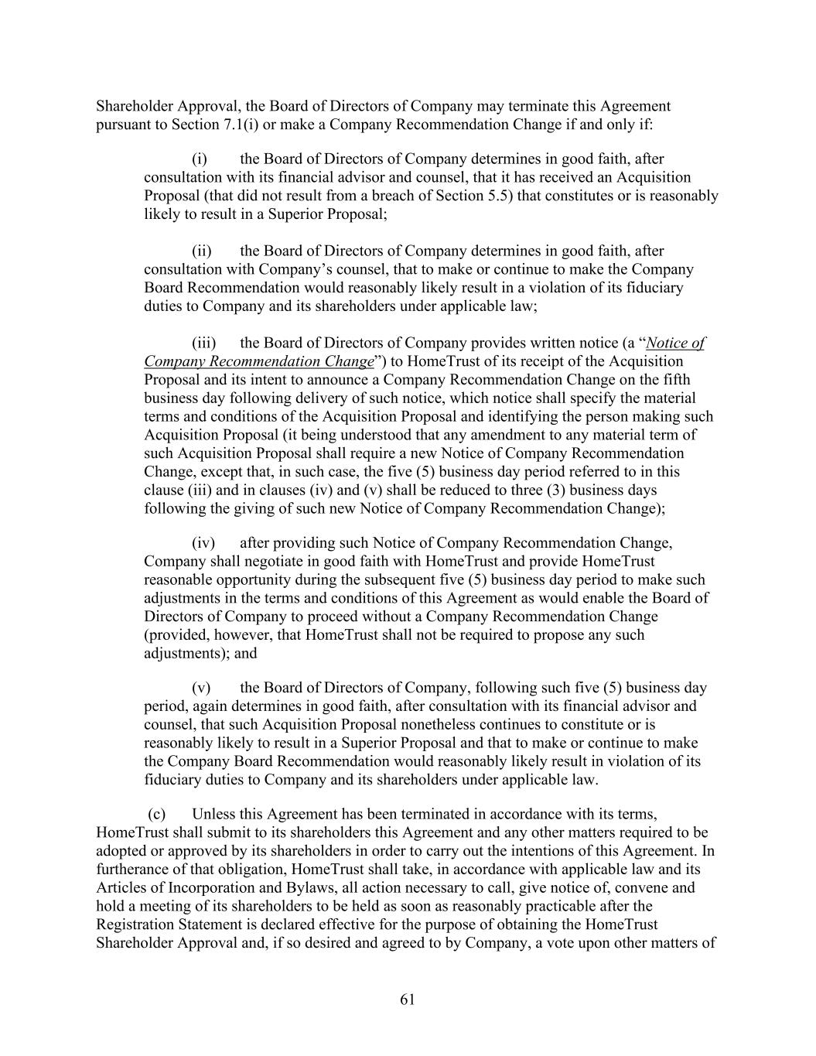
61 Shareholder Approval, the Board of Directors of Company may terminate this Agreement pursuant to Section 7.1(i) or make a Company Recommendation Change if and only if: (i) the Board of Directors of Company determines in good faith, after consultation with its financial advisor and counsel, that it has received an Acquisition Proposal (that did not result from a breach of Section 5.5) that constitutes or is reasonably likely to result in a Superior Proposal; (ii) the Board of Directors of Company determines in good faith, after consultation with Company’s counsel, that to make or continue to make the Company Board Recommendation would reasonably likely result in a violation of its fiduciary duties to Company and its shareholders under applicable law; (iii) the Board of Directors of Company provides written notice (a “Notice of Company Recommendation Change”) to HomeTrust of its receipt of the Acquisition Proposal and its intent to announce a Company Recommendation Change on the fifth business day following delivery of such notice, which notice shall specify the material terms and conditions of the Acquisition Proposal and identifying the person making such Acquisition Proposal (it being understood that any amendment to any material term of such Acquisition Proposal shall require a new Notice of Company Recommendation Change, except that, in such case, the five (5) business day period referred to in this clause (iii) and in clauses (iv) and (v) shall be reduced to three (3) business days following the giving of such new Notice of Company Recommendation Change); (iv) after providing such Notice of Company Recommendation Change, Company shall negotiate in good faith with HomeTrust and provide HomeTrust reasonable opportunity during the subsequent five (5) business day period to make such adjustments in the terms and conditions of this Agreement as would enable the Board of Directors of Company to proceed without a Company Recommendation Change (provided, however, that HomeTrust shall not be required to propose any such adjustments); and (v) the Board of Directors of Company, following such five (5) business day period, again determines in good faith, after consultation with its financial advisor and counsel, that such Acquisition Proposal nonetheless continues to constitute or is reasonably likely to result in a Superior Proposal and that to make or continue to make the Company Board Recommendation would reasonably likely result in violation of its fiduciary duties to Company and its shareholders under applicable law. (c) Unless this Agreement has been terminated in accordance with its terms, HomeTrust shall submit to its shareholders this Agreement and any other matters required to be adopted or approved by its shareholders in order to carry out the intentions of this Agreement. In furtherance of that obligation, HomeTrust shall take, in accordance with applicable law and its Articles of Incorporation and Bylaws, all action necessary to call, give notice of, convene and hold a meeting of its shareholders to be held as soon as reasonably practicable after the Registration Statement is declared effective for the purpose of obtaining the HomeTrust Shareholder Approval and, if so desired and agreed to by Company, a vote upon other matters of

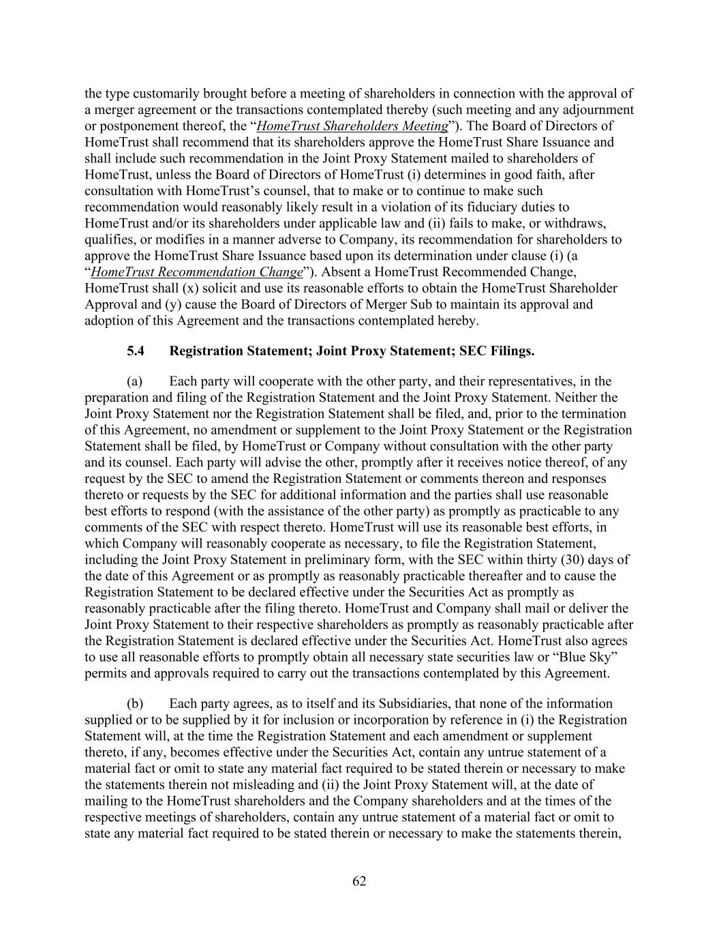
62 the type customarily brought before a meeting of shareholders in connection with the approval of a merger agreement or the transactions contemplated thereby (such meeting and any adjournment or postponement thereof, the “HomeTrust Shareholders Meeting”). The Board of Directors of HomeTrust shall recommend that its shareholders approve the HomeTrust Share Issuance and shall include such recommendation in the Joint Proxy Statement mailed to shareholders of HomeTrust, unless the Board of Directors of HomeTrust (i) determines in good faith, after consultation with HomeTrust’s counsel, that to make or to continue to make such recommendation would reasonably likely result in a violation of its fiduciary duties to HomeTrust and/or its shareholders under applicable law and (ii) fails to make, or withdraws, qualifies, or modifies in a manner adverse to Company, its recommendation for shareholders to approve the HomeTrust Share Issuance based upon its determination under clause (i) (a “HomeTrust Recommendation Change”). Absent a HomeTrust Recommended Change, HomeTrust shall (x) solicit and use its reasonable efforts to obtain the HomeTrust Shareholder Approval and (y) cause the Board of Directors of Merger Sub to maintain its approval and adoption of this Agreement and the transactions contemplated hereby. 5.4 Registration Statement; Joint Proxy Statement; SEC Filings. (a) Each party will cooperate with the other party, and their representatives, in the preparation and filing of the Registration Statement and the Joint Proxy Statement. Neither the Joint Proxy Statement nor the Registration Statement shall be filed, and, prior to the termination of this Agreement, no amendment or supplement to the Joint Proxy Statement or the Registration Statement shall be filed, by HomeTrust or Company without consultation with the other party and its counsel. Each party will advise the other, promptly after it receives notice thereof, of any request by the SEC to amend the Registration Statement or comments thereon and responses thereto or requests by the SEC for additional information and the parties shall use reasonable best efforts to respond (with the assistance of the other party) as promptly as practicable to any comments of the SEC with respect thereto. HomeTrust will use its reasonable best efforts, in which Company will reasonably cooperate as necessary, to file the Registration Statement, including the Joint Proxy Statement in preliminary form, with the SEC within thirty (30) days of the date of this Agreement or as promptly as reasonably practicable thereafter and to cause the Registration Statement to be declared effective under the Securities Act as promptly as reasonably practicable after the filing thereto. HomeTrust and Company shall mail or deliver the Joint Proxy Statement to their respective shareholders as promptly as reasonably practicable after the Registration Statement is declared effective under the Securities Act. HomeTrust also agrees to use all reasonable efforts to promptly obtain all necessary state securities law or “Blue Sky” permits and approvals required to carry out the transactions contemplated by this Agreement. (b) Each party agrees, as to itself and its Subsidiaries, that none of the information supplied or to be supplied by it for inclusion or incorporation by reference in (i) the Registration Statement will, at the time the Registration Statement and each amendment or supplement thereto, if any, becomes effective under the Securities Act, contain any untrue statement of a material fact or omit to state any material fact required to be stated therein or necessary to make the statements therein not misleading and (ii) the Joint Proxy Statement will, at the date of mailing to the HomeTrust shareholders and the Company shareholders and at the times of the respective meetings of shareholders, contain any untrue statement of a material fact or omit to state any material fact required to be stated therein or necessary to make the statements therein,

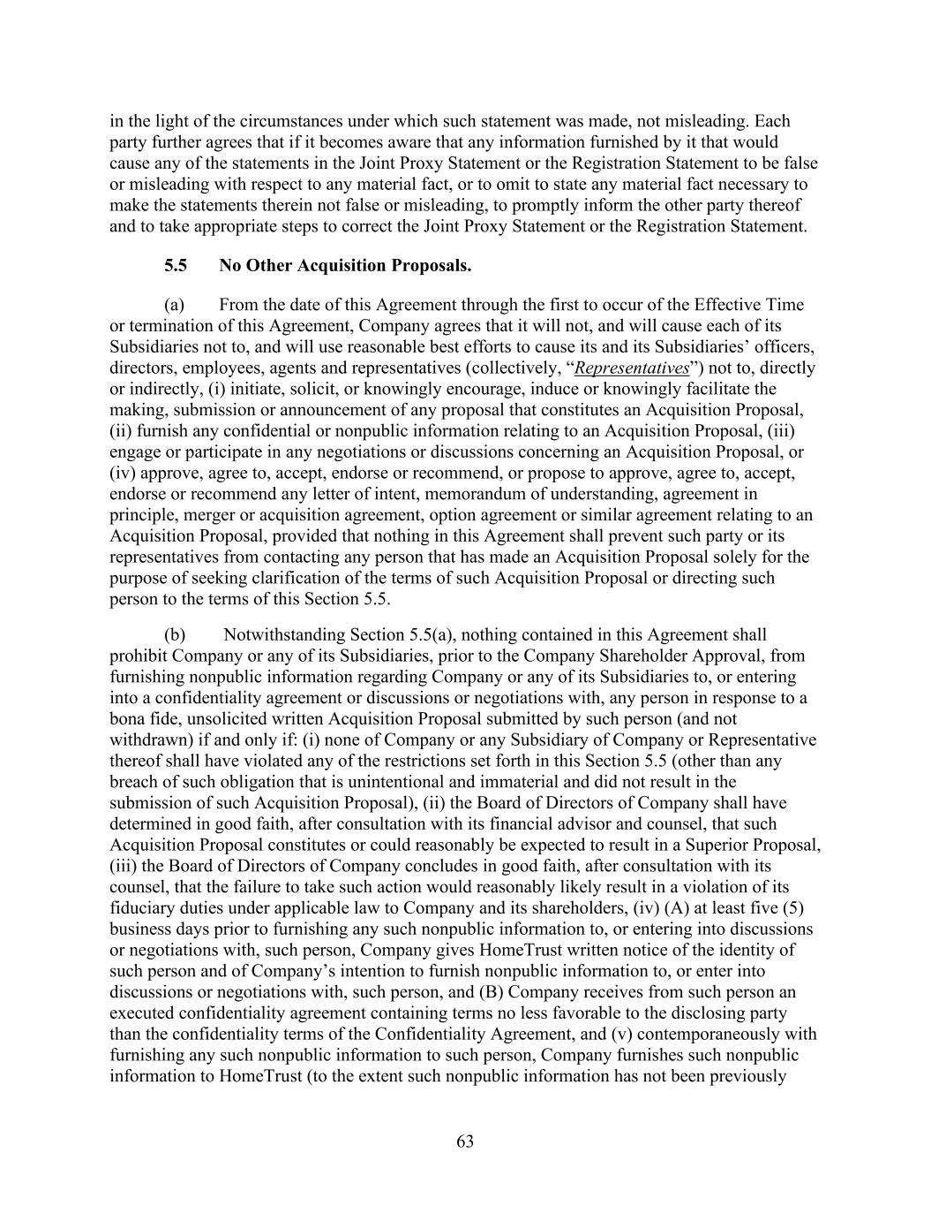
63 in the light of the circumstances under which such statement was made, not misleading. Each party further agrees that if it becomes aware that any information furnished by it that would cause any of the statements in the Joint Proxy Statement or the Registration Statement to be false or misleading with respect to any material fact, or to omit to state any material fact necessary to make the statements therein not false or misleading, to promptly inform the other party thereof and to take appropriate steps to correct the Joint Proxy Statement or the Registration Statement. 5.5 No Other Acquisition Proposals. (a) From the date of this Agreement through the first to occur of the Effective Time or termination of this Agreement, Company agrees that it will not, and will cause each of its Subsidiaries not to, and will use reasonable best efforts to cause its and its Subsidiaries’ officers, directors, employees, agents and representatives (collectively, “Representatives”) not to, directly or indirectly, (i) initiate, solicit, or knowingly encourage, induce or knowingly facilitate the making, submission or announcement of any proposal that constitutes an Acquisition Proposal, (ii) furnish any confidential or nonpublic information relating to an Acquisition Proposal, (iii) engage or participate in any negotiations or discussions concerning an Acquisition Proposal, or (iv) approve, agree to, accept, endorse or recommend, or propose to approve, agree to, accept, endorse or recommend any letter of intent, memorandum of understanding, agreement in principle, merger or acquisition agreement, option agreement or similar agreement relating to an Acquisition Proposal, provided that nothing in this Agreement shall prevent such party or its representatives from contacting any person that has made an Acquisition Proposal solely for the purpose of seeking clarification of the terms of such Acquisition Proposal or directing such person to the terms of this Section 5.5. (b) Notwithstanding Section 5.5(a), nothing contained in this Agreement shall prohibit Company or any of its Subsidiaries, prior to the Company Shareholder Approval, from furnishing nonpublic information regarding Company or any of its Subsidiaries to, or entering into a confidentiality agreement or discussions or negotiations with, any person in response to a bona fide, unsolicited written Acquisition Proposal submitted by such person (and not withdrawn) if and only if: (i) none of Company or any Subsidiary of Company or Representative thereof shall have violated any of the restrictions set forth in this Section 5.5 (other than any breach of such obligation that is unintentional and immaterial and did not result in the submission of such Acquisition Proposal), (ii) the Board of Directors of Company shall have determined in good faith, after consultation with its financial advisor and counsel, that such Acquisition Proposal constitutes or could reasonably be expected to result in a Superior Proposal, (iii) the Board of Directors of Company concludes in good faith, after consultation with its counsel, that the failure to take such action would reasonably likely result in a violation of its fiduciary duties under applicable law to Company and its shareholders, (iv) (A) at least five (5) business days prior to furnishing any such nonpublic information to, or entering into discussions or negotiations with, such person, Company gives HomeTrust written notice of the identity of such person and of Company’s intention to furnish nonpublic information to, or enter into discussions or negotiations with, such person, and (B) Company receives from such person an executed confidentiality agreement containing terms no less favorable to the disclosing party than the confidentiality terms of the Confidentiality Agreement, and (v) contemporaneously with furnishing any such nonpublic information to such person, Company furnishes such nonpublic information to HomeTrust (to the extent such nonpublic information has not been previously

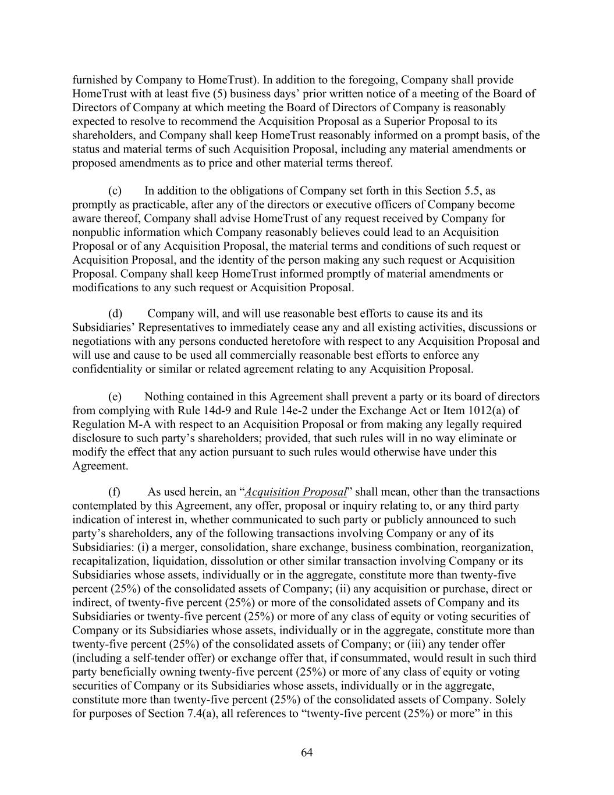
64 furnished by Company to HomeTrust). In addition to the foregoing, Company shall provide HomeTrust with at least five (5) business days’ prior written notice of a meeting of the Board of Directors of Company at which meeting the Board of Directors of Company is reasonably expected to resolve to recommend the Acquisition Proposal as a Superior Proposal to its shareholders, and Company shall keep HomeTrust reasonably informed on a prompt basis, of the status and material terms of such Acquisition Proposal, including any material amendments or proposed amendments as to price and other material terms thereof. (c) In addition to the obligations of Company set forth in this Section 5.5, as promptly as practicable, after any of the directors or executive officers of Company become aware thereof, Company shall advise HomeTrust of any request received by Company for nonpublic information which Company reasonably believes could lead to an Acquisition Proposal or of any Acquisition Proposal, the material terms and conditions of such request or Acquisition Proposal, and the identity of the person making any such request or Acquisition Proposal. Company shall keep HomeTrust informed promptly of material amendments or modifications to any such request or Acquisition Proposal. (d) Company will, and will use reasonable best efforts to cause its and its Subsidiaries’ Representatives to immediately cease any and all existing activities, discussions or negotiations with any persons conducted heretofore with respect to any Acquisition Proposal and will use and cause to be used all commercially reasonable best efforts to enforce any confidentiality or similar or related agreement relating to any Acquisition Proposal. (e) Nothing contained in this Agreement shall prevent a party or its board of directors from complying with Rule 14d-9 and Rule 14e-2 under the Exchange Act or Item 1012(a) of Regulation M-A with respect to an Acquisition Proposal or from making any legally required disclosure to such party’s shareholders; provided, that such rules will in no way eliminate or modify the effect that any action pursuant to such rules would otherwise have under this Agreement. (f) As used herein, an “Acquisition Proposal” shall mean, other than the transactions contemplated by this Agreement, any offer, proposal or inquiry relating to, or any third party indication of interest in, whether communicated to such party or publicly announced to such party’s shareholders, any of the following transactions involving Company or any of its Subsidiaries: (i) a merger, consolidation, share exchange, business combination, reorganization, recapitalization, liquidation, dissolution or other similar transaction involving Company or its Subsidiaries whose assets, individually or in the aggregate, constitute more than twenty-five percent (25%) of the consolidated assets of Company; (ii) any acquisition or purchase, direct or indirect, of twenty-five percent (25%) or more of the consolidated assets of Company and its Subsidiaries or twenty-five percent (25%) or more of any class of equity or voting securities of Company or its Subsidiaries whose assets, individually or in the aggregate, constitute more than twenty-five percent (25%) of the consolidated assets of Company; or (iii) any tender offer (including a self-tender offer) or exchange offer that, if consummated, would result in such third party beneficially owning twenty-five percent (25%) or more of any class of equity or voting securities of Company or its Subsidiaries whose assets, individually or in the aggregate, constitute more than twenty-five percent (25%) of the consolidated assets of Company. Solely for purposes of Section 7.4(a), all references to “twenty-five percent (25%) or more” in this

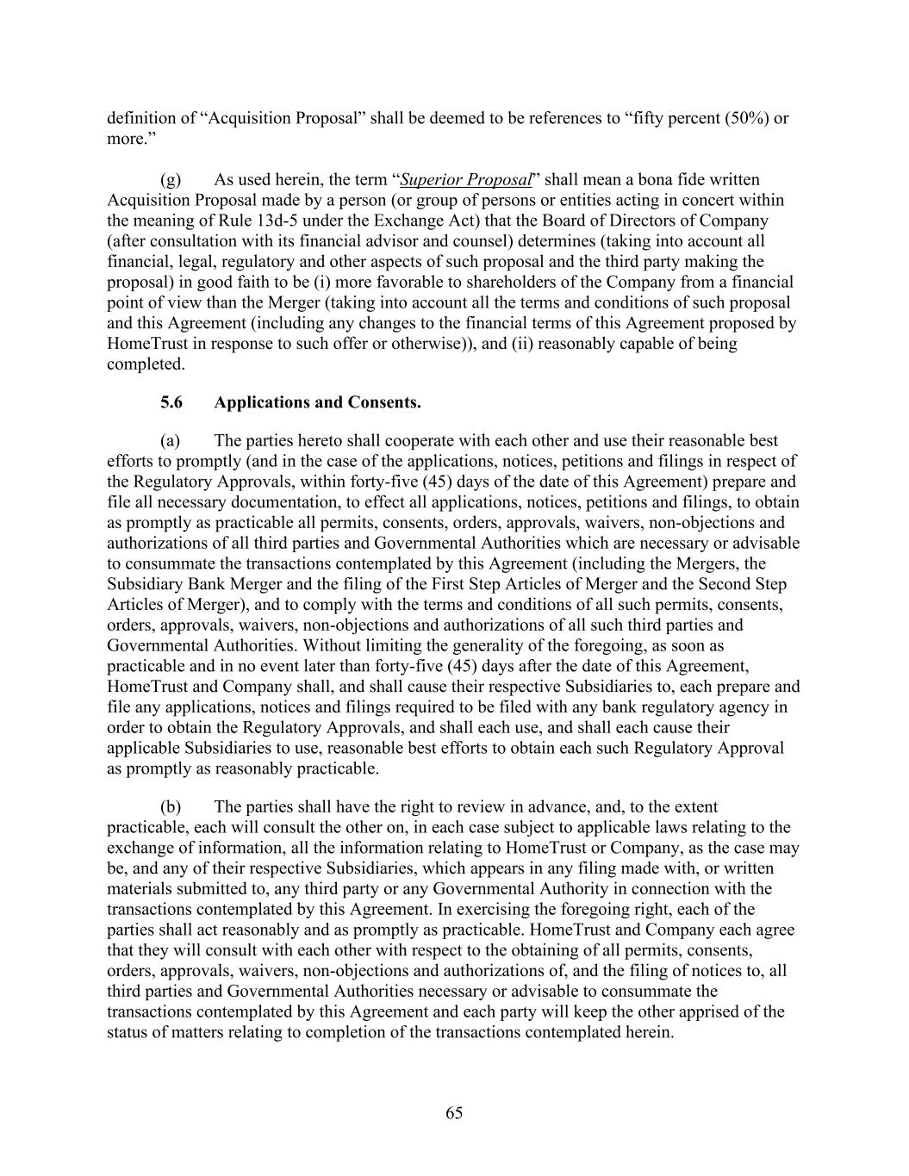
65 definition of “Acquisition Proposal” shall be deemed to be references to “fifty percent (50%) or more.” (g) As used herein, the term “Superior Proposal” shall mean a bona fide written Acquisition Proposal made by a person (or group of persons or entities acting in concert within the meaning of Rule 13d-5 under the Exchange Act) that the Board of Directors of Company (after consultation with its financial advisor and counsel) determines (taking into account all financial, legal, regulatory and other aspects of such proposal and the third party making the proposal) in good faith to be (i) more favorable to shareholders of the Company from a financial point of view than the Merger (taking into account all the terms and conditions of such proposal and this Agreement (including any changes to the financial terms of this Agreement proposed by HomeTrust in response to such offer or otherwise)), and (ii) reasonably capable of being completed. 5.6 Applications and Consents. (a) The parties hereto shall cooperate with each other and use their reasonable best efforts to promptly (and in the case of the applications, notices, petitions and filings in respect of the Regulatory Approvals, within forty-five (45) days of the date of this Agreement) prepare and file all necessary documentation, to effect all applications, notices, petitions and filings, to obtain as promptly as practicable all permits, consents, orders, approvals, waivers, non-objections and authorizations of all third parties and Governmental Authorities which are necessary or advisable to consummate the transactions contemplated by this Agreement (including the Mergers, the Subsidiary Bank Merger and the filing of the First Step Articles of Merger and the Second Step Articles of Merger), and to comply with the terms and conditions of all such permits, consents, orders, approvals, waivers, non-objections and authorizations of all such third parties and Governmental Authorities. Without limiting the generality of the foregoing, as soon as practicable and in no event later than forty-five (45) days after the date of this Agreement, HomeTrust and Company shall, and shall cause their respective Subsidiaries to, each prepare and file any applications, notices and filings required to be filed with any bank regulatory agency in order to obtain the Regulatory Approvals, and shall each use, and shall each cause their applicable Subsidiaries to use, reasonable best efforts to obtain each such Regulatory Approval as promptly as reasonably practicable. (b) The parties shall have the right to review in advance, and, to the extent practicable, each will consult the other on, in each case subject to applicable laws relating to the exchange of information, all the information relating to HomeTrust or Company, as the case may be, and any of their respective Subsidiaries, which appears in any filing made with, or written materials submitted to, any third party or any Governmental Authority in connection with the transactions contemplated by this Agreement. In exercising the foregoing right, each of the parties shall act reasonably and as promptly as practicable. HomeTrust and Company each agree that they will consult with each other with respect to the obtaining of all permits, consents, orders, approvals, waivers, non-objections and authorizations of, and the filing of notices to, all third parties and Governmental Authorities necessary or advisable to consummate the transactions contemplated by this Agreement and each party will keep the other apprised of the status of matters relating to completion of the transactions contemplated herein.

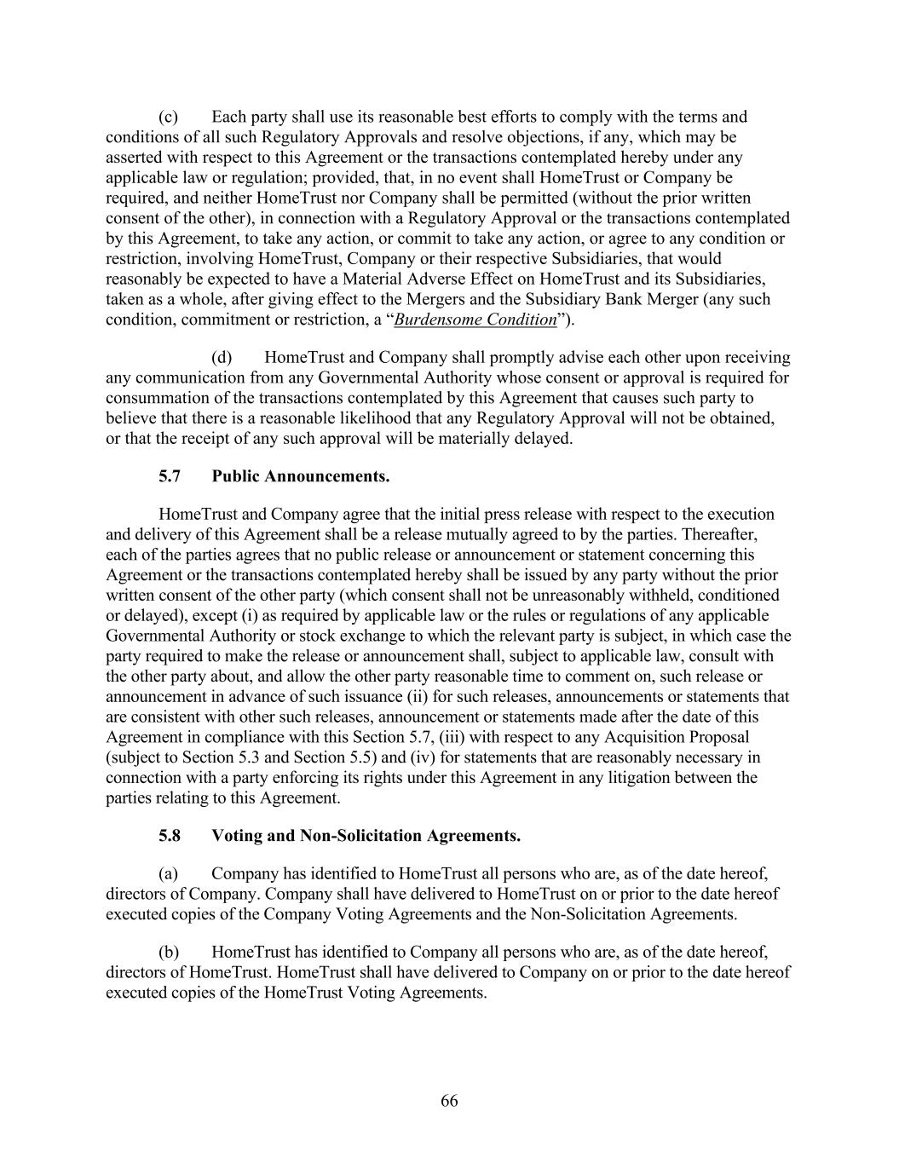
66 (c) Each party shall use its reasonable best efforts to comply with the terms and conditions of all such Regulatory Approvals and resolve objections, if any, which may be asserted with respect to this Agreement or the transactions contemplated hereby under any applicable law or regulation; provided, that, in no event shall HomeTrust or Company be required, and neither HomeTrust nor Company shall be permitted (without the prior written consent of the other), in connection with a Regulatory Approval or the transactions contemplated by this Agreement, to take any action, or commit to take any action, or agree to any condition or restriction, involving HomeTrust, Company or their respective Subsidiaries, that would reasonably be expected to have a Material Adverse Effect on HomeTrust and its Subsidiaries, taken as a whole, after giving effect to the Mergers and the Subsidiary Bank Merger (any such condition, commitment or restriction, a “Burdensome Condition”). (d) HomeTrust and Company shall promptly advise each other upon receiving any communication from any Governmental Authority whose consent or approval is required for consummation of the transactions contemplated by this Agreement that causes such party to believe that there is a reasonable likelihood that any Regulatory Approval will not be obtained, or that the receipt of any such approval will be materially delayed. 5.7 Public Announcements. HomeTrust and Company agree that the initial press release with respect to the execution and delivery of this Agreement shall be a release mutually agreed to by the parties. Thereafter, each of the parties agrees that no public release or announcement or statement concerning this Agreement or the transactions contemplated hereby shall be issued by any party without the prior written consent of the other party (which consent shall not be unreasonably withheld, conditioned or delayed), except (i) as required by applicable law or the rules or regulations of any applicable Governmental Authority or stock exchange to which the relevant party is subject, in which case the party required to make the release or announcement shall, subject to applicable law, consult with the other party about, and allow the other party reasonable time to comment on, such release or announcement in advance of such issuance (ii) for such releases, announcements or statements that are consistent with other such releases, announcement or statements made after the date of this Agreement in compliance with this Section 5.7, (iii) with respect to any Acquisition Proposal (subject to Section 5.3 and Section 5.5) and (iv) for statements that are reasonably necessary in connection with a party enforcing its rights under this Agreement in any litigation between the parties relating to this Agreement. 5.8 Voting and Non-Solicitation Agreements. (a) Company has identified to HomeTrust all persons who are, as of the date hereof, directors of Company. Company shall have delivered to HomeTrust on or prior to the date hereof executed copies of the Company Voting Agreements and the Non-Solicitation Agreements. (b) HomeTrust has identified to Company all persons who are, as of the date hereof, directors of HomeTrust. HomeTrust shall have delivered to Company on or prior to the date hereof executed copies of the HomeTrust Voting Agreements.

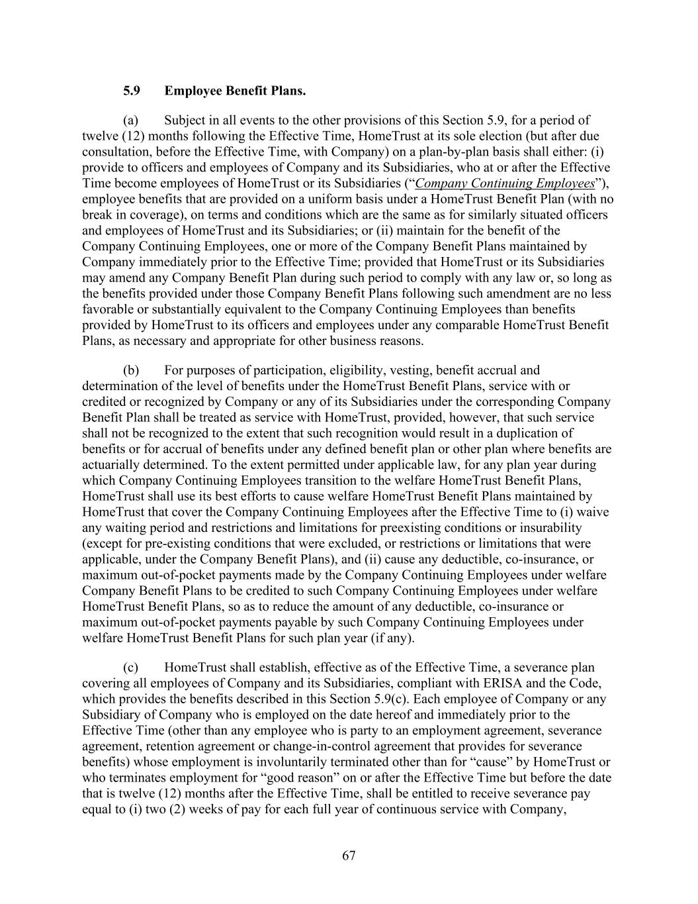
67 5.9 Employee Benefit Plans. (a) Subject in all events to the other provisions of this Section 5.9, for a period of twelve (12) months following the Effective Time, HomeTrust at its sole election (but after due consultation, before the Effective Time, with Company) on a plan-by-plan basis shall either: (i) provide to officers and employees of Company and its Subsidiaries, who at or after the Effective Time become employees of HomeTrust or its Subsidiaries (“Company Continuing Employees”), employee benefits that are provided on a uniform basis under a HomeTrust Benefit Plan (with no break in coverage), on terms and conditions which are the same as for similarly situated officers and employees of HomeTrust and its Subsidiaries; or (ii) maintain for the benefit of the Company Continuing Employees, one or more of the Company Benefit Plans maintained by Company immediately prior to the Effective Time; provided that HomeTrust or its Subsidiaries may amend any Company Benefit Plan during such period to comply with any law or, so long as the benefits provided under those Company Benefit Plans following such amendment are no less favorable or substantially equivalent to the Company Continuing Employees than benefits provided by HomeTrust to its officers and employees under any comparable HomeTrust Benefit Plans, as necessary and appropriate for other business reasons. (b) For purposes of participation, eligibility, vesting, benefit accrual and determination of the level of benefits under the HomeTrust Benefit Plans, service with or credited or recognized by Company or any of its Subsidiaries under the corresponding Company Benefit Plan shall be treated as service with HomeTrust, provided, however, that such service shall not be recognized to the extent that such recognition would result in a duplication of benefits or for accrual of benefits under any defined benefit plan or other plan where benefits are actuarially determined. To the extent permitted under applicable law, for any plan year during which Company Continuing Employees transition to the welfare HomeTrust Benefit Plans, HomeTrust shall use its best efforts to cause welfare HomeTrust Benefit Plans maintained by HomeTrust that cover the Company Continuing Employees after the Effective Time to (i) waive any waiting period and restrictions and limitations for preexisting conditions or insurability (except for pre-existing conditions that were excluded, or restrictions or limitations that were applicable, under the Company Benefit Plans), and (ii) cause any deductible, co-insurance, or maximum out-of-pocket payments made by the Company Continuing Employees under welfare Company Benefit Plans to be credited to such Company Continuing Employees under welfare HomeTrust Benefit Plans, so as to reduce the amount of any deductible, co-insurance or maximum out-of-pocket payments payable by such Company Continuing Employees under welfare HomeTrust Benefit Plans for such plan year (if any). (c) HomeTrust shall establish, effective as of the Effective Time, a severance plan covering all employees of Company and its Subsidiaries, compliant with ERISA and the Code, which provides the benefits described in this Section 5.9(c). Each employee of Company or any Subsidiary of Company who is employed on the date hereof and immediately prior to the Effective Time (other than any employee who is party to an employment agreement, severance agreement, retention agreement or change-in-control agreement that provides for severance benefits) whose employment is involuntarily terminated other than for “cause” by HomeTrust or who terminates employment for “good reason” on or after the Effective Time but before the date that is twelve (12) months after the Effective Time, shall be entitled to receive severance pay equal to (i) two (2) weeks of pay for each full year of continuous service with Company,

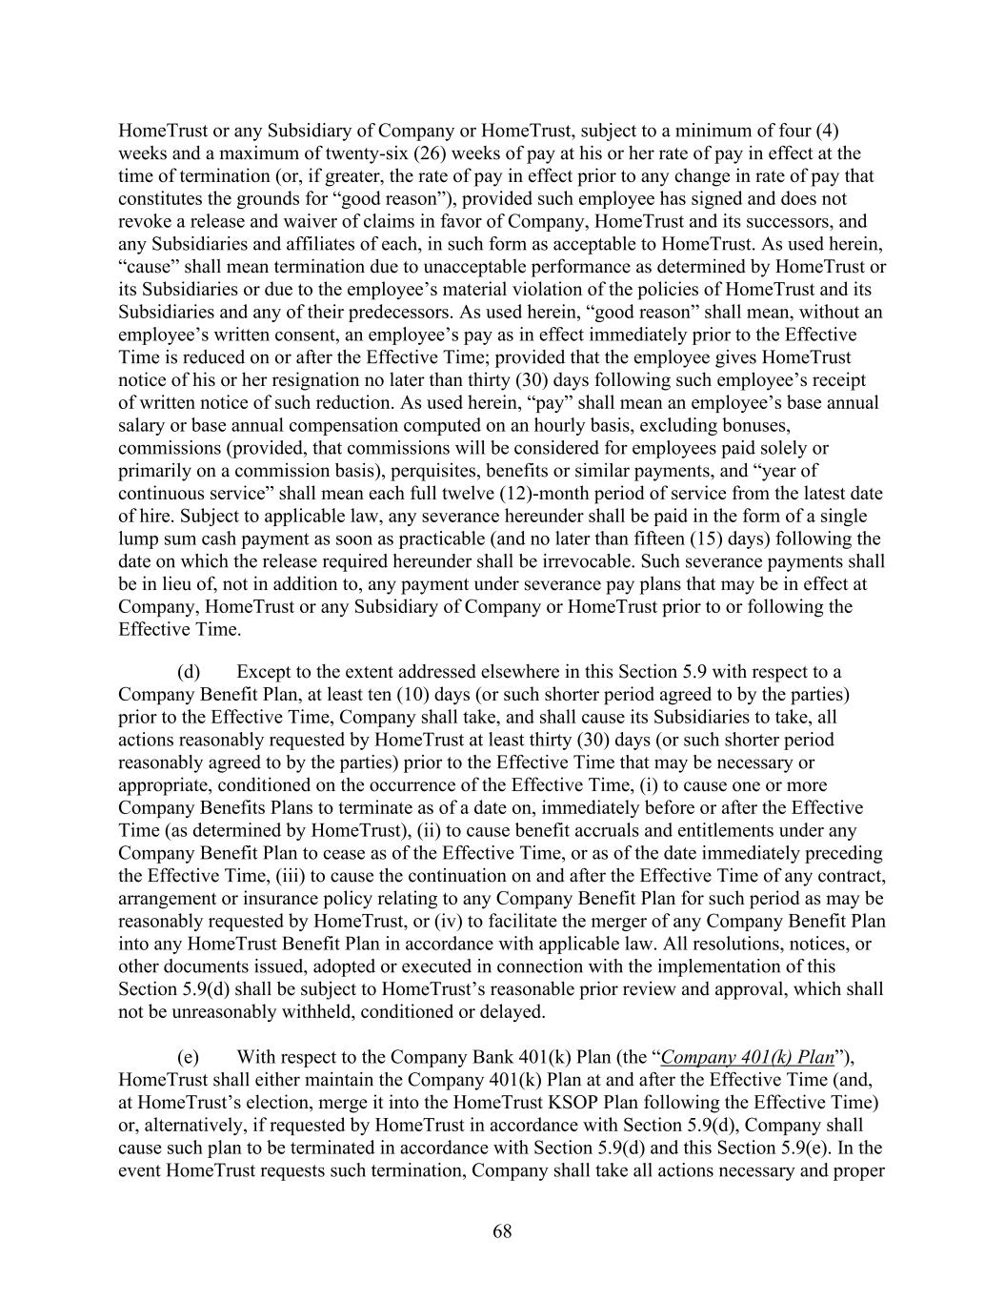
68 HomeTrust or any Subsidiary of Company or HomeTrust, subject to a minimum of four (4) weeks and a maximum of twenty-six (26) weeks of pay at his or her rate of pay in effect at the time of termination (or, if greater, the rate of pay in effect prior to any change in rate of pay that constitutes the grounds for “good reason”), provided such employee has signed and does not revoke a release and waiver of claims in favor of Company, HomeTrust and its successors, and any Subsidiaries and affiliates of each, in such form as acceptable to HomeTrust. As used herein, “cause” shall mean termination due to unacceptable performance as determined by HomeTrust or its Subsidiaries or due to the employee’s material violation of the policies of HomeTrust and its Subsidiaries and any of their predecessors. As used herein, “good reason” shall mean, without an employee’s written consent, an employee’s pay as in effect immediately prior to the Effective Time is reduced on or after the Effective Time; provided that the employee gives HomeTrust notice of his or her resignation no later than thirty (30) days following such employee’s receipt of written notice of such reduction. As used herein, “pay” shall mean an employee’s base annual salary or base annual compensation computed on an hourly basis, excluding bonuses, commissions (provided, that commissions will be considered for employees paid solely or primarily on a commission basis), perquisites, benefits or similar payments, and “year of continuous service” shall mean each full twelve (12)-month period of service from the latest date of hire. Subject to applicable law, any severance hereunder shall be paid in the form of a single lump sum cash payment as soon as practicable (and no later than fifteen (15) days) following the date on which the release required hereunder shall be irrevocable. Such severance payments shall be in lieu of, not in addition to, any payment under severance pay plans that may be in effect at Company, HomeTrust or any Subsidiary of Company or HomeTrust prior to or following the Effective Time. (d) Except to the extent addressed elsewhere in this Section 5.9 with respect to a Company Benefit Plan, at least ten (10) days (or such shorter period agreed to by the parties) prior to the Effective Time, Company shall take, and shall cause its Subsidiaries to take, all actions reasonably requested by HomeTrust at least thirty (30) days (or such shorter period reasonably agreed to by the parties) prior to the Effective Time that may be necessary or appropriate, conditioned on the occurrence of the Effective Time, (i) to cause one or more Company Benefits Plans to terminate as of a date on, immediately before or after the Effective Time (as determined by HomeTrust), (ii) to cause benefit accruals and entitlements under any Company Benefit Plan to cease as of the Effective Time, or as of the date immediately preceding the Effective Time, (iii) to cause the continuation on and after the Effective Time of any contract, arrangement or insurance policy relating to any Company Benefit Plan for such period as may be reasonably requested by HomeTrust, or (iv) to facilitate the merger of any Company Benefit Plan into any HomeTrust Benefit Plan in accordance with applicable law. All resolutions, notices, or other documents issued, adopted or executed in connection with the implementation of this Section 5.9(d) shall be subject to HomeTrust’s reasonable prior review and approval, which shall not be unreasonably withheld, conditioned or delayed. (e) With respect to the Company Bank 401(k) Plan (the “Company 401(k) Plan”), HomeTrust shall either maintain the Company 401(k) Plan at and after the Effective Time (and, at HomeTrust’s election, merge it into the HomeTrust KSOP Plan following the Effective Time) or, alternatively, if requested by HomeTrust in accordance with Section 5.9(d), Company shall cause such plan to be terminated in accordance with Section 5.9(d) and this Section 5.9(e). In the event HomeTrust requests such termination, Company shall take all actions necessary and proper

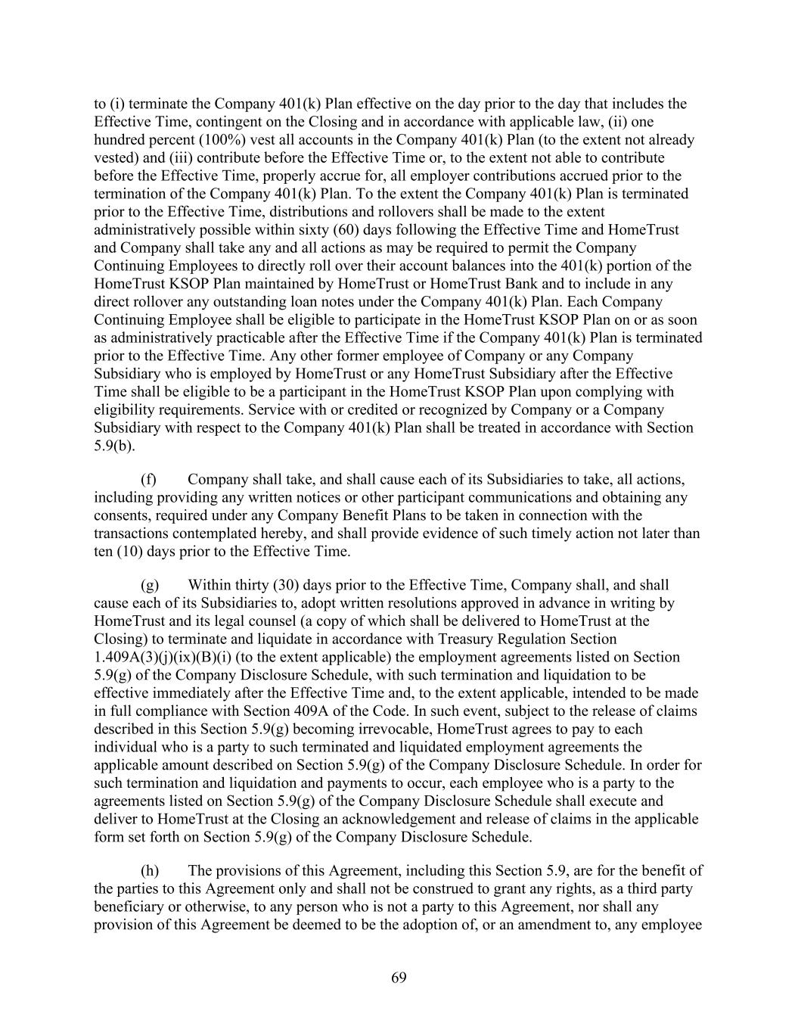
69 to (i) terminate the Company 401(k) Plan effective on the day prior to the day that includes the Effective Time, contingent on the Closing and in accordance with applicable law, (ii) one hundred percent (100%) vest all accounts in the Company 401(k) Plan (to the extent not already vested) and (iii) contribute before the Effective Time or, to the extent not able to contribute before the Effective Time, properly accrue for, all employer contributions accrued prior to the termination of the Company 401(k) Plan. To the extent the Company 401(k) Plan is terminated prior to the Effective Time, distributions and rollovers shall be made to the extent administratively possible within sixty (60) days following the Effective Time and HomeTrust and Company shall take any and all actions as may be required to permit the Company Continuing Employees to directly roll over their account balances into the 401(k) portion of the HomeTrust KSOP Plan maintained by HomeTrust or HomeTrust Bank and to include in any direct rollover any outstanding loan notes under the Company 401(k) Plan. Each Company Continuing Employee shall be eligible to participate in the HomeTrust KSOP Plan on or as soon as administratively practicable after the Effective Time if the Company 401(k) Plan is terminated prior to the Effective Time. Any other former employee of Company or any Company Subsidiary who is employed by HomeTrust or any HomeTrust Subsidiary after the Effective Time shall be eligible to be a participant in the HomeTrust KSOP Plan upon complying with eligibility requirements. Service with or credited or recognized by Company or a Company Subsidiary with respect to the Company 401(k) Plan shall be treated in accordance with Section 5.9(b). (f) Company shall take, and shall cause each of its Subsidiaries to take, all actions, including providing any written notices or other participant communications and obtaining any consents, required under any Company Benefit Plans to be taken in connection with the transactions contemplated hereby, and shall provide evidence of such timely action not later than ten (10) days prior to the Effective Time. (g) Within thirty (30) days prior to the Effective Time, Company shall, and shall cause each of its Subsidiaries to, adopt written resolutions approved in advance in writing by HomeTrust and its legal counsel (a copy of which shall be delivered to HomeTrust at the Closing) to terminate and liquidate in accordance with Treasury Regulation Section 1.409A(3)(j)(ix)(B)(i) (to the extent applicable) the employment agreements listed on Section 5.9(g) of the Company Disclosure Schedule, with such termination and liquidation to be effective immediately after the Effective Time and, to the extent applicable, intended to be made in full compliance with Section 409A of the Code. In such event, subject to the release of claims described in this Section 5.9(g) becoming irrevocable, HomeTrust agrees to pay to each individual who is a party to such terminated and liquidated employment agreements the applicable amount described on Section 5.9(g) of the Company Disclosure Schedule. In order for such termination and liquidation and payments to occur, each employee who is a party to the agreements listed on Section 5.9(g) of the Company Disclosure Schedule shall execute and deliver to HomeTrust at the Closing an acknowledgement and release of claims in the applicable form set forth on Section 5.9(g) of the Company Disclosure Schedule. (h) The provisions of this Agreement, including this Section 5.9, are for the benefit of the parties to this Agreement only and shall not be construed to grant any rights, as a third party beneficiary or otherwise, to any person who is not a party to this Agreement, nor shall any provision of this Agreement be deemed to be the adoption of, or an amendment to, any employee

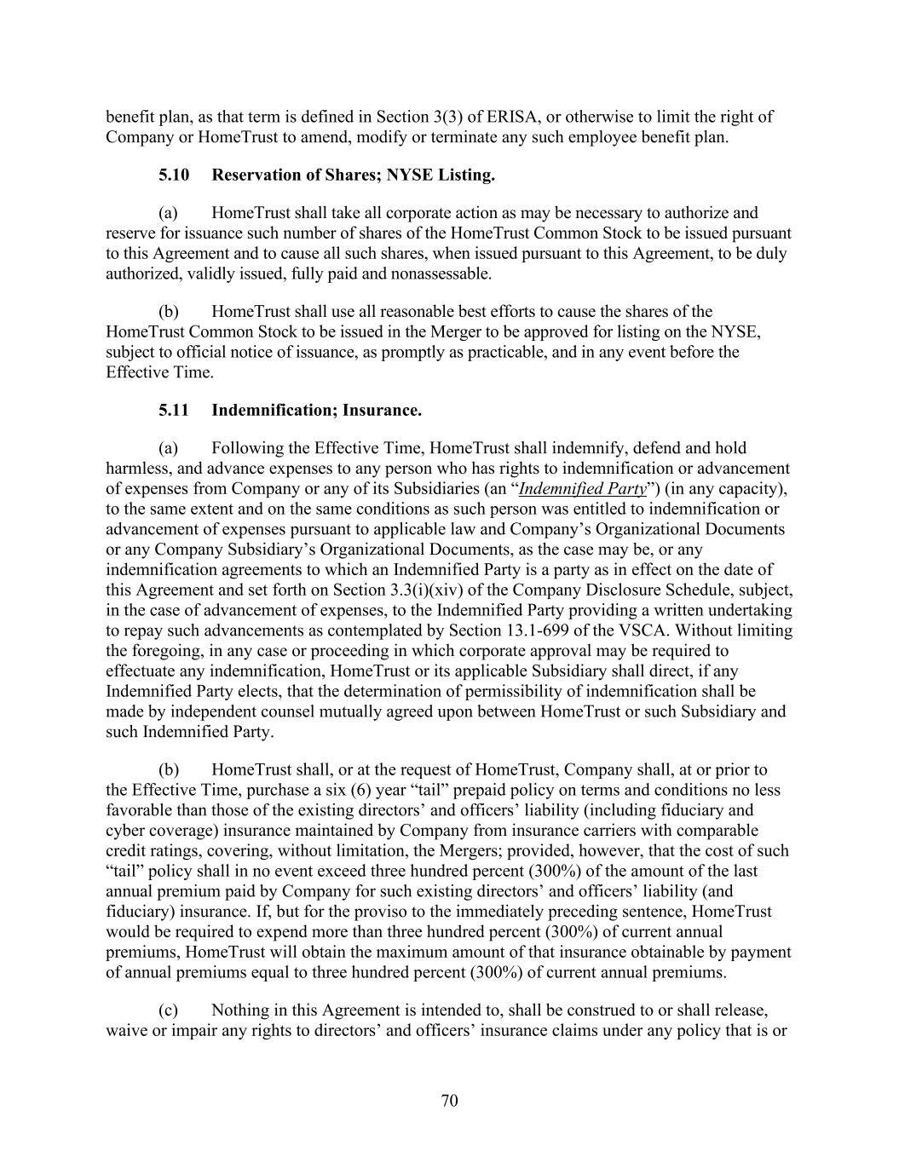
70 benefit plan, as that term is defined in Section 3(3) of ERISA, or otherwise to limit the right of Company or HomeTrust to amend, modify or terminate any such employee benefit plan. 5.10 Reservation of Shares; NYSE Listing. (a) HomeTrust shall take all corporate action as may be necessary to authorize and reserve for issuance such number of shares of the HomeTrust Common Stock to be issued pursuant to this Agreement and to cause all such shares, when issued pursuant to this Agreement, to be duly authorized, validly issued, fully paid and nonassessable. (b) HomeTrust shall use all reasonable best efforts to cause the shares of the HomeTrust Common Stock to be issued in the Merger to be approved for listing on the NYSE, subject to official notice of issuance, as promptly as practicable, and in any event before the Effective Time. 5.11 Indemnification; Insurance. (a) Following the Effective Time, HomeTrust shall indemnify, defend and hold harmless, and advance expenses to any person who has rights to indemnification or advancement of expenses from Company or any of its Subsidiaries (an “Indemnified Party”) (in any capacity), to the same extent and on the same conditions as such person was entitled to indemnification or advancement of expenses pursuant to applicable law and Company’s Organizational Documents or any Company Subsidiary’s Organizational Documents, as the case may be, or any indemnification agreements to which an Indemnified Party is a party as in effect on the date of this Agreement and set forth on Section 3.3(i)(xiv) of the Company Disclosure Schedule, subject, in the case of advancement of expenses, to the Indemnified Party providing a written undertaking to repay such advancements as contemplated by Section 13.1-699 of the VSCA. Without limiting the foregoing, in any case or proceeding in which corporate approval may be required to effectuate any indemnification, HomeTrust or its applicable Subsidiary shall direct, if any Indemnified Party elects, that the determination of permissibility of indemnification shall be made by independent counsel mutually agreed upon between HomeTrust or such Subsidiary and such Indemnified Party. (b) HomeTrust shall, or at the request of HomeTrust, Company shall, at or prior to the Effective Time, purchase a six (6) year “tail” prepaid policy on terms and conditions no less favorable than those of the existing directors’ and officers’ liability (including fiduciary and cyber coverage) insurance maintained by Company from insurance carriers with comparable credit ratings, covering, without limitation, the Mergers; provided, however, that the cost of such “tail” policy shall in no event exceed three hundred percent (300%) of the amount of the last annual premium paid by Company for such existing directors’ and officers’ liability (and fiduciary) insurance. If, but for the proviso to the immediately preceding sentence, HomeTrust would be required to expend more than three hundred percent (300%) of current annual premiums, HomeTrust will obtain the maximum amount of that insurance obtainable by payment of annual premiums equal to three hundred percent (300%) of current annual premiums. (c) Nothing in this Agreement is intended to, shall be construed to or shall release, waive or impair any rights to directors’ and officers’ insurance claims under any policy that is or

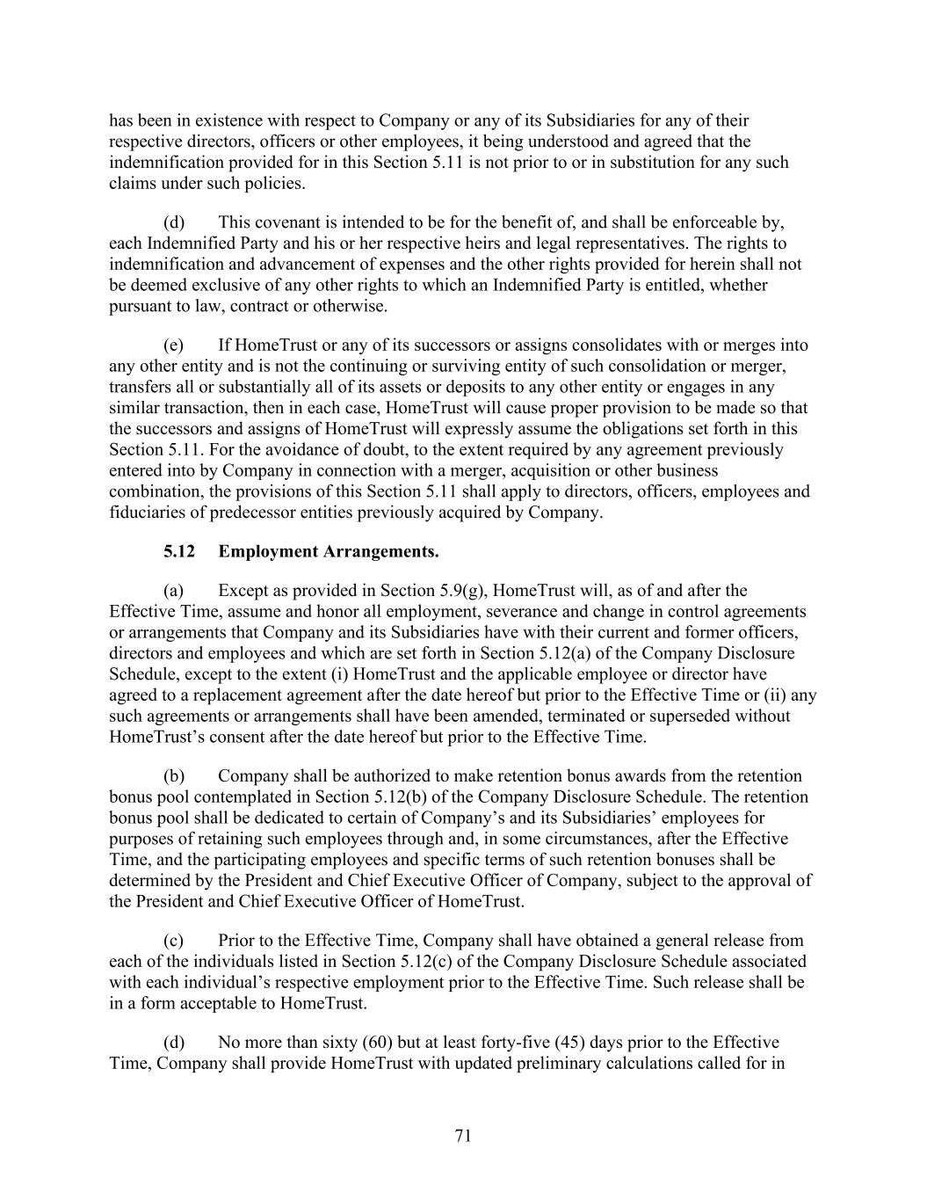
71 has been in existence with respect to Company or any of its Subsidiaries for any of their respective directors, officers or other employees, it being understood and agreed that the indemnification provided for in this Section 5.11 is not prior to or in substitution for any such claims under such policies. (d) This covenant is intended to be for the benefit of, and shall be enforceable by, each Indemnified Party and his or her respective heirs and legal representatives. The rights to indemnification and advancement of expenses and the other rights provided for herein shall not be deemed exclusive of any other rights to which an Indemnified Party is entitled, whether pursuant to law, contract or otherwise. (e) If HomeTrust or any of its successors or assigns consolidates with or merges into any other entity and is not the continuing or surviving entity of such consolidation or merger, transfers all or substantially all of its assets or deposits to any other entity or engages in any similar transaction, then in each case, HomeTrust will cause proper provision to be made so that the successors and assigns of HomeTrust will expressly assume the obligations set forth in this Section 5.11. For the avoidance of doubt, to the extent required by any agreement previously entered into by Company in connection with a merger, acquisition or other business combination, the provisions of this Section 5.11 shall apply to directors, officers, employees and fiduciaries of predecessor entities previously acquired by Company. 5.12 Employment Arrangements. (a) Except as provided in Section 5.9(g), HomeTrust will, as of and after the Effective Time, assume and honor all employment, severance and change in control agreements or arrangements that Company and its Subsidiaries have with their current and former officers, directors and employees and which are set forth in Section 5.12(a) of the Company Disclosure Schedule, except to the extent (i) HomeTrust and the applicable employee or director have agreed to a replacement agreement after the date hereof but prior to the Effective Time or (ii) any such agreements or arrangements shall have been amended, terminated or superseded without HomeTrust’s consent after the date hereof but prior to the Effective Time. (b) Company shall be authorized to make retention bonus awards from the retention bonus pool contemplated in Section 5.12(b) of the Company Disclosure Schedule. The retention bonus pool shall be dedicated to certain of Company’s and its Subsidiaries’ employees for purposes of retaining such employees through and, in some circumstances, after the Effective Time, and the participating employees and specific terms of such retention bonuses shall be determined by the President and Chief Executive Officer of Company, subject to the approval of the President and Chief Executive Officer of HomeTrust. (c) Prior to the Effective Time, Company shall have obtained a general release from each of the individuals listed in Section 5.12(c) of the Company Disclosure Schedule associated with each individual’s respective employment prior to the Effective Time. Such release shall be in a form acceptable to HomeTrust. (d) No more than sixty (60) but at least forty-five (45) days prior to the Effective Time, Company shall provide HomeTrust with updated preliminary calculations called for in

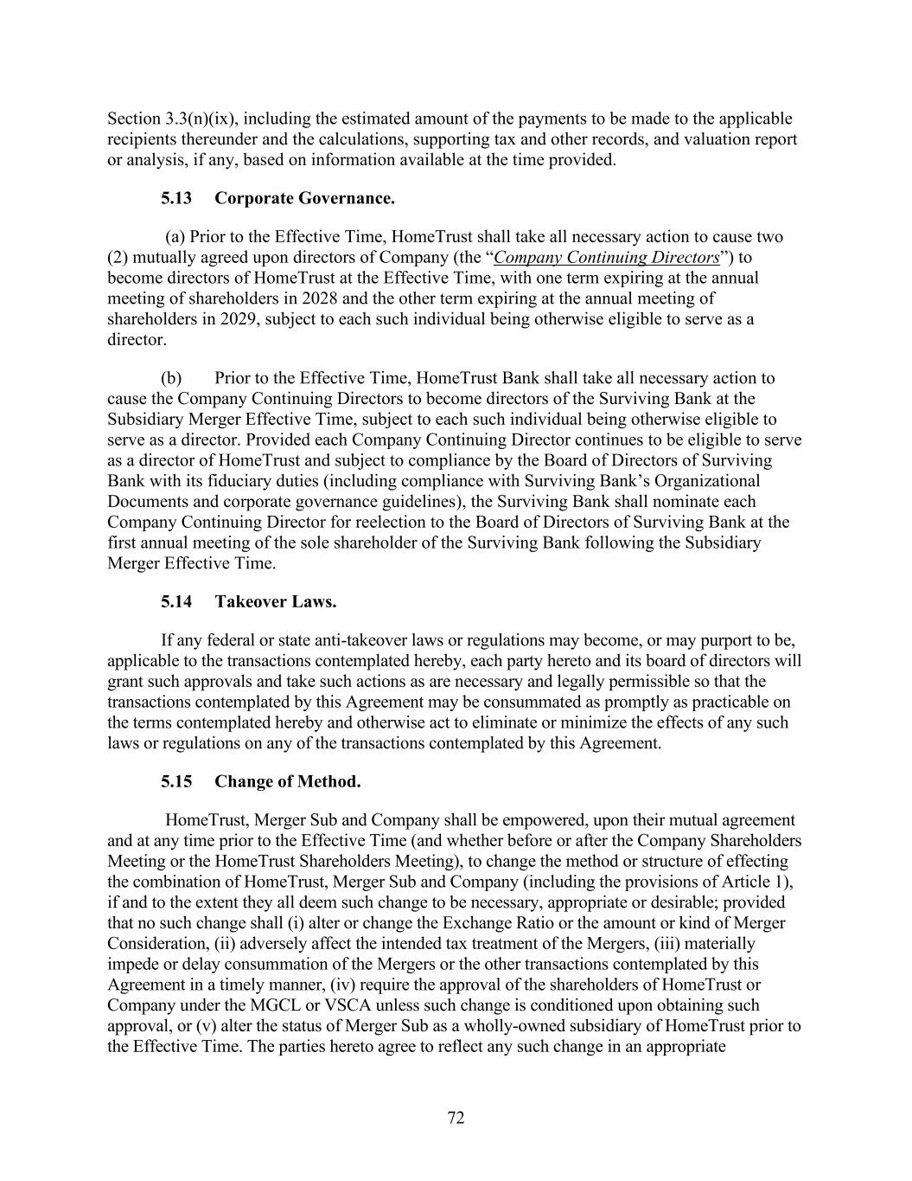
72 Section 3.3(n)(ix), including the estimated amount of the payments to be made to the applicable recipients thereunder and the calculations, supporting tax and other records, and valuation report or analysis, if any, based on information available at the time provided. 5.13 Corporate Governance. (a) Prior to the Effective Time, HomeTrust shall take all necessary action to cause two (2) mutually agreed upon directors of Company (the “Company Continuing Directors”) to become directors of HomeTrust at the Effective Time, with one term expiring at the annual meeting of shareholders in 2028 and the other term expiring at the annual meeting of shareholders in 2029, subject to each such individual being otherwise eligible to serve as a director. (b) Prior to the Effective Time, HomeTrust Bank shall take all necessary action to cause the Company Continuing Directors to become directors of the Surviving Bank at the Subsidiary Merger Effective Time, subject to each such individual being otherwise eligible to serve as a director. Provided each Company Continuing Director continues to be eligible to serve as a director of HomeTrust and subject to compliance by the Board of Directors of Surviving Bank with its fiduciary duties (including compliance with Surviving Bank’s Organizational Documents and corporate governance guidelines), the Surviving Bank shall nominate each Company Continuing Director for reelection to the Board of Directors of Surviving Bank at the first annual meeting of the sole shareholder of the Surviving Bank following the Subsidiary Merger Effective Time. 5.14 Takeover Laws. If any federal or state anti-takeover laws or regulations may become, or may purport to be, applicable to the transactions contemplated hereby, each party hereto and its board of directors will grant such approvals and take such actions as are necessary and legally permissible so that the transactions contemplated by this Agreement may be consummated as promptly as practicable on the terms contemplated hereby and otherwise act to eliminate or minimize the effects of any such laws or regulations on any of the transactions contemplated by this Agreement. 5.15 Change of Method. HomeTrust, Merger Sub and Company shall be empowered, upon their mutual agreement and at any time prior to the Effective Time (and whether before or after the Company Shareholders Meeting or the HomeTrust Shareholders Meeting), to change the method or structure of effecting the combination of HomeTrust, Merger Sub and Company (including the provisions of Article 1), if and to the extent they all deem such change to be necessary, appropriate or desirable; provided that no such change shall (i) alter or change the Exchange Ratio or the amount or kind of Merger Consideration, (ii) adversely affect the intended tax treatment of the Mergers, (iii) materially impede or delay consummation of the Mergers or the other transactions contemplated by this Agreement in a timely manner, (iv) require the approval of the shareholders of HomeTrust or Company under the MGCL or VSCA unless such change is conditioned upon obtaining such approval, or (v) alter the status of Merger Sub as a wholly-owned subsidiary of HomeTrust prior to the Effective Time. The parties hereto agree to reflect any such change in an appropriate

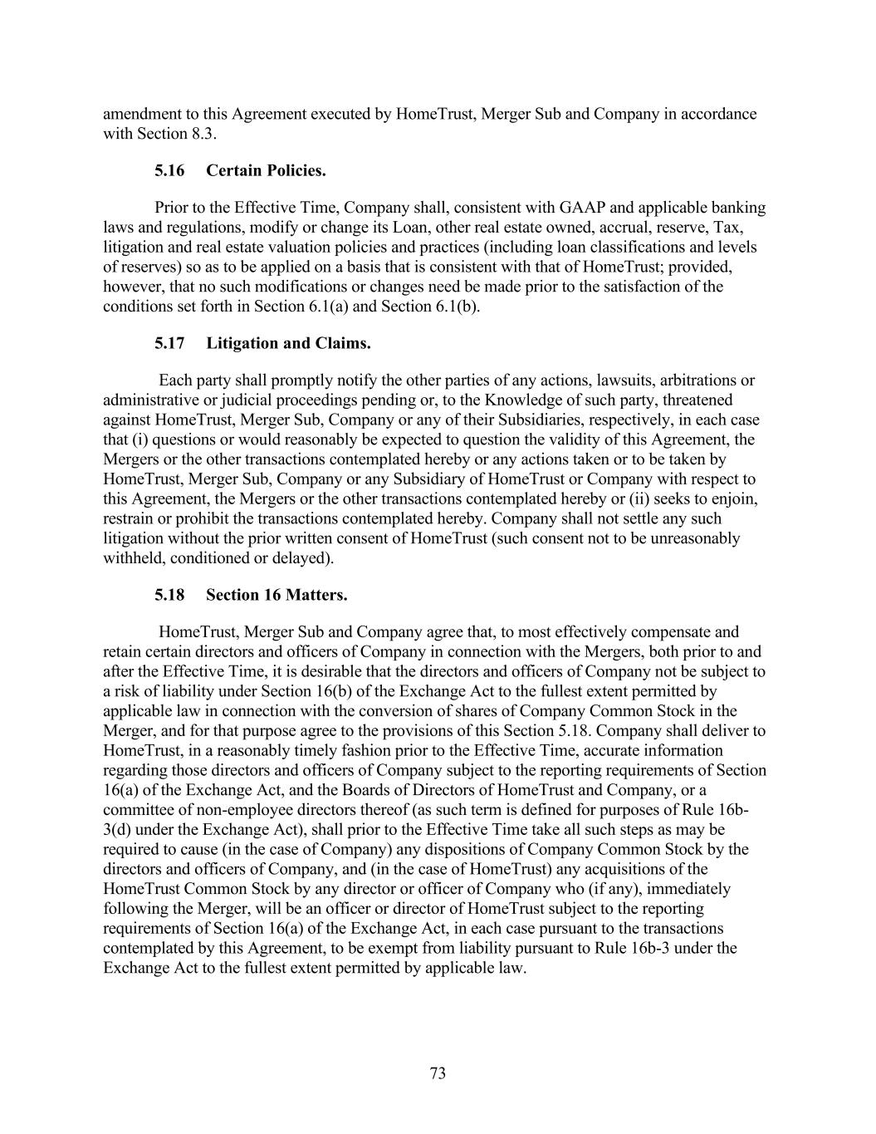
73 amendment to this Agreement executed by HomeTrust, Merger Sub and Company in accordance with Section 8.3. 5.16 Certain Policies. Prior to the Effective Time, Company shall, consistent with GAAP and applicable banking laws and regulations, modify or change its Loan, other real estate owned, accrual, reserve, Tax, litigation and real estate valuation policies and practices (including loan classifications and levels of reserves) so as to be applied on a basis that is consistent with that of HomeTrust; provided, however, that no such modifications or changes need be made prior to the satisfaction of the conditions set forth in Section 6.1(a) and Section 6.1(b). 5.17 Litigation and Claims. Each party shall promptly notify the other parties of any actions, lawsuits, arbitrations or administrative or judicial proceedings pending or, to the Knowledge of such party, threatened against HomeTrust, Merger Sub, Company or any of their Subsidiaries, respectively, in each case that (i) questions or would reasonably be expected to question the validity of this Agreement, the Mergers or the other transactions contemplated hereby or any actions taken or to be taken by HomeTrust, Merger Sub, Company or any Subsidiary of HomeTrust or Company with respect to this Agreement, the Mergers or the other transactions contemplated hereby or (ii) seeks to enjoin, restrain or prohibit the transactions contemplated hereby. Company shall not settle any such litigation without the prior written consent of HomeTrust (such consent not to be unreasonably withheld, conditioned or delayed). 5.18 Section 16 Matters. HomeTrust, Merger Sub and Company agree that, to most effectively compensate and retain certain directors and officers of Company in connection with the Mergers, both prior to and after the Effective Time, it is desirable that the directors and officers of Company not be subject to a risk of liability under Section 16(b) of the Exchange Act to the fullest extent permitted by applicable law in connection with the conversion of shares of Company Common Stock in the Merger, and for that purpose agree to the provisions of this Section 5.18. Company shall deliver to HomeTrust, in a reasonably timely fashion prior to the Effective Time, accurate information regarding those directors and officers of Company subject to the reporting requirements of Section 16(a) of the Exchange Act, and the Boards of Directors of HomeTrust and Company, or a committee of non-employee directors thereof (as such term is defined for purposes of Rule 16b- 3(d) under the Exchange Act), shall prior to the Effective Time take all such steps as may be required to cause (in the case of Company) any dispositions of Company Common Stock by the directors and officers of Company, and (in the case of HomeTrust) any acquisitions of the HomeTrust Common Stock by any director or officer of Company who (if any), immediately following the Merger, will be an officer or director of HomeTrust subject to the reporting requirements of Section 16(a) of the Exchange Act, in each case pursuant to the transactions contemplated by this Agreement, to be exempt from liability pursuant to Rule 16b-3 under the Exchange Act to the fullest extent permitted by applicable law.

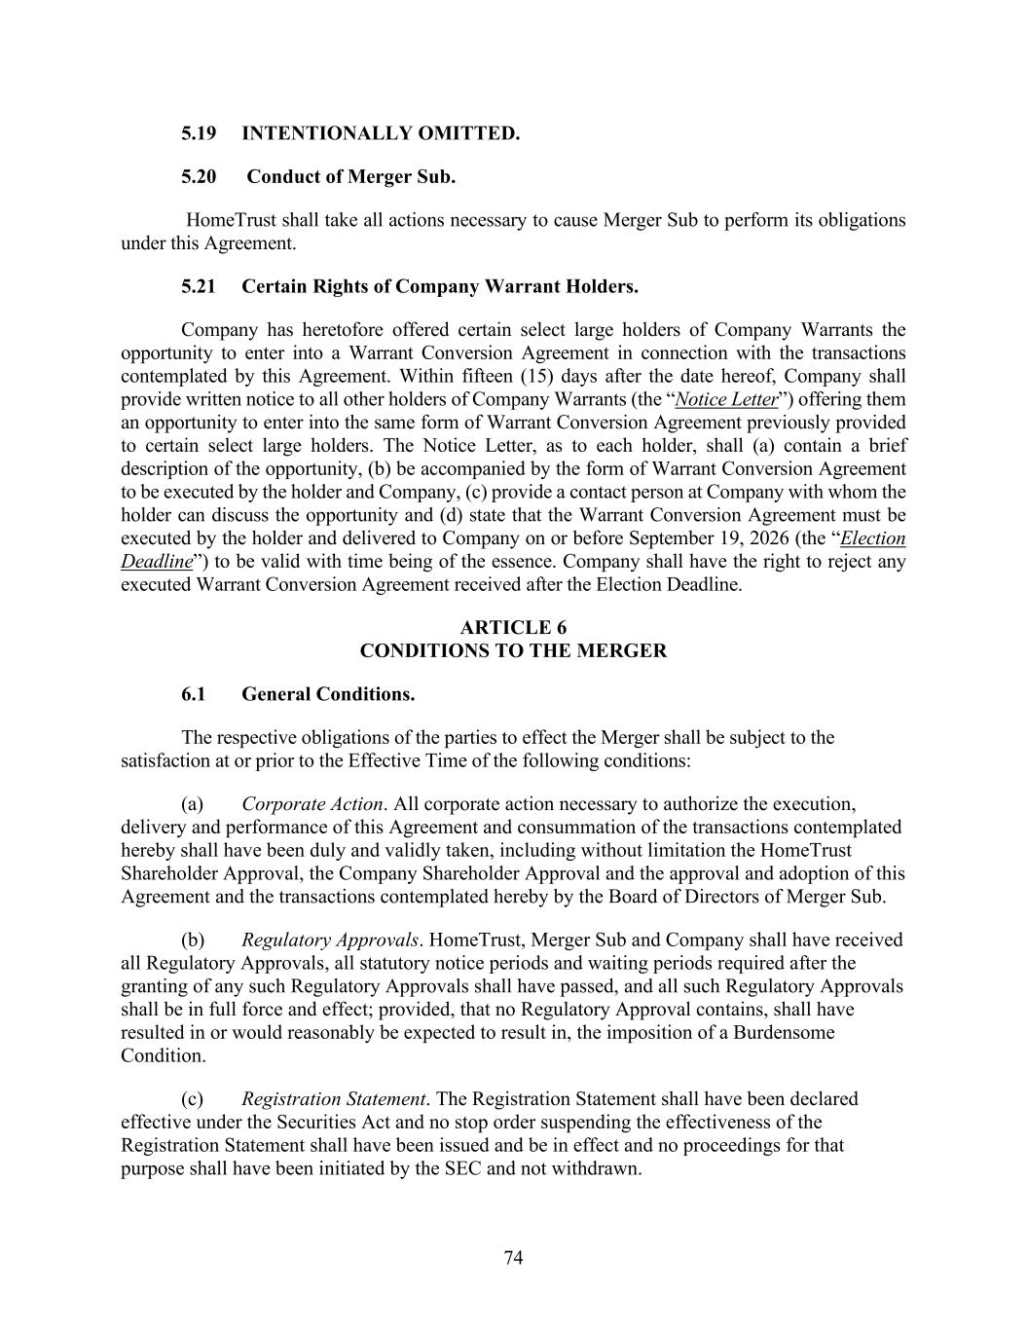
74 5.19 INTENTIONALLY OMITTED. 5.20 Conduct of Merger Sub. HomeTrust shall take all actions necessary to cause Merger Sub to perform its obligations under this Agreement. 5.21 Certain Rights of Company Warrant Holders. Company has heretofore offered certain select large holders of Company Warrants the opportunity to enter into a Warrant Conversion Agreement in connection with the transactions contemplated by this Agreement. Within fifteen (15) days after the date hereof, Company shall provide written notice to all other holders of Company Warrants (the “Notice Letter”) offering them an opportunity to enter into the same form of Warrant Conversion Agreement previously provided to certain select large holders. The Notice Letter, as to each holder, shall (a) contain a brief description of the opportunity, (b) be accompanied by the form of Warrant Conversion Agreement to be executed by the holder and Company, (c) provide a contact person at Company with whom the holder can discuss the opportunity and (d) state that the Warrant Conversion Agreement must be executed by the holder and delivered to Company on or before September 19, 2026 (the “Election Deadline”) to be valid with time being of the essence. Company shall have the right to reject any executed Warrant Conversion Agreement received after the Election Deadline. ARTICLE 6 CONDITIONS TO THE MERGER 6.1 General Conditions. The respective obligations of the parties to effect the Merger shall be subject to the satisfaction at or prior to the Effective Time of the following conditions: (a) Corporate Action. All corporate action necessary to authorize the execution, delivery and performance of this Agreement and consummation of the transactions contemplated hereby shall have been duly and validly taken, including without limitation the HomeTrust Shareholder Approval, the Company Shareholder Approval and the approval and adoption of this Agreement and the transactions contemplated hereby by the Board of Directors of Merger Sub. (b) Regulatory Approvals. HomeTrust, Merger Sub and Company shall have received all Regulatory Approvals, all statutory notice periods and waiting periods required after the granting of any such Regulatory Approvals shall have passed, and all such Regulatory Approvals shall be in full force and effect; provided, that no Regulatory Approval contains, shall have resulted in or would reasonably be expected to result in, the imposition of a Burdensome Condition. (c) Registration Statement. The Registration Statement shall have been declared effective under the Securities Act and no stop order suspending the effectiveness of the Registration Statement shall have been issued and be in effect and no proceedings for that purpose shall have been initiated by the SEC and not withdrawn.

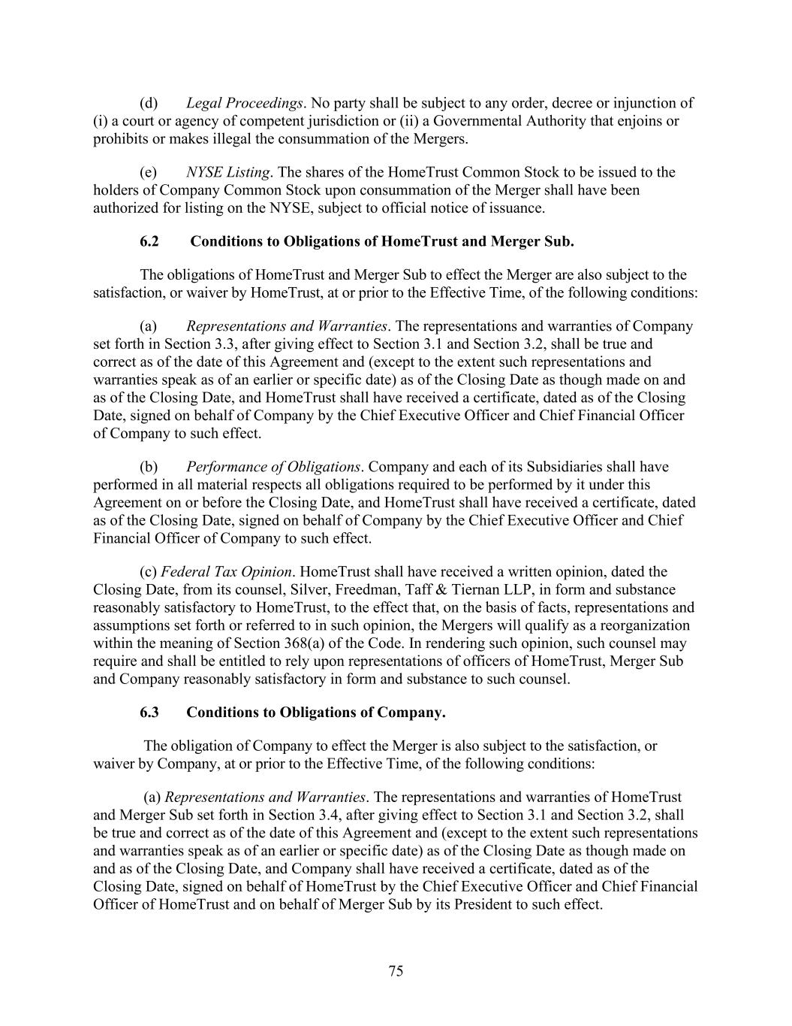
75 (d) Legal Proceedings. No party shall be subject to any order, decree or injunction of (i) a court or agency of competent jurisdiction or (ii) a Governmental Authority that enjoins or prohibits or makes illegal the consummation of the Mergers. (e) NYSE Listing. The shares of the HomeTrust Common Stock to be issued to the holders of Company Common Stock upon consummation of the Merger shall have been authorized for listing on the NYSE, subject to official notice of issuance. 6.2 Conditions to Obligations of HomeTrust and Merger Sub. The obligations of HomeTrust and Merger Sub to effect the Merger are also subject to the satisfaction, or waiver by HomeTrust, at or prior to the Effective Time, of the following conditions: (a) Representations and Warranties. The representations and warranties of Company set forth in Section 3.3, after giving effect to Section 3.1 and Section 3.2, shall be true and correct as of the date of this Agreement and (except to the extent such representations and warranties speak as of an earlier or specific date) as of the Closing Date as though made on and as of the Closing Date, and HomeTrust shall have received a certificate, dated as of the Closing Date, signed on behalf of Company by the Chief Executive Officer and Chief Financial Officer of Company to such effect. (b) Performance of Obligations. Company and each of its Subsidiaries shall have performed in all material respects all obligations required to be performed by it under this Agreement on or before the Closing Date, and HomeTrust shall have received a certificate, dated as of the Closing Date, signed on behalf of Company by the Chief Executive Officer and Chief Financial Officer of Company to such effect. (c) Federal Tax Opinion. HomeTrust shall have received a written opinion, dated the Closing Date, from its counsel, Silver, Freedman, Taff & Tiernan LLP, in form and substance reasonably satisfactory to HomeTrust, to the effect that, on the basis of facts, representations and assumptions set forth or referred to in such opinion, the Mergers will qualify as a reorganization within the meaning of Section 368(a) of the Code. In rendering such opinion, such counsel may require and shall be entitled to rely upon representations of officers of HomeTrust, Merger Sub and Company reasonably satisfactory in form and substance to such counsel. 6.3 Conditions to Obligations of Company. The obligation of Company to effect the Merger is also subject to the satisfaction, or waiver by Company, at or prior to the Effective Time, of the following conditions: (a) Representations and Warranties. The representations and warranties of HomeTrust and Merger Sub set forth in Section 3.4, after giving effect to Section 3.1 and Section 3.2, shall be true and correct as of the date of this Agreement and (except to the extent such representations and warranties speak as of an earlier or specific date) as of the Closing Date as though made on and as of the Closing Date, and Company shall have received a certificate, dated as of the Closing Date, signed on behalf of HomeTrust by the Chief Executive Officer and Chief Financial Officer of HomeTrust and on behalf of Merger Sub by its President to such effect.

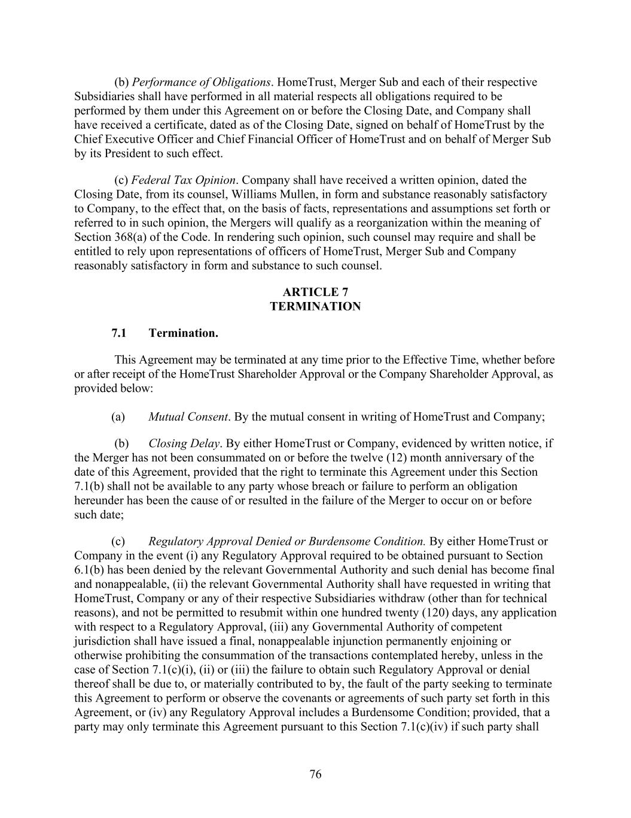
76 (b) Performance of Obligations. HomeTrust, Merger Sub and each of their respective Subsidiaries shall have performed in all material respects all obligations required to be performed by them under this Agreement on or before the Closing Date, and Company shall have received a certificate, dated as of the Closing Date, signed on behalf of HomeTrust by the Chief Executive Officer and Chief Financial Officer of HomeTrust and on behalf of Merger Sub by its President to such effect. (c) Federal Tax Opinion. Company shall have received a written opinion, dated the Closing Date, from its counsel, Williams Mullen, in form and substance reasonably satisfactory to Company, to the effect that, on the basis of facts, representations and assumptions set forth or referred to in such opinion, the Mergers will qualify as a reorganization within the meaning of Section 368(a) of the Code. In rendering such opinion, such counsel may require and shall be entitled to rely upon representations of officers of HomeTrust, Merger Sub and Company reasonably satisfactory in form and substance to such counsel. ARTICLE 7 TERMINATION 7.1 Termination. This Agreement may be terminated at any time prior to the Effective Time, whether before or after receipt of the HomeTrust Shareholder Approval or the Company Shareholder Approval, as provided below: (a) Mutual Consent. By the mutual consent in writing of HomeTrust and Company; (b) Closing Delay. By either HomeTrust or Company, evidenced by written notice, if the Merger has not been consummated on or before the twelve (12) month anniversary of the date of this Agreement, provided that the right to terminate this Agreement under this Section 7.1(b) shall not be available to any party whose breach or failure to perform an obligation hereunder has been the cause of or resulted in the failure of the Merger to occur on or before such date; (c) Regulatory Approval Denied or Burdensome Condition. By either HomeTrust or Company in the event (i) any Regulatory Approval required to be obtained pursuant to Section 6.1(b) has been denied by the relevant Governmental Authority and such denial has become final and nonappealable, (ii) the relevant Governmental Authority shall have requested in writing that HomeTrust, Company or any of their respective Subsidiaries withdraw (other than for technical reasons), and not be permitted to resubmit within one hundred twenty (120) days, any application with respect to a Regulatory Approval, (iii) any Governmental Authority of competent jurisdiction shall have issued a final, nonappealable injunction permanently enjoining or otherwise prohibiting the consummation of the transactions contemplated hereby, unless in the case of Section 7.1(c)(i), (ii) or (iii) the failure to obtain such Regulatory Approval or denial thereof shall be due to, or materially contributed to by, the fault of the party seeking to terminate this Agreement to perform or observe the covenants or agreements of such party set forth in this Agreement, or (iv) any Regulatory Approval includes a Burdensome Condition; provided, that a party may only terminate this Agreement pursuant to this Section 7.1(c)(iv) if such party shall

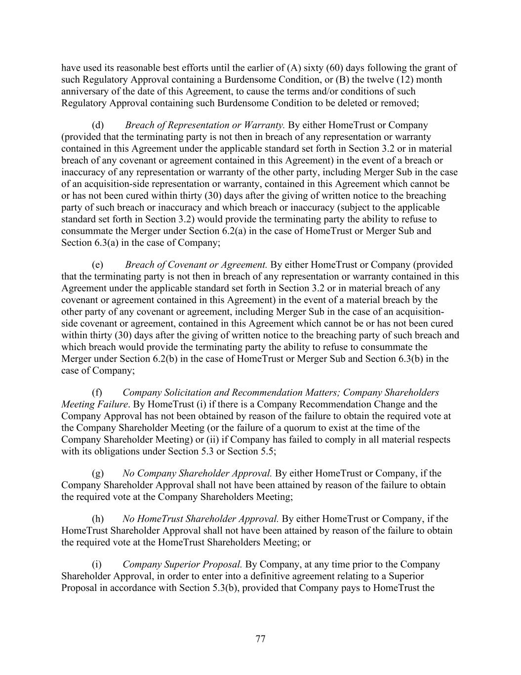
77 have used its reasonable best efforts until the earlier of (A) sixty (60) days following the grant of such Regulatory Approval containing a Burdensome Condition, or (B) the twelve (12) month anniversary of the date of this Agreement, to cause the terms and/or conditions of such Regulatory Approval containing such Burdensome Condition to be deleted or removed; (d) Breach of Representation or Warranty. By either HomeTrust or Company (provided that the terminating party is not then in breach of any representation or warranty contained in this Agreement under the applicable standard set forth in Section 3.2 or in material breach of any covenant or agreement contained in this Agreement) in the event of a breach or inaccuracy of any representation or warranty of the other party, including Merger Sub in the case of an acquisition-side representation or warranty, contained in this Agreement which cannot be or has not been cured within thirty (30) days after the giving of written notice to the breaching party of such breach or inaccuracy and which breach or inaccuracy (subject to the applicable standard set forth in Section 3.2) would provide the terminating party the ability to refuse to consummate the Merger under Section 6.2(a) in the case of HomeTrust or Merger Sub and Section 6.3(a) in the case of Company; (e) Breach of Covenant or Agreement. By either HomeTrust or Company (provided that the terminating party is not then in breach of any representation or warranty contained in this Agreement under the applicable standard set forth in Section 3.2 or in material breach of any covenant or agreement contained in this Agreement) in the event of a material breach by the other party of any covenant or agreement, including Merger Sub in the case of an acquisition- side covenant or agreement, contained in this Agreement which cannot be or has not been cured within thirty (30) days after the giving of written notice to the breaching party of such breach and which breach would provide the terminating party the ability to refuse to consummate the Merger under Section 6.2(b) in the case of HomeTrust or Merger Sub and Section 6.3(b) in the case of Company; (f) Company Solicitation and Recommendation Matters; Company Shareholders Meeting Failure. By HomeTrust (i) if there is a Company Recommendation Change and the Company Approval has not been obtained by reason of the failure to obtain the required vote at the Company Shareholder Meeting (or the failure of a quorum to exist at the time of the Company Shareholder Meeting) or (ii) if Company has failed to comply in all material respects with its obligations under Section 5.3 or Section 5.5; (g) No Company Shareholder Approval. By either HomeTrust or Company, if the Company Shareholder Approval shall not have been attained by reason of the failure to obtain the required vote at the Company Shareholders Meeting; (h) No HomeTrust Shareholder Approval. By either HomeTrust or Company, if the HomeTrust Shareholder Approval shall not have been attained by reason of the failure to obtain the required vote at the HomeTrust Shareholders Meeting; or (i) Company Superior Proposal. By Company, at any time prior to the Company Shareholder Approval, in order to enter into a definitive agreement relating to a Superior Proposal in accordance with Section 5.3(b), provided that Company pays to HomeTrust the

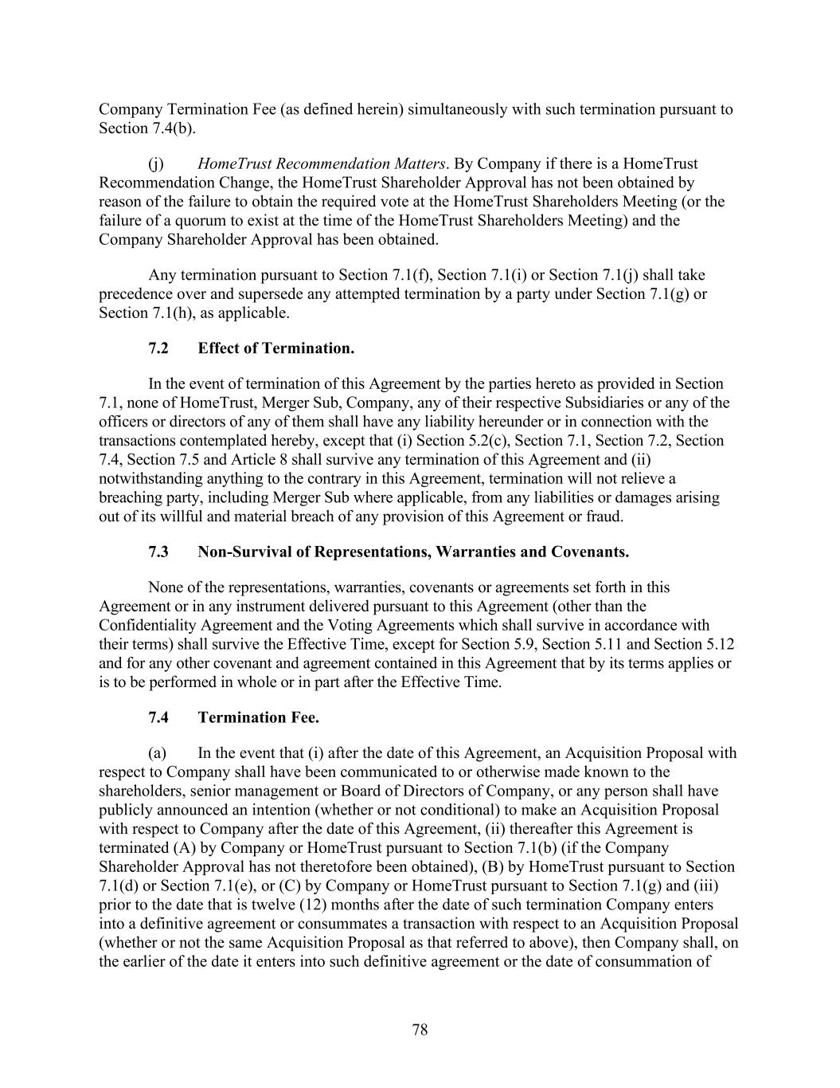
78 Company Termination Fee (as defined herein) simultaneously with such termination pursuant to Section 7.4(b). (j) HomeTrust Recommendation Matters. By Company if there is a HomeTrust Recommendation Change, the HomeTrust Shareholder Approval has not been obtained by reason of the failure to obtain the required vote at the HomeTrust Shareholders Meeting (or the failure of a quorum to exist at the time of the HomeTrust Shareholders Meeting) and the Company Shareholder Approval has been obtained. Any termination pursuant to Section 7.1(f), Section 7.1(i) or Section 7.1(j) shall take precedence over and supersede any attempted termination by a party under Section 7.1(g) or Section 7.1(h), as applicable. 7.2 Effect of Termination. In the event of termination of this Agreement by the parties hereto as provided in Section 7.1, none of HomeTrust, Merger Sub, Company, any of their respective Subsidiaries or any of the officers or directors of any of them shall have any liability hereunder or in connection with the transactions contemplated hereby, except that (i) Section 5.2(c), Section 7.1, Section 7.2, Section 7.4, Section 7.5 and Article 8 shall survive any termination of this Agreement and (ii) notwithstanding anything to the contrary in this Agreement, termination will not relieve a breaching party, including Merger Sub where applicable, from any liabilities or damages arising out of its willful and material breach of any provision of this Agreement or fraud. 7.3 Non-Survival of Representations, Warranties and Covenants. None of the representations, warranties, covenants or agreements set forth in this Agreement or in any instrument delivered pursuant to this Agreement (other than the Confidentiality Agreement and the Voting Agreements which shall survive in accordance with their terms) shall survive the Effective Time, except for Section 5.9, Section 5.11 and Section 5.12 and for any other covenant and agreement contained in this Agreement that by its terms applies or is to be performed in whole or in part after the Effective Time. 7.4 Termination Fee. (a) In the event that (i) after the date of this Agreement, an Acquisition Proposal with respect to Company shall have been communicated to or otherwise made known to the shareholders, senior management or Board of Directors of Company, or any person shall have publicly announced an intention (whether or not conditional) to make an Acquisition Proposal with respect to Company after the date of this Agreement, (ii) thereafter this Agreement is terminated (A) by Company or HomeTrust pursuant to Section 7.1(b) (if the Company Shareholder Approval has not theretofore been obtained), (B) by HomeTrust pursuant to Section 7.1(d) or Section 7.1(e), or (C) by Company or HomeTrust pursuant to Section 7.1(g) and (iii) prior to the date that is twelve (12) months after the date of such termination Company enters into a definitive agreement or consummates a transaction with respect to an Acquisition Proposal (whether or not the same Acquisition Proposal as that referred to above), then Company shall, on the earlier of the date it enters into such definitive agreement or the date of consummation of

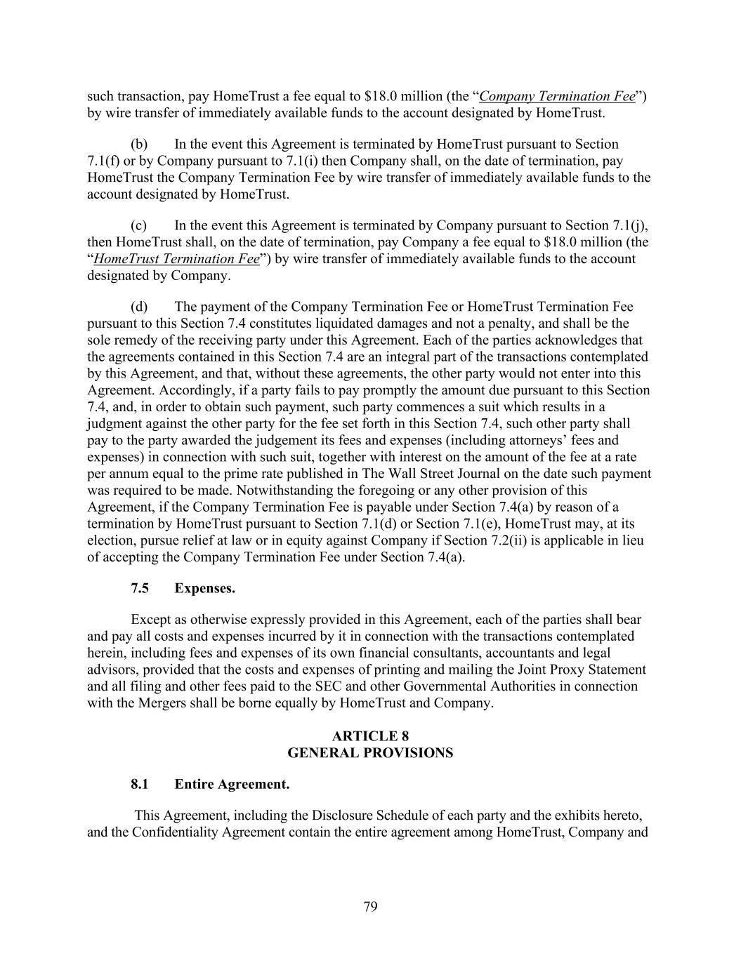
79 such transaction, pay HomeTrust a fee equal to $18.0 million (the “Company Termination Fee”) by wire transfer of immediately available funds to the account designated by HomeTrust. (b) In the event this Agreement is terminated by HomeTrust pursuant to Section 7.1(f) or by Company pursuant to 7.1(i) then Company shall, on the date of termination, pay HomeTrust the Company Termination Fee by wire transfer of immediately available funds to the account designated by HomeTrust. (c) In the event this Agreement is terminated by Company pursuant to Section 7.1(j), then HomeTrust shall, on the date of termination, pay Company a fee equal to $18.0 million (the “HomeTrust Termination Fee”) by wire transfer of immediately available funds to the account designated by Company. (d) The payment of the Company Termination Fee or HomeTrust Termination Fee pursuant to this Section 7.4 constitutes liquidated damages and not a penalty, and shall be the sole remedy of the receiving party under this Agreement. Each of the parties acknowledges that the agreements contained in this Section 7.4 are an integral part of the transactions contemplated by this Agreement, and that, without these agreements, the other party would not enter into this Agreement. Accordingly, if a party fails to pay promptly the amount due pursuant to this Section 7.4, and, in order to obtain such payment, such party commences a suit which results in a judgment against the other party for the fee set forth in this Section 7.4, such other party shall pay to the party awarded the judgement its fees and expenses (including attorneys’ fees and expenses) in connection with such suit, together with interest on the amount of the fee at a rate per annum equal to the prime rate published in The Wall Street Journal on the date such payment was required to be made. Notwithstanding the foregoing or any other provision of this Agreement, if the Company Termination Fee is payable under Section 7.4(a) by reason of a termination by HomeTrust pursuant to Section 7.1(d) or Section 7.1(e), HomeTrust may, at its election, pursue relief at law or in equity against Company if Section 7.2(ii) is applicable in lieu of accepting the Company Termination Fee under Section 7.4(a). 7.5 Expenses. Except as otherwise expressly provided in this Agreement, each of the parties shall bear and pay all costs and expenses incurred by it in connection with the transactions contemplated herein, including fees and expenses of its own financial consultants, accountants and legal advisors, provided that the costs and expenses of printing and mailing the Joint Proxy Statement and all filing and other fees paid to the SEC and other Governmental Authorities in connection with the Mergers shall be borne equally by HomeTrust and Company. ARTICLE 8 GENERAL PROVISIONS 8.1 Entire Agreement. This Agreement, including the Disclosure Schedule of each party and the exhibits hereto, and the Confidentiality Agreement contain the entire agreement among HomeTrust, Company and

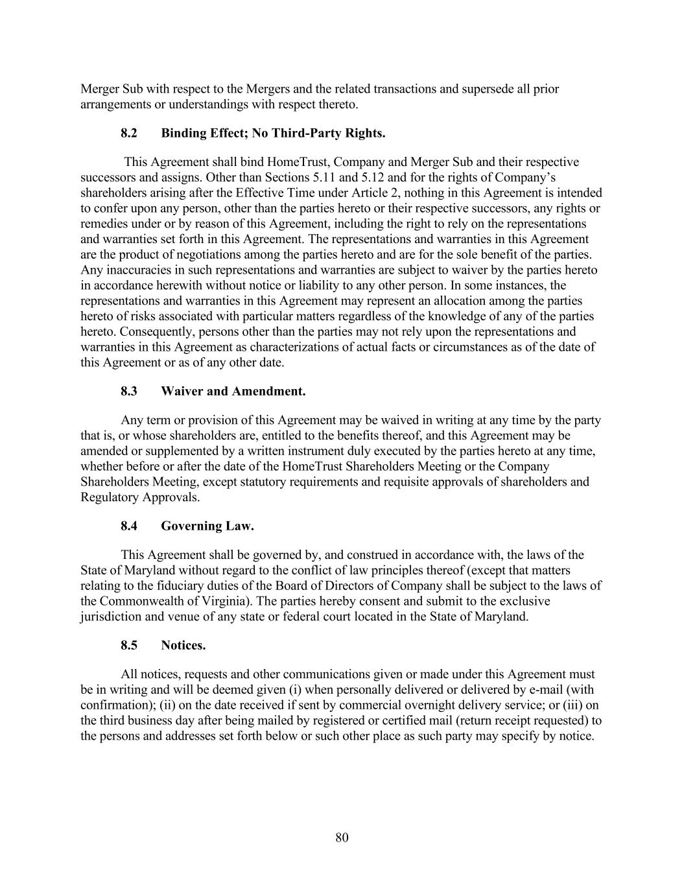
80 Merger Sub with respect to the Mergers and the related transactions and supersede all prior arrangements or understandings with respect thereto. 8.2 Binding Effect; No Third-Party Rights. This Agreement shall bind HomeTrust, Company and Merger Sub and their respective successors and assigns. Other than Sections 5.11 and 5.12 and for the rights of Company’s shareholders arising after the Effective Time under Article 2, nothing in this Agreement is intended to confer upon any person, other than the parties hereto or their respective successors, any rights or remedies under or by reason of this Agreement, including the right to rely on the representations and warranties set forth in this Agreement. The representations and warranties in this Agreement are the product of negotiations among the parties hereto and are for the sole benefit of the parties. Any inaccuracies in such representations and warranties are subject to waiver by the parties hereto in accordance herewith without notice or liability to any other person. In some instances, the representations and warranties in this Agreement may represent an allocation among the parties hereto of risks associated with particular matters regardless of the knowledge of any of the parties hereto. Consequently, persons other than the parties may not rely upon the representations and warranties in this Agreement as characterizations of actual facts or circumstances as of the date of this Agreement or as of any other date. 8.3 Waiver and Amendment. Any term or provision of this Agreement may be waived in writing at any time by the party that is, or whose shareholders are, entitled to the benefits thereof, and this Agreement may be amended or supplemented by a written instrument duly executed by the parties hereto at any time, whether before or after the date of the HomeTrust Shareholders Meeting or the Company Shareholders Meeting, except statutory requirements and requisite approvals of shareholders and Regulatory Approvals. 8.4 Governing Law. This Agreement shall be governed by, and construed in accordance with, the laws of the State of Maryland without regard to the conflict of law principles thereof (except that matters relating to the fiduciary duties of the Board of Directors of Company shall be subject to the laws of the Commonwealth of Virginia). The parties hereby consent and submit to the exclusive jurisdiction and venue of any state or federal court located in the State of Maryland. 8.5 Notices. All notices, requests and other communications given or made under this Agreement must be in writing and will be deemed given (i) when personally delivered or delivered by e-mail (with confirmation); (ii) on the date received if sent by commercial overnight delivery service; or (iii) on the third business day after being mailed by registered or certified mail (return receipt requested) to the persons and addresses set forth below or such other place as such party may specify by notice.

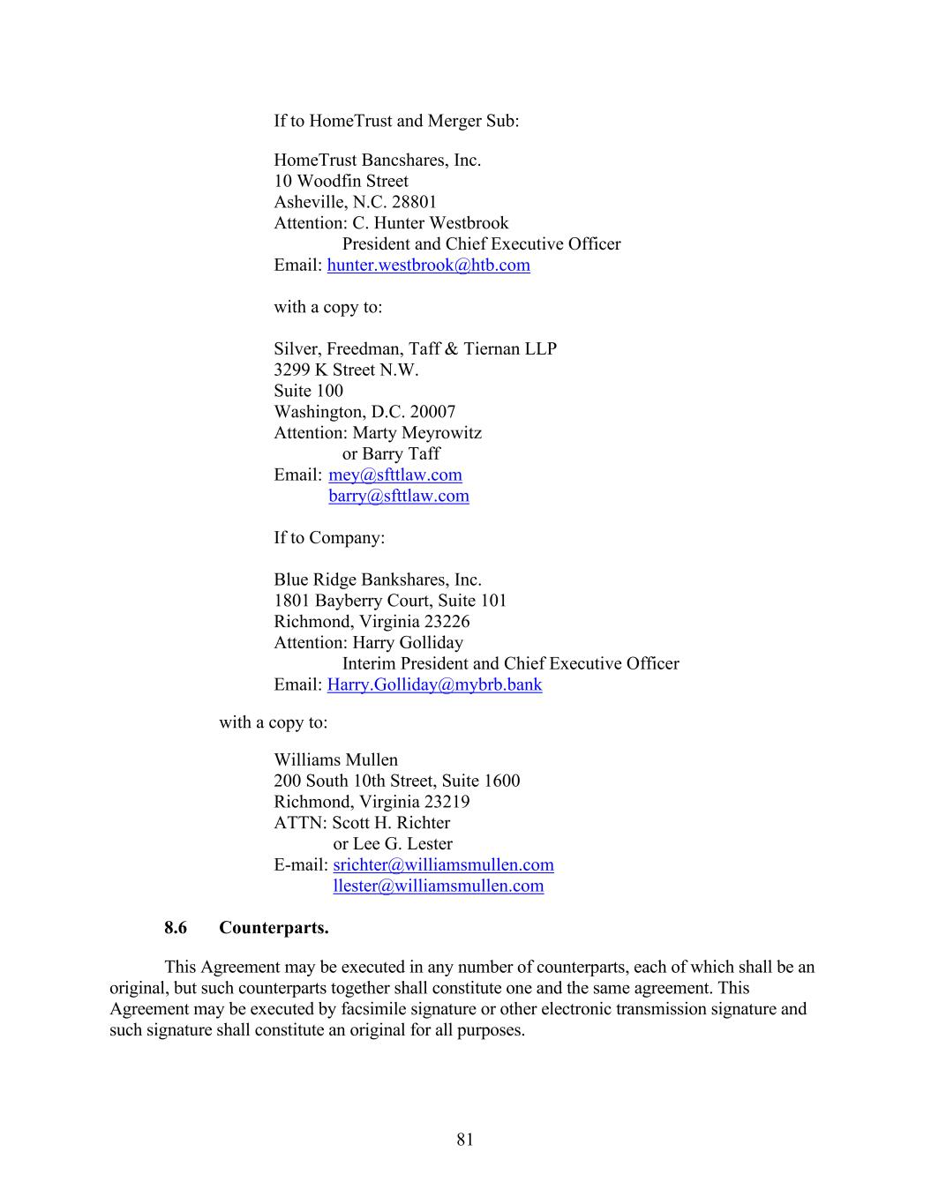
81 If to HomeTrust and Merger Sub: HomeTrust Bancshares, Inc. 10 Woodfin Street Asheville, N.C. 28801 Attention: C. Hunter Westbrook President and Chief Executive Officer Email: hunter.westbrook@htb.com with a copy to: Silver, Freedman, Taff & Tiernan LLP 3299 K Street N.W. Suite 100 Washington, D.C. 20007 Attention: Marty Meyrowitz or Barry Taff Email: mey@sfttlaw.com barry@sfttlaw.com If to Company: Blue Ridge Bankshares, Inc. 1801 Bayberry Court, Suite 101 Richmond, Virginia 23226 Attention: Harry Golliday Interim President and Chief Executive Officer Email: Harry.Golliday@mybrb.bank with a copy to: Williams Mullen 200 South 10th Street, Suite 1600 Richmond, Virginia 23219 ATTN: Scott H. Richter or Lee G. Lester E-mail: srichter@williamsmullen.com llester@williamsmullen.com 8.6 Counterparts. This Agreement may be executed in any number of counterparts, each of which shall be an original, but such counterparts together shall constitute one and the same agreement. This Agreement may be executed by facsimile signature or other electronic transmission signature and such signature shall constitute an original for all purposes.

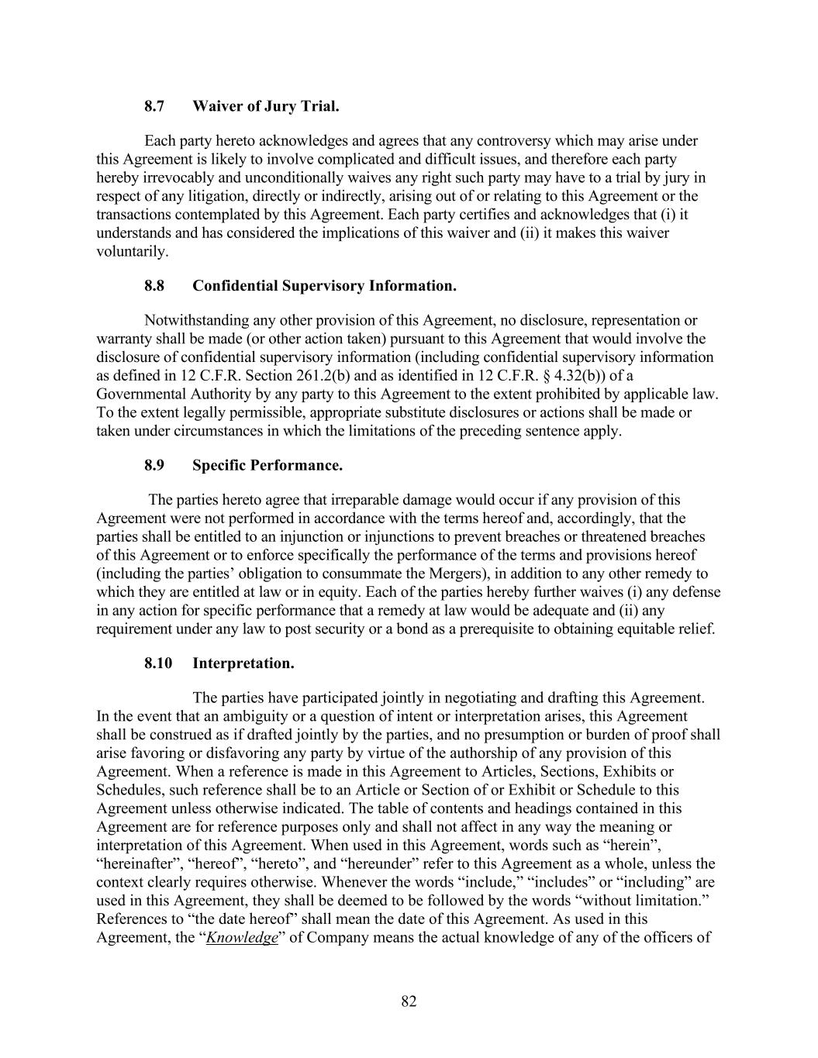
82 8.7 Waiver of Jury Trial. Each party hereto acknowledges and agrees that any controversy which may arise under this Agreement is likely to involve complicated and difficult issues, and therefore each party hereby irrevocably and unconditionally waives any right such party may have to a trial by jury in respect of any litigation, directly or indirectly, arising out of or relating to this Agreement or the transactions contemplated by this Agreement. Each party certifies and acknowledges that (i) it understands and has considered the implications of this waiver and (ii) it makes this waiver voluntarily. 8.8 Confidential Supervisory Information. Notwithstanding any other provision of this Agreement, no disclosure, representation or warranty shall be made (or other action taken) pursuant to this Agreement that would involve the disclosure of confidential supervisory information (including confidential supervisory information as defined in 12 C.F.R. Section 261.2(b) and as identified in 12 C.F.R. § 4.32(b)) of a Governmental Authority by any party to this Agreement to the extent prohibited by applicable law. To the extent legally permissible, appropriate substitute disclosures or actions shall be made or taken under circumstances in which the limitations of the preceding sentence apply. 8.9 Specific Performance. The parties hereto agree that irreparable damage would occur if any provision of this Agreement were not performed in accordance with the terms hereof and, accordingly, that the parties shall be entitled to an injunction or injunctions to prevent breaches or threatened breaches of this Agreement or to enforce specifically the performance of the terms and provisions hereof (including the parties’ obligation to consummate the Mergers), in addition to any other remedy to which they are entitled at law or in equity. Each of the parties hereby further waives (i) any defense in any action for specific performance that a remedy at law would be adequate and (ii) any requirement under any law to post security or a bond as a prerequisite to obtaining equitable relief. 8.10 Interpretation. The parties have participated jointly in negotiating and drafting this Agreement. In the event that an ambiguity or a question of intent or interpretation arises, this Agreement shall be construed as if drafted jointly by the parties, and no presumption or burden of proof shall arise favoring or disfavoring any party by virtue of the authorship of any provision of this Agreement. When a reference is made in this Agreement to Articles, Sections, Exhibits or Schedules, such reference shall be to an Article or Section of or Exhibit or Schedule to this Agreement unless otherwise indicated. The table of contents and headings contained in this Agreement are for reference purposes only and shall not affect in any way the meaning or interpretation of this Agreement. When used in this Agreement, words such as “herein”, “hereinafter”, “hereof”, “hereto”, and “hereunder” refer to this Agreement as a whole, unless the context clearly requires otherwise. Whenever the words “include,” “includes” or “including” are used in this Agreement, they shall be deemed to be followed by the words “without limitation.” References to “the date hereof” shall mean the date of this Agreement. As used in this Agreement, the “Knowledge” of Company means the actual knowledge of any of the officers of

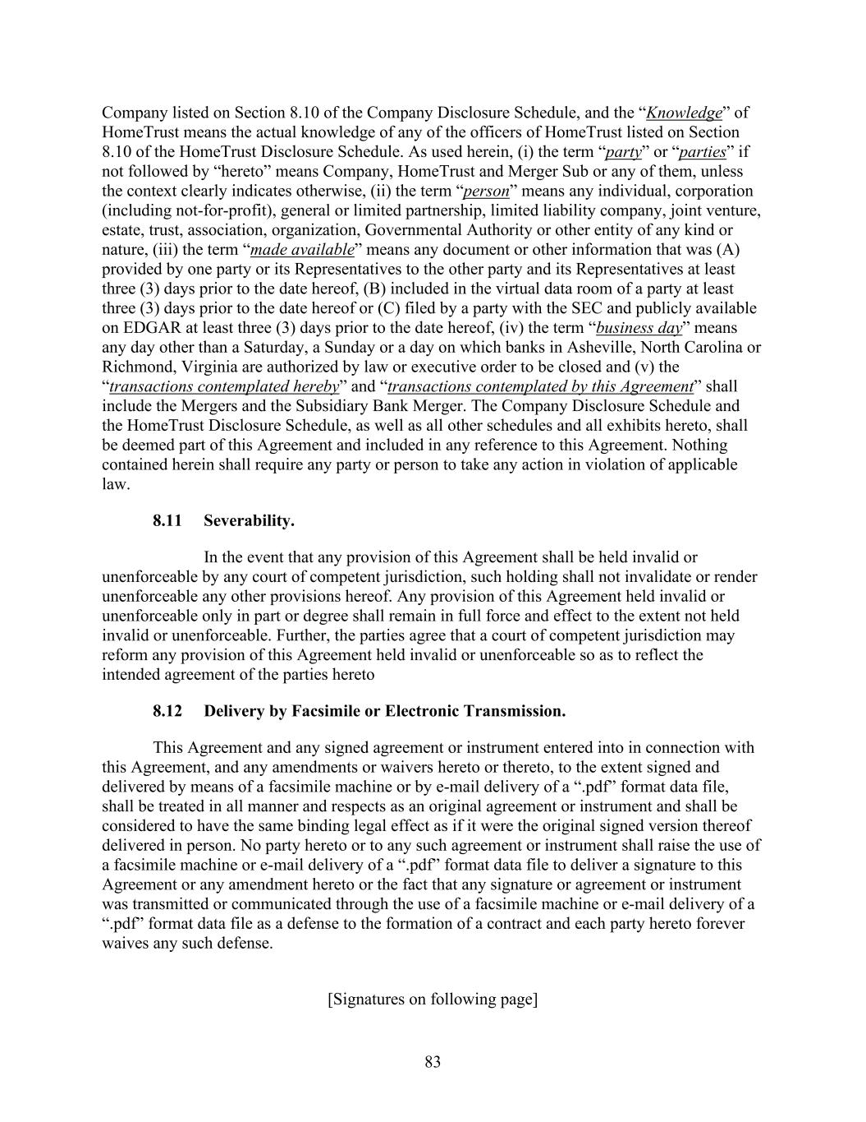
83 Company listed on Section 8.10 of the Company Disclosure Schedule, and the “Knowledge” of HomeTrust means the actual knowledge of any of the officers of HomeTrust listed on Section 8.10 of the HomeTrust Disclosure Schedule. As used herein, (i) the term “party” or “parties” if not followed by “hereto” means Company, HomeTrust and Merger Sub or any of them, unless the context clearly indicates otherwise, (ii) the term “person” means any individual, corporation (including not-for-profit), general or limited partnership, limited liability company, joint venture, estate, trust, association, organization, Governmental Authority or other entity of any kind or nature, (iii) the term “made available” means any document or other information that was (A) provided by one party or its Representatives to the other party and its Representatives at least three (3) days prior to the date hereof, (B) included in the virtual data room of a party at least three (3) days prior to the date hereof or (C) filed by a party with the SEC and publicly available on EDGAR at least three (3) days prior to the date hereof, (iv) the term “business day” means any day other than a Saturday, a Sunday or a day on which banks in Asheville, North Carolina or Richmond, Virginia are authorized by law or executive order to be closed and (v) the “transactions contemplated hereby” and “transactions contemplated by this Agreement” shall include the Mergers and the Subsidiary Bank Merger. The Company Disclosure Schedule and the HomeTrust Disclosure Schedule, as well as all other schedules and all exhibits hereto, shall be deemed part of this Agreement and included in any reference to this Agreement. Nothing contained herein shall require any party or person to take any action in violation of applicable law. 8.11 Severability. In the event that any provision of this Agreement shall be held invalid or unenforceable by any court of competent jurisdiction, such holding shall not invalidate or render unenforceable any other provisions hereof. Any provision of this Agreement held invalid or unenforceable only in part or degree shall remain in full force and effect to the extent not held invalid or unenforceable. Further, the parties agree that a court of competent jurisdiction may reform any provision of this Agreement held invalid or unenforceable so as to reflect the intended agreement of the parties hereto 8.12 Delivery by Facsimile or Electronic Transmission. This Agreement and any signed agreement or instrument entered into in connection with this Agreement, and any amendments or waivers hereto or thereto, to the extent signed and delivered by means of a facsimile machine or by e-mail delivery of a “.pdf” format data file, shall be treated in all manner and respects as an original agreement or instrument and shall be considered to have the same binding legal effect as if it were the original signed version thereof delivered in person. No party hereto or to any such agreement or instrument shall raise the use of a facsimile machine or e-mail delivery of a “.pdf” format data file to deliver a signature to this Agreement or any amendment hereto or the fact that any signature or agreement or instrument was transmitted or communicated through the use of a facsimile machine or e-mail delivery of a “.pdf” format data file as a defense to the formation of a contract and each party hereto forever waives any such defense. [Signatures on following page]

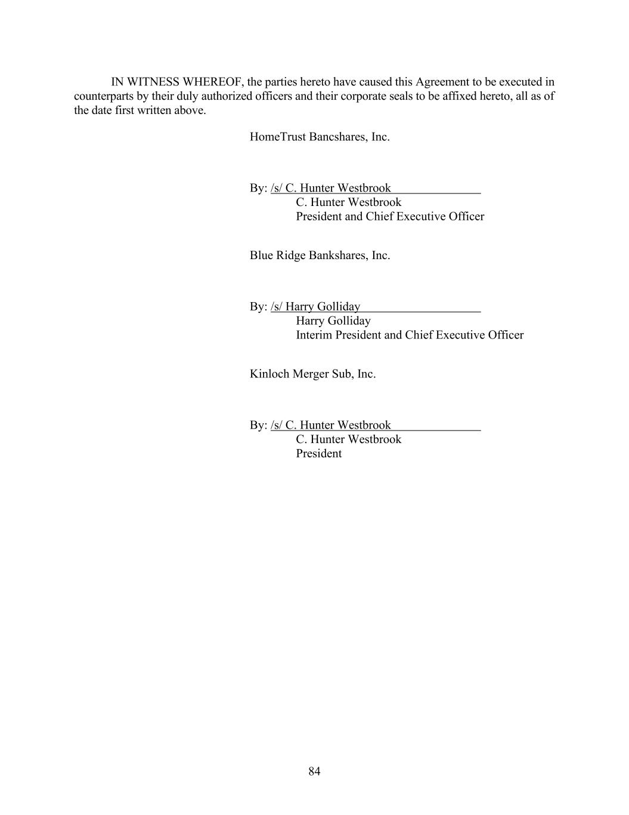
84 IN WITNESS WHEREOF, the parties hereto have caused this Agreement to be executed in counterparts by their duly authorized officers and their corporate seals to be affixed hereto, all as of the date first written above. HomeTrust Bancshares, Inc. By: /s/ C. Hunter Westbrook C. Hunter Westbrook President and Chief Executive Officer Blue Ridge Bankshares, Inc. By: /s/ Harry Golliday Harry Golliday Interim President and Chief Executive Officer Kinloch Merger Sub, Inc. By: /s/ C. Hunter Westbrook C. Hunter Westbrook President

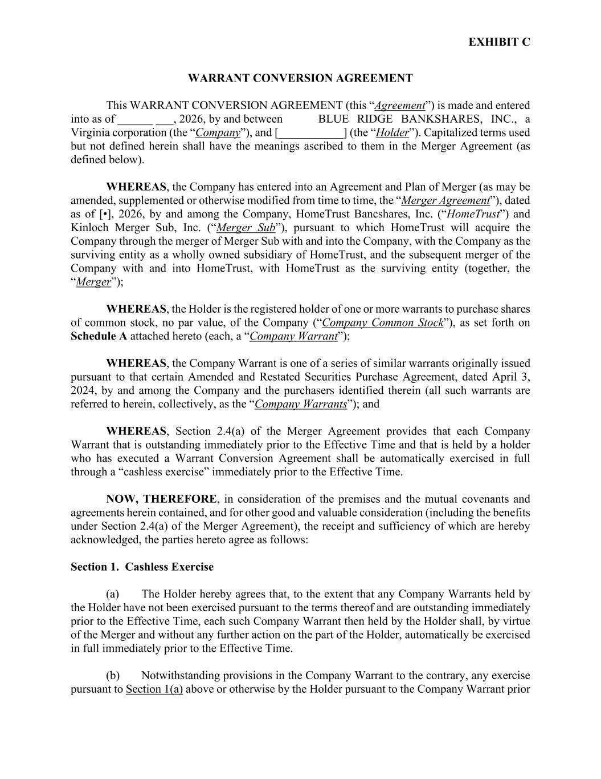
EXHIBIT C WARRANT CONVERSION AGREEMENT This WARRANT CONVERSION AGREEMENT (this “Agreement”) is made and entered into as of ______ ___, 2026, by and between BLUE RIDGE BANKSHARES, INC., a Virginia corporation (the “Company”), and [___________] (the “Holder”). Capitalized terms used but not defined herein shall have the meanings ascribed to them in the Merger Agreement (as defined below). WHEREAS, the Company has entered into an Agreement and Plan of Merger (as may be amended, supplemented or otherwise modified from time to time, the “Merger Agreement”), dated as of [•], 2026, by and among the Company, HomeTrust Bancshares, Inc. (“HomeTrust”) and Kinloch Merger Sub, Inc. (“Merger Sub”), pursuant to which HomeTrust will acquire the Company through the merger of Merger Sub with and into the Company, with the Company as the surviving entity as a wholly owned subsidiary of HomeTrust, and the subsequent merger of the Company with and into HomeTrust, with HomeTrust as the surviving entity (together, the “Merger”); WHEREAS, the Holder is the registered holder of one or more warrants to purchase shares of common stock, no par value, of the Company (“Company Common Stock”), as set forth on Schedule A attached hereto (each, a “Company Warrant”); WHEREAS, the Company Warrant is one of a series of similar warrants originally issued pursuant to that certain Amended and Restated Securities Purchase Agreement, dated April 3, 2024, by and among the Company and the purchasers identified therein (all such warrants are referred to herein, collectively, as the “Company Warrants”); and WHEREAS, Section 2.4(a) of the Merger Agreement provides that each Company Warrant that is outstanding immediately prior to the Effective Time and that is held by a holder who has executed a Warrant Conversion Agreement shall be automatically exercised in full through a “cashless exercise” immediately prior to the Effective Time. NOW, THEREFORE, in consideration of the premises and the mutual covenants and agreements herein contained, and for other good and valuable consideration (including the benefits under Section 2.4(a) of the Merger Agreement), the receipt and sufficiency of which are hereby acknowledged, the parties hereto agree as follows: Section 1. Cashless Exercise (a) The Holder hereby agrees that, to the extent that any Company Warrants held by the Holder have not been exercised pursuant to the terms thereof and are outstanding immediately prior to the Effective Time, each such Company Warrant then held by the Holder shall, by virtue of the Merger and without any further action on the part of the Holder, automatically be exercised in full immediately prior to the Effective Time. (b) Notwithstanding provisions in the Company Warrant to the contrary, any exercise pursuant to Section 1(a) above or otherwise by the Holder pursuant to the Company Warrant prior

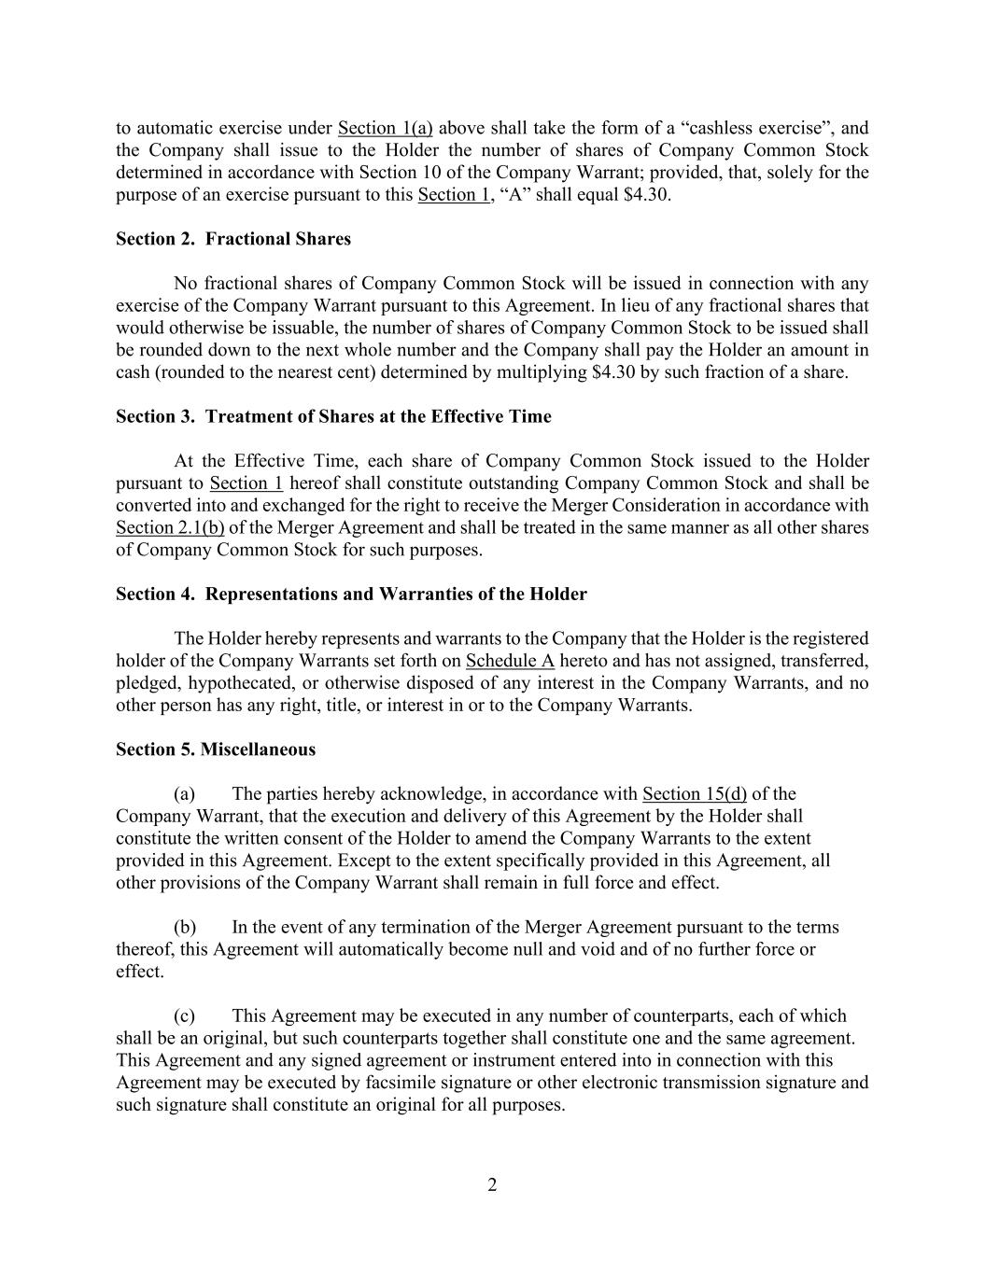
2 to automatic exercise under Section 1(a) above shall take the form of a “cashless exercise”, and the Company shall issue to the Holder the number of shares of Company Common Stock determined in accordance with Section 10 of the Company Warrant; provided, that, solely for the purpose of an exercise pursuant to this Section 1, “A” shall equal $4.30. Section 2. Fractional Shares No fractional shares of Company Common Stock will be issued in connection with any exercise of the Company Warrant pursuant to this Agreement. In lieu of any fractional shares that would otherwise be issuable, the number of shares of Company Common Stock to be issued shall be rounded down to the next whole number and the Company shall pay the Holder an amount in cash (rounded to the nearest cent) determined by multiplying $4.30 by such fraction of a share. Section 3. Treatment of Shares at the Effective Time At the Effective Time, each share of Company Common Stock issued to the Holder pursuant to Section 1 hereof shall constitute outstanding Company Common Stock and shall be converted into and exchanged for the right to receive the Merger Consideration in accordance with Section 2.1(b) of the Merger Agreement and shall be treated in the same manner as all other shares of Company Common Stock for such purposes. Section 4. Representations and Warranties of the Holder The Holder hereby represents and warrants to the Company that the Holder is the registered holder of the Company Warrants set forth on Schedule A hereto and has not assigned, transferred, pledged, hypothecated, or otherwise disposed of any interest in the Company Warrants, and no other person has any right, title, or interest in or to the Company Warrants. Section 5. Miscellaneous (a) The parties hereby acknowledge, in accordance with Section 15(d) of the Company Warrant, that the execution and delivery of this Agreement by the Holder shall constitute the written consent of the Holder to amend the Company Warrants to the extent provided in this Agreement. Except to the extent specifically provided in this Agreement, all other provisions of the Company Warrant shall remain in full force and effect. (b) In the event of any termination of the Merger Agreement pursuant to the terms thereof, this Agreement will automatically become null and void and of no further force or effect. (c) This Agreement may be executed in any number of counterparts, each of which shall be an original, but such counterparts together shall constitute one and the same agreement. This Agreement and any signed agreement or instrument entered into in connection with this Agreement may be executed by facsimile signature or other electronic transmission signature and such signature shall constitute an original for all purposes.

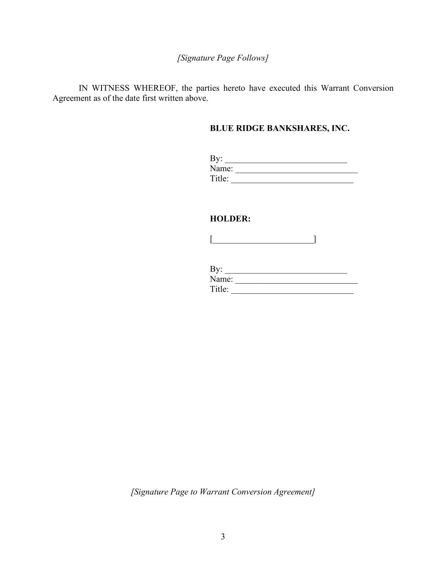
3 [Signature Page Follows] IN WITNESS WHEREOF, the parties hereto have executed this Warrant Conversion Agreement as of the date first written above. BLUE RIDGE BANKSHARES, INC. By: ____________________________ Name: ____________________________ Title: ____________________________ HOLDER: [_______________________] By: ____________________________ Name: ____________________________ Title: ____________________________ [Signature Page to Warrant Conversion Agreement]

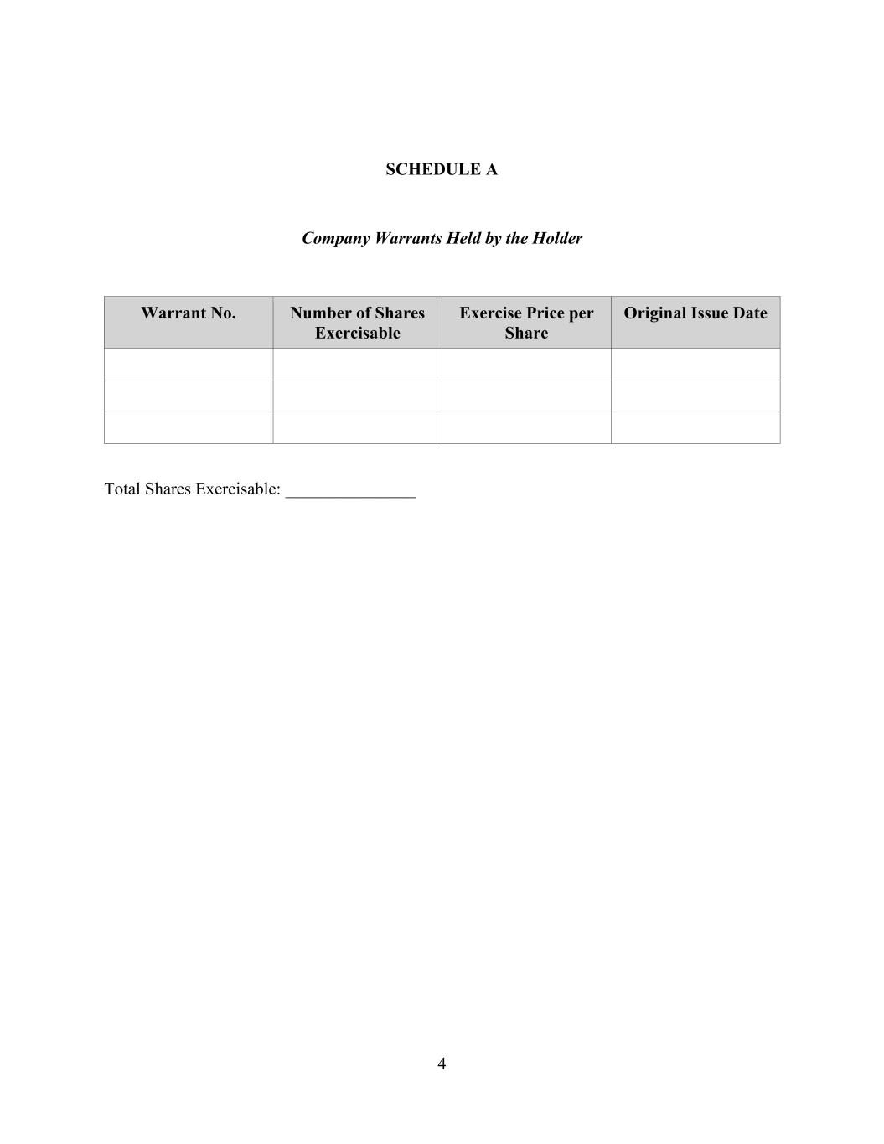
4 SCHEDULE A Company Warrants Held by the Holder Warrant No. Number of Shares Exercisable Exercise Price per Share Original Issue Date Total Shares Exercisable: _______________

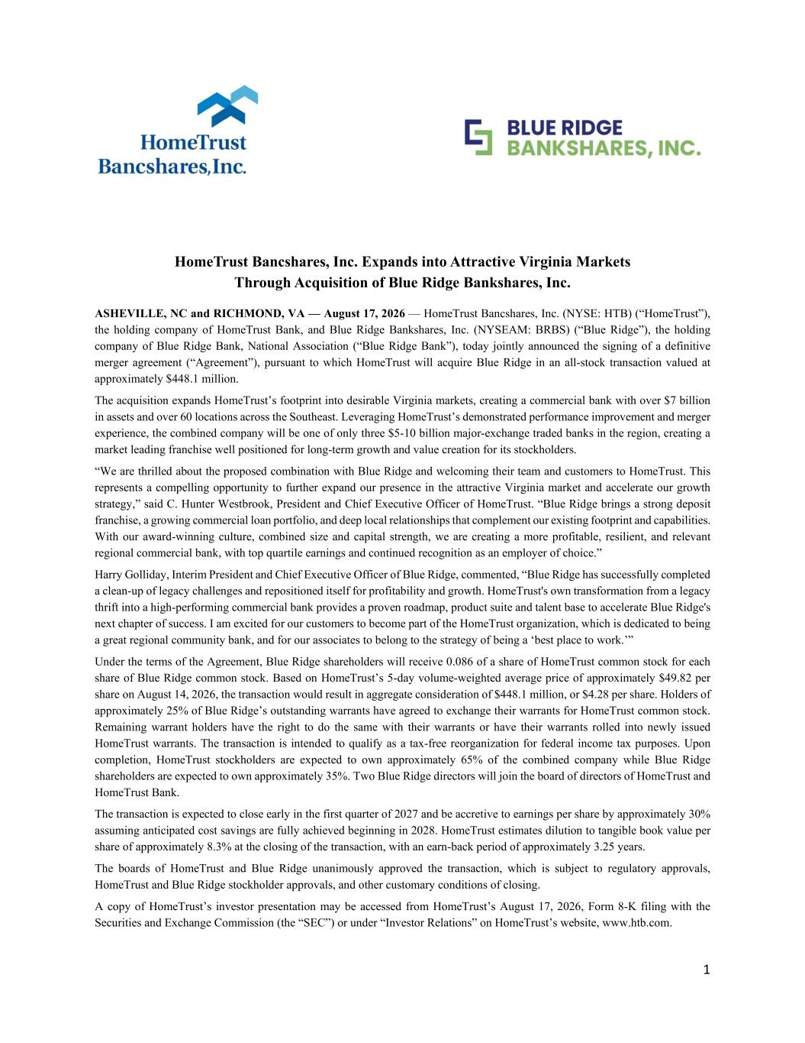
1 HomeTrust Bancshares, Inc. Expands into Attractive Virginia Markets Through Acquisition of Blue Ridge Bankshares, Inc. ASHEVILLE, NC and RICHMOND, VA — August 17, 2026 — HomeTrust Bancshares, Inc. (NYSE: HTB) (“HomeTrust”), the holding company of HomeTrust Bank, and Blue Ridge Bankshares, Inc. (NYSEAM: BRBS) (“Blue Ridge”), the holding company of Blue Ridge Bank, National Association (“Blue Ridge Bank”), today jointly announced the signing of a definitive merger agreement (“Agreement”), pursuant to which HomeTrust will acquire Blue Ridge in an all-stock transaction valued at approximately $448.1 million. The acquisition expands HomeTrust’s footprint into desirable Virginia markets, creating a commercial bank with over $7 billion in assets and over 60 locations across the Southeast. Leveraging HomeTrust’s demonstrated performance improvement and merger experience, the combined company will be one of only three $5-10 billion major-exchange traded banks in the region, creating a market leading franchise well positioned for long-term growth and value creation for its stockholders. “We are thrilled about the proposed combination with Blue Ridge and welcoming their team and customers to HomeTrust. This represents a compelling opportunity to further expand our presence in the attractive Virginia market and accelerate our growth strategy,” said C. Hunter Westbrook, President and Chief Executive Officer of HomeTrust. “Blue Ridge brings a strong deposit franchise, a growing commercial loan portfolio, and deep local relationships that complement our existing footprint and capabilities. With our award-winning culture, combined size and capital strength, we are creating a more profitable, resilient, and relevant regional commercial bank, with top quartile earnings and continued recognition as an employer of choice.” Harry Golliday, Interim President and Chief Executive Officer of Blue Ridge, commented, “Blue Ridge has successfully completed a clean-up of legacy challenges and repositioned itself for profitability and growth. HomeTrust's own transformation from a legacy thrift into a high-performing commercial bank provides a proven roadmap, product suite and talent base to accelerate Blue Ridge's next chapter of success. I am excited for our customers to become part of the HomeTrust organization, which is dedicated to being a great regional community bank, and for our associates to belong to the strategy of being a ‘best place to work.’” Under the terms of the Agreement, Blue Ridge shareholders will receive 0.086 of a share of HomeTrust common stock for each share of Blue Ridge common stock. Based on HomeTrust’s 5-day volume-weighted average price of approximately $49.82 per share on August 14, 2026, the transaction would result in aggregate consideration of $448.1 million, or $4.28 per share. Holders of approximately 25% of Blue Ridge’s outstanding warrants have agreed to exchange their warrants for HomeTrust common stock. Remaining warrant holders have the right to do the same with their warrants or have their warrants rolled into newly issued HomeTrust warrants. The transaction is intended to qualify as a tax-free reorganization for federal income tax purposes. Upon completion, HomeTrust stockholders are expected to own approximately 65% of the combined company while Blue Ridge shareholders are expected to own approximately 35%. Two Blue Ridge directors will join the board of directors of HomeTrust and HomeTrust Bank. The transaction is expected to close early in the first quarter of 2027 and be accretive to earnings per share by approximately 30% assuming anticipated cost savings are fully achieved beginning in 2028. HomeTrust estimates dilution to tangible book value per share of approximately 8.3% at the closing of the transaction, with an earn-back period of approximately 3.25 years. The boards of HomeTrust and Blue Ridge unanimously approved the transaction, which is subject to regulatory approvals, HomeTrust and Blue Ridge stockholder approvals, and other customary conditions of closing. A copy of HomeTrust’s investor presentation may be accessed from HomeTrust’s August 17, 2026, Form 8-K filing with the Securities and Exchange Commission (the “SEC”) or under “Investor Relations” on HomeTrust’s website, www.htb.com.

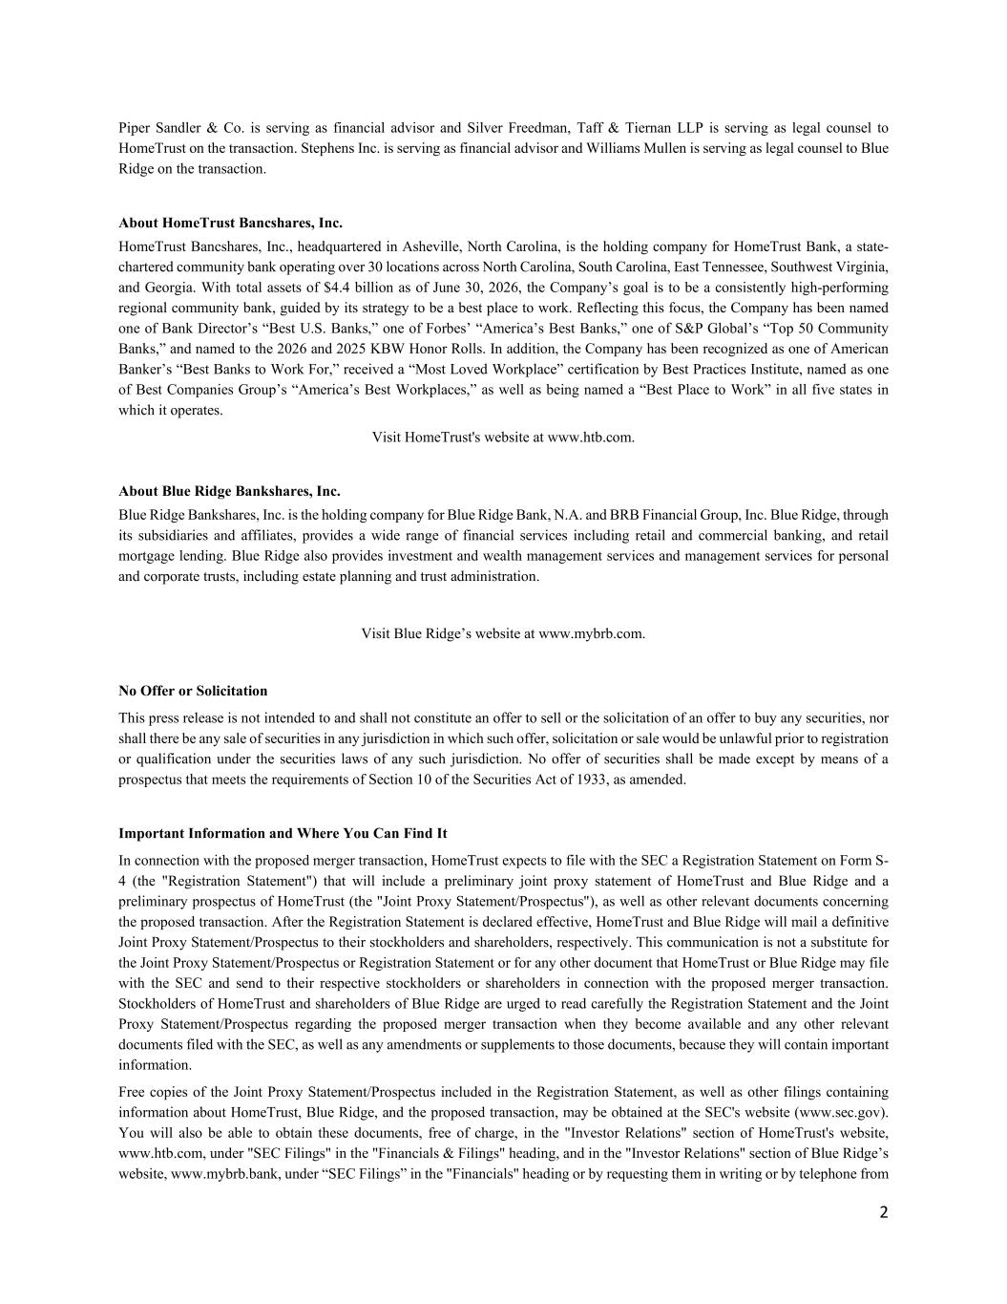
2 Piper Sandler & Co. is serving as financial advisor and Silver Freedman, Taff & Tiernan LLP is serving as legal counsel to HomeTrust on the transaction. Stephens Inc. is serving as financial advisor and Williams Mullen is serving as legal counsel to Blue Ridge on the transaction. About HomeTrust Bancshares, Inc. HomeTrust Bancshares, Inc., headquartered in Asheville, North Carolina, is the holding company for HomeTrust Bank, a state- chartered community bank operating over 30 locations across North Carolina, South Carolina, East Tennessee, Southwest Virginia, and Georgia. With total assets of $4.4 billion as of June 30, 2026, the Company’s goal is to be a consistently high-performing regional community bank, guided by its strategy to be a best place to work. Reflecting this focus, the Company has been named one of Bank Director’s “Best U.S. Banks,” one of Forbes’ “America’s Best Banks,” one of S&P Global’s “Top 50 Community Banks,” and named to the 2026 and 2025 KBW Honor Rolls. In addition, the Company has been recognized as one of American Banker’s “Best Banks to Work For,” received a “Most Loved Workplace” certification by Best Practices Institute, named as one of Best Companies Group’s “America’s Best Workplaces,” as well as being named a “Best Place to Work” in all five states in which it operates. Visit HomeTrust's website at www.htb.com. About Blue Ridge Bankshares, Inc. Blue Ridge Bankshares, Inc. is the holding company for Blue Ridge Bank, N.A. and BRB Financial Group, Inc. Blue Ridge, through its subsidiaries and affiliates, provides a wide range of financial services including retail and commercial banking, and retail mortgage lending. Blue Ridge also provides investment and wealth management services and management services for personal and corporate trusts, including estate planning and trust administration. Visit Blue Ridge’s website at www.mybrb.com. No Offer or Solicitation This press release is not intended to and shall not constitute an offer to sell or the solicitation of an offer to buy any securities, nor shall there be any sale of securities in any jurisdiction in which such offer, solicitation or sale would be unlawful prior to registration or qualification under the securities laws of any such jurisdiction. No offer of securities shall be made except by means of a prospectus that meets the requirements of Section 10 of the Securities Act of 1933, as amended. Important Information and Where You Can Find It In connection with the proposed merger transaction, HomeTrust expects to file with the SEC a Registration Statement on Form S- 4 (the "Registration Statement") that will include a preliminary joint proxy statement of HomeTrust and Blue Ridge and a preliminary prospectus of HomeTrust (the "Joint Proxy Statement/Prospectus"), as well as other relevant documents concerning the proposed transaction. After the Registration Statement is declared effective, HomeTrust and Blue Ridge will mail a definitive Joint Proxy Statement/Prospectus to their stockholders and shareholders, respectively. This communication is not a substitute for the Joint Proxy Statement/Prospectus or Registration Statement or for any other document that HomeTrust or Blue Ridge may file with the SEC and send to their respective stockholders or shareholders in connection with the proposed merger transaction. Stockholders of HomeTrust and shareholders of Blue Ridge are urged to read carefully the Registration Statement and the Joint Proxy Statement/Prospectus regarding the proposed merger transaction when they become available and any other relevant documents filed with the SEC, as well as any amendments or supplements to those documents, because they will contain important information. Free copies of the Joint Proxy Statement/Prospectus included in the Registration Statement, as well as other filings containing information about HomeTrust, Blue Ridge, and the proposed transaction, may be obtained at the SEC's website (www.sec.gov). You will also be able to obtain these documents, free of charge, in the "Investor Relations" section of HomeTrust's website, www.htb.com, under "SEC Filings" in the "Financials & Filings" heading, and in the "Investor Relations" section of Blue Ridge’s website, www.mybrb.bank, under “SEC Filings” in the "Financials" heading or by requesting them in writing or by telephone from

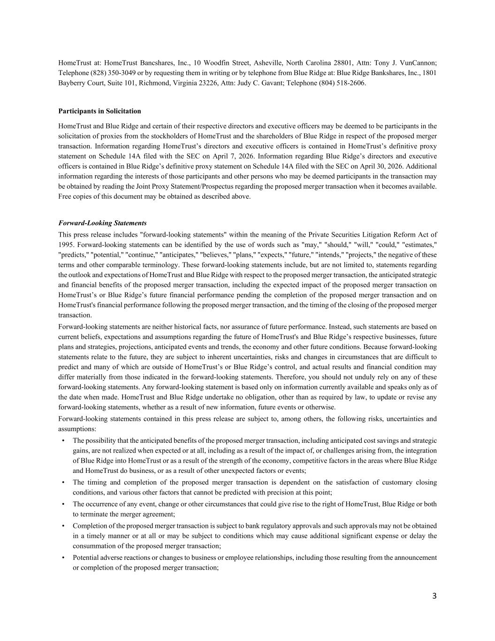
3 HomeTrust at: HomeTrust Bancshares, Inc., 10 Woodfin Street, Asheville, North Carolina 28801, Attn: Tony J. VunCannon; Telephone (828) 350-3049 or by requesting them in writing or by telephone from Blue Ridge at: Blue Ridge Bankshares, Inc., 1801 Bayberry Court, Suite 101, Richmond, Virginia 23226, Attn: Judy C. Gavant; Telephone (804) 518-2606. Participants in Solicitation HomeTrust and Blue Ridge and certain of their respective directors and executive officers may be deemed to be participants in the solicitation of proxies from the stockholders of HomeTrust and the shareholders of Blue Ridge in respect of the proposed merger transaction. Information regarding HomeTrust’s directors and executive officers is contained in HomeTrust’s definitive proxy statement on Schedule 14A filed with the SEC on April 7, 2026. Information regarding Blue Ridge’s directors and executive officers is contained in Blue Ridge’s definitive proxy statement on Schedule 14A filed with the SEC on April 30, 2026. Additional information regarding the interests of those participants and other persons who may be deemed participants in the transaction may be obtained by reading the Joint Proxy Statement/Prospectus regarding the proposed merger transaction when it becomes available. Free copies of this document may be obtained as described above. Forward-Looking Statements This press release includes "forward-looking statements" within the meaning of the Private Securities Litigation Reform Act of 1995. Forward-looking statements can be identified by the use of words such as "may," "should," "will," "could," "estimates," "predicts," "potential," "continue," "anticipates," "believes," "plans," "expects," "future," "intends," "projects," the negative of these terms and other comparable terminology. These forward-looking statements include, but are not limited to, statements regarding the outlook and expectations of HomeTrust and Blue Ridge with respect to the proposed merger transaction, the anticipated strategic and financial benefits of the proposed merger transaction, including the expected impact of the proposed merger transaction on HomeTrust’s or Blue Ridge’s future financial performance pending the completion of the proposed merger transaction and on HomeTrust's financial performance following the proposed merger transaction, and the timing of the closing of the proposed merger transaction. Forward-looking statements are neither historical facts, nor assurance of future performance. Instead, such statements are based on current beliefs, expectations and assumptions regarding the future of HomeTrust's and Blue Ridge’s respective businesses, future plans and strategies, projections, anticipated events and trends, the economy and other future conditions. Because forward-looking statements relate to the future, they are subject to inherent uncertainties, risks and changes in circumstances that are difficult to predict and many of which are outside of HomeTrust’s or Blue Ridge’s control, and actual results and financial condition may differ materially from those indicated in the forward-looking statements. Therefore, you should not unduly rely on any of these forward-looking statements. Any forward-looking statement is based only on information currently available and speaks only as of the date when made. HomeTrust and Blue Ridge undertake no obligation, other than as required by law, to update or revise any forward-looking statements, whether as a result of new information, future events or otherwise. Forward-looking statements contained in this press release are subject to, among others, the following risks, uncertainties and assumptions: • The possibility that the anticipated benefits of the proposed merger transaction, including anticipated cost savings and strategic gains, are not realized when expected or at all, including as a result of the impact of, or challenges arising from, the integration of Blue Ridge into HomeTrust or as a result of the strength of the economy, competitive factors in the areas where Blue Ridge and HomeTrust do business, or as a result of other unexpected factors or events; • The timing and completion of the proposed merger transaction is dependent on the satisfaction of customary closing conditions, and various other factors that cannot be predicted with precision at this point; • The occurrence of any event, change or other circumstances that could give rise to the right of HomeTrust, Blue Ridge or both to terminate the merger agreement; • Completion of the proposed merger transaction is subject to bank regulatory approvals and such approvals may not be obtained in a timely manner or at all or may be subject to conditions which may cause additional significant expense or delay the consummation of the proposed merger transaction; • Potential adverse reactions or changes to business or employee relationships, including those resulting from the announcement or completion of the proposed merger transaction;

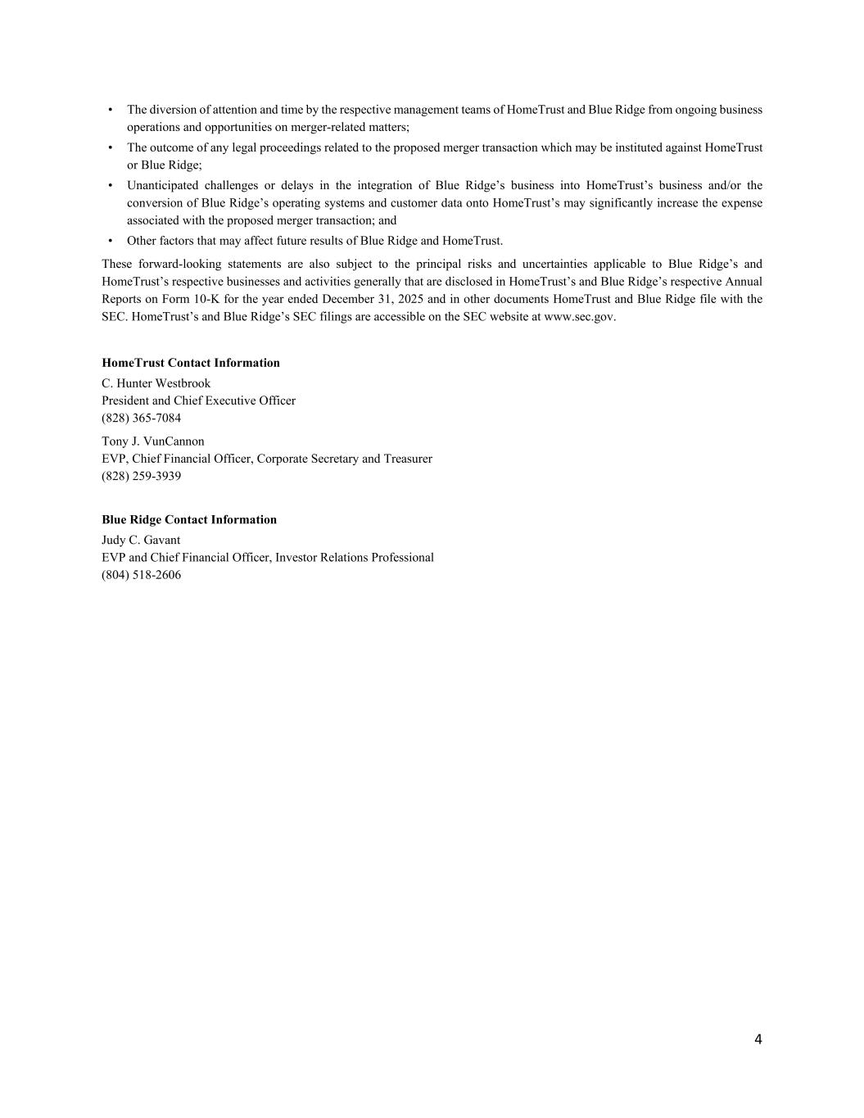
4 • The diversion of attention and time by the respective management teams of HomeTrust and Blue Ridge from ongoing business operations and opportunities on merger-related matters; • The outcome of any legal proceedings related to the proposed merger transaction which may be instituted against HomeTrust or Blue Ridge; • Unanticipated challenges or delays in the integration of Blue Ridge’s business into HomeTrust’s business and/or the conversion of Blue Ridge’s operating systems and customer data onto HomeTrust’s may significantly increase the expense associated with the proposed merger transaction; and • Other factors that may affect future results of Blue Ridge and HomeTrust. These forward-looking statements are also subject to the principal risks and uncertainties applicable to Blue Ridge’s and HomeTrust’s respective businesses and activities generally that are disclosed in HomeTrust’s and Blue Ridge’s respective Annual Reports on Form 10-K for the year ended December 31, 2025 and in other documents HomeTrust and Blue Ridge file with the SEC. HomeTrust’s and Blue Ridge’s SEC filings are accessible on the SEC website at www.sec.gov. HomeTrust Contact Information C. Hunter Westbrook President and Chief Executive Officer (828) 365-7084 Tony J. VunCannon EVP, Chief Financial Officer, Corporate Secretary and Treasurer (828) 259-3939 Blue Ridge Contact Information Judy C. Gavant EVP and Chief Financial Officer, Investor Relations Professional (804) 518-2606

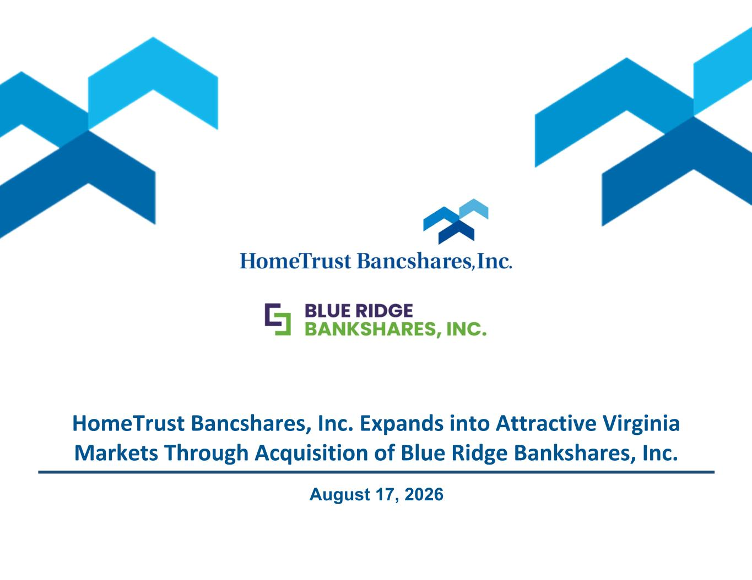
1 HomeTrust Bancshares, Inc. Expands into Attractive Virginia Markets Through Acquisition of Blue Ridge Bankshares, Inc. August 17, 2026

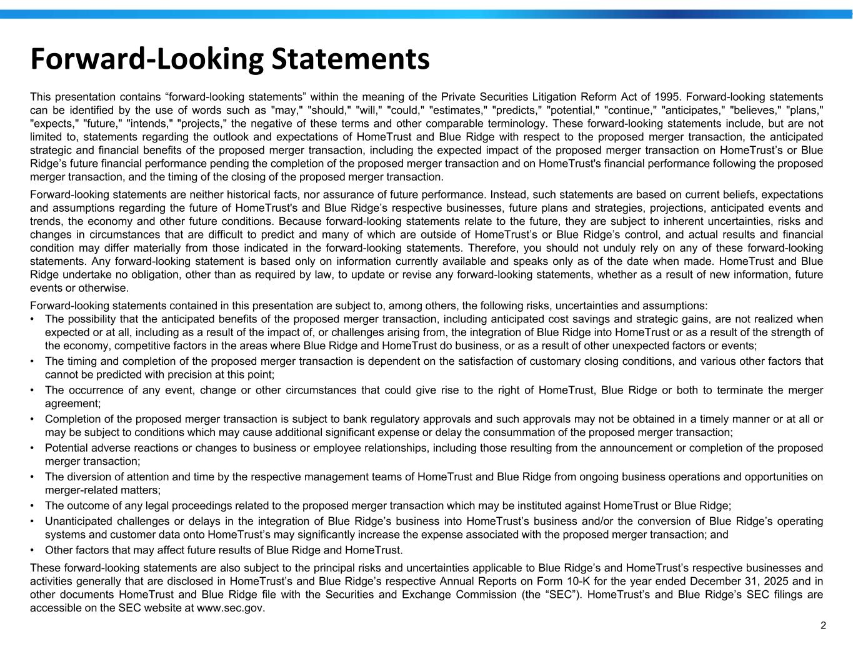
2 Forward-Looking Statements This presentation contains “forward-looking statements” within the meaning of the Private Securities Litigation Reform Act of 1995. Forward-looking statements can be identified by the use of words such as "may," "should," "will," "could," "estimates," "predicts," "potential," "continue," "anticipates," "believes," "plans," "expects," "future," "intends," "projects," the negative of these terms and other comparable terminology. These forward-looking statements include, but are not limited to, statements regarding the outlook and expectations of HomeTrust and Blue Ridge with respect to the proposed merger transaction, the anticipated strategic and financial benefits of the proposed merger transaction, including the expected impact of the proposed merger transaction on HomeTrust’s or Blue Ridge’s future financial performance pending the completion of the proposed merger transaction and on HomeTrust's financial performance following the proposed merger transaction, and the timing of the closing of the proposed merger transaction. Forward-looking statements are neither historical facts, nor assurance of future performance. Instead, such statements are based on current beliefs, expectations and assumptions regarding the future of HomeTrust's and Blue Ridge’s respective businesses, future plans and strategies, projections, anticipated events and trends, the economy and other future conditions. Because forward-looking statements relate to the future, they are subject to inherent uncertainties, risks and changes in circumstances that are difficult to predict and many of which are outside of HomeTrust’s or Blue Ridge’s control, and actual results and financial condition may differ materially from those indicated in the forward-looking statements. Therefore, you should not unduly rely on any of these forward-looking statements. Any forward-looking statement is based only on information currently available and speaks only as of the date when made. HomeTrust and Blue Ridge undertake no obligation, other than as required by law, to update or revise any forward-looking statements, whether as a result of new information, future events or otherwise. Forward-looking statements contained in this presentation are subject to, among others, the following risks, uncertainties and assumptions: • The possibility that the anticipated benefits of the proposed merger transaction, including anticipated cost savings and strategic gains, are not realized when expected or at all, including as a result of the impact of, or challenges arising from, the integration of Blue Ridge into HomeTrust or as a result of the strength of the economy, competitive factors in the areas where Blue Ridge and HomeTrust do business, or as a result of other unexpected factors or events; • The timing and completion of the proposed merger transaction is dependent on the satisfaction of customary closing conditions, and various other factors that cannot be predicted with precision at this point; • The occurrence of any event, change or other circumstances that could give rise to the right of HomeTrust, Blue Ridge or both to terminate the merger agreement; • Completion of the proposed merger transaction is subject to bank regulatory approvals and such approvals may not be obtained in a timely manner or at all or may be subject to conditions which may cause additional significant expense or delay the consummation of the proposed merger transaction; • Potential adverse reactions or changes to business or employee relationships, including those resulting from the announcement or completion of the proposed merger transaction; • The diversion of attention and time by the respective management teams of HomeTrust and Blue Ridge from ongoing business operations and opportunities on merger-related matters; • The outcome of any legal proceedings related to the proposed merger transaction which may be instituted against HomeTrust or Blue Ridge; • Unanticipated challenges or delays in the integration of Blue Ridge’s business into HomeTrust’s business and/or the conversion of Blue Ridge’s operating systems and customer data onto HomeTrust’s may significantly increase the expense associated with the proposed merger transaction; and • Other factors that may affect future results of Blue Ridge and HomeTrust. These forward-looking statements are also subject to the principal risks and uncertainties applicable to Blue Ridge’s and HomeTrust’s respective businesses and activities generally that are disclosed in HomeTrust’s and Blue Ridge’s respective Annual Reports on Form 10-K for the year ended December 31, 2025 and in other documents HomeTrust and Blue Ridge file with the Securities and Exchange Commission (the “SEC”). HomeTrust’s and Blue Ridge’s SEC filings are accessible on the SEC website at www.sec.gov.

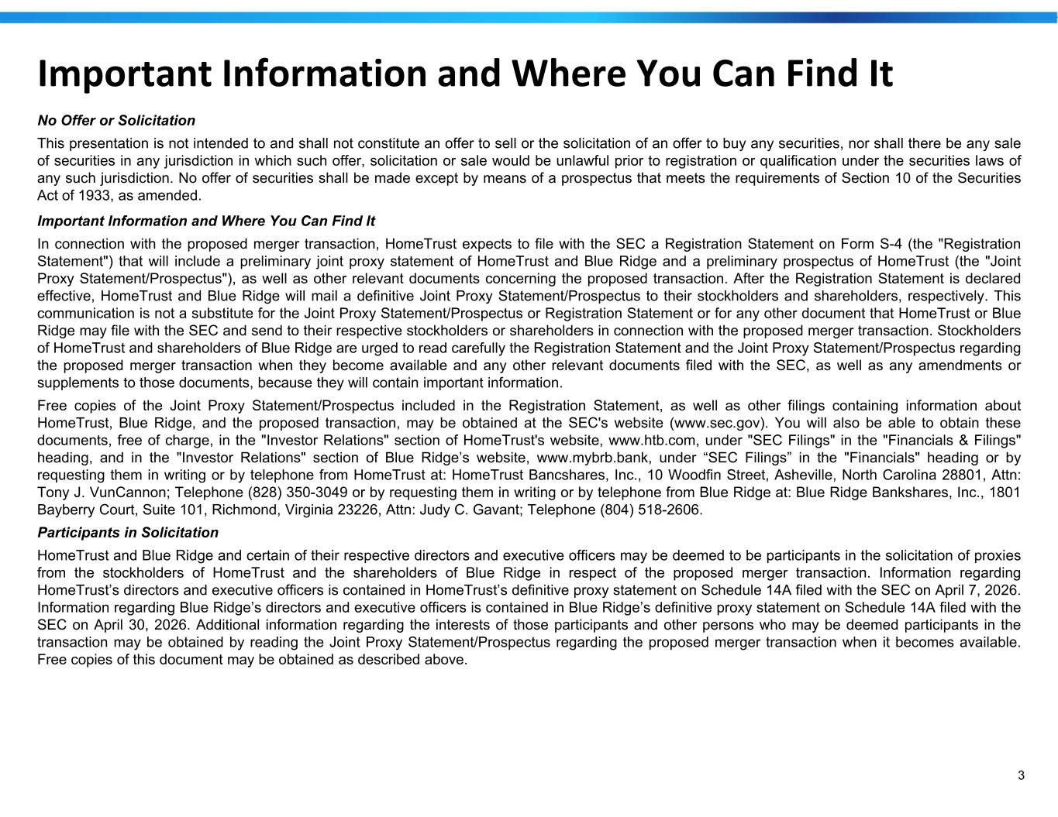
3 Important Information and Where You Can Find It No Offer or Solicitation This presentation is not intended to and shall not constitute an offer to sell or the solicitation of an offer to buy any securities, nor shall there be any sale of securities in any jurisdiction in which such offer, solicitation or sale would be unlawful prior to registration or qualification under the securities laws of any such jurisdiction. No offer of securities shall be made except by means of a prospectus that meets the requirements of Section 10 of the Securities Act of 1933, as amended. Important Information and Where You Can Find It In connection with the proposed merger transaction, HomeTrust expects to file with the SEC a Registration Statement on Form S-4 (the "Registration Statement") that will include a preliminary joint proxy statement of HomeTrust and Blue Ridge and a preliminary prospectus of HomeTrust (the "Joint Proxy Statement/Prospectus"), as well as other relevant documents concerning the proposed transaction. After the Registration Statement is declared effective, HomeTrust and Blue Ridge will mail a definitive Joint Proxy Statement/Prospectus to their stockholders and shareholders, respectively. This communication is not a substitute for the Joint Proxy Statement/Prospectus or Registration Statement or for any other document that HomeTrust or Blue Ridge may file with the SEC and send to their respective stockholders or shareholders in connection with the proposed merger transaction. Stockholders of HomeTrust and shareholders of Blue Ridge are urged to read carefully the Registration Statement and the Joint Proxy Statement/Prospectus regarding the proposed merger transaction when they become available and any other relevant documents filed with the SEC, as well as any amendments or supplements to those documents, because they will contain important information. Free copies of the Joint Proxy Statement/Prospectus included in the Registration Statement, as well as other filings containing information about HomeTrust, Blue Ridge, and the proposed transaction, may be obtained at the SEC's website (www.sec.gov). You will also be able to obtain these documents, free of charge, in the "Investor Relations" section of HomeTrust's website, www.htb.com, under "SEC Filings" in the "Financials & Filings" heading, and in the "Investor Relations" section of Blue Ridge’s website, www.mybrb.bank, under “SEC Filings” in the "Financials" heading or by requesting them in writing or by telephone from HomeTrust at: HomeTrust Bancshares, Inc., 10 Woodfin Street, Asheville, North Carolina 28801, Attn: Tony J. VunCannon; Telephone (828) 350-3049 or by requesting them in writing or by telephone from Blue Ridge at: Blue Ridge Bankshares, Inc., 1801 Bayberry Court, Suite 101, Richmond, Virginia 23226, Attn: Judy C. Gavant; Telephone (804) 518-2606. Participants in Solicitation HomeTrust and Blue Ridge and certain of their respective directors and executive officers may be deemed to be participants in the solicitation of proxies from the stockholders of HomeTrust and the shareholders of Blue Ridge in respect of the proposed merger transaction. Information regarding HomeTrust’s directors and executive officers is contained in HomeTrust’s definitive proxy statement on Schedule 14A filed with the SEC on April 7, 2026. Information regarding Blue Ridge’s directors and executive officers is contained in Blue Ridge’s definitive proxy statement on Schedule 14A filed with the SEC on April 30, 2026. Additional information regarding the interests of those participants and other persons who may be deemed participants in the transaction may be obtained by reading the Joint Proxy Statement/Prospectus regarding the proposed merger transaction when it becomes available. Free copies of this document may be obtained as described above.

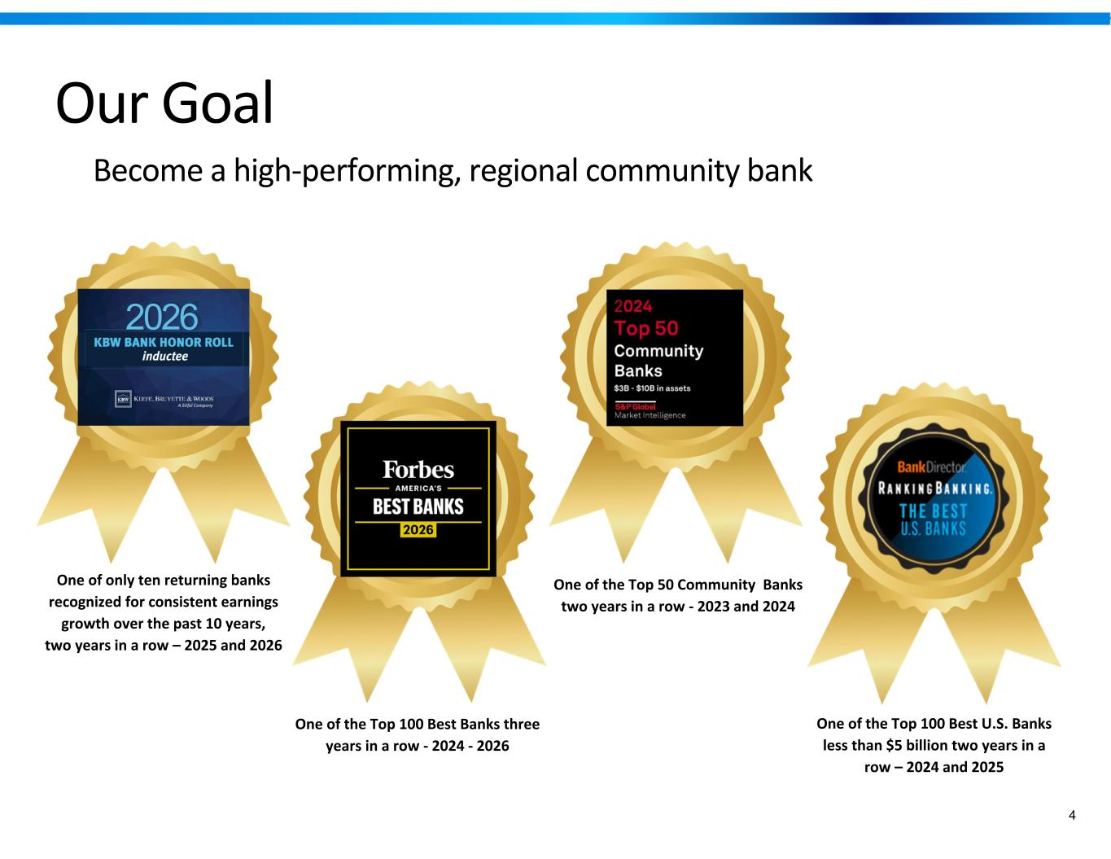
4 One of the Top 50 Community Banks two years in a row - 2023 and 2024 One of the Top 100 Best Banks three years in a row - 2024 - 2026 One of the Top 100 Best U.S. Banks less than $5 billion two years in a row – 2024 and 2025 Our Goal Become a high-performing, regional community bank One of only ten returning banks recognized for consistent earnings growth over the past 10 years, two years in a row – 2025 and 2026 2026


5 The Strategy to Reach Our Goal Become a regionally and nationally recognized ‘Best Place to Work’

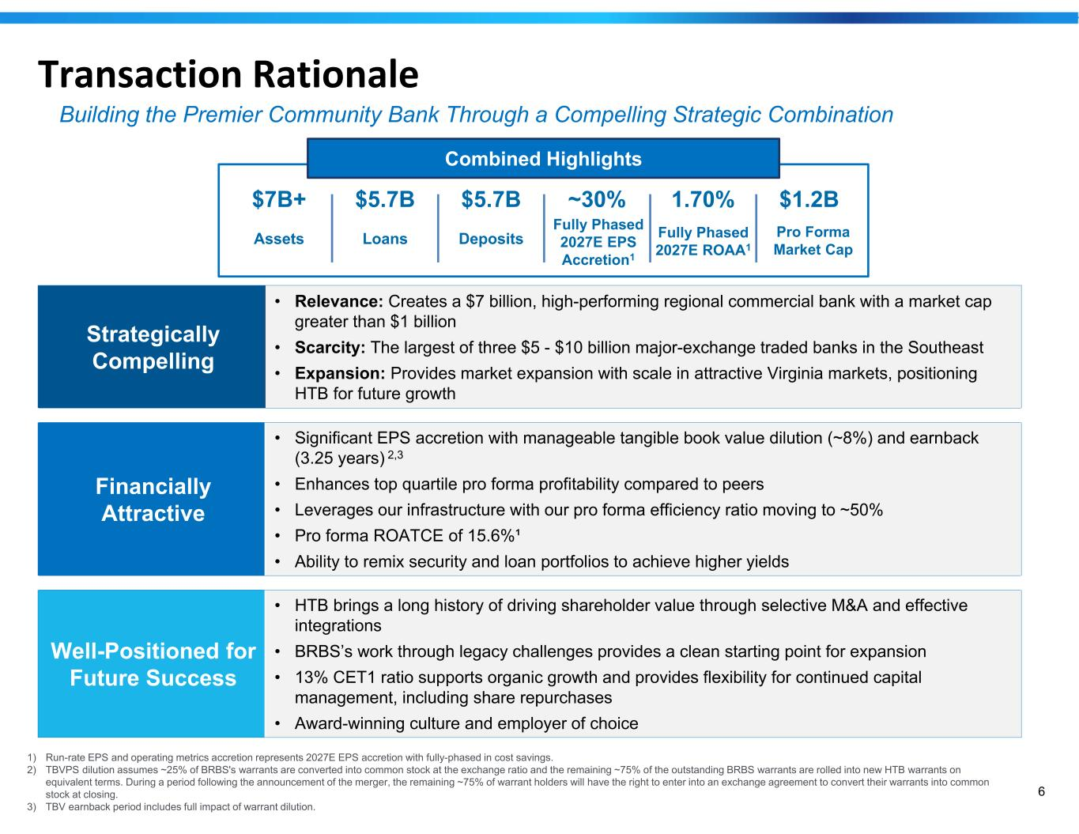
6 Transaction Rationale • Relevance: Creates a $7 billion, high-performing regional commercial bank with a market cap greater than $1 billion • Scarcity: The largest of three $5 - $10 billion major-exchange traded banks in the Southeast • Expansion: Provides market expansion with scale in attractive Virginia markets, positioning HTB for future growth Strategically Compelling • Significant EPS accretion with manageable tangible book value dilution (~8%) and earnback (3.25 years) 2,3 • Enhances top quartile pro forma profitability compared to peers • Leverages our infrastructure with our pro forma efficiency ratio moving to ~50% • Pro forma ROATCE of 15.6%¹ • Ability to remix security and loan portfolios to achieve higher yields Financially Attractive • HTB brings a long history of driving shareholder value through selective M&A and effective integrations • BRBS’s work through legacy challenges provides a clean starting point for expansion • 13% CET1 ratio supports organic growth and provides flexibility for continued capital management, including share repurchases • Award-winning culture and employer of choice Well-Positioned for Future Success 1) Run-rate EPS and operating metrics accretion represents 2027E EPS accretion with fully-phased in cost savings. 2) TBVPS dilution assumes ~25% of BRBS's warrants are converted into common stock at the exchange ratio and the remaining ~75% of the outstanding BRBS warrants are rolled into new HTB warrants on equivalent terms. During a period following the announcement of the merger, the remaining ~75% of warrant holders will have the right to enter into an exchange agreement to convert their warrants into common stock at closing. 3) TBV earnback period includes full impact of warrant dilution. Combined Highlights $7B+ $5.7B $5.7B ~30% 1.70% $1.2B Assets Loans Deposits Fully Phased 2027E EPS Accretion1 Fully Phased 2027E ROAA1 Pro Forma Market Cap Building the Premier Community Bank Through a Compelling Strategic Combination

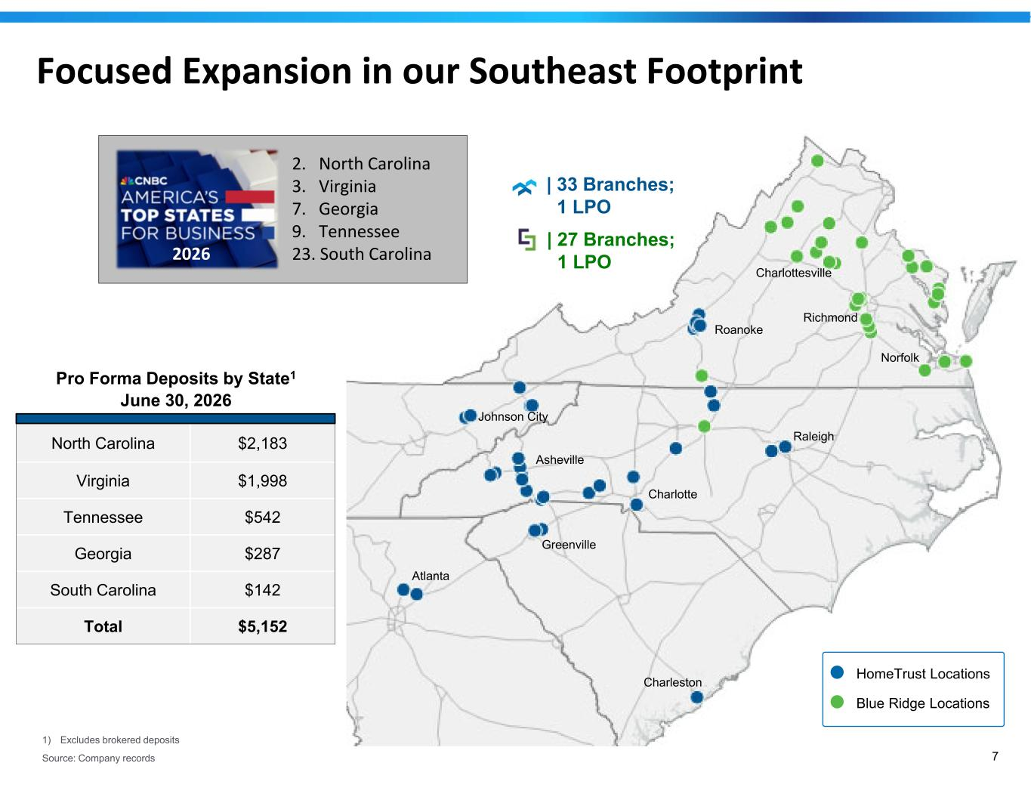
7 Focused Expansion in our Southeast Footprint HomeTrust Locations Blue Ridge Locations Charlottesville Richmond Charlotte Asheville Johnson City Charleston Atlanta Raleigh Norfolk | 27 Branches; 1 LPO | 33 Branches; 1 LPO Greenville Roanoke 2. North Carolina 3. Virginia 7. Georgia 9. Tennessee 23. South Carolina Pro Forma Deposits by State1 June 30, 2026 $2,183North Carolina $1,998Virginia $542Tennessee $287Georgia $142South Carolina $5,152Total 2026 1) Excludes brokered deposits Source: Company records

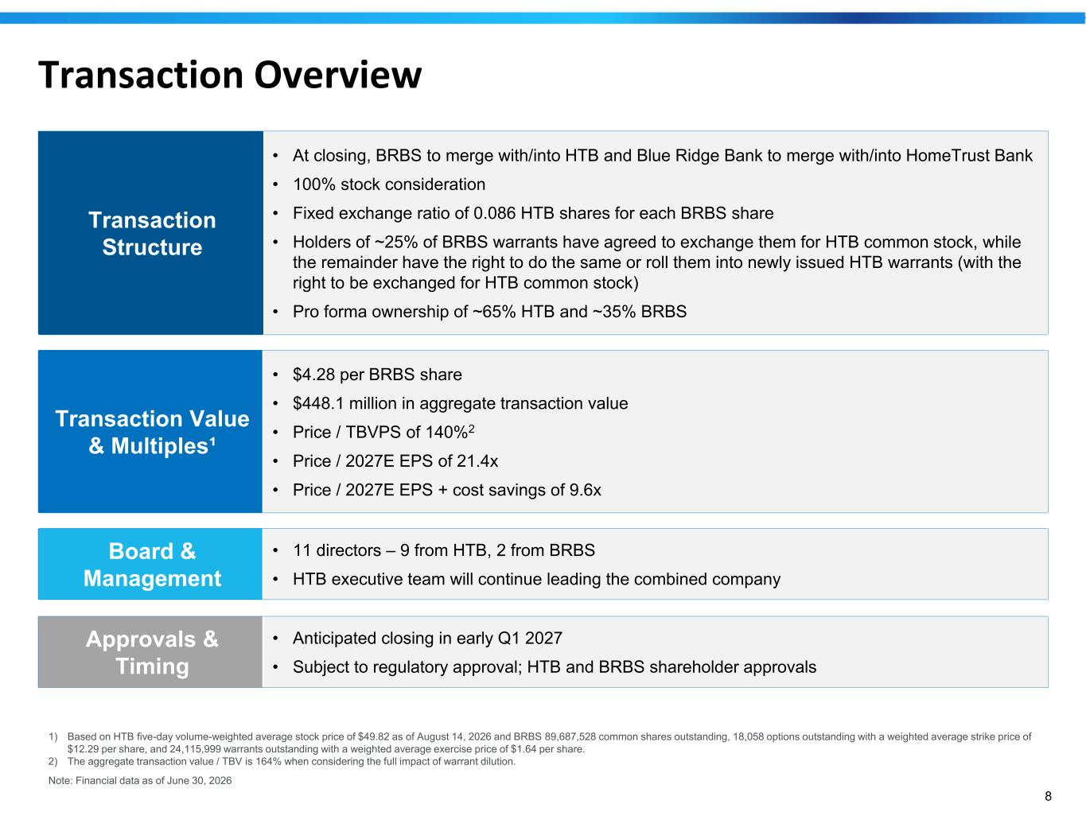
8 Transaction Overview • At closing, BRBS to merge with/into HTB and Blue Ridge Bank to merge with/into HomeTrust Bank • 100% stock consideration • Fixed exchange ratio of 0.086 HTB shares for each BRBS share • Holders of ~25% of BRBS warrants have agreed to exchange them for HTB common stock, while the remainder have the right to do the same or roll them into newly issued HTB warrants (with the right to be exchanged for HTB common stock) • Pro forma ownership of ~65% HTB and ~35% BRBS Transaction Structure • $4.28 per BRBS share • $448.1 million in aggregate transaction value • Price / TBVPS of 140%2 • Price / 2027E EPS of 21.4x • Price / 2027E EPS + cost savings of 9.6x Transaction Value & Multiples¹ • 11 directors – 9 from HTB, 2 from BRBS • HTB executive team will continue leading the combined company Board & Management • Anticipated closing in early Q1 2027 • Subject to regulatory approval; HTB and BRBS shareholder approvals Approvals & Timing 1) Based on HTB five-day volume-weighted average stock price of $49.82 as of August 14, 2026 and BRBS 89,687,528 common shares outstanding, 18,058 options outstanding with a weighted average strike price of $12.29 per share, and 24,115,999 warrants outstanding with a weighted average exercise price of $1.64 per share. 2) The aggregate transaction value / TBV is 164% when considering the full impact of warrant dilution. Note: Financial data as of June 30, 2026

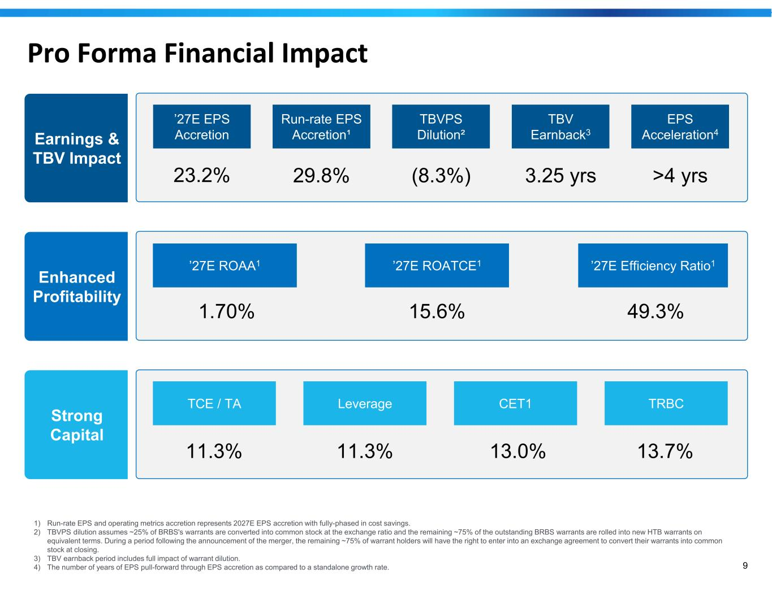
9 Pro Forma Financial Impact TBVPS Dilution² TBV Earnback3 EPS Acceleration4 ’27E EPS Accretion 23.2% Run-rate EPS Accretion¹ 29.8% (8.3%) 3.25 yrs >4 yrs Earnings & TBV Impact ’27E ROAA1 1.70% ’27E ROATCE1 15.6% ’27E Efficiency Ratio1 49.3% Enhanced Profitability Strong Capital CET1 TRBCTCE / TA 11.3% Leverage 11.3% 13.0% 13.7% 1) Run-rate EPS and operating metrics accretion represents 2027E EPS accretion with fully-phased in cost savings. 2) TBVPS dilution assumes ~25% of BRBS's warrants are converted into common stock at the exchange ratio and the remaining ~75% of the outstanding BRBS warrants are rolled into new HTB warrants on equivalent terms. During a period following the announcement of the merger, the remaining ~75% of warrant holders will have the right to enter into an exchange agreement to convert their warrants into common stock at closing. 3) TBV earnback period includes full impact of warrant dilution. 4) The number of years of EPS pull-forward through EPS accretion as compared to a standalone growth rate.

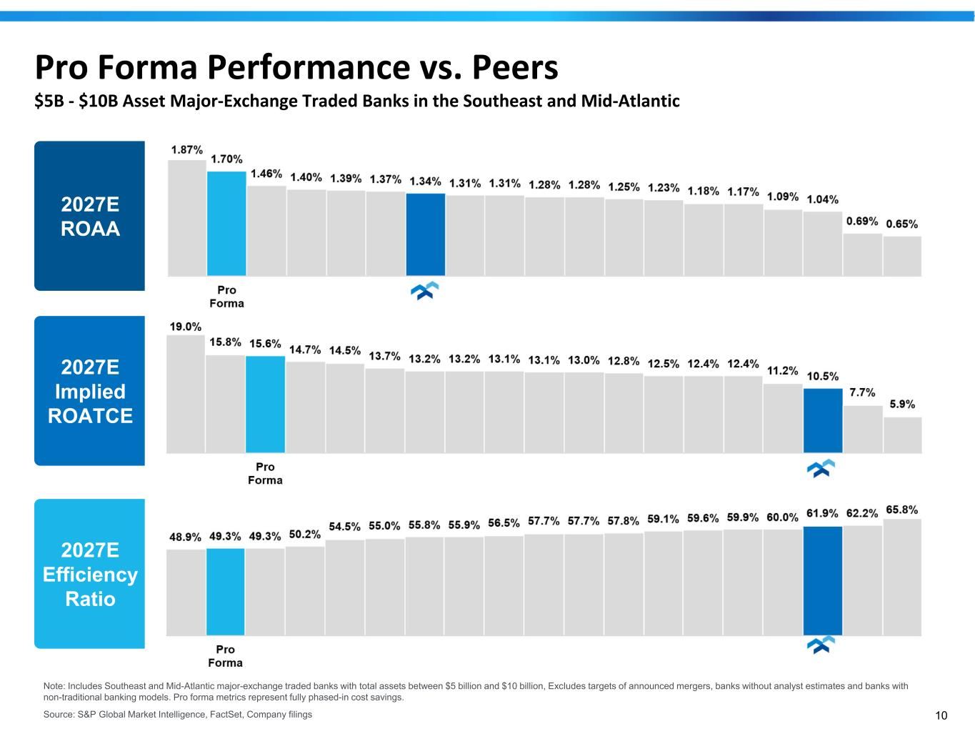
10 Pro Forma Performance vs. Peers $5B - $10B Asset Major-Exchange Traded Banks in the Southeast and Mid-Atlantic Note: Includes Southeast and Mid-Atlantic major-exchange traded banks with total assets between $5 billion and $10 billion, Excludes targets of announced mergers, banks without analyst estimates and banks with non-traditional banking models. Pro forma metrics represent fully phased-in cost savings. Source: S&P Global Market Intelligence, FactSet, Company filings 2027E ROAA 2027E Implied ROATCE 2027E Efficiency Ratio

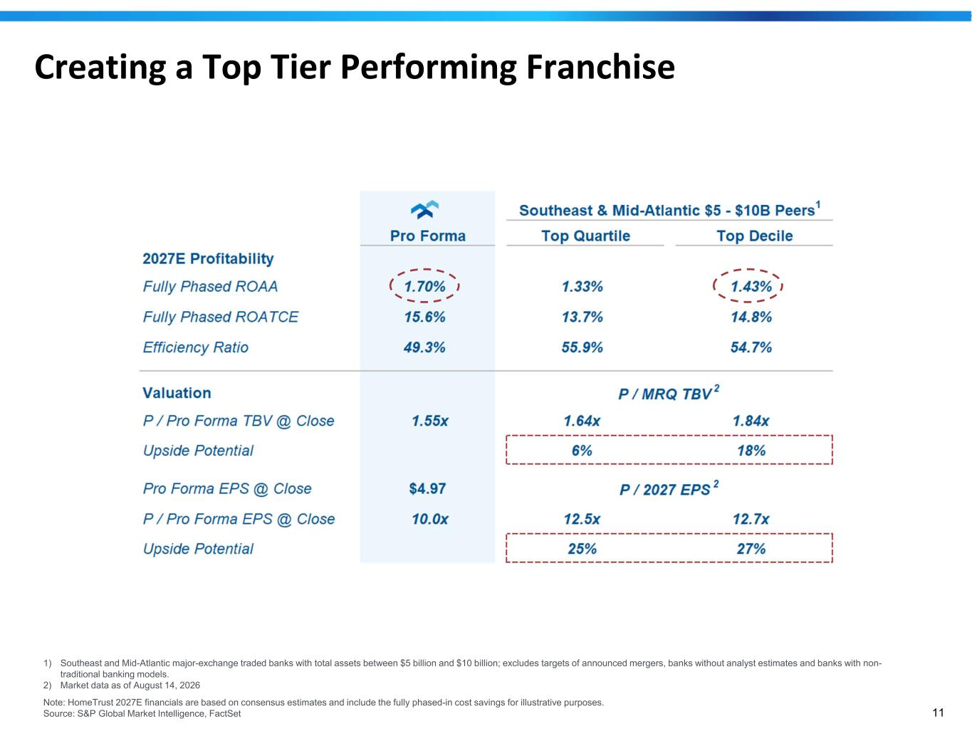
11 Creating a Top Tier Performing Franchise 1) Southeast and Mid-Atlantic major-exchange traded banks with total assets between $5 billion and $10 billion; excludes targets of announced mergers, banks without analyst estimates and banks with non- traditional banking models. 2) Market data as of August 14, 2026 Note: HomeTrust 2027E financials are based on consensus estimates and include the fully phased-in cost savings for illustrative purposes. Source: S&P Global Market Intelligence, FactSet

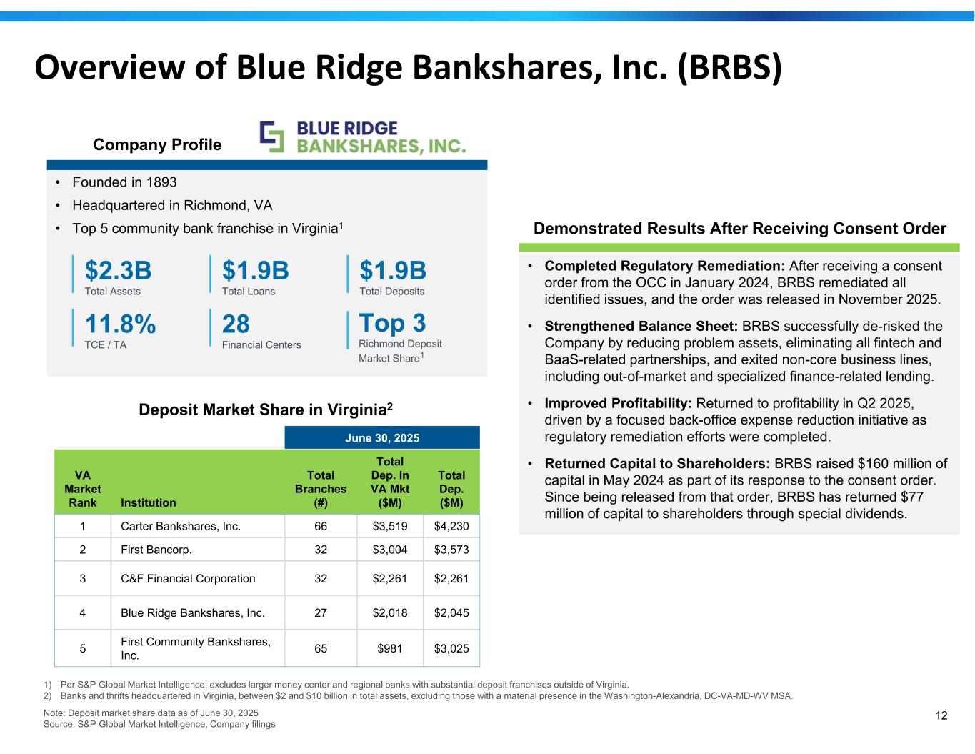
12 Overview of Blue Ridge Bankshares, Inc. (BRBS) 1) Per S&P Global Market Intelligence; excludes larger money center and regional banks with substantial deposit franchises outside of Virginia. 2) Banks and thrifts headquartered in Virginia, between $2 and $10 billion in total assets, excluding those with a material presence in the Washington-Alexandria, DC-VA-MD-WV MSA. Note: Deposit market share data as of June 30, 2025 Source: S&P Global Market Intelligence, Company filings Deposit Market Share in Virginia2 June 30, 2025 Total Dep. ($M) Total Dep. In VA Mkt ($M) Total Branches (#)Institution VA Market Rank $4,230$3,51966Carter Bankshares, Inc.1 $3,573$3,00432First Bancorp.2 $2,261$2,26132C&F Financial Corporation3 $2,045$2,01827Blue Ridge Bankshares, Inc.4 $3,025$98165First Community Bankshares, Inc.5 • Founded in 1893 • Headquartered in Richmond, VA • Top 5 community bank franchise in Virginia1 Company Profile • Completed Regulatory Remediation: After receiving a consent order from the OCC in January 2024, BRBS remediated all identified issues, and the order was released in November 2025. • Strengthened Balance Sheet: BRBS successfully de-risked the Company by reducing problem assets, eliminating all fintech and BaaS-related partnerships, and exited non-core business lines, including out-of-market and specialized finance-related lending. • Improved Profitability: Returned to profitability in Q2 2025, driven by a focused back-office expense reduction initiative as regulatory remediation efforts were completed. • Returned Capital to Shareholders: BRBS raised $160 million of capital in May 2024 as part of its response to the consent order. Since being released from that order, BRBS has returned $77 million of capital to shareholders through special dividends. Demonstrated Results After Receiving Consent Order $2.3B Total Assets $1.9B Total Loans $1.9B Total Deposits 11.8% TCE / TA 28 Financial Centers Top 3 Richmond Deposit Market Share1

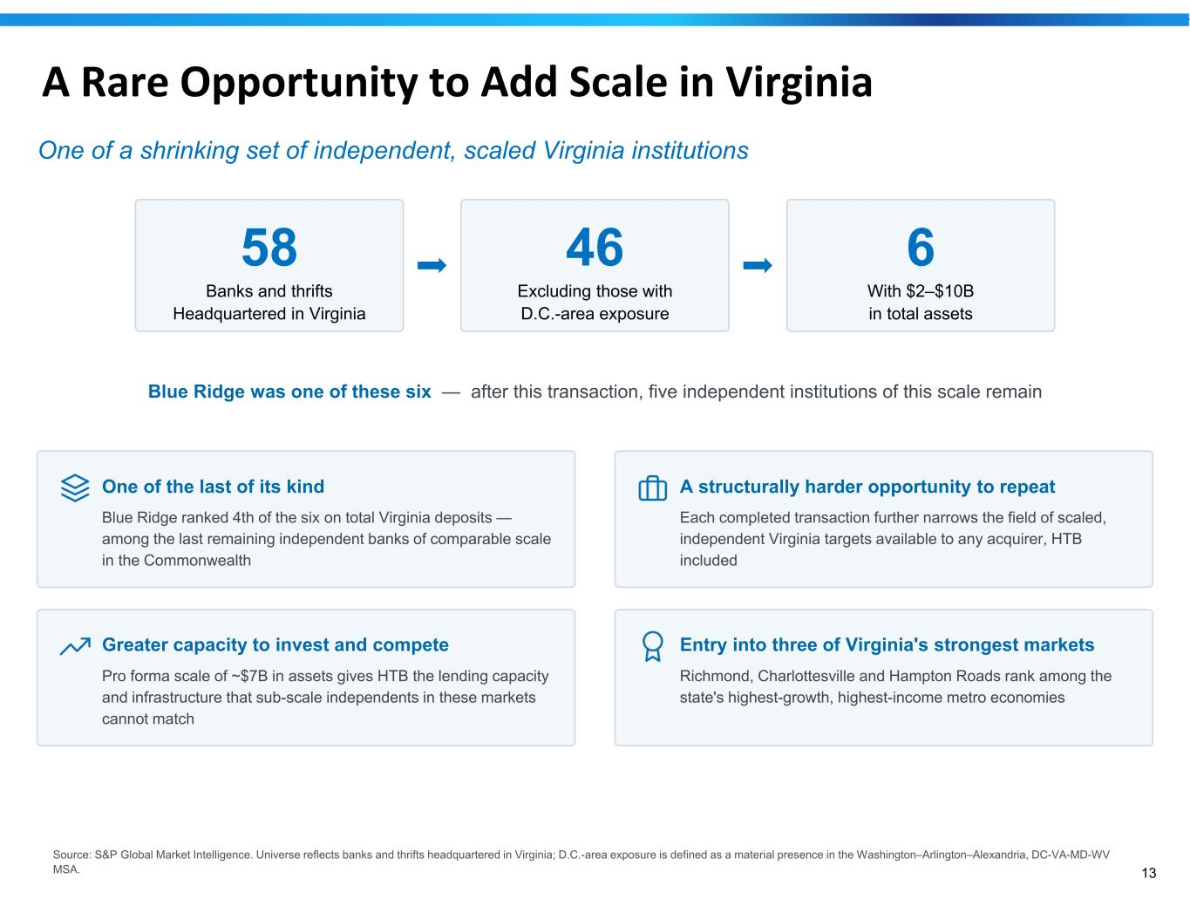
13 A Rare Opportunity to Add Scale in Virginia One of a shrinking set of independent, scaled Virginia institutions 58 Banks and thrifts Headquartered in Virginia 46 Excluding those with D.C.-area exposure 6 With $2–$10B in total assets Blue Ridge was one of these six — after this transaction, five independent institutions of this scale remain One of the last of its kind Blue Ridge ranked 4th of the six on total Virginia deposits — among the last remaining independent banks of comparable scale in the Commonwealth A structurally harder opportunity to repeat Each completed transaction further narrows the field of scaled, independent Virginia targets available to any acquirer, HTB included Greater capacity to invest and compete Pro forma scale of ~$7B in assets gives HTB the lending capacity and infrastructure that sub-scale independents in these markets cannot match Entry into three of Virginia's strongest markets Richmond, Charlottesville and Hampton Roads rank among the state's highest-growth, highest-income metro economies Source: S&P Global Market Intelligence. Universe reflects banks and thrifts headquartered in Virginia; D.C.-area exposure is defined as a material presence in the Washington–Arlington–Alexandria, DC-VA-MD-WV MSA.

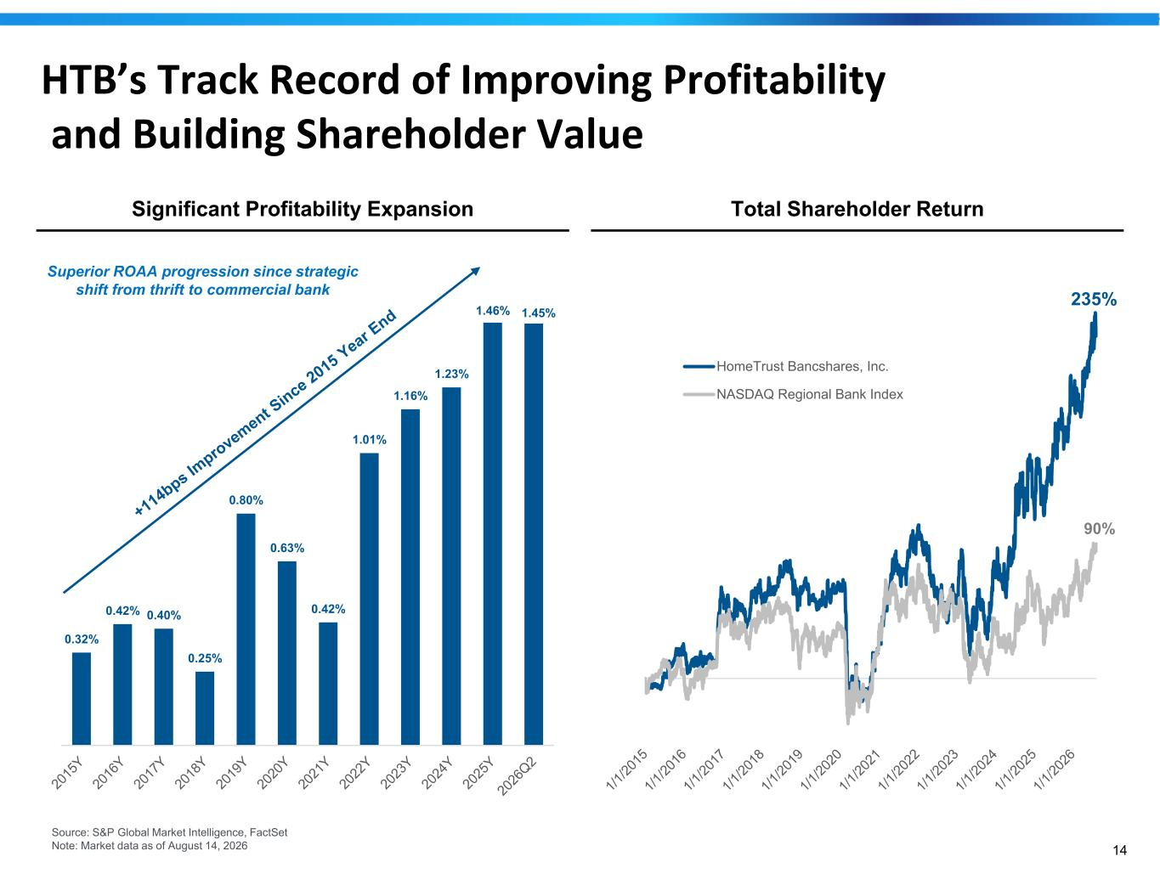
14 HTB’s Track Record of Improving Profitability and Building Shareholder Value Significant Profitability Expansion Total Shareholder Return Superior ROAA progression since strategic shift from thrift to commercial bank Source: S&P Global Market Intelligence, FactSet Note: Market data as of August 14, 2026 0.32% 0.42% 0.40% 0.25% 0.80% 0.63% 0.42% 1.01% 1.16% 1.23% 1.46% 1.45% 235% 90% HomeTrust Bancshares, Inc. NASDAQ Regional Bank Index

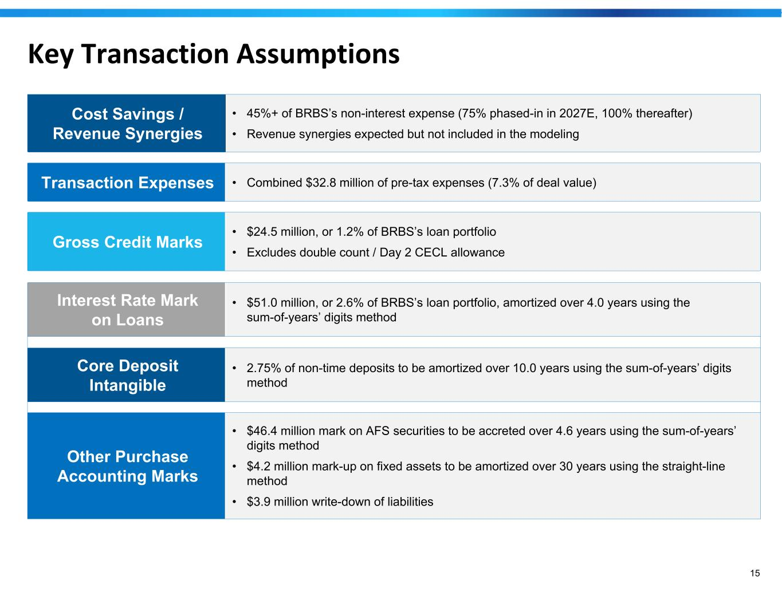
15 Key Transaction Assumptions • 45%+ of BRBS’s non-interest expense (75% phased-in in 2027E, 100% thereafter) • Revenue synergies expected but not included in the modeling Cost Savings / Revenue Synergies • Combined $32.8 million of pre-tax expenses (7.3% of deal value)Transaction Expenses • $24.5 million, or 1.2% of BRBS’s loan portfolio • Excludes double count / Day 2 CECL allowance Gross Credit Marks • $51.0 million, or 2.6% of BRBS’s loan portfolio, amortized over 4.0 years using the sum-of-years’ digits method Interest Rate Mark on Loans • 2.75% of non-time deposits to be amortized over 10.0 years using the sum-of-years’ digits method Core Deposit Intangible • $46.4 million mark on AFS securities to be accreted over 4.6 years using the sum-of-years’ digits method • $4.2 million mark-up on fixed assets to be amortized over 30 years using the straight-line method • $3.9 million write-down of liabilities Other Purchase Accounting Marks

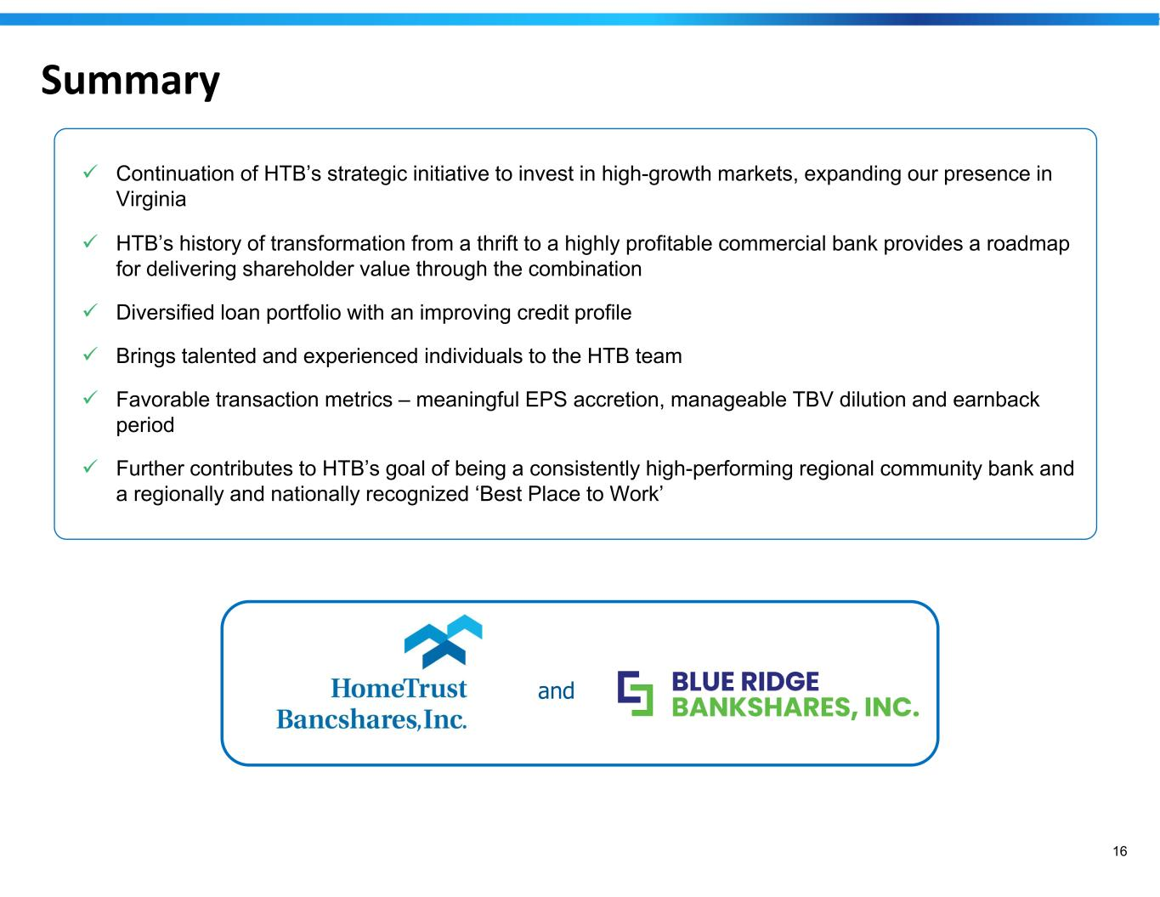
16 Summary ✓ Continuation of HTB’s strategic initiative to invest in high-growth markets, expanding our presence in Virginia ✓ HTB’s history of transformation from a thrift to a highly profitable commercial bank provides a roadmap for delivering shareholder value through the combination ✓ Diversified loan portfolio with an improving credit profile ✓ Brings talented and experienced individuals to the HTB team ✓ Favorable transaction metrics – meaningful EPS accretion, manageable TBV dilution and earnback period ✓ Further contributes to HTB’s goal of being a consistently high-performing regional community bank and a regionally and nationally recognized ‘Best Place to Work’ ANDand


17 Appendix

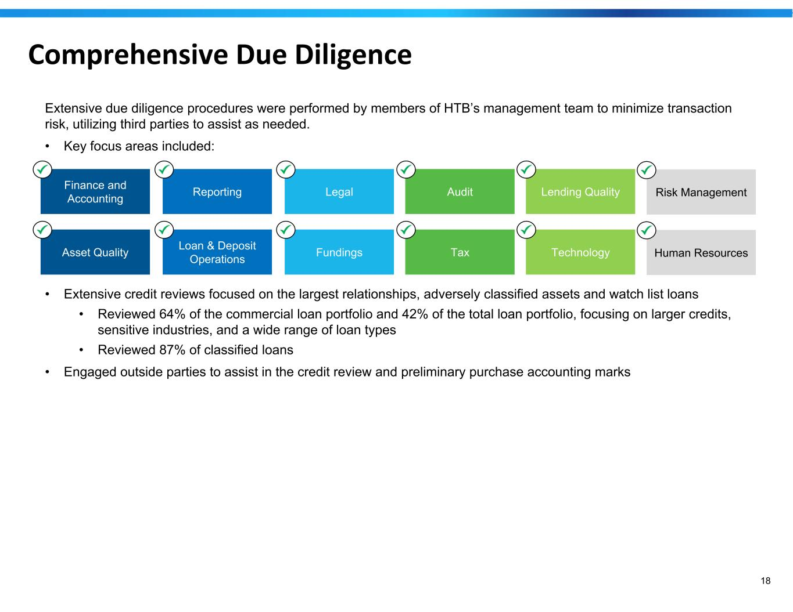
18 Comprehensive Due Diligence Extensive due diligence procedures were performed by members of HTB’s management team to minimize transaction risk, utilizing third parties to assist as needed. • Key focus areas included: • Extensive credit reviews focused on the largest relationships, adversely classified assets and watch list loans • Reviewed 64% of the commercial loan portfolio and 42% of the total loan portfolio, focusing on larger credits, sensitive industries, and a wide range of loan types • Reviewed 87% of classified loans • Engaged outside parties to assist in the credit review and preliminary purchase accounting marks Finance and Accounting Reporting Legal Audit Lending Quality Risk Management Asset Quality Loan & Deposit Operations Fundings Tax Technology Human Resources

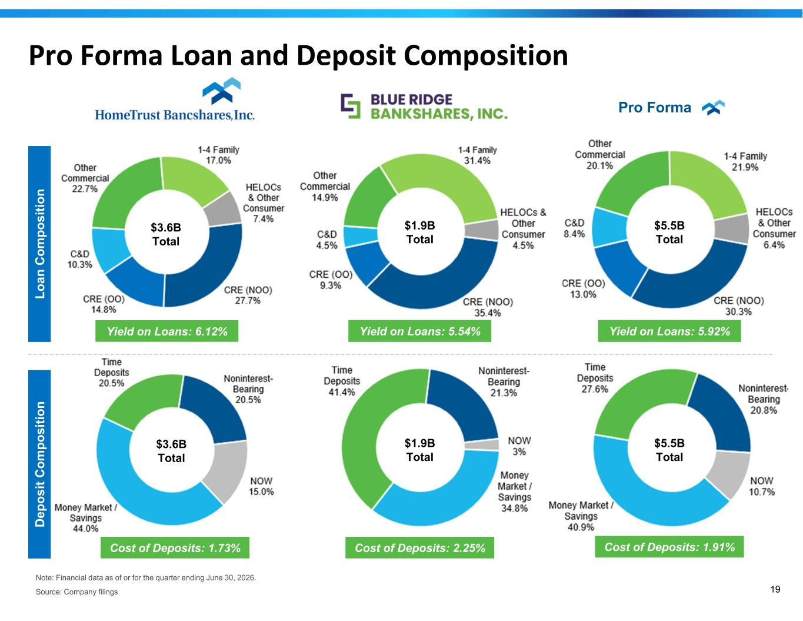
19 Pro Forma Loan and Deposit Composition Lo an C om po si tio n $1.9B Total $3.6B Total $3.6B Total $1.9B Total Yield on Loans: 6.12% Yield on Loans: 5.54% Cost of Deposits: 1.73% Cost of Deposits: 2.25% $5.5B Total $5.5B Total Yield on Loans: 5.92% Cost of Deposits: 1.91% Pro Forma D ep os it C om po si tio n Note: Financial data as of or for the quarter ending June 30, 2026. Source: Company filings

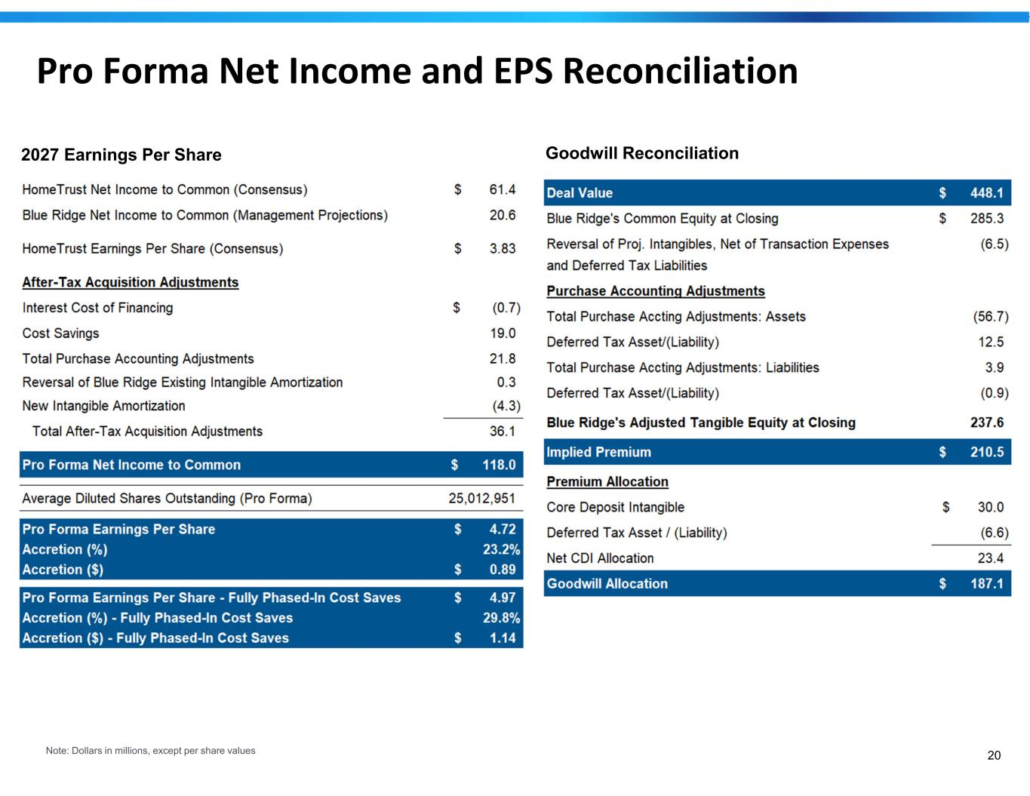
20 Pro Forma Net Income and EPS Reconciliation 2027 Earnings Per Share Goodwill Reconciliation Note: Dollars in millions, except per share values

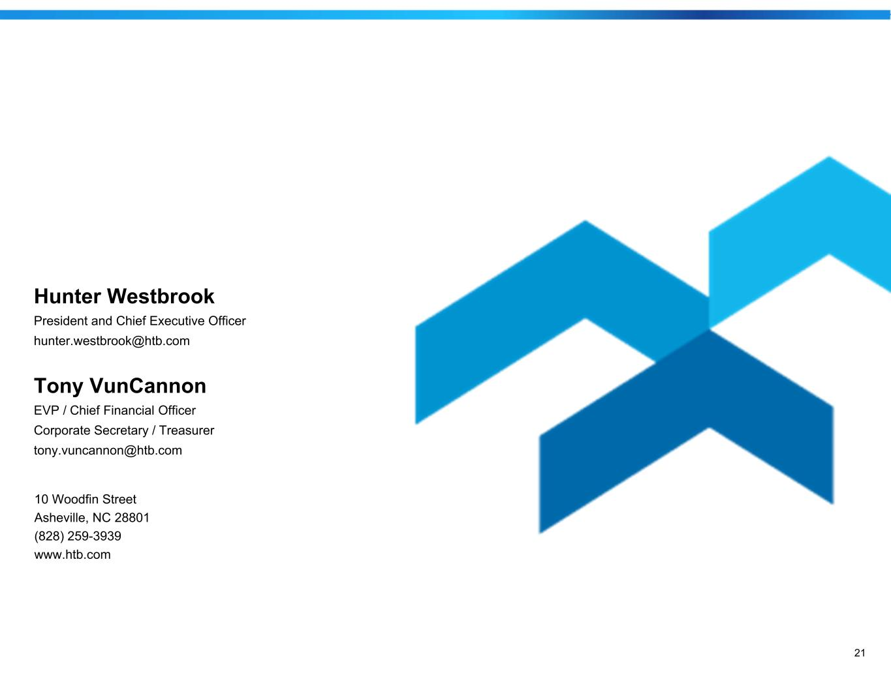
21 Hunter Westbrook President and Chief Executive Officer hunter.westbrook@htb.com Tony VunCannon EVP / Chief Financial Officer Corporate Secretary / Treasurer tony.vuncannon@htb.com 10 Woodfin Street Asheville, NC 28801 (828) 259-3939 www.htb.com

