SEC Form 3
FORM 3 | UNITED STATES SECURITIES AND EXCHANGE COMMISSION  Washington, D.C. 20549  INITIAL STATEMENT OF BENEFICIAL OWNERSHIP OF SECURITIES  Filed pursuant to Section 16(a) of the Securities Exchange Act of 1934  or Section 30(h) of the Investment Company Act of 1940
  OMB APPROVAL
  OMB Number: | 3235-0104
  Estimated average burden
  hours per response: | 0.5
1. Name and Address of Reporting Person*  (Street) | 2. Date of Event Requiring Statement (Month/Day/Year)  07/01/2026 | 3. Issuer Name and Ticker or Trading Symbol  HomeTrust Bancshares, Inc. [ HTB ]
  Bowman Charles Fred
  (Last) | (First) | (Middle)
  C/O HOMETRUST BANCSHARES, INC.
  10 WOODFIN ST
  ASHEVILLE | NC | 28801
  (City) | (State) | (Zip)
 |  | 4. Relationship of Reporting Person(s) to Issuer  (Check all applicable) | 5. If Amendment, Date of Original Filed (Month/Day/Year)
   | Director |  | 10% Owner
   | Officer (give title below) |  | Other (specify below)
  Advisory Director
6. Individual or Joint/Group Filing (Check Applicable Line)
Form filed by One Reporting Person
Form filed by More than One Reporting Person

Table I - Non-Derivative Securities Beneficially Owned
1. Title of Security (Instr. 4) | 2. Amount of Securities Beneficially Owned (Instr. 4) | 3. Ownership Form: Direct (D) or Indirect (I) (Instr. 5) | 4. Nature of Indirect Beneficial Ownership (Instr. 5)
Table II - Derivative Securities Beneficially Owned
(e.g., puts, calls, warrants, options, convertible securities)
1. Title of Derivative Security (Instr. 4) | 2. Date Exercisable and Expiration Date (Month/Day/Year) |  | 3. Title and Amount of Securities Underlying Derivative Security (Instr. 4) |  | 4. Conversion or Exercise Price of Derivative Security | 5. Ownership Form: Direct (D) or Indirect (I) (Instr. 5) | 6. Nature of Indirect Beneficial Ownership (Instr. 5)
1. Title of Derivative Security (Instr. 4) | Date Exercisable | Expiration Date | Title | Amount or Number of Shares | 4. Conversion or Exercise Price of Derivative Security | 5. Ownership Form: Direct (D) or Indirect (I) (Instr. 5) | 6. Nature of Indirect Beneficial Ownership (Instr. 5)
Explanation of Responses:
Remarks:
Exhibit 24 -- Power of Attorney of Charles Fred Bowman
No securities are beneficially owned.
 | /s/ Tony J. VunCannon, Attorney-in-Fact for Charles Fred Bowman | 07/10/2026
 | ** Signature of Reporting Person | Date
Reminder: Report on a separate line for each class of securities beneficially owned directly or indirectly.
* If the form is filed by more than one reporting person, see Instruction 5 (b)(v).
** Intentional misstatements or omissions of facts constitute Federal Criminal Violations See 18 U.S.C. 1001 and 15 U.S.C. 78ff(a).
Note: File three copies of this Form, one of which must be manually signed. If space is insufficient, see Instruction 6 for procedure.
Persons who respond to the collection of information contained in this form are not required to respond unless the form displays a currently valid OMB Number.
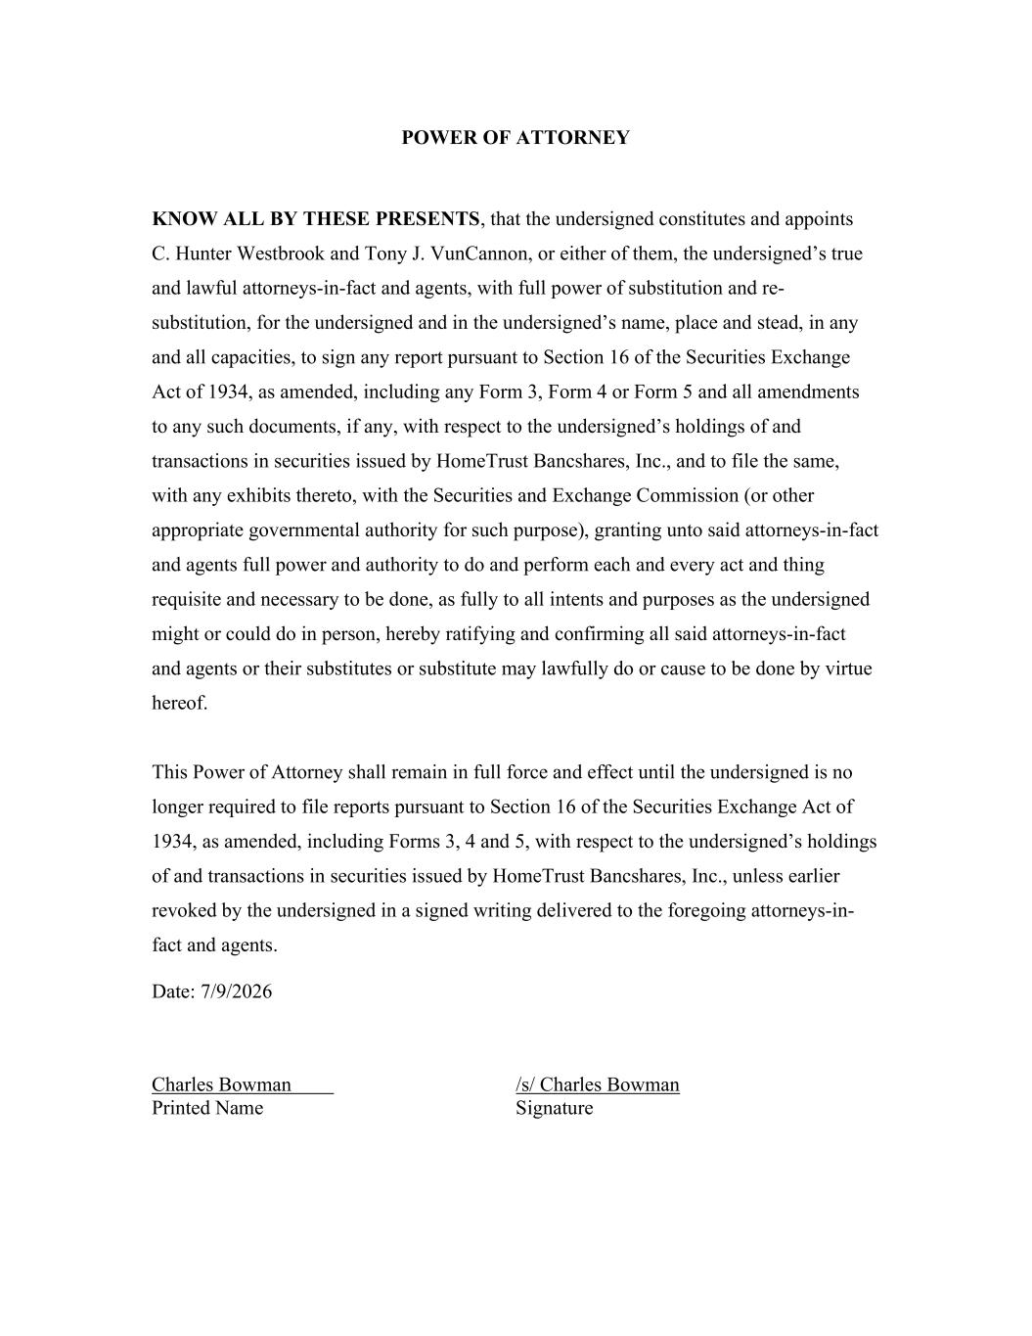
POWER OF ATTORNEY KNOW ALL BY THESE PRESENTS, that the undersigned constitutes and appoints C. Hunter Westbrook and Tony J. VunCannon, or either of them, the undersigned’s true and lawful attorneys-in-fact and agents, with full power of substitution and re- substitution, for the undersigned and in the undersigned’s name, place and stead, in any and all capacities, to sign any report pursuant to Section 16 of the Securities Exchange Act of 1934, as amended, including any Form 3, Form 4 or Form 5 and all amendments to any such documents, if any, with respect to the undersigned’s holdings of and transactions in securities issued by HomeTrust Bancshares, Inc., and to file the same, with any exhibits thereto, with the Securities and Exchange Commission (or other appropriate governmental authority for such purpose), granting unto said attorneys-in-fact and agents full power and authority to do and perform each and every act and thing requisite and necessary to be done, as fully to all intents and purposes as the undersigned might or could do in person, hereby ratifying and confirming all said attorneys-in-fact and agents or their substitutes or substitute may lawfully do or cause to be done by virtue hereof. This Power of Attorney shall remain in full force and effect until the undersigned is no longer required to file reports pursuant to Section 16 of the Securities Exchange Act of 1934, as amended, including Forms 3, 4 and 5, with respect to the undersigned’s holdings of and transactions in securities issued by HomeTrust Bancshares, Inc., unless earlier revoked by the undersigned in a signed writing delivered to the foregoing attorneys-in- fact and agents. Date: 7/9/2026 Charles Bowman /s/ Charles Bowman Printed Name Signature

