UNITED STATES SECURITIES AND EXCHANGE COMMISSION

Washington, D.C. 20549

FORM 10-Q

- QUARTERLY REPORT UNDER SECTION 13 OR 15(d) OF THE SECURITIES EXCHANGE ACT OF 1934

For the quarterly period ended September 30, 2024

- TRANSITION REPORT UNDER SECTION 13 OR 15(d) OF THE SECURITIES EXCHANGE ACT OF 1934

 | For the transition period from _______ to ________
 |  | Commission file number: 001-35593
 |  | HOMETRUST BANCSHARES, INC.
 | (Exact | name of registrant as specified in its charter)
Maryland | 45-5055422
(State or other jurisdiction of incorporation of organization) |  |  |  |  | (I.R.S. Employer Identification No.)

10 Woodfin Street, Asheville, North Carolina 28801

(Address of principal executive offices; Zip Code)

(828) 259-3939

(Registrant's telephone number, including area code)

None

(Former name, former address and former fiscal year, if changed since last report)

Securities registered pursuant to Section 12(b) of the Act:

Title of each class | Trading Symbol(s) | Name of each exchange on which registered
Common Stock, par value $.01 per share | HTBI | The NASDAQ Stock Market LLC

Indicate by check mark whether the registrant (1) has filed all reports required to be filed by Section 13 and 15(d) of the Exchange Act during the preceding 12 months (or for such shorter period that the registrant was required to file such reports), and (2) has been subject to such filing requirements for the past 90 days. Yes ☒ No ☐

Indicate by check mark whether the registrant has submitted electronically every Interactive Data File required to be submitted pursuant to Rule 405 of Regulation S-T (§232.405 of this chapter) during the preceding 12 months (or for such shorter period that the registrant was required to submit such files). Yes ☒ No ☐

Indicate by check mark whether the registrant is a large accelerated filer, an accelerated filer, a non-accelerated filer, a smaller reporting company, or an emerging growth company. See the definitions of “large accelerated filer,” “accelerated filer,” “smaller reporting company” and "emerging growth company" in Rule 12b-2 of the Exchange Act.

Large accelerated filer ☐ | Accelerated filer ☒
Non-accelerated filer ☐ | Smaller reporting company ☐
Emerging growth company ☐
 | If an emerging growth company, indicate by check mark if the registrant has elected not to use the extended transition period for | ☐
 | complying with any new or revised financial accounting standards provided pursuant to Section 13(a) of the Exchange Act. | ☐

Indicate by check mark whether the registrant is a shell company (as defined in Rule 12b-2 of the Exchange Act). Yes ☐ No ☒

There were 17,529,922 shares of common stock, par value of $0.01 per share, issued and outstanding as of November 1, 2024.

HOMETRUST BANCSHARES, INC. AND SUBSIDIARIES

FORM 10-Q

TABLE OF CONTENTS

 |  |  |  |  |  |  |  |  |  |  |  |  |  |  |  |  |  |  |  | Page
PART I FINANCIAL INFORMATION
Item 1 |  | Financial Statements
 |  |  | Consolidated Balance Sheets at September 30, 2024 (Unaudited) and December 31, 2023 |  |  |  |  |  |  |  |  |  |  |  |  |  |  |  |  | 3
 |  |  | Consolidated Statements of Income (Unaudited) for the Three and Nine Months Ended September 30, 2024 and 2023 |  |  |  |  |  |  |  |  |  |  |  |  |  |  |  |  |  | 4
 |  |  | Consolidated Statements of Comprehensive Income (Unaudited) for the Three and Nine Months Ended September 30, 2024 and 2023 |  |  |  |  |  |  |  |  |  |  |  |  |  |  |  |  |  | 5
 |  |  | Consolidated Statements of Changes in Stockholders' Equity (Unaudited) for the Three and Nine Months Ended September 30, 2024 and 2023 |  |  |  |  |  |  |  |  |  |  |  |  |  |  |  |  |  | 6
 |  |  | Consolidated Statements of Cash Flows (Unaudited) for the Nine Months Ended September 30, 2024 and 2023 |  |  |  |  |  |  |  |  |  |  |  |  |  |  |  |  |  | 8
 |  |  | Notes to Consolidated Financial Statements |  |  |  |  |  |  |  |  |  |  |  |  |  |  |  |  | 10
Item 2 |  | Management's Discussion and Analysis of Financial Condition and Results of Operations |  |  |  |  |  |  |  |  |  |  |  |  |  |  |  |  |  | 34
Item 3 |  | Quantitative and Qualitative Disclosures about Market Risk |  |  |  |  |  |  |  |  |  |  |  |  |  |  |  |  |  | 45
Item 4 |  | Controls and Procedures |  |  |  |  |  |  |  |  |  |  |  |  |  |  |  |  |  | 45
PART II OTHER INFORMATION
Item 1 |  | Legal Proceedings |  |  |  |  |  |  |  |  |  |  |  |  |  |  |  |  |  | 46
Item 1A |  | Risk Factors |  |  |  |  |  |  |  |  |  |  |  |  |  |  |  |  |  | 46
Item 2 |  | Unregistered Sales of Equity Securities and Use of Proceeds |  |  |  |  |  |  |  |  |  |  |  |  |  |  |  |  |  | 46
Item 3 |  | Defaults Upon Senior Securities |  |  |  |  |  |  |  |  |  |  |  |  |  |  |  |  |  | 46
Item 4 |  | Mine Safety Disclosures |  |  |  |  |  |  |  |  |  |  |  |  |  |  |  |  |  | 46
Item 5 |  | Other Information |  |  |  |  |  |  |  |  |  |  |  |  |  |  |  |  |  | 46
Item 6 |  | Exhibits |  |  |  |  |  |  |  |  |  |  |  |  |  |  |  |  |  | 46
SIGNATURES |  |  |  |  |  |  |  |  |  |  |  |  |  |  |  |  |  |  |  | 49

1

Glossary of Defined Terms

The following terms may be used throughout this Form 10-Q, including the Notes to Consolidated Financial Statements in Item 1 and Management's Discussion and Analysis of Financial Condition and Results of Operations in Item 2 of this Form 10-Q.

Term |  | Definition
ACL |  | Allowance for Credit Losses
AFS |  | Available-For-Sale
ASC |  | Accounting Standards Codification
ASU |  | Accounting Standards Update
BOLI |  | Bank Owned Life Insurance
CD |  | Certificate of Deposit
CDA |  | Collateral Dependent Asset
CECL |  | Current Expected Credit Losses
CET1 |  | Common Equity Tier 1
COVID-19 |  | Coronavirus Disease 2019
DCF |  | Discounted Cash Flows
Dodd-Frank Act |  | Dodd-Frank Wall Street Reform and Consumer Protection Act
ECL |  | Expected Credit Losses
EPS |  | Earnings Per Share
ESOP |  | Employee Stock Ownership Plan
FASB |  | Financial Accounting Standards Board
FDIC |  | Federal Deposit Insurance Corporation
Federal Reserve |  | Board of Governors of the Federal Reserve System
FHLB or FHLB of Atlanta |  | Federal Home Loan Bank
FRB |  | Federal Reserve Bank of Richmond
GSE |  | Government-Sponsored Enterprises
HELOC |  | Home Equity Line of Credit
IRLC |  | Interest Rate Lock Commitments
MBS |  | Mortgage-Backed Security
NCCOB |  | North Carolina Office of the Commissioner of Banks
OREO |  | Other Real Estate Owned
PCD |  | Purchased Financial Assets with Credit Deterioration
Quantum |  | Quantum Capital Corp. and its wholly owned subsidiary, Quantum National Bank
ROA |  | Return on Assets
ROE |  | Return on Equity
ROU |  | Right of Use
RSU |  | Restricted Stock Unit
SBA |  | U.S. Small Business Administration
SBIC |  | Small Business Investment Companies
SEC |  | Securities and Exchange Commission
SOFR |  | Secured Overnight Financing Rate
TBA |  | To-be-announced
US GAAP |  | Generally Accepted Accounting Principles in the United States

2

PART I. FINANCIAL INFORMATION
Item 1. Financial Statements
HOMETRUST BANCSHARES, INC. AND SUBSIDIARY
Consolidated Balance Sheets
(Dollars in thousands, except per share data)
 |  | (Unaudited)
 |  | September 30, 2024 |  |  | December 31, 2023
Assets
Cash | $ | 18,980 |  | $ | 18,307
Interest-bearing deposits |  | 274,497 |  |  | 328,833
Cash and cash equivalents |  | 293,477 |  |  | 347,140
Certificates of deposit in other banks |  | 29,290 |  |  | 34,722
Debt securities available for sale, at fair value (amortized cost of $140,486 and $128,964 at September 30, 2024 and December 31, 2023, |  | 140,552 |  |  | 126,950
respectively) |  | 140,552 |  |  | 126,950
FHLB and FRB stock |  | 18,384 |  |  | 18,393
SBIC investments, at cost |  | 15,489 |  |  | 13,789
Loans held for sale, at fair value |  | 2,968 |  |  | 3,359
Loans held for sale, at the lower of cost or fair value |  | 189,722 |  |  | 198,433
Loans, net of deferred loan fees and costs |  | 3,698,892 |  |  | 3,640,022
Allowance for credit losses – loans |  | (48,131) |  |  | (48,641)
Loans, net |  | 3,650,761 |  |  | 3,591,381
Premises and equipment, net |  | 69,603 |  |  | 70,937
Accrued interest receivable |  | 17,523 |  |  | 16,902
Deferred income taxes, net |  | 10,100 |  |  | 11,796
BOLI |  | 90,021 |  |  | 88,257
Goodwill |  | 34,111 |  |  | 34,111
Core deposit intangibles, net |  | 7,162 |  |  | 9,059
Other assets |  | 68,130 |  |  | 107,404
Total assets | $ | 4,637,293 |  | $ | 4,672,633
Liabilities and stockholders' equity
Liabilities
Deposits | $ | 3,761,588 |  | $ | 3,661,373
Junior subordinated debt |  | 10,096 |  |  | 10,021
Borrowings |  | 260,013 |  |  | 433,763
Other liabilities |  | 65,592 |  |  | 67,583
Total liabilities |  | 4,097,289 |  |  | 4,172,740
Commitments and contingencies – See Note 12
Stockholders' equity
Preferred stock, $0.01 par value, 10,000,000 shares authorized, none issued or outstanding |  | — |  |  | —
Common stock, $0.01 par value, 60,000,000 shares authorized, 17,514,922 shares issued and outstanding at September 30, 2024; 17,387,069 at |  | 175 |  |  | 174
December 31, 2023 |  | 175 |  |  | 174
Additional paid in capital |  | 175,495 |  |  | 172,366
Retained earnings |  | 368,383 |  |  | 333,401
Unearned ESOP shares |  | (4,099) |  |  | (4,497)
Accumulated other comprehensive income (loss) |  | 50 |  |  | (1,551)
Total stockholders' equity |  | 540,004 |  |  | 499,893
Total liabilities and stockholders' equity | $ | 4,637,293 |  | $ | 4,672,633

The accompanying notes are an integral part of these consolidated financial statements.

3

HOMETRUST BANCSHARES, INC. AND SUBSIDIARY

Consolidated Statements of Income

(Dollars in thousands, except per share data)

 |  | (Unaudited) |  |  |  |  |  | (Unaudited)
 |  | Three Months Ended September 30, |  |  |  |  |  | Nine Months Ended September 30,
 |  | 2024 |  |  | 2023 |  |  | 2024 |  |  | 2023
Interest and dividend income
Loans | $ | 63,305 |  | $ | 58,496 |  | $ | 185,418 |  | $ | 162,526
Debt securities available for sale |  | 1,616 |  |  | 1,259 |  |  | 4,424 |  |  | 3,780
Other investments and interest-bearing deposits |  | 1,728 |  |  | 2,110 |  |  | 5,576 |  |  | 5,356
Total interest and dividend income |  | 66,649 |  |  | 61,865 |  |  | 195,418 |  |  | 171,662
Interest expense
Deposits |  | 23,692 |  |  | 16,429 |  |  | 65,693 |  |  | 36,955
Junior subordinated debt |  | 235 |  |  | 236 |  |  | 705 |  |  | 563
Borrowings |  | 648 |  |  | 3,040 |  |  | 3,550 |  |  | 6,634
Total interest expense |  | 24,575 |  |  | 19,705 |  |  | 69,948 |  |  | 44,152
Net interest income |  | 42,074 |  |  | 42,160 |  |  | 125,470 |  |  | 127,510
Provision for credit losses |  | 2,975 |  |  | 2,570 |  |  | 8,400 |  |  | 11,735
Net interest income after provision for credit losses |  | 39,099 |  |  | 39,590 |  |  | 117,070 |  |  | 115,775
Noninterest income
Service charges and fees on deposit accounts |  | 2,336 |  |  | 2,318 |  |  | 6,839 |  |  | 6,967
Loan income and fees |  | 684 |  |  | 559 |  |  | 2,009 |  |  | 1,913
Gain on sale of loans held for sale |  | 1,900 |  |  | 1,293 |  |  | 5,185 |  |  | 4,213
BOLI income |  | 828 |  |  | 1,749 |  |  | 3,470 |  |  | 2,844
Operating lease income |  | 1,637 |  |  | 1,785 |  |  | 5,087 |  |  | 4,515
Gain (loss) on sale of premises and equipment |  | — |  |  | — |  |  | (9) |  |  | 982
Other |  | 897 |  |  | 923 |  |  | 2,625 |  |  | 2,391
Total noninterest income |  | 8,282 |  |  | 8,627 |  |  | 25,206 |  |  | 23,825
Noninterest expense
Salaries and employee benefits |  | 17,082 |  |  | 16,514 |  |  | 50,666 |  |  | 49,436
Occupancy expense, net |  | 2,436 |  |  | 2,489 |  |  | 7,292 |  |  | 7,556
Computer services |  | 3,192 |  |  | 3,173 |  |  | 9,396 |  |  | 9,386
Telephone, postage and supplies |  | 547 |  |  | 652 |  |  | 1,712 |  |  | 1,942
Marketing and advertising |  | 408 |  |  | 487 |  |  | 1,659 |  |  | 1,555
Deposit insurance premiums |  | 589 |  |  | 717 |  |  | 1,674 |  |  | 1,878
Core deposit intangible amortization |  | 567 |  |  | 859 |  |  | 1,896 |  |  | 2,324
Merger-related expenses |  | — |  |  | — |  |  | — |  |  | 4,741
Other |  | 5,764 |  |  | 4,673 |  |  | 16,364 |  |  | 14,490
Total noninterest expense |  | 30,585 |  |  | 29,564 |  |  | 90,659 |  |  | 93,308
Income before income taxes |  | 16,796 |  |  | 18,653 |  |  | 51,617 |  |  | 46,292
Income tax expense |  | 3,684 |  |  | 3,820 |  |  | 11,020 |  |  | 9,712
Net income | $ | 13,112 |  | $ | 14,833 |  | $ | 40,597 |  | $ | 36,580
Per share data
Net income per common share
Basic | $ | 0.77 |  | $ | 0.88 |  | $ | 2.38 |  | $ | 2.19
Diluted | $ | 0.76 |  | $ | 0.88 |  | $ | 2.37 |  | $ | 2.18
Average shares outstanding
Basic |  | 16,931,793 |  |  | 16,792,177 |  |  | 16,891,619 |  |  | 16,532,335
Diluted |  | 17,027,824 |  |  | 16,800,901 |  |  | 16,938,328 |  |  | 16,553,319

The accompanying notes are an integral part of these consolidated financial statements.

4

Net income

Other comprehensive income (loss)

Unrealized holding gains (losses) on debt securities available for sale Gains (losses) arising during the period

Deferred income tax (expense) benefit

HOMETRUST BANCSHARES, INC. AND SUBSIDIARY

Consolidated Statements of Comprehensive Income

(Dollars in thousands)

 | (Unaudited) |  |  |  |  |  | (Unaudited)
Three Months Ended September 30, |  |  |  |  |  |  | Nine Months Ended September 30,
2024 |  |  | 2023 |  |  |  | 2024 |  |  | 2023
$ | 13,112 |  | $ | 14,833 |  | $ | 40,597 |  | $ | 36,580
 | 3,143 |  |  | (643) |  |  | 2,080 |  |  | (1,121)
 | (724) |  |  | 147 |  |  | (479) |  |  | 258

Total other comprehensive income (loss) |  | 2,419 |  |  | (496) |  |  | 1,601 |  |  | (863)
Comprehensive income | $ | 15,531 |  | $ | 14,337 |  | $ | 42,198 |  | $ | 35,717

The accompanying notes are an integral part of these consolidated financial statements.

5

HOMETRUST BANCSHARES, INC. AND SUBSIDIARY

Consolidated Statements of Changes in Stockholders' Equity

(Dollars in thousands)

 |  |  |  |  |  |  |  |  |  | (Unaudited)
 |  |  |  |  |  |  | Three Months Ended September 30, 2024
 |  |  |  |  |  |  | Additional |  |  |  |  |  | Unearned |  |  | Accumulated |  |  | Total
 | Common Stock |  |  |  |  |  |  |  |  |  |  |  |  |  |  | Other |  |  | Total
 |  |  |  |  |  |  | Paid In |  |  | Retained |  |  | ESOP |  |  | Comprehensive |  |  | Stockholders'
 | Shares |  |  | Amount |  |  | Capital |  |  | Earnings |  |  | Shares |  |  | Income (Loss) |  |  | Equity
Balance at June 30, 2024 | 17,437,326 |  | $ | 175 |  | $ | 172,907 |  | $ | 357,147 |  | $ | (4,232) |  | $ | (2,369) |  | $ | 523,628
Net income | — |  |  | — |  |  | — |  |  | 13,112 |  |  | — |  |  | — |  |  | 13,112
Cash dividends declared on common stock, | — |  |  | — |  |  | — |  |  | (1,876) |  |  | — |  |  | — |  |  | (1,876)
$0.11/common share |  |  |  |  |  |  |  |  |  | (1,876) |  |  |  |  |  |  |  |  | (1,876)
Forfeited restricted stock | (2,211) |  |  | — |  |  | — |  |  | — |  |  | — |  |  | — |  |  | —
Retired stock | (3,989) |  |  | — |  |  | (132) |  |  | — |  |  | — |  |  | — |  |  | (132)
Granted restricted stock | 1,000 |  |  | — |  |  | — |  |  | — |  |  | — |  |  | — |  |  | —
Stock issued for RSUs | 10,683 |  |  | — |  |  | — |  |  | — |  |  | — |  |  | — |  |  | —
Exercised stock options | 72,113 |  |  | — |  |  | 1,865 |  |  | — |  |  | — |  |  | — |  |  | 1,865
Share-based compensation expense | — |  |  | — |  |  | 541 |  |  | — |  |  | — |  |  | — |  |  | 541
ESOP compensation expense | — |  |  | — |  |  | 314 |  |  | — |  |  | 133 |  |  | — |  |  | 447
Other comprehensive income | — |  |  | — |  |  | — |  |  | — |  |  | — |  |  | 2,419 |  |  | 2,419
Balance at September 30, 2024 | 17,514,922 |  | $ | 175 |  | $ | 175,495 |  | $ | 368,383 |  | $ | (4,099) |  | $ | 50 |  | $ | 540,004
 |  |  |  |  |  |  |  |  |  | (Unaudited)
 |  |  |  |  |  |  | Three Months Ended September 30, 2023
 |  |  |  |  |  |  | Additional |  |  |  |  |  | Unearned |  |  | Accumulated |  |  | Total
 | Common Stock |  |  |  |  |  |  |  |  |  |  |  |  |  |  | Other |  |  | Total
 |  |  |  |  |  |  | Paid In |  |  | Retained |  |  | ESOP |  |  | Comprehensive |  |  | Stockholders'
 | Shares |  |  | Amount |  |  | Capital |  |  | Earnings |  |  | Shares |  |  | Loss |  |  | Equity
Balance at June 30, 2023 | 17,366,673 |  | $ | 174 |  | $ | 171,222 |  | $ | 308,651 |  | $ | (4,761) |  | $ | (4,100) |  | $ | 471,186
Net income | — |  |  | — |  |  | — |  |  | 14,833 |  |  | — |  |  | — |  |  | 14,833
Cash dividends declared on common stock, | — |  |  | — |  |  | — |  |  | (1,685) |  |  | — |  |  | — |  |  | (1,685)
$0.10/common share |  |  |  |  |  |  |  |  |  | (1,685) |  |  |  |  |  |  |  |  | (1,685)
Forfeited restricted stock | (1,630) |  |  | — |  |  | — |  |  | — |  |  | — |  |  | — |  |  | —
Retired stock | (5,730) |  |  | — |  |  | (133) |  |  | — |  |  | — |  |  | — |  |  | (133)
Granted restricted stock | 1,000 |  |  | — |  |  | — |  |  | — |  |  | — |  |  | — |  |  | —
Stock issued for RSUs | 18,494 |  |  | — |  |  | — |  |  | — |  |  | — |  |  | — |  |  | —
Exercised stock options | 1,500 |  |  | — |  |  | 24 |  |  | — |  |  | — |  |  | — |  |  | 24
Share-based compensation expense | — |  |  | — |  |  | 383 |  |  | — |  |  | — |  |  | — |  |  | 383
ESOP compensation expense | — |  |  | — |  |  | 167 |  |  | — |  |  | 132 |  |  | — |  |  | 299
Other comprehensive loss | — |  |  | — |  |  | — |  |  | — |  |  | — |  |  | (496) |  |  | (496)
Balance at September 30, 2023 | 17,380,307 |  | $ | 174 |  | $ | 171,663 |  | $ | 321,799 |  | $ | (4,629) |  | $ | (4,596) |  | $ | 484,411

The accompanying notes are an integral part of these consolidated financial statements.

6

HOMETRUST BANCSHARES, INC. AND SUBSIDIARY

Consolidated Statements of Changes in Stockholders' Equity

(Dollars in thousands)

 |  |  |  |  |  |  |  |  |  | (Unaudited)
 |  |  |  |  |  |  | Nine Months Ended September 30, 2024
 |  |  |  |  |  |  | Additional |  |  |  |  |  | Unearned |  |  | Accumulated |  |  | Total
 | Common Stock |  |  |  |  |  |  |  |  |  |  |  |  |  |  | Other |  |  | Total
 |  |  |  |  |  |  | Paid In |  |  | Retained |  |  | ESOP |  |  | Comprehensive |  |  | Stockholders'
 | Shares |  |  | Amount |  |  | Capital |  |  | Earnings |  |  | Shares |  |  | Income (Loss) |  |  | Equity
Balance at December 31, 2023 | 17,387,069 |  | $ | 174 |  | $ | 172,366 |  | $ | 333,401 |  | $ | (4,497) |  | $ | (1,551) |  | $ | 499,893
Net income | — |  |  | — |  |  | — |  |  | 40,597 |  |  | — |  |  | — |  |  | 40,597
Cash dividends declared on common stock, | — |  |  | — |  |  | — |  |  | (5,615) |  |  | — |  |  | — |  |  | (5,615)
$0.33/common share |  |  |  |  |  |  |  |  |  | (5,615) |  |  |  |  |  |  |  |  | (5,615)
Common stock repurchased | (23,483) |  |  | — |  |  | (645) |  |  | — |  |  | — |  |  | — |  |  | (645)
Forfeited restricted stock | (2,211) |  |  | — |  |  | — |  |  | — |  |  | — |  |  | — |  |  | —
Retired stock | (12,751) |  |  | — |  |  | (365) |  |  | — |  |  | — |  |  | — |  |  | (365)
Granted restricted stock | 73,502 |  |  | — |  |  | — |  |  | — |  |  | — |  |  | — |  |  | —
Stock issued for RSUs | 10,683 |  |  | — |  |  | — |  |  | — |  |  | — |  |  | — |  |  | —
Exercised stock options | 82,113 |  |  | 1 |  |  | 2,023 |  |  | — |  |  | — |  |  | — |  |  | 2,024
Share-based compensation expense | — |  |  | — |  |  | 1,363 |  |  | — |  |  | — |  |  | — |  |  | 1,363
ESOP compensation expense | — |  |  | — |  |  | 753 |  |  | — |  |  | 398 |  |  | — |  |  | 1,151
Other comprehensive income | — |  |  | — |  |  | — |  |  | — |  |  | — |  |  | 1,601 |  |  | 1,601
Balance at September 30, 2024 | 17,514,922 |  | $ | 175 |  | $ | 175,495 |  | $ | 368,383 |  | $ | (4,099) |  | $ | 50 |  | $ | 540,004
 |  |  |  |  |  |  |  |  |  | (Unaudited)
 |  |  |  |  |  |  | Nine Months Ended September 30, 2023
 |  |  |  |  |  |  | Additional |  |  |  |  |  | Unearned |  |  | Accumulated |  |  | Total
 | Common Stock |  |  |  |  |  |  |  |  |  |  |  |  |  |  | Other |  |  | Total
 |  |  |  |  |  |  | Paid In |  |  | Retained |  |  | ESOP |  |  | Comprehensive |  |  | Stockholders'
 | Shares |  |  | Amount |  |  | Capital |  |  | Earnings |  |  | Shares |  |  | Loss |  |  | Equity
Balance at December 31, 2022 | 15,673,595 |  | $ | 157 |  | $ | 128,486 |  | $ | 290,271 |  | $ | (5,026) |  | $ | (3,733) |  | $ | 410,155
Net income | — |  |  | — |  |  | — |  |  | 36,580 |  |  | — |  |  | — |  |  | 36,580
Cash dividends declared on common stock, | — |  |  | — |  |  | — |  |  | (5,052) |  |  | — |  |  | — |  |  | (5,052)
$0.30/common share |  |  |  |  |  |  |  |  |  | (5,052) |  |  |  |  |  |  |  |  | (5,052)
Forfeited restricted stock | (5,520) |  |  | — |  |  | — |  |  | — |  |  | — |  |  | — |  |  | —
Retired stock | (14,796) |  |  | — |  |  | (382) |  |  | — |  |  | — |  |  | — |  |  | (382)
Granted restricted stock | 54,339 |  |  | — |  |  | — |  |  | — |  |  | — |  |  | — |  |  | —
Stock issued for RSUs | 18,494 |  |  | — |  |  | — |  |  | — |  |  | — |  |  | — |  |  | —
Stock issued for Quantum merger | 1,374,646 |  |  | 14 |  |  | 37,720 |  |  | — |  |  | — |  |  | — |  |  | 37,734
Exercised stock options | 279,549 |  |  | 3 |  |  | 4,096 |  |  | — |  |  | — |  |  | — |  |  | 4,099
Share-based compensation expense | — |  |  | — |  |  | 1,206 |  |  | — |  |  | — |  |  | — |  |  | 1,206
ESOP compensation expense | — |  |  | — |  |  | 537 |  |  | — |  |  | 397 |  |  | — |  |  | 934
Other comprehensive loss | — |  |  | — |  |  | — |  |  | — |  |  | — |  |  | (863) |  |  | (863)
Balance at September 30, 2023 | 17,380,307 |  | $ | 174 |  | $ | 171,663 |  | $ | 321,799 |  | $ | (4,629) |  | $ | (4,596) |  | $ | 484,411

The accompanying notes are an integral part of these consolidated financial statements.

7

HOMETRUST BANCSHARES, INC. AND SUBSIDIARY
Consolidated Statements of Cash Flows
(Dollars in thousands)
 |  | (Unaudited)
 | Nine Months Ended September 30,
 | 2024 |  |  |  | 2023
Operating activities
Net income | $ | 40,597 |  | $ | 36,580
Adjustments to reconcile net income to net cash used in operating activities:
Provision for credit losses |  | 8,400 |  |  | 11,735
Depreciation and amortization of premises and equipment and equipment for operating leases |  | 8,558 |  |  | 7,104
Deferred income tax expense |  | 1,217 |  |  | 492
Net accretion of purchase accounting adjustments on loans |  | (2,033) |  |  | (1,703)
Net amortization and accretion |  | 5,037 |  |  | 4,572
SBIC investments income |  | (895) |  |  | (1,415)
Loss (gain) on sale of premises and equipment |  | 9 |  |  | (982)
Loss on sale or writedown of REO |  | — |  |  | 89
Loss incurred at the end of operating leases - lessor |  | 1,308 |  |  | 211
BOLI income |  | (3,470) |  |  | (2,844)
Gain on sale of loans held for sale |  | (5,185) |  |  | (4,213)
Origination of loans held for sale |  | (201,485) |  |  | (302,355)
Proceeds from sales of loans held for sale |  | 198,199 |  |  | 163,179
New deferred loan origination costs, net |  | (1,931) |  |  | (1,108)
Increase in accrued interest receivable and other assets |  | (8,241) |  |  | (11,480)
Share-based compensation expense |  | 1,363 |  |  | 1,206
ESOP compensation expense |  | 1,151 |  |  | 934
Increase (decrease) in other liabilities |  | (1,932) |  |  | 1,121
Net cash provided by (used in) operating activities |  | 40,667 |  |  | (98,877)
Investing activities
Purchase of debt securities available for sale |  | (33,258) |  |  | (23,232)
Proceeds from maturities, calls and paydowns of debt securities available for sale |  | 22,598 |  |  | 47,055
Purchases of CDs in other banks |  | (3,925) |  |  | (12,683)
Proceeds from maturities of CDs in other banks |  | 9,357 |  |  | 6,674
Net (purchases) redemptions of FHLB and FRB stock |  | 9 |  |  | (4,826)
Net capital contributions in SBIC investments, at cost |  | (805) |  |  | (757)
Net increase in loans |  | (50,301) |  |  | (102,161)
Purchase of BOLI |  | (28) |  |  | (99)
Collection of receivable representing proceeds from redemption of BOLI policies |  | 44,334 |  |  | 2,285
Death benefit proceeds from BOLI policies |  | 2,363 |  |  | —
Purchase of equipment for operating leases |  | (13,703) |  |  | (11,676)
Proceeds from sale of equipment for operating leases - lessor |  | 8,657 |  |  | 9,236
Purchase of premises and equipment |  | (1,492) |  |  | (2,539)
Proceeds from sale of premises and equipment and assets held for sale |  | — |  |  | 2,332
Proceeds from sale of REO |  | — |  |  | 108
Net cash received in merger |  | — |  |  | 30,601
Net cash used in investing activities |  | (16,194) |  |  | (59,682)

8

HOMETRUST BANCSHARES, INC. AND SUBSIDIARY

Consolidated Statements of Cash Flows (continued)

(Dollars in thousands)

 |  |  | Unaudited
 |  | Nine Months Ended September 30,
 | 2024 |  |  |  |  |  |  | 2023
Financing activities
Net increase in deposits |  |  | 100,215 |  |  |  |  | 22,339
Net increase (decrease) in revolving line of credit |  |  | (12,750) |  |  |  |  | 20,263
Net increase (decrease) in short-term borrowings |  |  | (161,000) |  |  |  |  | 302,000
Repayment of long-term borrowings |  |  | — |  |  |  |  | (24,728)
Common stock repurchased |  |  | (645) |  |  |  |  | —
Cash dividends paid |  |  | (5,615) |  |  |  |  | (5,052)
Retired stock |  |  | (365) |  |  |  |  | (382)
Exercised stock options |  |  | 2,024 |  |  |  |  | 4,099
Net cash provided by (used in) financing activities |  |  | (78,136) |  |  |  |  | 318,539
Net increase (decrease) in cash and cash equivalents |  |  | (53,663) |  |  |  |  | 159,980
Cash and cash equivalents at beginning of period |  |  | 347,140 |  |  |  |  | 165,034
Cash and cash equivalents at end of period | $ |  | 293,477 |  |  | $ |  | 325,014
Supplemental disclosures
Cash paid during the period for
Interest | $ |  | 66,001 |  |  | $ |  | 38,415
Income taxes |  |  | 13,664 |  |  |  |  | 11,923
Noncash transactions
Unrealized gain (loss) in value of debt securities available for sale, net of income taxes | $ |  | 1,601 |  |  | $ |  | (863)
Transfer of loans held for sale to loans held for investment |  |  | 17,040 |  |  |  |  | 17,798
Transfer of loans to repossessed assets |  |  | 872 |  |  |  |  | —
ROU asset and lease liabilities for operating lease accounting |  |  | — |  |  |  |  | 3,917
Business combinations
Fair value of assets acquired | $ |  | — |  |  | $ |  | 665,090
Fair value of liabilities assumed |  |  | — |  |  |  |  | 610,188
Net assets acquired |  | $ | — |  |  |  | $ | 54,902

The accompanying notes are an integral part of these consolidated financial statements.

9

HOMETRUST BANCSHARES, INC. AND SUBSIDIARY

Notes to Consolidated Financial Statements

(Dollars in thousands, except per share data)

- Summary of Significant Accounting Policies

The consolidated unaudited financial statements presented in this report include the accounts of HomeTrust Bancshares, Inc., a Maryland corporation (“HomeTrust”), and its wholly-owned subsidiary, HomeTrust Bank (the “Bank”). As used throughout this report, the term the “Company” refers to HomeTrust and its consolidated subsidiary, unless the context otherwise requires. HomeTrust is a bank holding company primarily engaged in the business of planning, directing and coordinating the business activities of the Bank. The Bank is a North Carolina state chartered bank and provides a wide range of retail and commercial banking products within its geographic footprint, which includes: North Carolina (the Asheville metropolitan area, the "Piedmont" region, Charlotte and Raleigh/Cary), South Carolina (Greenville and Charleston), East Tennessee (Kingsport/Johnson City, Knoxville and Morristown), Southwest Virginia (the Roanoke Valley) and Georgia (Greater Atlanta). The Bank operates under a single set of corporate policies and procedures and is recognized as a single banking segment for financial reporting purposes.

As a result of its merger with Quantum on February 12, 2023, HomeTrust became the 100% successor owner of the Quantum Capital Statutory Trust II Delaware trust. The sole assets of the trust represent the proceeds of offerings loaned in exchange for subordinated debentures with similar terms to the trust preferred securities.

The accompanying unaudited consolidated financial statements have been prepared in accordance with US GAAP for interim financial information and in accordance with the instructions to Form 10-Q and Article 10 of Regulation S-X as promulgated by the SEC. Accordingly, they do not include all the information and footnotes required by US GAAP for complete financial statements. In the opinion of management, all adjustments (consisting of normal recurring accruals) considered necessary for a fair presentation of the financial position and results of operations for the periods presented have been included. It is recommended that these unaudited interim consolidated financial statements be read in conjunction with the audited consolidated financial statements and notes thereto included in the Company's Transition Report on Form 10-KT for the six-month transition period ended December 31, 2023 ("2023 Form 10-KT") filed with the SEC on March 12, 2024. The results of operations for the nine months ended September 30, 2024 are not necessarily indicative of results that may be expected for the year ending December 31, 2024, the period which will be covered on a Report on Form 10-K.

The preparation of financial statements in conformity with US GAAP requires management to make estimates and assumptions that affect amounts reported in the financial statements. Various elements of the Company's accounting policies, by their nature, are inherently subject to estimation techniques, valuation assumptions and other subjective assessments. In particular, management has identified the determination of the provision and the ACL on loans as an accounting policy that, due to the judgments, estimates and assumptions inherent in the policy, is critical to an understanding of the Company's financial statements. This policy and the related judgments, estimates and assumptions are described in greater detail in the notes to the Consolidated Financial Statements and Management's Discussion and Analysis of Financial Condition and Results of Operations (Critical Accounting Policies and Estimates) in the 2023 Form 10-KT. Management believes that the judgments, estimates and assumptions used in the preparation of the financial statements are appropriate based on the factual circumstances at the time. However, given the sensitivity of the financial statements to this critical accounting policy, the use of other judgments, estimates and assumptions could result in material differences in the Company's results of operations or financial condition. Further, subsequent changes in economic or market conditions could have a material impact on these estimates and the Company's financial condition and operating results in future periods.

Prior Period Disclosure Correction

Within "Note 6 – Loans and Allowance for Credit Losses on Loans", the tables disclosing our credit risk profile by origination year as of December 31, 2023, beginning on page 18 of this document, reflect the correction of an immaterial error in the prior period disclosure. The correction of the disclosure error redistributed $264,101 in loans from the "Revolving" columns to the "Term Loans By Origination Fiscal Year" columns. The error's only impact was to the identified disclosure and therefore had no effect on net income or stockholders' equity as previously reported.

- Recent Accounting Pronouncements

Newly Issued but Not Yet Effective Accounting Standards

ASU 2023-07, "Segment Reporting (Topic 280): Improvements to Reportable Segment Disclosures." In November 2023, the FASB issued ASU 2023-07 which will require public entities to disclose information about their reportable segments' significant expenses on an interim and annual basis. Public entities will be required to disclose other segment items for each reportable segment and provide a description of its composition. Significant expense categories are derived from expenses that are regularly reported to an entity's chief operating decision-makers and included in segment-reported measures of profit or loss. The ASU will also require a public entity to disclose the title and position of the chief operating decision-maker and explain how the chief operating decision-maker uses the reported measures of profit or loss to assess segment performance. Lastly, ASU 2023-07 also requires interim disclosures of certain segment-related disclosures that previously were required only on an annual basis and clarifies that entities with a single reportable segment are subject to both new and existing segment reporting requirements under Topic 280.

ASU 2023-07 is effective for fiscal years beginning after December 15, 2023 and interim periods within fiscal years beginning after December 15, 2024. The ASU requires entities to adopt the changes to the segment reporting guidance on a retrospective basis and early adoption is permitted. The Company will update its segment-related disclosures upon adoption of the ASU.

ASU 2023-09, "Income Taxes (Topic 740): Improvements to Income Tax Disclosures." In December 2023, the FASB issued ASU 2023-09 which requires entities to disclose more detailed information in the reconciliation of their statutory tax rate to their effective tax rate. The ASU also requires entities to disclose more detailed information about income taxes paid, including by jurisdiction. This ASU is effective for public business entities for annual reporting periods beginning after December 15, 2024 and interim periods beginning after December 15, 2025. The Company will update its income tax disclosures upon adoption of the ASU.

10

HOMETRUST BANCSHARES, INC. AND SUBSIDIARY

Notes to Consolidated Financial Statements

Dollars in thousands, except per share data)

- Merger with Quantum

On February 12, 2023, the Company merged with Quantum which operated two locations in the Atlanta metro area. The aggregate amount of consideration to be paid per the purchase agreement of approximately $70,771, inclusive of consideration of common stock, other cash consideration, and cash in lieu of fractional shares, included $15,869 of cash consideration paid by Quantum to its stockholders in advance of the closing date as is further described below. These distributions reduced Quantum's stockholders' equity by an equal amount prior to the transaction closing date.

The following table provides a summary of the assets acquired, liabilities assumed, associated preliminary fair value adjustments and provisional period adjustments by the Company as of the merger date. As provided for under US GAAP, management had up to 12 months following the date of merger to finalize the fair value adjustments. Management has completed its evaluation and the values in the table below are considered final.
 |  | Quantum |  |  | Fair Value |  |  | Provisional Period |  |  | As Recorded by
 |  |  |  |  | Adjustments |  |  | Adjustments |  |  | HomeTrust
Assets acquired
Cash and cash equivalents | $ | 47,769 |  | $ | — |  | $ | — |  | $ | 47,769
Debt securities available for sale |  | 10,608 |  |  | — |  |  | — |  |  | 10,608
FHLB and FRB stock |  | 1,125 |  |  | — |  |  | — |  |  | 1,125
Loans⁽¹⁾ |  | 567,140 |  |  | (5,207) |  |  | — |  |  | 561,933
Premises and equipment |  | 4,415 |  |  | 4,668 |  |  | — |  |  | 9,083
Accrued interest receivable |  | 1,706 |  |  | — |  |  | — |  |  | 1,706
BOLI |  | 9,066 |  |  | — |  |  | — |  |  | 9,066
Core deposit intangibles |  | — |  |  | 12,210 |  |  | — |  |  | 12,210
Other assets |  | 2,727 |  |  | 569 |  |  | (179) |  |  | 3,117
Total assets acquired | $ | 644,556 |  | $ | 12,240 |  | $ | (179) |  | $ | 656,617
Liabilities assumed
Deposits | $ | 570,419 |  | $ | 183 |  | $ | — |  | $ | 570,602
Junior subordinated debt |  | 11,341 |  |  | (1,408) |  |  | — |  |  | 9,933
Other borrowings |  | 24,728 |  |  | — |  |  | — |  |  | 24,728
Deferred income taxes |  | — |  |  | 1,341 |  |  | 250 |  |  | 1,591
Other liabilities |  | 3,334 |  |  | — |  |  | — |  |  | 3,334
Total liabilities assumed | $ | 609,822 |  | $ | 116 |  | $ | 250 |  | $ | 610,188
Net assets acquired |  |  |  |  |  |  |  |  |  | $ | 46,429
Consideration paid
Common stock consideration
Shares of Quantum |  |  |  |  |  |  |  |  |  |  | 574,157
Exchange ratio |  |  |  |  |  |  |  |  |  |  | 2.3942
HomeTrust common stock issued |  |  |  |  |  |  |  |  |  |  | 1,374,647
Price per share of HomeTrust common stock on February 10, 2023 |  |  |  |  |  |  |  |  |  | $ | 27.45
HomeTrust common stock consideration |  |  |  |  |  |  |  |  |  | $ | 37,734
Cash consideration⁽²⁾ |  |  |  |  |  |  |  |  |  |  | 17,168
Total consideration |  |  |  |  |  |  |  |  |  | $ | 54,902
Goodwill |  |  |  |  |  |  |  |  |  | $ | 8,473

- Adjustments to Quantum's total loans include the elimination of Quantum's existing allowance for loan losses of $5,972, the recognition of an ACL at close on PCD loans of $369, and adjustments to reflect the estimated credit fair value mark on the non-PCD loan portfolio of $2,932 and the estimated interest rate fair value adjustment on the loan portfolio as a whole (non-PCD and PCD) of $7,878.
- As indicated in the Current Report on Form 8-K/A filed with the SEC on March 30, 2023, the amount of cash consideration paid at closing differs from the $57.54 per share, or $33,037, reported in the Current Report on Form 8-K filed on February 13, 2023, which announced the closing of the merger. Consistent with the merger agreement, between the execution of the merger agreement and the transaction closing date, Quantum's principal stockholders had the option to withdraw some or all of the amount of cash consideration to eventually be paid at closing in advance of the closing date. The amount of cash consideration paid at closing was reduced by the amount withdrawn during this time period.

Goodwill of $8,473 arising from the merger consisted largely of synergies and the cost saves resulting from the combining of operations of the companies, and is not expected to be deductible for income tax purposes.

11

HOMETRUST BANCSHARES, INC. AND SUBSIDIARY

Notes to Consolidated Financial Statements

Dollars in thousands, except per share data)

4. Debt Securities
Debt securities available for sale consist of the following at the dates indicated:
 |  |  |  |  |  |  | September 30, 2024
 |  |  |  | Amortized |  |  | Gross |  |  | Gross |  |  | Estimated
 |  |  |  |  |  |  | Unrealized |  |  | Unrealized |  |  | Fair
 |  |  |  | Cost |  |  | Gains |  |  | Losses |  |  | Value
MBS, residential |  |  | $ | 132,026 |  | $ | 2,041 |  | $ | (1,311) |  | $ | 132,756
Municipal bonds |  |  |  | 3,460 |  |  | — |  |  | (36) |  |  | 3,424
Corporate bonds |  |  |  | 5,000 |  |  | — |  |  | (628) |  |  | 4,372
Total |  |  | $ | 140,486 |  | $ | 2,041 |  | $ | (1,975) |  | $ | 140,552
 |  |  |  |  |  |  | December 31, 2023
 |  |  |  | Amortized |  |  | Gross |  |  | Gross |  |  | Estimated
 |  |  |  |  |  |  | Unrealized |  |  | Unrealized |  |  | Fair
 |  |  |  | Cost |  |  | Gains |  |  | Losses |  |  | Value
MBS, residential |  |  | $ | 105,477 |  | $ | 1,194 |  | $ | (2,172) |  | $ | 104,499
Municipal bonds |  |  |  | 3,487 |  |  | — |  |  | (78) |  |  | 3,409
Corporate bonds |  |  |  | 20,000 |  |  | — |  |  | (958) |  |  | 19,042
Total |  |  | $ | 128,964 |  | $ | 1,194 |  | $ | (3,208) |  | $ | 126,950

Debt securities available for sale by contractual maturity at September 30, 2024 and December 31, 2023 are shown below. MBS are not included in the maturity categories because the borrowers in the underlying pools may prepay without penalty; therefore, it is unlikely that the securities will pay at their stated maturity schedule.

 |  | September 30, 2024
 |  | Amortized |  |  | Estimated
 |  | Cost |  |  | Fair Value
Due within one year | $ | 1,525 |  | $ | 1,522
Due after one year through five years |  | 1,935 |  |  | 1,902
Due after five years through ten years |  | 5,000 |  |  | 4,372
Due after ten years |  | — |  |  | —
MBS, residential |  | 132,026 |  |  | 132,756
Total | $ | 140,486 |  | $ | 140,552

 |  | December 31, 2023
 |  | Amortized |  |  | Estimated
 |  | Cost |  |  | Fair Value
Due within one year | $ | 15,000 |  | $ | 14,848
Due after one year through five years |  | 3,487 |  |  | 3,409
Due after five years through ten years |  | 5,000 |  |  | 4,194
Due after ten years |  | — |  |  | —
MBS, residential |  | 105,477 |  |  | 104,499
Total | $ | 128,964 |  | $ | 126,950

The Company had no sales of debt securities available for sale and no gross realized gains or losses were recognized during the nine months ended September 30, 2024 and 2023.

Debt securities available for sale with amortized costs totaling $19,310 and $43,846 and market values of $19,139 and $42,329 at September 30, 2024 and December 31, 2023, respectively, were pledged as collateral to secure various public deposits and other borrowings.

12

HOMETRUST BANCSHARES, INC. AND SUBSIDIARY

Notes to Consolidated Financial Statements

Dollars in thousands, except per share data)

The gross unrealized losses and the fair value for debt securities available for sale aggregated by the length of time that individual securities have been in a continuous unrealized loss position as of September 30, 2024 and

December 31, 2023 were as follows:

 |  |  |  |  |  |  |  |  |  |  |  |  | September 30, 2024
 |  |  | Less than 12 Months |  |  |  |  |  |  |  |  |  | 12 Months or More |  |  |  |  |  |  |  |  |  | Total
 |  |  | Fair |  |  |  |  | Unrealized |  |  |  |  | Fair |  |  |  |  | Unrealized |  |  |  |  | Fair |  |  |  |  | Unrealized
 |  |  | Value |  |  |  |  | Losses |  |  |  |  | Value |  |  |  |  | Losses |  |  |  |  | Value |  |  |  |  | Losses
MBS, residential | $ |  | 19 |  |  | $ |  | — |  |  | $ |  | 68,509 |  |  | $ |  | (1,311) |  |  | $ |  | 68,528 |  |  | $ |  | (1,311)
Municipal bonds |  |  | — |  |  |  |  | — |  |  |  |  | 3,424 |  |  |  |  | (36) |  |  |  |  | 3,424 |  |  |  |  | (36)
Corporate bonds |  |  | — |  |  |  |  | — |  |  |  |  | 3,622 |  |  |  |  | (628) |  |  |  |  | 3,622 |  |  |  |  | (628)
Total | $ |  | 19 |  |  | $ |  | — |  |  | $ |  | 75,555 |  |  | $ |  | (1,975) |  |  | $ |  | 75,574 |  |  | $ |  | (1,975)
 |  |  |  |  |  |  |  |  |  |  |  |  | December 31, 2023
 |  |  | Less than 12 Months |  |  |  |  |  |  |  |  |  | 12 Months or More |  |  |  |  |  |  |  |  |  | Total
 |  |  | Fair |  |  |  |  | Unrealized |  |  |  |  | Fair |  |  |  |  | Unrealized |  |  |  |  | Fair |  |  |  |  | Unrealized
 |  |  | Value |  |  |  |  | Losses |  |  |  |  | Value |  |  |  |  | Losses |  |  |  |  | Value |  |  |  |  | Losses
MBS, residential |  | $ | 46,978 |  |  |  | $ | (393) |  |  |  | $ | 35,200 |  |  |  | $ | (1,779) |  |  |  | $ | 82,178 |  |  |  | $ | (2,172)
Municipal bonds |  |  | — |  |  |  |  | — |  |  |  |  | 3,409 |  |  |  |  | (78) |  |  |  |  | 3,409 |  |  |  |  | (78)
Corporate bonds |  |  | 618 |  |  |  |  | (132) |  |  |  |  | 17,674 |  |  |  |  | (826) |  |  |  |  | 18,292 |  |  |  |  | (958)
Total |  | $ | 47,596 |  |  |  | $ | (525) |  |  |  | $ | 56,283 |  |  |  | $ | (2,683) |  |  |  | $ | 103,879 |  |  |  | $ | (3,208)

The total number of securities with unrealized losses at September 30, 2024 and December 31, 2023 were 157 and 187, respectively.

Management evaluates securities for impairment where there has been a decline in fair value below the amortized cost basis of a security to determine whether there is a credit loss associated with the decline in fair value on at least a quarterly basis, and more frequently when economic or market concerns warrant such evaluation. All debt securities available for sale in an unrealized loss position as of September 30, 2024 continue to perform as scheduled and management does not believe that there is a credit loss or that a provision for credit losses is necessary. Also, as part of management's evaluation of its intent and ability to hold investments for a period of time sufficient to allow for any anticipated recovery in the market, management considers its investment strategy, cash flow needs, liquidity position, capital adequacy and interest rate risk position. Management does not currently intend to sell the securities within the portfolio and it is not more-likely-than-not that securities will be required to be sold. See "Note 1 – Summary of Significant Accounting Policies" in our 2023 Form 10-KT for further discussion.

Management continues to monitor all of its securities with a high degree of scrutiny. There can be no assurance that management will not conclude in future periods that conditions existing at that time indicate some or all of its securities may be sold or would require a charge to earnings as a provision for credit losses in such periods.

Management excludes the accrued interest receivable balance from the amortized cost basis in measuring ECL on investment securities and does not record an ACL on accrued interest receivable. As of September 30, 2024 and December 31, 2023, accrued interest receivable for debt securities available for sale was $494 and $469, respectively.

5. Loans Held For Sale
Loans held for sale, at the lower of cost or fair value, consist of the following as of the dates indicated:
 |  |  |  | September 30, 2024 |  |  | December 31, 2023
One-to-four family |  |  | $ | 788 |  | $ | —
SBA |  |  |  | 23,267 |  |  | 30,650
HELOCs |  |  |  | 165,667 |  |  | 167,783
Total loans held for sale, at the lower of cost or fair value |  |  | $ | 189,722 |  | $ | 198,433

The carrying balance of loans held for sale, at fair value, was $2,968 and $3,359 at September 30, 2024 and December 31, 2023, respectively, while the amortized cost of these loans was $2,914 and $3,286 at the same dates.

13

HOMETRUST BANCSHARES, INC. AND SUBSIDIARY

Notes to Consolidated Financial Statements

Dollars in thousands, except per share data)

- Loans and Allowance for Credit Losses on Loans Loans consist of the following at the dates indicated⁽¹⁾:
 |  | September 30, 2024 |  |  | December 31, 2023
Commercial real estate loans
Construction and land development | $ | 300,905 |  | $ | 305,269
Commercial real estate – owner occupied |  | 544,689 |  |  | 536,545
Commercial real estate – non-owner occupied |  | 881,340 |  |  | 875,694
Multifamily |  | 114,155 |  |  | 88,623
Total commercial real estate loans |  | 1,841,089 |  |  | 1,806,131
Commercial loans
Commercial and industrial |  | 286,809 |  |  | 237,255
Equipment finance |  | 443,033 |  |  | 465,573
Municipal leases |  | 158,560 |  |  | 150,292
Total commercial loans |  | 888,402 |  |  | 853,120
Residential real estate loans
Construction and land development |  | 63,016 |  |  | 96,646
One-to-four family |  | 627,845 |  |  | 584,405
HELOCs |  | 194,909 |  |  | 185,878
Total residential real estate loans |  | 885,770 |  |  | 866,929
Consumer loans |  | 83,631 |  |  | 113,842
Total loans, net of deferred loan fees and costs |  | 3,698,892 |  |  | 3,640,022
ACL on loans |  | (48,131) |  |  | (48,641)
Loans, net | $ | 3,650,761 |  | $ | 3,591,381

(1) At September 30, 2024 and December 31, 2023 accrued interest receivable of $16,679 and $16,218, respectively, was accounted for separately from the amortized cost basis.

All qualifying one-to-four family loans, HELOCs, commercial real estate loans and FHLB of Atlanta stock are pledged as collateral by a blanket pledge to secure outstanding FHLB advances.

Loans are made to the Company's executive officers, directors and their associates during the ordinary course of business. The aggregate amount of loans to such related parties totaled approximately $253 and $209 at September 30, 2024 and December 31, 2023, respectively. In relation to these loans are unfunded commitments that totaled approximately $3 at both September 30, 2024 and December 31, 2023, respectively.

Loans are monitored for credit quality on a recurring basis and the composition of the loans outstanding by credit quality indicator is provided below. Loan credit quality indicators are developed through review of individual borrowers on an ongoing basis. Generally, loans are monitored for performance on a quarterly basis with the credit quality indicators adjusted as needed. The indicators represent the rating for loans as of the date presented based on the most recent assessment performed. These credit quality indicators are defined as follows:

Pass – A pass rated loan is not adversely classified because it does not display any of the characteristics for adverse classification.

Special Mention – A special mention loan has potential weaknesses that deserve management’s close attention. If left uncorrected, such potential weaknesses may result in deterioration of the repayment prospects or collateral position at some future date. Special mention loans are not adversely classified and do not warrant adverse classification.

Substandard – A substandard loan is inadequately protected by the current net worth and paying capacity of the obligor, or of the collateral pledged, if any. Loans classified as substandard generally have a well-defined weakness, or weaknesses, that jeopardize the liquidation of the debt. These loans are characterized by the distinct possibility of loss if the deficiencies are not corrected.

Doubtful – A loan classified as doubtful has all the weaknesses inherent in a loan classified substandard with the added characteristic that the weaknesses make collection or liquidation in full highly questionable and improbable, on the basis of currently existing facts, conditions and values.

Loss – Loans classified as loss are considered uncollectible and of such little value that their continuing to be carried as a loan is not warranted. This classification is not necessarily equivalent to no potential for recovery or salvage value, but rather that it is not appropriate to defer a full write-off even though partial recovery may be effected in the future.

14

HOMETRUST BANCSHARES, INC. AND SUBSIDIARY

Notes to Consolidated Financial Statements

Dollars in thousands, except per share data)

The following tables present the credit risk profile by risk grade for commercial real estate, commercial, residential real estate and consumer loans by origination year as of September 30, 2024. Also included in the tables detailing loan balances are gross charge-offs for the nine months ended September 30, 2024.

 |  |  |  |  |  |  | Term Loans By Origination Fiscal Year
September 30, 2024 |  | 2024 |  |  | 2023-S(1) |  |  | 2023 |  |  | 2022 |  |  | 2021 |  |  | Prior |  |  | Revolving |  |  | Total
Construction and land development
Risk rating
Pass | $ | 99,027 |  | $ | 57,217 |  | $ | 62,655 |  | $ | 59,756 |  | $ | 9,950 |  | $ | 7,439 |  | $ | 4,097 |  | $ | 300,141
Special mention |  | — |  |  | — |  |  | — |  |  | — |  |  | 764 |  |  | — |  |  | — |  |  | 764
Substandard |  | — |  |  | — |  |  | — |  |  | — |  |  | — |  |  | — |  |  | — |  |  | —
Doubtful |  | — |  |  | — |  |  | — |  |  | — |  |  | — |  |  | — |  |  | — |  |  | —
Loss |  | — |  |  | — |  |  | — |  |  | — |  |  | — |  |  | — |  |  | — |  |  | —
Total construction and land development | $ | 99,027 |  | $ | 57,217 |  | $ | 62,655 |  | $ | 59,756 |  | $ | 10,714 |  | $ | 7,439 |  | $ | 4,097 |  | $ | 300,905
Current period gross charge-offs | $ | — |  | $ | — |  | $ | — |  | $ | — |  | $ | — |  | $ | — |  | $ | — |  | $ | —
Commercial real estate – owner occupied
Risk rating
Pass | $ | 44,445 |  | $ | 35,877 |  | $ | 65,978 |  | $ | 99,150 |  | $ | 83,016 |  | $ | 201,112 |  | $ | 4,414 |  | $ | 533,992
Special mention |  | — |  |  | — |  |  | 151 |  |  | 136 |  |  | 441 |  |  | 2,239 |  |  | — |  |  | 2,967
Substandard |  | — |  |  | 274 |  |  | 254 |  |  | 284 |  |  | 1 |  |  | 6,588 |  |  | — |  |  | 7,401
Doubtful |  | — |  |  | — |  |  | — |  |  | 305 |  |  | — |  |  | 24 |  |  | — |  |  | 329
Loss |  | — |  |  | — |  |  | — |  |  | — |  |  | — |  |  | — |  |  | — |  |  | —
Total commercial real estate – owner occupied | $ | 44,445 |  | $ | 36,151 |  | $ | 66,383 |  | $ | 99,875 |  | $ | 83,458 |  | $ | 209,963 |  | $ | 4,414 |  | $ | 544,689
Current period gross charge-offs | $ | — |  | $ | — |  | $ | 77 |  | $ | — |  | $ | — |  | $ | 208 |  | $ | — |  | $ | 285
Commercial real estate – non-owner occupied
Risk rating
Pass | $ | 57,539 |  | $ | 22,168 |  | $ | 98,035 |  | $ | 147,252 |  | $ | 176,222 |  | $ | 335,226 |  | $ | 9,360 |  | $ | 845,802
Special mention |  | — |  |  | — |  |  | 3,675 |  |  | 3,830 |  |  | — |  |  | 15,095 |  |  | — |  |  | 22,600
Substandard |  | — |  |  | — |  |  | 3,046 |  |  | — |  |  | — |  |  | 9,892 |  |  | — |  |  | 12,938
Doubtful |  | — |  |  | — |  |  | — |  |  | — |  |  | — |  |  | — |  |  | — |  |  | —
Loss |  | — |  |  | — |  |  | — |  |  | — |  |  | — |  |  | — |  |  | — |  |  | —
Total commercial real estate – non-owner occupied | $ | 57,539 |  | $ | 22,168 |  | $ | 104,756 |  | $ | 151,082 |  | $ | 176,222 |  | $ | 360,213 |  | $ | 9,360 |  | $ | 881,340
Current period gross charge-offs | $ | — |  | $ | — |  | $ | — |  | $ | — |  | $ | — |  | $ | — |  | $ | — |  | $ | —
Multifamily
Risk rating
Pass | $ | 9,919 |  | $ | 5,505 |  | $ | 6,581 |  | $ | 19,195 |  | $ | 46,656 |  | $ | 25,961 |  | $ | — |  | $ | 113,817
Special mention |  | — |  |  | — |  |  | — |  |  | — |  |  | — |  |  | 87 |  |  | — |  |  | 87
Substandard |  | — |  |  | — |  |  | — |  |  | — |  |  | — |  |  | 251 |  |  | — |  |  | 251
Doubtful |  | — |  |  | — |  |  | — |  |  | — |  |  | — |  |  | — |  |  | — |  |  | —
Loss |  | — |  |  | — |  |  | — |  |  | — |  |  | — |  |  | — |  |  | — |  |  | —
Total multifamily | $ | 9,919 |  | $ | 5,505 |  | $ | 6,581 |  | $ | 19,195 |  | $ | 46,656 |  | $ | 26,299 |  | $ | — |  | $ | 114,155
Current period gross charge-offs | $ | — |  | $ | — |  | $ | — |  | $ | — |  | $ | — |  | $ | 10 |  | $ | — |  | $ | 10
Total commercial real estate
Risk rating
Pass | $ | 210,930 |  | $ | 120,767 |  | $ | 233,249 |  | $ | 325,353 |  | $ | 315,844 |  | $ | 569,738 |  | $ | 17,871 |  | $ | 1,793,752
Special mention |  | — |  |  | — |  |  | 3,826 |  |  | 3,966 |  |  | 1,205 |  |  | 17,421 |  |  | — |  |  | 26,418
Substandard |  | — |  |  | 274 |  |  | 3,300 |  |  | 284 |  |  | 1 |  |  | 16,731 |  |  | — |  |  | 20,590
Doubtful |  | — |  |  | — |  |  | — |  |  | 305 |  |  | — |  |  | 24 |  |  | — |  |  | 329
Loss |  | — |  |  | — |  |  | — |  |  | — |  |  | — |  |  | — |  |  | — |  |  | —
Total commercial real estate | $ | 210,930 |  | $ | 121,041 |  | $ | 240,375 |  | $ | 329,908 |  | $ | 317,050 |  | $ | 603,914 |  | $ | 17,871 |  | $ | 1,841,089
Total current period gross charge-offs | $ | — |  | $ | — |  | $ | 77 |  | $ | — |  | $ | — |  | $ | 218 |  | $ | — |  | $ | 295

- As previously announced, on July 24, 2023, the Board of Directors approved a change in the Company's fiscal year end from June 30 to December 31. "2023-S" represents the six-month transition period ended December 31, 2023. All subsequent periods are based on a calendar year end.

15

HOMETRUST BANCSHARES, INC. AND SUBSIDIARY

Notes to Consolidated Financial Statements

Dollars in thousands, except per share data)

 |  |  |  |  |  |  | Term Loans By Origination Fiscal Year
September 30, 2024 |  | 2024 |  |  | 2023-S⁽¹⁾ |  |  | 2023 |  |  | 2022 |  |  | 2021 |  |  | Prior |  |  | Revolving |  |  | Total
Commercial and industrial
Risk rating
Pass | $ | 63,013 |  | $ | 26,895 |  | $ | 43,555 |  | $ | 38,078 |  | $ | 11,407 |  | $ | 23,761 |  | $ | 71,858 |  | $ | 278,567
Special mention |  | — |  |  | — |  |  | — |  |  | 449 |  |  | 99 |  |  | 2,617 |  |  | 151 |  |  | 3,316
Substandard |  | — |  |  | 279 |  |  | 1,340 |  |  | 1,498 |  |  | 524 |  |  | 860 |  |  | 169 |  |  | 4,670
Doubtful |  | — |  |  | — |  |  | — |  |  | — |  |  | — |  |  | 256 |  |  | — |  |  | 256
Loss |  | — |  |  | — |  |  | — |  |  | — |  |  | — |  |  | — |  |  | — |  |  | —
Total commercial and industrial | $ | 63,013 |  | $ | 27,174 |  | $ | 44,895 |  | $ | 40,025 |  | $ | 12,030 |  | $ | 27,494 |  | $ | 72,178 |  | $ | 286,809
Current period gross charge-offs | $ | — |  | $ | — |  | $ | 1,168 |  | $ | 1,056 |  | $ | 51 |  | $ | 1,089 |  | $ | — |  | $ | 3,364
Equipment finance
Risk rating
Pass | $ | 98,055 |  | $ | 69,198 |  | $ | 138,203 |  | $ | 77,660 |  | $ | 35,051 |  | $ | 14,040 |  | $ | — |  | $ | 432,207
Special mention |  | — |  |  | 84 |  |  | 752 |  |  | 932 |  |  | 429 |  |  | 260 |  |  | — |  |  | 2,457
Substandard |  | — |  |  | — |  |  | — |  |  | 3,218 |  |  | — |  |  | 114 |  |  | — |  |  | 3,332
Doubtful |  | — |  |  | 328 |  |  | 1,953 |  |  | 2,221 |  |  | 485 |  |  | 50 |  |  | — |  |  | 5,037
Loss |  | — |  |  | — |  |  | — |  |  | — |  |  | — |  |  | — |  |  | — |  |  | —
Total equipment finance | $ | 98,055 |  | $ | 69,610 |  | $ | 140,908 |  | $ | 84,031 |  | $ | 35,965 |  | $ | 14,464 |  | $ | — |  | $ | 443,033
Current period gross charge-offs | $ | — |  | $ | — |  | $ | 2,129 |  | $ | 2,509 |  | $ | 486 |  | $ | 307 |  | $ | — |  | $ | 5,431
Municipal leases
Risk rating
Pass | $ | 17,098 |  | $ | 18,901 |  | $ | 25,129 |  | $ | 23,173 |  | $ | 24,869 |  | $ | 49,390 |  | $ | — |  | $ | 158,560
Special mention |  | — |  |  | — |  |  | — |  |  | — |  |  | — |  |  | — |  |  | — |  |  | —
Substandard |  | — |  |  | — |  |  | — |  |  | — |  |  | — |  |  | — |  |  | — |  |  | —
Doubtful |  | — |  |  | — |  |  | — |  |  | — |  |  | — |  |  | — |  |  | — |  |  | —
Loss |  | — |  |  | — |  |  | — |  |  | — |  |  | — |  |  | — |  |  | — |  |  | —
Total municipal leases | $ | 17,098 |  | $ | 18,901 |  | $ | 25,129 |  | $ | 23,173 |  | $ | 24,869 |  | $ | 49,390 |  | $ | — |  | $ | 158,560
Current period gross charge-offs | $ | — |  | $ | — |  | $ | — |  | $ | — |  | $ | — |  | $ | — |  | $ | — |  | $ | —
Total commercial
Risk rating
Pass | $ | 178,166 |  | $ | 114,994 |  | $ | 206,887 |  | $ | 138,911 |  | $ | 71,327 |  | $ | 87,191 |  | $ | 71,858 |  | $ | 869,334
Special mention |  | — |  |  | 84 |  |  | 752 |  |  | 1,381 |  |  | 528 |  |  | 2,877 |  |  | 151 |  |  | 5,773
Substandard |  | — |  |  | 279 |  |  | 1,340 |  |  | 4,716 |  |  | 524 |  |  | 974 |  |  | 169 |  |  | 8,002
Doubtful |  | — |  |  | 328 |  |  | 1,953 |  |  | 2,221 |  |  | 485 |  |  | 306 |  |  | — |  |  | 5,293
Loss |  | — |  |  | — |  |  | — |  |  | — |  |  | — |  |  | — |  |  | — |  |  | —
Total commercial | $ | 178,166 |  | $ | 115,685 |  | $ | 210,932 |  | $ | 147,229 |  | $ | 72,864 |  | $ | 91,348 |  | $ | 72,178 |  | $ | 888,402
Total current period gross charge-offs | $ | — |  | $ | — |  | $ | 3,297 |  | $ | 3,565 |  | $ | 537 |  | $ | 1,396 |  | $ | — |  | $ | 8,795

16

HOMETRUST BANCSHARES, INC. AND SUBSIDIARY

Notes to Consolidated Financial Statements

Dollars in thousands, except per share data)

 |  |  |  |  |  |  | Term Loans By Origination Fiscal Year
September 30, 2024 |  | 2024 |  |  | 2023-S⁽¹⁾ |  |  | 2023 |  |  | 2022 |  |  | 2021 |  |  | Prior |  |  | Revolving |  |  | Total
Construction and land development
Risk rating
Pass | $ | 8,676 |  | $ | 13,703 |  | $ | 27,536 |  | $ | 9,671 |  | $ | 2,712 |  | $ | 584 |  | $ | — |  | $ | 62,882
Special mention |  | — |  |  | — |  |  | — |  |  | — |  |  | — |  |  | — |  |  | — |  |  | —
Substandard |  | — |  |  | — |  |  | — |  |  | — |  |  | — |  |  | 134 |  |  | — |  |  | 134
Doubtful |  | — |  |  | — |  |  | — |  |  | — |  |  | — |  |  | — |  |  | — |  |  | —
Loss |  | — |  |  | — |  |  | — |  |  | — |  |  | — |  |  | — |  |  | — |  |  | —
Total construction and land development | $ | 8,676 |  | $ | 13,703 |  | $ | 27,536 |  | $ | 9,671 |  | $ | 2,712 |  | $ | 718 |  | $ | — |  | $ | 63,016
Current period gross charge-offs | $ | — |  | $ | — |  | $ | — |  | $ | — |  | $ | — |  | $ | — |  | $ | — |  | $ | —
One-to-four family
Risk rating
Pass | $ | 30,254 |  | $ | 20,789 |  | $ | 147,351 |  | $ | 152,076 |  | $ | 101,669 |  | $ | 161,554 |  | $ | 7,590 |  | $ | 621,283
Special mention |  | — |  |  | — |  |  | — |  |  | — |  |  | — |  |  | 493 |  |  | 45 |  |  | 538
Substandard |  | 189 |  |  | 355 |  |  | 594 |  |  | 670 |  |  | — |  |  | 4,201 |  |  | — |  |  | 6,009
Doubtful |  | — |  |  | — |  |  | — |  |  | — |  |  | — |  |  | 15 |  |  | — |  |  | 15
Loss |  | — |  |  | — |  |  | — |  |  | — |  |  | — |  |  | — |  |  | — |  |  | —
Total one-to-four family | $ | 30,443 |  | $ | 21,144 |  | $ | 147,945 |  | $ | 152,746 |  | $ | 101,669 |  | $ | 166,263 |  | $ | 7,635 |  | $ | 627,845
Current period gross charge-offs | $ | — |  | $ | — |  | $ | — |  | $ | 7 |  | $ | — |  | $ | 5 |  | $ | — |  | $ | 12
HELOCs
Risk rating
Pass | $ | — |  | $ | — |  | $ | — |  | $ | — |  | $ | — |  | $ | — |  | $ | 190,533 |  | $ | 190,533
Special mention |  | — |  |  | — |  |  | — |  |  | — |  |  | — |  |  | — |  |  | — |  |  | —
Substandard |  | — |  |  | — |  |  | — |  |  | — |  |  | — |  |  | — |  |  | 4,376 |  |  | 4,376
Doubtful |  | — |  |  | — |  |  | — |  |  | — |  |  | — |  |  | — |  |  | — |  |  | —
Loss |  | — |  |  | — |  |  | — |  |  | — |  |  | — |  |  | — |  |  | — |  |  | —
Total HELOCs | $ | — |  | $ | — |  | $ | — |  | $ | — |  | $ | — |  | $ | — |  | $ | 194,909 |  | $ | 194,909
Current period gross charge-offs | $ | — |  | $ | — |  | $ | — |  | $ | — |  | $ | — |  | $ | — |  | $ | 48 |  | $ | 48
Total residential real estate
Risk rating
Pass | $ | 38,930 |  | $ | 34,492 |  | $ | 174,887 |  | $ | 161,747 |  | $ | 104,381 |  | $ | 162,138 |  | $ | 198,123 |  | $ | 874,698
Special mention |  | — |  |  | — |  |  | — |  |  | — |  |  | — |  |  | 493 |  |  | 45 |  |  | 538
Substandard |  | 189 |  |  | 355 |  |  | 594 |  |  | 670 |  |  | — |  |  | 4,335 |  |  | 4,376 |  |  | 10,519
Doubtful |  | — |  |  | — |  |  | — |  |  | — |  |  | — |  |  | 15 |  |  | — |  |  | 15
Loss |  | — |  |  | — |  |  | — |  |  | — |  |  | — |  |  | — |  |  | — |  |  | —
Total residential real estate | $ | 39,119 |  | $ | 34,847 |  | $ | 175,481 |  | $ | 162,417 |  | $ | 104,381 |  | $ | 166,981 |  | $ | 202,544 |  | $ | 885,770
Total current period gross charge-offs | $ | — |  | $ | — |  | $ | — |  | $ | 7 |  | $ | — |  | $ | 5 |  | $ | 48 |  | $ | 60
 |  |  |  |  |  |  | Term Loans By Origination Fiscal Year
September 30, 2024 |  | 2024 |  |  | 2023-S⁽¹⁾ |  |  | 2023 |  |  | 2022 |  |  | 2021 |  |  | Prior |  |  | Revolving |  |  | Total
Total consumer
Risk rating
Pass | $ | 5,013 |  | $ | 20,200 |  | $ | 37,074 |  | $ | 9,780 |  | $ | 6,192 |  | $ | 4,075 |  | $ | 250 |  | $ | 82,584
Special mention |  | — |  |  | — |  |  | — |  |  | — |  |  | — |  |  | — |  |  | — |  |  | —
Substandard |  | 54 |  |  | 52 |  |  | 479 |  |  | 123 |  |  | 169 |  |  | 147 |  |  | 16 |  |  | 1,040
Doubtful |  | — |  |  | — |  |  | 5 |  |  | — |  |  | 2 |  |  | — |  |  | — |  |  | 7
Loss |  | — |  |  | — |  |  | — |  |  | — |  |  | — |  |  | — |  |  | — |  |  | —
Total consumer | $ | 5,067 |  | $ | 20,252 |  | $ | 37,558 |  | $ | 9,903 |  | $ | 6,363 |  | $ | 4,222 |  | $ | 266 |  | $ | 83,631
Total current period gross charge-offs | $ | 35 |  | $ | 165 |  | $ | 459 |  | $ | 227 |  | $ | 86 |  | $ | 47 |  | $ | 2 |  | $ | 1,021

17

HOMETRUST BANCSHARES, INC. AND SUBSIDIARY

Notes to Consolidated Financial Statements

Dollars in thousands, except per share data)

The following tables present the credit risk profile by risk grade for commercial real estate, commercial, residential real estate and consumer loans by origination year as of December 31, 2023^{(2).} Also included in the tables detailing loan balances are gross charge-offs for the year ended December 31, 2023.

 |  |  |  |  |  |  | Term Loans By Origination Fiscal Year
December 31, 2023 |  | 2023-S(1) |  |  | 2023 |  |  | 2022 |  |  | 2021 |  |  | 2020 |  |  | Prior |  |  | Revolving |  |  | Total
Construction and land development
Risk rating
Pass | $ | 61,716 |  | $ | 105,170 |  | $ | 88,320 |  | $ | 37,197 |  | $ | 201 |  | $ | 7,581 |  | $ | 4,805 |  | $ | 304,990
Special mention |  | — |  |  | — |  |  | — |  |  | — |  |  | — |  |  | — |  |  | — |  |  | —
Substandard |  | — |  |  | — |  |  | 279 |  |  | — |  |  | — |  |  | — |  |  | — |  |  | 279
Doubtful |  | — |  |  | — |  |  | — |  |  | — |  |  | — |  |  | — |  |  | — |  |  | —
Loss |  | — |  |  | — |  |  | — |  |  | — |  |  | — |  |  | — |  |  | — |  |  | —
Total construction and land development | $ | 61,716 |  | $ | 105,170 |  | $ | 88,599 |  | $ | 37,197 |  | $ | 201 |  | $ | 7,581 |  | $ | 4,805 |  | $ | 305,269
Current period gross charge-offs | $ | — |  | $ | — |  | $ | — |  | $ | — |  | $ | — |  | $ | — |  | $ | — |  | $ | —
Commercial real estate – owner occupied
Risk rating
Pass | $ | 35,428 |  | $ | 61,090 |  | $ | 104,005 |  | $ | 90,506 |  | $ | 72,121 |  | $ | 159,328 |  | $ | 3,486 |  | $ | 525,964
Special mention |  | — |  |  | 149 |  |  | 148 |  |  | 447 |  |  | 2,033 |  |  | 3,699 |  |  | — |  |  | 6,476
Substandard |  | — |  |  | — |  |  | 379 |  |  | 1 |  |  | 338 |  |  | 2,886 |  |  | — |  |  | 3,604
Doubtful |  | — |  |  | — |  |  | — |  |  | — |  |  | 289 |  |  | 212 |  |  | — |  |  | 501
Loss |  | — |  |  | — |  |  | — |  |  | — |  |  | — |  |  | — |  |  | — |  |  | —
Total commercial real estate – owner occupied | $ | 35,428 |  | $ | 61,239 |  | $ | 104,532 |  | $ | 90,954 |  | $ | 74,781 |  | $ | 166,125 |  | $ | 3,486 |  | $ | 536,545
Current period gross charge-offs | $ | — |  | $ | — |  | $ | — |  | $ | — |  | $ | — |  | $ | 290 |  | $ | — |  | $ | 290
Commercial real estate – non-owner occupied
Risk rating
Pass | $ | 11,716 |  | $ | 104,881 |  | $ | 155,782 |  | $ | 185,264 |  | $ | 95,749 |  | $ | 302,341 |  | $ | 6,460 |  | $ | 862,193
Special mention |  | — |  |  | — |  |  | — |  |  | — |  |  | — |  |  | 294 |  |  | — |  |  | 294
Substandard |  | — |  |  | 3,078 |  |  | — |  |  | — |  |  | 6,180 |  |  | 3,949 |  |  | — |  |  | 13,207
Doubtful |  | — |  |  | — |  |  | — |  |  | — |  |  | — |  |  | — |  |  | — |  |  | —
Loss |  | — |  |  | — |  |  | — |  |  | — |  |  | — |  |  | — |  |  | — |  |  | —
Total commercial real estate – non-owner occupied | $ | 11,716 |  | $ | 107,959 |  | $ | 155,782 |  | $ | 185,264 |  | $ | 101,929 |  | $ | 306,584 |  | $ | 6,460 |  | $ | 875,694
Current period gross charge-offs | $ | — |  | $ | — |  | $ | — |  | $ | — |  | $ | — |  | $ | — |  | $ | — |  | $ | —
Multifamily
Risk rating
Pass | $ | 5,515 |  | $ | 4,184 |  | $ | 18,597 |  | $ | 21,411 |  | $ | 10,921 |  | $ | 25,400 |  | $ | 644 |  | $ | 86,672
Special mention |  | — |  |  | — |  |  | 1,583 |  |  | — |  |  | — |  |  | 89 |  |  | — |  |  | 1,672
Substandard |  | — |  |  | — |  |  | — |  |  | — |  |  | — |  |  | 279 |  |  | — |  |  | 279
Doubtful |  | — |  |  | — |  |  | — |  |  | — |  |  | — |  |  | — |  |  | — |  |  | —
Loss |  | — |  |  | — |  |  | — |  |  | — |  |  | — |  |  | — |  |  | — |  |  | —
Total multifamily | $ | 5,515 |  | $ | 4,184 |  | $ | 20,180 |  | $ | 21,411 |  | $ | 10,921 |  | $ | 25,768 |  | $ | 644 |  | $ | 88,623
Current period gross charge-offs | $ | — |  | $ | — |  | $ | — |  | $ | — |  | $ | — |  | $ | — |  | $ | — |  | $ | —
Total commercial real estate
Risk rating
Pass | $ | 114,375 |  | $ | 275,325 |  | $ | 366,704 |  | $ | 334,378 |  | $ | 178,992 |  | $ | 494,650 |  | $ | 15,395 |  | $ | 1,779,819
Special mention |  | — |  |  | 149 |  |  | 1,731 |  |  | 447 |  |  | 2,033 |  |  | 4,082 |  |  | — |  |  | 8,442
Substandard |  | — |  |  | 3,078 |  |  | 658 |  |  | 1 |  |  | 6,518 |  |  | 7,114 |  |  | — |  |  | 17,369
Doubtful |  | — |  |  | — |  |  | — |  |  | — |  |  | 289 |  |  | 212 |  |  | — |  |  | 501
Loss |  | — |  |  | — |  |  | — |  |  | — |  |  | — |  |  | — |  |  | — |  |  | —
Total commercial real estate | $ | 114,375 |  | $ | 278,552 |  | $ | 369,093 |  | $ | 334,826 |  | $ | 187,832 |  | $ | 506,058 |  | $ | 15,395 |  | $ | 1,806,131
Total current period gross charge-offs | $ | — |  | $ | — |  | $ | — |  | $ | — |  | $ | — |  | $ | 290 |  | $ | — |  | $ | 290

- As previously announced, on July 24, 2023, the Board of Directors approved a change in the Company's fiscal year end from June 30 to December 31. "2023-S" represents the six-month transition period ended December 31, 2023. All subsequent periods are based on a calendar year end.

- This table reflects the correction of an immaterial error in the prior period disclosure. See "Note 1 – Summary of Significant Accounting Policies" for further information.

18

HOMETRUST BANCSHARES, INC. AND SUBSIDIARY

Notes to Consolidated Financial Statements

Dollars in thousands, except per share data)

 |  |  |  |  |  |  | Term Loans By Origination Fiscal Year
December 31, 2023 |  | 2023-S⁽¹⁾ |  |  | 2023 |  |  | 2022 |  |  | 2021 |  |  | 2020 |  |  | Prior |  |  | Revolving |  |  | Total
Commercial and industrial
Risk rating
Pass | $ | 19,180 |  | $ | 51,742 |  | $ | 60,487 |  | $ | 14,146 |  | $ | 11,071 |  | $ | 22,352 |  | $ | 49,663 |  | $ | 228,641
Special mention |  | — |  |  | 329 |  |  | 227 |  |  | 158 |  |  | 54 |  |  | 81 |  |  | — |  |  | 849
Substandard |  | — |  |  | 671 |  |  | 341 |  |  | 29 |  |  | 1,380 |  |  | 307 |  |  | 3,707 |  |  | 6,435
Doubtful |  | — |  |  | 713 |  |  | — |  |  | — |  |  | 222 |  |  | — |  |  | 264 |  |  | 1,199
Loss |  | — |  |  | — |  |  | — |  |  | — |  |  | — |  |  | 131 |  |  | — |  |  | 131
Total commercial and industrial | $ | 19,180 |  | $ | 53,455 |  | $ | 61,055 |  | $ | 14,333 |  | $ | 12,727 |  | $ | 22,871 |  | $ | 53,634 |  | $ | 237,255
Current period gross charge-offs | $ | — |  | $ | 1,337 |  | $ | 402 |  | $ | 184 |  | $ | 574 |  | $ | 618 |  | $ | — |  | $ | 3,115
Equipment finance
Risk rating
Pass | $ | 83,332 |  | $ | 172,704 |  | $ | 113,363 |  | $ | 57,295 |  | $ | 25,552 |  | $ | 4,854 |  | $ | — |  | $ | 457,100
Special mention |  | — |  |  | 338 |  |  | 666 |  |  | 383 |  |  | 341 |  |  | 252 |  |  | — |  |  | 1,980
Substandard |  | — |  |  | 206 |  |  | — |  |  | — |  |  | — |  |  | 134 |  |  | — |  |  | 340
Doubtful |  | — |  |  | 2,645 |  |  | 2,498 |  |  | 626 |  |  | 384 |  |  | — |  |  | — |  |  | 6,153
Loss |  | — |  |  | — |  |  | — |  |  | — |  |  | — |  |  | — |  |  | — |  |  | —
Total equipment finance | $ | 83,332 |  | $ | 175,893 |  | $ | 116,527 |  | $ | 58,304 |  | $ | 26,277 |  | $ | 5,240 |  | $ | — |  | $ | 465,573
Current period gross charge-offs | $ | — |  | $ | 550 |  | $ | 912 |  | $ | 539 |  | $ | 29 |  | $ | 14 |  | $ | — |  | $ | 2,044
Municipal leases
Risk rating
Pass | $ | 17,372 |  | $ | 34,203 |  | $ | 28,241 |  | $ | 15,742 |  | $ | 7,358 |  | $ | 47,376 |  | $ | — |  | $ | 150,292
Special mention |  | — |  |  | — |  |  | — |  |  | — |  |  | — |  |  | — |  |  | — |  |  | —
Substandard |  | — |  |  | — |  |  | — |  |  | — |  |  | — |  |  | — |  |  | — |  |  | —
Doubtful |  | — |  |  | — |  |  | — |  |  | — |  |  | — |  |  | — |  |  | — |  |  | —
Loss |  | — |  |  | — |  |  | — |  |  | — |  |  | — |  |  | — |  |  | — |  |  | —
Total municipal leases | $ | 17,372 |  | $ | 34,203 |  | $ | 28,241 |  | $ | 15,742 |  | $ | 7,358 |  | $ | 47,376 |  | $ | — |  | $ | 150,292
Current period gross charge-offs | $ | — |  | $ | — |  | $ | — |  | $ | — |  | $ | — |  | $ | — |  | $ | — |  | $ | —
Total commercial
Risk rating
Pass | $ | 119,884 |  | $ | 258,649 |  | $ | 202,091 |  | $ | 87,183 |  | $ | 43,981 |  | $ | 74,582 |  | $ | 49,663 |  | $ | 836,033
Special mention |  | — |  |  | 667 |  |  | 893 |  |  | 541 |  |  | 395 |  |  | 333 |  |  | — |  |  | 2,829
Substandard |  | — |  |  | 877 |  |  | 341 |  |  | 29 |  |  | 1,380 |  |  | 441 |  |  | 3,707 |  |  | 6,775
Doubtful |  | — |  |  | 3,358 |  |  | 2,498 |  |  | 626 |  |  | 606 |  |  | — |  |  | 264 |  |  | 7,352
Loss |  | — |  |  | — |  |  | — |  |  | — |  |  | — |  |  | 131 |  |  | — |  |  | 131
Total commercial | $ | 119,884 |  | $ | 263,551 |  | $ | 205,823 |  | $ | 88,379 |  | $ | 46,362 |  | $ | 75,487 |  | $ | 53,634 |  | $ | 853,120
Total current period gross charge-offs | $ | — |  | $ | 1,887 |  | $ | 1,314 |  | $ | 723 |  | $ | 603 |  | $ | 632 |  | $ | — |  | $ | 5,159

19

HOMETRUST BANCSHARES, INC. AND SUBSIDIARY

Notes to Consolidated Financial Statements

Dollars in thousands, except per share data)

 |  |  |  |  |  |  |  |  |  | Term Loans By Origination Fiscal Year
December 31, 2023 |  |  | 2023-S⁽¹⁾ |  |  |  |  | 2023 |  |  | 2022 |  |  | 2021 |  |  | 2020 |  |  | Prior |  |  | Revolving |  |  | Total
Construction and land development
Risk rating
Pass | $ |  | 7,669 |  |  | $ |  | 64,716 |  | $ | 18,841 |  | $ | 4,002 |  | $ | 44 |  | $ | 1,237 |  | $ | — |  | $ | 96,509
Special mention |  |  | — |  |  |  |  | — |  |  | — |  |  | — |  |  | — |  |  | — |  |  | — |  |  | —
Substandard |  |  | — |  |  |  |  | — |  |  | — |  |  | — |  |  | — |  |  | 137 |  |  | — |  |  | 137
Doubtful |  |  | — |  |  |  |  | — |  |  | — |  |  | — |  |  | — |  |  | — |  |  | — |  |  | —
Loss |  |  | — |  |  |  |  | — |  |  | — |  |  | — |  |  | — |  |  | — |  |  | — |  |  | —
Total construction and land development | $ |  | 7,669 |  |  | $ |  | 64,716 |  | $ | 18,841 |  | $ | 4,002 |  | $ | 44 |  | $ | 1,374 |  | $ | — |  | $ | 96,646
Current period gross charge-offs | $ |  | — |  |  | $ |  | — |  | $ | — |  | $ | — |  | $ | — |  | $ | — |  | $ | — |  | $ | —
One-to-four family
Risk rating
Pass | $ |  | 19,532 |  |  | $ |  | 102,902 |  | $ | 153,029 |  | $ | 109,870 |  | $ | 48,971 |  | $ | 139,061 |  | $ | 5,395 |  | $ | 578,760
Special mention |  |  | — |  |  |  |  | — |  |  | — |  |  | — |  |  | — |  |  | 511 |  |  | — |  |  | 511
Substandard |  |  | — |  |  |  |  | 383 |  |  | 258 |  |  | — |  |  | 202 |  |  | 4,268 |  |  | — |  |  | 5,111
Doubtful |  |  | — |  |  |  |  | — |  |  | — |  |  | — |  |  | — |  |  | 23 |  |  | — |  |  | 23
Loss |  |  | — |  |  |  |  | — |  |  | — |  |  | — |  |  | — |  |  | — |  |  | — |  |  | —
Total one-to-four family | $ |  | 19,532 |  |  | $ |  | 103,285 |  | $ | 153,287 |  | $ | 109,870 |  | $ | 49,173 |  | $ | 143,863 |  | $ | 5,395 |  | $ | 584,405
Current period gross charge-offs | $ |  | — |  |  | $ |  | — |  | $ | 13 |  | $ | 3 |  | $ | 12 |  | $ | 4 |  | $ | — |  | $ | 32
HELOCs
Risk rating
Pass | $ |  | — |  |  | $ |  | — |  | $ | — |  | $ | — |  | $ | — |  | $ | — |  | $ | 183,815 |  | $ | 183,815
Special mention |  |  | — |  |  |  |  | — |  |  | — |  |  | — |  |  | — |  |  | — |  |  | — |  |  | —
Substandard |  |  | — |  |  |  |  | — |  |  | — |  |  | — |  |  | — |  |  | — |  |  | 2,034 |  |  | 2,034
Doubtful |  |  | — |  |  |  |  | — |  |  | — |  |  | — |  |  | — |  |  | — |  |  | 29 |  |  | 29
Loss |  |  | — |  |  |  |  | — |  |  | — |  |  | — |  |  | — |  |  | — |  |  | — |  |  | —
Total HELOCs | $ |  | — |  |  | $ |  | — |  | $ | — |  | $ | — |  | $ | — |  | $ | — |  | $ | 185,878 |  | $ | 185,878
Current period gross charge-offs | $ |  | — |  |  | $ |  | — |  | $ | — |  | $ | — |  | $ | — |  | $ | — |  | $ | — |  | $ | —
Total residential real estate
Risk rating
Pass | $ |  | 27,201 |  |  | $ |  | 167,618 |  | $ | 171,870 |  | $ | 113,872 |  | $ | 49,015 |  | $ | 140,298 |  | $ | 189,210 |  | $ | 859,084
Special mention |  |  | — |  |  |  |  | — |  |  | — |  |  | — |  |  | — |  |  | 511 |  |  | — |  |  | 511
Substandard |  |  | — |  |  |  |  | 383 |  |  | 258 |  |  | — |  |  | 202 |  |  | 4,405 |  |  | 2,034 |  |  | 7,282
Doubtful |  |  | — |  |  |  |  | — |  |  | — |  |  | — |  |  | — |  |  | 23 |  |  | 29 |  |  | 52
Loss |  |  | — |  |  |  |  | — |  |  | — |  |  | — |  |  | — |  |  | — |  |  | — |  |  | —
Total residential real estate | $ |  | 27,201 |  |  | $ |  | 168,001 |  | $ | 172,128 |  | $ | 113,872 |  | $ | 49,217 |  | $ | 145,237 |  | $ | 191,273 |  | $ | 866,929
Total current period gross charge-offs | $ |  | — |  |  | $ |  | — |  | $ | 13 |  | $ | 3 |  | $ | 12 |  | $ | 4 |  | $ | — |  | $ | 32
 |  |  |  |  |  |  |  |  |  | Term Loans By Origination Fiscal Year
December 31, 2023 |  |  | 2023-S(1) |  |  |  |  | 2023 |  |  | 2022 |  |  | 2021 |  |  | 2020 |  |  | Prior |  |  | Revolving |  |  | Total
Total consumer
Risk rating
Pass | $ |  | 26,569 |  |  | $ |  | 51,351 |  | $ | 14,408 |  | $ | 9,672 |  | $ | 6,313 |  | $ | 4,068 |  | $ | 309 |  | $ | 112,690
Special mention |  |  | — |  |  |  |  | — |  |  | — |  |  | — |  |  | — |  |  | — |  |  | — |  |  | —
Substandard |  |  | — |  |  |  |  | 329 |  |  | 265 |  |  | 210 |  |  | 172 |  |  | 141 |  |  | 24 |  |  | 1,141
Doubtful |  |  | — |  |  |  |  | 7 |  |  | — |  |  | 3 |  |  | — |  |  | — |  |  | — |  |  | 10
Loss |  |  | — |  |  |  |  | — |  |  | — |  |  | — |  |  | — |  |  | 1 |  |  | — |  |  | 1
Total consumer |  | $ | 26,569 |  |  |  | $ | 51,687 |  | $ | 14,673 |  | $ | 9,885 |  | $ | 6,485 |  | $ | 4,210 |  | $ | 333 |  | $ | 113,842
Total current period gross charge-offs | $ |  | 6 |  |  | $ |  | 401 |  | $ | 118 |  | $ | 34 |  | $ | 11 |  | $ | 9 |  | $ | — |  | $ | 579

20

HOMETRUST BANCSHARES, INC. AND SUBSIDIARY

Notes to Consolidated Financial Statements

Dollars in thousands, except per share data)

The following tables present aging analyses of past due loans (including nonaccrual loans) by segment and class for the periods indicated:
 |  |  |  |  | Past Due
 | 30-89 Days |  |  |  | 90 Days+ |  |  | Total |  |  | Current |  |  | Total Loans
September 30, 2024
Commercial real estate
Construction and land development | $ | — |  | $ | — |  | $ | — |  | $ | 300,905 |  | $ | 300,905
Commercial real estate – owner occupied |  | 4,040 |  |  | 612 |  |  | 4,652 |  |  | 540,037 |  |  | 544,689
Commercial real estate – non-owner occupied |  | — |  |  | 4,004 |  |  | 4,004 |  |  | 877,336 |  |  | 881,340
Multifamily |  | — |  |  | — |  |  | — |  |  | 114,155 |  |  | 114,155
Total commercial real estate |  | 4,040 |  |  | 4,616 |  |  | 8,656 |  |  | 1,832,433 |  |  | 1,841,089
Commercial
Commercial and industrial |  | 227 |  |  | 3,283 |  |  | 3,510 |  |  | 283,299 |  |  | 286,809
Equipment finance |  | 1,938 |  |  | 3,235 |  |  | 5,173 |  |  | 437,860 |  |  | 443,033
Municipal leases |  | — |  |  | — |  |  | — |  |  | 158,560 |  |  | 158,560
Total commercial |  | 2,165 |  |  | 6,518 |  |  | 8,683 |  |  | 879,719 |  |  | 888,402
Residential real estate
Construction and land development |  | — |  |  | 132 |  |  | 132 |  |  | 62,884 |  |  | 63,016
One-to-four family |  | 1,360 |  |  | 1,287 |  |  | 2,647 |  |  | 625,198 |  |  | 627,845
HELOCs |  | 1,564 |  |  | 1,914 |  |  | 3,478 |  |  | 191,431 |  |  | 194,909
Total residential real estate |  | 2,924 |  |  | 3,333 |  |  | 6,257 |  |  | 879,513 |  |  | 885,770
Consumer |  | 463 |  |  | 211 |  |  | 674 |  |  | 82,957 |  |  | 83,631
Total loans | $ | 9,592 |  | $ | 14,678 |  | $ | 24,270 |  | $ | 3,674,622 |  | $ | 3,698,892

 |  |  |  |  | Past Due
 |  | 30-89 Days |  |  | 90 Days+ |  |  | Total |  |  | Current |  |  | Total Loans
December 31, 2023
Commercial real estate
Construction and land development | $ | — |  | $ | — |  | $ | — |  | $ | 305,269 |  | $ | 305,269
Commercial real estate – owner occupied |  | 657 |  |  | 501 |  |  | 1,158 |  |  | 535,387 |  |  | 536,545
Commercial real estate – non-owner occupied |  | 4,032 |  |  | — |  |  | 4,032 |  |  | 871,662 |  |  | 875,694
Multifamily |  | — |  |  | — |  |  | — |  |  | 88,623 |  |  | 88,623
Total commercial real estate |  | 4,689 |  |  | 501 |  |  | 5,190 |  |  | 1,800,941 |  |  | 1,806,131
Commercial
Commercial and industrial |  | 974 |  |  | 2,667 |  |  | 3,641 |  |  | 233,614 |  |  | 237,255
Equipment finance |  | 5,411 |  |  | 4,019 |  |  | 9,430 |  |  | 456,143 |  |  | 465,573
Municipal leases |  | — |  |  | — |  |  | — |  |  | 150,292 |  |  | 150,292
Total commercial |  | 6,385 |  |  | 6,686 |  |  | 13,071 |  |  | 840,049 |  |  | 853,120
Residential real estate
Construction and land development |  | — |  |  | 132 |  |  | 132 |  |  | 96,514 |  |  | 96,646
One-to-four family |  | 958 |  |  | 1,068 |  |  | 2,026 |  |  | 582,379 |  |  | 584,405
HELOCs |  | 1,240 |  |  | 1,622 |  |  | 2,862 |  |  | 183,016 |  |  | 185,878
Total residential real estate |  | 2,198 |  |  | 2,822 |  |  | 5,020 |  |  | 861,909 |  |  | 866,929
Consumer |  | 535 |  |  | 301 |  |  | 836 |  |  | 113,006 |  |  | 113,842
Total loans | $ | 13,807 |  | $ | 10,310 |  | $ | 24,117 |  | $ | 3,615,905 |  | $ | 3,640,022

21

HOMETRUST BANCSHARES, INC. AND SUBSIDIARY

Notes to Consolidated Financial Statements

Dollars in thousands, except per share data)

The following table presents the recorded investment in loans on nonaccrual status, by segment and class, including restructured loans. It also includes interest income recognized on nonaccrual loans for the nine months ended September 30, 2024.
 |  |  |  |  |  |  | 90 Days+ & |  |  |  | Nonaccrual with No ACL |  |  | Interest Income
 |  | September 30, 2024 |  |  | December 31, 2023 |  | Still Accruing as of |  |  |  |  |  |  | Interest Income
 |  |  |  |  |  |  | September 30, 2024 |  |  |  | as of September 30, 2024 |  |  | Recognized
Commercial real estate
Commercial real estate – owner occupied | $ | 7,215 |  | $ | 912 |  | $ | — |  | $ | 5,370 |  | $ | 70
Commercial real estate – non-owner occupied |  | 4,004 |  |  | 4,032 |  |  | — |  |  | — |  |  | 39
Multifamily |  | 55 |  |  | 74 |  |  | — |  |  | — |  |  | 4
Total commercial real estate |  | 11,274 |  |  | 5,018 |  |  | — |  |  | 5,370 |  |  | 113
Commercial
Commercial and industrial |  | 3,978 |  |  | 2,774 |  |  | — |  |  | 643 |  |  | 56
Equipment finance |  | 8,543 |  |  | 6,463 |  |  | — |  |  | 3,321 |  |  | 166
Total commercial |  | 12,521 |  |  | 9,237 |  |  | — |  |  | 3,964 |  |  | 222
Residential real estate
Construction and land development |  | 132 |  |  | 132 |  |  | — |  |  | — |  |  | —
One-to-four family |  | 2,102 |  |  | 2,205 |  |  | — |  |  | — |  |  | 70
HELOCs |  | 2,477 |  |  | 2,173 |  |  | — |  |  | — |  |  | 34
Total residential real estate |  | 4,711 |  |  | 4,510 |  |  | — |  |  | — |  |  | 104
Consumer |  | 400 |  |  | 568 |  |  | — |  |  | — |  |  | 17
Total loans | $ | 28,906 |  | $ | 19,333 |  | $ | — |  | $ | 9,334 |  | $ | 456

The following tables present analyses of the ACL on loans by segment for the periods indicated. In addition to the provision for credit losses on loans presented below, benefits of $15 and $35 for off-balance sheet credit exposures were recorded during the three and nine months ended September 30, 2024, respectively. Benefits of $280 and $385 for off-balance sheet credit exposures were recorded during the three and nine months ended September 30, 2023, respectively. In addition, for the nine months ended September 30, 2023, $4,921 and $369 of the provision for credit losses was recognized to establish ACLs on Quantum's loan portfolio and off-balance-sheet credit exposure, respectively.

 |  |  |  |  | Three Months Ended September 30, 2024
 |  | Commercial Real |  |  | Commercial |  |  | Residential Real |  |  | Consumer |  |  | Total
 |  | Estate |  |  |  |  |  | Estate |  |  |  |  |  | Total
Balance at beginning of period | $ | 20,539 |  | $ | 18,115 |  | $ | 9,103 |  | $ | 1,466 |  | $ | 49,223
Provision for credit losses |  | 134 |  |  | 2,061 |  |  | 714 |  |  | 81 |  |  | 2,990
Charge-offs |  | (87) |  |  | (3,987) |  |  | — |  |  | (370) |  |  | (4,444)
Recoveries |  | 24 |  |  | 255 |  |  | 9 |  |  | 74 |  |  | 362
Net (charge-offs) recoveries |  | (63) |  |  | (3,732) |  |  | 9 |  |  | (296) |  |  | (4,082)
Balance at end of period | $ | 20,610 |  | $ | 16,444 |  | $ | 9,826 |  | $ | 1,251 |  | $ | 48,131

 |  |  |  |  | Three Months Ended September 30, 2023
 |  | Commercial Real |  |  | Commercial |  |  | Residential Real |  |  | Consumer |  |  | Total
 |  | Estate |  |  |  |  |  | Estate |  |  |  |  |  | Total
Balance at beginning of period | $ | 20,690 |  | $ | 15,216 |  | $ | 9,284 |  | $ | 2,003 |  | $ | 47,193
Provision for credit losses |  | (30) |  |  | 2,383 |  |  | 260 |  |  | 237 |  |  | 2,850
Charge-offs |  | (290) |  |  | (2,167) |  |  | (27) |  |  | (320) |  |  | (2,804)
Recoveries |  | 1 |  |  | 94 |  |  | 31 |  |  | 52 |  |  | 178
Net (charge-offs) recoveries |  | (289) |  |  | (2,073) |  |  | 4 |  |  | (268) |  |  | (2,626)
Balance at end of period | $ | 20,371 |  | $ | 15,526 |  | $ | 9,548 |  | $ | 1,972 |  | $ | 47,417

 |  |  |  |  | Nine Months Ended September 30, 2024
 |  | Commercial Real |  |  | Commercial |  |  | Residential Real |  |  | Consumer |  |  | Total
 |  | Estate |  |  |  |  |  | Estate |  |  |  |  |  | Total
Balance at beginning of period | $ | 20,323 |  | $ | 17,025 |  | $ | 9,285 |  | $ | 2,008 |  | $ | 48,641
Provision for credit losses |  | 558 |  |  | 7,381 |  |  | 442 |  |  | 54 |  |  | 8,435
Charge-offs |  | (295) |  |  | (8,795) |  |  | (60) |  |  | (1,021) |  |  | (10,171)
Recoveries |  | 24 |  |  | 833 |  |  | 159 |  |  | 210 |  |  | 1,226
Net (charge-offs) recoveries |  | (271) |  |  | (7,962) |  |  | 99 |  |  | (811) |  |  | (8,945)
Balance at end of period | $ | 20,610 |  | $ | 16,444 |  | $ | 9,826 |  | $ | 1,251 |  | $ | 48,131

22

HOMETRUST BANCSHARES, INC. AND SUBSIDIARY

Notes to Consolidated Financial Statements

Dollars in thousands, except per share data)

 |  |  |  |  | Nine Months Ended September 30, 2023
 |  | Commercial Real |  |  | Commercial |  |  | Residential Real |  |  | Consumer |  |  | Total
 |  | Estate |  |  |  |  |  | Estate |  |  |  |  |  | Total
Balance at beginning of period | $ | 15,059 |  | $ | 12,382 |  | $ | 9,048 |  | $ | 2,370 |  | $ | 38,859
Provision for credit losses |  | 5,309 |  |  | 6,484 |  |  | 286 |  |  | 41 |  |  | 12,120
Initial ACL on PCD loans |  | 292 |  |  | 72 |  |  | 5 |  |  | — |  |  | 369
Charge-offs |  | (290) |  |  | (3,830) |  |  | (96) |  |  | (667) |  |  | (4,883)
Recoveries |  | 1 |  |  | 418 |  |  | 305 |  |  | 228 |  |  | 952
Net (charge-offs) recoveries |  | (289) |  |  | (3,412) |  |  | 209 |  |  | (439) |  |  | (3,931)
Balance at end of period | $ | 20,371 |  | $ | 15,526 |  | $ | 9,548 |  | $ | 1,972 |  | $ | 47,417

A loan is considered to be collateral dependent when the borrower is experiencing financial difficulty and the repayment is expected to be provided substantially through the operation or sale of collateral. The following tables provide a breakdown between loans identified as CDAs and non-CDAs, by segment and class, as well as collateral coverage for those loans for the periods indicated below:

 |  |  | Type and Extent of Collateral Securing CDAs
September 30, 2024 | Residential Property |  |  | Investment Property |  |  | Commercial Property |  |  |  | Business Assets |  |  | Non-CDAs |  |  | Total
Commercial real estate
Construction and land development | $ | — | $ |  | — |  | $ | — |  | $ | — | $ |  | 300,905 |  | $ | 300,905
Commercial real estate – owner occupied |  | — |  |  | — |  |  | 6,495 |  |  | — |  |  | 538,194 |  |  | 544,689
Commercial real estate – non-owner occupied |  | — |  |  | — |  |  | 4,276 |  |  | — |  |  | 877,064 |  |  | 881,340
Multifamily |  | — |  |  | — |  |  | — |  |  | — |  |  | 114,155 |  |  | 114,155
Total commercial real estate |  | — |  |  | — |  |  | 10,771 |  |  | — |  |  | 1,830,318 |  |  | 1,841,089
Commercial
Commercial and industrial |  | — |  |  | — |  |  | — |  |  | 829 |  |  | 285,980 |  |  | 286,809
Equipment finance |  | — |  |  | — |  |  | — |  |  | 4,536 |  |  | 438,497 |  |  | 443,033
Municipal leases |  | — |  |  | — |  |  | — |  |  | — |  |  | 158,560 |  |  | 158,560
Total commercial |  | — |  |  | — |  |  | — |  |  | 5,365 |  |  | 883,037 |  |  | 888,402
Residential real estate
Construction and land development |  | — |  |  | — |  |  | — |  |  | — |  |  | 63,016 |  |  | 63,016
One-to-four family |  | — |  |  | — |  |  | — |  |  | — |  |  | 627,845 |  |  | 627,845
HELOCs |  | — |  |  | — |  |  | — |  |  | — |  |  | 194,909 |  |  | 194,909
Total residential real estate |  | — |  |  | — |  |  | — |  |  | — |  |  | 885,770 |  |  | 885,770
Consumer |  | — |  |  | — |  |  | — |  |  | — |  |  | 83,631 |  |  | 83,631
Total | $ | — |  | $ | — |  | $ | 10,771 |  | $ | 5,365 |  | $ | 3,682,756 |  | $ | 3,698,892
Total collateral value | $ | — |  | $ | — |  | $ | 15,743 |  | $ | 4,879

23

HOMETRUST BANCSHARES, INC. AND SUBSIDIARY

Notes to Consolidated Financial Statements

Dollars in thousands, except per share data)

 |  |  | Type and Extent of Collateral Securing CDAs
December 31, 2023 | Residential Property |  |  | Investment Property |  |  | Commercial Property |  |  |  | Business Assets |  |  | Non-CDAs |  |  | Total
Commercial real estate
Construction and land development | $ | — | $ |  | — |  | $ | — |  | $ | — | $ |  | 305,269 |  | $ | 305,269
Commercial real estate – owner occupied |  | — |  |  | — |  |  | 1,821 |  |  | — |  |  | 534,724 |  |  | 536,545
Commercial real estate – non-owner occupied |  | — |  |  | — |  |  | 4,310 |  |  | — |  |  | 871,384 |  |  | 875,694
Multifamily |  | — |  |  | — |  |  | — |  |  | — |  |  | 88,623 |  |  | 88,623
Total commercial real estate |  | — |  |  | — |  |  | 6,131 |  |  | — |  |  | 1,800,000 |  |  | 1,806,131
Commercial
Commercial and industrial |  | — |  |  | — |  |  | — |  |  | 1,322 |  |  | 235,933 |  |  | 237,255
Equipment finance |  | — |  |  | — |  |  | — |  |  | 1,304 |  |  | 464,269 |  |  | 465,573
Municipal leases |  | — |  |  | — |  |  | — |  |  | — |  |  | 150,292 |  |  | 150,292
Total commercial |  | — |  |  | — |  |  | — |  |  | 2,626 |  |  | 850,494 |  |  | 853,120
Residential real estate
Construction and land development |  | — |  |  | — |  |  | — |  |  | — |  |  | 96,646 |  |  | 96,646
One-to-four family |  | — |  |  | — |  |  | — |  |  | — |  |  | 584,405 |  |  | 584,405
HELOCs |  | 510 |  |  | — |  |  | — |  |  | — |  |  | 185,368 |  |  | 185,878
Total residential real estate |  | 510 |  |  | — |  |  | — |  |  | — |  |  | 866,419 |  |  | 866,929
Consumer |  | — |  |  | — |  |  | — |  |  | — |  |  | 113,842 |  |  | 113,842
Total | $ | 510 |  | $ | — |  | $ | 6,131 |  | $ | 2,626 |  | $ | 3,630,755 |  | $ | 3,640,022
Total collateral value | $ | 733 |  | $ | — |  | $ | 5,627 |  | $ | 686

Modifications to Borrowers Experiencing Financial Difficulty

The Company modifies loans to borrowers experiencing financial difficulty by providing principal forgiveness, a term extension, an other-than-insignificant payment delay or interest rate adjustments. In some cases, the Company provides multiple types of modifications on one loan. Typically, one type of modification, such as a term extension, is granted initially. If the borrower continues to experience financial difficulty, another modification, such as principal forgiveness, may be granted. For loans included in the combination columns in the table below, multiple types of modifications have been made on the same loan within the current reporting period.

The following table presents the amortized cost basis of loans at September 30, 2024, that were both experiencing financial difficulty and modified during the three and nine months ended September 30, 2024, by class and type of modification. The percentage of the amortized cost basis of loans that were modified to borrowers in financial difficulty as compared to the amortized cost basis of each class of financing receivable is also presented.

 |  |  |  |  |  |  |  | Three Months Ended September 30, 2024
 | Principal |  |  |  |  |  |  |  |  |  | Interest Rate |  |  | Combination Term |  |  | Combination Term |  | % of Total Class of
 | Principal |  |  | Payment Delay |  |  | Term Extension |  |  |  |  |  |  | Extension & |  | Extension & Interest |  |  | % of Total Class of
 | Forgiveness |  |  |  |  |  |  |  |  |  | Adjustment |  | Principal Forgiveness |  |  |  | Rate Reduction |  | Financing Receivable
Commercial real estate
Commercial real estate – owner-occupied | $ | — |  | $ | 675 |  | $ | — |  | $ | 161 |  | $ | — |  | $ | — |  | 0.15 %
 |  |  |  |  |  |  |  | Nine Months Ended September 30, 2024
 | Principal |  |  |  |  |  |  |  |  |  | Interest Rate |  |  | Combination Term |  |  | Combination Term |  | % of Total Class of
 | Principal |  |  | Payment Delay |  |  | Term Extension |  |  |  |  |  |  | Extension & |  | Extension & Interest |  |  | % of Total Class of
 | Forgiveness |  |  |  |  |  |  |  |  |  | Adjustment |  | Principal Forgiveness |  |  |  | Rate Reduction |  | Financing Receivable
Commercial real estate
Commercial real estate – owner-occupied | $ | — |  | $ | 675 |  | $ | — |  | $ | 161 |  | $ | — |  | $ | — |  | 0.15 %
Commercial real estate – non-owner-occupied |  | — |  |  | 956 |  |  | — |  |  | — |  |  | — |  |  | — |  | 0.11 %
Commercial loans
Commercial and industrial |  | — |  |  | 2,137 |  |  | 630 |  |  | 147 |  |  | — |  |  | — |  | 1.02 %
Total | $ | — |  | $ | 3,768 |  | $ | 630 |  | $ | 308 |  | $ | — |  | $ | — |  | 0.10 %

24

HOMETRUST BANCSHARES, INC. AND SUBSIDIARY

Notes to Consolidated Financial Statements

Dollars in thousands, except per share data)

The following table presents loans that had a payment default during the periods indicated that had previously been modified within the prior twelve months. For purposes of this table, a loan is considered to be in default when it becomes 30 days contractually past due under the modified terms.

 |  |  |  | Three Months Ended September 30, 2024
 | Principal |  |  |  | Payment Delay |  |  | Term Extension |  |  | Interest Rate
 | Forgiveness |  |  |  |  |  |  |  |  |  | Adjustment
Commercial real estate
Commercial real estate – non-owner-occupied | $ | — |  | $ | 305 |  | $ | — |  | $ | —
Commercial loans
Commercial and industrial |  | — |  |  | 637 |  |  | — |  |  | —
Total | $ | — |  | $ | 942 |  | $ | — |  | $ | —

 |  |  |  | Nine Months Ended September 30, 2024
 | Principal |  |  |  | Payment Delay |  |  | Term Extension |  |  | Interest Rate
 | Forgiveness |  |  |  |  |  |  |  |  |  | Adjustment
Commercial real estate
Commercial real estate – non-owner-occupied | $ | — |  | $ | 1,261 |  | $ | — |  | $ | —
Commercial loans
Commercial and industrial |  | — |  |  | 637 |  |  | — |  |  | —
Total | $ | — |  | $ | 1,898 |  | $ | — |  | $ | —

Off-Balance Sheet Credit Exposure

The Company maintains a separate reserve for credit losses on off-balance sheet credit exposures, including unfunded loan commitments, which is included in other liabilities on the consolidated balance sheet. The reserve for credit losses on off-balance sheet credit exposures is adjusted as a provision for credit losses in the consolidated statement of income. The estimate includes consideration of the likelihood that funding will occur and an estimate of ECLs on commitments expected to be funded over its estimated life, utilizing the same models and approaches for the Company's other loan portfolio segments described above, as these unfunded commitments share similar risk characteristics as its loan portfolio segments. The Company has identified the unfunded portion of certain lines of credit as unconditionally cancellable credit exposures, meaning the Company can cancel the unfunded commitment at any time. No credit loss estimate is reported for off-balance sheet credit exposures that are unconditionally cancellable by the Company or for undrawn amounts under such arrangements that may be drawn prior to the cancellation of the arrangement. At September 30, 2024 and December 31, 2023, the ACL on off-balance sheet credit exposures included in other liabilities was $2,552 and $2,587, respectively.

7. Deposit Accounts
Deposit accounts at the dates indicated consist of the following:
 |  |  |  | September 30, 2024 |  |  | December 31, 2023
Noninterest-bearing accounts |  |  | $ | 684,501 |  | $ |  |  | 784,950
NOW accounts |  |  |  | 534,517 |  |  |  |  | 591,270
Money market accounts |  |  |  | 1,345,289 |  |  |  |  | 1,246,807
Savings accounts |  |  |  | 179,762 |  |  |  |  | 194,486
Certificates of deposit |  |  |  | 1,017,519 |  |  |  |  | 843,860
Total |  |  | $ | 3,761,588 |  | $ |  |  | 3,661,373
Deposits from executive officers and directors and their associates totaled approximately $522 and $1,555 at September 30, 2024 and December 31, 2023, respectively.
As of September 30, 2024, scheduled maturities of certificates of deposit were as follows:
Remainder of 2024 |  |  |  |  |  |  | $ |  | 323,770
2025 |  |  |  |  |  |  |  |  | 675,894
2026 |  |  |  |  |  |  |  |  | 11,266
2027 |  |  |  |  |  |  |  |  | 4,586
2028 |  |  |  |  |  |  |  |  | 1,329
Thereafter |  |  |  |  |  |  |  |  | 674
 | Total |  |  |  |  |  |  | $ | 1,017,519

Certificates of deposit with balances of $250 or greater totaled $158,523 and $118,035 at September 30, 2024 and December 31, 2023, respectively. Generally, deposit amounts in excess of $250 are not federally insured.

25

HOMETRUST BANCSHARES, INC. AND SUBSIDIARY

Notes to Consolidated Financial Statements

Dollars in thousands, except per share data)

- Borrowings

Junior Subordinated Debentures

On February 21, 2007, Quantum formed a Connecticut statutory trust, Quantum Capital Statutory Trust II (the "Trust"), which issued $11,000 of trust preferred securities that were designed to qualify as Tier I capital under Federal Reserve Board guidelines. All of the common securities of the Trust were owned by Quantum. The proceeds from the issuance of the common securities and the trust preferred securities were used by the Trust to purchase $11,341 of junior subordinated debentures of Quantum. As a result of its merger with Quantum on February 12, 2023, HomeTrust became the 100% successor owner of the Trust.

The trust preferred securities accrue and pay quarterly distributions at a floating rate of 3-month Term SOFR plus 2.20%, which was 6.79% at September 30, 2024. The Company has guaranteed distributions and other payments due on the trust preferred securities to the extent the Trust has insufficient funds with which to make the distributions and other payments. The net combined effect of all documents entered into in connection with the trust preferred securities is that the Company is liable to make the distributions and other payments required on the trust preferred securities.

The trust preferred securities are mandatorily redeemable upon maturity of the debentures on March 15, 2037, or upon earlier redemption as provided in the indenture. The Company has the right to redeem the debentures purchased by the Trust, in whole or in part, on or after March 15, 2012. As specified in the indenture, if the debentures are redeemed prior to maturity, the redemption price will be the principal amount and any accrued but unpaid interest.

Other Borrowings
Borrowings, outside of junior subordinated debt, consist of the following at the dates indicated:
 |  | September 30, 2024 |  |  |  |  | December 31, 2023
 |  | Balance |  | Weighted |  |  | Balance |  | Weighted
 |  |  |  | Average Rate |  |  |  |  | Average Rate
FHLB advances (short-term) | $ | 100,000 |  | 5.07 % |  | $ | 105,000 |  | 5.44 %
FRB advances (short-term) |  | 154,000 |  | 5.00 |  |  | 310,000 |  | 5.50
Revolving lines of credit |  | 6,013 |  | 8.50 |  |  | 18,763 |  | 9.00
Total other borrowings | $ | 260,013 |  | 5.11 % |  | $ | 433,763 |  | 5.64 %

All qualifying one-to-four family loans, HELOCs, commercial real estate loans, multifamily loans and FHLB of Atlanta stock are pledged as collateral to secure outstanding FHLB advances while commercial construction, indirect auto, and equipment and municipal leases are pledged as collateral to secure outstanding FRB advances. At September 30, 2024 and December 31, 2023, the Company had the ability to borrow $162,189 and $72,766, respectively, through additional FHLB advances and $170,507 and $55,254, respectively, through the unused portion of a line of credit with the FRB.

At September 30, 2024 and December 31, 2023, the Company maintained revolving lines of credit with three unaffiliated banks, the unused portions of which totaled $158,987 and $146,237, respectively. At September 30, 2024 and December 31, 2023, HomeTrust had drawn $6,013 and $18,763, respectively, on a $40,000 revolving line of credit which bears interest at The Wall Street Journal prime rate plus 50 basis points, maturing on January 28, 2025, although the term may be extended for an additional year if no events of default have occurred.

- Leases

As Lessee - Operating Leases

The Company's operating leases primarily include office space and bank branches. Certain leases include one or more options to renew, with renewal terms that can extend the lease term up to 15 additional years. The exercise of lease renewal options is at management's sole discretion. When it is reasonably certain that the Company will exercise our option to renew or extend the lease term, that option is included in estimating the value of the ROU and lease liability. The Company's lease agreements do not contain any material residual value guarantees or material restrictive covenants. Most of the Company's lease agreements include periodic rate adjustments for inflation. The depreciable life of ROU assets and leasehold improvements are limited to the shorter of the useful life or the expected lease term. Leases with an initial term of 12 months or less are not recorded on the Company's Consolidated Balance Sheet. The Company recognizes lease expenses for these leases over the lease term.

The following table presents supplemental balance sheet information related to operating leases. ROU assets are included in other assets and lease liabilities are included in other liabilities.

 |  | September 30, 2024 |  |  | December 31, 2023
Supplemental balance sheet information
ROU assets | $ | 8,373 |  | $ | 9,259
Lease liabilities | $ | 9,917 |  | $ | 10,975
Weighted-average remaining lease terms (years) |  | 8.4 |  |  | 8.8
Weighted-average discount rate |  | 3.46 % |  |  | 3.41 %

26

 | HOMETRUST BANCSHARES, INC. AND SUBSIDIARY
 | Notes to Consolidated Financial Statements
 | Dollars in thousands, except per share data)
The following schedule summarizes aggregate future minimum lease payments under these operating leases at September 30, 2024:
Remainder of 2024 |  |  |  |  |  |  |  |  |  |  | $ |  | 460
2025 |  |  |  |  |  |  |  |  |  |  |  |  | 1,716
2026 |  |  |  |  |  |  |  |  |  |  |  |  | 1,707
2027 |  |  |  |  |  |  |  |  |  |  |  |  | 1,729
2028 |  |  |  |  |  |  |  |  |  |  |  |  | 1,539
Thereafter |  |  |  |  |  |  |  |  |  |  |  |  | 4,413
Total undiscounted minimum lease payments |  |  |  |  |  |  |  |  |  |  |  |  | 11,564
Less: amount representing interest |  |  |  |  |  |  |  |  |  |  |  |  | (1,647)
Total lease liability |  |  |  |  |  |  |  |  |  |  | $ |  | 9,917
The following table presents components of operating lease expense for the periods indicated:
 |  | Three Months Ended September 30, |  |  |  |  |  |  | Nine Months Ended September 30,
 |  | 2024 |  |  |  | 2023 |  |  | 2024 |  |  |  | 2023
Operating lease cost (included in occupancy expense, net) |  | $ | 407 |  | $ | 430 |  | $ | 1,221 |  |  | $ | 1,240
Variable lease cost (included in occupancy expense, net) |  |  | 1 |  |  | 1 |  |  | 4 |  |  |  | 3
Sublease income (included in other noninterest income) |  |  | (43) |  |  | (42) |  |  | (128) |  |  |  | (126)
Total operating lease expense, net |  | $ | 365 |  | $ | 389 |  | $ | 1,097 |  |  | $ | 1,117

As Lessee - Finance Lease

During the quarter ended March 31, 2023, the Company purchased the property associated with the finance lease reported historically. The Company purchased the property for $1,249, terminating the existing land lease.

Prior to the purchase, interest expense on the lease liability totaled $15 for the three months ended March 31, 2023.

The following table presents supplemental lease cash flow information for the periods indicated:
 | Nine Months Ended September 30,
 | 2024 | 2023
ROU assets - noncash additions (operating leases) | $ | — |  | $ | 3,956
Cash paid for amounts included in the measurement of lease liabilities (operating leases) |  | 1,140 |  |  | 1,019
Cash paid for amounts included in the measurement of lease liabilities (finance leases) |  | — |  |  | 22

As Lessor - General

The Company leases equipment to commercial end users under operating and finance lease arrangements. The Company's equipment finance leases consist mainly of construction, transportation, healthcare and manufacturing equipment. Many of its operating and finance leases offer the lessee the option to purchase the equipment at fair value or for a fixed purchase option, and most of the leases that do not have a purchase option include renewal provisions resulting in some leases continuing beyond initial contractual terms. The Company's leases do not include early termination options, and continued rent payments are due if leased equipment is not returned at the end of the lease.

As Lessor - Operating Leases

Operating lease income is recognized as a component of noninterest income on a straight-line basis over the lease term. Lease terms range from one to seven years. Assets related to operating leases are included in other assets and the corresponding depreciation expense is recorded on a straight-line basis as a component of other noninterest expense. The net book value of leased assets totaled $33,865 and $30,121 with a residual value of $14,140 and $14,958 as of September 30, 2024 and December 31, 2023, respectively.

The following table presents total equipment finance operating lease income and depreciation expense for the periods indicated:
 | Three Months Ended September 30, |  |  |  |  |  |  | Nine Months Ended September 30,
 | 2024 |  |  | 2023 |  |  |  | 2024 |  |  |  | 2023
Operating lease income | $ | 1,637 |  | $ | 1,785 |  | $ | 5,087 |  | $ |  | 4,515
Depreciation expense |  | 2,102 |  |  | 1,393 |  |  | 5,666 |  |  |  | 3,924
The following schedule summarizes aggregate future minimum lease payments to be received at September 30, 2024:
Remainder of 2024 |  |  |  |  |  |  |  |  |  | $ |  | 2,170
2025 |  |  |  |  |  |  |  |  |  |  |  | 7,924
2026 |  |  |  |  |  |  |  |  |  |  |  | 6,001
2027 |  |  |  |  |  |  |  |  |  |  |  | 3,410
2028 |  |  |  |  |  |  |  |  |  |  |  | 3,134
Thereafter |  |  |  |  |  |  |  |  |  |  |  | 4,045
Total of future minimum payments |  |  |  |  |  |  |  |  |  |  | $ | 26,684

27

HOMETRUST BANCSHARES, INC. AND SUBSIDIARY

Notes to Consolidated Financial Statements

Dollars in thousands, except per share data)

As Lessor - Financing Leases

Finance lease income is recognized as a component of loan interest income over the lease term. The finance leases are included as a component of the equipment finance class of financing receivables under the commercial loan segment of the loan portfolio. For the three months ended September 30, 2024 and 2023, interest income on equipment finance leases totaled $1,181 and $995, respectively. For the nine months ended September 30, 2024 and 2023, interest income on equipment finance leases totaled $3,348 and $2,810, respectively.

The lease receivable component of finance lease net investment included within the equipment finance class of financing receivables was $72,125 and $70,150 at September 30, 2024 and December 31, 2023, respectively.

The following schedule summarizes, as of September 30, 2024, aggregate future minimum finance lease payments to be received:
Remainder of 2024 | $ | 7,891
2025 |  | 24,024
2026 |  | 20,199
2027 |  | 15,546
2028 |  | 9,013
Thereafter |  | 6,627
Total undiscounted minimum lease payments |  | 83,300
Less: amount representing interest |  | (11,175)
Total lease receivable | $ | 72,125

- Equity Incentive Plan

The Company historically provided stock-based awards through the 2013 Omnibus Incentive Plan, which provided for awards of restricted stock, restricted stock units, stock options, stock appreciation rights and cash awards to directors, directors emeritus, officers, employees and advisory directors. On November 14, 2022, at the Company's annual meeting, stockholders approved the 2022 Omnibus Incentive Plan which provides for the same types of awards as described under the 2013 Omnibus Incentive Plan. Going forward, any future grants will be made under this plan.

The cost of equity-based awards under the 2022 Omnibus Incentive Plan generally is based on the fair value of the awards on their grant date. The maximum number of shares that may be utilized for awards under the plan is 1,000,000. Shares of common stock issued under the plan will be issued out of authorized but unissued shares, some or all of which may be repurchased shares.

The table below presents share-based compensation expense and the estimated related tax benefit for stock options and restricted stock for the dates indicated below:

 | Three Months Ended September 30, |  |  |  |  |  | Nine Months Ended September 30,
 | 2024 |  |  | 2023 |  |  | 2024 |  |  |  | 2023
Share-based compensation expense | $ | 541 |  | $ | 383 |  | $ | 1,363 |  | $ | 1,206
Tax benefit |  | 128 |  |  | 90 |  |  | 323 |  |  | 283

The table below presents stock option activity and related information for the nine months ended September 30, 2024 and 2023:

 |  |  |  | Weighted-Average Exercise |  |  | Remaining Contractual |  |  | Aggregate
 | Options |  |  |  |  |  | Life |  |  | Intrinsic
 | Options |  |  | Price |  |  | (Years) |  |  | Value
Options outstanding at December 31, 2022 |  | 849,623 |  | $ | 22.06 |  | 3.9 |  | $ | 2,958
Exercised |  | (279,549) |  |  | 14.66
Forfeited |  | (27,724) |  |  | 25.39
Options outstanding at September 30, 2023 |  | 542,350 |  | $ | 25.70 |  | 4.8 |  | $ | 157
Exercisable at September 30, 2023 |  | 467,390 |  | $ | 25.40 |  | 4.4 |  | $ | 157
Non-vested at September 30, 2023 |  | 74,960 |  | $ | 27.58 |  | 7.7 |  | $ | —
Options outstanding at December 31, 2023 |  | 534,350 |  | $ | 25.85 |  | 4.6 |  | $ | 776
Exercised |  | (82,113) |  |  | 24.65
Forfeited |  | (23,600) |  |  | 25.94
Options outstanding at September 30, 2024 |  | 428,637 |  | $ | 26.07 |  | 4.0 |  | $ | 3,433
Exercisable at September 30, 2024 |  | 379,667 |  | $ | 25.85 |  | 3.7 |  | $ | 3,124
Non-vested at September 30, 2024 |  | 48,970 |  | $ | 27.77 |  | 6.9 |  | $ | 309

There were no options granted during the nine months ended September 30, 2024 and 2023.

At September 30, 2024, the Company had $261 of unrecognized compensation expense related to 48,970 stock options originally scheduled to vest over a five-year period. The weighted average period over which compensation cost related to non-vested awards is expected to be recognized was 1.1 years at September 30, 2024. At September 30, 2023, the Company had $428 of unrecognized compensation expense

28

HOMETRUST BANCSHARES, INC. AND SUBSIDIARY

Notes to Consolidated Financial Statements

Dollars in thousands, except per share data)

related to 74,960 stock options originally scheduled to vest over a five-year period. The weighted average period over which compensation cost related to non-vested awards is expected to be recognized was 1.4 years at September 30, 2023.

The table below presents restricted stock award activity and related information:
 | Restricted |  | Performance-Based |  |  | Weighted- |  |  | Aggregate
 |  |  | Restricted |  |  | Average Grant |  |  | Intrinsic
 | Stock Awards⁽¹⁾ |  | Stock Units⁽²⁾ |  |  | Date Fair Value |  |  | Value
Non-vested at December 31, 2022 | 100,992 |  | 22,843 |  | $ | 27.28 |  | $ | 2,033
Granted | 54,339 |  | 23,684 |  |  | 27.39
Vested | (41,590) |  | (18,494) |  |  | 26.07
Forfeited | (5,520) |  | (3,032) |  |  | 27.14
Non-vested at September 30, 2023 | 108,221 |  | 25,001 |  | $ | 27.69 |  | $ | 2,887
Non-vested at December 31, 2023 | 106,143 |  | 25,001 |  | $ | 27.70 |  | $ | 3,530
Granted | 73,502 |  | 17,690 |  |  | 26.96
Vested | (36,639) |  | (10,683) |  |  | 28.26
Forfeited | (2,211) |  | (501) |  |  | 27.36
Non-vested at September 30, 2024 | 140,795 |  | 31,507 |  | $ | 27.16 |  | $ | 5,872

- Restricted stock awards are scheduled to vest over 1.0 year for director awards and 5.0 years for employee awards.

- Performance-based restricted stock units are scheduled to vest over 3.0 years assuming the applicable financial goals are met.

At September 30, 2024, unrecognized compensation expense was $3,523 related to 172,302 shares of restricted stock and restricted stock units. The weighted average period over which compensation cost related to non-vested awards was expected to be recognized was 1.7 years at September 30, 2024. At September 30, 2023, unrecognized compensation expense was $2,751 related to 133,222 shares of restricted stock and restricted stock units. The weighted average period over which compensation cost related to non-vested awards was expected to be recognized was 1.7 years at September 30, 2023.

- Net Income per Share

The following is a reconciliation of the numerator and denominator of basic and diluted net income per common share as of the dates indicated:

 |  | Three Months Ended September 30, |  |  |  |  |  | Nine Months Ended September 30,
 |  | 2024 |  |  | 2023 |  |  | 2024 |  |  | 2023
Numerator
Net income | $ | 13,112 |  | $ | 14,833 |  | $ | 40,597 |  | $ | 36,580
Allocation of earnings to participating securities |  | (132) |  |  | (117) |  |  | (410) |  |  | (292)
Numerator for basic and diluted EPS - net income available to common stockholders | $ | 12,980 |  | $ | 14,716 |  | $ | 40,187 |  | $ | 36,288
Denominator
Weighted-average common shares outstanding - basic |  | 16,931,793 |  |  | 16,792,177 |  |  | 16,891,619 |  |  | 16,532,335
Dilutive effect of assumed exercise of stock options |  | 96,031 |  |  | 8,724 |  |  | 46,709 |  |  | 20,984
Weighted-average common shares outstanding - diluted |  | 17,027,824 |  |  | 16,800,901 |  |  | 16,938,328 |  |  | 16,553,319
Net income per share - basic | $ | 0.77 |  | $ | 0.88 |  | $ | 2.38 |  | $ | 2.19
Net income per share - diluted | $ | 0.76 |  | $ | 0.88 |  | $ | 2.37 |  | $ | 2.18

Potential dilutive shares are excluded from the computation of earnings per share if their effect is anti-dilutive. There were 45,450 and 512,150 stock options that were anti-dilutive as of September 30, 2024 and 2023, respectively.

- Commitments and Contingencies

Loan Commitments – Legally binding commitments to extend credit are agreements to lend to a customer as long as there is no violation of any condition established in the contract. Commitments generally have fixed expiration dates or other termination clauses and may require payment of a fee. Since many commitments may expire without being drawn upon, the total commitment amounts do not necessarily represent future cash requirements. In the normal course of business, there are various outstanding commitments to extend credit that are not reflected in the consolidated financial statements.

29

HOMETRUST BANCSHARES, INC. AND SUBSIDIARY

Notes to Consolidated Financial Statements

Dollars in thousands, except per share data)

The table below presents details of loan commitments outstanding as of the dates indicated:
 |  | September 30, 2024 |  |  | December 31, 2023
Variable rate commitments | $ | 62,261 |  | $ | 42,826
Fixed rate commitments⁽¹⁾ |  | 32,157 |  |  | 27,682
Total loan commitments | $ | 94,418 |  | $ | 70,508
Range of fixed interest rates |  | 2.00% - 16.40% |  |  | 2.11% - 11.25%
Undisbursed portions of construction loans | $ | 152,434 |  | $ | 170,425
Pre-approved but unused lines of credit⁽²⁾ | $ | 689,013 |  | $ | 690,566

- Fixed rate commitments had terms ranging from three to 30 years as of each date presented.

- Principally second mortgage home equity loans and overdraft protection loans.

The commitments presented in the above table represent the Company’s exposure to credit risk and, in the opinion of management, have no more than the normal lending risk that the Company commits to its borrowers.

The Company has two types of commitments related to certain one-to-four family loans held for sale: rate lock commitments and forward loan commitments. Rate lock commitments are commitments to extend credit to a customer that has an interest rate lock and are considered derivative instruments. The rate lock commitments do not qualify for hedge accounting. In order to mitigate the risk from interest rate fluctuations, the Company enters into forward loan sale commitments such as TBAs, mandatory delivery commitments with investors, or best efforts forward sale commitments with investors. The fair value of these interest rate lock commitments was not material at September 30, 2024 or December 31, 2023.

SBIC Commitments – As of September 30, 2024, the Company had committed $28,000 across nine SBIC investments with $8,598 remaining to be drawn, while as of December 31, 2023, the Company had committed $24,000 across eight SBIC investments with $7,984 remaining to be drawn. Although the remaining capital commitments may or may not be called in the future, under the terms of the associated limited partnership agreements, the Company's exposure will not extend beyond the amount of the original commitments.

Guarantees – Standby letters of credit obligate the Company to meet certain financial obligations of its customers, if, under the contractual terms of the agreement, the customers are unable to do so. The financial standby letters of credit issued by the Company are irrevocable and payment is only guaranteed upon the borrower's failure to perform its obligations to the beneficiary. Total commitments under standby letters of credit as of September 30, 2024 and December 31, 2023 were $52,686 and $50,897, respectively. There was no liability recorded for these letters of credit at September 30, 2024 or December 31, 2023.

Litigation – From time to time, the Company is involved in litigation matters in the ordinary course of business. These proceedings and the associated legal claims are often contested, and the outcome of individual matters is not always predictable. These claims and counter claims typically arise during the course of collection efforts on problem loans or with respect to actions to enforce liens on properties in which the Company holds a security interest. The Company is not a party to any pending legal proceedings that management believes would have a material adverse effect on the Company’s financial condition or results of operations.

- Fair Value of Financial Instruments

Fair value is the exchange price that would be received for an asset or paid to transfer a liability (exit price) in the principal or most advantageous market for the asset or liability in an orderly transaction between market participants on the measurement date. There are three levels of inputs that may be used to measure fair values:

Level 1: Quoted prices (unadjusted) for identical assets or liabilities in active markets that the entity has the ability to access as of the measurement date.

Level 2: Significant other observable inputs other than Level 1 prices such as quoted prices for similar assets or liabilities; quoted prices in markets that are not active; or other inputs that are observable or can be corroborated by observable market data.

Level 3: Significant unobservable inputs that reflect a company's own assumptions about the assumptions that market participants would use in pricing an asset or liability.

A financial instrument's level within the fair value hierarchy is based on the lowest level of any input that is significant to the fair value measurement. The following is a description of valuation methodologies used for assets recorded at fair value. As of both September 30, 2024 and December 31, 2023, the Company did not have any liabilities recorded at fair value.

The methods of determining the fair value of assets and liabilities presented in this note are consistent with the methodologies disclosed in Note 20 of the 2023 Form 10-KT.

30

HOMETRUST BANCSHARES, INC. AND SUBSIDIARY

Notes to Consolidated Financial Statements

Dollars in thousands, except per share data)

Financial Assets Recorded at Fair Value
The following table presents financial assets measured at fair value on a recurring basis at the dates indicated:
 |  |  |  | September 30, 2024
 | Total |  |  | Level 1 |  |  | Level 2 |  |  |  | Level 3
Debt securities available for sale
MBS, residential | $ | 132,756 |  | $ | — |  | $ | 132,756 |  | $ | —
Municipal bonds |  | 3,424 |  |  | — |  |  | 3,424 |  |  | —
Corporate bonds |  | 4,372 |  |  | — |  |  | 4,372 |  |  | —
Total debt securities available for sale | $ | 140,552 |  | $ | — |  | $ | 140,552 |  | $ | —
Loans held for sale
Loans held for sale | $ | 2,968 |  | $ | — |  | $ | 2,968 |  | $ | —
 |  |  |  |  | December 31, 2023
 | Total |  |  | Level 1 |  |  | Level 2 |  |  |  | Level 3
Debt securities available for sale
MBS, residential | $ | 104,499 |  | $ | — |  | $ | 104,499 |  | $ | —
Municipal bonds |  | 3,409 |  |  | — |  |  | 3,409 |  |  | —
Corporate bonds |  | 19,042 |  |  | — |  |  | 19,042 |  |  | —
Total debt securities available for sale | $ | 126,950 |  | $ | — |  | $ | 126,950 |  | $ | —
Loans held for sale
Loans held for sale | $ | 3,359 |  | $ | — |  | $ | 3,359 |  | $ | —

Debt securities available for sale are valued on a recurring basis at quoted market prices where available. If quoted market prices are not available, fair values are based on quoted prices of comparable securities. Level 1 securities include those traded on an active exchange, such as the New York Stock Exchange or U.S. Treasury securities that are traded by dealers or brokers in active over-the-counter markets and money market funds. Level 2 securities include MBS and debentures issued by GSEs, municipal bonds and corporate debt securities. The Company has no Level 3 securities.

Loans held for sale carried at fair value are valued at the individual loan level using quoted secondary market prices.

There were no transfers between levels during the nine months ended September 30, 2024 or 2023.

The following table presents financial assets measured at fair value on a non-recurring basis at the dates indicated:

 |  |  |  | September 30, 2024
 | Total |  |  | Level 1 |  |  | Level 2 |  |  |  | Level 3
Collateral dependent loans
Commercial real estate loans
Commercial real estate – owner occupied | $ | 593 |  | $ | — |  | $ | — |  | $ | 593
Commercial real estate – non-owner occupied |  | 3,186 |  |  | — |  |  | — |  |  | 3,186
Commercial loans
Commercial and industrial |  | 240 |  |  | — |  |  | — |  |  | 240
Equipment finance |  | 768 |  |  | — |  |  | — |  |  | 768
Total | $ | 4,787 |  | $ | — |  | $ | — |  | $ | 4,787

 |  |  |  |  | December 31, 2023
 | Total |  |  | Level 1 |  |  | Level 2 |  |  |  | Level 3
Collateral dependent loans
Commercial real estate loans
Commercial real estate – owner occupied | $ | 438 |  | $ | — |  | $ | — |  | $ | 438
Commercial loans
Commercial and industrial |  | 108 |  |  | — |  |  | — |  |  | 108
Equipment finance |  | 578 |  |  | — |  |  | — |  |  | 578
Total | $ | 1,124 |  | $ | — |  | $ | — |  | $ | 1,124

A loan is considered to be collateral dependent when, based on current information and events, the Company expects repayment of the financial assets to be provided substantially through the operation or sale of the collateral and the Company has determined that the borrower is experiencing financial difficulty as of the measurement date. For real estate loans, the fair value of the loan's collateral is determined by a third-party appraisal, which is then adjusted for the estimated selling and closing costs related to liquidation of the collateral (typically ranging from 8% to 12% of the appraised value). For this asset class, the actual valuation methods (income, sales comparable or cost) vary based on the status of the project or property. Additional discounts of 5% to 15% may be applied depending on the age of the appraisals. The unobservable inputs may vary depending on the age of the appraisals. The unobservable inputs may vary depending on the individual asset

31

HOMETRUST BANCSHARES, INC. AND SUBSIDIARY

Notes to Consolidated Financial Statements

Dollars in thousands, except per share data)

with no one of the three methods being the predominant approach. For non-real estate loans, the fair value of the loan's collateral may be determined using an appraisal, net book value per the borrower's financial statements or aging reports, adjusted or discounted based on management's historical knowledge, changes in market conditions from the time of the valuation and management's expertise and knowledge of the customer and customer's business.

The stated carrying value and estimated fair value amounts of financial instruments as of September 30, 2024 and December 31, 2023, are summarized below:

 |  |  |  |  |  |  |  | September 30, 2024
 |  | Carrying |  |  | Fair |  |  | Level 1 |  |  | Level 2 |  |  | Level 3
 |  | Value |  |  | Value |  |  |  |  |  |  |  |  | Level 3
Assets
Cash and cash equivalents | $ | 293,477 |  | $ | 293,477 |  | $ | 293,477 |  | $ | — $ |  |  | —
Certificates of deposit in other banks |  | 29,290 |  |  | 29,290 |  |  | — |  |  | 29,290 |  |  | —
Debt securities available for sale, at fair value |  | 140,552 |  |  | 140,552 |  |  | — |  |  | 140,552 |  |  | —
FHLB and FRB stock |  | 18,384 |  |  | N/A |  |  | N/A |  |  | N/A |  |  | N/A
SBIC investments, at cost |  | 15,489 |  |  | 15,489 |  |  | — |  |  | — |  |  | 15,489
Loans held for sale, at fair value |  | 2,968 |  |  | 2,968 |  |  | 2,968 |  |  | — |  |  | —
Loans held for sale, at the lower of cost or fair value |  | 189,722 |  |  | 191,792 |  |  | — |  |  | — |  |  | 191,792
Loans, net |  | 3,650,761 |  |  | 3,568,832 |  |  | — |  |  | — |  |  | 3,568,832
Accrued interest receivable |  | 17,523 |  |  | 17,523 |  |  | 229 |  |  | 615 |  |  | 16,679
Liabilities
Noninterest-bearing and NOW deposits |  | 1,219,018 |  |  | 1,219,018 |  |  | — |  |  | 1,219,018 |  |  | —
Money market accounts |  | 1,345,289 |  |  | 1,345,289 |  |  | — |  |  | 1,345,289 |  |  | —
Savings accounts |  | 179,762 |  |  | 179,762 |  |  | — |  |  | 179,762 |  |  | —
Certificates of deposit |  | 1,017,519 |  |  | 1,018,102 |  |  | — |  |  | 1,018,102 |  |  | —
Junior subordinated debt |  | 10,096 |  |  | 9,802 |  |  | — |  |  | 9,802 |  |  | —
Borrowings |  | 260,013 |  |  | 260,185 |  |  | — |  |  | 260,185 |  |  | —
Accrued interest payable |  | 10,796 |  |  | 10,796 |  |  | — |  |  | 10,796 |  |  | —

 |  |  |  |  |  |  |  | December 31, 2023
 |  | Carrying |  |  | Fair |  |  | Level 1 |  |  | Level 2 |  |  | Level 3
 |  | Value |  |  | Value |  |  |  |  |  |  |  |  | Level 3
Assets
Cash and cash equivalents | $ | 347,140 |  | $ | 347,140 |  | $ | 347,140 |  | $ | — $ |  |  | —
Certificates of deposit in other banks |  | 34,722 |  |  | 34,722 |  |  | — |  |  | 34,722 |  |  | —
Debt securities available for sale, at fair value |  | 126,950 |  |  | 126,950 |  |  | — |  |  | 126,950 |  |  | —
FHLB and FRB stock |  | 18,393 |  |  | N/A |  |  | N/A |  |  | N/A |  |  | N/A
SBIC investments, at cost |  | 13,789 |  |  | 13,789 |  |  | — |  |  | — |  |  | 13,789
Loans held for sale, at fair value |  | 3,359 |  |  | 3,359 |  |  | 3,359 |  |  | — |  |  | —
Loans held for sale, at the lower of cost or fair value |  | 198,433 |  |  | 200,869 |  |  | — |  |  | — |  |  | 200,869
Loans, net |  | 3,591,381 |  |  | 3,472,491 |  |  | — |  |  | — |  |  | 3,472,491
Accrued interest receivable |  | 16,902 |  |  | 16,902 |  |  | 107 |  |  | 656 |  |  | 16,139
Liabilities
Noninterest-bearing and NOW deposits |  | 1,376,220 |  |  | 1,376,220 |  |  | — |  |  | 1,376,220 |  |  | —
Money market accounts |  | 1,246,807 |  |  | 1,246,807 |  |  | — |  |  | 1,246,807 |  |  | —
Savings accounts |  | 194,486 |  |  | 194,486 |  |  | — |  |  | 194,486 |  |  | —
Certificates of deposit |  | 843,860 |  |  | 839,501 |  |  | — |  |  | 839,501 |  |  | —
Junior subordinated debt |  | 10,021 |  |  | 9,767 |  |  | — |  |  | 9,767 |  |  | —
Borrowings |  | 433,763 |  |  | 433,747 |  |  | — |  |  | 433,747 |  |  | —
Accrued interest payable |  | 6,849 |  |  | 6,849 |  |  | — |  |  | 6,849 |  |  | —

The Company had off-balance sheet financial commitments, which included approximately $988,551 and $982,397 of commitments to originate loans, undisbursed portions of construction loans, unused lines of credit and standby letters of credit at September 30, 2024 and December 31, 2023, respectively (see "Note 12 – Commitments and Contingencies"). Since these commitments are based on current rates, the carrying amount approximates the fair value.

32

HOMETRUST BANCSHARES, INC. AND SUBSIDIARY

Notes to Consolidated Financial Statements

Dollars in thousands, except per share data)

- Subsequent Event

Hurricane Helene made landfall on September 26, 2024, causing significant property damage across certain parts of our market areas, particularly in Western North Carolina. This resulted in widespread disruptions in power, water, internet and cellular service. The Bank remained functionally operational throughout the storm and, as of November 8, 2024, all of our banking locations were open and most of the affected areas in our markets were recovering well. We do, however, expect to experience increased loan delinquencies and loan restructurings as a result of the storm, particularly in the short-term, as customers undertake recovery and clean-up efforts, including the submission of insurance claims. In order to assist our customers, we continue to offer payment deferrals of up to six months. Through November 8, 2024, customers with loan balances totaling approximately $120.0 million have accepted such a deferment.

Based on our initial assessments of the potential credit impact and damage, during the quarter ended September 30, 2024, we recorded a qualitative allocation of $2.2 million in our allowance for credit losses for the potential impact of the storm upon our loan portfolio. Although the total impact of the storm will not be known for some time, through November 8, 2024, no concerns have been raised regarding the adequacy of the reserve established at September 30, 2024.

33

Item 2. Management's Discussion and Analysis of Financial Condition and Results of Operations

Forward-Looking Statements

Certain matters in this Form 10-Q constitute forward-looking statements within the meaning of the Private Securities Litigation Reform Act of 1995. These statements relate to our financial condition, results of operations, plans, objectives, future performance or business. Forward-looking statements are not statements of historical fact, but instead are based on certain assumptions and are generally identified by use of the words "believes," "expects," "anticipates," "estimates," "forecasts," "intends," "plans," "targets," "potentially," "probably," "projects," "outlook" or similar expressions or future or conditional verbs such as "may," "will," "should," "would," and "could." Forward-looking statements include statements with respect to our beliefs, plans, objectives, goals, expectations, assumptions, and statements about future economic performance and projections of financial items. These forward-looking statements are subject to known and unknown risks, uncertainties and other factors that could cause actual results to differ materially from the results anticipated or implied by our forward-looking statements.

The factors that could result in material differentiation include, but are not limited to:

- the impact of bank failures or adverse developments involving other banks and related negative press about the banking industry in general on investor and depositor sentiment;

- the remaining effects of the COVID-19 pandemic on general economic and financial market conditions and on public health, both nationally and in our market areas;

- natural disasters, including the effects of Hurricane Helene;
- expected revenues, cost savings, synergies and other benefits from our merger and acquisition activities might not be realized to the extent anticipated, within the anticipated time frames, or at all, costs or difficulties relating to integration matters, including but not limited to customer and employee retention, might be greater than expected, and goodwill impairment charges might be incurred;

- the credit risks of lending activities, including changes in the level and trend of loan delinquencies and write offs and changes in our ACL and provision for credit losses that may be impacted by deterioration in the housing and commercial real estate markets;

- changes in general economic conditions, both nationally and in our market areas;
- changes in the levels of general interest rates, and the relative differences between short and long term interest rates, deposit interest rates, our net interest margin and funding sources and the effects of inflation or a potential recession;

- fluctuations in the demand for loans, the number of unsold homes, land and other properties and fluctuations in real estate values in our market areas;
- decreases in the secondary market for the sale of loans that we originate;

- results of examinations of us by the Federal Reserve, the NCCOB, or other regulatory authorities, including the possibility that any such regulatory authority may, among other things, require us to increase our ACL, write-down assets, change our regulatory capital position or affect our ability to borrow funds or maintain or increase deposits, which could adversely affect our liquidity and earnings;

- legislative or regulatory changes that adversely affect our business including the effects of the Dodd-Frank Act, changes in laws or regulations, changes in regulatory policies and principles or the application or interpretation of laws and regulations by regulatory agencies and tax authorities, including changes in deferred tax asset and liability activity, and the interpretation of regulatory capital or other rules, including as a result of Basel III;
- our ability to attract and retain deposits;

- our ability to access cost-effective funding and maintain sufficient liquidity;

- management's assumptions in determining the adequacy of the ACL;

- our ability to control operating costs and expenses, especially costs associated with our operation as a public company;
- the use of estimates in determining the fair value of certain assets, which estimates may prove to be incorrect and result in significant declines in valuation;

- difficulties in reducing risks associated with the loans on our balance sheet;

- staffing fluctuations in response to product demand or the implementation of corporate strategies that affect our workforce and potential associated charges;

- disruptions, security breaches, or other adverse events, failures or interruptions in, or attacks on, our information technology systems or on the third-party vendors who perform several of our critical processing functions;
- our ability to retain key members of our senior management team;

- costs and effects of litigation, including settlements and judgments;

- increased competitive pressures among financial services companies;
- changes in consumer spending, borrowing and savings habits;

- the availability of resources to address changes in laws, rules, or regulations or to respond to regulatory actions;

- adverse changes in the securities markets;

- inability of key third-party providers to perform their obligations to us;

- changes in accounting principles, policies or guidelines and practices, as may be adopted by the financial institution regulatory agencies, the Public Company Accounting Oversight Board or the FASB;
- other economic, competitive, governmental, regulatory, and technological factors affecting our operations, pricing, products and services; and

- other risks detailed from time to time in documents we file with or furnish to the SEC, including this Form 10-Q.

Any forward-looking statements are based upon management’s beliefs and assumptions at the time they are made. We undertake no obligation to publicly update or revise any forward-looking statements included in this report or to update the reasons why actual results could differ from those contained in such statements, whether as a result of new information, future events or otherwise. In light of these risks, uncertainties and assumptions, the forward-looking statements discussed in this report might not occur and you should not put undue reliance on any forward-looking statements.

As used throughout this report, the terms “we,” “our,” “us,” “HomeTrust Bancshares” or the “Company” refer to HomeTrust Bancshares, Inc. and its consolidated subsidiaries, including HomeTrust Bank (“HomeTrust” or "Bank") unless the context indicates otherwise.

34

Overview

HomeTrust Bancshares, Inc., a Maryland corporation, was formed for the purpose of becoming the holding company for HomeTrust Bank in connection with the Bank’s conversion from mutual to stock form, which was completed on July 10, 2012. As a bank holding company and financial holding company, we are regulated by the Federal Reserve. At September 30, 2024, the Company had consolidated total assets of $4.6 billion, total deposits of $3.8 billion and stockholders' equity of $540.0 million. The Company has not engaged in any significant activity other than holding the stock of the Bank. Accordingly, the information set forth in this Form 10-Q, including the consolidated unaudited financial statements and related data, relates primarily to the Bank and its subsidiary. As a North Carolina state-chartered bank, and member of the FRB, the Bank's primary regulators are the NCCOB and the Federal Reserve. The Bank's deposits are federally insured up to applicable limits by the FDIC. The Bank is a member of the FHLB of Atlanta, which is one of the 11 regional banks in the FHLB System. Our headquarters is located in Asheville, North Carolina.

The Bank has more than 30 locations across Georgia, North Carolina, South Carolina, Tennessee and Virginia, many of which are located in markets experiencing growth rates above the national average. Historically, our branches and facilities have primarily been located in small- to medium-sized communities, but in recent years we have implemented a strategy of expanding into larger, higher growth markets via business banking centers rather than retail-focused branches.

Our principal business consists of attracting deposits from the general public and investing those funds, along with borrowed funds, in commercial real estate loans, construction and development loans, commercial and industrial loans, equipment finance leases, municipal leases, loans secured by first and second mortgages on one-to-four family residences including home equity and other consumer loans. We also originate one-to-four family loans, SBA loans and HELOCs to sell to third-parties. In addition, we invest in debt securities issued by United States Government agencies and GSEs, municipal bonds, corporate bonds, commercial paper and certificates of deposit insured by the FDIC. We offer a variety of deposit accounts for individuals, businesses and nonprofit organizations.

Our primary source of pre-tax income is net interest income. Net interest income is the difference between interest income, which is the income that we earn on our loans and investments, and interest expense, which is the interest that we pay on our deposits and borrowings. Changes in levels of interest rates affect our net interest income. A secondary source of income is noninterest income, which includes revenue we receive from providing products and services including service charges and fees on deposit accounts, loan income and fees, gains on sale of loans held for sale, BOLI income and operating lease income.

An offset to net interest income is the provision for credit losses to establish the ACL at a level that provides for ECLs inherent in our loan portfolio, off balance sheet commitments and available for sale debt securities.

See "Note 1 – Summary of Significant Accounting Policies" in Item 1 of our 2023 Form 10-KT for further discussion.

Our noninterest expenses consist primarily of salaries and employee benefits, occupancy expenses, marketing and computer services and FDIC deposit insurance premiums. Salaries and benefits consist primarily of the salaries and wages paid to our employees, payroll taxes, expenses for retirement and other employee benefits. Occupancy expenses, which are the fixed and variable costs of buildings and equipment, consist primarily of lease payments, property taxes, depreciation charges, maintenance and costs of utilities.

Critical Accounting Policies and Estimates

Certain of our accounting policies are important to the portrayal of our financial condition, since they require management to make difficult, complex or subjective judgments, some of which may relate to matters that are inherently uncertain. Estimates associated with these policies are susceptible to material changes as a result of changes in facts and circumstances which could include, but are not limited to, changes in interest rates, changes in the performance of the economy and changes in the financial condition of borrowers. The following represents our critical accounting policy:

Allowance for Credit Losses, or ACL, on Loans. The ACL on loans held for investment reflects our estimate of credit losses that will result from the inability of our borrowers to make required loan payments. We charge off loans against the ACL and subsequent recoveries, if any, increase the ACL when they are recognized. We use a systematic methodology to determine our ACL for loans held for investment and certain off-balance-sheet credit exposures. The ACL on loans held for investment is a valuation account that is deducted from the amortized cost basis to present the net amount expected to be collected on the loan portfolio. The estimate of our ACL on loans held for investment involves a high degree of judgment including consideration of the effects of past events, current conditions and reasonable and supportable forecasts on the collectability of the loan portfolio. We recognize in net income the amount needed to adjust the ACL on loans held for investment and certain off-balance-sheet credit exposures for management’s current estimate of ECLs. Our ACL on loans held for investment is calculated using collectively evaluated and individually evaluated loans.

Financial Highlights

For the quarter ended September 30, 2024 compared to the quarter ended June 30, 2024:

- net income was $13.1 million compared to $12.4 million;

- diluted EPS was $0.76 compared to $0.73;
- annualized ROA was 1.17% compared to 1.13%;

- annualized ROE was 9.76% compared to 9.58%;

- net interest margin was 4.00% compared to 4.08%;
- provision for credit losses was $3.0 million compared to $4.3 million; and

- quarterly cash dividends continued at $0.11 per share totaling $1.9 million for both periods.

35

For the nine months ended September 30, 2024 compared to the nine months ended September 30, 2023:

- net income was $40.6 million compared to $36.6 million;

- diluted EPS were $2.37 compared to $2.18;

- annualized ROA was 1.22% compared to 1.15%;

- annualized ROE was 10.39% compared to 10.56%;

- net interest margin was 4.03% compared to 4.29%;

- provision for credit losses was $8.4 million compared to $11.7 million;
- tax-free death benefit proceeds from life insurance were $1.1 million for both periods; and

- cash dividends of $0.33 per share totaling $5.6 million compared to $0.30 per share totaling $5.1 million.

 |  | Three Months Ended |  |  |  |  |  | Nine Months Ended
(Dollars in thousands) |  | September 30, 2024 |  |  | June 30, 2024 |  |  | September 30, 2024 |  |  | September 30, 2023
Interest and dividend income | $ | 66,649 |  | $ | 65,414 |  | $ | 195,418 |  | $ | 171,662
Interest expense |  | 24,575 |  |  | 23,248 |  |  | 69,948 |  |  | 44,152
Net interest income |  | 42,074 |  |  | 42,166 |  |  | 125,470 |  |  | 127,510
Provision for credit losses |  | 2,975 |  |  | 4,260 |  |  | 8,400 |  |  | 11,735
Net interest income after provision for credit losses |  | 39,099 |  |  | 37,906 |  |  | 117,070 |  |  | 115,775
Noninterest income |  | 8,282 |  |  | 8,113 |  |  | 25,206 |  |  | 23,825
Noninterest expense |  | 30,585 |  |  | 30,210 |  |  | 90,659 |  |  | 93,308
Income before income taxes |  | 16,796 |  |  | 15,809 |  |  | 51,617 |  |  | 46,292
Income tax expense |  | 3,684 |  |  | 3,391 |  |  | 11,020 |  |  | 9,712
Net income | $ | 13,112 |  | $ | 12,418 |  | $ | 40,597 |  | $ | 36,580
Net income per common share⁽¹⁾
Basic | $ | 0.77 |  | $ | 0.73 |  | $ | 2.38 |  | $ | 2.19
Diluted |  | 0.76 |  |  | 0.73 |  |  | 2.37 |  |  | 2.18
Cash dividends declared per common share |  | 0.11 |  |  | 0.11 |  |  | 0.33 |  |  | 0.30
Book value per share at end of period |  | 30.83 |  |  | 30.03 |  |  | 30.83 |  |  | 27.87
Tangible book value per share at end of period⁽²⁾ |  | 28.57 |  |  | 27.73 |  |  | 28.57 |  |  | 25.47
Market price per share at end of period |  | 34.08 |  |  | 30.03 |  |  | 34.08 |  |  | 21.67
(1) Basic and diluted net income per common share have been prepared in accordance with the two-class method.
(2) See Non-GAAP reconciliations below for adjustments.

GAAP Reconciliation of Non-GAAP Financial Measures

We believe the non-GAAP financial measures included within this report provide useful information to management and investors that is supplementary to our financial condition, results of operations and cash flows computed in accordance with US GAAP; however, we acknowledge that our non-GAAP financial measures have a number of limitations. The following reconciliation tables provide detailed analyses of these non-GAAP financial measures.

Set forth below is a reconciliation to US GAAP of tangible book value and tangible book value per share:
 |  |  |  |  | As of
(Dollars in thousands, except per share data) |  | September 30, 2024 |  |  | June 30, 2024 |  |  | September 30, 2023
Total stockholders' equity | $ | 540,004 |  | $ | 523,628 |  | $ | 484,411
Less: goodwill, core deposit intangibles, net of taxes |  | 39,626 |  |  | 40,063 |  |  | 41,748
Tangible book value | $ | 500,378 |  | $ | 483,565 |  | $ | 442,663
Common shares outstanding
Common shares outstanding |  | 17,514,922 |  |  | 17,437,326 |  |  | 17,380,307
Book value per share | $ | 30.83 |  | $ | 30.03 |  | $ | 27.87
Tangible book value per share | $ | 28.57 |  | $ | 27.73 |  | $ | 25.47
Set forth below is a reconciliation to US GAAP of tangible equity to tangible assets:
 |  |  |  |  | As of
(Dollars in thousands) |  | September 30, 2024 |  |  | June 30, 2024 |  |  | September 30, 2023
Tangible equity⁽¹⁾ | $ | 500,378 |  | $ | 483,565 |  | $ | 442,663
Total assets |  | 4,637,293 |  |  | 4,670,864 |  |  | 4,651,997
Less: goodwill, core deposit intangibles, net of taxes |  | 39,626 |  |  | 40,063 |  |  | 41,748
Total tangible assets | $ | 4,597,667 |  | $ | 4,630,801 |  | $ | 4,610,249
Tangible equity to tangible assets |  | 10.88 % |  |  | 10.44 % |  |  | 9.60 %

(1) Tangible equity (or tangible book value) is equal to total stockholders' equity less goodwill and core deposit intangibles, net of related deferred tax liabilities.

36

Comparison of Results of Operations for the Three Months Ended September 30, 2024 and June 30, 2024

Net Income. Net income totaled $13.1 million, or $0.76 per diluted share, for the three months ended September 30, 2024 compared to $12.4 million, or $0.73 per diluted share, for the three months ended June 30, 2024, an increase of $694,000, or 5.6%. Results for the three months ended September 30, 2024 were positively impacted by a decrease of $1.3 million in the provision for credit losses. Details of the changes in the various components of net income are further discussed below.

Net Interest Income. The following table presents the distribution of average assets, liabilities and equity, as well as interest income earned on average interest-earning assets and interest expense paid on average interest-bearing liabilities. All average balances are daily average balances. Nonaccruing loans have been included in the table as loans carrying a zero yield.
 |  |  |  |  |  |  | Three Months Ended
 |  |  |  | September 30, 2024 |  |  |  |  |  |  |  |  | June 30, 2024
 |  | Average |  |  | Interest |  | Yield / |  |  | Average |  |  | Interest |  | Yield /
(Dollars in thousands) |  | Balance |  |  | Earned / |  |  |  |  | Balance |  |  | Earned / |  | Yield /
(Dollars in thousands) |  | Outstanding |  |  | Paid |  | Rate |  |  | Outstanding |  |  | Paid |  | Rate
Assets
Interest-earning assets
Loans receivable⁽¹⁾ | $ | 3,899,460 |  | $ | 63,305 | 6.46 % |  |  | $ | 3,885,222 |  | $ | 62,161 | 6.43 %
Debt securities available for sale |  | 140,246 |  |  | 1,616 | 4.58 |  |  |  | 134,334 |  |  | 1,495 | 4.48
Other interest-earning assets⁽²⁾ |  | 144,931 |  |  | 1,728 | 4.74 |  |  |  | 140,376 |  |  | 1,758 | 5.04
Total interest-earning assets |  | 4,184,637 |  |  | 66,649 |  | 6.34 |  |  | 4,159,932 |  |  | 65,414 |  | 6.32
Other assets |  | 264,579 |  |  |  |  |  |  |  | 266,983
Total assets | $ | 4,449,216 |  |  |  |  |  |  | $ | 4,426,915
Liabilities and equity
Interest-bearing liabilities
Interest-bearing checking accounts | $ | 548,024 |  | $ | 1,278 | 0.93 % |  |  | $ | 586,396 |  | $ | 1,445 | 0.99 %
Money market accounts |  | 1,335,798 |  |  | 10,757 | 3.20 |  |  |  | 1,298,177 |  |  | 10,221 | 3.17
Savings accounts |  | 182,618 |  |  | 40 | 0.09 |  |  |  | 188,028 |  |  | 41 | 0.09
Certificate accounts |  | 1,012,765 |  |  | 11,617 | 4.56 |  |  |  | 902,864 |  |  | 9,976 | 4.44
Total interest-bearing deposits |  | 3,079,205 |  |  | 23,692 |  | 3.06 |  |  | 2,975,465 |  |  | 21,683 |  | 2.93
Junior subordinated debt |  | 10,079 |  |  | 235 | 9.28 |  |  |  | 10,054 |  |  | 234 | 9.36
Borrowings |  | 40,399 |  |  | 648 | 6.38 |  |  |  | 87,315 |  |  | 1,331 | 6.13
Total interest-bearing liabilities |  | 3,129,683 |  |  | 24,575 |  | 3.12 |  |  | 3,072,834 |  |  | 23,248 |  | 3.04
Noninterest-bearing deposits |  | 719,710 |  |  |  |  |  |  |  | 769,016
Other liabilities |  | 65,097 |  |  |  |  |  |  |  | 63,503
Total liabilities |  | 3,914,490 |  |  |  |  |  |  |  | 3,905,353
Stockholders' equity |  | 534,726 |  |  |  |  |  |  |  | 521,562
Total liabilities and stockholders' equity | $ | 4,449,216 |  |  |  |  |  |  | $ | 4,426,915
Net earning assets | $ | 1,054,954 |  |  |  |  |  |  | $ | 1,087,098
Average interest-earning assets to average interest-bearing liabilities |  | 133.71 % |  |  |  |  |  |  |  | 135.38 %
Non-tax-equivalent
Net interest income |  |  |  | $ | 42,074 |  |  |  |  |  |  | $ | 42,166
Interest rate spread |  |  |  |  |  | 3.22 % |  |  |  |  |  |  |  | 3.28 %
Net interest margin⁽³⁾ |  |  |  |  |  | 4.00 % |  |  |  |  |  |  |  | 4.08 %
Tax-equivalent⁽⁴⁾
Net interest income |  |  |  | $ | 42,442 |  |  |  |  |  |  | $ | 42,520
Interest rate spread |  |  |  |  |  | 3.25 % |  |  |  |  |  |  |  | 3.32 %
Net interest margin⁽³⁾ |  |  |  |  |  | 4.03 % |  |  |  |  |  |  |  | 4.11 %

- Average loans receivable balances include loans held for sale and nonaccruing loans.

- Average other interest-earning assets consist of FRB stock, FHLB stock, SBIC investments and deposits in other banks.
- Net interest income divided by average interest-earning assets.

- Tax-equivalent results include adjustments to interest income of $368 and $354 for the three months ended September 30, 2024 and June 30, 2024, respectively, calculated based on a combined federal and state tax rate of 24%.

Total interest and dividend income for the three months ended September 30, 2024 increased $1.2 million, or 1.9%, compared to the three months ended June 30, 2024, which was driven by a $1.1 million, or 1.8%, increase in loan interest income primarily due to the difference in the number of days in each quarter. Accretion income on acquired loans of $640,000 and $678,000 was recognized during the same periods, respectively, and was included in interest income on loans.

37

Total interest expense for the three months ended September 30, 2024 increased $1.3 million, or 5.7%, compared to the three months ended June 30, 2024. The increase was primarily the result of increases in the average balances of money market and certificate accounts, partially offset by a decline in average borrowings outstanding.

The following table shows the effects that changes in average balances (volume), including the difference in the number of days in the periods compared, and average interest rates (rate) had on the interest earned on interest-earning assets and interest paid on interest-bearing liabilities:
 | Increase / (Decrease) |  |  |  |  |  |  | Total
 |  | Due to |  |  |  |  |  | Total
 |  |  |  |  |  |  |  | Increase /
(Dollars in thousands) | Volume |  |  | Rate |  |  |  | (Decrease)
Interest-earning assets
Loans receivable | $ | 916 |  | $ | 228 |  | $ | 1,144
Debt securities available for sale |  | 83 |  |  | 38 |  |  | 121
Other interest-earning assets |  | 76 |  |  | (106) |  |  | (30)
Total interest-earning assets |  | 1,075 |  |  | 160 |  |  | 1,235
Interest-bearing liabilities
Interest-bearing checking accounts |  | (81) |  |  | (86) |  |  | (167)
Money market accounts |  | 413 |  |  | 123 |  |  | 536
Savings accounts |  | (1) |  |  | — |  |  | (1)
Certificate accounts |  | 1,341 |  |  | 300 |  |  | 1,641
Junior subordinated debt |  | 3 |  |  | (2) |  |  | 1
Borrowings |  | (708) |  |  | 25 |  |  | (683)
Total interest-bearing liabilities |  | 967 |  |  | 360 |  |  | 1,327
Decrease in net interest income |  |  |  |  |  |  | $ | (92)

Provision for Credit Losses. The provision for credit losses is the amount of expense that, based on our judgment, is required to maintain the ACL at an appropriate level under the current expected credit losses model.

The following table presents a breakdown of the components of the provision for credit losses:

 | Three Months Ended
(Dollars in thousands) | September 30, 2024 |  |  | June 30, 2024 |  |  | $ | Change |  | % Change
Provision for credit losses
Loans | $ | 2,990 |  | $ | 4,300 |  | $ | (1,310) |  | (30)%
Off-balance-sheet credit exposure |  | (15) |  |  | (40) |  |  | 25 |  | 63
Total provision for credit losses | $ | 2,975 |  | $ | 4,260 |  | $ | (1,285) |  | (30)%

For the quarter ended September 30, 2024, the "loans" portion of the provision for credit losses was the result of the following, offset by net charge-offs of $4.1 million during the quarter:

- $0.4 million benefit driven by changes in the loan mix.

- $1.2 million provision due to changes in the projected economic forecast, specifically the national unemployment rate, and changes in qualitative adjustments. Included in this change was the addition of a $2.2 million qualitative allocation for the potential impact of Hurricane Helene upon our loan portfolio.

- $1.9 million decrease in specific reserves on individually evaluated loans as we charged-off specific reserves which had previously been established.

For the quarter ended June 30, 2024, the "loans" portion of the provision for credit losses was the result of the following, in addition to net charge-offs of $2.6 million during the quarter:

- $0.1 million provision driven by changes in the loan mix.

- $0.4 million benefit due to changes in the projected economic forecast and changes in qualitative adjustments.

- $2.0 million increase in specific reserves on individually evaluated loans which was proportional to the increase in the associated loan balances which increased from $8.3 million to $16.3 million quarter-over-quarter, concentrated in the equipment finance and SBA portfolios.

For the quarters ended September 30, 2024 and June 30, 2024, the amounts recorded for off-balance-sheet credit exposure were the result of changes in the balance of loan commitments, loan mix and projected economic forecast as outlined above.

38

Noninterest Income. Noninterest income for the three months ended September 30, 2024 increased $169,000, or 2.1%, when compared to the quarter ended June 30, 2024. Changes in the components of noninterest income are discussed below:

 | Three Months Ended
(Dollars in thousands) | September 30, 2024 |  |  | June 30, 2024 |  |  | $ | Change |  | % Change
Noninterest income
Service charges and fees on deposit accounts | $ | 2,336 |  | $ | 2,354 |  | $ | (18) |  | (1)%
Loan income and fees |  | 684 |  |  | 647 |  |  | 37 |  | 6
Gain on sale of loans held for sale |  | 1,900 |  |  | 1,828 |  |  | 72 |  | 4
BOLI income |  | 828 |  |  | 807 |  |  | 21 |  | 3
Operating lease income |  | 1,637 |  |  | 1,591 |  |  | 46 |  | 3
Other |  | 897 |  |  | 886 |  |  | 11 |  | 1
Total noninterest income | $ | 8,282 |  | $ | 8,113 |  | $ | 169 |  | 2 %

- Gain on sale of loans held for sale: The increase was primarily driven by residential mortgage loans sold during the period. There were $21.7 million of residential mortgage loans originated for sale which were sold during the current quarter with gains of $479,000 compared to $21.3 million sold with gains of $351,000 in the prior quarter, with the improvement in profitability due to movement in interest rates. There were $54.6 million of HELOCs sold for a gain of $414,000 compared to $32.9 million sold with gains of $457,000 in the prior quarter. There were $12.9 million in sales of the guaranteed portion of SBA commercial loans with gains of $1.0 million for the quarter compared to $12.7 million sold and gains of $1.1 million for the prior quarter. Our hedging of mandatory commitments on the residential mortgage loan pipeline resulted in a gain of $18,000 for the quarter ended September 30, 2024 versus a loss of $58,000 for the quarter ended June 30, 2024.

Noninterest Expense. Noninterest expense for the three months ended September 30, 2024 increased $375,000, or 1.2%, when compared to the three months ended June 30, 2024. Changes in the components of noninterest expense are discussed below:

 |  | Three Months Ended
(Dollars in thousands) |  | September 30, 2024 |  | June 30, 2024 |  |  | $ | Change |  | % Change
Noninterest expense
Salaries and employee benefits | $ | 17,082 |  | $ | 16,608 |  | $ | 474 |  | 3 %
Occupancy expense, net |  | 2,436 |  |  | 2,419 |  |  | 17 |  | 1
Computer services |  | 3,192 |  |  | 3,116 |  |  | 76 |  | 2
Telephone, postage and supplies |  | 547 |  |  | 580 |  |  | (33) |  | (6)
Marketing and advertising |  | 408 |  |  | 606 |  |  | (198) |  | (33)
Deposit insurance premiums |  | 589 |  |  | 531 |  |  | 58 |  | 11
Core deposit intangible amortization |  | 567 |  |  | 567 |  |  | — |  | —
Other |  | 5,764 |  |  | 5,783 |  |  | (19) |  | —
Total noninterest expense | $ | 30,585 |  | $ | 30,210 |  | $ | 375 |  | 1 %

- Salaries and employee benefits: The quarter-over-quarter increase was primarily the result of executive pay increases effective this quarter and additional stock incentive expense associated with the vesting of performance-based equity awards.
- Marketing and advertising: The decrease in expense was the result of both differences in the timing of when expenses were incurred quarter-over-quarter as well as a reduction in traditional media advertising (print, billboards, etc.) in favor of digital platforms at lower costs.

Income Taxes. The amount of income tax expense is influenced by the amount of pre-tax income, tax-exempt income, changes in the statutory rate and the effect of changes in valuation allowances maintained against deferred tax benefits. The effective tax rates for the three months ended September 30, 2024 and June 30, 2024 were 21.9% and 21.4%, respectively.

Comparison of Results of Operations for the Nine Months Ended September 30, 2024 and September 30, 2023

Net Income. Net income totaled $40.6 million, or $2.37 per diluted share, for the nine months ended September 30, 2024 compared to $36.6 million, or $2.18 per diluted share, for the nine months ended September 30, 2023, an increase of $4.0 million, or 11.0%. The results for the nine months ended September 30, 2024 were positively impacted by a decrease of $3.3 million in the provision for credit losses, a $1.4 million increase in noninterest income, and a $2.6 million decrease in noninterest expense, partially offset by a $2.0 million decrease in net interest income and a $1.3 million increase in income tax expense. Details of the changes in the various components of net income are further discussed below.

39

Net Interest Income. The following table presents the distribution of average assets, liabilities and equity, as well as interest income earned on average interest-earning assets and interest expense paid on average interest-bearing liabilities. All average balances are daily average balances. Nonaccruing loans have been included in the table as loans carrying a zero yield.

 |  |  |  |  |  |  | Nine Months Ended
 |  |  |  | September 30, 2024 |  |  |  |  |  |  |  | September 30, 2023
 |  | Average |  |  | Interest |  | Yield / |  |  | Average |  |  | Interest |  | Yield /
(Dollars in thousands) |  | Balance |  |  | Earned / |  |  |  |  | Balance |  |  | Earned / |  | Yield /
(Dollars in thousands) |  | Outstanding |  |  | Paid |  | Rate |  |  | Outstanding |  |  | Paid |  | Rate
Assets
Interest-earning assets
Loans receivable⁽¹⁾ | $ | 3,883,040 |  | $ | 185,418 | 6.38 % |  |  | $ | 3,684,518 |  | $ | 162,526 | 5.90 %
Debt securities available for sale |  | 133,779 |  |  | 4,424 | 4.42 |  |  |  | 155,884 |  |  | 3,780 | 3.24
Other interest-earning assets⁽²⁾ |  | 138,956 |  |  | 5,576 | 5.36 |  |  |  | 137,065 |  |  | 5,356 | 5.22
Total interest-earning assets |  | 4,155,775 |  |  | 195,418 |  | 6.28 |  |  | 3,977,467 |  |  | 171,662 |  | 5.77
Other assets |  | 276,516 |  |  |  |  |  |  |  | 266,867
Total assets | $ | 4,432,291 |  |  |  |  |  |  | $ | 4,244,334
Liabilities and equity
Interest-bearing liabilities
Interest-bearing checking accounts | $ | 574,954 |  | $ | 4,149 | 0.96 % |  |  | $ | 627,200 |  | $ | 3,241 | 0.69 %
Money market accounts |  | 1,305,217 |  |  | 30,642 | 3.14 |  |  |  | 1,206,119 |  |  | 18,604 | 2.06
Savings accounts |  | 187,447 |  |  | 124 | 0.09 |  |  |  | 218,683 |  |  | 143 | 0.09
Certificate accounts |  | 934,702 |  |  | 30,778 | 4.40 |  |  |  | 649,755 |  |  | 14,967 | 3.08
Total interest-bearing deposits |  | 3,002,320 |  |  | 65,693 |  | 2.92 |  |  | 2,701,757 |  |  | 36,955 |  | 1.83
Junior subordinated debt |  | 10,054 |  |  | 705 | 9.37 |  |  |  | 8,428 |  |  | 563 | 8.93
Borrowings |  | 76,823 |  |  | 3,550 | 6.17 |  |  |  | 158,965 |  |  | 6,634 | 5.58
Total interest-bearing liabilities |  | 3,089,197 |  |  | 69,948 |  | 3.02 |  |  | 2,869,150 |  |  | 44,152 |  | 2.06
Noninterest-bearing deposits |  | 766,110 |  |  |  |  |  |  |  | 857,315
Other liabilities |  | 55,217 |  |  |  |  |  |  |  | 54,513
Total liabilities |  | 3,910,524 |  |  |  |  |  |  |  | 3,780,978
Stockholders' equity |  | 521,767 |  |  |  |  |  |  |  | 463,356
Total liabilities and stockholders' equity | $ | 4,432,291 |  |  |  |  |  |  | $ | 4,244,334
Net earning assets | $ | 1,066,578 |  |  |  |  |  |  | $ | 1,108,317
Average interest-earning assets to average interest-bearing liabilities |  | 134.53 % |  |  |  |  |  |  |  | 138.63 %
Non-tax-equivalent
Net interest income |  |  |  | $ | 125,470 |  |  |  |  |  |  | $ | 127,510
Interest rate spread |  |  |  |  |  | 3.26 % |  |  |  |  |  |  |  | 3.71 %
Net interest margin⁽³⁾ |  |  |  |  |  | 4.03 % |  |  |  |  |  |  |  | 4.29 %
Tax-equivalent
Net interest income |  |  |  | $ | 126,542 |  |  |  |  |  |  | $ | 128,413
Interest rate spread |  |  |  |  |  | 3.30 % |  |  |  |  |  |  |  | 3.74 %
Net interest margin⁽³⁾ |  |  |  |  |  | 4.07 % |  |  |  |  |  |  |  | 4.32 %

- Average loans receivable balances include loans held for sale and nonaccruing loans.

- Average other interest-earning assets consist of FRB stock, FHLB stock, SBIC investments and deposits in other banks.

- Net interest income divided by average interest-earning assets.

- Tax-equivalent results include adjustments to interest income of $1,072 and $903 for the nine months ended September 30, 2024 and September 30, 2023, respectively, calculated based on a combined federal and state tax rate of 24%.

Total interest and dividend income for the nine months ended September 30, 2024 increased $23.8 million, or 13.8%, compared to the nine months ended September 30, 2023, which was driven by a $22.9 million, or 14.1%, increase in interest income on loans. Accretion income on acquired loans of $2.0 million and $1.7 million was recognized during the same periods, respectively, and was included in interest income on loans. The overall increase in average yield on interest-earning assets was the result of both higher average balances and rising interest rates.

Total interest expense for the nine months ended September 30, 2024 increased $25.8 million, or 58.4%, compared to the nine months ended September 30, 2023. The change was primarily the result of increases in the cost of funds across all funding sources driven by higher market interest rates and increases in the average balances of money market and certificate accounts, partially offset by a decline in average borrowings outstanding.

40

The following table shows the effects that changes in average balances (volume), including the difference in the number of days in the periods compared, and average interest rates (rate) had on the interest earned on interest-earning assets and interest paid on interest-bearing liabilities:

 |  |  |  |  |  | Increase / (Decrease) |  |  |  |  |  |  |  |  | Total
 |  |  |  |  |  | Due to |  |  |  |  |  |  |  |  | Total
 |  |  |  |  |  |  |  |  |  |  |  |  |  |  | Increase /
(Dollars in thousands) |  |  |  |  |  | Volume |  |  |  | Rate |  |  |  |  | (Decrease)
Interest-earning assets
Loans receivable |  |  |  | $ |  | 8,927 |  | $ |  | 13,965 |  |  |  | $ | 22,892
Debt securities available for sale |  |  |  |  |  | (532) |  |  |  | 1,176 |  |  |  |  | 644
Other interest-earning assets |  |  |  |  |  | 79 |  |  |  | 141 |  |  |  |  | 220
Total interest-earning assets |  |  |  |  |  | 8,474 |  |  |  | 15,282 |  |  |  |  | 23,756
Interest-bearing liabilities
Interest-bearing checking accounts |  |  |  |  |  | (266) |  |  |  | 1,174 |  |  |  |  | 908
Money market accounts |  |  |  |  |  | 1,557 |  |  |  | 10,481 |  |  |  |  | 12,038
Savings accounts |  |  |  |  |  | (20) |  |  |  | 1 |  |  |  |  | (19)
Certificate accounts |  |  |  |  |  | 6,592 |  |  |  | 9,219 |  |  |  |  | 15,811
Junior subordinated debt |  |  |  |  |  | 109 |  |  |  | 33 |  |  |  |  | 142
Borrowings |  |  |  |  |  | (3,425) |  |  |  | 341 |  |  |  |  | (3,084)
Total interest-bearing liabilities |  |  |  |  |  | 4,547 |  |  |  | 21,249 |  |  |  |  | 25,796
Decrease in net interest income |  |  |  |  |  |  |  |  |  |  |  |  |  | $ | (2,040)
Provision for Credit Losses. The following table presents a breakdown of the components of the provision for credit losses:
 | Nine Months Ended
(Dollars in thousands) | September 30, 2024 |  |  | September 30, 2023 |  |  |  |  |  | $ Change |  |  |  |  | % Change
Provision for credit losses
Loans | $ | 8,435 |  | $ |  | 12,120 |  | $ |  | (3,685) |  |  |  |  | (30)%
Off-balance-sheet credit exposure |  | (35) |  |  |  | (385) |  |  |  | 350 |  |  |  |  | 91
Total provision for credit losses | $ | 8,400 |  | $ |  | 11,735 |  | $ |  | (3,335) |  |  |  |  | (28)%

For the nine months ended September 30, 2024, the "loans" portion of the provision for credit losses was the result of net charge-offs of $8.9 million during the period, partially offset by a $0.4 million benefit due to changes in the loan mix.
For the nine months ended September 30, 2023, the "loans" portion of the provision for credit losses was the result of the following, in addition to net charge-offs of $3.9 million during the period:

- $4.9 million provision to establish an allowance on Quantum's loan portfolio.

- $3.0 million provision due to changes in the projected economic forecast, specifically the national unemployment rate, and changes in qualitative adjustments.

- $0.3 million increase in specific reserves on individually evaluated credits.

For the nine months ended September 30, 2024 and September 30, 2023, the amounts recorded for off-balance-sheet credit exposure were the result of changes in the balance of loan commitments, loan mix and projected economic forecast as outlined above.

41

Noninterest Income. Noninterest income for the nine months ended September 30, 2024 increased $1.4 million, or 5.8%, when compared to the same period last year. Changes in the components of noninterest income are discussed below:

 |  | Nine Months Ended
(Dollars in thousands) |  | September 30, 2024 |  |  | September 30, 2023 |  |  | $ Change |  | % Change
Noninterest income
Service charges and fees on deposit accounts | $ | 6,839 |  | $ | 6,967 |  | $ | (128) |  | (2)%
Loan income and fees |  | 2,009 |  |  | 1,913 |  |  | 96 |  | 5
Gain on sale of loans held for sale |  | 5,185 |  |  | 4,213 |  |  | 972 |  | 23
BOLI income |  | 3,470 |  |  | 2,844 |  |  | 626 |  | 22
Operating lease income |  | 5,087 |  |  | 4,515 |  |  | 572 |  | 13
Gain (loss) on sale of premises and equipment |  | (9) |  |  | 982 |  |  | (991) |  | (101)
Other |  | 2,625 |  |  | 2,391 |  |  | 234 |  | 10
Total noninterest income | $ | 25,206 |  | $ | 23,825 |  | $ | 1,381 |  | 6 %

- Gain on sale of loans held for sale: The increase in the gain on sale of loans held for sale was primarily driven by residential mortgage and SBA loans sold during the period. During the nine months ended September 30, 2024, there were $58.3 million of residential mortgage loans originated for sale which were sold with gains of $1.1 million compared to $48.7 million sold with gains of $633,000 for the corresponding period in the prior year, with the improvement in profitability due to movement in interest rates. There were $38.5 million of sales of the guaranteed portion of SBA commercial loans with gains of $3.1 million compared to $41.1 million sold and gains of $2.6 million for the corresponding period in the prior year. There were $95.4 million of HELOCs sold during the current period for a gain of $887,000 compared to $66.4 million sold and gains of $552,000 for the corresponding period in the prior year. Our hedging of mandatory commitments on the residential mortgage loan pipeline resulted in a gain of $15,000 for the nine months ended September 30, 2024 versus a gain of $426,000 for the nine months ended September 30, 2023.
- BOLI income: The increase was due to higher yielding policies as a result of restructuring the portfolio at the end of the prior calendar year.

- Operating lease income: The increase in operating lease income was the result of $1.7 million in additional contractual earnings on a higher average outstanding balance of the associated contracts, partially offset by losses incurred on previously leased equipment, where we recognized a net loss of $1.3 million for the nine months ended September 30, 2024 versus a net loss of $210,000 in the same period last year.

- Gain (loss) on sale of premises and equipment: During the nine months ended September 30, 2023, two properties were sold for a combined gain of $982,000. No material disposal activity occurred during the nine months ended September 30, 2024.

Noninterest Expense. Noninterest expense for the nine months ended September 30, 2024 decreased $2.6 million, or 2.8%, when compared to the same period last year. Changes in the components of noninterest expense are discussed below:

 |  | Nine Months Ended
(Dollars in thousands) |  | September 30, 2024 |  |  | September 30, 2023 |  |  | $ Change |  | % Change
Noninterest expense
Salaries and employee benefits | $ | 50,666 |  | $ | 49,436 |  | $ | 1,230 |  | 2 %
Occupancy expense, net |  | 7,292 |  |  | 7,556 |  |  | (264) |  | (3)
Computer services |  | 9,396 |  |  | 9,386 |  |  | 10 |  | —
Telephone, postage and supplies |  | 1,712 |  |  | 1,942 |  |  | (230) |  | (12)
Marketing and advertising |  | 1,659 |  |  | 1,555 |  |  | 104 |  | 7
Deposit insurance premiums |  | 1,674 |  |  | 1,878 |  |  | (204) |  | (11)
Core deposit intangible amortization |  | 1,896 |  |  | 2,324 |  |  | (428) |  | (18)
Merger-related expenses |  | — |  |  | 4,741 |  |  | (4,741) |  | (100)
Other |  | 16,364 |  |  | 14,490 |  |  | 1,874 |  | 13
Total noninterest expense | $ | 90,659 |  | $ | 93,308 |  | $ | (2,649) |  | (3)%

- Salaries and employee benefits: The increase was primarily the result of pay increases, partially offset by reductions in incentive pay.

- Core deposit intangible amortization: The intangible recorded associated with the Quantum merger is being amortized on an accelerated basis, so the rate of amortization slowed year-over-year.

- Merger-related expenses: The prior period included expenses associated with the Company's merger with Quantum. No such expenses were incurred in the nine months ended September 30, 2024.
- Other: The increase period-over-period was primarily driven by $1.7 million of additional depreciation expense on equipment subject to operating leases.

Income Taxes. The amount of income tax expense is influenced by the amount of pre-tax income, tax-exempt income, changes in the statutory rate and the effect of changes in valuation allowances maintained against deferred tax benefits. The effective tax rates for the nine months ended September 30, 2024 and September 30, 2023 were 21.3% and 21.0%, respectively.

42

Comparison of Financial Condition at September 30, 2024 and December 31, 2023

General. Total assets decreased by $35.3 million to $4.6 billion and total liabilities decreased by $75.5 million to $4.1 billion, respectively, at September 30, 2024 as compared to December 31, 2023. The majority of these changes were the result of an increase in deposits, which, combined with the collection of BOLI redemption proceeds and cash and cash equivalents, were used to fund growth in loans and pay down borrowings.

Cash and Cash Equivalents. Total cash and cash equivalents decreased $53.7 million, or 15.5%, to $293.5 million at September 30, 2024 from $347.1 million at December 31, 2023.

Debt Securities Available for Sale. Debt securities available for sale increased $13.6 million, or 10.7%, to $140.6 million at September 30, 2024 from $127.0 million at December 31, 2023. Outside of changes in value, the changes between periods were the result of $33.3 million in purchases, partially offset by $22.6 million in proceeds from the maturity, call and paydown of securities.

Loans Held for Sale. Loans held for sale decreased $9.1 million, or 4.5%, to $192.7 million at September 30, 2024 from $201.8 million at December 31, 2023. This was driven by decreases in all loans held for sale categories.

Loans, Net of Deferred Loan Fees and Costs. Total loans increased $58.9 million, or 1.6%, to $3.7 billion at September 30, 2024. The following table illustrates the changes within the portfolio:

 |  | As of |  |  |  |  |  | Change |  |  |  |  | Percent of Total
(Dollars in thousands) |  | September 30, 2024 |  |  | December 31, 2023 |  |  |  |  |  |  |  | September 30, 2024 |  | December 31, 2023
(Dollars in thousands) |  |  |  |  |  |  |  | $ |  |  | % |  |  |  | December 31, 2023
Commercial real estate loans
Construction and land development | $ | 300,905 |  | $ | 305,269 |  | $ | (4,364) |  |  | (1)% |  | 8 % |  | 8 %
Commercial real estate – owner occupied |  | 544,689 |  |  | 536,545 |  |  | 8,144 |  |  | 2 |  | 15 |  | 15
Commercial real estate – non-owner occupied |  | 881,340 |  |  | 875,694 |  |  | 5,646 |  |  | 1 |  | 24 |  | 24
Multifamily |  | 114,155 |  |  | 88,623 |  |  | 25,532 |  |  | 29 |  | 3 |  | 2
Total commercial real estate loans |  | 1,841,089 |  |  | 1,806,131 |  |  | 34,958 |  |  | 2 |  | 50 |  | 49
Commercial loans
Commercial and industrial |  | 286,809 |  |  | 237,255 |  |  | 49,554 |  |  | 21 |  | 8 |  | 7
Equipment finance |  | 443,033 |  |  | 465,573 |  |  | (22,540) |  |  | (5) |  | 12 |  | 13
Municipal leases |  | 158,560 |  |  | 150,292 |  |  | 8,268 |  |  | 6 |  | 4 |  | 4
Total commercial loans |  | 888,402 |  |  | 853,120 |  |  | 35,282 |  |  | 4 |  | 24 |  | 24
Residential real estate loans
Construction and land development |  | 63,016 |  |  | 96,646 |  |  | (33,630) |  |  | (35) |  | 2 |  | 3
One-to-four family |  | 627,845 |  |  | 584,405 |  |  | 43,440 |  |  | 7 |  | 17 |  | 16
HELOCs |  | 194,909 |  |  | 185,878 |  |  | 9,031 |  |  | 5 |  | 5 |  | 5
Total residential real estate loans |  | 885,770 |  |  | 866,929 |  |  | 18,841 |  |  | 2 |  | 24 |  | 24
Consumer loans |  | 83,631 |  |  | 113,842 |  |  | (30,211) |  |  | (27) |  | 2 |  | 3
Total loans, net of deferred loan fees and costs | $ | 3,698,892 |  | $ | 3,640,022 |  | $ | 58,870 |  |  | 2 % |  | 100 % |  | 100 %

Asset Quality. Nonperforming assets, made up of nonaccrual loans and repossessed assets, increased by $10.4 million, or 54.0%, to $29.8 million, or 0.64% of total assets, at September 30, 2024 compared to $19.3 million, or 0.41% of total assets, at December 31, 2023. Consistent with the change in net charge-offs discussed below, equipment finance loans made up the largest portion of nonperforming assets at $8.5 million and $6.5 million, respectively, at these same dates. In addition, owner occupied commercial real estate totaled $7.2 million and $912,000, respectively, at these same dates. These increases were mainly the result of a $3.1 million medical equipment relationship and a $5.1 million owner occupied commercial real estate (OO CRE) relationship; however, in both cases losses are not currently anticipated. The ratio of nonperforming loans to total loans was 0.78% at September 30, 2024 compared to 0.53% at December 31, 2023.

The ratio of classified assets to total assets increased to 0.99% at September 30, 2024 from 0.90% at December 31, 2023 as classified assets increased $4.1 million, or 9.8%, to $46.1 million at September 30, 2024 compared to $42.0 million at December 31, 2023. The largest portfolios of classified assets at September 30, 2024 included $11.7 million of non-owner occupied commercial real estate loans, $8.4 million of equipment finance loans, $7.1 million of SBA loans, $6.0 million of 1-4 family residential real estate loans, and $6.0 million of OO CRE loans.

Allowance for Credit Losses on Loans. The ACL on loans was $48.1 million, or 1.30% of total loans, at September 30, 2024 compared to $48.6 million, or 1.34% of total loans, as of December 31, 2023. The drivers of this change are discussed in the "Comparison of Results of Operations for the Nine Months Ended September 30, 2024 and September 30, 2023 – Provision for Credit Losses" section above.

Net loan charge-offs totaled $8.9 million for the nine months ended September 30, 2024 compared to $3.9 million for the same period last year. As discussed in previous quarters, the increase in net charge-offs has been concentrated in our equipment finance portfolio, primarily smaller over-the-road truck loans, with net charge-offs of $5.1 million during the nine months ended September 30, 2024. In response, during the first quarter of calendar year 2024 the Company elected to cease further originations within the transportation sector of equipment finance loans. In spite of the increase, annualized net charge-offs as a percentage of average assets for the loan portfolio as a whole were 0.31% for the nine months ended September 30, 2024, in line with the Company's historical experience, as compared to 0.14% for the nine months ended September 30, 2023.

43

Other Assets. Other assets decreased by $39.3 million, or 36.6%, to $68.1 million at September 30, 2024 from $107.4 million at December 31, 2023. During the quarter ended December 31, 2023, we had established a $47.9 million receivable for proceeds from the redemption of BOLI policies. The decrease between periods was due to the collection of $44.3 million of this receivable.

Deposits. The following table summarizes the composition of our deposit portfolio as of the dates indicated:

(Dollars in thousands) |  | September 30, 2024 |  |  | December 31, 2023 |  |  | $ Change |  | % Change
Core deposits
Noninterest-bearing accounts | $ | 684,501 |  | $ | 784,950 |  | $ | (100,449) |  | (13)%
NOW accounts |  | 534,517 |  |  | 591,270 |  |  | (56,753) |  | (10)
Money market accounts |  | 1,345,289 |  |  | 1,246,807 |  |  | 98,482 |  | 8
Savings accounts |  | 179,762 |  |  | 194,486 |  |  | (14,724) |  | (8)
Total core deposits |  | 2,744,069 |  |  | 2,817,513 |  |  | (73,444) |  | (3)
Certificates of deposit |  | 1,017,519 |  |  | 843,860 |  |  | 173,659 |  | 21
Total | $ | 3,761,588 |  | $ | 3,661,373 |  | $ | 100,215 |  | 3 %

Liquidity Management

Management maintains a liquidity position that it believes will adequately provide for funding of loan demand and deposit run-off that may occur in the normal course of business. We rely on a number of different sources in order to meet our potential liquidity demands. The primary sources are increases in deposit accounts, wholesale borrowings and cash flows from loan payments and the securities portfolio.

In addition to these primary sources of funds, management has several secondary sources available to meet potential funding requirements. All qualifying one-to-four family loans, HELOCs, commercial real estate loans, multifamily loans and FHLB of Atlanta stock are pledged as collateral to secure outstanding FHLB advances while commercial construction, indirect auto, and equipment and municipal leases are pledged as collateral to secure outstanding FRB advances. At September 30, 2024, the Company had the ability to borrow $162.2 million through FHLB advances and $170.5 million through the unused portion of a line of credit with the FRB. At this same date, the Company maintained revolving lines of credit with three unaffiliated banks, the unused portion of which totaled $159.0 million. HomeTrust had drawn $6.0 million on a $40.0 million revolving line of credit which bears interest at The Wall Street Journal prime rate plus 50 basis points, maturing on January 28, 2025, although the term may be extended for an additional year if no events of default have occurred.

Additionally, we classify our securities portfolio as available for sale, providing an additional source of liquidity. Management believes that our securities portfolio is of high quality, of short duration, and the securities would therefore be readily marketable. In addition, we have historically sold fixed-rate mortgage loans in the secondary market to reduce interest rate risk and to create still another source of liquidity. From time to time we also utilize brokered time deposits to supplement our other sources of funds. Brokered time deposits are obtained by utilizing an outside broker that is paid a fee. This funding requires advance notification to structure the type of deposit desired by us. Brokered deposits can vary in term from one month to several years and have the benefit of being a source of longer-term funding. We also utilize brokered deposits to help manage interest rate risk by extending the term to repricing of our liabilities, enhance our liquidity and fund asset growth. Brokered deposits are typically from outside our primary market areas, and our brokered deposit levels may vary from time to time depending on competitive interest rate conditions and other factors. At September 30, 2024, brokered deposits totaled $422.2 million, or 11.2% of total deposits.

Liquidity management is both a daily and long-term function of business management. Excess liquidity is generally invested in short-term investments, such as overnight deposits and federal funds. On a longer term basis, we maintain a strategy of investing in various lending products and debt securities, including MBS. On a stand-alone level we are a separate legal entity from the Bank and must provide for our own liquidity and pay our own operating expenses. Our primary source of funds consists of dividends or capital distributions from the Bank, although there are regulatory restrictions on the ability of the Bank to pay dividends. At September 30, 2024, we (on an unconsolidated basis) had liquid assets of $1.1 million.

At the Bank level, we use our sources of funds primarily to meet our ongoing commitments, pay maturing deposits and fund withdrawals and to fund loan commitments. At September 30, 2024, the total approved loan commitments and unused lines of credit outstanding amounted to $246.9 million and $689.0 million, respectively, as compared to $240.9 million and $690.6 million as of December 31, 2023. Certificates of deposit scheduled to mature in one year or less at September 30, 2024 totaled $963.5 million. It is management's policy to manage deposit rates that are competitive with other local financial institutions. Based on this strategy, we believe that a majority of maturing deposits will be retained.

Off-Balance Sheet Activities

In the normal course of operations, we engage in a variety of financial transactions that are not recorded in our financial statements, mainly to manage customers' requests for funding. These transactions primarily take the form of loan commitments and lines of credit and involve varying degrees of off-balance sheet credit, interest rate and liquidity risks. For further information, see "Note 12 – Commitments and Contingencies" in this Quarterly Report on Form 10-Q.

Capital Resources

HomeTrust Bancshares, Inc. is a bank holding company subject to regulation by the Federal Reserve. As a bank holding company, we are subject to capital adequacy requirements of the Federal Reserve under the Bank Holding Company Act of 1956, as amended and the regulations of the Federal Reserve. The Company's subsidiary, the Bank, an FDIC-insured, North Carolina state-chartered bank and a member of the Federal Reserve System, is supervised and regulated by the Federal Reserve and the NCCOB and is subject to minimum capital requirements applicable to state member banks established by the Federal Reserve that are calculated in a manner similar to those applicable to bank holding companies. Failure to meet minimum capital requirements can initiate certain mandatory and possibly discretionary actions by bank regulators that, if undertaken, could have a direct material effect on the Company's financial statements.

44

Under capital adequacy guidelines and the regulatory framework for prompt corrective action, the Bank must meet specific capital guidelines that involve quantitative measures of the Bank’s assets, liabilities and certain off-balance-sheet items as calculated under regulatory accounting practices. The Bank’s capital amounts and classification are also subject to qualitative judgments by the regulators about components, risk weightings and other factors.

At September 30, 2024, HomeTrust Bancshares, Inc. and the Bank each exceeded all regulatory capital requirements. Consistent with the Company's goals to operate a sound and profitable organization, its policy is for the Bank to maintain a “well-capitalized” status under the regulatory capital categories of the Federal Reserve. The Bank was categorized as "well-capitalized" at September 30, 2024 under applicable regulatory requirements.

HomeTrust Bancshares, Inc.'s and the Bank's actual and required minimum capital amounts and ratios are as follows:

 |  |  |  |  |  |  |  |  |  | Regulatory Requirements
 |  | Actual |  |  |  |  |  | Minimum for Capital |  |  |  |  |  | Minimum to Be
 |  |  |  |  |  |  |  | Adequacy Purposes |  |  |  |  |  | Well Capitalized
(Dollars in thousands) |  | Amount |  |  | Ratio |  |  | Amount |  | Ratio |  |  |  | Amount |  | Ratio
HomeTrust Bancshares, Inc.
September 30, 2024
CET1 Capital (to risk-weighted assets) | $ | 501,529 |  |  | 12.22 % |  | $ | 184,724 |  |  | 4.50 % |  | $ | 266,824 |  | 6.50 %
Tier I Capital (to total adjusted assets) |  | 511,624 |  |  | 11.60 |  |  | 176,486 |  |  | 4.00 |  |  | 220,607 |  | 5.00
Tier I Capital (to risk-weighted assets) |  | 511,624 |  |  | 12.46 |  |  | 246,299 |  |  | 6.00 |  |  | 328,399 |  | 8.00
Total Risk-based Capital (to risk-weighted assets) |  | 558,894 |  |  | 13.62 |  |  | 328,399 |  |  | 8.00 |  |  | 410,499 |  | 10.00
December 31, 2023
CET1 Capital (to risk-weighted assets) | $ | 463,946 |  |  | 11.33 % |  | $ | 184,256 |  |  | 4.50 % |  | $ | 266,148 |  | 6.50 %
Tier I Capital (to total adjusted assets) |  | 473,966 |  |  | 10.84 |  |  | 174,910 |  |  | 4.00 |  |  | 218,638 |  | 5.00
Tier I Capital (to risk-weighted assets) |  | 473,966 |  |  | 11.58 |  |  | 245,675 |  |  | 6.00 |  |  | 327,567 |  | 8.00
Total Risk-based Capital (to risk-weighted assets) |  | 517,942 |  |  | 12.65 |  |  | 327,567 |  |  | 8.00 |  |  | 409,458 |  | 10.00
HomeTrust Bank
September 30, 2024
CET1 Capital (to risk-weighted assets) | $ | 508,756 |  |  | 12.39 % |  | $ | 184,724 |  |  | 4.50 % |  | $ | 266,824 |  | 6.50 %
Tier I Capital (to total adjusted assets) |  | 508,756 |  |  | 11.54 |  |  | 176,372 |  |  | 4.00 |  |  | 220,465 |  | 5.00
Tier I Capital (to risk-weighted assets) |  | 508,756 |  |  | 12.39 |  |  | 246,299 |  |  | 6.00 |  |  | 328,399 |  | 8.00
Total Risk-based Capital (to risk-weighted assets) |  | 556,026 |  |  | 13.55 |  |  | 328,399 |  |  | 8.00 |  |  | 410,499 |  | 10.00
December 31, 2023
CET1 Capital (to risk-weighted assets) | $ | 484,238 |  |  | 11.83 % |  | $ | 184,249 |  |  | 4.50 % |  | $ | 266,137 |  | 6.50 %
Tier I Capital (to total adjusted assets) |  | 484,238 |  |  | 11.08 |  |  | 174,849 |  |  | 4.00 |  |  | 218,562 |  | 5.00
Tier I Capital (to risk-weighted assets) |  | 484,238 |  |  | 11.83 |  |  | 245,665 |  |  | 6.00 |  |  | 327,553 |  | 8.00
Total Risk-based Capital (to risk-weighted assets) |  | 528,214 |  |  | 12.90 |  |  | 327,553 |  |  | 8.00 |  |  | 409,442 |  | 10.00

As permitted by the interim final rule issued on March 27, 2020 by the federal banking regulatory agencies, the Company elected the option to delay the estimated impact on regulatory capital of ASU 2016-13, which was adopted on July 1, 2020. The initial adoption of ASU 2016-13 as well as 25% of the quarterly increases in the ACL subsequent to adoption (collectively the “transition adjustments”) was delayed for two years. Starting July 1, 2022, the cumulative amount of the transition adjustments became fixed and will be phased out of the regulatory capital calculations evenly over a three-year period, with 75% recognized in year three, 50% recognized in year four, and 25% recognized in year five. After five years, the temporary regulatory capital benefits will be fully reversed.

In addition to the minimum CET1, Tier 1 and total risk-based capital ratios, both HomeTrust Bancshares, Inc. and the Bank have to maintain a capital conservation buffer consisting of additional CET1 capital of more than 2.50% above the required minimum levels in order to avoid limitations on paying dividends, engaging in share repurchases, and paying discretionary bonuses based on percentages of eligible retained income that could be utilized for such actions. As of September 30, 2024, the Company's and Bank's risk-based capital exceeded the required capital contribution buffer.

Dividends paid by HomeTrust Bank are limited, without regulatory approval, to current year earnings and earnings less dividends paid during the preceding two years.

Item 3. Quantitative and Qualitative Disclosures About Market Risk

There has not been any material change in the market risk disclosures contained in our 2023 Form 10-KT.

Item 4. Controls and Procedures

Evaluation of Disclosure Controls and Procedures: An evaluation of our disclosure controls and procedures (as defined in Rule 13a-15(e) of the Securities Exchange Act of 1934 (the "Act")) as of September 30, 2024, was carried out under the supervision and with the participation of the Company's Chief Executive Officer, Chief Financial Officer and several other members of the Company's senior management. The Company's Chief Executive Officer and Chief Financial Officer concluded that the Company's disclosure controls and procedures in effect as of September 30, 2024, were effective in ensuring that the information required to be disclosed by the Company in the reports it files or submits under the Act is: (i) accumulated and communicated to the Company's management (including the Chief Executive Officer and Chief

45

Financial Officer) in a timely manner and (ii) recorded, processed, summarized and reported within the time periods specified in the SEC's rules and forms.

The Company does not expect that its disclosure controls and procedures and internal control over financial reporting will prevent all errors and all fraud. A control procedure, no matter how well conceived and operated, can provide only reasonable, not absolute, assurance that the objectives of the control procedure are met. Because of the inherent limitations in all control procedures, no evaluation of controls can provide absolute assurance that all control issues and instances of fraud, if any, within the Company have been detected. These inherent limitations include the realities that judgments in decision-making can be faulty, and that breakdowns can occur because of simple error or mistake. Additionally, controls may be circumvented by the individual acts of some persons, by collusion of two or more people, or by override of the control. The design of any control procedure also is based in part upon certain assumptions about the likelihood of future events, and there can be no assurance that any design will succeed in achieving its stated goals under all potential future conditions; over time, controls may become inadequate because of changes in conditions, or the degree of compliance with the policies or procedures may deteriorate. Because of the inherent limitations in a cost-effective control procedure, misstatements due to error or fraud may occur and not be detected.

Changes in Internal Controls: There have been no changes in the Company’s internal control over financial reporting during the quarter ended September 30, 2024 that have materially affected, or are reasonably likely to materially affect, the Company’s internal control over financial reporting.

PART II. OTHER INFORMATION

Item 1. Legal Proceedings

The "Litigation" section of "Note 12 – Commitments and Contingencies" to the Consolidated Financial Statements included in Part I, Item 1 is incorporated herein by reference.

Item 1A. Risk Factors

There have been no material changes in the Risk Factors previously disclosed in Item 1A of the 2023 Form 10-KT.

Item 2. Unregistered Sales of Equity Securities and Use of Proceeds

- Not applicable

- Not applicable

- The following table provides information about repurchases of common stock by the Company during the quarter ended September 30, 2024:

 |  |  |  |  |  |  |  | Maximum # of
 |  |  |  |  |  | Total # of Shares Purchased as |  | Shares that May
Period | Total # of Shares Purchased |  | Average Price Paid per Share |  |  |  |  | Yet Be Purchased Under Publicly
Period |  |  |  |  |  | Part of Publicly Announced Plans |  | Announced Plans
July 1 - July 31, 2024 | — |  | $ | — |  | — |  | 243,156
August 1 - August 31, 2024 | — |  |  | — |  | — |  | 243,156
September 1 - September 30, 2024 | — |  |  | — |  | — |  | 243,156
Total | — |  | $ | — |  | — |  | 243,156

Over the years as a public company, the Company's Board of Directors has, from time to time, authorized the repurchase of its common stock. The most recent time this was done, on February 28, 2022, 806,000 shares of common stock were authorized for repurchase representing approximately 5% of the Company's outstanding shares at the time of the announcement. As of September 30, 2024, 562,844 of these shares had been purchased at an average price of $28.83 per share, 23,483 of which were repurchased during the nine months ended September 30, 2024. The shares may be purchased in the open market or in privately negotiated transactions, from time to time depending upon market conditions and other factors.

Item 3. Defaults Upon Senior Securities

Nothing to report.

Item 4. Mine Safety Disclosures

Not applicable.

Item 5. Other Information

Trading Plans: During the quarter ended September 30, 2024, no director or officer (as defined in Rule 16a-1(f) under the Exchange Act) of the Company adopted or terminated a "Rule 10b5-1 trading arrangement" or "non-Rule 10b5-1 trading arrangement," as each term is defined in Item 408(a) of Regulation S-K.

Item 6. Exhibits
Regulation |  |  |  | Document |  |  | Reference to Prior Filing or
S-K Exhibit # |  |  |  |  |  |  | Exhibit # Attached Hereto
3.1 |  | Charter of HomeTrust Bancshares, Inc. |  |  |  |  | (d)
3.2 |  | Amended and Restated Bylaws of HomeTrust Bancshares, Inc. |  |  |  |  | (p)
10.1 |  | HomeTrust Bancshares, Inc. Senior Leadership Incentive Plan (formerly known as Operating Committee Incentive Program) |  |  |  |  | (f)

46

Regulation |  |  |  |  |  |  |  |  |  |  |  |  |  |  |  |  |  |  |  |  | Document
S-K Exhibit #
10.2 |  | Amended and Restated Employment and Transition Agreement between HomeTrust Bancshares, Inc. and Dana L. Stonestreet
10.3 |  | Amended and Restated Employment Agreement between HomeTrust Bancshares, Inc. and C. Hunter Westbrook
10.3A |  | Amendment No. 1 to Amended and Restated Employment Agreement between HomeTrust Bancshares, Inc. and C. Hunter Westbrook
10.3B |  | Amendment No. 2 to Amended and Restated Employment Agreement between HomeTrust Bancshares, Inc. and C. Hunter Westbrook
10.3C |  | Amendment No. 3 to Amended and Restated Employment Agreement between HomeTrust Bancshares, Inc. and C. Hunter Westbrook
10.3D |  | Amendment No. 4 to Amended and Restated Employment Agreement between HomeTrust Bancshares, Inc. and C. Hunter Westbrook
10.4 |  | Amended and Restated Employment Agreement between HomeTrust Bancshares, Inc. and Tony J. VunCannon
10.4A |  | Amendment No. 1 to Amended and Restated Employment Agreement between HomeTrust Bancshares, Inc. and Tony VunCannon
10.5 |  | HomeTrust Bank Executive Supplemental Retirement Income Master Agreement (“SERP”)
10.6 |  | Amendment No. 1 to SERP
10.7 |  | Amendment No. 2 to SERP
10.7A |  | SERP Joinder Agreement for F. Edward Broadwell, Jr.
10.7B |  | SERP Joinder Agreement for Dana L. Stonestreet
10.7C |  | SERP Joinder Agreement for Tony J. VunCannon
10.7D |  | SERP Joinder Agreement for Howard L. Sellinger
10.7E |  | SERP Joinder Agreement for Stan Allen
10.7F |  | SERP Joinder Agreement for Sidney A. Biesecker
10.7G |  | SERP Joinder Agreement for Peggy C. Melville
10.7H |  | SERP Joinder Agreement for William T. Flynt
10.7I |  | Amended and Restated Supplemental Income Agreement between HomeTrust Bank, as successor to Industrial Federal Savings Bank, and Sidney Biesecker
10.8 |  | HomeTrust Bank Director Emeritus Plan (“Director Emeritus Plan”)
10.8A |  | Director Emeritus Plan Joinder Agreement for William T. Flynt
10.8B |  | Director Emeritus Plan Joinder Agreement for J. Steven Goforth
10.8C |  | Director Emeritus Plan Joinder Agreement for Craig C. Koontz
10.8D |  | Director Emeritus Plan Joinder Agreement for Larry S. McDevitt
10.8E |  | Director Emeritus Plan Joinder Agreement for F.K. McFarland, III
10.8F |  | Director Emeritus Plan Joinder Agreement for Peggy C. Melville
10.8G |  | Director Emeritus Plan Joinder Agreement for Robert E. Shepherd, Sr.
10.9 |  | HomeTrust Bank Defined Contribution Executive Medical Care Plan
10.9A |  | Amendment No. 1 to HomeTrust Bank Defined Contribution Executive Medical Care Plan
10.9B |  | Form of Joinder Agreement Under the HomeTrust Bank Defined Contribution Executive Medical Care Plan
10.9C |  | Amendment No. 2 to HomeTrust Bank Defined Contribution Executive Medical Care Plan
10.9D |  | Amendment No. 3 to HomeTrust Bank Defined Contribution Executive Medical Care Plan
10.10 |  | HomeTrust Bank 2005 Deferred Compensation Plan
10.10A |  | Amendment No. 1 to HomeTrust Bank 2005 Deferred Compensation Plan
10.11 |  | HomeTrust Bank Pre-2005 Deferred Compensation Plan
10.11A |  | Amendment No. 1 to HomeTrust Bank Pre-2005 Deferred Compensation Plan
10.12 |  | HomeTrust Bancshares, Inc. 2013 Omnibus Incentive Plan (“2013 Omnibus Incentive Plan”)
10.12A |  | Form of Incentive Stock Option Award Agreement under 2013 Omnibus Incentive Plan
10.12B |  | Form of Non-Qualified Stock Option Award Agreement under 2013 Omnibus Incentive Plan
10.12C |  | Form of Stock Appreciation Right Award Agreement under 2013 Omnibus Incentive Plan
10.12D |  | Form of Restricted Stock Award Agreement under 2013 Omnibus Incentive Plan
10.12E |  | Form of Restricted Stock Unit Award Agreement under 2013 Omnibus Incentive Plan
10.13 |  | HomeTrust Bancshares, Inc. 2022 Omnibus Incentive Plan (“2022 Omnibus Incentive Plan”)

47

Reference to Prior Filing or Exhibit # Attached Hereto

(a)

(g)

(b)

(h)

(o)

(e)

(g)

(a)

(d)

(m)

(l)

(d)

(d)

(d)

(d)

(d)

(d)

(d)

(d)

(i)

(d)

(d)

(d)

(d)

(d)

(d)

(d)

(d)

(d)

(m)

(m)

(r)

(t)

(d)

(m)

(d)

(m)

(j)

(k)

(k)

(k)

(k)

(k)

(q)

Regulation |  |  | Document
S-K Exhibit #
10.13A |  | Form of Non-Qualified Stock Option Award Agreement under the Registrant’s 2022 Omnibus Incentive Plan
10.13B |  | Form of Restricted Stock Award Agreement for Employees under the Registrant’s 2022 Omnibus Incentive Plan
10.13C |  | Form of Restricted Stock Award Agreement for Directors under the Registrant’s 2022 Omnibus Incentive Plan
10.14 |  | Change in Control Severance Agreement between HomeTrust Bancshares, Inc. and Marty Caywood
10.14A |  | Amendment No. 1 to Change in Control Severance Agreement between HomeTrust Bancshares, Inc. and Marty Caywood
10.15 |  | Amended and Restated Change in Control Severance Agreement between HomeTrust Bancshares, Inc. and John Sprink
10.16 |  | Change in Control Severance Agreement between HomeTrust Bancshares, Inc. and Kristin Powell
10.16A |  | Amendment No. 1 to Change in Control Severance Agreement between HomeTrust Bancshares, Inc. and Kristin Powell
10.17 |  | Change in Control Severance Agreement between HomeTrust Bancshares, Inc. and Megan Pelletier
10.18 |  | Change in Control Severance Agreement between HomeTrust Bancshares, Inc. and Lora Jex
10.19 |  | Change in Control Severance Agreement between HomeTrust Bancshares, Inc. and Chuck Sivley
10.20 |  | Change in Control Severance Agreement between HomeTrust Bancshares, Inc. and Kevin Nunley
31.1 |  | Certification of Chief Executive Officer pursuant to Securities Exchange Act Rules 13a-14(a) and 15d-14(a) as adopted pursuant to Section 302 of the Sarbanes-
 |  | Oxley Act of 2002
31.2 |  | Certification of Chief Financial Officer pursuant to Securities Exchange Act Rules 13a-14(a) and 15d-14(a) as adopted pursuant to Section 302 of the Sarbanes-
 |  | Oxley Act of 2002
32.0 |  | Certificate of Chief Executive Officer and Chief Financial Officer pursuant to Section 906 of the Sarbanes-Oxley Act of 2002

- Policy Relating to Recovery of Erroneously Awarded Compensation

  - The following materials from HomeTrust Bancshares’ Transition Report on Form 10-KT for the six-month transition period ended December 31, 2023, formatted in Extensible Business Reporting Language (XBRL): (a) Consolidated Balance Sheets; (b) Consolidated Statements of Income; (c) Consolidated Statements of Comprehensive Income; (d) Consolidated Statements of Changes in Stockholders' Equity; (e) Consolidated Statements of Cash Flows; and (f) Notes to Consolidated Financial Statements.

- Filed as an exhibit to HomeTrust Bancshares's Annual Report on Form 10-K for the fiscal year ended June 30, 2022 (File No. 001-35593).

- Filed as an exhibit to HomeTrust Bancshares’s Current Report on Form 8-K filed on September 25, 2018 (File No. 001-35593).

- Filed as an exhibit to HomeTrust Bancshares's Quarterly Report on Form 10-Q for the quarter ended March 31, 2019 (File No. 001-35593).

- Filed as an exhibit to HomeTrust Bancshares’s Registration Statement on Form S-1 (File No. 333-178817) filed on December 29, 2011.

- Filed as an exhibit to HomeTrust Bancshares's Current Report on Form 8-K filed on May 24, 2022 (File No. 001-35593).

- Filed as an exhibit to HomeTrust Bancshares's Transition Report on Form 10-KT for the-six month transition period ended December 31, 2023 (File No. 001-35593).

- Filed as an exhibit to HomeTrust Bancshares’s Current Report on Form 8-K filed on September 11, 2018 (File No. 001-35593).

- Filed as an exhibit to HomeTrust Bancshares's Current Report on Form 8-K filed on October 28, 2020 (File No. 001-35593).

- Filed as an exhibit to Amendment No. 1 to HomeTrust Bancshares’s Registration Statement on Form S-1 (File No. 333-178817) filed on March 9, 2012.

- Attached as Appendix A to HomeTrust Bancshares’s definitive proxy statement filed on December 5, 2012 (File No. 001-35593).

- Filed as an exhibit to HomeTrust Bancshares’s Registration Statement on Form S-8 (File No. 333-186666) filed on February 13, 2013.

- Filed as an exhibit to HomeTrust Bancshares's Current Report on Form 8-K filed on February 15, 2022 (File No. 001-35593).

- Filed as an exhibit to HomeTrust Bancshares's Quarterly Report on Form 10-Q for the quarter ended March 31, 2022 (File No. 001-35593).

- Filed as an exhibit to HomeTrust Bancshares's Annual Report on Form 10-K for the fiscal year ended June 30, 2014 (File No. 001-35593).

- Filed as an exhibit to HomeTrust Bancshares's Current Report on Form 8-K filed on July 28, 2021 (File No. 001-35593).

- Filed as an exhibit to HomeTrust Bancshares's Quarterly Report on Form 10-Q for the quarter ended September 30, 2023 (File No. 001-35593).

- Attached as Appendix A to HomeTrust Bancshares’s definitive proxy statement filed on October 3, 2022 (File No. 001-35593).

- Filed as an exhibit to HomeTrust Bancshares's Quarterly Report on Form 10-Q for the quarter ended September 30, 2022 (File No. 001-35593).

- Filed as an exhibit to HomeTrust Bancshares's Annual Report on Form 10-K for the fiscal year ended June 30, 2023 (File No. 001-35593).

- Filed as an exhibit to HomeTrust Bancshares's Current Report on Form 8-K filed on August 28, 2023 (File No. 001-35593).

- Filed as an exhibit to HomeTrust Bancshares's Registration Statement on Form S-8 (File No. 333-186666) filed on February 6, 2023.

- Filed as an exhibit to HomeTrust Bancshares's Quarterly Report on Form 10-Q for the quarter ended June 30, 2024 (File No. 001-35593).

48

Reference to Prior Filing or Exhibit # Attached Hereto

(u)

(u)

(u)

(c)

(a)

(s)

(r)

(a)

(a)

(p)

(v)

10.20

31.1

31.2

32.0

97

101

SIGNATURES

Pursuant to the requirements of the Securities Exchange Act of 1934, the registrant has duly caused this report to be signed on its behalf by the undersigned thereunto duly authorized.

 | HOMETRUST BANCSHARES, INC.
Date: November 8, 2024 | By: | /s/ C. Hunter Westbrook
 |  | C. Hunter Westbrook
 |  | President and Chief Executive Officer
 |  | (Duly Authorized Officer)
Date: November 8, 2024 | By: | /s/ Tony J. VunCannon
 |  | Tony J. VunCannon
 |  | Executive Vice President, CFO, Corporate Secretary and Treasurer
 |  | (Principal Financial and Accounting Officer)

49

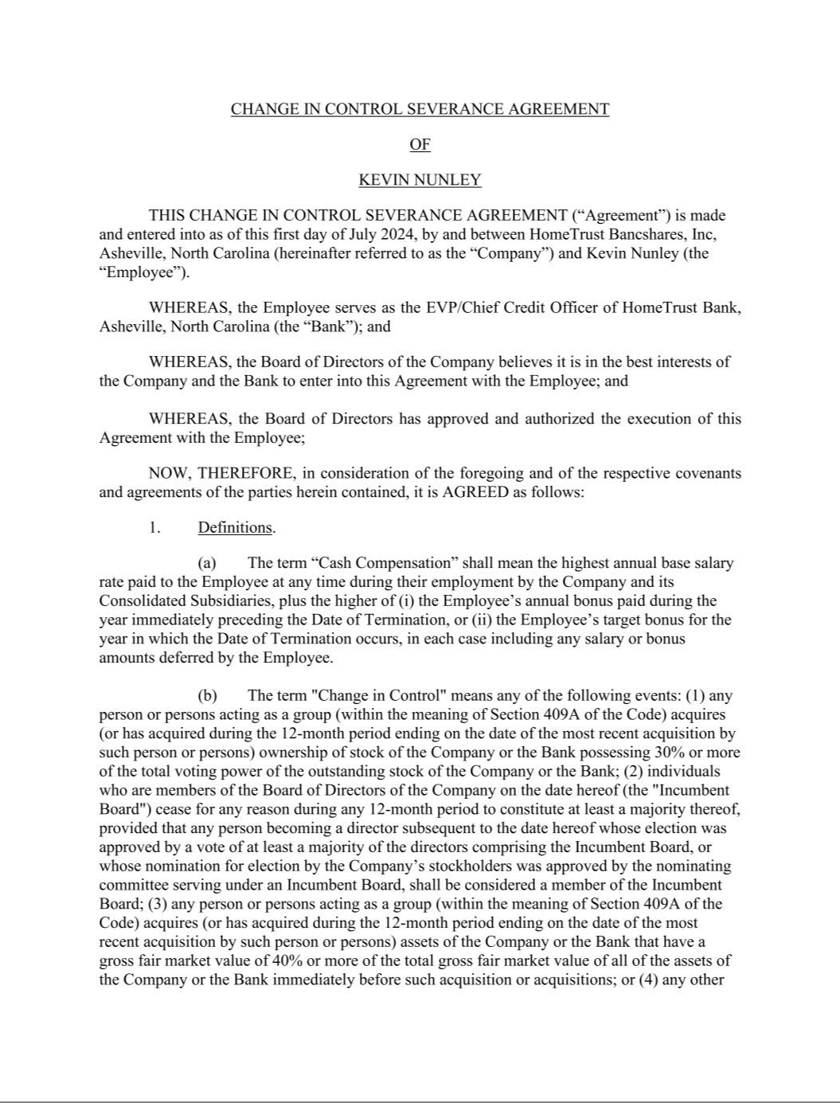

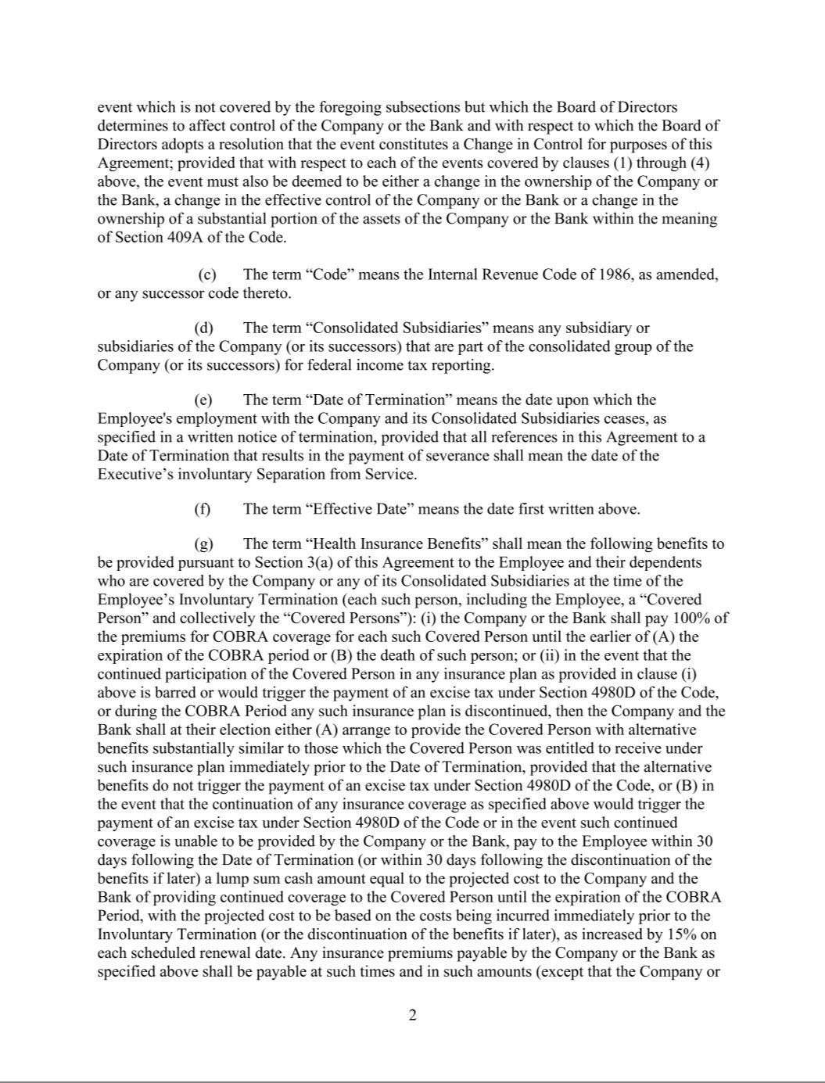

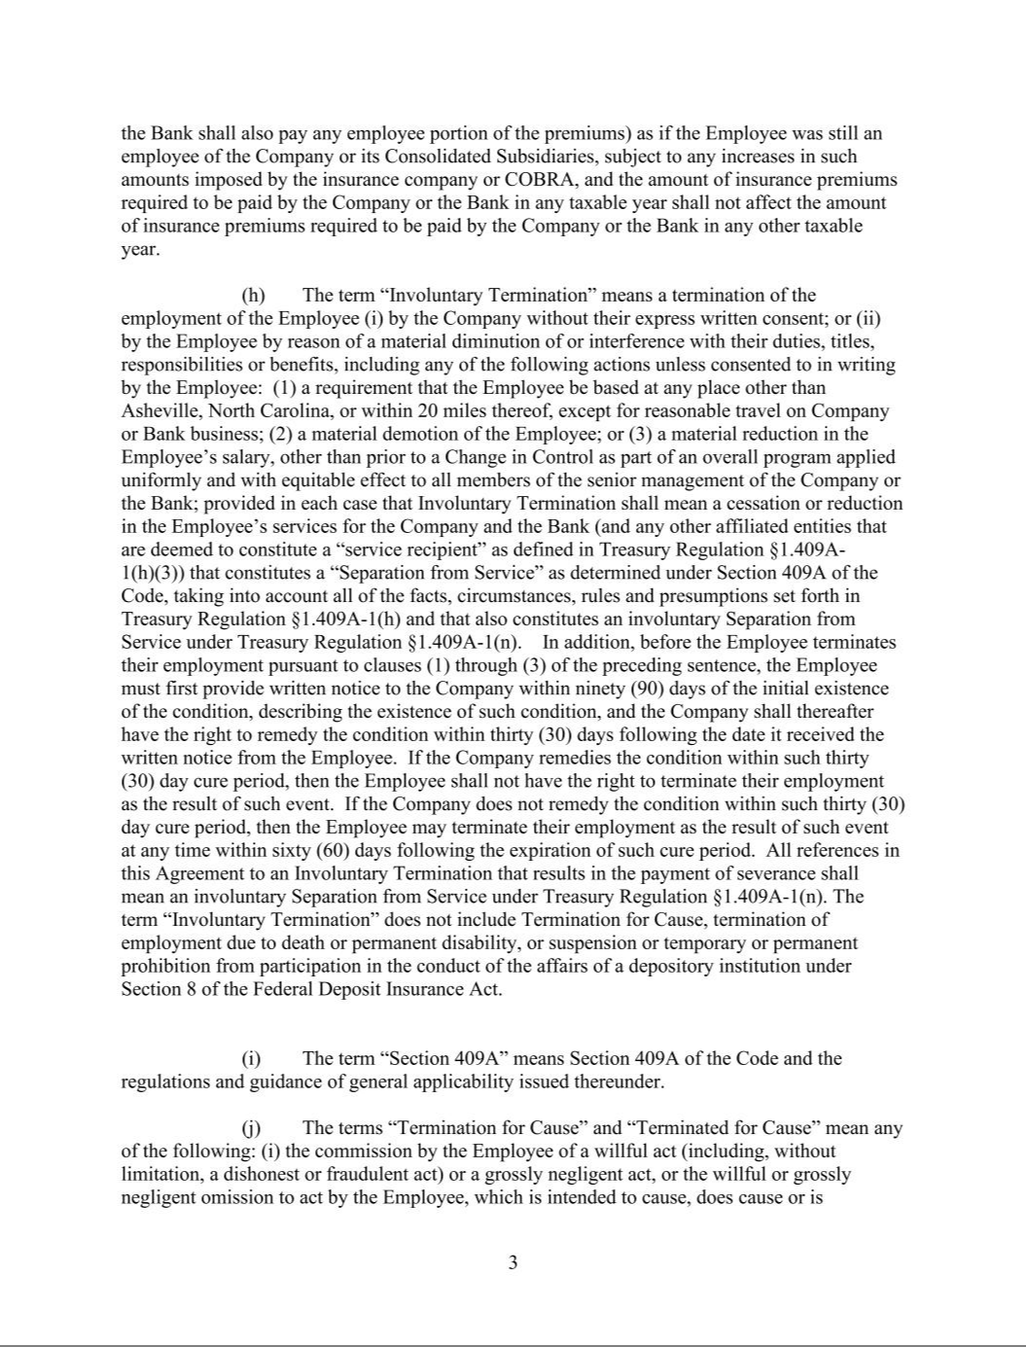

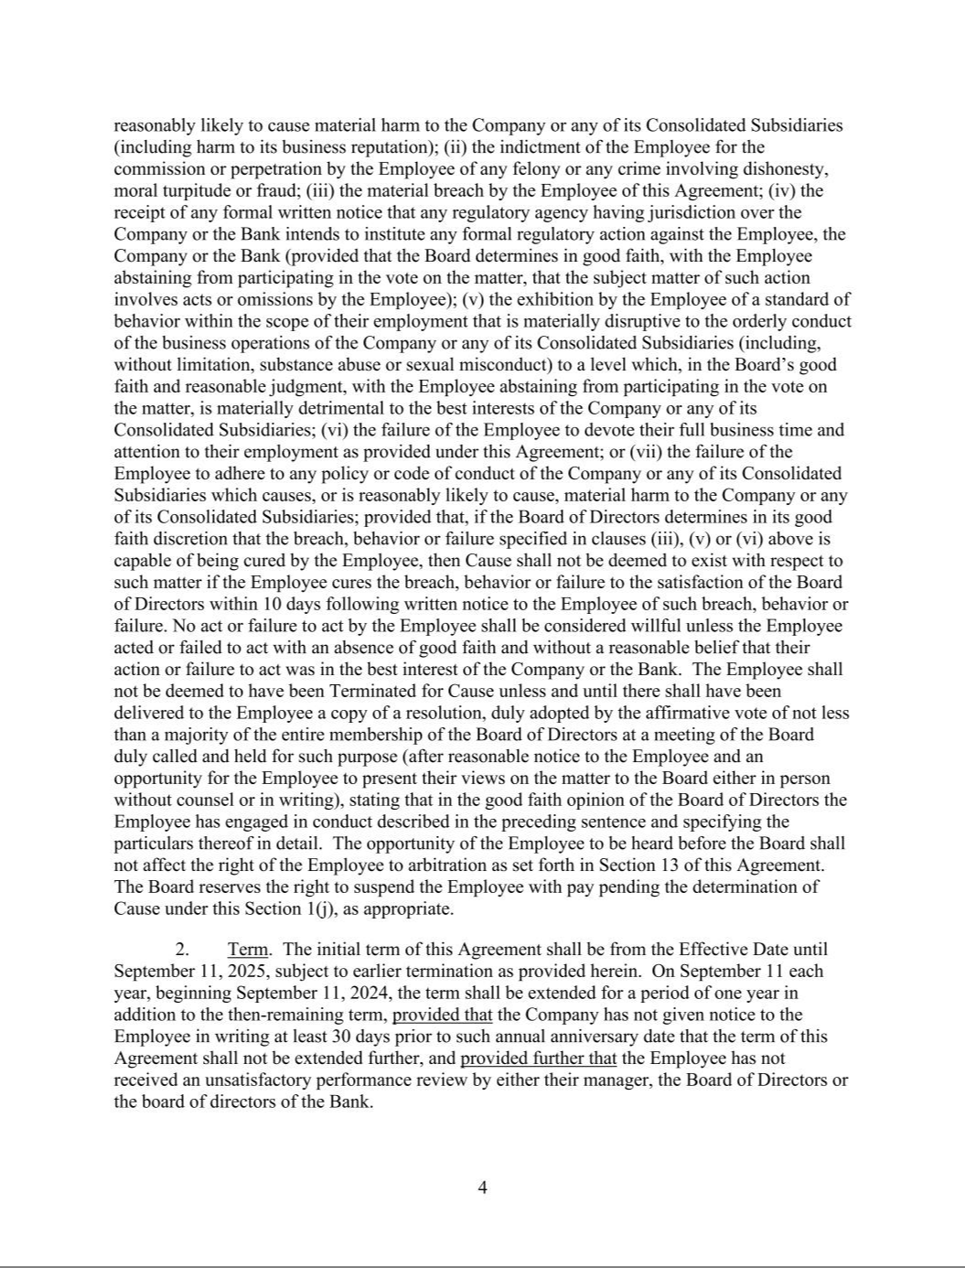

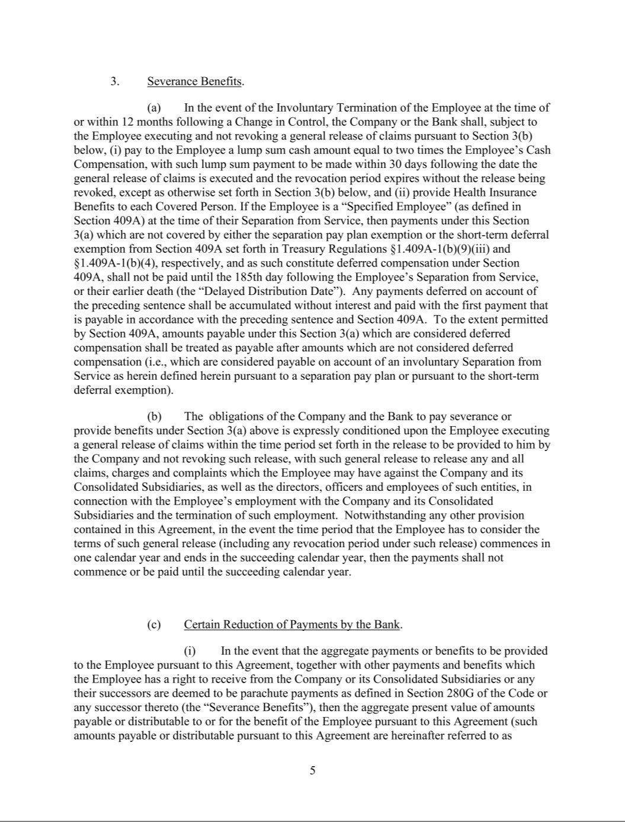

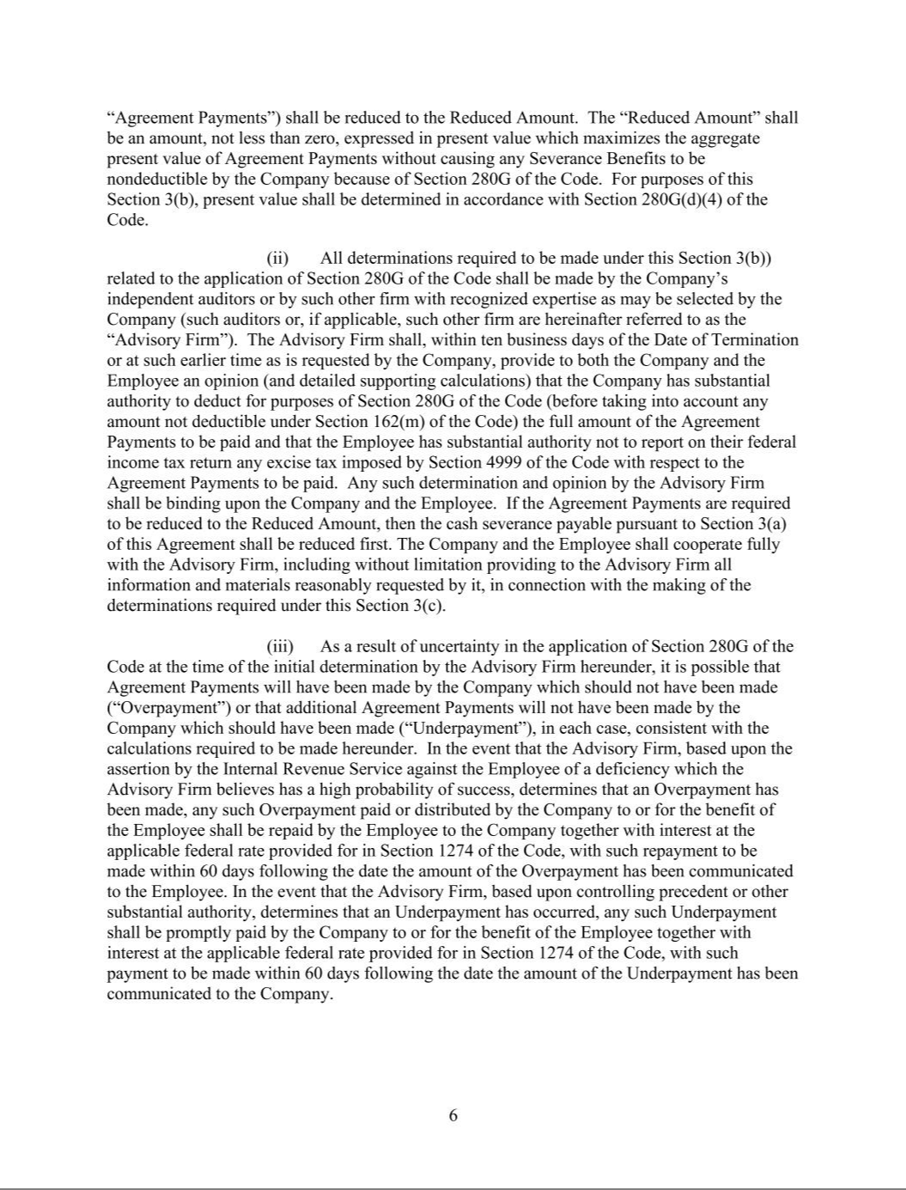

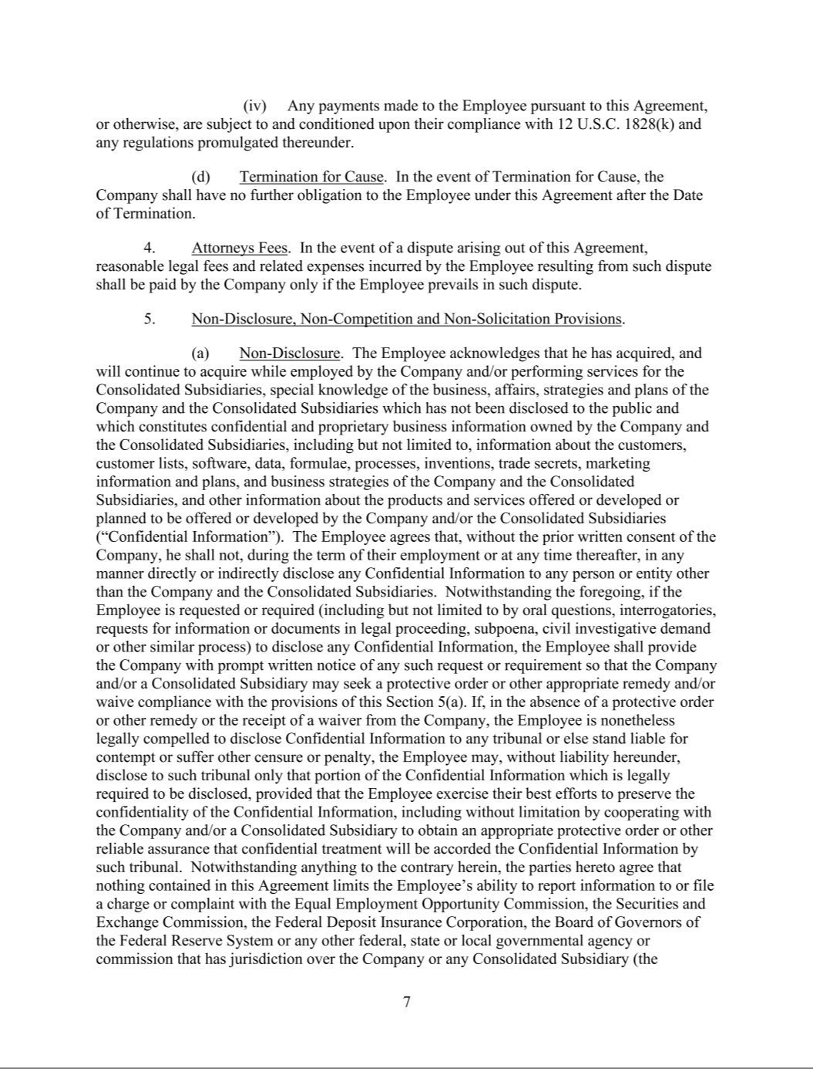

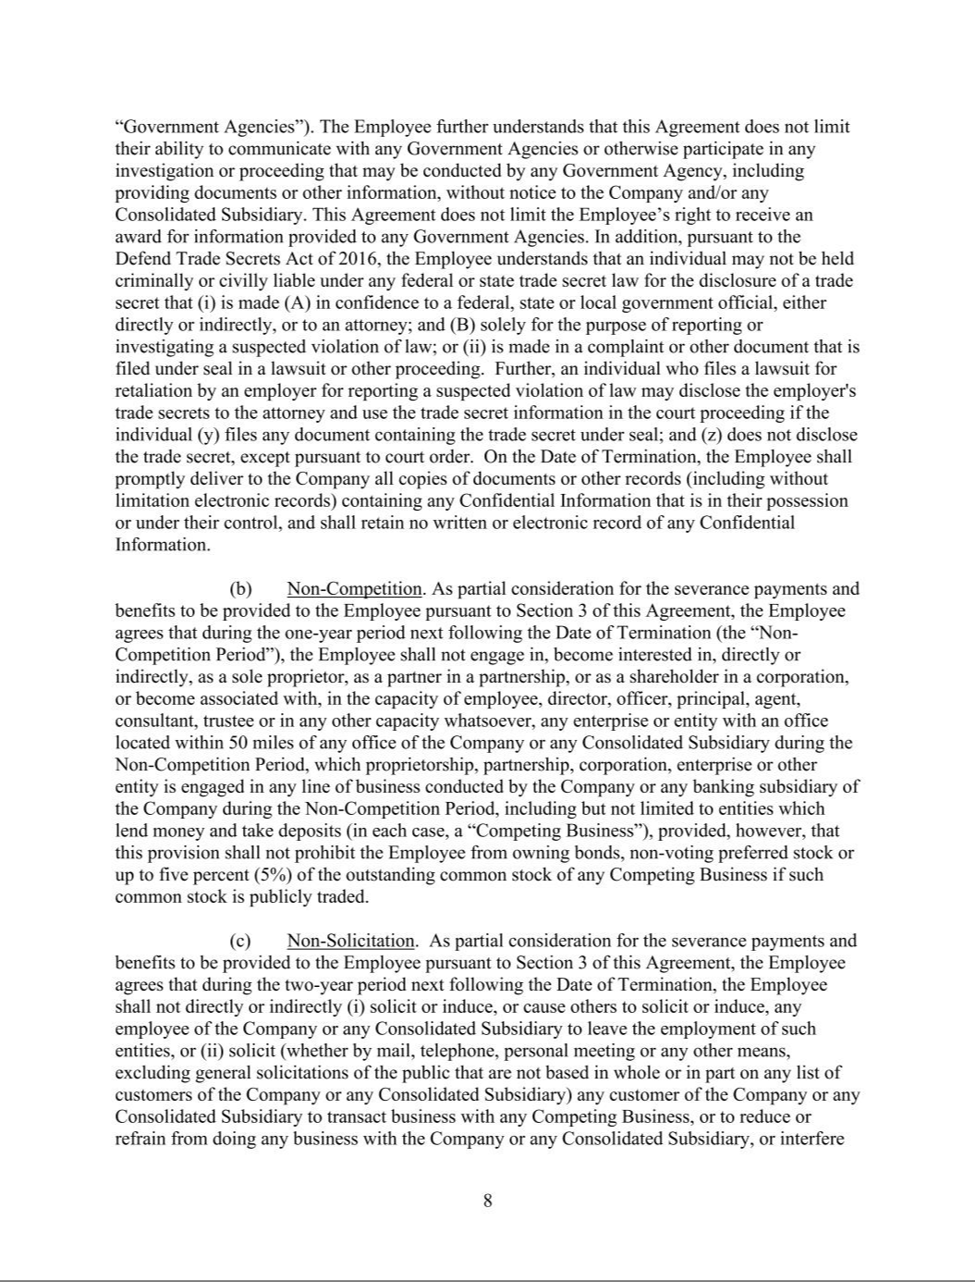

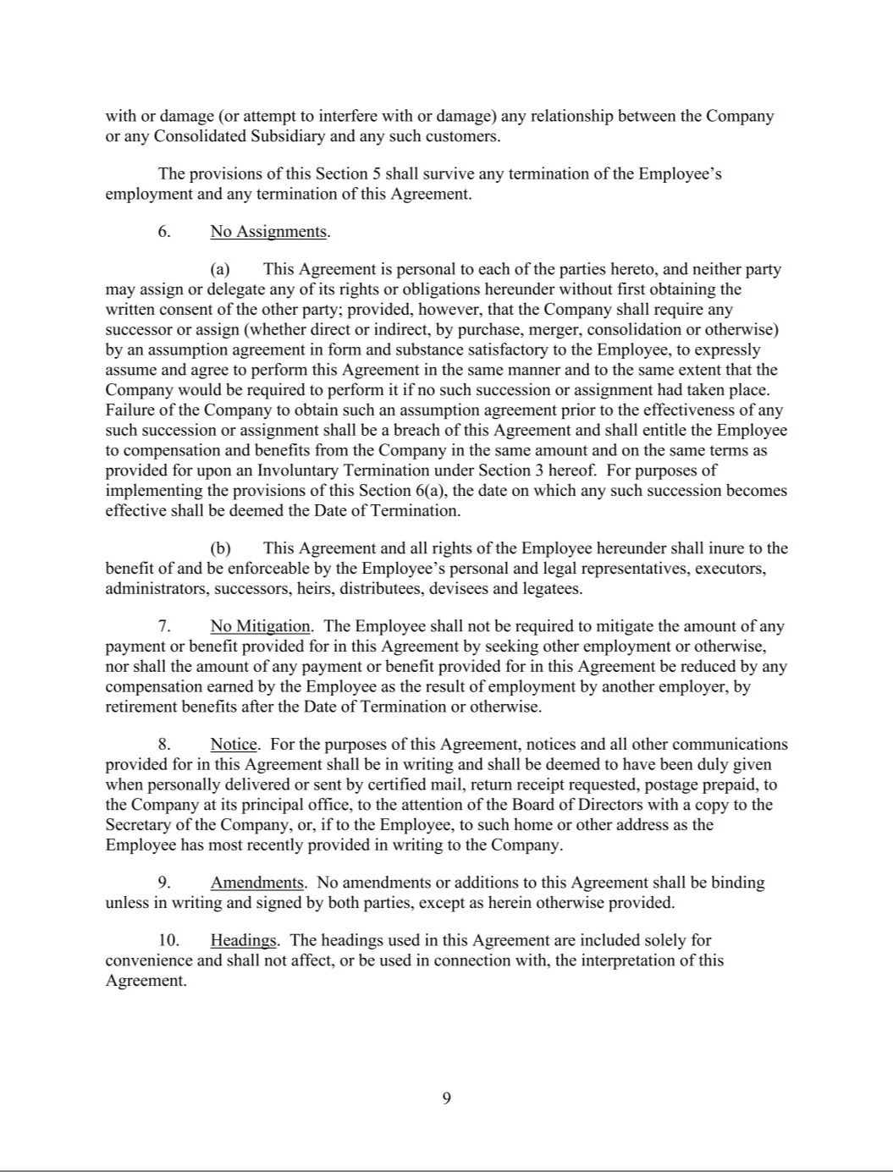

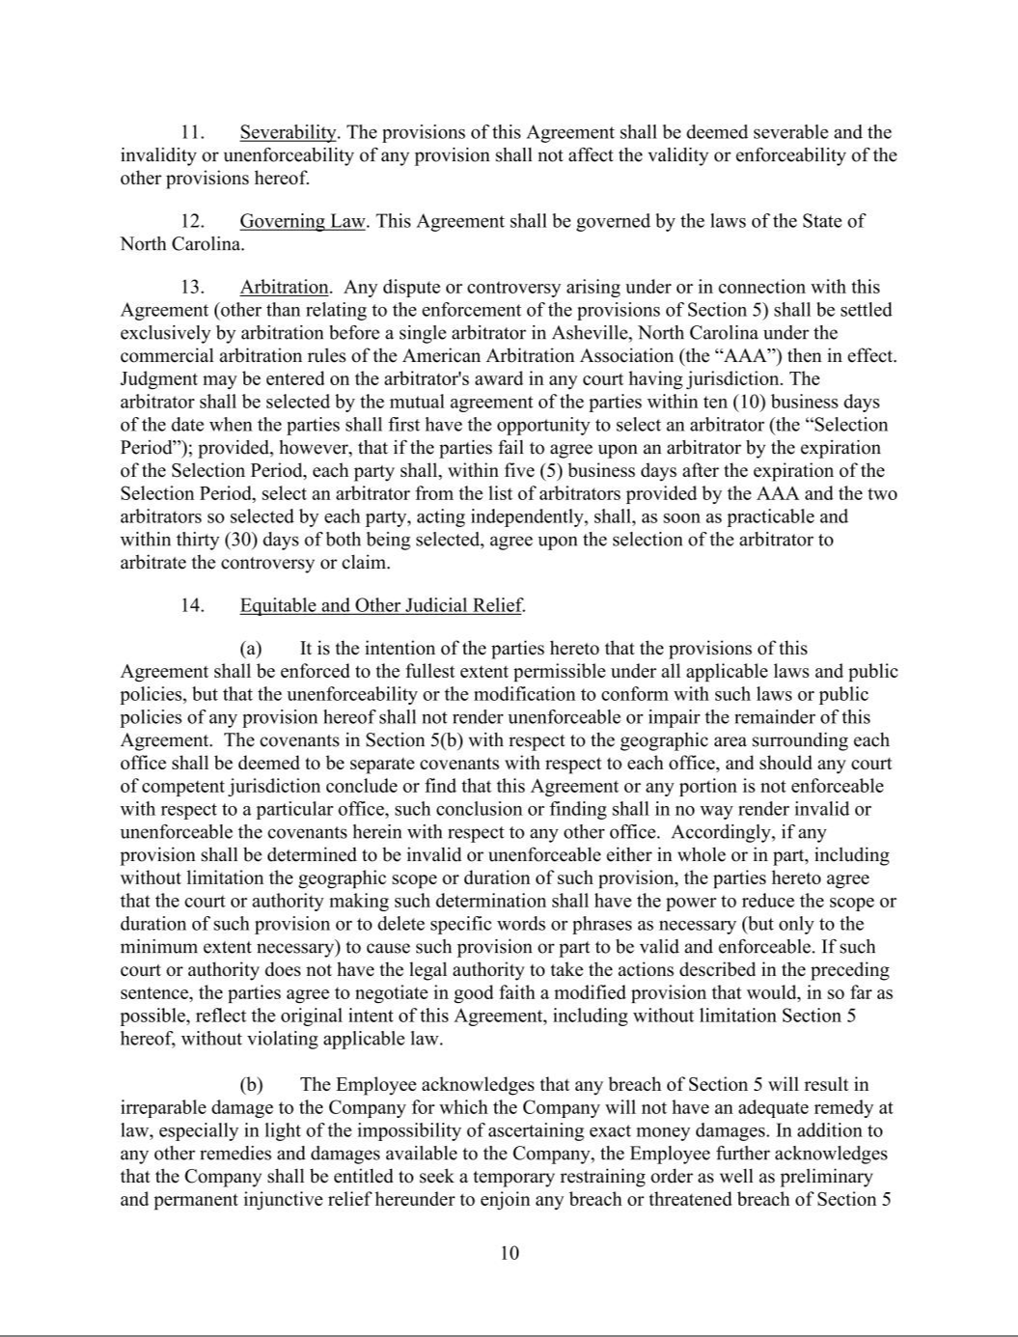

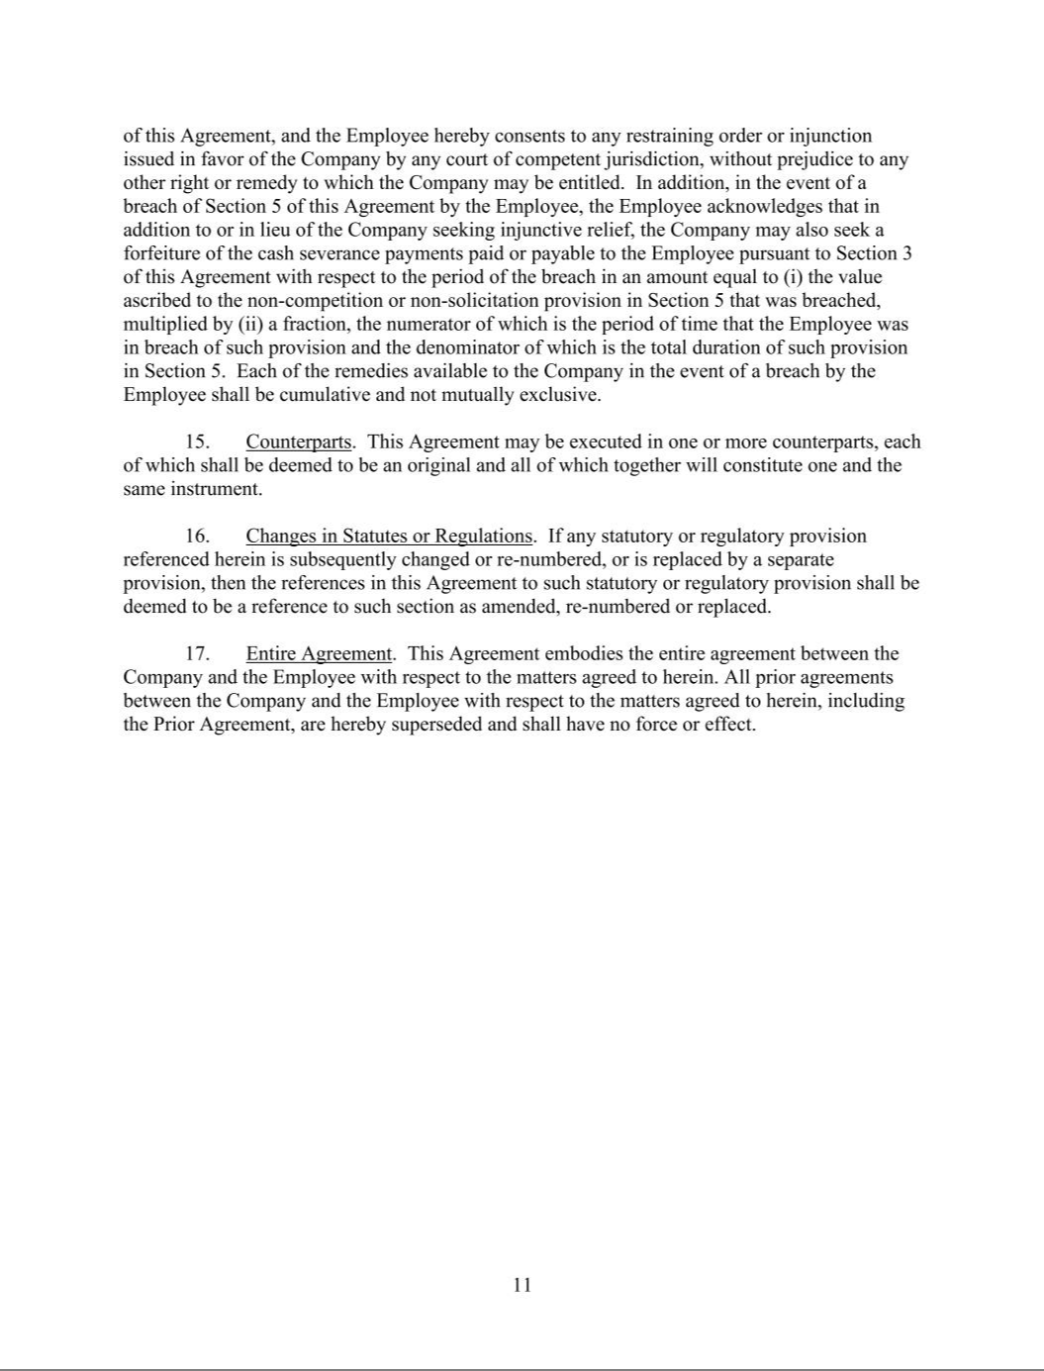

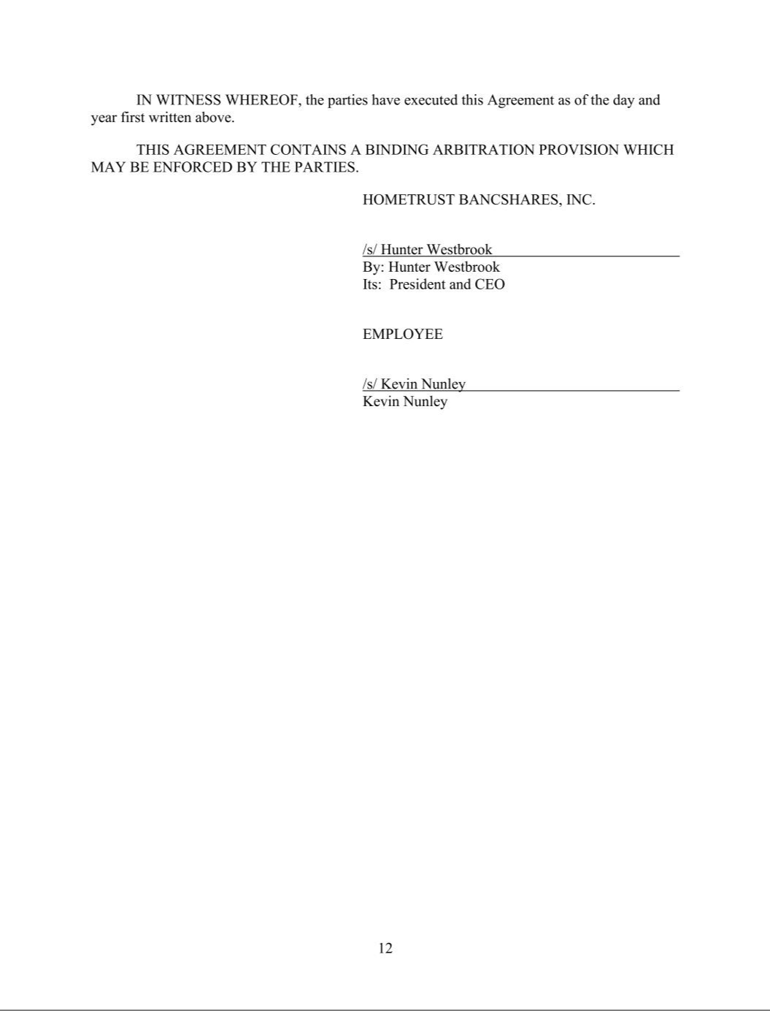

Exhibit 31.1

RULE 13a-14(a) CERTIFICATION

I, C. Hunter Westbrook, certify that:

- I have reviewed this quarterly report on Form 10-Q of HomeTrust Bancshares, Inc. (the "Company");

- Based on my knowledge, this report does not contain any untrue statement of material fact or omit to state a material fact necessary to make the statements made, in light of the circumstances under which such statements were made, not misleading with respect to the period covered by this report;

- Based on my knowledge, the financial statements, and other financial information included in this report, fairly present in all material respects the financial condition, results of operations and cash flows of the Company as of, and for, the periods presented in this report;

- The Company's other certifying officer and I are responsible for establishing and maintaining disclosure controls and procedures (as defined in Exchange Act Rules 13a-15(e) and 15d-15(e)) for the Company and have:

  - designed such disclosure controls and procedures, or caused such disclosure controls and procedures to be designed under our supervision, to ensure that material information relating to the Company, including its consolidated subsidiary, is made known to us by others within those entities, particularly during the period in which this report is being prepared;

  - designed such internal controls over financial reporting, or caused such internal controls over financial reporting to be designed under our supervision, to provide reasonable assurance regarding the reliability of financial reporting and the preparation of financial statements for external purposes in accordance with generally accepted accounting principles;

  - evaluated the effectiveness of the Company's disclosure controls and procedures and presented in this report our conclusions about the effectiveness of the disclosure controls and procedures as of the end of the period covered by this report based on such evaluations; and

  - disclosed in this report any change in the Company's internal control over financial reporting that occurred during the Company's most recent fiscal quarter that has materially affected, or is reasonably likely to materially affect, the Company's internal control over financial reporting; and

- The Company's other certifying officer and I have disclosed, based on our most recent evaluation of internal control over financial reporting, to the Company's auditors and the audit committee of the Company's board of directors (or persons performing the equivalent functions):

  - all significant deficiencies and material weaknesses in the design or operation of internal control over financial reporting which are reasonably likely to adversely affect the Company's ability to record, process, summarize and report financial information; and

  - any fraud, whether or not material, that involves management or other employees who have a significant role in the Company's internal control over financial reporting.

November 8, 2024 By: /s/ C. Hunter Westbrook

C. Hunter Westbrook

President and Chief Executive Officer

Exhibit 31.2

RULE 13a-14(a) CERTIFICATION

I, Tony J. VunCannon, certify that:

- I have reviewed this quarterly report on Form 10-Q of HomeTrust Bancshares, Inc. (the "Company");

- Based on my knowledge, this report does not contain any untrue statement of material fact or omit to state a material fact necessary to make the statements made, in light of the circumstances under which such statements were made, not misleading with respect to the period covered by this report;

- Based on my knowledge, the financial statements, and other financial information included in this report, fairly present in all material respects the financial condition, results of operations and cash flows of the Company as of, and for, the periods presented in this report;

- The Company's other certifying officer and I are responsible for establishing and maintaining disclosure controls and procedures (as defined in Exchange Act Rules 13a-15(e) and 15d-15(e)) for the Company and have:

  - designed such disclosure controls and procedures, or caused such disclosure controls and procedures to be designed under our supervision, to ensure that material information relating to the Company, including its consolidated subsidiary, is made known to us by others within those entities, particularly during the period in which this report is being prepared;

  - designed such internal controls over financial reporting, or caused such internal controls over financial reporting to be designed under our supervision, to provide reasonable assurance regarding the reliability of financial reporting and the preparation of financial statements for external purposes in accordance with generally accepted accounting principles;

  - evaluated the effectiveness of the Company's disclosure controls and procedures and presented in this report our conclusions about the effectiveness of the disclosure controls and procedures as of the end of the period covered by this report based on such evaluations; and

  - disclosed in this report any change in the Company's internal control over financial reporting that occurred during the Company's most recent fiscal quarter that has materially affected, or is reasonably likely to materially affect, the Company's internal control over financial reporting; and

- The Company's other certifying officer and I have disclosed, based on our most recent evaluation of internal control over financial reporting, to the Company's auditors and the audit committee of the Company's board of directors (or persons performing the equivalent functions):

  - all significant deficiencies and material weaknesses in the design or operation of internal control over financial reporting which are reasonably likely to adversely affect the Company's ability to record, process, summarize and report financial information; and

  - any fraud, whether or not material, that involves management or other employees who have a significant role in the Company's internal control over financial reporting.

November 8, 2024 By: /s/ Tony J. VunCannon

Tony J. VunCannon

Executive Vice President, CFO, and Treasurer

Exhibit 32

SECTION 1350 CERTIFICATION

Each of the undersigned hereby certifies in his capacity as an officer of HomeTrust Bancshares, Inc. (the "Company") that the Quarterly Report of the Company on Form 10-Q for the period ended September 30, 2024, fully complies with the requirements of Section 13(a) of the Securities and Exchange Act of 1934, as amended, and that the information contained in such report fairly presents, in all material respects, the financial condition and results of operations of the Company as of the dates and periods presented in the financial statements included in such report.

November 8, 2024 By: /s/ C. Hunter Westbrook

C. Hunter Westbrook

President and Chief Executive Officer

November 8, 2024 By: /s/ Tony J. VunCannon

Tony J. VunCannon

Executive Vice President, CFO, and Treasurer

